**PAEDIATRICS 2.2 SEM 2 SUPPLIMENTARY**

SECTION A:MCQS

1. Which of the following is cyanotic heart disease?

1. Pulmonary stenosis
2. Tricuspid atresia
3. **Coarctation of the aorta**
4. Overriding aorta

2. John aged six years of age weighing 15kgs presents to you with history of diarrhea and vomiting for two days. On examination the AVPU<A, has a weak pulse and her hands are cold on touch. How will you manage her?

1. **Give ringers lactate 20mls/kg in a bolus within 15 minutes**
2. Give ringers lactate 20mls/kg in 5 % dextrose over 2 hours
3. Give ringers lactate 4mls/kg /hr in 5% dextrose
4. Give Resomal at 20mls/kg over one hour.

3. Which among the following is acyanotic heart disease?

1. **Ventricular septal defect**
2. Tetralogy of fallot
3. Truncus arteriosus
4. Transposition of great vessels.

4. Identify among the following that which belongs to the minor criteria for the diagnosis of acute rheumatic fever

1. Sydenham’s chorea
2. Elevated antistreptolysin O titres
3. **Prolonged PR interval**
4. Migratory polyarthritis

5. As regards to infective endocarditis in children which of the following statement is false?

1. There is a charging murmur
2. **Patient has normal temperatures**
3. May present with microscopic haematuria
4. Have splinter haemorrages

6. Black currant jelly stool indicates

1. Anal outlet bleeding
2. **Intussusception**
3. Volvulus
4. Esophageal varices

7. The most common cause of nephrotic syndrome in children is

1. Membranes glomerulonephrits
2. **Minimal change disease**
3. Focal segmental glomerulonephritis
4. Membranes neuropathy.

9. The following is an intrinsic renal cause of renal failure

1. Burns of 50% body surface area
2. Shock
3. **Acute glomerulonephritis**
4. Severe anaemia

10.Baby prosper presents with history of diarrhea and vomiting for two days ,on examination he has sunken eyes and he is restlessness but he is able to drink.Which among the following is the best management?

1. Give intravenous ringers lactate 30mls/kg for 30 minutes.
2. **Give ORS 75mls over 4 hrs.**
3. Give intravenous ringers lactate 20mls/kg over 15 minutes.
4. Give ORS 120mls/kg over 6 hours.

11. Which of the following is indicated in the management of hemophilia in children?

1. Omeprazole
2. Digoxin
3. **Cryoprecipitate**
4. Aspirin

12. A 10-year-old girl appears with dysuria, suprapubic pain, urgency, frequency, and incontinence. Physical examination reveals temperature 98.6°F, presence of suprapubic tenderness. Most likely diagnosis:

1. Perinephric abscess
2. Renal stone
3. Pyelonephritis
4. **Cystitis**

**13.** Most common cardiac lesion in trisomies:

1. ASD
2. **VSD**
3. Aortic stenosis
4. Mitral stenosis

14. Most common cause of ESRD (end stage renal disease) in children:

1. Glomerulonephritis
2. Focal segmental glomerulosclerosis
3. Pyelonephritis
4. **Congenital renal disease**

15. A common renal manifestation of sickle cell anemia:

1. **Hematuria**
2. Kidney infection
3. Polycystic kidney
4. Multicystic kidney

16.A child was brought to the er due to edema. It started on the feet progressing towards the thight. The eyes were noted to be puffy particularly in the morning. The mother cannot recall any prior illness. On pe, you notice several healing wounds on the legs, and his bp is high. On further probing, the child confesses that his urine is cola colored. Your primary diagnosis is:

1. Nephrotic syndrome
2. Renal tubular acidosis
3. **Acute glomerulonephritis**
4. IgA nephropathy

17.The most common cause of idiopathic nephrotic syndrome is

1. Focal segmental sclerosis
2. Membranous nephropathy
3. Membranoproliferative GN type 1
4. **Minimal change nephrotic syndrome**

**18.** You note that a newborn baby boy’s prepuce cannot be retracted. He has

1. Hypospadias
2. **Phimosis**
3. Chordee
4. Paraphimosis

19. Which of the following congenital heart diseases can cause fetal hemodynamic disturbance and hydrops?

1. **Ebstein anomaly**
2. Pulmonary atresia
3. Transposition of great arteries
4. Severe type of hypoplastic left heart syndrome

20. A 4-year-old boy with tetralogy of Fallot and B-T shunt had dental procedure 1 week ago. Now he has spikes of high grade fever, rigors, and splenomegaly. Echocardiography shows moderate Size vegetation attached to pulmonary valve. Which of the following is the most likely causative Organism?

1. Staphylococcus aureus
2. **Streptococcus viridans**
3. Group D enterococci
4. Streptococcus pneumonia

**SHORT ESSAY QUESTIONS**

1. **State the Duke’s criteria as used in the diagnosis of infective endocarditis (5 marks)**

For diagnosis the requirement is:

2 major and 1 minor criteria OR

1 major and 3 minor OR

5 minor.

* Major criteria
  + positive blood culture for IE
  + Evidence of endocardial involvement-positive echocardiogram.
* Minor criteria
  + predisposition (heart condition or IV drug use)
  + fever of 38 or higher
  + vascular or immunologic phenomena
  + Microbiologic(positive blood culture) or echocardiographic evidence not meeting major criteria

**2. Classify congenital heart diseases giving an example in each case (5 marks)**

* Acyanotic-VSD, AVSD, Coarctation of the aorta
* Cyanotic-Tetrallogy of fallot, tricuspid atresia, Transposition of the great arteries.

**3. Baby Malik who is 2 years old was noted to assume a squatting position frequently during playtime at the day care center. The mother noticed a change of colour around the tongue appearing as bluish during the same time of the squatting.**

1. What is the most likely diagnosis? (1 mark)

Tetrallogy of fallot

1. State 4 anatomical defects present in this defect (4 marks).

* Ventricular septal defect(VSD)
* Overriding aorta
* Pulmonary stenosis
* Right ventricular hypertrophy

**4. State five features in a child diagnosed with Nephrotic syndrome (5 marks)**

* + Heavy proteinuria
  + Edema
  + Hyperlipidemia
  + Hypoproteinemia
  + Hypoalbuminemia

**5. A 5 years old female presented with history of lower abdominal pain,vomiting and fever.The mother mentioned that she has noticed change in frequency of urination which is accompanied with pain.**

a) What your diagnosis? (1 mark)

* Urinary tract infection

b) List two organisms responsible for the above condition (1 mark)

* Escherichia coli
* Klebsiella species
* Proteus species

c) What is the definitive treatment for the patient.(3 marks).

* Antipyretics
* First line antibiotics-Amoxyclav
* Cefuroxime

**6. State five congenital anomalies of the gastrointestinal system (5 marks)**

* Cleft clip and palate
* Tracheo-oesophageal fistula and Oesophagal Atresia
* Pyloric stenosis
* Hirchsprung’s disease
* Meckel’s diverticulum

**7. Describe five Laboratory Signs of Iron Deficit Anemia in children (5 marks)**

* A decrease MCV - less than 75
* Reduction in the colored index - less than 0,85
* Increase RDW
* A decrease MCHC - less than 30.
* Morphology of the erythrocytes - hypochromic, anisocytosis and poikilocytosis

**8. State five complications found in a child with sickle cell diseases (5 marks)**

* Anemia/Jaundice
* Brain Damage/Stroke
* Kidney failure
* Decreased lung function
* Eye disease (bleeding, retinal detachment)
* Leg ulcers

**LONG ESSAY QUESTIONS**

**1. Discuss acute renal failure in children basing on;**

1. Definition (2marks)

* A clinical syndrome where the kidney fails in its excretory function and is hence unable to maintain fluid and electrolyte homeostasis.
* Defined as sudden potentially reversible reduction in renal functions.
* It is an abrupt reduction in glomerular filtration rate characterised by increased blood urea nitrogen.

1. Classify the causes and give two examples in each case (8 marks)

1) pre-renal= this is due to renal hypo perfusion

* Dehydration
* Hemorrhage
* Sepsis
* Hypoalbuminemia
* Cardiac failure

* ii) intrinsic renal= due to parenchyma kidney damage
* Acute Glomerulonephritis
* Hemolytic-uremic syndrome
* Acute tubular necrosis Cortical necrosis
* Renal vein thrombosis
* Rhabdomyolysis
* Acute interstitial nephritis
* Tumor infiltration
* Tumor lysis syndrome

iii) Post renal -which is due to bilateral obstruction of urinary tract

* Posterior urethral valves
* Ureteropelvic junction obstruction
* Ureterocele (swelling at the bottom of ureters)
* Malignancy
* Urolithiasis
* Hemorrhagic cystitis

c) Highlight 4 investigations for the above condition (4 marks)

* Full haemogram
* UECS
* Urinalysis
* Chest x-rays
* Renal ultrasound
* Renal biopsy

d) Enumerate 6 indications for dialysis in a patient with the above condition (6 marks)

* + Volume overload with evidence of hypertension/pulmonary oedema
  + Persistence hyperkalemia
  + Severe metabolic acidosis unresponsive to medical management.
  + Neurologic symptoms(altered mental status,seizures)
  + Blood urea nitrogen>100-150mgldl.
  + Calcium-phosphorus imbalance with hypocalcemic tetany.

**2. A 6 year old male patient was brought in the outpatient department with a history of sore throat two weeks ago. He has complains of painful swollen joints which he described as moving from one joint to the other joint. He also has fever.**

1. What is your diagnosis (2 marks?)

Acute rheumatic fever

1. State the criteria used in making the diagnosis (10 marks)

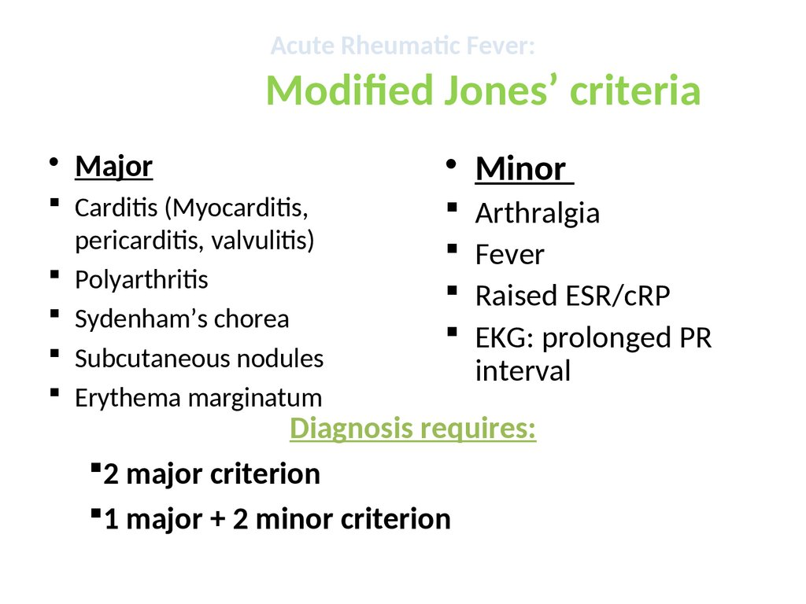

1. How will you manage this patient (8 marks)

Acute phase

* Bed rest during acute febrile .patients with carditis should have bed rest untill symptoms of carditis resolve.
* Penicillin to eradicate streptococcal infection in the throat
* Anti-inflammatory-ASA 20mgs/kg/day relieves arthritis
* Steroids-for carditis;prednisolone 2mgs/kg.
* Haloperidol 0.25mg/24hrs in 2 doses or diazepam to treat chorea.
* Heart failure
* Digoxin
* Diuretics
* ACE inhibitors
* Secondary prophlaxis with Monthly benzathine penicillin 600,000 i.u IM or oral penicillin V 250mg twice daily.
* Allergic to penicillins give erythromycin 250 mg twice daily.
* Ensure vaccinations are up to date