DIRECTORATE OF LEARNING SYSTEMS

DISTANCE EDUCATION PROGRAMME

Unit 15
Tuberculosis and Leprosy

Allan and Nesta
Ferguson Trust
COMMUNICABLE DISEASES COURSE

Unit 15: Tuberculosis and Leprosy

A distance learning course of the Directorate of Learning Systems (AMREF)

Published by the African Medical Research Foundation (AMREF)
© 2007

This course is distributed under the Creative Commons Attribution-Share Alike 3.0 License. Any part of this unit including the illustrations, may be copied, reproduced or adapted to meet the needs of local health workers, or for teaching purposes, provided proper citation is accorded AMREF. If this work is altered, transformed or built upon, the resulting work may be distributed only under a license identical to this one. AMREF would be grateful to learn how you are using this course, and welcomes constructive comments and suggestions. Please address any correspondence to:

Directorate of Learning Systems
AMREF Headquarters
P O Box 27691 – 00506, Nairobi, Kenya
Email: amreftraining@amrefhq.org

Writer: Dr Paolo Muthama, National TB/Leprosy Control Programme
Cover Design: Bruce Kynes
Technical Co-ordinator: Joan Mutero

The African Medical Research Foundation (AMREF would like to acknowledge the generous contributions of the Commonwealth of Learning (COL) and the Allan and Nesta Ferguson Trust towards the production of this course.
Table of Contents

INTRODUCTION 5
OBJECTIVES 5
15.2: TUBERCULOSIS 8
15.2.1 Epidemiology 8
15.2.2 Mode of Transmission 8
15.2.3 Types of Tuberculosis 10
15.2.4: Clinical Features of Tuberculosis 12
15.2.5: Diagnosis 13
15.2.6: Management of TB 15
15.2.7: Side effects of common TB drugs 19
15.2.8: HIV and TB Interactions 20
15.2.9: Drug Resistance TB 25
15.2.10: Prevention and Control of TB 26
15.3: LEPROSY DISEASE (Hansen’s Disease) 28
15.3.1 Mode of Transmission. 28
15.3.2Classification and Types of Leprosy 29
15.3.2 Clinical Features 30
15.3.3: Diagnosis of Leprosy: “The Three Cardinal Signs” 30
15.3.4 Types of Patients 32
15.3.5 Management of Leprosy 32
15.3.6 Leprosy Complications 34
15.3.7 Prevention and Control 37
Summary 39
Annex 1: What every leprosy patient should know 40

List of Abbreviations
AFB Acid fast bacilli
ARC AIDS related complex
BCG Bacille Calmette Guerin
DST Drug Sensitivity Testing
DTLC District TB & Leprosy Coordinator
ENL Erythema nodosum leprosum
F Failure
FDC Fixed Dose Combination
MB Multi-bacillary Leprosy
MDT Multiple drug therapy
MOH Medical Officer of Health
N New (patient)
NGO Non-governmental organization
NLTP National Leprosy Tuberculosis Programme
NLR Netherlands Leprosy Relief Association
PB Pauci-bacillary
PTB Pulmonary Tuberculosis
PHC Primary health care
PTLC Provincial TB and Leprosy Coordinator
R Relapse
RFT Released from treatment
RR Reversal reaction
SCC Short-Course Chemotherapy
TC Treatment completed
TI Transfer in
TO Transfer out
TR Treatment resumed
TST Tuberculin Skin Test
PLWA People living with AIDS
WHO World Health Organisation

Unit 15: Tuberculosis and Leprosy

INTRODUCTION

Congratulations for coming this far! You are just a heart beat away from the end of this course. Welcome to the fifteenth unit on Tuberculosis and Leprosy. You will recall in the first Unit of this course we stressed that communicable diseases are important for a number of reasons. This are because:
- They are common;
- They may cause widespread outbreaks of disease;
- They may cause death and disability;
- Most are preventable by fairly simple means.

In this unit you will learn about Tuberculosis (TB) and Leprosy. You probably are wondering why we have chosen to discuss the two diseases together. Well, TB and leprosy have a lot in common and are both referred to as chronic endemic communicable diseases. They are also both caused by bacteria that belong to the family of Mycobacteria. In this unit we shall discuss their causes, mode of transmission, management and prevention. Let’s start by looking at our objectives for this unit.

OBJECTIVES

After completing this lesson you will be able to:

- Describe TB and leprosy.
- Estimate the number of cases in the catchments area where you work;
- Recognize early symptoms and signs of TB and leprosy;
- Describe the standard treatment for both these diseases;
- Outline the complications for both TB and leprosy;
- Discuss how to prevent both TB and leprosy;
- List the principles of control.

15.1 Tuberculosis and Leprosy
As earlier mentioned, TB and leprosy are characterized as chronic communicable diseases. The mycobacteria that causes these two diseases are relatively slow-growing organisms. They therefore have a long incubation period and it takes a long time to develop the diseases. Equally, it takes a relatively long time to cure them. The other thing about the TB and Leprosy mycobacteria is that they are not equally active in the same patient. Some may be present in the so called dormant or sleeping state. When they are in this state they do not divide or metabolise and therefore they are not susceptible to drugs. It is only when they become active again that they become susceptible to drugs. Thus, in order to kill all the mycobacteria, treatment must be continued over a long period of time so as to give time for all the dormant mycobacteria to become active again and be subjected to the drugs. Both infections can also be spread from an infectious patient to a susceptible host The risk of becoming infected with these organisms is determined by the number of organisms coughed (TB) or sneezed (Leprosy) into the air as a fine spray of droplets (aerosol) and the time such droplets remain in the room where other people are.

Before you read on do the following activity. It shouldn’t take you more than 5 minutes to complete.

ACTIVITY 1

List two risk factors for becoming infected with TB or Leprosy
_____________________________________________________________________
_____________________________________________________________________
_____________________________________________________________________

I hope your answers had the following risk factors for TB and/or leprosy:

- Staying with infectious patient in a poorly ventilated room;
- Staying in contact with a patient who is not on treatment or has not completed the full course;
- Overcrowding, since this increases the chances of catching the infection from many other people.
Fortunately not all people who are infected will develop clinical disease. A great proportion of those infected overcome the infection and develop a natural immunity. What factors make one develop the disease? Once again, lets start with your thoughts on this issue.

ACTIVITY 2

List the factor that contribute to the development of TB or leprosy,
_____________________________________________________________________
_____________________________________________________________________
_____________________________________________________________________

The following factors contribute to the development of TB or leprosy:

- Poor general nutritional and health status (poverty)
- Not having received a BCG vaccination;
- HIV infection at the same time;
- History of recent measles (especially for paediatric TB);
- Metabolic disorders, e.g. diabetes mellitus.

With the current HIV epidemic, many HIV-positive patients who had successfully overcome mycobacterial infection in the past experience a flare-up of this infection leading to clinical disease. This is particularly true for tuberculosis. HIV infection causes a breakdown in the immune defence mechanisms, and thus the few mycobacteria that were kept under control by the immune system get a chance to become active again and cause disease.

TB is common all over the country, and especially now with the HIV/AIDS epidemic. Leprosy is still as common in areas such as western and coast provinces.

15.2: TUBERCULOSIS

Tuberculosis is a chronic bacterial infection caused by bacteria that belongs to the family of Mycobacterium. These are Mycobacterium tuberculosis, Mycobacterium bovis and Mycobacterium avium.. This bacterium is rod shaped explaining why it’s called a bacillus. M. tuberculosis only attacks human beings. In most cases the bacterium affects the lungs giving rise to pulmonary tuberculosis (PTB), although other organs such as the brain, intestines and bones may also be affected. Occasionally, tuberculosis is caused by M. bovis, a mycobacterium that affects cattle and can infect those who consume milk that has not been boiled or pasteurized. Mycobacterium avium causes the disease in birds. Bird droppings spread pulmonary tuberculosis in individuals whose immunity is depressed. Tuberculosis is also known as Koch’s disease.

15.2.1 Epidemiology
A third of the world’s population is infected with the bacteria with the majority being found in the Asian continent. In 2005, 14,602,000 people worldwide were diagnosed with TB and 1,693,000 died from this disease. Of these cases 3,741,000 (24%) cases were found in Africa with 587,000 (34%) deaths occurring in Africa. According to the MOH TB guidelines, Kenya is one of the 22 high TB burdened countries in the world which collectively contribute 80% of the global TB disease burden. Kenya is experiencing a generalized TB epidemic affecting the young economically productive age groups (15-44 year old). Males are 1.4 times more likely to have TB than females. In 2004 a total of 106, 000 cases of TB were notified to the National Leprosy and Tuberculosis Programme (NLTP) which represents a TB case notification rate of 320 per 100,000 population. Since the early nineties, TB cases have increased almost ten-fold, mainly due to the HIV/AIDS epidemic. The case detection rate for Kenya is only 50%. This implies that the rest who are undetected keep on transmitting the disease. That is why as a health care worker you should be very keen in suspecting and diagnosis for TB.

15.2.2 Mode of Transmission

TB is spread when a patient with open TB or pulmonary tuberculosis produces droplets into the atmosphere. This happens when they cough, sneeze, laugh, sing or talk. Coughing and sneezing produce by far the highest number of droplets. These droplets float in the air and anyone breathing them in may develop TB infection.

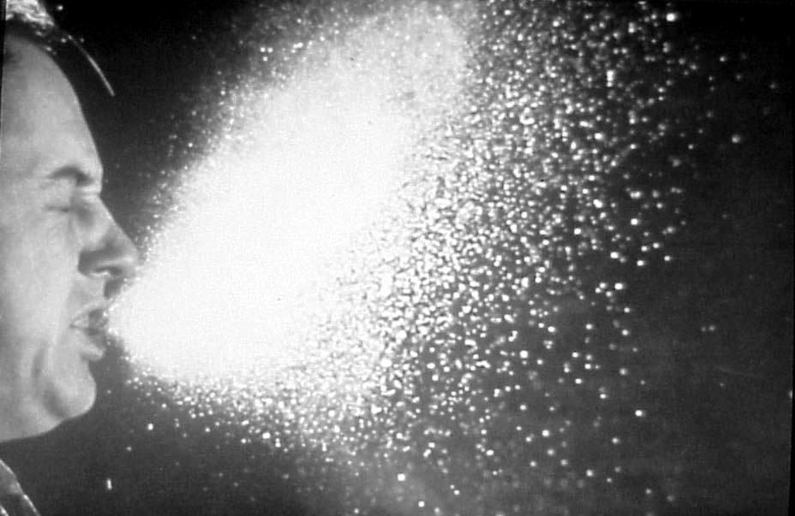
Figure 15.1: A sneeze can produces thousands of droplets into the atmosphere

When a person breathes in the TB bacteria, it multiplies in the lungs and some of the bacteria escapes into the blood and is carried to all body parts where they establish foci or sites of infection. Fortunately the body’s immune system recognizes the infection, fights it and overwhelms it in majority of those infected. But despite this the bacteria is not killed but remains dormant in the body cells for the rest of ones life time

Not everybody however is able to fight or contain the initial bout of TB infection. Such people therefore proceed to develop active disease. This is known as primary TB. This occurs in about 5% of those who get infection with TB. In cases where the dormant TB infection is reactivated and starts to multiply and develop into active TB disease, this phase is known as secondary TB. This chance of reactivation is 5-10% of a life time of the TB infected person.

The presence of actively multiplying TB bacilli, for example in the lungs, causes a granulomatous inflammation that causes destruction of the lung tissue leading to formation of sputum. Initially the sputum is white but in time it changes to yellow, mucoid and purulent. It increases in amount as the disease progresses. The damage in the lungs causes cavities (cavitations) which may get calcified with time. As damage continues blood vessels may be involved and resulting in bleeding and leading to blood in the sputum – a condition called haemoptysis.

ACTIVITY 3

What factors increase the risk of secondary tuberculosis disease?
_____________________________________________________________________
_____________________________________________________________________
_____________________________________________________________________
_____________________________________________________________________
_____________________________________________________________________
_____________________________________________________________________

Now read through the following section and see if your ideas are included.

The following factors increase the risk of tuberculosis disease::

HIV/AIDS;

Malnutrition;

Recent infection with TB;

Silicosis;

Other immune suppressive states e.g., diabetes, leukemia, post-transplant patients and those receiving chemotherapy.

Next let us look at the different types of tuberculosis.

15.2.3 Types of Tuberculosis

 | List down three types of tuberculosis?

I hope your list contained pulmonary tuberculosis, extra pulmonary tuberculosis and military tuberculosis. Let us briefly consider each type.

- In Pulmonary tuberculosis the disease is confined to the lungs only. It can either be Smear positive TB or Smear negative TB. Smear positive TB is one whereby the patients sputum is found to have the bacilli upon examination. Such patients are the most important in public health as they are the ones responsible for transmitting TB infections. They can infect up to 20 people in one year. A diagnosis of smear negative TB can be reached if the patient satisfies the following conditions:
- Symptoms and signs persistently consistent with those of TB;
- Being repeatedly smear negative;

Chest x-ray (CXR) features suggestive of TB, such as, cavitations, mediastinal masses, and patchy consolidation in the lung fields;
- No response to ordinary antibiotics.

- In extra pulmonary tuberculosis the disease may spread outside the lungs and settle in other body organs such as the meninges of brain and spinal cord, kidney, bones, joints, pleura, pericardium or the periosteum.

- In Miliary tuberculosis mycobacterium enter the blood stream and are disseminated widely to the lungs and other body organs. Miliary tuberculosis is a very severe form of tuberculosis.

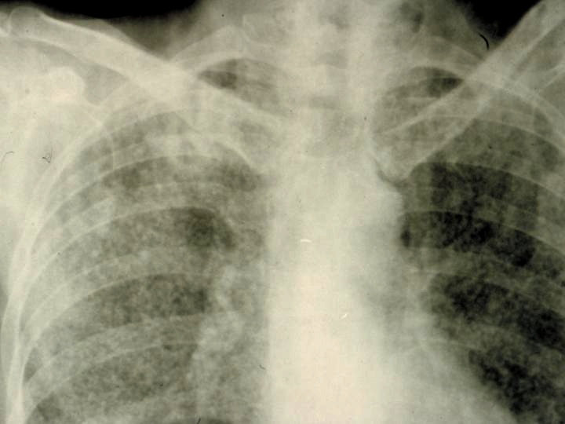
Figure 15.2: Chest x-ray of a patient with miliary tuberculosis showing multiple small millet-sized nodular shadows.

15.2.4: Clinical Features of Tuberculosis

The signs of TB are non specific and develop very slowly (insidious onset) and thus lead a chronic course. They include cough for more than two weeks, production of sputum, fever, night sweats, general malaise, loss of appetite and weigh. Advanced disease may present with breathlessness, chest pain and haemoptysis. The clinical features of tuberculosis can be divided according to the early and late signs and symptoms.

Early signs and symptoms of Tuberculosis
- Productive cough of 3 or more weeks
- Night sweats
- Unexplained weight loss
- Loss of appetite
- Fatigue
- Evening fever (pyrexia)
- Positive tuberculin test.

Late signs and symptoms of tuberculosis
- Coughing blood –stained sputum (haemoptysis)
- Difficulty breathing
- Enlargement of lymph nodes
- Extreme loss of weight
- Signs and symptoms of other body organs affected e.g. meningitis, pleurisy, pericarditis, peritonitis, and pleural effusion.

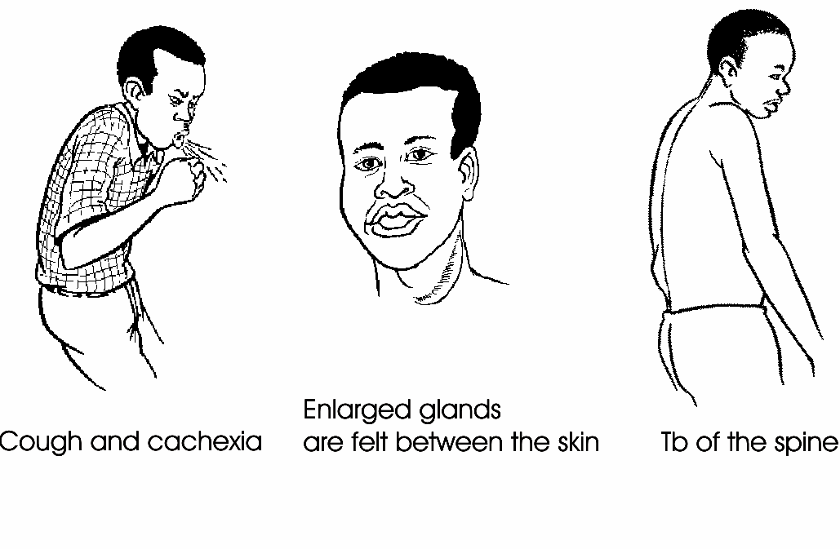
Figure 15.3: Clinical features of TB

15.2.5: Diagnosis

The best way to diagnose tuberculosis is by means of a direct sputum smear examination (AFB) in the laboratory, using the Ziehl-Nielsen staining technique for acid-fast bacilli. At least three early morning specimens must be examined within 2 days.

 | All patients suspected to have PTB should have three sputum samples collected for microscopic examination for Acid Fast Bacilli (AFB).

The recommended sputum collection procedure is as follows:
- When the patient first presents ask them to produce on the spot sputum collection;
- Give the patient a sputum container to collect an early morning specimen the next day and bring to your health facility;
- On delivery of the second specimen request the patient to produce a third specimen on the spot.

This strategy enables three sputum samples to be collected within a twenty-four hour period. The results of these tests should also be available within the same time frame of 24 hours so that you can rapidly identify infectious cases and start treatment immediately. This will interrupt further transmission of TB interrupted.

In order to ensure that the patient produces the real sputum and not just saliva, you should do the following:
- Ask the patient to cough deeply (demonstration is usually more effective than words);
- Ensure that no one is standing in front of a patient producing sputum;
- Avoid contaminating the outside of the sputum container. If the outside is contaminated, discard the container and repeat the collection with a fresh one;
- If the specimen is not suitable (e.g. if the quantity is insufficient or if it contains saliva), ask the patient to repeat the coughing until a sufficient amount of sputum has been obtained (3 to 5 ml).

After collecting the specimen remember to close the lid of the container tightly and to wash your hands. Ensure it is well labeled and send the specimen as soon as possible - within one day of collection.

There are two other tests that can be used for investigating patients with TB. These are the heaf and Mantoux tests. However they are not as reliable as the sputum examination for AFBs. Indeed many people, particularly children after a BCG immunization react positively to these tests while they have no clinical disease. The mantoux test used to identify whether a persons immune system has been previously exposed to M. tuberculosis or not. It is really a test for infection rather than disease.

The Mantoux test SHOULD NOT be used to diagnose TB disease.

A chest x-ray may also aid the diagnosis of PTB but it should never be used as the sole means of establishing a TB diagnosis. All patients with chest x-ray features suggestive of PTB should have sputum specimens submitted for microbiological examination. It is a major error to diagnose TB on the basis of a chest x-ray and fail to examine sputum.

Differential diagnosis of PTB
If a person presents with a chronic cough and negative sputum smears, you should consider other diagnoses. These include:
- pneumonia especially pneumonia caused by unusual pathogens (fungi including Pneumocytis jirovecii),
- lung abscess,
- lung cancer,
- sarcoidosis and
- bronchiectasis.

The diagnosis of these alternative diagnoses require a careful history, physical examination and various tests including chest computed tomographic scan which may not be easily accessible to the majority of PTB suspects. If you are not sure about the diagnosis of TB you should refer the patient to the next level for appropriate evaluation.

15.2.6: Management of TB

The treatment of tuberculosis serves two main purposes: to cure the individual patient and to prevent the spread of the disease to others. The aim of the treatment is to kill the mycobacterium as efficiently as possible and within the shortest possible time. The treatment regimen depends on the type of tuberculosis as well as the age of patient.

Tuberculosis treatment involves the use of multiple drugs taken in combination. This is done to prevent the emergence of drug resistance to any of the drugs. When single drugs are used (monotherapy) the tubercle bacilli quickly develop resistance to the drug used. Therefore anti-TB drugs should always be used in combination and currently most anti-TB drugs are available as tablets containing multiple drugs in Fixed Dose Combinations (FDC).

The drugs used for the treatment of tuberculosis are abbreviated as follows:
S - Streptomycin
E - Ethambutol (plain 400 mg tablet)
H - Isoniazid (150g combined with Ethambutol 400 mg, tablet)
R - Rifampicin ( tablet or capsule)
Z - Pyrazinamide (500 mg tablet)
Rifater (RHZ): a combination of Rifampicin 120 mg, Isoniazid 50 mg, and Pyrazinamide 300 mg
Rifinah (RH): a combination of Rifampicin 150 mg and Isoniazid 100 mg
Ethizide: a combination of Ethambutol 400 mg and Isoniazid 150 mg

In order to promote total adherence to treatment an individualized patient centered approach was introduced by WHO, known as DOTS Strategy. DOTS stands for Directly Observed Treatment Short Course and this strategy works as follows:
Directly : The sick infectious cases are identified
Observed : Health workers or trained volunteers observe the patient taking
Medicine
Treatment : TheTB patient must be provided with the complete treatment and
monitored to assess progress until cured. There must be good reporting and record keeping
Short Course : The correct combination and dosages or anti-TB drugs must be
used for the correct length of time.

The treatment of TB patients can be divided into two phases:
- The intensive phase: This is the first two months of starting treatment. Four drugs are used to rapidly reduce the number of tubercle bacilli (bacillary load) in the body
- The continuation phase: this follows after the first two months and two drugs are used for 4-6 months.

Treatment Classification of TB Patients
The treatment of TB patients depends on whether they are patients or whether they have previously been treated for TB.

Treatment for new patients:
All new patients should have a two month initial phase of treatment consisting of isoniazid, rifampicin, pyrazinamide and ethambutol. This should be followed by a continuation phase of ethambutol and isoniazid for six months or isoniazid and rifampicin for four months.

According to the Kenya MOH TB treatment guidelines, the treatment regimen for new adult TB patients is 2ERHZ/6EH or 2ERHZ/4RH. Use the key below to decipher the individual drugs.

Key to Anti-Tuberculosis Drugs and their Symbols

S: Streptomycin
H: Isoniazid
R: Rifampicin
Z: Pyrazinamide
E: Ethambutol

The following tables give you the treatment dosages for adults and children.

Table 15.1 Treatment regimen for new adult TB patients. (Source: MOH, (2005). TB Management Guidelines.)
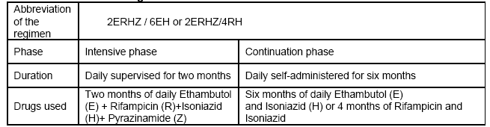

Table 15.2: TB drug dosages for Adults. (Source: MOH, (2005). TB Management Guidelines.)
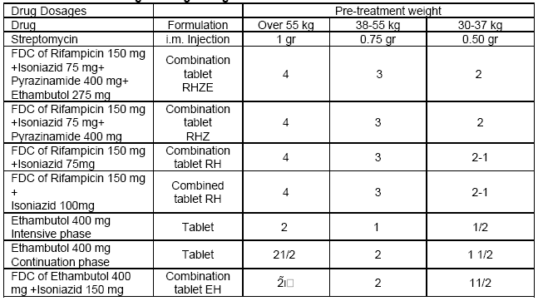

Table 15.3 TB treatment regimen for children. (Source: MOH, (2005). TB Management Guidelines.)

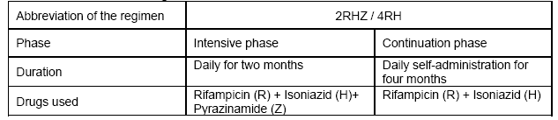

Table 15.3: TB drug dosages for Children. (Source: MOH, (2005). TB Management Guidelines.)

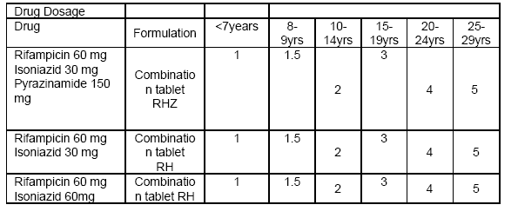

Table 15.4: Anti-tuberculosis drug dosages for children
Drug | Daily dosage in mg/kg (maximum)
Isoniazid | 5-10 (300mg)
Rifampicin | 10-20 (600mg)
Pyrazinamide | 25-40 (2000mg)
Ethambutol* | 15-25 (1200mg)
Streptomycin | 15-20 mg (1000mg)

Although there is evidence that ethambutol may be safe in children it is reasonable to limit the use of this drug to children who are able to indicate when visual problems occur (over the age of 6).

Retreatment of TB patients:

Retreatment patients fall into 4 groups:

Relapses – patients who were treated declared cured but now present with a smear positive result;

Return after default – patients who missed 3 consecutive clinics (missing treatment for more than 14 days in intensive phase or 56 days in continuation phase). These patients are described as out of controls returned to control;

Treatment failures – those patients who are still smear positive after five or eight months of treatment;

Other retreatment patients previously treated for TB for whom a diagnosis of smear negative or extra pulmonary has been made.

All retreatment patients must submit a sputum specimen to the central reference laboratory (CRL) in Nairobi for culture and drug susceptibility (DST) testing to rule out development of drug resistant TB

When using the DOTS strategy, you must adhere to the following rules:
- Follow the National Treatment guidelines;
- Ensure that there is an adequate supply of anti- TB drugs;
- Ensure each patient is on the correct treatment regimen;
- Administer the initial (intensive) phase of treatment under supervision;
- Encourage all patients to attend the TB clinic regularly during the continuation treatment phase;
- Promptly trace defaulters;
- Maintain accurate records on patient personal data and clinic attendance.

15.2.7: Side effects of common TB drugs

While most patients treated for TB experience no problems with the treatment, a few patients may have significant side effects which can threaten life or interfere with the quality of life. As a health care worker you need to be familiar with the common side effects of anti-TB drugs and how to manage these side effects. Table 15.5 summarizes the common side effects.

Table 15.5 TB drugs and associated side effects
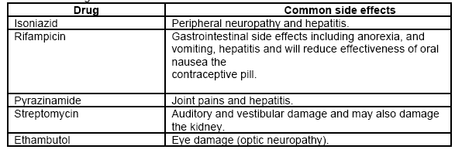

Well having looked at the management of TB in adults and children, our lesson would not be complete if we did not discuss the interaction between TB and HIV. So in the next section we shall discuss this interaction and see why it’s important to integrate the treatment of both infections in our health care settings.

15.2.8: HIV and TB Interactions

Apart from poverty and social deprivation, the other key factor that has is responsible for the large TB burden in Kenya is concurrent HIV infection.

Before you proceed do the following activity. It should take you 5 minutes to complete.

ACTIVITY

List the various ways that HIV influences TB
_____________________________________________________________________
_____________________________________________________________________
_____________________________________________________________________
_____________________________________________________________________
_____________________________________________________________________
_____________________________________________________________________

I hope you answers included the following ways that HIV influences TB:
- The virus is the most potent known risk factor for reactivation of dormant infection;
- HIV infected individuals infected with the tubercle bacilli have an annual risk of disease of 5-10% as opposed to non-HIV infected individuals who have a similar risk but over a life time;
- About one in two to three persons infected with both TB and HIV will have TB in their lifetime;
- HIV increases the rate of progression of new TB infections to disease and also increases the risk of recurrence of previously successfully treated disease;
- HIV infected TB patients are more likely to develop other acute infections and be hospitalized while receiving TB treatment. Some of these infections include bacteremic Streptococcal pneumonia and Non-typhi Salmonella septicemia;
- HIV infected TB patients are more likely to die while receiving TB treatment than TB patients who are not HIV infected.

According to the MOH 2005 estimates, more than 60% of TB patients in Kenya are HIV infected.

TB also influences HIV in a number of ways. Can you think of some? Put your thoughts to paper in the following activity.

ACTIVITY

List down the ways in which TB influences HIV.
_____________________________________________________________________
_____________________________________________________________________
_____________________________________________________________________
_____________________________________________________________________
_____________________________________________________________________
_____________________________________________________________________

Now confirm your answers as you read the following discussion.

TB influences HIV in the following ways:
- Rapid progression of HIV disease. TB is one of the most common opportunistic infection among PLWHA in high TB burden countries;
- TB is the leading cause of HIV-related morbidity;
- TB is also one of the leading causes of mortality: one-third of all AIDS related deaths are due to TB;
- Early deaths in HIV infected TB patients may be due to TB itself and related to late diagnosis of the TB while late deaths are usually due to non-TB HIV related infections

All persons found to be HIV positive at HIV testing sites, such as VCT centres, STI clinics and PMTCT sites should be screened for TB or referred to the nearest TB screening centre.

The close association between TB and HIV makes it imperative to develop strategies for the delivery of combined TB and HIV services in what is commonly referred to as TB/HIV collaborative activities. These activities are aimed at reducing the burden of TB in people living with HIV/AIDS and, on the flip side, to reduce the burden of HIV in TB patients.

The key TB/HIV collaborative activities include:
- Persons found to be HIV positive at HIV testing sites should be screened for TB. This is more critical in clients who have a cough, fever, weight loss, chronic diarrhea or the presence of lymph node enlargement;

TB Preventive Therapy;
- Prevention of TB transmission at health care settings;

Screening of TB patients for HIV through Diagnostic Testing and Counseling (DTC).

TB Preventive Therapy in HIV Patients
There is good evidence that TB preventive therapy using a six to nine months course of daily Isoniazid prevents the development of active TB in HIV infected persons. This beneficial effect may last up to two or so years after the course of treatment. It is critical however to ensure that active TB is confidently ruled out to avoid inadvertent mono-therapy with Isoniazid which would only serve to generate resistance to this drug. Suitable persons for Isoniazid TB preventive therapy include HIV infected individuals who:
- are well;
- have had no fever in the past month;
- have not lost weight;
- do not have persistent diarrhea;
- do not have palpable lymph glands;
- do no have a palpable liver or spleen;
- do not have clinical or biochemical evidence of liver disease;
- have a normal chest x-ray.

Because the screening of HIV infected persons for active TB may be clinically challenging the NLTP recommends that Isoniazid TB Preventive Therapy in Kenya be limited to situations where feasibility studies are being conducted and thorough screening and follow up of patients can be ensured. Isoniazid TB Preventive Therapy may therefore be offered in congregate settings, for example prisons, among health care workers and in industrial medical clinics where client follow up and monitoring may be relatively easy.

Prevention of TB transmission at health care settings
Simple infection prevention procedures should be introduced and maintained at all health care facilities to reduce the risk of nosocomial transmission of TB especially to People Living with HIV/AIDS (PLWAs). These include hand capping, triaging of patients to allow for physical separation of TB suspects (the coughers) from other patients, rapid screening of coughers for TB and maximizing natural ventilation and lighting in wards and outpatient areas.

Screening of TB patients for HIV through Diagnostic Testing and Counseling
Because of the relationship between TB and HIV all TB patients should be offered HIV testing and counseling through the process of Diagnostic Testing and Counseling (DTC).

What is Diagnostic Testing and Counseling?

Diagnostic Testing and Counseling is the process of preparing patients for an HIV test within health care settings. The underlying principle is that clinicians have a duty to provide patients who come with signs and symptoms of HIV related illnesses with an accurate and a complete diagnosis, and with appropriate advice about management of this condition.
It is considered substandard care not to offer HIV diagnostic testing and counseling to patients presenting with an illness that may be HIV related including TB

The emphasis here is on the patient knowing his/her HIV status as a way of improving treatment outcomes. Benefits of knowing ones HIV status include prevention of HIV infection, treatment and prevention of HIV related opportunistic infections, life-prolonging ARV drugs and access to psychological and social support.

When carrying out DTC the health care worker should ensure that the patient fully understands the purpose and benefits of testing during the pre-test (discussion) counseling. The patient should also be informed of the disadvantages of declining the HIV test including the missed opportunities for treatment and prevention of opportunistic infections. The health care worker should be able to respond to the patient’s questions and concerns and, very importantly, the patient should know that he or she has a right to decline the test (opt-out). For those who decline the test the health care worker should try and identify the barriers to testing to try and solve them. All patients who decline the test should be encouraged to think about returning for the test during the course of TB treatment.

During a post-test counseling session to disclose a negative result, you should:
- Inform the patient about couple discordance and encourage them to refer their partners for testing;
- Motivated them to maintain non-risky behavior so as to avoid acquisition of the HIV infection.

During Post-test counseling to disclose a positive result , you should:
- Discuss with the patient about the care available and referral to a Comprehensive Care Clinic as soon as feasible.
- Discuss disclosure of result to the partner and partner referral for a HIV test
- Nutritional advise
- Positive living
- Referral to post test clubs or any other support groups for psychosocial support

Provision of Cotrimoxazole preventive therapy
Cotrimoxazole Preventive Therapy (CPT) should be provided to all TB patients found to be infected with HIV. If the patient declines the HIV test you should decide the best course of action for them. The dose of CPT is 960mg once daily. The formulation comes in two tablets or one tablet for the double strength type. Patients given cotrimoxazole should be monitored for side effects which include skin rashes and gastrointestinal disturbances. Minor skin reactions may be managed with an antihistamine e.g. chlopheniramine (piriton) while minor gastrointestinal reactions can be managed with metoclopramide (plasil). Cotrimoxazole should be withdrawn whenever moderate to severe reactions occur. HIV infected patients should be made to understand that treatment with cotrimoxazole is life long unless treatment with ARVs is given and the CD4 cell count has risen above 200.

Provision of Anti-Retroviral Therapy (ART)
Tuberculosis patients with HIV should be offered or referred to ART centers at the earliest possible opportunity. The majority of HIV infected TB patients will initiate ART after the intensive phase of TB treatment and this may be the optimal time for these patients to be referred to ART centers. However, very sick patients may need to initiate ART earlier. The recommended national first line regimen for TB patients initiating treatment while on rifampicin is d4t (stavudine) + 3TC (lamivudine) + EFV (efavirenz) but for patients who are no longer on rifampicin the standard national first line regimen of d4t (stavudine) + 3TC (lamivudine) + NVP (Nevirapine) should be used.

Recording and Reporting of TB/HIV
The TB patient record cards and registers have been modified to capture TB/HIV data. This is essential for monitoring and evaluation of TB control activities including TB/HIV collaborative activities. It is very important that you complete these reporting records for every patient.

15.2.9: Drug Resistance TB

Start by doing the following activity. It should take you less than 5 minutes to complete.

ACTIVITY

What are the main causes of drug resistance in TB? List them down in the space provided.
_____________________________________________________________________
_____________________________________________________________________

_______________________________________

Now confirm your answers as you read the following discussion.

The main reason why people develop drug resistance in TB is non-adherence. I am sure you are already pointing a finger at the patient. But look again, four fingers are also pointing at you. Why is this? This is because you also contribute to drug resistance through failure to prescribe efficacious regimens for the treatment of TB. Drug resistance can be classified as follows:

- Primary if there is definitely no previous treatment;
- Initial when previous treatment cannot definitely be excluded;
- Acquired if there is a definite history of previous treatment.

The TB bacillus are said to be:
- Mono-resistant when there is resistance to any one single drug;
- Poly resistant when there is resistance to two or more drugs but excluding resistance to both rifampicin and isoniazid;
- Multi-Drug resistant when there is resistance to both rifampicin and isoniazid.

The management of multi-drug resistant TB (MDRTB) is known as DOTS Plus. Since its treatment is a complex affaire, only those clinicians who have been cleared by the National Leprosy and TB Programme can treat drug resistance TB. The treatment is done in the usual two phases. The intensive phase lasts for 6 months during which an injectible is administered under strict DOT or preferably in hospital. The continuation phase goes on for 18 months after culture conversion and is administered as a health care worker DOT on an ambulatory basis.

15.2.10: Prevention and Control of TB

The control of tuberculosis depends on the success of treatment of registered TB patients and contact tracing. Emphasis must be placed on those who are sputum smear-positive to make them smear-negative. Health education for the patient, relatives and community is also an essential part of TB control.

To eliminate TB, find the people who have infectious TB and cure them so that they do not continue to infect new people.

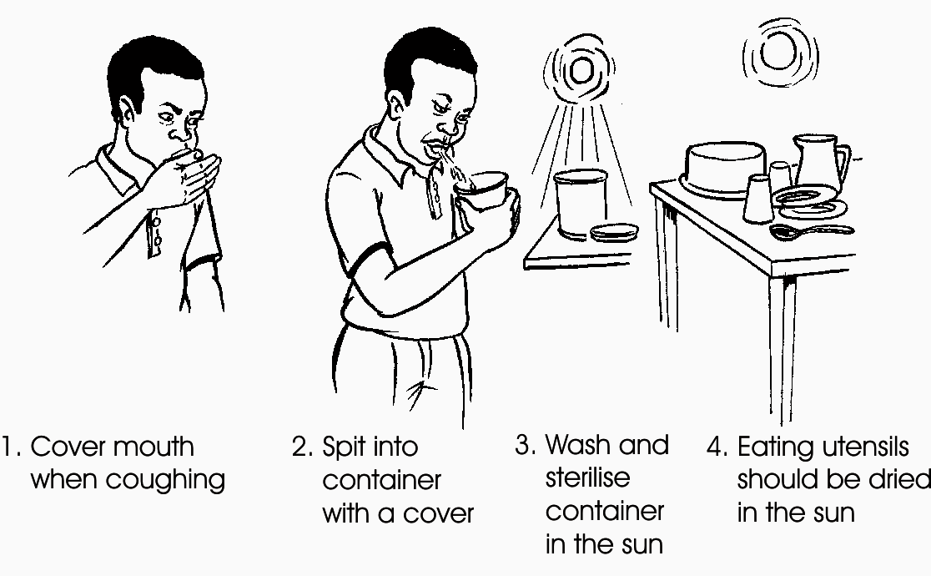

Figure 15.4: TB prevention

You should observe the following preventive guidelines:

- Put all patients with open tuberculosis on treatment as early as possible to prevent them from infecting others;
- You should know the early symptoms of tuberculosis so that you can diagnose it whenever a patient report to your health centre with suggestive complaints;
- Liaise with community health workers to visit the homes of all new TB cases to look for other cases (contact tracing);
- Give health education to the affected so that they can bring any symptomatic contacts for investigation;
- Advice patients on the importance of adherence to TB treatment;
- Advertise the routine methods of TB treatment in your health facility;
- Select a special clinic day when all TB cases are seen and given health education. Health education should be more than a lecture: it should be good dialogue between y you and the patient;
- Immunize all healthy newborns with BCG except if they have AIDS. This is because they might develop a systemic disease which looks very much like TB;
- Advice TB patients not to spit anywhere carelessly;
- Overcrowding and poor ventilation at home should be avoided whenever possible;

15.3: LEPROSY (Hansen’s Disease)

Leprosy is one of the oldest diseases of human beings. For many years it was feared and associate with a lot of social stigma. In the bible leprosy was judged as “unclean” and people with this crippling disease were considered outcasts. Now with early diagnosis and the institution of chemotherapy, the deformities that were once familiar can now be prevented.

Leprosy is caused by a bacteria belonging to the same family as the mycobacterium that causes tuberculosis, known as Mycobacterium leprae. It is an infectious disease with a slow onset and a chronic course if not treated properly at an early stage. But most people have sufficient body resistance (immunity) to prevent them from getting the disease. Only a minority of infected people will actually develop the disease. Leprosy is not a fatal disease: it is a crippling disease. The life expectancy of an individual with leprosy is not much less than the life expectancy of a healthy person, but leprosy is very disabling and deforming and therefore frightening.

15.3.1 Mode of Transmission.

The bacillus has a preference for the skin and peripheral nerves, which are relatively the coolest places in the body. It multiplies very slowly (every 14 – 30 days), which explains why the incubation period is so long - on average 5 to 8 years. The body reacts to the bacilli through inflammatory reactions causing nerve tissue damage. This may cause damage of one or more of the three different components of the nerves, namely:

- Sensation fibres: The damage causes loss of sensation in innervated skin;
- Motor fibres: The damage causes weakness or paralysis in innervated muscles;
- Autonomic fibres: The damage causes dryness and hypo-pigmentation of the innervated skin.

The disease has different manifestations depending on the level of immunity (resistance). Patients with a high degree of immunity will develop pauci-bacillary leprosy. Patients with a low degree of immunity will develop multi-bacillary leprosy. These two spectrums of the disease have varying modes of presentation and require different approaches in management.

15.3.2 Classification and Types of Leprosy

As we have just mentioned there are two main types of leprosy. Lets look at each in turn.
- Pauci – bacillary leprosy (PBL), also called tuberculoid leprosy is characterized by:
  - Absence or presence of very few of bacilli in the skin smears or skin biopsy (skin smear is negative)
  - Skin patches 1 – 5 cm
  - Reaction type I
  - Nerve involvement/damages affects one or more peripheral nerves
  - Disability and deformities are common as a result of irreversible nerve damage and most are disfiguring.

In the pauci-bacillary (PB) or tuberculoid type of leprosy, the bacilli are few, and very difficult to observe in a skin smear or a skin biopsy. They are concentrated in the superficial skin layers and in peripheral nerves.

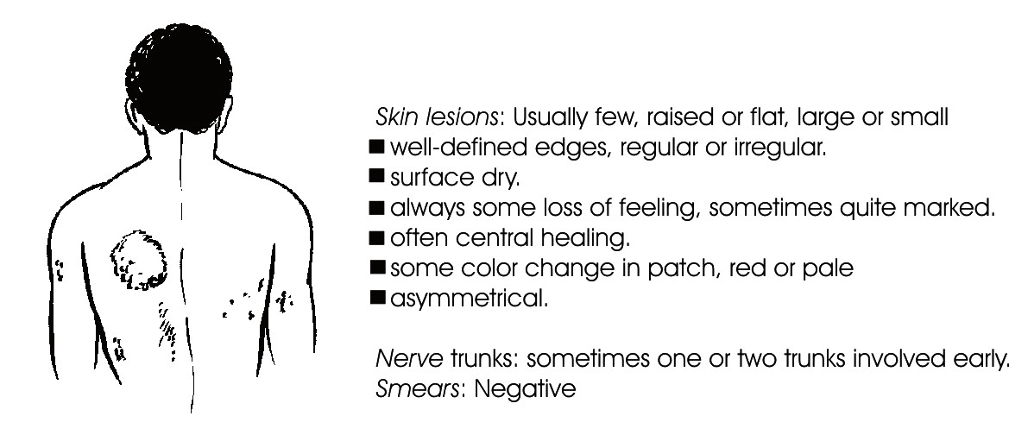
Figure 15.5: Tuberculoid leprosy

- Multibacillary Leprosy (MBL), also called Lepromatous Leprosy, is characterized by:
  - Presence of numerous bacilli in most tissues of the body, except brain and spinal cord.
  - Skin patches six or more.
  - Skin smears positive (numerous bacilli present)
  - Reaction both type I and type II
  - Nerve damage comes late
  - Disability and deformities usually develop at a later stage of the disease.

In the multi-bacillary (MB), or lepromatous, type of leprosy, the bacilli are numerous and can spread to almost all parts of the body except the brain and spinal cord. All other organs may be affected by the leprosy bacilli and may be damaged in the long run if the disease is not treated early.

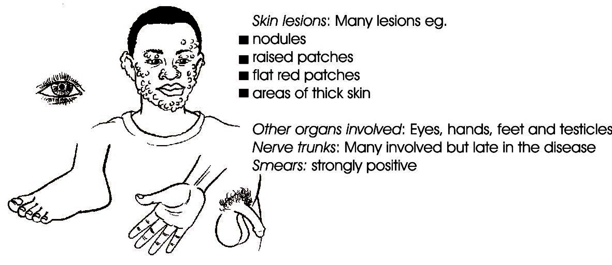
Figure 15.6: Lepromatous leprosy
Nerve Involvement in Leprosy
As we earlier mentioned, the main cause of disability in leprosy is the destruction of the nerves. Damage to the sensory nerve fibres causes anaesthesia, while damage to the motor nerve fibres causes paralysis. Impaired circulation, loss of sweating and skin atrophy is caused by damage to autonomic nerve fibres.

Leprosy patients may get burned or injured on their limbs and fail to notice because of nerve damage that leads to anaesthesia. The patient may walk on an injured foot without realizing it.

In the eye, the cornea may become anaesthetic so that foreign bodies may enter unnoticed leading to corneal damage. Anaesthetic eyelids may lose the blinking reflex or fail to close the eye (lagopthalmos) leading to dryness, iritis, adhesions, glaucoma and blindness.

15.3.2 Clinical Features

The leprosy control programme relies on passive case finding. General health staff should identify suspected leprosy cases among the patients who visit the health units. A patient should be suspected of having leprosy when showing one or more of the following signs or symptoms:

- Burning sensations in the skin
- Pale patches on the skin with loss of feeling
- Numbness and tingling of the feet and/or hands
- Weakness of eyelids, hands or feet
- Tender nerves
- Painless swellings or lumps, especially on the face and ear lobes
- Painless wounds or burns on the hands or feet.

Such a patient requires to be reviewed by the District TB and Leprosy Coordinator (DTLC) or a dermatologist at the earliest possible time. They will examine the patient and decide if or not to put him on treatment.

15.3.3: Diagnosis of Leprosy: “The Three Cardinal Signs”

A diagnosis of leprosy is made if ONE of the following signs is positive:
- Skin patch with loss of sensation
- One or more peripheral enlarged nerves
- The presence of leprosy bacilli on the slit skin or nasal smear.

In addition the following chemical tests can be used to diagnose leprosy:
  - Histamine test
  - Lepromin test

Grading of leprosy patients
All leprosy patients should be accessed for degree of disability and the grading recorded. The criteria in the table below should be used.

Table 15.6: Grading of leprosy disease
Either of the two features or both |  | Grade
Eyes | Limbs
No visual impairment | No abnormality detected | 0
Eye complication but can see | Anaesthesia, weakness or dryness | 1
Impaired visual acuity | Obvious permanent deformity | 2

15.3.4 Types of Patients

Patients are classified into the following groups for epidemiological and treatment reasons. The same categories are used in the leprosy register for reporting.

- New (N): This is a patient who has never been treated before.
- Relapse (R): This is a patient who has received treatment and was declared cured but now has leprosy again.
- Transferred in (TI): This is a patient who was registered in another district and has now reported to another district for continuation of treatment.
- Treatment resumed (TR): This is a patient who interrupted his treatment, and was declared "out of control", but is now resuming treatment.

15.3.5 Management of Leprosy

The aim of leprosy treatment is to prevent nerve damage, deformity, blindness and defaulting. In Kenya, the National Leprosy and Tuberculosis Programme (NLTP) uses the WHO recommended multiple drug therapy for the treatment of the two classes of leprosy. The regimen that is being used in the NLTP is multiple drug therapy (MDT), as advocated by the WHO. Multiple drug therapy was introduced in 1984 and replaced the Dapsone monotherapy. During the introduction of MDT, many patients who were still on mono-therapy were assessed and released from treatment. Some of these patients however, may present with signs and symptoms suggestive of a relapse of leprosy and may require assessment and possible treatment with MDT.

MDT differs from mono-therapy in that it is a combination of several powerful anti-leprosy drugs. This combination of drugs prevents the development of drug resistant bacilli, and has shortened the duration of treatment to six months in pauci-bacillary leprosy and to one year in multi-bacillary leprosy

Table 15.7: MDT for pauci-bacillary leprosy (PB) patients (duration six months)
 | 0-5 years | 6-14 years | >14 years
Dapsone daily | 25 mg | 50 mg | 100 mg
Rifampicin four-weekly supervised | 150 mg | 300 mg | 600 mg

15.8: MDT for multi-bacillary leprosy (MB) patients (duration one year)
 | 0-5 years | 6-14 years | >14 years
Dapsone daily | 25 mg | 50 mg | 100 mg
Clofazimine (Lamprene) four-weekly supervised | 100 mg | 200 mg | 300 mg
Clofazimine (Lamprene) unsupervised | 50 mg  alternate days | 50 mg  daily | 50 mg  daily
Rifampicin four-weekly supervised | 150 mg | 300 mg | 600 mg

Treatment Outcome

At the end of treatment the following outcomes may be realized:
- Released from treatment (RFT): This is a leprosy patient who has completed his treatment as required.
- Out of Control (OOC): This is a leprosy patient who has not attended three consecutive clinics and all efforts to motivate him/her to attend the clinic have failed.
- Transferred out (TO): A patient who is transferred to continue treatment in another district
- Died (D): A patient who died during treatment from any cause whatsoever.

It’s important to note that although many leprosy patients may have been declared cured , that is Released From Treatment (RFT), they may still suffer from the consequences of the disease e.g. ulcers, paralysis in hands, feet or eyes. You should manage these effects separately.

Commonly Encountered Side Effects of Anti-Leprosy Drugs

The side effects of leprosy can be divided into minor and major side effects.

Minor Side Effects
Advice the patient to continue taking MDT and to report if they notice any of the following side effects:
- Slight itching: This is caused by dapsone and should be treated symptomatically with antihistamines
- Gastro-intestinal disturbances: These are mostly caused by clofazimine and include nausea, vomiting, and abdominal pains. Give the drug after a meal.
- Red urine: This is caused by rifampicin and is harmless. No action needed but continued reassurance of the patient.
- Red skin, eyes: This is caused by clofazimine and is harmless. No action is needed. The patient has no complaints at all apart from the cosmetic effect.
- Symptoms as for a severe flu: This is caused by rifampicin. Treat symptomatically and reduce the dosage to half until the symptoms have disappeared.

Major Side Effects
If a patient presents with any of the following side effects, you should refer them to the medical officer or DTLC as soon as possible and stop all MDT drugs.
- Jaundice: This is caused by rifampicin. Stop all drugs immediately and refer patient to DTLC.
- Anaemia: This is caused by rifampicin, dapsone. Rule out other causes of anaemia (parasites, malaria). Refer to the medical officer or the DTLC.
- Exfoliate dermatitis: This is caused by dapsone. The skin is itchy, and later peels off. The patient is very ill. Stop drugs immediately and refer the patient to the medical officer or DTLC or to the nearest hospital.
- Fixed drug eruption: This is caused by dapsone. Stop dapsone immediately. The eruption will slowly clear after stopping.

15.3.6 Leprosy Complications

Reactions
Leprosy reaction occurs when the body's immune system suddenly reacts to the leprosy bacilli in the body ( which may be dead or alive bacilli). This causes an inflammation at the affected sites with all the classic features of acute inflammation such as swelling, pain, redness, warmth, and loss of function. In severe cases, the patient may be in great pain because of the swelling of nerves, and be very ill with a high fever. A reaction may occur before, during and after chemotherapy. It can be provoked by a disturbance of the body's defence system, for example, by inter-current disease or during and after pregnancy.

Most deformities and disabilities in leprosy are the result of reactions thus early diagnosis and adequate treatment of reactions prevents the disabilities.

There are two types of reaction:
- Reversal reaction (or Type I reaction)
- Erythema nodosum leprosum (or Type II reaction).

Reversal reaction (RR), Type I reaction
This reaction is common in Pauci-bacillary leprosy (PBL). It occurs after a sudden increase in immunity results in a rapidly increased response of the body to the leprosy bacilli. This reaction causes sudden inflammation in places where the leprosy bacilli are present. It causes nerve damage, inflamed and raised red skin lesions and oedema of hands, face or feet.
Its main features include:
- Acute or sub-acute redness and swelling of one or more skin patches;
- Oedema of hands, feet or face;
- Acute or sub-acute pain, swelling and tenderness of peripheral nerves; combined with acute or slowly developing loss of sensation and weakness in the area innervated by the affected peripheral nerve;

Beware of Silent neuritis. This is a type of reversal reaction which is asymptomatic. Nerve function deteriorates slowly and goes unnoticed by the patient. It can only be detected by doing regular - at least quarterly - assessments of sensation and muscle function. It is the responsibility of the DTLC to do this.

Refer a patient with Reversal reactions immediately!

Treatment of reversal reaction
All patients with reversal reaction must be examined by a DTLC and referred immediately. Any delay may increase loss of nerve function. The treatment includes the following:
- Mild cases of pain - anti-inflammatory drugs e.g. aspirin or indomethacin
- Severe cases of pain - high doses of prednisolone
- The patient may be admitted for treatment depending on severity of disability
- The total duration of treatment may be six months.

Erythema Nodosum Leprosum (ENL), Type II Reaction
This reaction appears 6 months or more after treatment and is caused by a reaction between dead leprosy bacilli and circulating antibodies. Nerve damage is not common in this reaction. Eyes, joints and testes become inflamed, nerves become tender and ulcerating tender nodules appear on the skin. Thus, reaction is usually of sudden onset and tends to recur. This reaction occurs only in multi-bacillary patients. The severe form may be life threatening. The main features include:

- A history of sudden onset;
- The appearance of red, tender nodules in the skin. Lasting about three days then disappearing and cropping up again in other places;
- Mild to high fever;
- A painful red eye with loss of vision;
- Painful swollen testicles;
- Tender nerves;
- Other organs: swollen tender lymph nodes and joints, swollen liver/spleen.

Suspect severe ENL if:
- Temperature higher than 38.5 ºC
- Red painful eye
- Painful swollen testicles
- Ulcerating skin nodules
- Severe arthritis, lymphadenitis
- Severe nerve pains.

The treatment of ENL reactions is as follows:
Mild ENL:
- Paracetamol, indomethacin or other anti inflammatory drug for one week by the general health staff
- But refer If no improvement to the DTLC.
Severe ENL:
- Refer to DTLC as an emergency;
- Prednisolone and/or clofazimine for 4 - 6 weeks, on average;
- Patients may be treated in hospital, or on an ambulatory basis;.

This reaction may recur repeatedly as is the case in reversal reactions,

Having looked at leprosy reactions, let us now find out what else can be done to prevent blindness and deformity.

15.3.7 Prevention of Deformity

Wound Prevention in Leprosy
Wounds are caused and made worse by the loss of sensation to pain, pressure or burning.
Therefore to prevent further damage you should advice the patient to do the following:
- Wear protective footware;
- Wear heatproof gloves when working and handling hot objects;
- To inspect the feet and legs regularly for swelling, cracks, bruises, injuries, dryness – a small mirror can be used to inspect the soles of feet;
- To soak feet for 20 minutes twice daily in salty water, then rub oil on the skin to keep it moist and prevent cracks;
- To remove grit from inside the shoes.

Eye Care
For the patients who are suffering from lagophthalmos, you should advice them as follows:
- To wear sun glasses;
- To check the eye daily in front of a mirror for inflammation and foreign bodies;
- To cover the eyes with pads at night;
- To avoid rubbing the insensitive eyes.

Exercises
It is common knowledge that joints which are not used become stiff, while muscles atrophy and become weak. Also scar tissue tends to retract resulting in contractures. That is why all patients with weak or damaged hands should do suitable exercises. For paralyzed muscles, passive exercises help to loosen the stiff joints and lengthen the skin. The exercises should be done for 5 – 10 minutes daily on a regular basis.

15.3.8 Leprosy Control

The cornerstone of leprosy control is to reduce the number of infective cases and interrupt transmission. These can be achieved through the following preventive measures:
- Treatment of all infective cases until cured;
- Searching for unknown cases, registering and treating them;
- Administration of BCG vaccine which gives some immunity against leprosy.

There are a number of factors that complicate leprosy management . These include:
- People with the disease are still stigmatised;
- The patches in pauci-bacillary patients only disappear several years after MDT has been stopped and the patient is told that he is cured;
- Leprosy reactions with complications such as paresis, paralysis or blindness can occur months or years after a patient is declared cured;
- Leprosy disabilities are often irreversible if patients report very late. They may have expected their disabilities to be "cured"; therefore this leads to disappointment and may influence their compliance with treatment;
- Even with MDT the treatment period is still quite long (6 months to 1 year) and this causes problems of adherence.

In these circumstances, it is clear that health education of leprosy patients at large is a painstaking task which requires patience and understanding of the patient's way of thinking and his individual circumstances. It is your role to educate the community about this disease so that they can bring their patients early for treatment and reduce stigmatization. Annex 1 gives you a list of points to cover when talking to a leprosy patient.

Recording and Reporting

If you are incharge of the tuberculosis or leprosy clinic, it is your responsible to fill out and maintain following records and registers used for case reporting, analysis of treatment and defaulter tracing:
- Leprosy patient treatment file
- Leprosy appointment card
- Leprosy treatment register
- Defaulter action card

Defaulter tracing
Another one of your responsibility is defaulter tracing. During the full course of leprosy treatment and the continuation phase of tuberculosis treatment, patients attend clinics at four-weekly intervals. Failure to attend this clinic may lead to interruption of treatment and treatment failure. Therefore, any leprosy patient who has missed one clinic should be traced as soon as possible to establish why he/she defaulted and to persuade him/her to attend again.

Summary

In this unit we have discussed two important diseases caused by mycobacterium. These are tuberculosis and leprosy. You have finished the work in unit 15.
Look back at the objectives – if you are uncertain about any of them go back to the wok again. If you think that you have learned it, close your books and complete the attached assignment.

Good luck!

Appendix 1: What every leprosy patient should know

At diagnosis

- Leprosy is an infectious disease caused by bacteria not by a curse, witchcraft, or anything similar.
- The patient may have infected several other people who may also develop leprosy. They should therefore encourage those people to have themselves checked for leprosy when they develop patches.
- Leprosy bacilli are killed by MDT if the drugs are taken regularly for the recommended period.
- Much of the damage that had been done to nerves and tissues before the patient was started on MDT cannot be reversed.
- During (and after) MDT, patients are no longer infectious and therefore pose no danger at all for the family or the community.
- In PB patient’s patches will still be present when the MDT course is already finished. The patches will disappear slowly over a period of 1 - 3 years.
- Tablets need to be taken daily, as prescribed, and preferably at the same time each day.
- Drugs have to be collected from the clinic every four weeks. On the clinic day the patient takes rifampicin and clofazimine under supervision, and collects dapsone and clofazimine to be self-administered at home.
- Keep the drugs out of reach of children.

During Multi Drug Therapy

A patient on MDT should report to the clinic in case one of the following happens:
- A soon as patches have started becoming red and swollen again
- As soon as he notices sudden weakness of muscles
- As soon as he notices that one or both of his eyes are red and painful
- As soon as he notices pain in one of his limbs
- A soon as he notices the appearance of red, swollen, tender nodules in the skin

Additionally the patient should be advised about the following:
- To take the drugs after a meal or in the evening just before going to bed if he feels nausea after ingesting them.
- To inform the staff at the clinic when they intend to travel. An adequate supply of drugs can then be given to cater for the period of travelling.
- To inform the staff at the clinic when they intend to move to another area. The clinic staff will then write a transfer letter and give advice on where they should continue treatment.

After Multi Drug Therapy

- Leprosy reactions can still develop after MDT. These reactions must not be treated with a new course of MDT but can be effectively treated with other drugs. Early reporting is absolutely necessary to prevent irreversible damage.
- Patients should report as soon as they notice new patches or if old patches become thick and red. This may indicate that the disease has started again, or that a reaction is taking place.
- Patients should report as soon as they notice pain in their hands and feet.
Wound Prevention
The patient should be educated as is appropriate for his individual case, and may be advised as follows:

Care for insensitive feet
- To wear protective footwear throughout the day to avoid injury.
- To avoid too much walking because this is the most common cause of a sole wound in an insensitive foot. So, take a ride on a bicycle when you can; send others in your place; if you must go, stop often, rest your feet, watch where you step.
- To learn from any earlier wounds to his feet so that he does not make similar mistakes again.
- To avoid heat. To sit with his feet protected, when he sits close to a fire.
- To avoid sitting on his lower legs when he sits on the ground because this may cause pressure ulcers.

Daily foot inspection
- To inspect insensitive parts of his feet and legs and also to look for signs of injury, dryness, cracks, and swellings. A small mirror is useful for inspecting the sole of his feet.
- To feel for warm spots: this may warn of injury, and to press for tenderness caused by infection in the deeper layers of the sole of the foot.

Care of dry feet
- To soak for 20 minutes twice daily in salty water, then to rub oil into the skin. This helps to keep the skin of his feet moist and prevents cracks.
- To trim and to rub off any callus.

Care of wounds at home
- To remove the cause, e.g. a nail or small stone in a shoe.
- To soak the wound in soapy or salty water for 20 minutes, at least once a day, or more frequently when the wound is discharging. To remove dirt gently.
- To cover the wound with a bandage. This can be made of old clean cloth.
- To rest the foot.

Care for insensitive hands
Generally apply the same kind of care as for the feet. Hands are most frequently damaged during cooking (burns) and manual labour as a result of too much friction.

Care for eyes with lagophthalmos
- Patients with lagophthalmos (inability to close the eye) need special attention. Patients should be advised as follows:
- To wear sunglasses
- To check the eye daily in a mirror for redness and foreign bodies
- To bind a pad of clean cloth over the eyes at night
- To avoid rubbing the insensitive eye.



DIRECTORATE OF LEARNING SYSTEMS
DISTANCE EDUCATION COURSES

Student Number: ________________________________  Name: _________________________________________  Address: _______________________________________  _______________________________________________ | 

COMMUNICABLE DISEASES
Tutor Marked Assignment

Unit 15: Tuberculosis and Leprosy

Instructions: Answer all the questions in this assignment.

- Give reasons why TB is an important disease in this country.

_____________________________________________________________________________________
_____________________________________________________________________________________
_____________________________________________________________________________________
_____________________________________________________________________________________
_____________________________________________________________________________________
_____________________________________________________________________________________

- What are the common causes of cough that you see?

_____________________________________________________________________________________
_____________________________________________________________________________________
_____________________________________________________________________________________
_____________________________________________________________________________________
_____________________________________________________________________________________
_____________________________________________________________________________________

- What are three important tests you need to do if you suspect that a patient may be having TB?
_____________________________________________________________________________________
_____________________________________________________________________________________
_____________________________________________________________________________________
_____________________________________________________________________________________
_____________________________________________________________________________________
_____________________________________________________________________________________

- What types of treatment are available in the treatment of TB? Who do you give these regimens?
________________________________________________________
_____________________________________________________________________________________
_____________________________________________________________________________________
_____________________________________________________________________________________
_____________________________________________________________________________________
_____________________________________________________________________________________
_____________________________________________________________________________________

- What are the early indications that a patient may be having leprosy?

_____________________________________________________________________________________
_____________________________________________________________________________________
_____________________________________________________________________________________
_____________________________________________________________________________________
_____________________________________________________________________________________
_____________________________________________________________________________________

- List important points in the control of both diseases:

TB | Leprosy

- How would you treat leprosy?

_____________________________________________________________________________________
_____________________________________________________________________________________
_____________________________________________________________________________________
_____________________________________________________________________________________
_____________________________________________________________________________________
_____________________________________________________________________________________
_____________________________________________________________________________________
_____________________________________________________________________________________
_____________________________________________________________________________________
_____________________________________________________________________________________
_____________________________________________________________________________________
_____________________________________________________________________________________

- What complications are you trying to avoid in the management of:

TUBERCULOSIS | LEPROSY

Congratulations! You have now come to the end of this unit. Remember to indicate your Student Number, names and address before sending the assignment.

Once you complete this assignment, post it to:

Directorate of Learning Systems
P O Box 27691-00506
Nairobi, Kenya
Email: amreftraining@amrefhq.org

or bring it in person to AMREF Training Centre. We will mark it and return it to you with comments.

