**Biomechanics of the lower limb-extremity**

Objectives

* Explain how anatomical structure affects movement capabilities of lower-extremity articulations.
* Identify factors influencing the relative mobility and stability of lower-extremity articulations.
* Explain the ways in which the lower extremity is adapted to its weight-bearing function.
* Identify muscles that are active during specific lower-extremity movements.
* Describe the biomechanical contributions to common injuries of the lower extremity.

Although there are some similarities between the joints of the upper and the lower extremities, the upper extremity is more specialized for activities requiring large ranges of motion. In contrast, the lower extremity is well equipped for its functions of weight-bearing and locomotion. Beyond these basic functions, activities such as kicking a field goal in football, performing a long jump or a high jump, and maintaining balance *pointe* in ballet reveal some of the more specialized capabilities of the lower extremity.

The hip is a ball-and-socket joint. The ball is the head of the femur, which forms approximately two-thirds of a sphere. The socket is the concave acetabulum, which is angled obliquely in an anterior, lateral, and inferior direction. Joint cartilage covers both articulating surfaces. The cartilage on the acetabulum is thicker around its periphery, where it merges with a rim, or labrum, of fibrocartilage that contributes to the stability of the joint. Hydrostatic pressure is greater within the labrum than outside of it, contributing to lubrication of the joint. The acetabulum provides a much deeper socket than the glenoid fossa of the shoulder joint, and the bony structure of the hip is therefore much more stable or less likely to dislocate than that of the shoulder.

Several large, strong ligaments also contribute to the stability of the hip. The extremely strong iliofemoral or Y ligament and the pubofemoral ligament strengthen the joint capsule anteriorly, with posterior reinforcement from the iliofemoral ligament. Tension in these major ligaments acts to twist the head of the femur into the acetabulum during hip extension, as when a person moves from a sitting to a standing position. Inside the joint capsule, the ligament teres supply a direct attachment from the rim of the acetabulum to the head of the femur.

As with the shoulder joint, several bursae are present in the surrounding tissues to assist with lubrication. The most prominent are the iliopsoas bursa and the deep trochanteric bursa. The iliopsoas bursa is positioned between the iliopsoas and the articular capsule, serving to reduce the friction between these structures. The deep trochanteric bursa ...

**Lower Extremities Landmarks**

**Bones – Hip Joint**

**Structure of the Hip**

* 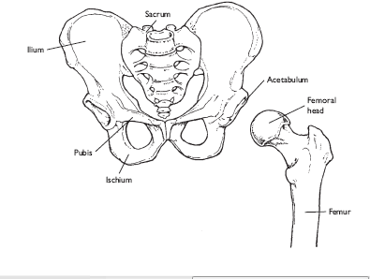

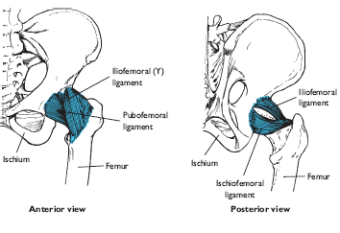

**Movements at the Hip**

Although movements of the femur are due primarily to rotation occurring at the hip joint, the pelvic girdle has a function similar to that of the shoulder girdle in positioning the hip joint for effective limb movement.

Unlike the shoulder girdle, the pelvis is a single non jointed structure, but it can rotate in all three planes of movement. The pelvis facilitates movement of the femur by rotating so that the acetabulum is positioned toward the direction of impending femoral movement. For example, posterior pelvic tilt, with the anterior superior iliac spine tilted backward with respect to the acetabulum, positions the head of the femur in front of the hipbone to enable ease of flexion. Likewise, anterior pelvic tilt promotes femoral extension, and lateral pelvic tilt toward the opposite side facilitates lateral movements of the femur. The movement of the pelvic girdle also coordinates with certain movements of the spine.

**Flexion**

The six muscles primarily responsible for flexion at the hip are those crossing the joint anteriorly: **the iliacus, psoas major, pectineus, rectus femoris, sartorius, and tensor fascia latae**. Of these, the large iliacus and psoas major—often referred to jointly as the iliopsoas because of their common attachment to the femur—are the major hip flexors.

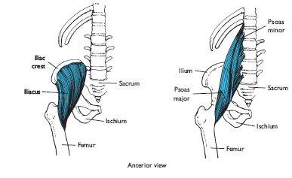

Because the rectus femoris is a two-joint muscle active during both hip fl exion and knee extension, it functions more effectively as a hip fl exor when the knee is in fl exion, as when a person kicks a ball.

The thin, straplike sartorius, or tailor’s muscle, is also a two-joint muscle. Crossing from the superior anterior iliac spine to the medial tibia just below the tuberosity, the sartorius is the longest muscle in the body.

**Extension**

The hip extensors are the **gluteus maximus** and the three hamstrings—the **biceps femoris, semitendinosus, and semimembranosus.** The gluteus maximus is a massive, powerful muscle that is usually active only when the hip is in flexion, as during stair climbing or cycling, or when extension at the hip is resisted. The hamstrings derive their name from their prominent tendons, which can readily be palpated on the posterior aspect of the knee. These two-joint muscles contribute to both extension at the hip and flexion at the knee, and are active during standing, walking, and running.

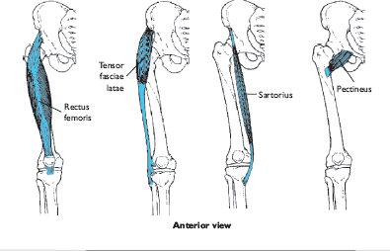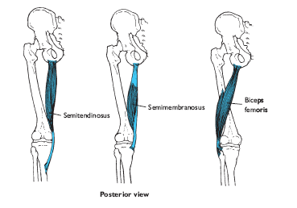

**Abduction**

The gluteus medius is the major abductor acting at the hip, with the gluteus minimus assisting. These muscles stabilize the pelvis during the support phase of walking and running and when an individual stands on one leg. For example, when body weight is supported by the right foot during walking, the right hip abductors contract isometrically and eccentrically to prevent the left side of the pelvis from being pulled downward by the weight of the swinging left leg. This allows the left leg to move freely through the swing phase. If the hip abductors are too weak to perform this function, then lateral pelvic tilt and dragging of the swing foot occurs with every step during gait. The hip abductors are also active during the performance of dance movements such as the grande ronde jambe.

**Adduction**

The hip adductors are those muscles that cross the joint medially and include the adductor longus, adductor brevis, adductor magnus, and gracilis. The hip adductors are regularly active during the swing phase of the gait cycle to bring the foot beneath the body’s center of gravity for placement during the support phase. During stair and hill-climbing, the adductors are even more active (28). The gracilis is a long, relatively weak strap muscle that also contributes to flexion of the leg at the knee.

The other three adductor muscles also contribute to flexion and lateral rotation at the hip, particularly when the femur is medially rotated.

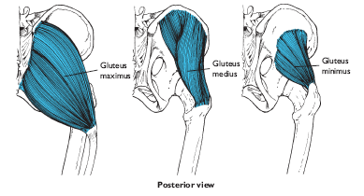

**Medial and Lateral Rotation of the Femur**

Although a number of muscles contribute to lateral rotation of the femur, six muscles function solely as lateral rotators. These are the piriformis, gemellus superior, gemellus inferior, obturator internus, obturator externus, and quadratus femoris. Although we tend to think of walking and running as involving strictly sagittal plane movement at the joints of the lower extremity, outward rotation of the femur also occurs with every step to accommodate the rotation of the pelvis.

The major medial rotator of the femur is the gluteus minimus, with assistance from the tensor fascia lata, semitendinosus, semimembranosus, and gluteus medius. Medial rotation of the femur is usually not a resisted motion requiring a substantial amount of muscular force. Both medial and lateral rotators are able to exert more tension when the hip is in 90° of flexion than when it is fully or partially extended. However, in all positions, the medial rotators are weak in comparison to the lateral rotators.

**Horizontal Abduction and Adduction**

Horizontal abduction and adduction of the femur occur when the hip is in 90° of flexion while the femur is either abducted or adducted. These actions require the simultaneous, coordinated actions of several muscles. Tension is required in the hip flexors for elevation of the femur. The hip abductors can then produce horizontal abduction and, from a horizontally abducted position, the hip adductors can produce horizontal adduction.

The muscles located on the posterior aspect of the hip are more effective as horizontal abductors and adductors than the muscles on the anterior aspect, because the former are stretched when the femur is in 90° of flexion, whereas tension in the anterior muscles is usually reduced with the femur in this position.

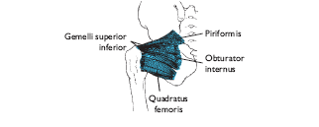

**Loads on the Hip**

The hip is a major weight-bearing joint that is never fully unloaded during daily activities. When bodyweight is evenly distributed across both legs during upright standing, the weight supported at each hip is one-half the weight of the body segments above the hip, or about one-third of total body weight. However, the total load on each hip in this situation is greater than the weight supported, because the tension in the large, strong hip muscles further adds to compression at the joint.

Because of muscle tension, compression on the hip is approximately the same as body weight during the swing phase of walking.

As gait speed increases, the load on the hip increases during both swing and support phases.

In summary, body weight, impact forces translated upward through the skeleton from the foot, and muscle tension all contribute to this large compressive load on the hip.

.

Fortunately, the hip joint is well designed to bear the large loads it habitually sustains. Because the diameter of the humeral head is somewhat larger than the articulating surface of the acetabulum, contact between the two bones during initiation of weight bearing begins around the periphery.

As loading increases, the contact area at the joint also increases, such that stress levels remain approximately constant.

Use of a crutch or cane on the side opposite an injured or painful hip is beneficial in that it serves to more evenly distribute the load between the legs throughout the gait cycle. During stance, a support opposite the painful hip reduces the amount of tension required of the powerful abductor muscles, thereby reducing the load on the painful hip. This reduction in load on the painful hip, however, increases the stress on the opposite hip.

**Common Injuries of the Hip**

**Fractures**

Although the pelvis and the femur are large, strong bones, the hip is subjected to high, repetitive loads ranging from four to seven times body weight during locomotion. Fractures of the femoral neck frequently occur during the support phase of walking among elderly individuals with osteoporosis, a condition of reduced bone mineralization and strength. These femoral neck fractures often result in loss of balance and a fall. A common misconception is that the fall always causes the fracture rather than the reverse, which may also be true. Researchers have estimated that approximately half of all femoral neck fractures can be attributed to osteoporosis. Hip fractures in the elderly are a serious health issue, with increased risk of death increasing five- to eight-fold during the first three months following the fracture. A high percentage of cortical bone in the proximal femur is protective against hip fractures. When the hipbones have good health and mineralization, they can sustain tremendous loads, as illustrated during many weight-lifting events. Regular physical activity helps protect against the risk of hip fracture.

**Contusions**

The muscles on the anterior aspect of the thigh are in a prime location for sustaining blows during participation in contact sports. The resulting internal hemorrhaging and appearance of bruises vary from mild to severe.

A relatively uncommon but potentially serious complication secondary to thigh contusions is acute compartment syndrome, in which internal bleeding causes a build-up of pressure in the muscle compartment causing compression of nerves, blood vessels, and muscle. If not treated, this can lead to tissue death due to a lack of oxygenation as the blood vessels are compressed by the raised pressure within the compartment.

**Strains**

Because most daily activities do not require simultaneous hip flexion and knee extension, the hamstrings are rarely stretched unless exercises are performed for that specific purpose. The resulting loss of extensibility makes the hamstrings particularly susceptible to strain. Strains to these muscles most commonly occur during sprinting, particularly if the individual is fatigued and neuromuscular coordination is impaired. Researchers believe that hamstring strains typically occur during the late stance or late swing phases of gait as a result of an eccentric contraction.

These injuries are troubling for athletes, given their high incidence rate and slowness of healing, and with a recurrence rate of nearly one-third during the first year following return to athletic participation. Strains to the groin area are also relatively common among athletes in sports in which forceful thigh abduction movements may overstretch the adductor muscles.

**Structure of the Knee**

The structure of the knee permits the bearing of tremendous loads, as well as the mobility required for locomotor activities. The knee is a large synovial joint, including three articulations within the joint capsule. The weight-bearing joints are the two condylar articulations of the tibiofemoral joint, with the third articulation being the patellofemoral joint. Although not a part of the knee, the proximal tibiofibular joint has soft-tissue connections that also slightly influence knee motion.

**Tibiofemoral Joint**

The medial and lateral condyles of the tibia and the femur articulate to form two side-by-side condyloid joints. These joints function together primarily as a modified hinge joint because of the restricting ligaments, with some lateral and rotational motions allowed. The condyles of the tibia, known as the tibial plateaus, form slight depressions separated by a region known as the intercondylar eminence. Because the medial and lateral condyles of the femur differ somewhat in size, shape, and orientation, the tibia rotates laterally on the femur during the last few degrees of extension to produce “locking” of the knee. This phenomenon, known as the “screw-home” mechanism, brings the knee into the close-packed position of full extension. Because the curvatures of the tibial plateau are complex, asymmetric, and vary significantly from individual to individual, some knees are much more stable and resistant to injury than others.

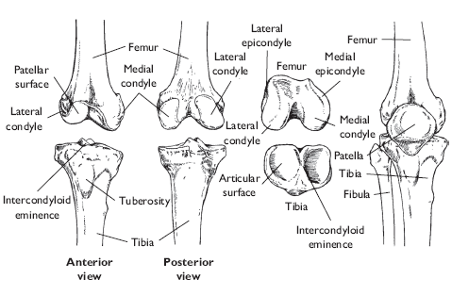

**Menisci**

The menisci, also known as semilunar cartilages after their half-moon shapes, are discs of fibrocartilage firmly attached to the superior plateaus of the tibia by the coronary ligaments and joint capsule. They are also joined to each other by the transverse ligament. The menisci are thickest at their peripheral borders, where fibers from the joint capsule solidly anchor them to the tibia. The medial semilunar disc is also directly attached to the medial collateral ligament. Medially, both menisci taper down to paper thinness, with the inner edges unattached to the bone.

The menisci receive a rich supply of both blood vessels and nerves. The blood supply enables inflammation, repair, and remodeling. The outer portion of each meniscus is innervated, providing proprioceptive information regarding knee position, as well as the velocity and acceleration of knee movements. The menisci deepen the articulating depressions of the tibial plateaus and assist with load transmission and shock absorption at the knee. The internal structure of the medial two-thirds of each meniscus is particularly well suited to resisting compression. The stress on the tibiofemoral joint can be several times higher during load bearing if the menisci have been removed. Injured knees, in which part or all of the menisci have been removed, may still function adequately but undergo increased wear on the articulating surfaces, significantly increasing the likelihood of the development of degenerative conditions at the joint. Knee osteoarthritis is frequently accompanied by meniscal tears. Whereas a meniscal tear can lead to the development of osteoarthritis over time, having osteoarthritis can also cause a spontaneous meniscal tear.

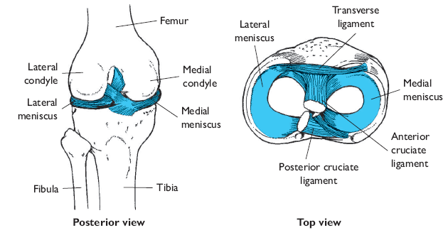

**Ligaments**

Many ligaments cross the knee, significantly enhancing its stability. The location of each ligament determines the direction in which it is capable of resisting the dislocation of the knee.

The medial and lateral collateral ligaments prevent lateral motion at the knee, as do the collateral ligaments at the elbow. They are also respectively referred to as the tibial and fibular collateral ligaments, after their distal attachments.

The attachment is just below the pesanserinus, the common attachment of the semitendinosus, semimembranosus, and gracilis to the tibia, thereby positioning the ligament to resist medially directed shear (valgus) and rotational forces acting on the knee.

The lateral collateral ligament courses from a few millimeters posterior to the ridge of the lateral epicondyle of the femur to the head of the fibula, contributing to lateral stability of the knee. The fan-shaped medial collateral ligament is considerably longer, wider, and thinner than the cord-like lateral collateral ligament.

The anterior and posterior cruciate ligaments limit the forward and backward sliding of the femur on the tibial plateaus during knee flexion and extension, and also limit knee hyperextension. The name cruciate is derived from the fact that these ligaments cross each other; anterior and posterior refer to their respective **tibial attachments**.

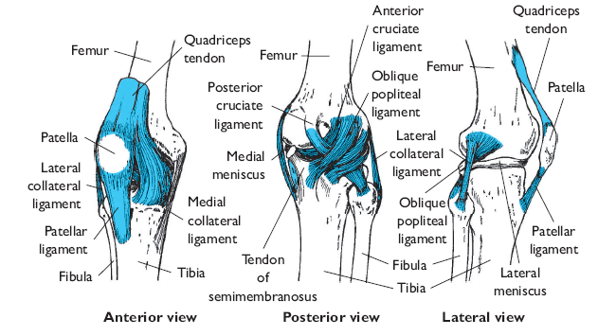

These ligaments restrict the anterior and posterior sliding of the femur on the tibial plateaus during knee flexion and extension and limit knee hyperextension.

Another restricting tissue is the iliotibial band or tract, a broad, thickened band of the fascia lata with attachments to the lateral condyle of the femur and the lateral tubercle of the tibia.

**Patellofemoral Joint**

The patellofemoral joint consists of the articulation of the triangularly shaped patella, encased in the patellar tendon, with the trochlear groove between the femoral condyles

The patella serves several biomechanical functions.

1. Most notably, it increases the angle of pull of the quadriceps tendon on the tibia, thereby improving the mechanical advantage of the quadriceps muscles for producing knee extension.
2. It also centralizes the divergent tension from the quadriceps muscles that are transmitted to the patellar tendon.
3. The patella also increases the area of contact between the patellar tendon and the femur, thereby decreasing patellofemoral joint contact stress.
4. Finally, it also provides some protection for the anterior aspect of the knee and helps protect the quadriceps tendon from friction against the adjacent bones.

**Joint Capsule and Bursae**

The thin articular capsule at the knee is large and lax, encompassing both the tibiofemoral and the patellofemoral joints. A number of bursae are located in and around the capsule to reduce friction during knee movements.

The suprapatellar bursa, positioned between the femur and the quadriceps femoris tendon, is the largest bursa in the body. Other important bursae are the subpopliteal bursa, located between the lateral condyle of the femur and the popliteal muscle, and the semimembranosus bursa, situated between the medial head of the gastrocnemius and semimembranosus tendons.

The prepatellar bursa is located between the skin and the anterior surface of the patella, allowing free movement of the skin over the patella during flexion and extension.

The superficial infrapatellar bursa provides cushioning between the skin and the patellar tendon, and the deep infrapatellar bursa reduces friction between the tibial tuberosity and the patellar tendon.

**Movements at the Knee**

**Muscles Crossing the Knee**

Like the elbow, the knee is crossed by a number of two-joint muscles.

**Flexion and Extension**

Flexion and extension are the primary movements permitted at the tibiofemoral joint.

For flexion to be initiated from a position of full extension, however, the knee must first be “unlocked.” In full extension, the articulating surface of the medial condyle of the femur is longer than that of the lateral condyle, rendering motion almost impossible.

The service of locksmith is provided by the popliteus, which acts to medially rotate the tibia with respect to the femur, enabling flexion to occur. As flexion proceeds, the femur must slide forward on the tibia to prevent rolling off the tibial plateaus. Likewise, the femur must slide backwards on the tibia during extension.

Medial rotation of the tibia and anterior translation of the fibia on the tibial plateau have been shown to be coupled to flexion at the knee, even when flexion is passive.

Both the ligaments of the knee and the shapes of the articular surfaces influence the patterns of these coupled motions at the knee.

The three hamstring muscles are the primary flexors acting at the knee. Muscles that assist with knee flexion are the gracilis, sartorius, popliteus, and gastrocnemius.

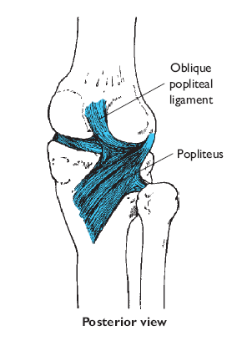

The quadriceps muscles, consisting of the **rectus femoris, vastus lateralis, vastus medialis, and vastus intermedius,** are the extensors of the knee. The rectus femoris is the only one of these muscles that also crosses the hip joint. All four muscles attach distally to the patellar tendon, which inserts on the tibia.

**Rotation and Passive Abduction and Adduction**

Rotation of the tibia relative to the femur is possible when the knee is in flexion and not bearing weight, with rotational capability greatest at approximately 90° of flexion. Tension development in the semimembranosus, semitendinosus, and popliteus produces medial rotation of the tibia, with the gracilis and sartorius assisting. The biceps femoris is solely responsible for lateral rotation of the tibia.

A few degrees of passive abduction and adduction are permitted at the knee. Abduction and adduction moments at the knee can also be actively generated by co-contraction of the muscles crossing the medial and lateral aspects of the knee to resist externally applied adduction and abduction moments. The primary contribution to these resistive moments comes from the co-contraction of the hamstrings and the quadriceps, with secondary contributions from the gracilis and the tensor fascia lata.

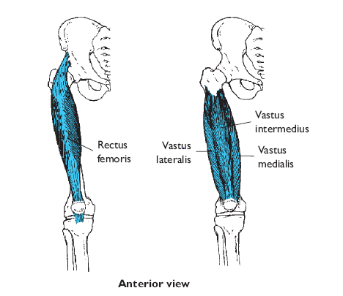

**Patellofemoral Joint Motion**

During flexion and extension at the tibiofemoral joint, the patella glides inferiorly and superiorly against the distal end of the femur with an excursion of approximately 7 cm. The path of the center of the patella is circular and uniplanar. Tracking of the patella against the femur is dependent on the direction of the net force produced by the attached quadriceps. The vastus lateralis (VL) tends to pull the patella laterally, while the vastus medialis oblique (VMO) opposes the lateral pull of the vastus lateralis, keeping the patella centered in the patellofemoral groove. The medial and lateral quadriceps force components also tilt the patella in the sagittal and transverse planes. The iliotibial band also influences knee mechanics, and excessive tightness can cause maltracking of the patella.

**Loads on the Knee**

Because the knee is positioned between the body’s two longest bony levers (the femur and the tibia), the potential for torque development at the joint is large. The knee is also a major weight-bearing joint.

**Forces at the Tibiofemoral Joint**

The tibiofemoral joint is loaded in both compression and shear during daily activities. Weight bearing and tension development in the muscles crossing the knee contribute to these forces, with compression dominating when the knee is fully extended. The muscles that cross the knee are primary contributors to tibiofemoral compression, although the gluteus medius also contributes substantially to compression on the medial tibial plateau.

Compressive force at the tibiofemoral joint is slightly greater than three times body weight during the stance phase of gait, increasing up to approximately four times body weight during stair climbing. The medial tibial plateau bears most of this load during stance when the knee is extended, with the lateral tibial plateau bearing more of the medial tibial plateau has a surface area roughly 60% larger than that of the lateral tibial plateau, the stress acting on the joint is less than if peak loads were distributed medially. The fact that the articular cartilage on the medial plateau is three times thicker than that on the lateral plateau also helps protect the joint from wear.

The menisci act to distribute loads at the tibiofemoral joint over a broader area, thus reducing the magnitude of joint stress. The menisci also directly assist with force absorption at the knee, bearing as much as an estimated 45% of the total load. Because the menisci help protect the articulating bone surfaces from wear, knees that have undergone either complete or partial meniscectomies are more likely to develop degenerative conditions.

Measurements of articular cartilage deformation on the tibial plateau during weight bearing show that stress at the joint is maximal from 180 to 120 degrees of flexion, with minimal stress at approximately 30 degrees of flexion. Comparison of front and back squat exercises shows no difference in overall muscle recruitment, but significantly less compressive force acting on the knee during the front squat. Among runners larger loads on the knee are related to reduced hamstring flexibility, greater body weight, greater weekly mileage, and greater muscular strength. Other general risk factors for development of knee osteoarthritis include a high body mass index and meniscal damage.

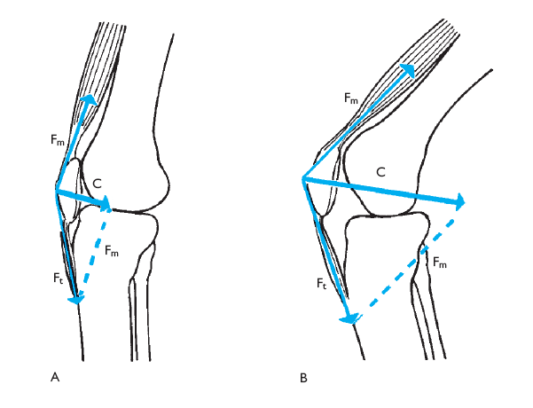

**Forces at the Patellofemoral Joint**

Compressive force at the patellofemoral joint has been found to be one-half of body weight during normal walking gait, increasing up to over three times body weight during stair climbing.

There are two reasons for this. First, the increase in knee flexion increases the compressive component of force acting at the joint. Second, as flexion increases, a larger amount of quadriceps tension is required to prevent the knee from buckling against gravity.

The squat exercise is known for being particularly stressful to the patellofemoral joint, and joint reaction forces increase with the depth of the squat, as well as with load. Training within the 0–50° knee flexion range is recommended for those who wish to minimize knee forces, however. The squat has been shown to be an effective exercise for use during rehabilitation following cruciate ligament or patellofemoral surgery.

**Common Injuries of the Knee and Lower Leg**

The location of the knee between the long bones of the lower extremity, combined with its weight-bearing and locomotion functions, makes it susceptible to injury, particularly during participation in contact sports.

A common injury mechanism involves the stretching or tearing of soft tissues on one side of the joint when a blow is sustained from the opposite side during weight-bearing.

**Anterior Cruciate Ligament Injuries**

Injuries to the anterior cruciate ligament (ACL) are common in sports such as basketball and team handball, which involve pivoting and cutting, as well as in Alpine skiing, where a common mechanism involves catching a ski tip in the snow, with the skier simultaneously twisting and falling.

Approximately 70% of ACL injuries are noncontact, with most of these being sustained when the femur is rotated on the planted leg with the knee close to full extension during cutting, landing, or stopping. These kinds of activities involving sudden changes in direction combined with acceleration or deceleration of the body produce large rotational moments and varus/valgus forces at the knee, particularly when such movements are inadequately planned. The ACL is loaded when the net shear force at the knee is directed anteriorly. So, for ACL rupture to occur, there must be excess anterior translation or rotation of the femur on the tibia.

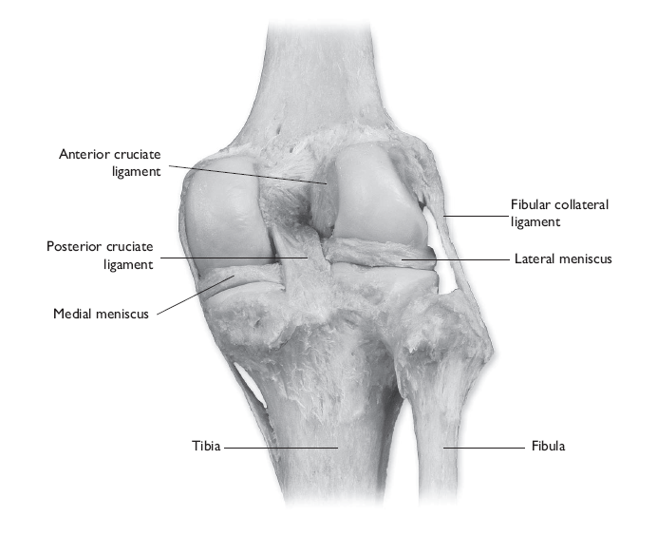

There is a striking gender disparity in the incidence of ACL injuries, with women 3.5 more times likely to sustain a non-contact ACL injury than men. A number of hypotheses related to anatomical or neuromuscular factors have been advanced.

One suggestion is that shorter, more highly convex articulating surfaces on the lateral side of the tibiofemoral joint may be inherently less stable in allowing more anterior tibial translation and rotation during activities involving vigorous motion at the knee.

Research has shown that during running, cutting, and landing, women, as compared to men, tend to have less knee flexion, greater knee valgus angles, more hip abduction, greater quadriceps activation, less hamstring activation, and generally less variability in lower-extremity coordination patterns. Researchers have demonstrated that a combination of valgus and internal rotation at the knee places more strain on the ACL than either form of loading alone.

Numerous strategies for preventing ACL injuries, especially in female athletes, have been advocated. Some have advocated strengthening or stiffening of the hamstrings to protect the ACL because female athletes tend to have greater quadriceps-to-hamstrings strength ratios than do male athletes.

Others have advocated strengthening the quadriceps to protect against ACL injuries because the quadriceps provide the primary muscular restraint to anterior tibial translation during activities such as running and jumping.

However, it has been demonstrated that sagittal plane knee forces cannot rupture the ACL during sidestep cutting, so during this maneuver, valgus loading is a more likely injury mechanism.

Another perspective is that increasing ability to control lateral trunk motion during cutting and landing movements can help prevent ACL injuries in female athletes because lateral trunk motion increases the abduction moment at the knee.

Following unrepaired ACL rupture, there is a notable lessening of flexion–extension range of motion at the knee during walking, which has been attributed to “quadriceps avoidance”. This does not appear to be related to a deficit in quadriceps strength, but instead may be attributed to the fact that quadriceps tension produces an anteriorly directed force on the tibia when the knee is near full extension. Individuals seem to adapt to the absence of the ACL by minimizing activation of the quadriceps when the knee is near full extension.

There is also evidence of general impairment of neuromuscular control of the quadriceps, with the muscles remaining active during tasks not requiring quadriceps activation.

Although some ACL-deficient individuals are able to stabilize their knees even during cutting and pivoting, for most, the absence of the ACL results in local instability of the knee, a change in the location of the center of rotation at the knee, a change in the area of tibiofemoral contact during gait, and altered joint kinetics, with subsequent onset of osteoarthritis.

Surgical repair of ACL rupture involves reconstruction of the ligament using either the middle third of the patellar tendon, the semitendinosus, or the semitendinosus and gracilis.

Problems that follow trauma to the knee, whether the trauma is injury- or surgery-induced, include notable

1. weakness and loss of mass in the knee extensor muscles,
2. dramatic reduction of joint range of motion,
3. And impaired joint proprioception.

One factor hypothesized to play a major role in precipitating these changes is muscle inhibition, or the inability to activate all motor units of a muscle during maximal voluntary contraction.

It has been shown that muscle inhibition can persist for an extended time and may be responsible for long-term strength deficits that alter joint kinetics and lead to osteoarthritis.

**Posterior Cruciate Ligament Injuries**

Posterior cruciate ligament (PCL) injuries most commonly result from sport participation or motor vehicle accidents. When the PCL is ruptured in isolation, with no damage to the other ligaments or to the menisci, the mechanism is usually hyperflexion of the knee with the foot plantar flexed. Impact with the dashboard during motor vehicle accidents, on the other hand, with direct force on the proximal anterior tibia, results in combined ligamentous damage in most cases. Isolated PCL injuries are usually treated non-operatively.

**Medial Collateral Ligament Injuries**

Blows to the lateral side of the knee are much more common than blows to the medial side, because the opposite leg commonly protects the medial side of the joint. When the foot is planted and a lateral blow of sufficient force is sustained, the result is sprain or rupture of the medial collateral ligament (MCL). Modeling studies suggest that the muscles crossing the knee are able to resist approximately 17% of external medial and lateral loads on the knee, with the remaining 83% sustained by the ligaments and other soft tissues. In contact sports such as football, the MCL is the most frequently injured knee ligament.

**Meniscus Injuries**

Because the medial collateral ligament attaches to the medial meniscus, stretching or tearing of the ligament can also result in damage to the meniscus. A torn meniscus is the most common knee injury, with damage to the medial meniscus occurring approximately 10 times as frequently as damage to the lateral meniscus. This is the case partly because the medial meniscus is more securely attached to the tibia, and therefore less mobile than the lateral meniscus. In knees that have undergone ACL rupture, the normal stress distribution is disrupted such that the force on the medial meniscus is increased. In the absence of ACL reconstruction, this results in an increased incidence of medial meniscal tears, although loading of the meniscus returns to normal if the ACL is reconstructed.

A torn meniscus is problematic in that the unattached cartilage often slips from its normal position, interfering with normal joint mechanics.

Symptoms include pain, which is sometimes accompanied by intermittent bouts of locking or buckling of the joint.

**Iliotibial Band Friction Syndrome**

The tensor fascia lata develops tension to assist with stabilization of the pelvis when the knee is in flexion during weight bearing. This can produce friction of the posterior edge of the iliotibial band (ITB) against the lateral condyle of the femur around the time of heelstrike, primarily during foot contact with the ground. The result is inflammation of the distal portion of the ITB, as well as the knee joint capsule under the ITB, with accompanying symptoms of pain and tenderness over the lateral aspect of the knee.

This condition is an overuse syndrome that affects approximately 2–12% of runners and can also affect cyclists.

Both training errors and anatomical malalignments within the lower extremity increase the risk of ITB syndrome. Training factors in running include excessive running in the same direction on a track, greater than- normal weekly mileage, and downhill running. Runners who had previously sustained iliotibial band syndrome displayed characteristic gait anomalies, including greater peak knee internal rotation and greater peak hip adduction compared to normal runners. Both of these kinematic differences place added stress on the iliotibial band.

Improper seat height, as well as greater-than-normal weekly mileage, predisposes cyclists to the syndrome. Predisposing malalignments include excessive femoral anteversion, increased Q-angle, lateral tibial torsion, tibial genu varum or valgum, subtalar varus, and excessive pronation.

**Patellofemoral Pain Syndrome**

Painful patellofemoral joint motion involves anterior knee pain during and after physical activity, particularly activities requiring repeated flexion at the knee, such as running, ascending and descending stairs, and squatting. It is more common among females than among males. This syndrome, involving maltracking of the patella, has been attributed to a number of possible causes, including anatomical malalignment(s), activation timing, decreased quadriceps and hamstring strength, increased hip external rotator strength, and overactivity.

An anatomical factor hypothesized to contribute to lower-extremity malalignment that could trigger patellofemoral pain is an excessively large Q-angle, the angle formed between the anterior superior iliac spine, the center of the patella, and the tibial tuberosity. The Q-angle provides an approximation of the angle of pull of the quadriceps on the patella, and it has been hypothesized that a large Q-angle could lead to lateral patellar dislocation or increased lateral patellofemoral contact pressures.

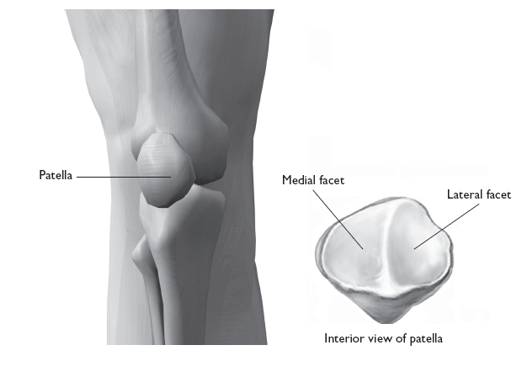

**Shin Splints**

Generalized pain along the anterolateral or posteromedial aspect of the lower leg is commonly known as shin splints. This is a loosely defined overuse injury, often associated with running or dancing, that may involve microdamage to muscle attachments on the tibia and/or inflammation of the periosteum. Common causes of the condition include running or dancing on a hard surface and running uphill. A change in workout conditions or rest usually alleviates shin splints.

**Structure of the Ankle**

The ankle region includes the distal tibiofibular, tibiotalar, and fibulotalar joints.

The distal tibiofibular joint is a syndesmosis where dense fibrous tissue binds the bones together.

The joint is supported by the anterior and posterior tibiofibular ligaments, as well as by the crura-linterosseous tibiofibular ligament.

Most motion at the ankle occurs at the tibiotalar hinge joint, where the convex surface of the superior talus articulates with the concave surface of the distal tibia.

Three ligaments—the anterior and posterior talofibular, and the calcaneofibular—reinforce the joint capsule laterally.

The four bands of the deltoid ligament contribute to joint stability on the medial side.

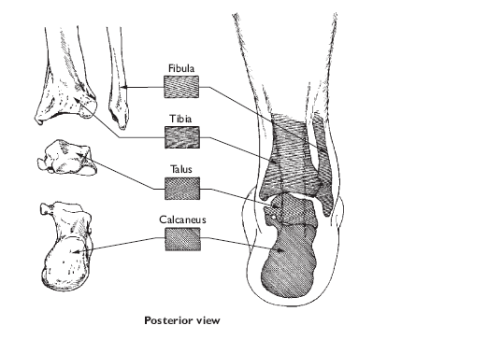

**Movements at the Ankle**

The axis of rotation at the ankle is essentially frontal, although it is slightly oblique and its orientation changes somewhat as rotation occurs at the joint. Motion at the ankle occurs primarily in the sagittal plane, with the ankle functioning as a hinge joint with a moving axis of rotation during the stance phase of gait.

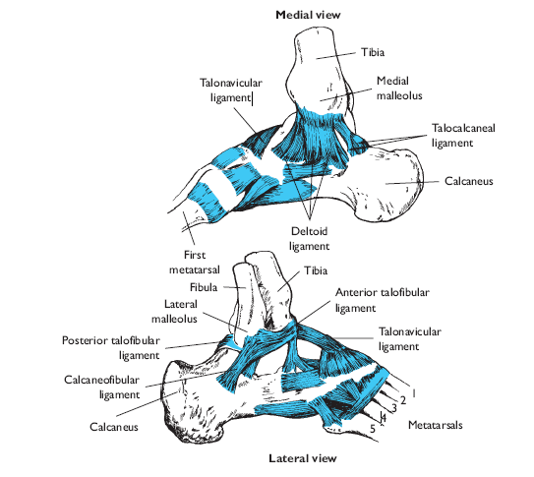

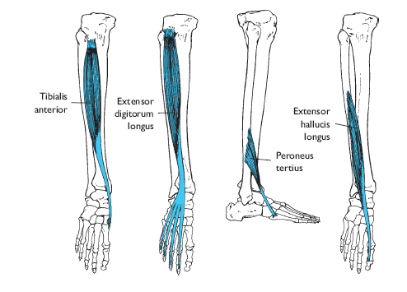

Ankle flexion and extension are termed dorsiflexion and plantarflexion, respectively

The medial and lateral malleoli serve as pulleys to channel the tendons of muscles crossing the ankle either posterior or anterior to the axis of rotation, thereby enabling their contributions to either dorsiflexion or plantar flexion.

The tibialis anterior, extensor digitorum longus, and peroneus tertius are the prime dorsiflexors of the foot. The extensor hallucis longus assists in dorsiflexion

The major plantar flexors are the two heads of the powerful two-joint gastrocnemius and the soleus, which lies beneath the gastrocnemius. Assistant plantar flexors include the tibialis posterior, peroneus longus, peroneus brevis, plantaris, flexor hallucis longus, and flexor digitorum longus.

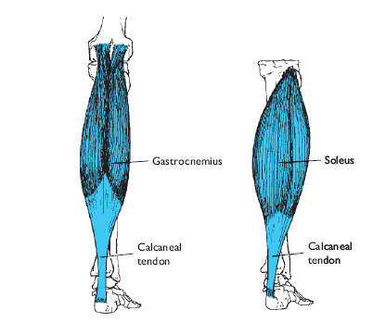

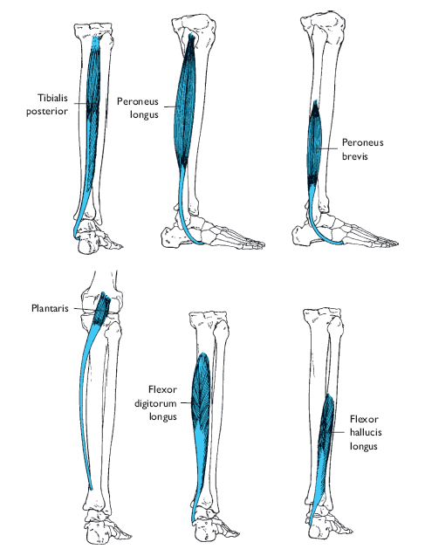

**Structure of the Foot**

Like the hand, the foot is a multibone structure. It contains a total of 26 bones with numerous articulations. Included are the subtalar and midtarsal joints and several tarsometatarsal, intermetatarsal, metatarsophalangeal, and interphalangeal joints.

Together, the bones and joints of the foot provide a foundation of support for the upright body and help it adapt to uneven terrain and absorb shock.

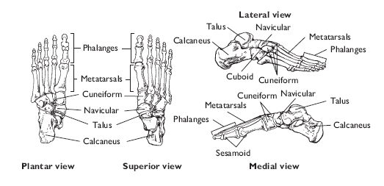

**Subtalar Joint**

As the name suggests, the subtalar joint lies beneath the talus, where anterior and posterior facets of the talus articulate with the sustentaculum-tali on the superior calcaneus. Four talocalcaneal ligaments join the talus and the calcaneus. The joint is essentially uniaxial, with an alignment slightly oblique to the conventional descriptive planes of motion.

**Tarsometatarsal and Intermetatarsal Joints**

Both the tarsometatarsal and the intermetatarsal joints are nonaxial, with the bone shapes and the restricting ligaments permitting only gliding movements. These joints enable the foot to function as a semirigid unit or to adapt flexibly to uneven surfaces during weight bearing.

**Metatarsophalangeal and Interphalangeal Joints**

The metatarsophalangeal and interphalangeal joints are similar to their counterparts in the hand, with the former being condyloid joints and the latter being hinge joints. Numerous ligaments provide reinforcement for these joints. The toes function to smooth the weight shift to the opposite foot during walking and help maintain stability during weight bearing by pressing against the ground when necessary. The first digit is referred to as the hallux, or “great toe.”

**Plantar Arches**

The tarsal and metatarsal bones of the foot form three arches. The medial and lateral longitudinal arches stretch from the calcaneus to the metatarsals and tarsals. The transverse arch is formed by the bases of the metatarsal bones.

**Several ligaments and the plantar fascia support the plantar arches.**

The spring ligament is the primary supporter of the medial longitudinal arch, stretching from the sustentaculum tali on the calcaneus to the inferior navicular.

The long plantar ligament provides the major support for the lateral longitudinal arch, with assistance from the short plantar ligament. Thick, fibrous, interconnected bands of connective tissue known as the plantar fascia extend over the plantar surface of the foot, assisting with support of the longitudinal arch.

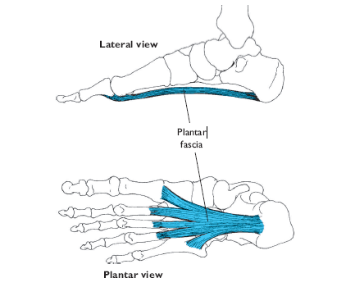

When muscle tensionis present, the muscles of the foot, particularly the tibialis posterior, also contribute support to the arches and joints as they cross them.

As the arches deform during weight bearing, mechanical energy is stored in the stretched tendons, ligaments, and plantar fascia. Additional energy is stored in the gastrocnemius and soleus as they develop eccentric tension.

During the push-off phase, the stored energy in all of these elastic structures is released, contributing to the force of push-off and actually reducing the metabolic energy cost of walking or running.

**Movements of the Foot**

**Muscles of the Foot**

As with the muscles of the hand, extrinsic muscles are those crossing the ankle, and intrinsic muscles have both attachments within the foot.

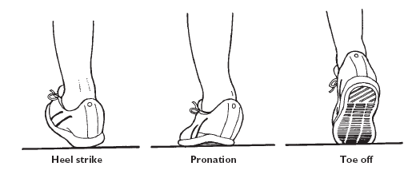

**Toe Flexion and Extension**

Flexion involves the curling under of the toes. Flexors of the toes include the flexor digitorum longus, flexor digitorum brevis, quadratus plantae, lumbricals, and interossei. The flexor hallucis longus and brevis produce flexion of the hallux. Conversely, the extensor hallucis longus, extensor digitorum longus, and extensor digitorum brevis are responsible for extension of the toes.

**Inversion and Eversion**

Rotational movements of the foot in medial and lateral directions are termed inversion and eversion, respectively.

These movements occur largely at the subtalar joint, although gliding actions among the intertarsal and tarsometatarsal joints also contribute. Inversion results in the sole of the foot turning inward toward the midline of the body.

The tibialis posterior and tibialis anterior are the main muscles involved. Turning the sole of the foot outward is termed eversion.

The muscles primarily responsible for eversion are the peroneus longus and the peroneus brevis, both with long tendons coursing around the lateral malleolus. The peroneus tertius assists.

**Pronation and Supination**

During walking and running, the foot and ankle undergo a cyclical sequence of movements. As the heel contacts the ground, the rear portion of the foot typically inverts to some extent. When the foot rolls forward and the forefoot contacts the ground, plantar flexion occurs.

The combination of inversion, plantar flexion, and adduction of the foot is known as supination. While the foot supports the weight of the body during midstance, there is a tendency for eversion and abduction to occur as the foot moves into dorsiflexion.

These movements are known collectively as pronation. Pronation serves to reduce the magnitude of the ground reaction force sustained during gait by increasing the time interval over which the force is sustained.

**Loads on the Foot**

Impact forces sustained during gait increase with body weight and with gait speed in accordance with Newton’s third law of motion.

The vertical ground reaction force applied to the foot during running is bimodal, with an initial impact peak followed almost immediately by a propulsive peak, as the foot pushes off against the ground, impact forces range from 1.6 to 2.3 times body weight and propulsive forces range from 2.5 to 2.8 times body weight.

The structures of the foot are anatomically linked such that the load is evenly distributed over the foot during weight bearing. Approximately 50% of body weight is distributed through the subtalar joint to the calcaneus, with the remaining 50% transmitted across the metatarsal heads.

The head of the first metatarsal sustains twice the load borne by each of the other metatarsal heads. A factor that influences this loading pattern, however, is the architecture of the foot.

A pes planus (relatively flat arch) condition tends to reduce the load on the forefoot, with pes cavus (relatively high arch) significantly increasing the load on the forefoot

**Common Injuries of the Ankle and Foot**

Because of the crucial roles played by the ankle and foot during locomotion, injuries to this region can greatly limit mobility. Injuries of the lower extremity, especially those of the foot and ankle, may result in weeks or even months of lost training time for athletes, particularly runners.

Among dancers, the foot and the ankle are the most common sites of both chronic and acute injuries.

**Ankle Injuries**

**Ankle sprains** are the most common of all sport- and dance-related injuries.

Because the joint capsule and ligaments are stronger on the medial side of the ankle, inversion sprains involving stretching or rupturing of the lateral ligaments are much more common than eversion sprains of the medial ligaments. In fact, the bands of the deltoid ligament are so strong that excessive eversion is more likely to result in a fracture of the distal fibula than in rupturing of the deltoid ligament.

The ligaments most commonly injured are the anterior and posterior talofibular ligaments and the calcaneofibular ligament. Because of the protection by the opposite limb on the medial side, fractures in the ankle region also occur more often on the lateral than on the medial side. Repeated ankle sprains can result in functional ankle instability, which is characterized by significantly altered patterns of ankle and knee movement. Researchers hypothesize that this is related to altered motor control of the foot/ankle complex, which unfortunately predisposes the ankle to further injury.

**Overuse Injuries**

**Achilles tendinitis** involves inflammation and sometimes micro-rupturing of tissues in the Achilles tendon, typically accompanied by swelling. Two possible mechanisms for tendinitis have been proposed. The first is that repeated tension development results in fatigue and decreased flexibility in the muscle, increasing tensile load on the tendon even during relaxation of the muscle. The second theory is that repeated loading actually leads to failure or rupturing of the collagen threads in the tendon.

**Achilles tendinitis** is usually associated with running and jumping activities and is extremely common among theatrical dancers.

The Achilles tendon is the most frequently ruptured tendon in the body. The most commonly affected group are male skiers.

Repetitive stretching of the plantar fascia can result in plantar fasciitis, a condition characterized by micro-tears and inflammation of the plantar fascia near its attachment to the calcaneus.

The symptoms are pain in the heel and/or arch of the foot.

Anatomical factors believed to contribute to the development of plantar fasciitis include pes planus (flat foot), a rigid cavus (high-arch) foot, and tightness in the posterior muscles of the lower extremity, all of which reduce the foot’s shock-absorbing capability.

A stretching program for the plantar fascia and posterior leg muscles can alleviate plantar fasciitis when the condition has not reached a chronic state.

**Stress fractures** occur relatively frequently in the bones of the lower extremity. Among runners, factors associated with stress fractures include training errors, forefoot striking (toe–heel gait), running on hard surfaces such as concrete, improper footwear, and alignment anomalies of the trunk and/or lower extremity.

Female runners with a history of tibial stress fracture displayed greater peak hip adduction and peak rear foot eversion angles as compared to other runners, suggesting that this kinematic pattern may be predisposing for the injury.

Stress fractures among women runners, dancers, and gymnasts may be related to decreased bone mineral density secondary to oligomenorrhea.

Low BMI, late menarche, and prior participation in gymnastics and dance are all risk factors for stress fractures in girls.

**Alignment Anomalies of the Foot**

Varus and valgus conditions (inward and outward lateral deviation, respectively, of a body segment) can occur in all of the major links of the lower extremity. These may be congenital or may arise from an imbalance in muscular strength.

In the foot, varus and valgus conditions can affect the forefoot, the rear foot, and the toes. Forefoot varus and forefoot valgus refer to inversion and eversion misalignments of the metatarsals, and rear foot varus and valgus involve inversion and eversion misalignments at the subtalar joint

Hallux valgus is a lateral deviation of the big toe often caused by wearing women’s shoes with pointed toes.

Varus and valgus conditions in the tibia and the femur can alter the kinematics and kinetics of joint motion, because they cause added tensile stress on the stretched side of the affected joint. For example, a combination of femoral varus and tibial valgus (a knock-knee condition) places added tension on the medial aspect of the knee.

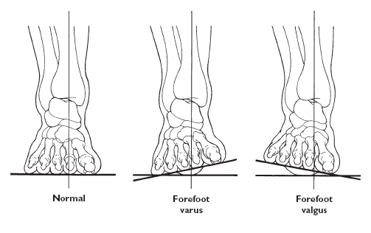

In contrast, the bow-legged condition of femoral valgus and tibial varus stresses the lateral aspect of the knee and is therefore a predisposing factor for iliotibial band friction syndrome. Unfortunately, lateral misalignments at one joint of the lower extremity are typically accompanied by compensatory misalignments at other lower-extremity joints because of the nature of joint loading during weight bearing.

Depending on the cause of the misalignment problem, correctional procedures may involve exercises to strengthen or stretch specific muscles and ligaments of the lower extremity, as well as the use of orthotics, specially designed inserts worn inside the shoe to provide added support for a portion of the foot. Injuries Related to High and Low Arch Structures

Arches that are higher or lower than the normal range have been found to influence lower-extremity kinematics and kinetics, with implications for injury. Specifically, as compared to those with normal arches, high-arched runners have been found to exhibit increased vertical loading rate, with related higher incidences of ankle sprains, plantar fasciitis, iliotibial band friction syndrome, and fifth metatarsal stress fractures.

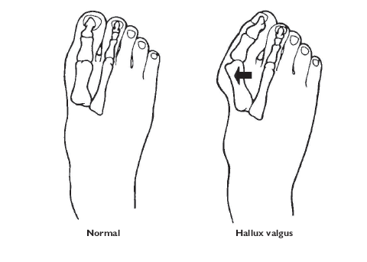

Low-arched runners, as compared to those with normal arches, have been found to exhibit increased range of motion and velocity in rear foot eversion, as well as an increased ratio of eversion to tibial internal rotation. These kinematic alterations were found to result in increased incidences of general knee pain, patellar tendinitis, and patellar fasciitis.

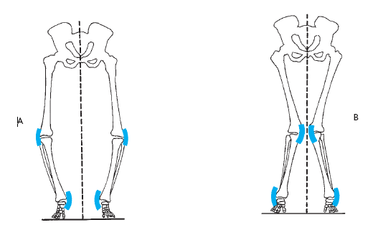

**Summary**

The lower extremity is well adapted to its functions of weight bearing and locomotion. This is particularly evident at the hip, where the bony structure and several large, strong ligaments provide considerable joint stability.

The hip is a typical ball-and-socket joint, with flexion, extension, abduction, adduction, horizontal abduction, horizontal adduction, medial and lateral rotation, and circumduction of the femur permitted.

The knee is a large, complex joint composed of two side-by-side condyloid articulations. Medial and lateral menisci improve the fit between the articulating bone surfaces and assist in absorbing forces transmitted across the joint.

Because of differences in the sizes, shapes, and orientations of the medial and lateral articulations, medial rotation of the tibia accompanies full knee extension.

A number of ligaments cross the knee and restrain its mobility. The primary movements allowed at the knee are flexion and extension, although some rotation of the tibia is also possible when the knee is in flexion and not bearing weight.

The ankle includes the articulations of the tibia and the fibula with the talus. This is a hinge joint that is reinforced both laterally and medially by ligaments. Movements at the ankle joint are dorsiflexion and plantarflexion.

Like the hand, the foot is composed of numerous small bones and their articulations. Movements of the foot include inversion and eversion, abduction and adduction, and flexion and extension of the toes.

**Tendon and Ligament – Hip Joint**

Abbuductor longus

Femoral triangle

**Bones – Knee Joint**

Adductor tubercle

Femoral epicondyles

Femoral condyles

PatellaMedial tibial flare

Medial tibial condyle

Medial tibial plateau

Lateral tibial flare

Lateral tibial condyle

Lateral tibial plateau

Head of fibula

Tibial tubercle (tuberosity)

Tibial crest (shin)

**Tendon and Ligament – Knee Joint**

Quadriceps tendon

Patella ligament

Semitendinosus tendon

Bicep femoris

Popliteal fossa

**Bones of the Foot**

Medial malleolus

Lateral malleolus

Medial part of head of talus

Lateral part of head of talus

Body of talus

Navicular tuberosity

First metatarsal

Fifth metatarsal

Calcaneus

**Tendons of the Foot**

Body of talus

Navicular tuberosity

First metatarsal

Fifth metatarsal

Calcaneus Peronei longus and brevis

Extensor halluces longus

Extensor digitorum longus

Arches of the foot

**Arthrology**

Arthrology is the science concerned with the study of anatomy, function, dysfunction and treatment of joints and articulations.

Arthrology, which stems from the ancient Greek word arthros (meaning “jointed”), is the study of those structures that hold bones together, allowing them to move to varying degrees — or fixing them in place — depending on the design and function of the joint. The term articulation, or joint, applies to any union of bones, whether it moves freely or not at all.

Inside some joints, such as knees and elbows, are fluid-filled sacs called bursae that help reduce friction between tendons and bones; inflammation in these sacs is called bursitis.

**Syndesmosis joints** are stabilized by connective tissue called ligaments, or interosseus membranes, that range from bundles of collagenous fibers that restrict movement and hold a joint in place to elastic fibers that can repeatedly stretch and return to their original shapes.

**Examples Include;**

The shoulder joint, or corticohumeral ligament that extends from the coracoid process of the scapula to the greater tubercle of the humerus

The pubofemoral ligament that extends from the pubic bone to the femur.

The knee joint (oblique popliteal ligament), where the tendon of the semimembranous muscle expands to cross the posterior of the knee joint

**The three types of joints are as follows:**

**Fibrous:** Fibrous tissue rigidly joins the bones in a form of articulation called synarthrosis, which is characterized by no movement at all. The sutures of the skull are fibrous joints. Any slight movement in a joint depends on the length of the fibers uniting the bones.

**Cartilaginous:** This type of joint is found in two forms:

**Synchondrosis** articulation involves hyaline (rigid) cartilage that allows no movement. Once bone growth ends, the joint becomes ossified and immobile. The most common example is the epiphyseal plate of the long bone. Other examples are the joint between the ribs, costal cartilage, and sternum

**Symphysis** joints occur where fibrocartilage fuses bones in such a way that pressure can cause slight movement, called amphiarthrosis. Examples include the intervertebral discs and the symphysis pubis.

**Synovial:** Also known as diarthrosis, or freely moving, joints, this type of articulation involves a synovial cavity, which contains articular fluid secreted from the synovial membrane to lubricate the opposing surfaces of bone covered by smooth articulating cartilage.

The synovial membrane is covered by a fibrous joint capsule layer that’s continuous with the periosteum of the bone. Ligaments surrounding the joint strengthen the capsule and hold the bones in place, preventing dislocation.

In some synovial joints, such as the knee, fibrocartilage pads called menisci (singular: meniscus) develop in the cavity, dividing it into two parts. In the knees, these menisci stabilize the joint and act as shock absorbers.

**Classes of Joints**

There are six classifications of moveable, or synovial, joints:

**Gliding:** Curved or flat surfaces slide against one another, such as between the carpal bones in the wrist or between the tarsal bones in the ankle.

**Hinge:** A convex surface joints with a concave surface, allowing right-angle motions in one plane, such as elbows, knees, and joints between the finger bones.

**Pivot (or rotary):** One bone pivots or rotates around a stationary bone, such as the atlas rotating around the odontoid process of the axis at the top of the vertebral column.

**Condyloid:** The oval head of one bone fits into a shallow depression in another, to allow for five movements: flexion, extension, abduction, adduction, and circumduction. Examples are the carpal-metacarpal joint at the wrist and the tarsal-metatarsal joint at the ankle.

**Saddle**: Each of the adjoining bones is shaped like a saddle (the technical term is reciprocally concavo-convex). The saddle joints resemble condyloid joints but have even greater freedom of movement. An example is the carpometacarpal joint of the thumb.

**Ball-and-socket:** The round head of one bone fits into a cuplike cavity in the other bone, allowing movement in many directions so long as the bones are neither pulled apart nor forced together, such as the shoulder joint between the humerus and scapula and the hip joints between the femur and the os coxa.

**The following are the types of joint movement**

**Flexion:** A decrease in the angle between two bones

**Extension:** An increase in the angle between two bones

**Abduction:** Movement away from the midline of the body

**Adduction:** Movement toward the midline of the body

**Rotation**: Turning around an axis

**Pronation:** Downward or palm downward

**Supination:** Upward or palm upward

**Eversion:** Turning of the sole of the foot outward

**Inversion:** Turning of the sole of the foot inward

**Circumduction:** Forming a cone with the arm or leg