**Communicable diseases**

**Presenter: Ayier Tobias**

* **Communicable Disease**- illness due to a specific ***infectious agent or its toxic product*** that arises through ***transmission*** of that agent or its product from an infected person, animal or reservoir to a ***susceptible host.***

**Classification of communicable disease**

1. ***Contact diseases :*** scabies, fungal skin infections, pediculous infestation, (pediculosis) Trachoma, Acute bacterial conjunctivitis, STIs ( gonorrhea ,non- gonococcal urethritis, trichomoniasis, syphilis, chancroid, lymphogranuloma venereum, viral hepatitis, HIV/AIDS
2. ***Vector borne diseases*** :: Malaria, Filariasis, trypanosomiasis,schistosomiasis,yellow fever, onchocerciasis, plaque, drancunculosis, Leishmaniasis
3. ***Diseases caused by fecal contamination*** : Acute GE, Cholera, Typhoid fever, Bacillary and amoebic dysentery, food poisoning, poliomyelitis, Acute viral hepatitis, helminthic diseases.
4. ***Zoonoses (animals and their products) :*** Tetanus, Rabies, Anthrax, Brucellosis.
5. ***Air borne diseases :*** TB, measles, Pertussis, Herpes zoster, Rubella, Mumps, Leprosy.
6. ***Emerging and re-emerging infectious diseases-*** ebola,H1N1 (swine flu), SARs CoV, H5N1(avian flu), CJD, Diphteria

Natural history of infection and definition of terms

**Natural history of infection/dynamics of an infection**

* + **Acquisition of infection-**asymptomatic phase
  + **Incubation period-** acquisition of infection to the development of first clinical signs and symptoms
  + **Latent period-** infection to period of infectiousness
  + **Infectious period**-time during which infected person can transmit to others.
  + **Recovery period**-incubation to full resolution.

**Definition of terms**

* **Serial interval-**period from similar stages two successive cases in a chain of transmission.
* **Endemic** - Habitual presence or occurrence within a given geographical area within a specific period of time
* **Epidemic**-occurence of illness clearly of excess of normal expectancy
* **Pandemic**- World wide/global

***Type of agent Characteristics***

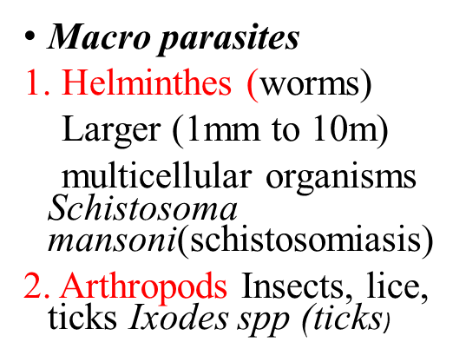

* ***Micro parasites***

1. Virus

Small, simple, obligatory parasites of larger cells Measles, smallpox, respiratory syncytial virus(RSV), influenza

2. Bacteria

Larger and more complex than viruses *Salmonella typhi (typhoid* fever), *Mycobacterium tuberculosis (tuberculosis)*

3. Protozoa

Larger single-celled organisms, more complex than bacteria *Plasmodium falciparum* (malaria); *Entamoeba histolytica (dysentery)*

**Host and infection**

* *Humans* are the *main hosts* for many communicable diseases
* Few animal infections spread to humans-> ***Zoonoses*** e.g. rabies and plaque
* *Carrier*-> asymptomatic infected host(special tests required)
* *Possible results of invasion of host*
  + Clinical infection(s/s present)
  + Subclinical infection( without s/s but spread may occur)
  + No infection( agent killed by host)

*Reservoir->* animal or place in which a particular organism usually lives and reproduces.

* + humans for many communicable diseases.
  + cattle for brucellosis
  + wild animals for rabies
  + soil for tetanus

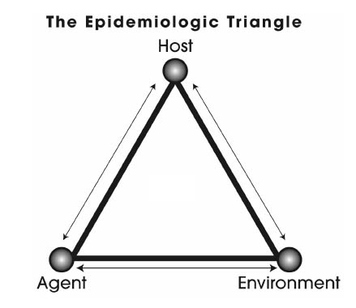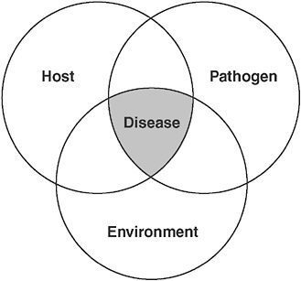

* **balance** between the host, agent ,environment
* For preventon to be realized need to understand the factors that affect:
* •**what can be done** to the balance in favour of control
* ***source of infection->*** Animal or place from which a particular infectious organism spreads to its new host.
* ***Route of transmission->*** way which organism leaves its host or source and travels to a new susceptible host.
  + ***Significance***
    - Dictates how organisms are spread in the community.
* ***Transmission cycle->*** how organisms grow, multiply and spread= life cycle

**Routes of transmission**

**1. Direct**

* ***Airborne-***TB,measles,pertussis
* ***Mucosa to mucosa***-STI
* ***Vertical*** - mother to child....rubella
* ***Body fluids-*** Hepatitis B
* ***Skin to skin***-Staphylococcal infections

**2. Indirect**

* ***Water***-Cholera,Hep A
* ***Food-***Salmonella typhoid
* ***Vector-***Malaria
* ***Reservoir involvement***-Rodents to rodents by sand fly with occasional transmission to human beings.

**Principles of communicable disease control**

Aim-> tip the balance against the agent.

**3 ways**

* Attacking the source
* Interrupt the route of transmission
* Protecting the host

**Source**

**Transmission Route**

**Susceptible host**

1. **Attacking the source**
   * Treatment
   * Isolation
   * Reservoir control
   * Notification
2. **Interrupting transmission**
   * Environmental sanitation
   * Behavior change
   * Vector control
   * Disinfection and sterilization
3. **Protecting the host** 
   * Immunization
   * Chemoprophylaxis
   * Personal protection
   * Better nutrition

* Leading cause of childhood morbidity ((1.7 B) and mortality((0.8M)
* Important (cause of malnutrition.
* On average 3 episodes per year
* • Deaths caused by dehydration



**Fecal-oral transmission route**

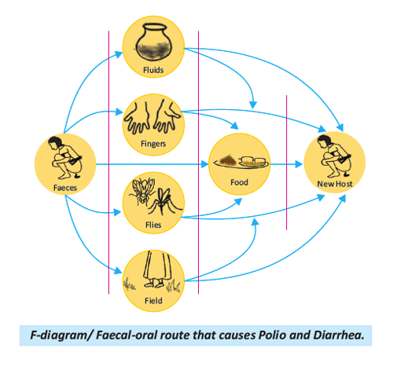

**Major diseases in which the gastro-intestinal tract is the portal of entry**

**1.Bacteria**

• Typhoid

• Cholera

• Bacillary dysentery

• **Anthrax**

• E. coli

**2.Viruses**

• **Polio((also(droplets)**

• Hepatitis A, E

•Viral diarrheas

enteroviruses (rotaviruses)

**3.Worms**

• Ascariasis

• Enterobiasis

• Trichuriasis

• Taeniasis

• Hydatidosis

• Schistosomiasis

**4.Protozoal**

• Amoebiasis

• Giardiasis

**5.Toxins**

• **Staphylococcal food poisoning**

• Botulism

**Diagnosis:**

– stool specimen

* **Treatment:**
* Rehydration((ORS/I.V.F)
* Antibiotics

**General Prevention and control**

• Hand washing soap and clean running water

• Control flies:

* + proper refuse and feces disposal
  + Screening kitchens and food stores
  + Spraying with insecticides

• Food should be properly cooked

• Wash raw vegetables and fresh fruits

• Public eating places inspected

• Improved stool disposal

• Protection, purification, and chlorination of public Water supplies

• Drinking water boiled/filtered

• Supply of piped water

• Health education

• Immunization of infants

**Acute gastro-enteritis**

* Clinical syndrome of diarrhoea
* Dehydration rapidly occurs in children and a common cause of death.
* At risk
  + Infants
    - Malnourished
    - LBW
    - Premature
    - Weanlings
    - Bottle-fed infants
  + Travelers (enterotoxin *E. coli*)
  + Endemic in poor sanitation areas

Epidemiology

• Causes

– Bacteria

• Enteropathic E. coli

– Viruses

• Rotaviruses

• Enteroviruses

– protozoa

• Cryptosporidium

**Clinical presentation**

**Depends with cause and age of the infected**

– **E. coli in babies**:

profuse watery diarrhea with mucous but

No blood; fever often absent

– Onset acute

– May progress rapidly to severe diarrhea

**– Dehydration**

• The degree of dehydration is rated on a scale of three:

– Early dehydration

* no(signs(or(symptoms.

– Moderate (dehydration:

* Thirst;
* restlessness/irritable behavior;
* decreased skin elasticity
* sunken eyes

– Severe (dehydration

* shock,
* diminished consciousness,
* lack of urine output,
* cool moist extremities,
* a rapid and feeble pulse
* low or undetectable blood pressure
* pale skin

**Management**

* **Rehydration-**> ORS replaces H20 and electrolytes incase of shock use IVFs, Breast feeding.
* **Zinc supplements-**> reduces diarrhea episode by 25% and reduces stool volume by 30%
* **Antibiotics**. Only given in bloody stool
  + NB: do not give anti-diarrheals. WHY??
* **Vitamin A supplement-**> immune booster & promote healing.

**Prevention and control**

* access to safe drinking water
* use of improved sanitation
* hand washing with soap
* exclusive breast feeding for the first six months of life
* good personal and food hygiene
* health education about how infections spread
* rotavirus vaccination

**Bacillary dysentery**

* Acute diarrheal disease characterized by:
* Bloody stools
* fever > 38 degrees Celsius
* vomiting
* Abdominal cramps
* Shigellosis
* Common where sanitary conditions are poor
* **Factors influencing occurrence**

– Methods of disposal of faeces

– Availability of water

– Housefly population

– Seasonal changes

– Nutrition

**Epidemiology**

* **Cause:**

– Non-motile (gram –ve bacilli of *shingella spp.*

*(S. sonnei, S. dysenteriae, S. flexneri)*

* Humans (children)-only reservoir for outbreaks.
* **Infection**-asymptomatic carriers for up to 3 months.
* **Transmission**: Faecal -oral route.
* Shigellae multiply very fast in food.

**Clinical picture and manifestations**

* Incubation period (1–4 days)
* Mild cases esp. in adults ->not recognized
* Typical cases:
* Onset is sudden with
  + fever
  + Colicky abdominal pains
  + diarrhea
* After a few months, the diarrhea stops and ***dysenteric Syndrome*** starts ***(Abdominal cramps and tenesmus)***
* Associated vomiting
* Toxemia (absorption of an exotoxin secreted by the Bacilli)
* Dehydration
* High grade fever
* Convulsions
* Oliguria and shock
* **Diagnosis:**
  + Stools appear **dark red(blood)** with lots of mucus
  + Positive stool culture for shigella
* **Management:**
  + **Rehydration**
  + Antibiotics (severe forms) e.g. **nalidixic acid** and **ciprofloxacin.**
* Dispose of faeces adequately and refrain from handling food.

**Prevention and control**

* Improve water supply
* Use of safe food (preparation and storage)
* Hand washing – (soap and water)
* Proper refuse disposal
* Proper faeces disposal
* Health education
* Inspection of public eating places

**Amoebiasis**

* Caused by pathogenic amoeba, ***Entamoeba histolytica***
* Infections in most cases are asymptomatic
* Under certain circumstances, the amoebae may invade the intestinal wall causing amoebic dysentery.
  + May also spread to the **liver (causing an abscess)**

**Pathophysiology**

* Acquired when cysts are ingested
* Trophozoites move to large intestines (live as commensals)
* Penetrate through the intestinal wall causing small mucosal ulcerations which result in dysentery.
* The parasite penetrates thorough the mucosa and into the muscularis layer of the colon
* Scarring can occur leading to **amoeboma**
* Invasion in blood by the trophozoites into liver especially the right lobe ->Liver abscess.

***Patients with amoebic dysentery unlikely to spread the disease. Why? Only the Cysts are infective.***

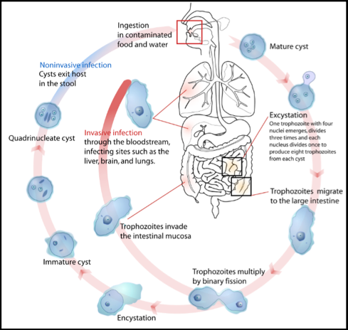

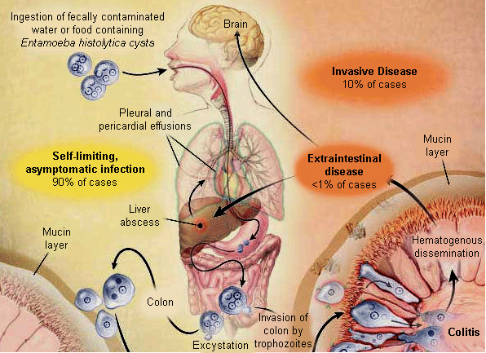

**Management**

* Asymptomatic–no need to treat
* Invasive disease
  + metronidazole/tinidazole
  + diloxanide furoate

*Prevention and control*

* Food handlers screened
* Boil drinking water: kills cysts
* Proper faecal disposal

**Cholera**

* Acute diarrheal disease characterized sudden onset of:
  + Profuse watery stool
  + Vomiting
  + Rapid dehydration
  + Circulatory collapse
* 1-2% of infected persons develop symptoms of severe cholera.
* Severe cholera has high CFR >50% if untreated
* Children but not infants are more susceptible. ***WHY?***
* Cause:
  + *Vibrio cholera*
  + coma’ bacillus a gram-negative, very small, curved, motile organism
  + Bacteria very sensitive to gastric acid
* Faecal-oral route
  + mainly water-borne
  + **Can live in water for 2 weeks esp. salty water**
* • Reservoir: asymptomatic carriers

**Cholera: Presentation +mnx**

* Incubation "2-3 days
* Caused by water and electrolyte loss
* Typical 3(stages)
  + ① Lasts 3-12hrs
    - Profuse watery stools; later almost clear fluid with flakes of **mucus rice-water appearance** vomiting follows
    - Severe cramps abdomen and limbs due to **salt loss**
  + ② Collapse due to dehydration;
    - BP low/unreportable
    - Feeble and rapid pulse;
    - Oliguria;
    - shock
  + ③ Recovery:
    - spontaneous or either treatment
* Management
  + Admission temporary; Cholera bed
  + Rehydration (ORS)
  + **Cotrimoxazole high dose**

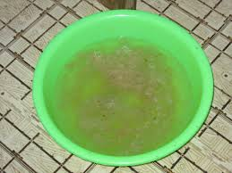

**Nursing management**

1. Hydration therapy – ORS / IVF
2. Hygiene – clean water and personal hygiene
3. Positioning- to prevent pressure sores formation
4. Health education-
5. Nutrition
6. Medication administration
7. Expert nursing care-> assessment and mnx of complications
8. Psychosocial support

**Prevention and control**

* Surveillance: internationally notifiable disease
* **Safe drinking water: chlorine or boiling**
* Milk products pasteurized
* Avoid uncooked foods or washed with safe water.
* Improve sanitation in facilities
* Cholera vaccine: Vaccine efficacy 50% for 3-6 months only

**Typhoid and paratyphoid fevers**

* Acute illness associated with fever caused by:
  + *Salmonella typhi*
  + *Salmonella paratyphoid A, B, C*
* **Pathophysiology**
  + Ingested via contaminated food or water.
  + Bacteria reaches and multiplies in distal ileum
  + Enter systemic circulation
    - Reticulo-endothelial organs
    - Gall bladder
* **Risk factors**
  + Travel to endemic areas.
  + Clinical microbiologist
  + Close contact with those recently diagnosed
  + Poor sanitation
  + overcrowding
* **Clinical picture**
  + Incubation period 1-2 wks
  + Duration of illness around 3-4 wks
* **Clinical manifestations**
  + **Early illness**
    - Fever starts low and increases daily as high as 40 .c
    - Headache
    - Weakness and fatigue
    - Muscle aches
    - Sweating
    - Dry cough
    - Loss of appetite
    - Abd pain
    - Diarrhea or constipation
  + **Later illness**
    - **No treatment?**
      * **Delirious**
      * **Lie motionless and exhausted with eyes half-closed (*typhoid state)***
* **Medical management**.
  + CAF
  + **Ciprofloxacin**
  + Ceftriaxone

**Complications**

* + Delirium
  + Obtundation
  + Intestinal hemorrhage
  + Bowel perforation
  + Death

**Taeniasis**

* Infection of humans by tapeworms
  + class ***cestrodes***
* Cause:
  + *Taenia saginata* (beef tapeworm)
  + *Taenia solium* (pork tapeworm)
* Adult tapeworms live in the small intestine of humans

**Pathophysiology**

* The adult worm lives in the small intestine of man.
* Gravid segments (**proglottids**) pass out in the stool and become disintegrated and eggs come out to the soil.
* Eggs are ingested by an intermediate host, cattle/pig.
* The hooked embryo ***(onchospheres)*** escape from its shell, penetrates through the intestinal wall into the blood vessels and is carried to the muscles where it develops into a larval stage, **cysticercus-> cysticercosis**
  + Infection to man takes place by the ingestion of raw or insufficiently cooked beef.

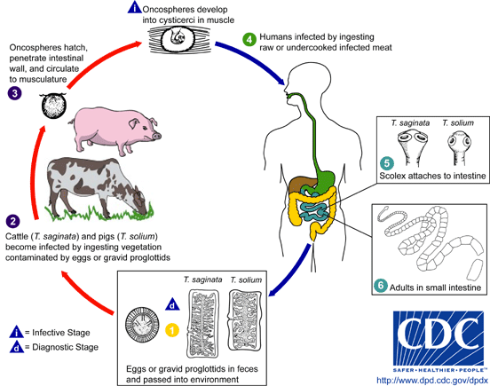

**Clinical manifestation**

* + abdominal discomfort,
  + diarrhea,
  + weight loss,
  + hunger sensation,
  + vomiting

**Complications**

* + - Bowel obstruction
    - Cysticercosis encephalopathy
    - Hemorrhage

**Treatment**

* Niclosamide: Four tablets 500mg each (chewed in a single dose)
  + **P.O Niclosamide 2g STAT**
* P.O Albendazole 400 mg OD daily for 3/7
* P.O Mebendazole 100 mg BD daily for 3/7

**Prevention:**

* Thorough cooking of meat
  + above 57 degrees Centigrade.
* Proper disposal of human excreta

**Nursing Process: Application of nursing process in the management of patients with diarrheal**

**Pick any diarrheal disease. Okay??**

1. **Assessment**

* Take vital signs T, P, R BP.
* health history to identify:
  + onset, duration and characteristics of abdominal pain;
  + presence of loose stool and its frequency.
  + fecal urgency
  + straining at stool (tenesmus)
  + nausea, anorexia, weight loss
  + patterns of bowel elimination
    - * (character, frequency, and presence of blood, pus, fat, or mucus)
  + note allergies and food intolerance.
  + sleep disturbances if diarrhea or pain occurs at night.
* Auscultate for **bowel sounds and *classify***
* Palpate the abdomen for **distention,** **tenderness**, **or pain**;
* Inspect the skin for evidence **of dehydration**.
* Stool **is inspected for blood and mucus.**

**2. Nursing diagnoses**

***Based on the assessment data***

* ***Diarrhea*** related to the inflammatory process evidenced by frequent loose stool
* ***Acute pain*** related to increased peristalsis and GI inflammation
* ***Fluid volume deficit*** related to anorexia, nausea, and diarrhea, vomiting
* ***Risk for impaired skin integrity*** related to malnutrition and diarrhea
* ***Risk for electrolyte imbalances*** relate to episodes of vomiting/diarrhea
* ***Imbalanced nutrition (***less than body requirements) related to dietary restrictions, nausea, and malabsorption
* ***Activity intolerance*** related to fatigue
* ***Anxiety*** related to disease process or situational crisis
* ***Ineffective coping*** related to episodes of diarrhea
* ***Self-care deficit(toileting)*** related to urgency of bowels
* ***knowledge deficit related to*** the process and management of the disease

**3. Planning and Goals**

***Goals Should Be Realistic And Time Bound***

***The major goals for the patient may include:***

* Attainment of normal bowel elimination patterns
* Relief of abdominal pain and cramping,
* Prevention of **fluid volume deficit**
* **Absence of skin breakdown**
* Maintenance of optimal nutrition and weight
* Avoidance of fatigue
* Reducing anxiety
* Promoting effective coping
* Learning about the disease process and therapeutic regimen
* **Avoidance of complications**

1. **Nursing Interventions**
2. ***Maintaining Normal bowel Elimination Patterns***

* Determine if there is a relationship between diarrhea and certain foods, activity, or emotional stress, Identifying precipitating factors to help in management of acute diarrheal episodes and
* *Frequency of bowel movements* for nutritional planning purposes
* Monitor frequency, character, consistency, and amount of stool passed for effective monitoring of I/O
* Ready *access to a bathroom or bedpan*
* Environment clean and odor free.
* Administer anti-diarrheal medications as prescribed
* Encourage bed rest to decrease peristalsis

ii) ***Relieving Pain***

* Administers medications as prescribed
  + Muscle relaxant to decrease intestinal motility
  + Analgesics for cramps
* Position changes
* Diversional activities e.g. storing with patient and watching TV
* Prevention of fatigue also are helpful for reducing pain.

iii) ***Maintaining adequate Fluid Intake***

* accurate record of oral and intravenous fluids -> record of I/O
* Daily weights for fluid gains or losses
* Signs of fluid volume deficit
  + dry skin mucous membranes,
  + decreased skin turgor
  + Oliguria,
  + Exhaustion/lethargy
  + decreased temperature,
  + increased hematocrit, elevated urine specific gravity, hypotension
* Encourage oral intake of fluids ASAP when tolerated.
* Initiates measures to decrease diarrhea
  + dietary restrictions,
  + stress reduction
  + **Antibiotics only in bloody stool…**
    - **NEVER Give Antidiarrheal Agent WHY????**

*iv)* ***Maintaining Optimal Nutrition***

* TPN when the symptoms are severe
* Accurate record of fluid intake and output
* Daily weighing *(should gain 0.5 kg daily during PN therapy)*
* Monitor blood glucose
  + every 6 hours to prevent hyperglycemia
* Elemental feedings high in protein and low in fat instituted after PN therapy
* If oral foods are tolerated,
  + small, frequent, low-residue feedings
* Bed rest to:
  + conserve energy
  + reduce peristalsis
  + reduce calorie requirements

v) ***Reducing Anxiety***

* Rapport building (be calm, confident)
* Allow time to ask questions and express feelings
* Careful listening to the patient
* Explain procedures and interventions

vi*)* ***Promoting Rest***

* Restrict activities to conserve energy and reduce the metabolic rate.
* Encourage activity within the limits of the patient’s capacity.
* Suggest bed rest when febrile, has frequent diarrheal stools
  + Passive ROM exercises
  + Activity restrictions are modified as needed on a day-to-day basis

vii) ***Preventing Skin Breakdown***

* Examine patient’s skin frequently, esp. the peri-anal skin.
* Gives immediate attention to reddened or irritated areas over a bony prominence
* Uses pressure-relieving devices to prevent skin breakdown

Viii*)* ***Enhancing Coping Measures***

* Understanding and emotional support.
* Recognize that the patient’s coping behavior and reinforce where necessary.
* Be there for patient and encourage communication of feelings and worries
* Stress reduction measures
  + relaxation techniques.
  + breathing exercises

*ix)* ***Monitoring And Managing potential Complications***

* Serum electrolyte levels are monitored daily to monitor for potential complications.
* Electrolyte replacements are administered as prescribed.
* Report evidence of dysrhythmias or change in level of consciousness immediately.
* Administer volume expanders as prescribed to prevent hypovolemia.
* Monitor the blood pressure for hypotension

**Promoting Home And Community-based Care**

1. ***Teaching Patients Self-Care***
   * Assess patient’s understanding of the disease process
     + Etiology
     + Transmission route
     + Danger signs
     + medications
   * Need for information about nutritional management;
   * Hygiene (food and personal)
2. ***Continuing Care***
   * Arrange for follow-up care by
     + Outpatient clinic or Home visiting.

**5.Evaluation: Expected outcomes**

**1. Reports a decrease in the frequency of diarrhea stools**

* Complies with dietary restrictions; maintains bed rest
* Takes medications as prescribed

2**. Has reduced pain**

**3. Maintains fluid volume balance**

* Drinks 1 to 2 L of oral fluids daily
* Has a normal body temperature
* Displays adequate skin turgor and moist mucous membranes

**4. Attains optimal nutrition;**

* tolerates small, frequent feedings without diarrhea

**5. Avoids fatigue**

* Rests periodically during the day
* Adheres to activity restrictions

**6. Is less anxious**

**7. Copes successfully with diagnosis**

* Expresses feelings freely
* Uses appropriate stress reduction behaviors

**8. Maintains skin integrity**

* Cleans perianal skin after defecation
* Uses lotion or ointment as skin barrier

**9. Acquires an understanding of the disease process**

* Modifies diet appropriately to decrease diarrhea
* Adheres to medication regimen

**10. Recovers without complications**

* Maintains electrolytes within normal ranges
* Maintains normal sinus or baseline cardiac rhythm
* Maintains fluid balance
* Experiences no perforation or rectal bleeding

**QUESTIONS???????????**

1