

**Kenya Medical Training College**

**COVID-19 Teaching Handout Notes For**

**Diploma Programs**

**Kenya Medical Training College P.O. Box 30195- 00100**

**Tel: +254- 2725191, 2725711/14**

**Email:** [**info@kmtc.ac.ke**](mailto:info@kmtc.ac.ke) **Website:** [**www.kmtc.ac.ke**](http://www.kmtc.ac.ke/)

# Prepared by

**COVID-19 Content Development Team**

**March 2021**

# Table of Contents

|  |  |
| --- | --- |
| **Foreword** | 2 |
| **Acknowledgement** | 107 |
| **List of abbreviations/Acronyms** | 3 |
| **Introduction/rationale** | 5 |
| **Target population** | 5 |
| **Content structure** | 6 |
| **Mode of delivery of the course** | 6 |
| **Duration** | 6 |
| **Unit 1: Concepts related to COVID-19** | 7 |
| **Unit 3: MANAGEMENT OF COVID-19** | 36 |
| **UNIT 4: PREVENTION OF INFECTION/SPREAD OF COVID-19** | 60 |
| **Unit 6: COVID-19 RISK COMMUNICATION AND COMMUNITY ENGAGEMENT** | 93 |
| **Unit7; OCCUPATIONAL HEALTH AND SAFETY** | 98 |
| **References/Further Reading** | 103 |
| **APPENDIX I: Contact listing Form** | 106 |

**Introduction**

The vision of Kenya Medical Training College (KMTC) is “a model institution in the training and development of competent health professionals”. In addition to training various cadres of health care providers (HCP) at Certificate, Diploma and Higher Diploma level, the College is keen on capacity building of HCP through development of in-service short courses. This will address emerging issues in regard to COVID-19.

The COVID-19 module seeks to equip health care providers with the necessary knowledge, skills and attitude to be competitive within and outside the country. The module intends to build capacities and empower individuals involved in provision of health care in different setups and organizations.

# List of abbreviations/Acronyms

**ACE:** Angiotensin Converting Enzyme **CHW**: Community Health Worker **COVID-19:** Corona Virus Disease 2019

**DC:** Dendritic cells

**ER:** Endoplasmic Reticulum

**FBO**: Faith Based Organization

* 1. **SF:** Granulocyte-colony stimulating factor **HBIC:** Home Based Isolation and Care **HCP**: Health Care Providers

**HCW**: Health Care Worker

**IEC**: Information Education Communication

**IL:** Interleukin

**IPC**: Infection Prevention Control

**ISO**: International Standard Operations **KMTC**: Kenya Medical Training College **MCP1:** Monocyte chemoattractant protein 1

**MERS:** Middle East respiratory syndrome.

**MERS-CoV:** Middle East respiratory syndrome coronavirus

**MIP:** Macrophage inflammatory protein **NGO:** Non-Governmental Organization **OHS**: Occupation………

**PCR**: Polymerase Chain Reaction

**PHEIC:** Public health emergency of international concern.

**PPE**: Personal Protective Equipment

**RNA:** Ribonucleic Acid

**SARS-CoV:** Severe acute respiratory syndrome coronavirus.

**SOPs**: Standard Operating Practices

**TNF:** Tumor necrosis factor.

**UN:** United Nations

**WHO:** World Health Organization

# Introduction/rationale

The emergence of the novel Coronavirus disease (COVID-19) in December, 2019, brought unexpected rapid spread globally. On 13th January, 2020, the World Health Organization (WHO) reported 90,335,008 confirmed cases of COVID-19 and 1,954,336 deaths. Therefore with emergence of this virus it has necessitated change in lifestyle globally. In Kenya the Ministry of Health in collaboration with World Health Organization has come up with measures to mitigate the spread, management and prevention of the disease. The same measures has been detailed in the public health act Cap. 242 (2020).

KMTC being accredited training institution, it is imperative therefore to include COVID-19 content in the curriculum. This will equip the learners with requisite knowledge and skills to create awareness, prevent and manage the disease among themselves and extend the same to their clients.

# Target population

* + 1. Student
    2. Health care workers
    3. Hospital support staff
    4. NGOs, FBOs and other private hospitals
    5. Patient care givers
    6. Public

# Certification

The student will be issued a certificate of attendance upon completion of the course.

# Content structure

|  |  |  |  |  |
| --- | --- | --- | --- | --- |
| **No.** | **Unit Name** | **Course Code** | **Hours** | |
| **Theory** | **Practical** |
| **1** | **Concepts related to covid-19** |  | **2** |  |
| **2** | **Diagnosis of COVID-19** |  | **1** | **1** |
| **3** | **Management of covid-19** |  | **1** |  |
| **4** | **Prevention of infection/spread**  **of covid-19** |  | **2** | **2** |
| **5** | **Surveillance of covid-19** |  | **1** |  |
| **6** | **COVID-19 risk**  **communication and community engagement** |  | **2** |  |
| **7.** | **Occupational health and**  **safety** |  | **1** | **1** |

**Mode of delivery of the course**

Face to face/online

Duration**: 14 hours**

# Module Competence

This module is designed to enable the learner effectively prevent and manage COVID-19 at individual and community level.

# Module Outcomes

By the end of this module the learner should;

1. Demonstrate understanding of concepts related to COVID-19
2. Demonstrate understanding of diagnostic procedures of COVID-19
3. Manage patient/client of COVID-19
4. Advice on preventive measures on spread of COVID-19 to the community
5. Participate in surveillance activities related to COVID-19
6. Communicate effectively on issues related to COVID-19 to the community
7. Explain the occupational health and safety measures related to COVID-19

# Unit 1: Concepts related to COVID-19 CORONAVIRUSES

Coronaviruses are a large family of viruses that usually cause mild to moderate upper- respiratory tract illnesses, like the common cold.

There are hundreds of coronaviruses, most of which circulate among such animals as pigs, camels, bats and cats. Sometimes those viruses jump to humans—called a spillover event— and can cause disease.

Some cause mild illnesses, such as the common cold. Others can cause severe acute respiratory syndrome (SARS) or Middle East respiratory syndrome (MERS), which can be life threatening.

Researchers first identified a coronavirus in 1937. They isolated one that was responsible for a type of bronchitis in birds and had the potential to devastate poultry stocks.

Scientists found evidence of human coronaviruses in the 1960s, in the noses of people with the common cold.

Four subfamilies, namely alpha-α, beta-β, gamma-γ and delta-δ coronaviruses exist. Alpha‐ and beta‐coronaviruses originate from mammals, in particular from bats, gamma‐ and delta‐ viruses originate from pigs and birds.

Seven coronaviruses that can infect humans are: Common human CoVs, HCoV-229E (alpha), HCoV-OC43 (alpha), HCoV-NL63 (beta), HCoV-HKU1 (beta), SARS-CoV (beta), MERS- CoV (beta) and SARS-CoV-2.

Among the seven subtypes of coronaviruses that can infect humans, the beta‐coronaviruses may cause severe disease and fatalities, whereas alpha‐coronaviruses cause asymptomatic or mildly symptomatic infections. SARS‐CoV‐2 belongs to the B lineage of the beta‐ coronaviruses and is closely related to the SARS‐CoV virus.

At the end of 2019, scientists identified a coronavirus outbreak in China. Experts named the newly identified virus severe acute respiratory syndrome coronavirus 2 (SARS-CoV-2) and the illness that it causes coronavirus disease 19 (COVID-19).

# Structure of the coronavirus

Coronaviruses are large, enveloped, positive-stranded RNA viruses. They have the largest genome among all RNA viruses, typically ranging from 27 to 32 kb.

The genome is packed inside a helical capsid formed by the nucleocapsid protein (N) and further surrounded by an envelope.

Associated with the viral envelope are at least three structural proteins: The membrane protein

1. and the envelope protein (E) are involved in virus assembly, whereas the spike protein (S) mediates virus entry into host cells.

Some coronaviruses also encode an envelope-associated hemagglutinin-esterase protein (HE).

Among these structural proteins, the spike forms large protrusions from the virus surface, giving coronaviruses the appearance of having crowns (hence their name; corona in Latin means crown)

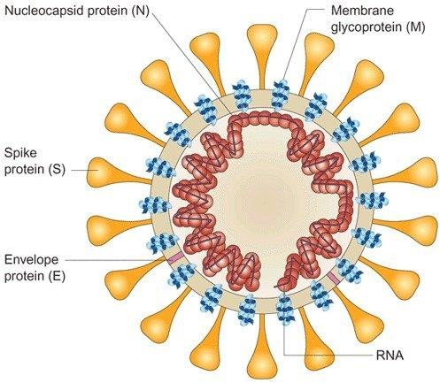

# Epidemiology of Coronavirus

Coronaviruses pose serious health threats to humans and other animals. From 2002 to 2003, severe acute respiratory syndrome coronavirus (SARS-CoV) infected 8,000 people, with a fatality rate of ∼10%.

Since 2012, Middle East respiratory syndrome coronavirus (MERS-CoV) has infected more than 1,700 people, with a fatality rate of ∼36%

In general, coronaviruses cause widespread respiratory, gastrointestinal, and central nervous system diseases in humans and other animals, threatening human health and causing economic loss.

Coronaviruses are capable of adapting to new environments through mutation and recombination with relative ease and hence are programmed to alter host range and tissue tropism efficiently.

Covid-19 is continuing to spread around the world, with nearly 120 million confirmed cases and 2.6 million deaths across nearly 200 countries. Kenya has reported over 113,000 cases with a with a death rate of 3.4% with 1,900 deaths.

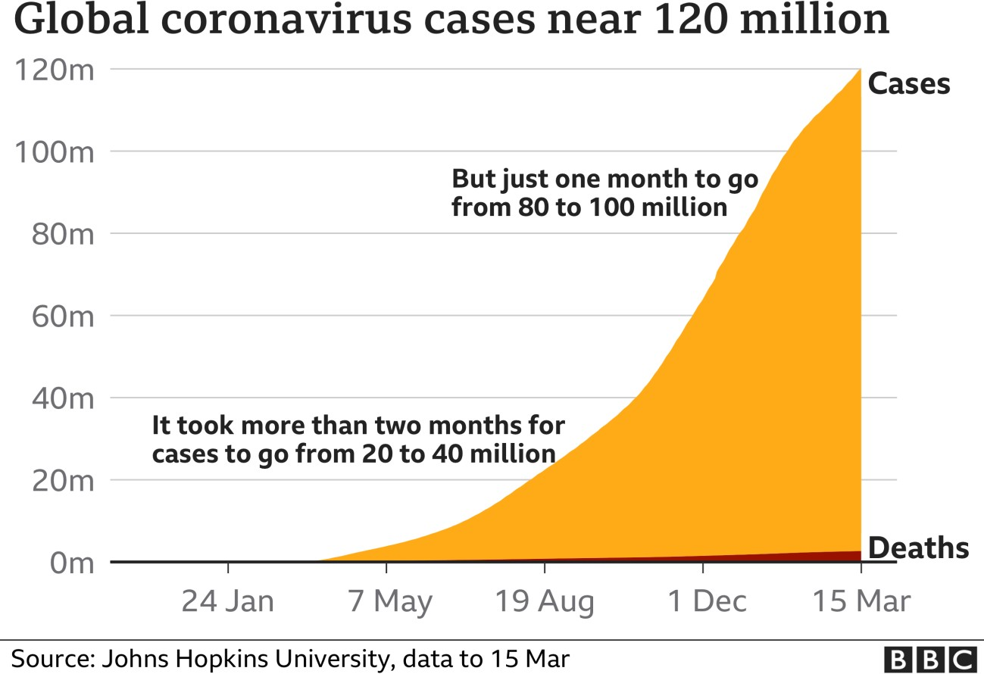

# Outbreak and spread patterns of COVID-19

On 31 December 2019, WHO was informed of cases of pneumonia of unknown cause in Wuhan City, China. A novel coronavirus was identified as the cause by Chinese authorities on 7 January 2020 and was temporarily named “2019-nCoV”.

Initial cases all linked to Huanan Seafood Market in Wuhan City, China. The Market was closed 01.01.20 for environmental sanitation and disinfection.

On 10 January 2020, WHO launched a website with updated general and travel guidance <https://www.who.int/healthtopics/coronavirus>

On 11 January 2020, China shared the genetic sequence of COVID-19 enabling the rapid development of diagnostic tests.

On 30 January 2020, WHO declared the novel coronavirus outbreak a public health emergency of international concern (PHEIC), WHO's highest level of alarm. At that time there were 98 cases and no deaths in 18 countries outside China.

On 11 March 2020, the rapid increase in the number of cases outside China led the WHO to announce that the outbreak could be characterized as a pandemic. By then more than 118 000 cases had been reported in 114 countries, and 4291 deaths had been recorded.

By mid-March 2020, the WHO European Region had become the epicenter of the epidemic, reporting over 40% of globally confirmed cases. As of 28 April 2020, 63% of global mortality from the virus was from the Region.

Kenya reported the first case of COVID -19 on March12, 2020. Initially, the infection was concentrated at Nairobi and Mombasa cities but later cases were reported across all counties.

Kenya put in place several measures to curb spread:

* + Travel from any countries with any case of Corona virus were restricted.
  + Initially, Only Kenyan Citizens, and any foreigners with valid residence permits were to be allowed to come into the country provided they proceed on self-quarantine or to a government designated quarantine facility. Later lockdown measures were put in place.
  + All schools and higher learning institutions were closed as from Friday March 20, 2020 up to November 2020.
  + Government and businesses people started working from home with exception of essential services.
  + Cashless transactions over cash. Cost of transactions were reduced.
  + No congressional meetings were allowed – weddings, malls, night clubs, churches, limitation of visits to hospitals.
  + Hospitals and Shopping malls were to give soap and water/hand sanitizers, and regular cleaning of facilities.
  + Cargo vessels, aircraft or ships were allowed into the country provided they disinfected at point of departure and the crew quarantined on arrival.
  + UN Headquarters in Kenya continued operating diplomats travelling to the UN are also exempted from the travel restrictions but observe were required to self-quarantine rule.
  + A toll-free number (719) set up to report suspected corona virus cases
  + The Cessation of Movement into and out of Nairobi Metropolitan Area, Mombasa County and Mandera County
  + Nationwide curfew
  + Ban on social gatherings and suspension on operation of bars
  + Places of worship will also commence phased reopening in strict conformity with all applicable guidelines. No congregants under 13 or over 58 years were be allowed. Those with underlying health conditions were also cautioned against congregating to worship.
  + Local air travel shall resumption measures.
  + International flights to resumption measures
  + Vaccination against COVID-19

# Modes of transmission of virus causing COVID-19

COVID-19 virus is primarily transmitted between people through respiratory droplets and contact (direct or indirect) routes. when the droplet particles are >5-10 μm in diameter they are referred to as **respiratory droplets**, and when then are <5μm in diameter, they are referred to as **droplet nuclei**

Droplet transmission occurs when a person is in in close contact (**within 1 m**) with someone who has respiratory symptoms (e.g., coughing or sneezing) and is therefore at risk of having his/her mucosae (mouth and nose) or conjunctiva (eyes) exposed to potentially infective respiratory droplets

Transmission may also occur through fomites in the immediate environment around the infected person. Therefore, transmission of the COVID-19 virus can occur by direct contact with infected people and indirect contact with surfaces in the immediate environment or with objects used on the infected person (e.g., stethoscope or thermometer).

**Airborne transmission** is different from droplet transmission as it refers to the presence of microbes within droplet nuclei, which are generally considered to be particles <5μm in

diameter, can remain in the air for long periods of time and be transmitted to others over distances greater than 1 m.

Airborne transmission is increased in procedures or support treatments that generate aerosols are performed; i.e., endotracheal intubation, bronchoscopy, open suctioning, administration of nebulized treatment, manual ventilation before intubation, turning the patient to the prone position, disconnecting the patient from the ventilator, non-invasive positive-pressure ventilation, tracheostomy, and cardiopulmonary resuscitation

There is some evidence that COVID-19 infection may lead to intestinal infection and be present in faeces. However, to date only one study has cultured the COVID-19 virus from a single stool specimen.

# Life cycle Coronavirus

The virus is transmitted via respiratory droplets and aerosols from person to person. Once inside the body, the virus binds to host receptors and enters host cells through endocytosis or membrane fusion. The coronaviruses are made up of four structural proteins, namely, the spike (S), membrane (M), envelop (E) and nucleocapsid (N) proteins.



The S protein is seen to be protruding from the viral surface and is the most important one for host attachment and penetration. This protein is composed of two functional subunits (S1 and S2), among which S1 is responsible for binding to the host cell receptor and S2 subunit plays a role in the fusion of viral and host cellular membranes.

ACE-2 has been identified as a functional receptor for SARS-CoV and is highly expressed on the pulmonary epithelial cells. ACE2 is highly expressed on the apical side of lung epithelial cells in the alveolar space. It is through this host receptor that the S protein binds initially to start the host cell invasion by the virus.

After binding of SARS-CoV-2 to the ACE-2, the S protein undergoes activation via a two-step protease cleavage: the first one for priming at the S1/S2 cleavage site and the second cleavage for activation at a position adjacent to a fusion peptide within the S2 subunit.

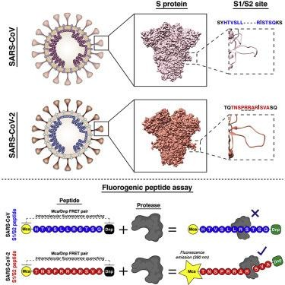

The initial cleavage stabilizes the S2 subunit at the attachment site and the subsequent cleavage presumably activates the S protein causing conformational changes leading to viral and host cell membrane fusion.

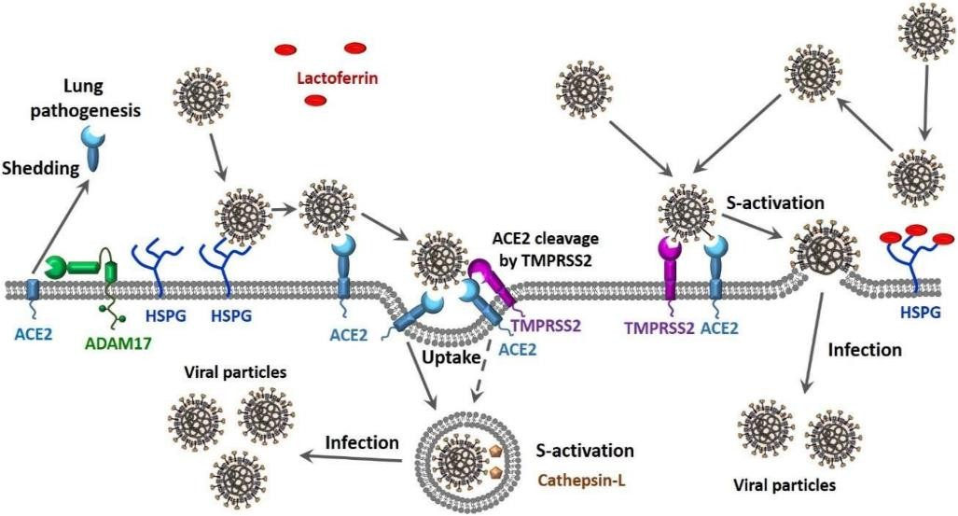

Post membrane fusion, the virus enters the pulmonary alveolar epithelial cells and the viral contents are released inside.

Now inside the host cell, the virus undergoes replication and formation of a negative strand RNA by the pre-existing single-strand positive RNA through RNA polymerase activity (transcription).

This newly formed negative strand RNA serves to produce new strands of positive RNAs which then go on to synthesize new proteins in the cell cytoplasm (translation)

The viral N protein binds the new genomic RNA and the M protein facilitates integration to the cellular endoplasmic reticulum.

These newly formed Nucleocapsids are then enclosed in the ER membrane and transported to the lumen, from where they are transported via golgi vesicles to the cell membrane and then via exocytosis to the extracellular space.

The new viral particles are now ready to invade the adjacent epithelial cells as well as for providing fresh infective material for community transmission via respiratory droplets.

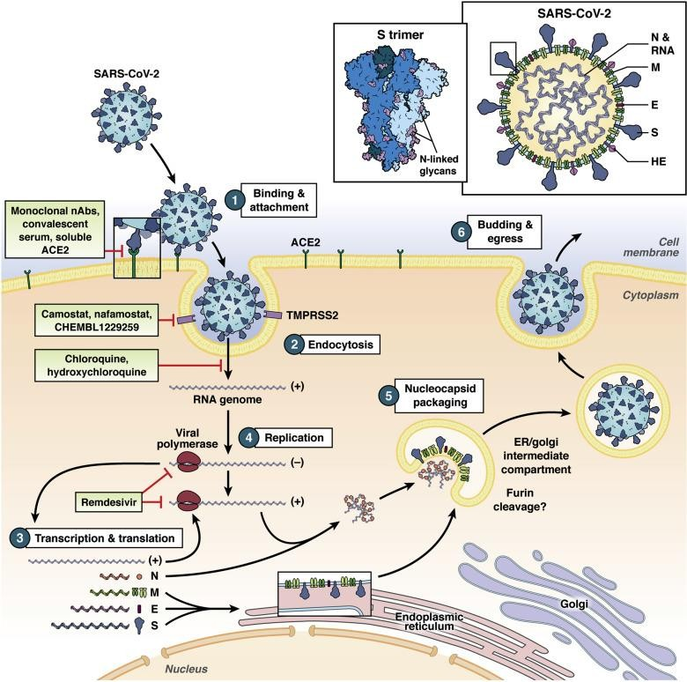

# Pathophysiology of COVID-19

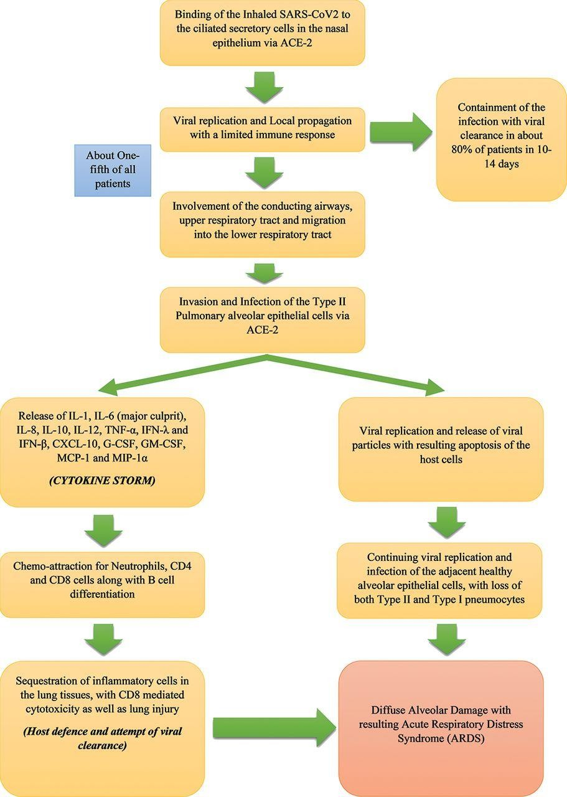

Epithelial cells, alveolar macrophages and dendritic cells (DCs) are three main components for innate immunity in the airway. T cell responses are initiated by antigen presentation via DCs

and macrophages. Virus-infected apoptotic epithelial cells are phagocytized by DCs and macrophages, which leads to antigen presentation to T cells.

Patients with severe diseases are reported to have increased plasma concentrations of pro- inflammatory cytokines, including interleukin (IL)-6, IL-10, granulocyte-colony stimulating factor (G-CSF), monocyte chemoattractant protein 1 (MCP1), macrophage inflammatory protein (MIP)1α, and tumor necrosis factor (TNF)-α

Further studies of SARS-CoV have showed that virus infected lung epithelial cells produced IL-8 in addition to IL-6. IL-8 is a well-known chemoattractant for neutrophils and T cells. Infiltration of a large number of inflammatory cells were observed in the lungs from severe COVID-19 patients and these cells presumably consist of a constellation of innate immune cells and adaptive immune cells. Among innate immune cells, we expect the majority to be neutrophils. Neutrophils can act as double-edged sword as neutrophils can induce lung injury.

The majority of the observed infiltrating adaptive immune cells are likely T cells, considering that the significant reduction in circulating T cells has been reported. CD8+ T cells are primary cytotoxic T cells. Severe patients also showed pathological cytotoxic T cells derived from CD4+ T cells. These cytotoxic T cells can kill virus but also contribute to lung injury.

Circulating monocytes respond to GM-CSF released by these pathological T cells. CD14+CD16+ inflammatory monocyte subsets, which seldom exist in healthy controls and are also found at significantly higher percentage in COVID-19 patients. These inflammatory CD14+CD16+ monocytes have high expression of IL-6, which likely accelerated the progression of systemic inflammatory response.

In addition to respiratory symptoms, thrombosis and pulmonary embolism have been observed in severe diseases. This is in line with the finding that elevated d-dimer and fibrinogen levels have been observed in severe diseases.

The function of the endothelium includes promotion of vasodilation, fibrinolysis, and anti- aggregation. Because endothelium plays a significant role in thrombotic regulation, hypercoagulable profiles seen in severe diseases likely indicate significant endothelial injury. Endothelial cells also express ACE2. Of note, the endothelial cells represent the one third of lung cells.

# Host response differences between children and adults in COVID-19

Infants and young children are typically at high risk for admission to hospitals due to respiratory tract infection with viruses as respiratory syncytial virus and influenza virus.

In contrast, pediatric COVID-19 patients have relatively milder symptoms in general compared to elder patients. The reason for this difference between children and adults remains elusive.

In this line, a couple of hypotheses can be considered:

* + There is possibility that the expression level of ACE2 differ between adults and children with adult having well-differentiated ciliated epithelial cells.

o Circulating ACE2 levels are higher in men than in women. This may be in part responsible for the difference in severity and mortality between men and women both in the adult and the pediatric population.

* + With ageing, continuous antigen stimulation and thymic involution lead to a shift in T cell subset distribution from naïve T cells to central memory T cells, effector T cells and effector memory T cells.
  + Simultaneous presence of other viruses in the mucosa lungs and airways, common in young children, can let SARS-CoV-2 virus compete with them and limit its growth

# Clinical Presentation

The incubation period of COVID-19, which is the time period from exposure to the virus to symptom onset, is 5–6 days, but can be up to 14 days.

During this period, also known as the ‘pre-symptomatic’ period, the infected individuals can be contagious and transmit the virus to healthy individuals in the population.

The patients of COVID-19 belong mostly to the 40–70 years age group, and most commonly present with fever, body aches, breathlessness, malaise and dry cough, although patients may present with asymptomatic, mild, moderate or severe disease.

Some patients may also present with gastrointestinal symptoms such as abdominal pain, vomiting and loose stools.

The complications seen in patients with COVID-19 infection are caused mostly due to the ‘cytokine storm’

# Summary of the symptoms.

* + Fever
  + Chills or night sweats
  + Cough
  + Sore throat
  + Tiredness (fatigue)
  + Difficulty breathing
  + Headaches
  + Muscle pain (myaglia)
  + Loss of sense of smell (anosmia)
  + Distortion of sense of taste (dysgeusia)
  + Nausea/vomiting
  + Diarrhoea
  + Joint pains
  + Loss of appetite
  + Runny nose

# COVID-19 disease severity categorization

Covid – 19 severity definitions based on clinical indicators for only confirmed cases. The purpose for this is to provide appropriate management for the subgroups. The categories include:

* + - **Critical COVID-19**: Defined by the criteria for acute respiratory distress syndrome (ARDS), sepsis, septic shock, or other conditions that would normally require the provision of life-sustaining therapies such as mechanical ventilation (invasive or non-invasive) or vasopressor therapy.
    - **Severe COVID-19**: Defined by any of:
      * Oxygen saturation < 90% on room air.
      * Respiratory rate > 30 breaths/min in adults and children > 5 years old; ≥ 60 breaths/min in children < 2 months old; ≥ 50 in children 2–11 months old; and ≥ 40 in children 1–5 years old.
      * Signs of severe respiratory distress (accessory muscle use, inability to complete full sentences, and, in children, very severe chest wall indrawing, grunting, central cyanosis, or presence of any other general danger signs).
    - **Non-severe COVID-19**: Defined as absence of any criteria for severe or critical COVID-19.

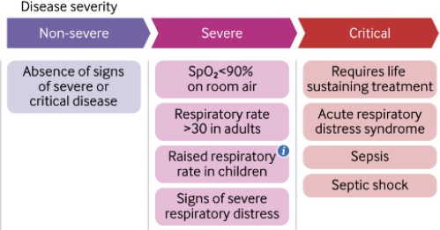

# UNIT 2: Diagnostic and Testing of COVID -19

The laboratory diagnoses of COVID-19 is based on confirmation of COVID-19 infection in suspected person and detect an immune response confirmed cases. Testing plays an important role in a public health response to COVID-19 Pandemic. There are different types of diagnostic tests available. They are antigen rapid test, antibody serology test and molecular testing. WHO highly recommends molecular testing based detection of specific viral sequences by nucleic acid amplification tests (NAATs) using platforms such as real-time reverse-transcription polymerase chain reaction (rRT-PCR). However, molecular platforms by design are quite expensive to maintain in terms of acquisition costs, operational costs which make them unaffordable in low-income settings.

# What do the diagnostic tests for COVID-19 detect?

Diagnostic tests for COVID-19 are based on either detection of the viral RNA or the immune response through the production of IgM and IgG antibodies. The Viral RNA detected by NAAT/RT-PCR (molecular testing) and COVID-19 viral antigen, while the immune response is detected by serology test .

|  |  |
| --- | --- |
| Structure of the COVID-19 | Immune response |

|  |  |
| --- | --- |
| STRUCTURE OF COVID 19.png | igm.jpg |

Monto, Cowling and Pereis. Coronaviruses. R.A. kaslowet al. (eds.), Viral infections in humans. https://link.springer.com/content/pdf/10.1007%2F978-1-4899-7448-8_10.pdf

The immune response to COVID-19 infection have four structural proteins:

* + spike (S), nucleocapsid (N),, envelope (E) andmembrane (M).

During an infection the body’s immune system makes antibodies (immunoglobulins) that bind themselves to the structural proteins and neutralize the virus. The spike (S) and the nucleocapsid (N) are the main proteins (antigens) which trigger an antibody response in humans. The most important antibodies in the response are IgG and IgM. IgM antibodies are produced first during a response while IgG is the last antibody released. When t**esting COVID- 19** infection **timing** of testing is important as what testing method/kit to used, as illustrated in diagram below.

Molecular testing to detect o virus

Molecular testing to detect o virus

Molecular testing to detect o virus

Molecular testing to detect o virus

Molecular testing to detect o virus

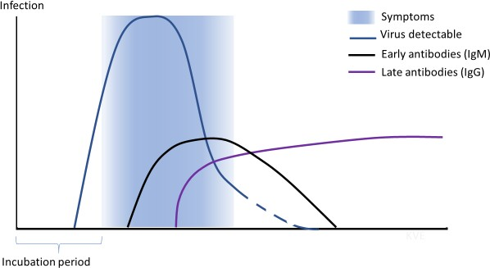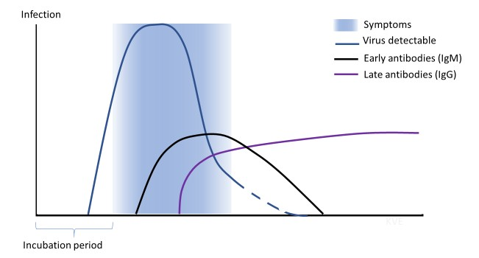

Molecular testing to detect o virus

# Serology testing to detect the immune response (antibodies)

.

# Pre-analytic phase Biosafety measures

Samples should be collected by well-trained healthcare personnel, donning proper personal

protective equipment (PPE) which includes masks, gloves, goggles, gown, head cover, shoe cover and hand sanitizer, soap and water following adequate infection control measures including hand hygiene and adequate biosafety precautions to protect individual and the environment.

***The correct sequence of donning the PPE*:**

* + **Home clothes, jewellery, watches, rings, bangles, etc. should be removed and hospital scrub suite should be donned.**
  + **Proper hand hygiene to be done using alcohol-based hand rub or soap and water prior to donning of the PPE.**
  + **Sequence of donning PPE: Shoe cover → clean, disposable non-permeable gown → N95 respirator with proper fit testing → Eye goggles/face shield → Head cover → Gloves.**

*The correct sequence of doffing the PPE*:

# Doffing should be done only in designated areas.

* + **Any soiling in the PPE must be checked before doffing. If any, the area should be disinfected before doffing.**
  + **Hand hygiene must be followed after every step.**
  + **Sequence of doffing the PPE: Shoe cover → Gloves → Eye goggles/face shield → Head cover → Gown → N95 respirator.**
  + **All the PPE must be disinfected and discarded following the local biomedical waste management rules.**

**Specimen types, collection and transportation**

Adequate standard operating procedures (SOPs) should be followed before collecting any specimen, including the accurate training of the staff for appropriate specimen collection, packaging, storage and transport. The staff should be very well aware of the preventive measures and control guidelines for COVID-19, for that purpose WHO interim guidance should be followed. Collected specimens should be regarded as potentially infectious and therefore extreme precautions should be taken during the handling of the samples.

The diagnosis of clinical specimens collected from the suspected individuals should be executed in appropriately equipped laboratories by the staff specifically trained in technical and biosafety measures. National guidelines on laboratory biosafety should be strictly followed, and all the procedures should be undertaken based on a risk assessment.

Specimens for molecular diagnostics require Biosafety level 2 (BSL-2) or equivalent facilities, whereas any attempt to culture virus requires BSL-3 facilities at minimum. At least respiratory material should be collected for the diagnosis of COVID-19 from suspected individuals.

Types of Specimen for covid-19

* Upper respiratory specimens:
  + Nasopharyngeal and oropharyngeal swab or wash in ambulatory patients
* Lower respiratory specimens:
  + Sputum and/or endotracheal aspirate, bronchoalveolar lavage in patients with more severe respiratory disease.
* Blood and Stool, however the duration and frequency of shedding of COVID-19 virus in stool and potentially in urine is unknown.
* Paired sera should be collected during acute and convalescent phase for retrospective study using serological assays
* Deceased patients, consider autopsy from the lungs tissue.

|  |  |  |  |  |  |  |  |
| --- | --- | --- | --- | --- | --- | --- | --- |
| Sourc | Type of | Collection | | Transpo | Storage | | comments |
| e /site | Specime | material | | rt to | temperature | |  |
|  | n |  | | laborato | before | |  |
|  |  |  | | ry | testing | |  |
| Upper | Nasopha | Dacron | or | 4oc | ≤ 5 days: | | To increase the viral load both |
| repirat | ryngeal | polyester |  |  | 4oc | | nasopharyngeal or oropharyngeal |
| ory | and | flocked |  |  | ≥ 6days: - | | swam be in same tube |
| tract | orophary | swab |  |  | 70oC | |  |
|  | ngeal |  |  |  |  | |  |
| Lower | Broncho | Sterile | | 4oc | 5 days: 4oc |  | Some dilution may be there but |
| respira | alveolar | container | |  | ≥ 6days: | - | important specimen for patients |
| tory | lavage |  | |  | 70oC |  | with serious infection |
| tract | Tracheal | Sterile | | 4oc | ≥48hours: | |  |
|  | aspirate, | container | |  | 4oc | |
|  | Nasopha |  | |  | ≥ 48hours: - | |
|  | ryngeal |  | |  | 70oC | |
|  | aspirate |  | |  |  | |

|  |  |  |  |  |  |  |  |  |
| --- | --- | --- | --- | --- | --- | --- | --- | --- |
|  | or nasal  wash |  |  |  | |  | | |
| Sputum | Sterile contain | 4oc | ≥48hours: 4oc  ≥ 48hours: -  70oC | | Ensure that material is of lower respiratory tract | | |
| Lung tissue | Tissue from biopsy or autopy includin  g lung | Sterile container with saline | 4oc | ≥24hours: 4oc  ≥ 24hours: - 70oC | | Post mortem diagnosis | | |
| Whole blood | Serum(a cute and convalen t sample) | Serum separator tubes(adults  :3-5ml whole  blood) | 4oc | 5 days: 4oc  ≥ 6days: 70oC | - | Paird sample to be collected: Acute-first week of illness Chronic-2-3 weeks later | | |
| GIT | stool | Stool container | 4oc | 5 days: 4oc  ≥ 6days: 70oC | - | To rule infection | out | gastrointestinal |
| Urinar y | Urine | Urine  collection container | 4oc | 5 days: 4oc  ≥ 6days: 70oC | - |  | | |

# Methods of specimen collection

|  |  |
| --- | --- |
| Specimen | Image |

|  |  |
| --- | --- |
| Material used for specimen collection and transportation | material for specimen collection.jpg |
| Nasopharyngea l swab  specimen collection | covid test 3.jpg |
| Pharyngeal swab: | Pharyngeal swab.jpg |

1. **Nasopharyngeal swab:**

The sampler gently holds the person's head with one hand, the swab in another, insert the swab via nostril to enter, slowly get deep along the bottom of the lower nasal canal. Because the nasal canal is curved, do not force too hard to avoid traumatic bleeding. When the tip of the swab reaches the posterior wall of the nasopharyngeal cavity, rotate gently once (pause for a moment in case of reflex cough), then slowly remove the swab and dip the swab tip into a tube containing 2-3ml virus preservation solution (or isotonic saline solution, tissue culture solution or phosphate buffer), discard the tail and tighten the cap.

1. **Pharyngeal swab**: the sampled person first gargles with normal saline, the sampler immerses the swabs in sterile saline (virus preservation solution is not allowed to avoid antibiotic allergies), holds the head of the sampled person up slightly, with one’s mouth wide open, making a sound "ah" to expose the lateral pharyngeal tonsils, insert the swabs, stick across the tongue roots, and wipe both sides of the pharyngeal tonsils with pressure at least 3 times, then wipe on the upper and lower walls of the pharynx for at least 3 times, and dip the swabs in a tube containing 2-3ml storage solution (or isotonic saline solution , tissue culture solution or phosphate buffer solution), ), discard the tail and tighten the cap.

The pharyngeal swabs can also be placed in the same tube together with the nasopharyngeal swab.

1. **Nasopharyngeal or respiratory tract extract:** Extract mucus from the nasopharynx or extract respiratory secretions from the trachea with a collector connected to a negative- pressure pump; insert the head of the collector into the nasal cavity or trachea, turn on the negative pressure, rotate and slowly withdraw the head of the collector, collect the extracted mucus, and rinse the collector once with 3 ml of sampling solution (a pediatric catheter connected to a 50-ml syringe may be used as an alternative to the collector).
2. **Deep cough sputum:** Ask the patient to cough deeply, and collect the sputum coughed up in a 50- ml screw-capped plastic tube containing 3 ml of sampling solution. If the sputum is not collected in the sampling solution, 2-3 ml of the sampling solution can be added into the tube before testing, or add sputum digestive reagents of equal volume of sputum.
3. **Bronchial lavage fluid**: Insert the head of the collector into the trachea (about 30cm deep) from the nostril or the tracheal insertion part, inject 5 ml of physiological saline, turn on the negative pressure, rotate the head of the collector and slowly withdraw it. Collect the extracted mucus and rinse the collector once with the sampling solution (a pediatric catheter connected to a 50-ml syringe may be used as an alternative to the collector). 6) Alveolar lavage fluid: After local anesthesia, insert a bronchoscope through the mouth or nose, pass through the pharynx into the branch of the right middle lobe or the lingular segment of the left lung, and insert the tip into the bronchial branch opening; slowly add sterilized physiological saline through the biopsy hole of the bronchoscope, with 30-50 ml of saline each time, 100-250 ml in total, 300 ml at most.
4. **Fecal specimen**: Take 1ml sample treatment solution, pick up a little sample about the size of a soybean and add it into the tube, gently blow for 3-5 times, set aside at room temperature for 10 minutes, centrifuge at 8,000rpm for 5 minutes, absorb the supernatant for detection. If the patient has diarrhea symptoms, collect 3-5 ml of stool specimen, gently blow and mix, centrifuge it at 8,000rpm for 5 minutes, absorb the supernatant to reserve for use.
5. **Anal swab:** Gently insert sterile cotton swab into the anus for 3-5cm in depth, then gently rotate and pull out, immediately put the swab into a 15-ml screw-capped sampling tube containing 3-5ml virus preservation solution, discard the tail and tighten the tube cover.
6. **Blood samples:** it is recommended to use vacuum blood vessels containing EDTA anticoagulant to collect 5ml of blood samples. Nucleic acid extraction should be performed on whole blood or plasma according to the type of nucleic acid extraction reagent selected.

For plasma separation, the whole blood should be centrifuged at 1,500 to 2,000 rpm for 10 minutes, and the supernatant will be collected in a in sterile plastic tubes with screw cap.

1. Serum specimen: Collect a 5-ml blood specimen with a vacuum negative-pressure blood collection tube. Keep the specimen at room temperature for 30 minutes, centrifuge it at 1,500- 2,000 rpm for 10 minutes, and collect the serum in a sterile plastic tube with screw cap. Other materials: To be collected in a standardized manner in accordance with design requirements.

# Specimen storage, packaging and transportation Specimen Storage

Specimens for virus isolation and nucleic acid detection purposes should be tested as soon as possible. Specimens to be tested within 24 hours can be stored at 4 °C; and if the specimen cannot be tested within 24 hours should be stored at -70 °C. Serum can be stored at 4 °C for 3 days and below -20 °C for a longer period.

Specimen packaging

Collected specimens shall be packaged separately in a biosafety cabinet of a BSL-2 laboratory.

* 1. All specimens should be placed in an airtight freeze-tolerant sample collection tube of appropriate size, with a screw cap and a gasket inside. The sample number, category, name and sampling date should be indicated on the outside of the container.
  2. Specimens kept in an airtight container should be sealed in a plastic bag of appropriate size, with each bag containing one specimen.
  3. Prior to transportation, external specimens shall undergo the three-layer packaging applicable to Category A and Category B infectious substances based on the categories of the specimens.

|  |  |  |  |  |  |
| --- | --- | --- | --- | --- | --- |
| Sourc e /site | Type of Specime n | Collection material | Transpo rt to  laborato  ry | Storage temperature before  testing | comments |
| Upper repirat | Nasopha  ryngeal and | Dacron or polyester | 4oc | ≤ 5 days: 4oc | To increase the viral load both  nasopharyngeal or oropharyngeal swam be in same tube |

|  |  |  |  |  |  |  |  |  |
| --- | --- | --- | --- | --- | --- | --- | --- | --- |
| ory  tract | orophary  ngeal | flocked  swab |  | ≥ 6days:  70oC | - |  | | |
| Lower respira tory tract | Broncho  alveolar lavage | Sterile container | 4oc | 5 days: 4oc  ≥ 6days: 70oC | - | Some dilution may be there but  important specimen for patients with serious infection | | |
| Tracheal aspirate, Nasopha ryngeal aspirate or nasal  wash | Sterile container | 4oc | ≥48hours: 4oc  ≥ 48hours: - 70oC | |  | | |
| Sputum | Sterile contain | 4oc | ≥48hours: 4oc  ≥ 48hours: -  70oC | | Ensure that material is of lower respiratory tract | | |
| Lung tissue | Tissue from biopsy or autopy includin  g lung | Sterile container with saline | 4oc | ≥24hours: 4oc  ≥ 24hours: - 70oC | | Post mortem diagnosis | | |
| Whole blood | Serum(a cute and convalen t sample) | Serum separator tubes(adults  :3-5ml  whole blood) | 4oc | 5 days: 4oc  ≥ 6days: 70oC | - | Paird sample to be collected: Acute-first week of illness Chronic-2-3 weeks later | | |
| GIT | stool | Stool container | 4oc | 5 days: 4oc  ≥ 6days: 70oC | - | To rule infection | out | gastrointestinal |

|  |  |  |  |  |  |
| --- | --- | --- | --- | --- | --- |
| Urinar y | Urine | Urine  collection container | 4oc | 5 days: 4oc  ≥ 6days: - 70oC |  |

# Specimen package

|  |  |
| --- | --- |
| Zip-lock bag transportation | covid test 2.jpg |
| Procedure for specimen for specimen package | infection pc covid 19.jpg |
| Specimen package & transportation (Triple package) | triple packages.jpg |

**Analytic phase**

**Laboratory testing of Covid-19**

***Analytic phase***

*Steps for processing of samples*:

# Laboratory work involving molecular methods (e.g. sequencing, nucleic acid amplification test [NAAT]) should be conducted in a Biosafety Level 2 (BSL-2) facility.

* **Laboratory work involving propagative methods (e.g. virus culture, isolation or neutralization assays)e conducted at a containment laboratory with inward directional airflow in a Biosafety Level-3 (BSL-3) facility.**

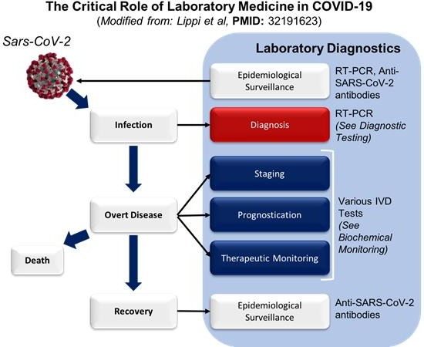

The conventional testing method for Covid-19 infection is real-time fluorescence-based (RT- PCR) assays. Any test Covid-19 must be performed in Biosafety level 2 laboratories with trained personnel in relevant technical safety skills. The nucleic acid detection method introduced in this guideline mainly targets at open reading frame 1ab (ORF lab) and

nucleocapsid protein (N) in the novel coronavirus genome. To confirm a case as positive in the laboratory, one of the following criteria shall be met:

1. The real-time fluorescence-based RT-PCR assay of the novel coronavirus in the same specimen shows that the two targets, ORF1ab and Protein N, are both positive. In case of the result showing positive for one target, then samples shall be re-collected for another test. If it is still positive for a single target, it is determined to be positive.
2. The real-time fluorescence-based RT-PCR assay of two types of specimens show one single target positive at the same time, or one target positive in two samples of the same type, it could be determined as positive. Negative nucleic acid results cannot rule out Covid-19 infections.
3. Factors leading to false negatives including:
   * poor qualities of samples, for instance the respiratory tract samples in the oropharynx and other parts;
   * samples collected too early or too late
   * samples that are improperly stored, transported or processed;
   * Technical reasons such as virus mutations, PCR inhibition, etc.

# Analytic phase

Laboratory testing for COVID-19 virus

Laboratories undertaking testing for COVID-19 virus should adhere strictly to appropriate Biosafety practices.

# 1. Nucleic acid amplification tests (NAAT) for COVID-19 virus

Routine confirmation of cases of COVID-19 is based on detection of unique sequences of virus RNA by NAAT such as real-time reverse-transcription polymerase chain reaction (rRT-PCR) with confirmation by nucleic acid sequencing when necessary. Biosafety:

RNA extraction should be done in a biosafety cabinet in a BSL-2 or equivalent facility. Heat treatment of samples prior to RNA extraction is not recommended.

Laboratory confirmation of cases by NAAT in areas with no known COVID-19 virus circulation means:

* A positive NAAT result for at least two different targets on the COVID-19 virus genome,
* Rapid antigen testing for screening and surveillance

Antigen serological test is used for surveys and can aid investigation of an on-going outbreak and retrospective assessment of the attack rate or extent of an outbreak.

In cases where NAAT assays are negative and there is a strong epidemiological link to COVID- 19 infection, paired serum samples (in the acute and convalescent phase) could support diagnosis once validated serology tests are available.

Serum samples can be stored for these purposes.

Cross reactivity to other corona viruses can be challenging (24) but commercial and non- commercial serological tests are currently under development. Some studies with COVID-19 serological data on clinical samples have been published (25,26).

* Real-time Polymerase chain reaction (PCR).
* Quality controls( internal and external)

# Post-analytic phase

* Documentation, recording and reporting( use of standard recording form tool and reporting to correct channels.

Waste disposal

# Disinfectants that targets enveloped viruses are used and these includes; (hypochlorite [bleach], alcohol, hydrogen peroxide, quaternary ammonium compounds and phenolic compounds).

* **Use of incinerator for complete sterilization Specimen Submission**

**Form Specimen submission unit (seal): …………Submission date: year**

**…….month………. day ………Submitted by….**:

|  |  |  |  |  |  |  |  |  |  |  |
| --- | --- | --- | --- | --- | --- | --- | --- | --- | --- | --- |
| **N**  **o.** | **Speci men**  **type** | **Na me** | **Se x** | **Da te**  **of** | **Dat e of**  **clini** | **Samp ling**  **date** | **Test ing**  **date** | **Real-time fluorescent**  **RTPCR** | **Gene sequence homology\*** | No te. |

|  |  |  |  |  |  |  |  |  |  |  |  |  |
| --- | --- | --- | --- | --- | --- | --- | --- | --- | --- | --- | --- | --- |
|  |  |  | **A**  **ge** | **on set** | **cal visit** | **From a cluste red outbr eak or**  **not** |  | **Reagent manufa cturer** | **Tar get gen e** | **First gener ation** | **Deep seque ncin g** |  |
| 1. |  |  |  |  |  |  |  |  |  |  |  |  |
| 2. |  |  |  |  |  |  |  |  |  |  |  |  |
| 3. |  |  |  |  |  |  |  |  |  |  |  |  |
| 4. |  |  |  |  |  |  |  |  |  |  |  |  |
| 5 |  |  |  |  |  |  |  |  |  |  |  |  |
| 6. |  |  |  |  |  |  |  |  |  |  |  |  |
|  |  |  |  |  |  |  |  |  |  |  |  |  |
|  |  |  |  |  |  |  |  |  |  |  |  |  |

Gene sequence homology * is not a required option; it Indicates completion of the specific target gene sequence / whole genome sequence and its homology with the novel coronavirus. For the column of “from a clustered break or not”, fill in “yes” or “no”.

# Unit 3: MANAGEMENT OF COVID-19

**Definitive management**

Management of mild COVID-19: Symptomatic treatment

1. Isolate to contain virus transmission according to the established COVID-19 care pathway for patients with suspected or confirmed mild COVID-19. This can be done at a designated COVID-19 health facility, community facility or at home (self-isolation).
2. Give symptomatic treatment such as antipyretics for fever and pain, adequate nutrition and appropriate rehydration.
3. Counsel patients about signs and symptoms of complications that should prompt urgent care.

Management of moderate COVID-19: pneumonia treatment

1. Isolate to contain virus transmission. Patients with moderate illness may not require emergency interventions or hospitalization; however, isolation is necessary for all suspect or confirmed cases.
2. Close monitor for signs or symptoms of disease progression. Provision of mechanisms for close follow up in case of need of escalation of medical care should be available.

Management of severe COVID-19: severe pneumonia treatment

1. Adults with emergency signs (obstructed or absent breathing, severe respiratory distress, central cyanosis, shock, coma and/or convulsions) should receive emergency airway management and oxygen therapy during resuscitation to target SpO2 ≥ 94% (72,116).
2. Once the patient is stable, target > 90% SpO2 in non-pregnant adults and ≥ 92–95% in pregnant women.
3. Deliver oxygen flow rates using appropriate delivery devices (e.g. use nasal cannula for rates up to 5 L/min; Venturi mask for flow rates 6–10 L/min; and face mask with reservoir bag for flow rates 10–15 L/min).
4. In adults, techniques such as positioning, e.g. high supported sitting may help to optimize oxygenation, ease breathlessness and reduce energy expenditure.
5. In adult patients with evidence of increased secretion production, secretion retention, and/or weak cough, airway clearance management may assist with secretion clearance.

Techniques include gravity-assisted drainage and active cycle of breathing technique. Devices including mechanical insufflation-exsufflation and inspiratory positive pressure breathing should be avoided where possible.

Management of critical COVID-19 with Acute Respiratory Distress Syndrome (ARDS)

1. Endotracheal intubation performed by a trained and experienced provider using airborne precautions to provide mechanical ventilation
2. Mechanical ventilation using lower tidal volumes (4–8 mL/kg predicted body weight [PBW]) and lower inspiratory pressures (plateau pressure < 30 cmH2O).

# Management of critical COVID-19: Septic shock

1. Standard care includes early recognition and the following treatments to be done immediately, within 1 hour of recognition:
   1. Antimicrobial therapy, and initiation of fluid bolus and vasopressors for hypotension
   2. The use of central venous and arterial catheters should be based on resource availability and individual patient needs.
   3. In resuscitation for septic shock in adults, give 250–500 mL crystalloid fluid as rapid bolus in first 15–30 minutes.
   4. In resuscitation for septic shock in children, give 10–20 mL/kg crystalloid fluid as a bolus in the first 30–60 minutes.
   5. In adults, administer vasopressors when shock persists during or after fluid resuscitation. The initial blood pressure target is MAP ≥ 65 mmHg in adults and improvement of markers of perfusion. Vasopressors (i.e. norepinephrine, epinephrine, vasopressin and dopamine)
   6. Norepinephrine is considered the first-line treatment in adult patients; epinephrine or vasopressin can be added to achieve the MAP target. Because of the risk of tachyarrhythmia, reserve dopamine for selected patients with low risk of tachyarrhythmia or those with bradycardia.
   7. In children, epinephrine is considered the first-line treatment, while norepinephrine can be added if shock persists despite optimal dose of epinephrine

NOTE:

* + 1. Norepinephrine is considered the first-line treatment in adult patients; epinephrine or vasopressin can be added to achieve the MAP target.

Because of the risk of tachyarrhythmia, reserve dopamine for selected patients with low risk of tachyarrhythmia or those with bradycardia.

* + 1. In children, epinephrine is considered the first-line treatment, while norepinephrine can be added if shock persists despite optimal dose of epinephrine.

# Drug management

**Antimicrobial Use in COVID-19 General Considerations**

Acute cough with upper respiratory tract infection: no antibiotic needed

* Acute bronchitis no routine antibiotic needed
* Acute cough and higher risk of complications at face to face examination) immediate or back up antibiotic

1. Higher risk of complications includes people with:

* Preexisting comorbidity
* Young children born prematurely

1. People over 65 yrs. with 2 or more of, or over 80 yrs. with 1 or more of:
   * Hospitalization in previous year
   * Type 1 or 2 diabetes
   * History of congestive heart failure
   * Current use of oral corticosteroids

* Acute cough and systemically very unwell (at face to face examination): immediate antibiotic.
* Do not offer a mucolytic, an oral or inhaled bronchodilator, or an oral or inhaled corticosteroid unless otherwise indicated

When Antibiotics Needed (Prescribing Antimicrobials Therapy)

Start with appropriate, empiric broad spectrum antimicrobials WITHIN ONE ( 1 ) hour of diagnosis or as soon as possible (in the emergency area when possible)

* Preferably administer antimicrobial after the clinical specimen collection (upper and/or lower respiratory samples and blood cultures

NB: Each hour delay in administration of effective antimicrobial therapy in septic shock is associated with increased mortality

# Antivirals For COVID 19

•There are no known effective antivirals for coronavirus infections.

–Various candidates ( Remdesivir ; lopinovir + ritonovir ) with potential anti SARSCoV 2 activity are being evaluated in clinical trials

•Use of unregistered or unproven therapeutics for COVID 19 should ONLY be done under strict monitoring and ethical approval

•Use WHO Monitored Emergency Use of Unregistered Interventions (MEURI) framework for guidance

NB: Hydroxychloroquine Had Shown Potential In Some Clinical Trials Earlier, But may have failed international acclaim so far July 2020

# Therapy for Patients with SARI

* Empiric therapy may include one or more effective drugs to treat all likely pathogens:

–

* i.e. antibiotics for suspected bacterial pathogens, antiviral for suspected viral pathogen (if effective antiviral is known), antifungal for suspected fungal pathogen, etc.)
* For patients with septic shock, can consider combination therapy i.e. using two antibiotics of different antimicrobial classes aimed at most likely bacterial pathogen

Dose of antimicrobials is optimally based on

* pharmacokinetic principles –
* i.e. take into account renal or hepatic function
* i.e. take into account volume of distribution
* Ensure drug used adequately penetrates into tissue
* presumed to be site of infection (i.e. lungs): e.g. gentamycin and daptomycin are not reliable for community acquired pneumonia(CAP) treatments in adults

Considerations When Choosing Antibiotics In Patients

# Patients factors

* risk for resistant pathogens (i.e. recent IV antibiotics)
* risk for opportunistic infections (i.e. immunosuppression, co morbidities or presence of invasive devices).

# Epidemiologic factors

* Community acquired OR hospital acquired, etc. Pathogen factors
* Prevalent pathogens in community or particular hospital, etc.
* Susceptibility and resistance patterns of prevalent pathogens. Examples of Antibiotic Regimens For Severe CAP:

IDSA And BTS Guidelines

* Combination therapy:

–B lactam e.g. ampicillin sulbactam, cefuroxime, cefotaxime or

* Ceftriaxone and antibiotic against atypical pneumonia (e.g. macrolide or doxycycline) or respiratory flouroquinolone (e.g. levofloxacin
* If community acquired methicillin resistant S. aureus (CA MRSA) suspected:
* add vancomycin or linezolid Combination therapy:
* If immunosuppressed (i.e. PL HIV):

–Consider anti pneumocystis treatment (e.g. Sulfamethoxazole/trimethoprim

–In pregnant women the use of macrolides, cephalosporins and penicillin are SAFE

–DO NOT USE FLOUOROQUINOLONES

Paediatric Recommendation From IDSA Combination therapy:

* For fully immunized child if local epidemiology documents lack of substantial high level penicillin resistance for invasive S. pneumoniae

–Ampicillin or penicillin G

–Or third generation cephalosporin (e.g. cefotaxime or ceftriaxone)

For Non fully immunized child, known high level, penicillin resistance for invasive S. pneumoniae or life threatening infection – Add antibiotic against atypical pneumonia (i.e. macrolide

If community acquired S. aureus suspected: Add vancomycin or clindamycin based on local Susceptibility data

Flouroquinolones and Doxycyline are not used to treat CAP in children

# Paediatric recommendation from WHO Child Handbook

Severe pneumonia: Ampicillin or penicillin G + gentamicin.

If no signs of improvement within 48 hours: switch to third generation cephalosporin (e.g. cefotaxime or ceftriaxone

If no improvement in 48 hours and suspect community acquired Severe pneumonia aureus switch to cloxacillin and gentamicin

* + If HIV infection or exposure to HIV, suspect PCP pneumonia:
* child < 12 months, give high dose co trimoxazole and sulfamethoxazole
* child 1 5 years, give PCP treatment only if clinical signs of PCP are present

# •Fluoroquinolones and doxycycline are not used to treat CAP in Children Possible Reasons for Clinical Deterioration

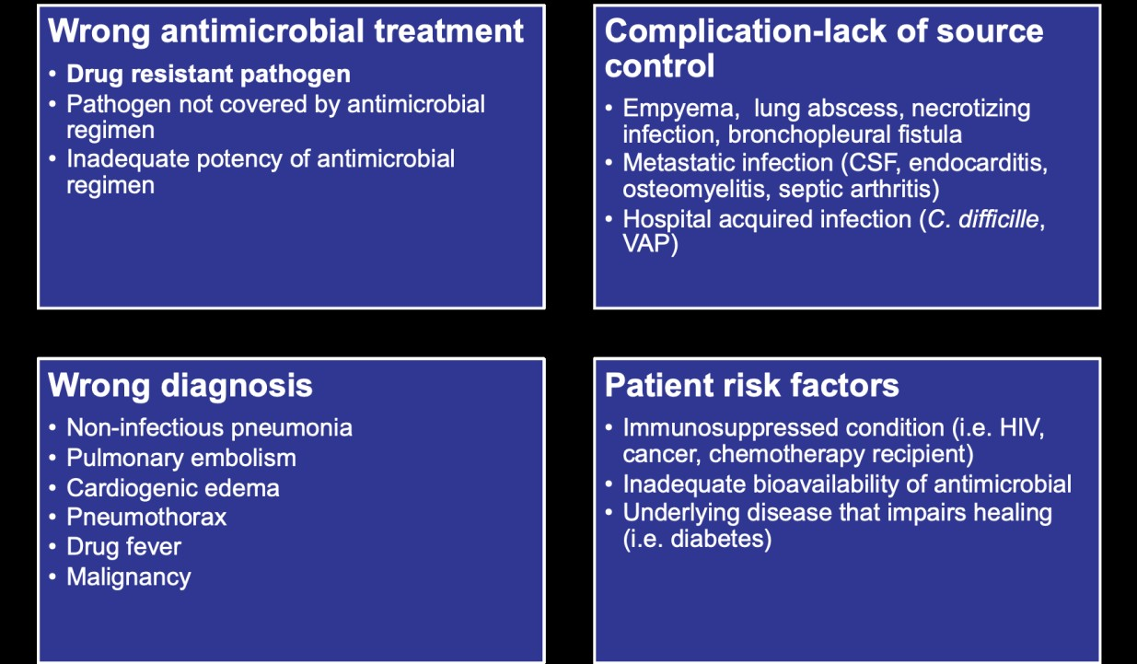

**Antivirals pharmacology of Antiviral Agents for Influenza**

Neuraminidase inhibitors:

–Oseltamivir (including Tamiflu ™ , Antiflu ™

–Zanamivir inhaler(including Relenza ™

* + IV formulation is investigational drug

–Peramivir (including RapivabTM

–Remdensivir

# Prescribing Antivirals for Patients with Influenza Virus Infection

•For patient with or at risk of severe seasonal influenza A or B viruses or those with zoonotic influenza A virus infection:

–Give antiviral (NAI, oseltamivir) as soon as possible earlier treatment has greater clinical benefit than later treatment or no treatment

* + It can be given at any stage of active disease when ogoing viral replication is anticipated or proven
  + Influenza viral replication can be prolonged in the lower respiratory tract in critically ill patients

Prescribing Oseltamivir

•WHO recommends for patient with severe or at risk for severe, seasonal influenza virus infection and zoonotic influenza virus infection

–Oral capsule or suspension that can be given via nasogastric or orogastric tube in ventilated patients

–Dose is 75 mg twice daily for 5 days in adults

# Prescribing Oseltamivir in Children

•Dose in children up to 40 kg is 3 mg/kg twice daily for 5 days

•Dose in children over 40 kg is adult dose (75 mg twice daily for 5 days)

•Available as oral suspension (6 or 12 mg/mL) and tablets 30 mg, 45 mg, 75 mg) **N/B:** Give As Soon As Possible to Patients with Suspected or Confirmed Influenza Virus Infection In patients Of All Ages

Immunomodulating Agents Corticosteroids and Viral Pneumonia

•Corticosteroid use is associated with various negative clinical outcomes, such as:

* Prolonged viral replication
* Avascular necrosis
* Promotion of Immunosuppression leading to bacterial or fungal super infection
* Psychosis
* Hyperglycaemia
* Increased mortality

Immunomodulating Agents Corticosteroids and Viral Pneumonia

•Consider its use only for specific indications such as: (NB:

If used, use only low dose)

* Exacerbation of asthma/COPD or
* Suspected adrenal insufficiency or
* Refractory shock or
* Co infection with PJP

There is NO proven role for corticosteroids in acute influenza pneumonia or SARS/MERS infection

# Nursing Interventions

Based on assessment data, nursing interventions for COVID-19 should focus on monitoring vital signs, maintaining respiratory function, managing hyperthermia, and reducing transmission.

* + - Monitor vital signs – particularly temperature and respiratory rate, as fever and dyspnea are common symptoms of COVID-19.
    - Monitor O2 saturation – normal O2 saturation as measured with pulse oximeter should be 94 or higher; patients with severe COVID-19 symptoms can develop hypoxia, with values dropping low enough to warrant supplemental oxygen.
    - Manage fever – use appropriate therapy for hyperthermia, including adjusting room temperature, eliminating excess clothing and covers, using cooling mattresses, applying cold packs to major blood vessels, starting or increasing intravenous (IV) fluids as allowed, administering antipyretic medications as prescribed, and readying oxygen therapy in the event of respiratory problems resulting from the metabolic demands for oxygen during a fever.
    - Maintain respiratory isolation – isolation rooms should be well-marked with limited access; all who enter the restricted-access room should use personal protective equipment, such as masks and gowns.
    - Enforce strict hand hygiene – to reduce or prevent transmission of coronavirus, patients should wash hands after coughing, as should all who enter or leave the room.
    - Patients with COVID-19 should be treated cautiously with intravenous fluids; aggressive fluid resuscitation may worsen oxygenation, especially in settings where there is limited availability of mechanical ventilation. This applies to both children and adults.
    - Provide information – educate the patient and patient’s family members of the transmission of COVID-19, the tests to diagnose the disease, disease process, possible complications, and ways to protect oneself and one’s family from coronavirus.

# Supportive Management Psychosocial support

**What is psychosocial first aid (pfa)?**

* It’s a humane, supportive and practical assistance to fellow human beings who recently suffered exposure to serious stressors, during this COVID-19 pandemic period
* That is:
  + Non-intrusive, practical care and support
  + Assessing needs and concerns of the affected
  + Helping people to address basic needs (food, water)
  + Listening, but not pressuring people to talk
  + Helping people connect to information, services and social supports
  + Protecting people from further harm

# Rationale

* COVID-19 is generating stress throughout the population
* Psychosocial support addresses the ongoing psychological and social problems of Covid-19 infected individual, their families, communities, health care workers and care givers
* Messages that can be used in communications to support mental and provide psychosocial well-being to different target groups during the outbreak is imperative
* The considerations presented in this module have heavily borrowed from WHO

# Why PFA?

People do better over the long-term if they,

* Feel safe, connected to others, calm & hopeful
* Have access to social, physical & emotional support
* Regain a sense of control by being able to help themselves

# Who needs PFA support?

* Very distressed people who may have symptoms of COVID 19 or may have been exposed COVID-19 or any other serious stressful event.
* Those with other underlying health problems e.g. chronic illness

# Who needs more advanced support than PFA alone?

* People who have tested positive for COVID-19
* People who have been quarantined and those who may have symptoms similar to those of COVID-19
* The close family members of the above group
* People who have chronic illness /mental disorders
* People so upset that they cannot care for themselves or their children
* People who may want to harm themselves or endanger the lives of others

# Basic needs and requirements

1. Basic needs:

Shelter Food Water Sanitation

1. Health services for those infected or exposed to Covid-19. Help with chronic medical conditions
2. Access to correct information about disease, loved ones and available services
3. Being able to contact loved ones
4. Access to specific support related to one’s culture or religion
5. Access to emotional, cultural and spiritual support
6. Being consulted and involved in important decisions

# Positive coping mechanisms and strategies

1. Help people to regain a sense of control by telling them to:
   * Get enough rest
   * Eat as regularly as possible and drink water
   * Call and talk to family as frequently as possible
   * Discuss problems with someone you trust
   * Relax: walk, sing, pray, play with children (Maintaining Social Distance)
   * Exercise (While maintaining social distance)
   * Avoid alcohol, drugs and substance abuse e.g. caffeine, nicotine
2. Help people to regain a sense of control by telling them to:
   * Attend to personal hygiene (Encourage washing of hands with soap frequently or use sanitizer
   * Find safe ways to help others
3. Give information
   * Find accurate information before helping
   * Keep updated
   * Make sure people are informed where & how to access services – especially vulnerable people
   * Say ONLY what you know – don’t make up information
   * Keep messages simple & accurate, repeat often
   * Give same information to groups to decrease rumors
   * Explain source & reliability of info you give
   * Let them know when/where you will update them
4. Give Social Support

Social support is very important to recovery

* + Help people contact friends and loved ones
  + Give access to religious support
  + Affected people may be able to help each other – bring them together through virtual means if possible
  + Make sure people know about how to access services (especially vulnerable people)

# People who most likely need special attention

* + Children and adolescents (especially those separated from caregivers due to hospitalization or quarantine)
  + People with health conditions and disabilities
  + People who are non-mobile, or who have chronic illness, hearing/visual impairments (deaf or blind), or severe mental disorders
  + Frail elderly people, pregnant or nursing women
  + People at risk of discrimination or violence e.g orphans
  + People with mental disabilities

# Home based care and Isolation

Introduction and Rationale for HBIC

* + It is no longer possible to isolate all COVID 19 patients in hospital based treatment facilities.
  + Hospital care should be prioritized for those with highest probability of poor outcomes (patients with severe and critical illness and those with mild disease and risk of poor outcome (age >60 years, cases with underlying co morbidities,

e.g. chronic cardiovascular disease, chronic respiratory disease, diabetes, cancer)

* + Where possible safe home care should be considered for patients with suspected COVID 19 who present with no symptoms or mild symptoms.

# Patients Eligible for Home Based Care

Patients who meet the criteria below will be considered for home based isolation and care:

* + - Laboratory Confirmed COVID 19
    - Asymptomatic patients or patients with mild symptoms of COVID 19
    - Absence of co morbidities

Assessing Feasibility of Home Based Isolation and Care

* + The patient is stable enough to receive care at home
  + Appropriate caregivers are available at home
  + There is a separate bedroom or isolation space where the patient can recover without sharing immediate space with others
  + Resources for access to food and other amenities and necessities are available

# Feasibility of Home Based Isolation and Care

* + The patient and other household members have access to appropriate, recommended personal protective equipment
  + Availability of thermometer and a person able to read and record the temperature (Non-contact or individually used thermometers)
  + There are NO household members who may be at increased risk of complications from COVID 19 infection e g people 65 years old, young children, pregnant women, people who are immunocompromised or who have chronic heart, lung, or kidney conditions
  + Place the patient in a well-ventilated single room (i e with open windows)

# Procedures for Home Based Isolation and Care

* Limit the movement of the patient in the house and minimize shared space
* Ensure that shared spaces (e g. Kitchen, bathroom) are well ventilated (keep windows open)
* Household members should stay in a different room
* Limit the number of caregivers ideally, assign one person who is in good health and has no underlying chronic or immunocompromising conditions
* Visitors should not be allowed in the isolation room, except the caregiver, until the patient has completely recovered and has no signs or symptoms of COVID 19 and has tested negative as per the protocol
* Perform hand hygiene after any type of contact with patients or their immediate environment.

Hand hygiene should also be performed before and after preparing food, before eating, after using the toilet, and whenever hands look dirty.

Use of soap and water is highly encouraged, but in the event that either or both are not available then an alcohol based hand rub can be used.

# Nutritional Management

* The main goal of nutrition management is to build immunity, prevent disease, maintain good health and to speed up recovery from illnesses
* Nutritional management for maternal, infant and young children is essential to prevent malnutrition
* Nutritional management is also essential for the vulnerable groups in relation to Covid-19 especially maternal, infant and young children, elderly and patients with comorbidities

# Nutrition management for the prevention of covid-19 on general population

* + Fruits and vegetables provide lots of vitamins and minerals as well as fiber that we need for healthy diet
  + Consume foods from at least 4 to 5 food groups and eat plenty of fruits and vegetables daily as outlined below:
    - Grains and grain products and all other starch foods (maize/maize flour, rice, sweet potato, cassava)
    - Legumes and pulses, nuts and seeds - Alternate between peas, lentils, cowpeas, pigeon peas, soya, nuts and edible seeds
    - Lean meat, fish/seafood and poultry in your daily meals- vary within the sources such as peas, beans, etc
    - Milk and milk products – consume fresh milk, sour milk or yogurt daily
    - Vegetables – alternate among:
      * Dark green leafy vegetables - such as indigenous vegetables (managu, terere, saga), spinach and kales
      * Yellow or orange vegetables are rich in vitamin A e.g., carrots, pumpkin, sweet peppers
      * Other vegetables such as, courgettes, cabbage and French beans
    - Fruits – Vary the types such as:
      * Yellow or orange fruits such as mangoes, pawpaws that are rich in vitamin A
      * Citrous fruits such as oranges, lemons
      * Other fruits like passions, melons and pinaeapples
    - Drink plenty of safe water everyday spread throughout the day
    - Avoid or reduce the consumption of highly refined, processed foods, sweets and sugar sweetened or flavoured drinks or beverages - They have little nutrition value and contain high amounts of unhealthy fats, sugar and salt
    - Watch your intake of fats, and salt
      * Use fat and salt sparingly
      * If you use sugar, use it sparingly

# Nutrition management for covid-19 patients

* COVID-19 presents with symptoms that require different types of nutrition management
* COVID-19 patients exhibit difference symptoms;
  + Mild symptoms
  + Severe pneumonia/ pulmonary disease
  + Critical cases

The recommended Nutrition management below is based on symptoms that come with the COVID-19

# Nutrition management for covid-19 patients with mild symptoms

* Ensure intake of adequate fluids; at least two liters of water per day or more if there is fever
* •Fever increases the need for more calories: Increase the amount of nutritious food by increasing the number of times you eat
* Consider supplementation with Vitamin C, zinc, Vitamin A, B6, D, E, iron, Folate and fiber if not getting enough from the diet
* Coughs can be relieved by use of honey, pineapple and chicken soup
* Sore throat can be relieved by taking tea, honey, ginger, turmeric, sage
* The use of culinary herbs like oregano, sage and cinnamon as well as increased consumption of fruits and vegetables is encouraged to improve antioxidant levels in the body
* Limit intake of refined carbohydrates such as sugar, sweets, cake, soft drinks and sugar sweetened beverages
* Limit intake of foods containing trans-fats and saturated fats e.g. fat and skin from meat, hydrogenated vegetable oils, shortening, fried foods, cookies, and pastries
* Fluid intake should be based on weight

# Nutrition management for patients with pulmonary disease

* For cough, use honey, lemon and warm water
* Eat preferred nutritious meals and snacks, fruits, vitamins and mineral supplements
* Eat a diet with fewer carbohydrates and healthy fats to meet energy requirements for the period when breathing is difficult
* Provide adequate but not excessive nutrients - avoid overfeeding
* For abnormal production of sputum, increase intake of warm drinks including clear broth soups, meaning soups without cream or dairy and warm decaffeinated tea
* Avoid foods naturally containing histamine. Histamine levels in the body can cause increased production of mucus
* Some patients with fluid retention require sodium and fluid retention. Depending on the diuretics ,increased dietary intake of potassium may be required

# Nutrition management for critically ill patients

* + Consider medical nutrition therapy for all patients staying in the ICU, mainly for more than 48 hrs
  + General clinical assessment could include report of unintentional weight loss or decrease in physical performance before ICU admission, body composition, muscle mass and strength
  + Oral diet shall be preferred over enteral nutrition or parenteral nutrition in critically ill patients who are able to eat, and if not possible, initiate early enteral nutrition and if possible within 48 hours
  + In case of contradictions to oral and enteral nutrition, parenteral nutrition should be initiated within three to seven days
  + Gastric access should be used as the standard approach to initiate enteral nutrition unless there is gastric feeding intolerance then consider post pyloric or jejunal feeding
  + Hypocaloric nutrition (not exceeding 70% of Estimated Energy) should be administered in the early phase of acute illness and increased from day 3 to day 7 to 80-100% based on stability and tolerance of the patient
  + Nutrition support should begin as soon as the patient is hemodynamically stable
  + Critically ill patients who are injured, septic, or bedridden may not gain weight, lean body mass or strength as expected until the source of hyper metabolism is treated or corrected and physical therapy or exercise is begun
  + To avoid overfeeding, early full enteral nutrition and Parenteral Nutrition shall not be used in critically ill patients but shall be prescribed within three to seven days
  + Use continuous rather than bolus enteral nutrition
  + In unstable and complex ICU patients, particularly in those suffering from liver and renal failure, parenteral glutamine –dipeptide(GLN) shall not be administered
  + Antioxidants as high dose monotherapy should not be administered without proven deficiency
  + In non-intubated patients with dysphagia, texture-adapted food can be considered. If swallowing is proven unsafe, enteral nutrition should be administered
  + To enable substrate metabolism, micronutrients (i.e. trace elements and vitamins) should be provided daily with Parenteral Nutrition
  + Enteral Nutrition should be delayed if there is uncontrolled shock, hypoxemia, hypercapnia or acidosis upper GI bleeding, high-output intestinal fistula or gastric residual volume is above 500 ml
  + In non-intubated patients not reaching the energy target with an oral diet, oral nutritional supplements should be considered first and then Enteral Nutrition

# Maternal, infant and young child nutrition (MIYCN) management in context to covid-19

1. Nutrition Management For All Pregnant And Lactating Mothers

Current MOH guidelines for nutrition during pregnancy and lactation should be applied including;

* Meals for pregnant and breastfeeding mothers need to comprise at least 5 of 10 food groups daily necessary for their optimal nutrition and that of the baby
* Maintain a healthy diet considering 1 extra small meal for pregnant women and 2 extra small meals for breastfeeding mothers
* The food group are; grains, white roots and tubers, and plantains, pulses (beans, peas and lentils), nuts and seeds, dairy, meat, poultry and fish, eggs, dark green leafy vegetables, other vitamin A-rich fruits and vegetables

# Nutrition Management for Mothers Suspected or Infected with COVID-19 – able to Breastfeed

* Assess and teach mothers to identify breast conditions and seek help from health care workers trained on lactation management
* Mothers should express breastmilk by hand or pump (manual, electric) while observing respiratory and general hygiene including disinfecting the pump equipment after every pumping session
* Expressed breastmilk should be fed to the baby by an open cup while following infection prevention measures
* There should be no promotion of breastmilk substitutes, feeding bottles and teats, pacifiers or dummies in any part of facilities providing maternity and newborn services, or in the community
* Mothers should receive psychosocial support for sustained breast milk production

# Nutrition Management for Mothers too Unwell to Breastfeed

* An appropriate breastmilk substitutes in line with the Breast milk substitutes (Regulation and Control) Act, 2012 should be provided such as:
  + Ready to use infant formula ( RUIF)
  + Powder infant formula
* Family members or health care workers if in hospital can assist with feeding the baby
* Milk feeds should be given to the baby using an open cup while following infection prevention measures
* There should be no promotion of breastmilk substitutes, feeding bottles and teats, pacifiers or dummies in any part of facilities providing maternity and newborn services, or by any of the staff

# Nutrition management for infants too ill to breastfeed

* Infants who are ill need fluids to stay hydrated and breast milk is the best option
* Expressed breast milk can also be given from an open cup if the infant is unable to breastfeed directly at the breast
* Age appropriate feeding recommendations should be adhered to as per MIYCN guidelines

# Nutrition Management for Complementary Feeding

* Caregivers and health workers should be informed on the importance of healthy diets during complementary feeding
* Children 6-23 months of age should be fed the minimum number of meals per day (age appropriate) to ensure dietary adequacy
* Children 6-23 months of age should be fed from at least 4 out of 7 food groups to ensure dietary diversity
* Families should be informed and encouraged to prioritize purchase of fresh and healthy food options (as explained above) for young children
* Discourage use of highly processed packaged foods as they are often less healthy, and contain high amounts of saturated fats, free sugars and/or salt
* There should be no promotion of complementary foods in any part of facilities providing maternity and newborn services, or in the community
* Mothers/Caregivers should avoid providing drinks or foods with low nutritional value, such as sugar-sweetened beverages, candy, chips and other foods high in sugar, salt and Trans fats

# Nutrition Management for Elderly People in Context to COVID-19

* It is generally recommended a protein intake of at least 1.0 g/kg of body weight/day in older people to maintain muscle mass, increasing the intake up to 1.2–1.5 g/kg of body weight/day in presence of acute or chronic illnesses
* In the presence of COVID-19, the amount of required proteins might even be increased up to 2.0 g/kg of body weight/day
* A high amount of protein per meal (i.e. 25–30 g with at least 2.5 g of leucine) is required for guaranteeing an adequate anabolic response of the aging skeletal muscle
* Supplementation with essential amino acids may overcome anabolic resistance since they are the primary stimulus for protein synthesis
* Specific multi-nutrient formulas providing both macro- and micronutrients should be provided to the older people

# Nutrition Management for HIV Patients in Relation to COVID-19

* A HIV –infected adult requires 10-15 percent more energy per day (or approximate 400 additional kcal for men and 300 kcal for women)
* A HIV-infected adult needs approximately 50 to 100 percent more protein for a total of 85 grams/day for men and 72 grams/day for women
* Consuming micronutrients (especially Vitamins A, B6 and B12, iron and zinc) is important for building a strong immune system and fighting infections
* Micronutrient consumption can be increased through eating specific foods or through special supplements which can include vitamins and foods reach in minerals

# Nutrition Management for Diabetes Patients In Relation to COVID-19

* Give priority to foods with a low glycemic index such as vegetables and whole grains
* Avoid excessive consumption of fried foods
* Choose lean proteins such as eggs and fish
* Eat green, leafy vegetables
* Eat fruits in at least two servings a day
* Limit consumption of foods high in carbohydrates and sugar

# Nutrition Management for Diabetes Patients in Relation to COVID-19

* Give priority to foods with a low glycemic index such as vegetables and whole grains
* Avoid excessive consumption of fried foods
* Choose lean proteins such as eggs and fish
* Eat green, leafy vegetables
* Eat fruits in at least two servings a day
* Limit consumption of foods high in carbohydrates and sugar

# Nutrition Management for Cancer Patients in Relation to COVID-19

* Fresh vegetables and fruit and frozen produce is also a nutritious, inexpensive option with a longer shelf-life with essential vitamins and minerals. You can add frozen veggies to soups, stews, one-pot meals and casseroles
* Consume whole grains like oatmeal, brown rice, quinoa and 100% whole-wheat bread. Research shows that eating whole grains helps protect against colorectal cancer
* Beans, lentils, nuts and seeds, along with lean proteins such as fish, chicken and turkey, are all great options. Other high-quality protein sources include eggs and tuna canned in water

# Rehabilitation

**Management by Physiotherapist Objectives:**

* Aims of Physiotherapy management for COVID-19
* Describe strategies for the physical examination, management and evaluation for patients with covid -19
* Outlining the physiotherapy intervention in acute, sub-acute and post – acute stages.
* Articulate the importance of physiotherapy in post- discharge and optimal functions in ADLS and IADLS.

# Aims of Physiotherapy management for COVID-19

* Close monitoring of vital parameters (cardio-respiratory and neurological).
* Patient education and reassurance
* Reduce difficulty in breathing
* Prevent complications such as bed sores, nerve compression damage, contractures and pulmonary complication.
* Address underlining comorbidities e.g. DM, Cancer, RVD, HTN, TB, obesity etc.
* Improve the patient’s quality of life.

# How do we achieve the aims?

* Re-education and psychological empowerment
* Chest physiotherapy; airway clearance techniques, breathing exercises (Deep breathing: Slow prolonged breath in with a hold to allow more time for gas exchange and for collateral ventilation with the Lambert canals, thoracic expansion with shoulder elevation, and diaphragmatic breathing)
* Early mobilization
* Positioning in bed (including prone lying)
* Respiratory muscle training
* Agility exercises and relaxation

# Sub-acute/Post-acute stage

* Evaluating clinical parameters (Temp, SpO2, BP, cough, dyspnea, RBS, respiratory rate, chest expansion, ECG) are indicated on a daily basis. Under lining pathologies.
* Evaluate peripheral muscle strength with the MRC scale, manual muscle test, isokinetic muscle test and measurement of joint range of motion (ROM)
* In patients weaned from prolonged mechanical ventilation and oxygen use, reconditioning interventions are indicated in order to improve the physical status
* Simple and repeatable treatment protocols therapy are indicated

# Monitor the following carefully to avoid excess stressing on respiratory system

* Shortness of breath
* PaO2  95%
* BP  90/60 or  140/90
* HR 100 bpm
* temp  37.2C
* Excessive fatigue
* Chest pain

# Critical Care Unit

* Chest physiotherapy-postural drainage, vibrations (others have been limited due to aerosol generation to the environment)
* Closed suctioning catheters are used during this procedure.
* Prone positioning is most effectively used in the suctioning set up. NB: Musculoskeletal and other system should not be overlooked.

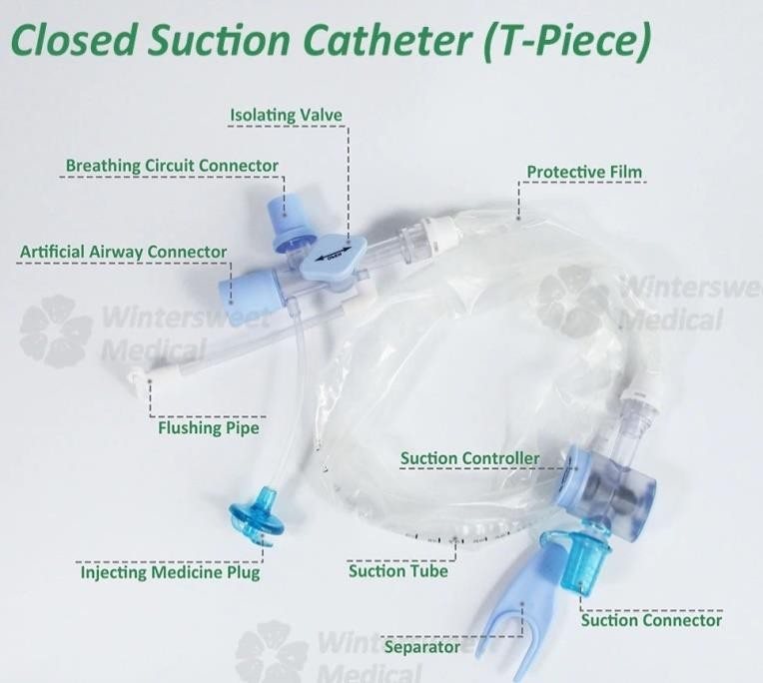

# Post Critical Care

**Effects of covid-19**

* Scarring/fibrosis of the lungs
* Breathlessness
* Loss of function and independence
* Anxiety and psychological issues

# Evaluation and Prognosis

* Use outcome measure that are valid and reliable
* Baseline measures are obtained and tracked overtime
* Normative data is compared with patients’ data.

# Restoration interventions

* Increased flexibility
* Aerobic training
* Strengthening and endurance
* Task specific training
* Circuit and High intensity training

# Dysfunctions that require rehabilitation after discharge

* Respiratory dysfunction. It manifests as cough, sputum, dyspnea, shortness of breath after activity, and may be accompanied by respiratory muscle weakness and impaired lung function.
* Physical dysfunction. Manifestations include General Body Weakness (GBW), fatigue, muscle soreness, and some may be accompanied by muscle atrophy and decreased muscle strength.
* Mental dysfunction. There are emotional problems such as fear, anger, anxiety, and depression.
* Barriers to Activities of Daily Living (ADLs) and social participation. Unable to complete dressing/ undressing, toileting, bathing, etc. Inability to achieve normal interpersonal communication and return to work.

# Personal Protective Equipment (PPE) recommendations for Physiotherapists

* All staff will be trained in correct donning and doffing of PPE, including N95 ―fit checking‖. A registry of staff that has completed PPE education and fit checking should be maintained.
* "Fit testing" is recommended when available, but the evidence for fit testing effectiveness is limited and the variation in the supply of N95 mask types may make any recommendation on fit testing difficult to implement from a practical perspective.
* Staff with beards should be encouraged to remove facial hair to ensure a good mask fit.
* For all suspected and confirmed cases, extra precaution is implemented. Staff will wear the following items: a. Surgical mask, b. The fluid-resistant long-sleeved gown c. Goggles/face shield, d. Gloves

# Mobility and Functional Rehab

* Early mobilization- monitor cardiopulmonary states
* Frequent posture changes
* Bed mobility: rolling, supine to sit, hip raises (bridging), hook-lying while rolling knees side to side, etc.
* Sit-stand
* Simple bed exercises
  + Ankle pumps
  + Bridging
  + Supine to sit
  + SLR’s
  + Supine marches
  + Prone- elbow push-ups, hams curls, glut lifts
* ADLs

# Progressive muscle strengthening

* 8-12 reps to fatigue
* 1-3 sets
* 2 min rest between sets
* 3X/ week
* 6 weeks minimum

# Aerobic conditioning

* Walking, ergometry UE/ LE
* At first limit to 3 METs (walking 2.5mph, walking downstairs, cleaning house, cooking on jiko, milking a cow, standing, easy stationary bike)
* Longer term rehab, increase to 20-30 min, 3-5X/ week
* Balance exercises added to aerobic exercises
  + 1 leg stance, star exercise, 1 leg squat, etc.
* Studies on SARS have shown exercise to be effective in improving:
  + Endurance
  + Max O2 consumption
  + Strength

# References

World Health Organization. (2021). *COVID-19 clinical management: living guidance*, 25 January 2021. World Health Organization. <https://apps.who.int/iris/handle/10665/338882>.

# Teaching strategies

Interactive lectures

Small group demonstrations Small group discussions Role plays

Case scenarios Simulations

# UNIT 4: PREVENTION OF INFECTION/SPREAD OF COVID-19

**Hygienic Practices Hand hygiene: how**

* **Use appropriate product & technique**
  + An alcohol base hand rub product is preferable, if hands are not visibly soiled
  + Rub hands for 20 – 30 seconds
  + Soap, running water and single use towel, when visibly dirty.
  + Wash hands for 40 – 60 seconds!

# Hand hygiene: when

* Always perform hand hygiene when indicated, i.e. “ Five moments”
  + before and after any contact with patients
  + before any clean procedure and after body fluid exposure risk
  + after contact with patient surrounding/contaminated items

# Respiratory hygiene

* + Cover nose and mouth when sneezing and/or coughing with a piece of cloth, a tissue or a surgical mask
  + Immediately and appropriately dispose of these items
  + Cough/sneeze into your sleeve/inside of your elbow if no tissue is available

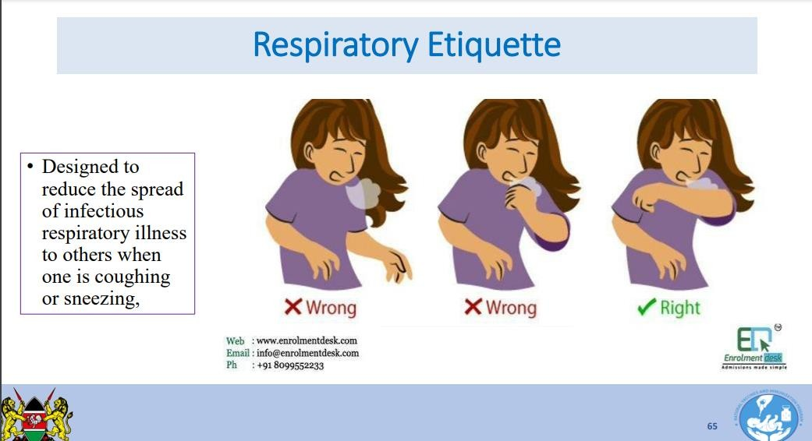

* + Perform hand hygiene with alcohol based hand rub products or water and soap if hands are visibly soiled
  + Wear a medical mask if having respiratory symptoms
  + Stay away from others when sick
  + No introductory kissing or shaking hands when ill
  + Avoid close contact with people who exhibit symptoms

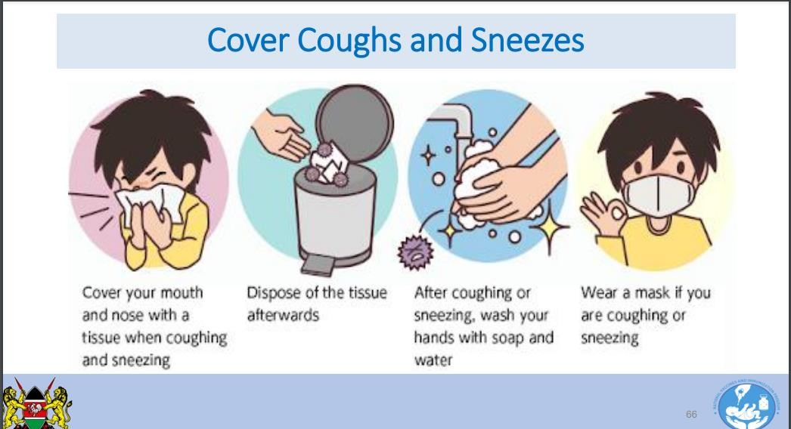

# Personal Protective Equipment

Specialized clothing or equipment worn by an employee for protection against infectious materials.

Last line of defence against hazards that cannot otherwise be eliminated or controlled.

# Appropriate use of PPE:

* Only effective if used throughout potential exposure periods
* Only effective if adherence is 100%
* Must be properly used and maintained
* Does not eliminate need for hand hygiene.

# Examples of PPES for COVID-19

|  |  |  |  |  |  |  |  |  |
| --- | --- | --- | --- | --- | --- | --- | --- | --- |
| **Face Mask** | | **N95 Mask** | | **Face shield** | | **Goggle** | | |
|  |  | Image result for n95 mask | |  |  |  |  | |
|  | |  | |  | | |
| **Nose + mouth** | | **Nose + mouth** | | **Eyes + nose + mouth** | | **Eyes** | | |
|  | | | | | | | | |
| **Gown** | | **Apron** | | **Gloves** | | **Head cover** | | |
|  |  |  |  |  |  |  |  |  |
|  | |  | |  | |  | | |
| **Body** | | **Body** | | **Hands** | | **Head + hair** | | |

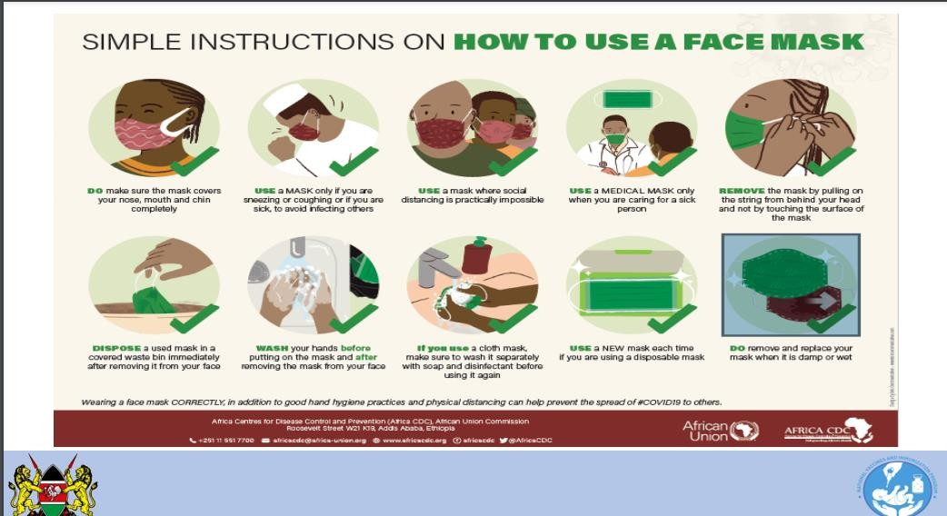

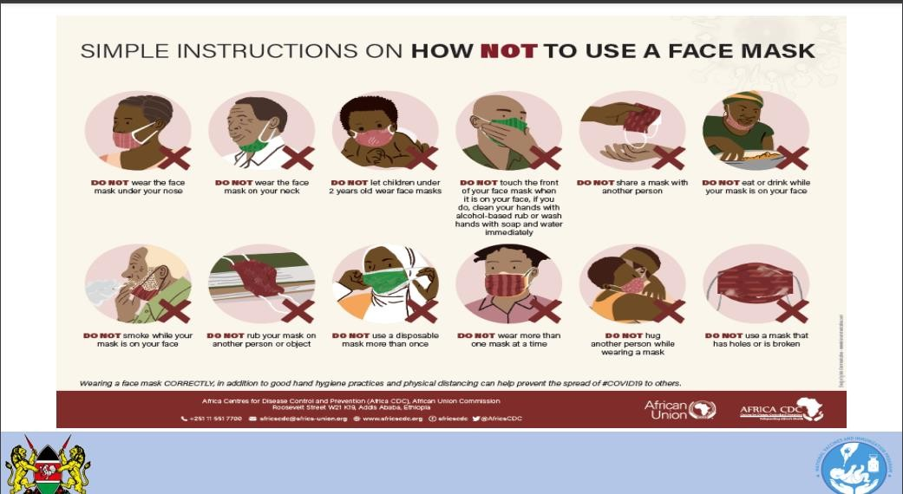

**Risk assessment for appropriate use of PPE**

Minimize direct unprotected exposure to blood and body fluids. (Table)

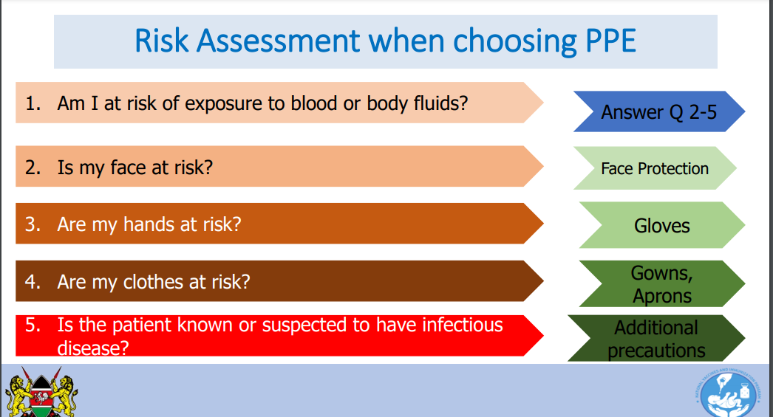

# Considerations when choosing PPE

1. **The procedure**
   * What procedures will be undertaken?
   * What are the chances of contact with the patient's blood or other body fluids

# The health-care worker

* + Does the health care worker have any skin abrasions?

Considerations when choosing PPE

# The equipment and facilities

* + Are all PPE available to use?
  + Is there a designated area for putting on and taking off PPE?
  + Is assistance required in putting on or taking off PPE?
  + Where are the nearest hand-hygiene facilities located?
  + Do all PPE fit correctly?
  + Where are the waste disposal facilities located?

# General principles when using PPE

* + Perform hand hygiene **before** handling and putting on PPE
  + Immediately remove and replace broken pieces of re-usable PPE
  + Immediately remove PPE after completing the procedure to avoid contaminating other surfaces and areas
  + Properly discard all single-use PPE immediately after use
  + Perform hand hygiene immediately **after** removing and discarding any item of PPE

# Recommended type of personal protective equipment

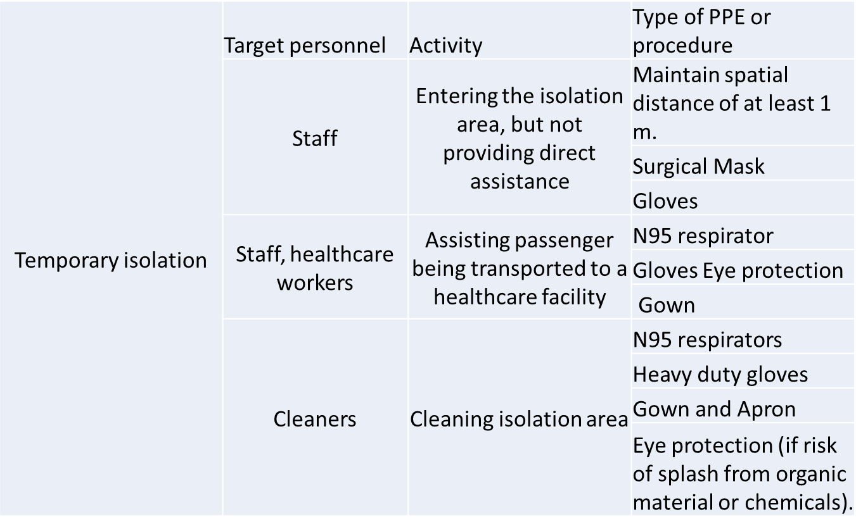

**Donning (PUTTING ON) a Gown**

* Don before contact with the patient or before entering the room.
* Perform hand hygiene.
* Use PPE cautiously – don’t compromise its integrity and effectiveness (tear or break it).

# Sequence for Donning Multiple PPE

1. Gown
2. Mask or respirator
3. Goggles or face shield
4. Gloves

# How to Don a Gown

1. Select appropriate type and size
2. Inspect for nonconformities
3. With the opening at the back, secure at neck and waist
4. If gown is too small, use two gowns
   * Gown #1 ties in front
   * Gown #2 ties in back

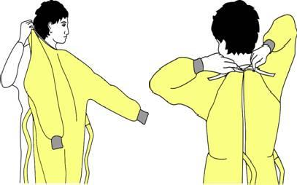

# How to Don a Mask

1. Select appropriate type and size
2. Inspect for nonconformities
3. Place over nose, mouth and chin
4. Fit flexible nose piece over nose bridge
5. Secure mask with ties or elastic as shown on the picture
6. Adjust to fit snugly

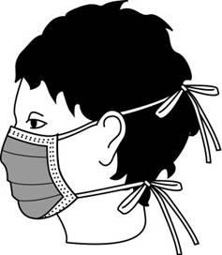

# How to Don Gloves

1. Select appropriate type and size
2. Inspect for nonconformities
3. Insert hands into gloves
4. Extend gloves over isolation gown cuffs

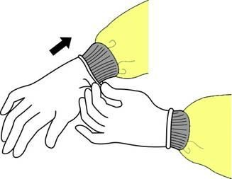

# How to Don Eye and Face Protection

1. Select appropriate type and size
2. Inspect for nonconformities
3. Position goggles over eyes and secure to the head using the earpieces or headband
4. Position face shield over face and secure on brow with headband
5. Adjust to fit comfortably

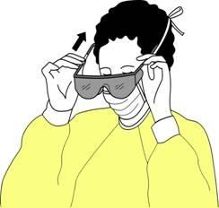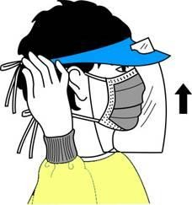

# Doffing (REMOVING) PPE

**How to take off all PPE items (Doffing) Step 1: Remove gloves and gowns**

* Avoid contamination of self, others and environment
* Remove the most heavily contaminated items first

***Remove gloves and gowns***

**Disposable**

* Peel off gown and gloves and roll inside-out
* Dispose of safely

# Reusable

* Peel off gloves and roll inside out; dispose of safely
* Remove gown and roll inside out; place in laundry bin

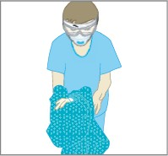

# Step 2: Hand hygiene

Perform hand hygiene

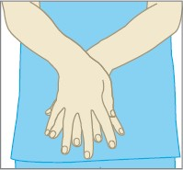

# Step 3:Remove Goggles and Face Shield

* Remove cap (if worn; a cap is not required PPE)
* Grasp ear or head pieces with ungloved hands
* Remove eye protection from behind
* Lift away from face
* Place in designated receptacle for reprocessing or disposal

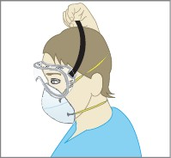

# Step 4: Remove a Particulate Respirator

‾ Remove mask from behind

‾ Lift the bottom elastic over your head first

‾ Then lift off the top elastic

‾ Discard

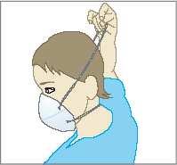

# Step 5: hand hygiene

* Perform hand hygiene

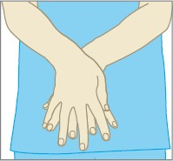

# How to Remove Gloves (1)

1. Grasp outside edge near wrist
2. Peel away from hand, turning glove inside-out
3. Hold in opposite gloved hand

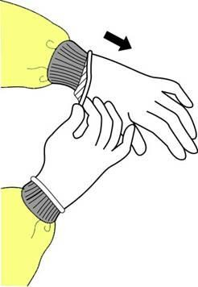

# How to Remove Gloves (2)

1. Slide ungloved finger under the wrist of the remaining glove
2. Peel off from inside, creating a bag for both gloves
3. Discard appropriately

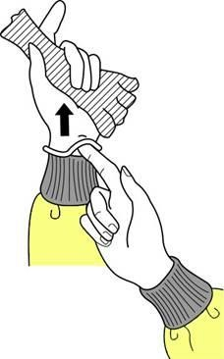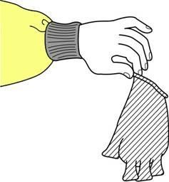

# How to Remove Gown

1. Unfasten ties
2. Peel gown away from neck and shoulder
3. Turn contaminated outside toward the inside
4. Fold or roll into a bundle
5. Discard

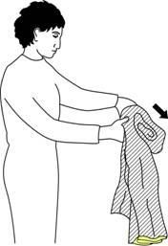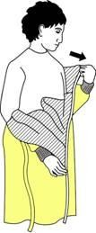

# How to remove a mask

1. Lift the bottom elastic over your head first
2. Then lift off the top elastic
3. Discard

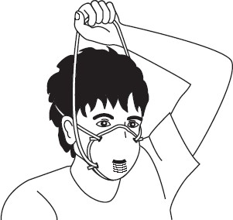

# How to Remove a Mask

1. Untie the bottom, then top tie
2. Remove from face
3. Discard

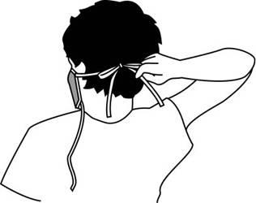 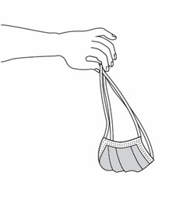

# Key points about removing PPE

* Remove and discard carefully, either at the doorway or immediately outside patient room; remove respirator outside room if anteroom is available.
* Immediately perform hand hygiene.

# Key messages

* Isolation is an effective method of preventing the spread of COVID 19 to family and community members
* Perform hand hygiene **before** handling and putting on PPE
* Perform hand hygiene immediately **after** removing and discarding any item of PPE

# COVID-19 Vaccine

By the end of this module the learner will be able to describe:

* Epidemiology of COVID disease
* Rationale for use of COVID-19 Vaccine
* Why AstraZeneca for Kenya

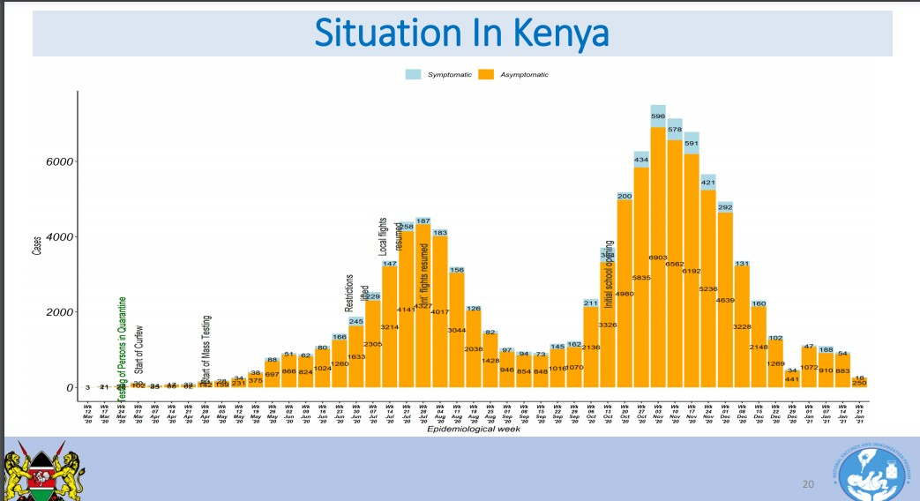

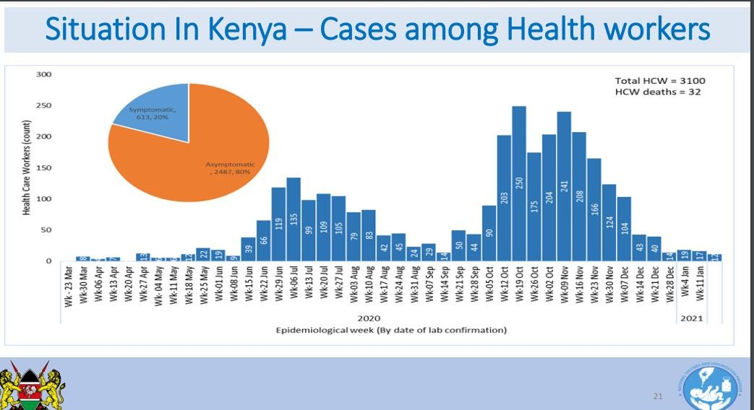

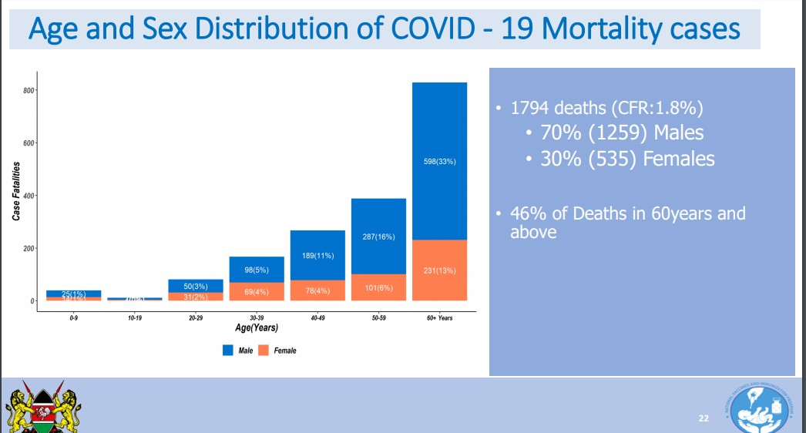

# Rationale for COVID – 19 Vaccine

COVID-19 disease has no known treatment and therefore prevention is key. COVID-19 vaccination will help protect you from getting COVID-19 disease. All COVID-19 vaccines currently available have been shown to be highly effective at preventing the disease. Based on what is known about vaccines for other diseases and early data from clinical trials, COVID-19 vaccine protects from getting severe COVID-19 disease. Getting vaccinated protects people around you, particularly people at increased risk for severe illness from the disease.

COVID-19 vaccination is a safer way to help build protection. Getting COVID-19 may offer some natural protection, known as immunity COVID-19 vaccination will help protect you by creating an antibody (immune system) response without having to experience sickness. The AZD1222 vaccine against COVID-19 has an efficacy of 63.09% (95% CI 51.81; 71.73) against symptomatic SARS-CoV-2 infection. Serum Institute India Aztra Zeneca (SII-AZ AZD1222 ) vaccine is available vaccine through COVAX Facility (Gavi, WHO, CEPI, UNICEF) – Vaccine to be stored 2-8 °C which is the available cold chain storage in Kenya.

COVID-19 vaccination will be an important additional tool to help stop the pandemic. Wearing masks and social distancing help reduce your chance of being exposed to the virus

or spreading it to others, but these measures are not enough. Vaccines will work with your immune system so it will be ready to fight the virus if you are exposed. Stopping a pandemic requires using all the tools we have available, COVID vaccine is an additional tool in stopping the effect of the pandemic

# Target Population, Eligibility Criteria and Contraindications

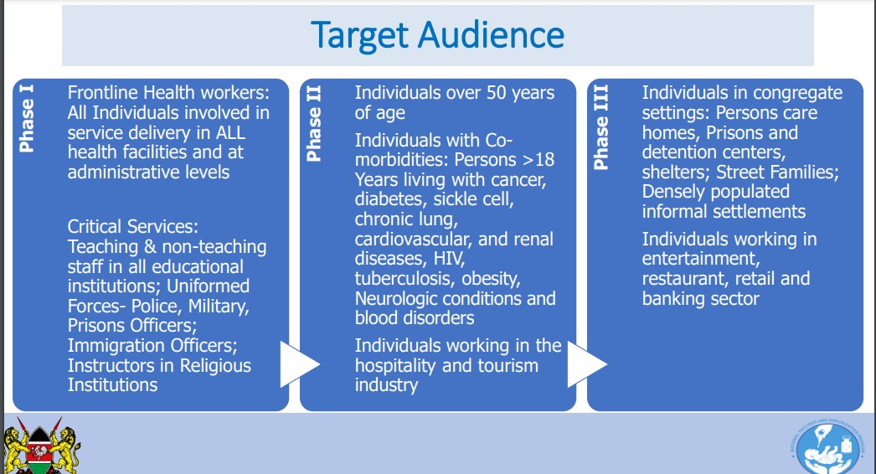

**Eligibility Criteria**

Part of target population for the phase being rolled out include; Age ≥18 years, provide verbal consent, persons who have previously had SARS-CoV-2 infection, vaccination may be offered regardless of a person’s history of symptomatic or asymptomatic SARS-CoV-2 infection.

# Contraindications

Hypersensitivity to the 1st dose, hypersensitivity to the active substance or to any of the excipients, anaphylaxis reaction following consumption of eggs or chicken and severe illness warranting admission

# Precautions

Precautions include; Acute febrile illness (38C and above), postpone administration in individuals suffering from an acute severe febrile illness. However, the presence of a minor infection, such as cold, and/or low-grade fever (37.5-37.9 C) should not delay vaccination.

Persons with acute PCR-confirmed COVID-19, should not be vaccinated until after they have recovered from acute illness and the criteria for discontinuation of isolation have been met (completion of the 10 days of isolation). People with bleeding disorders. Pregnancy only considered when the potential benefits outweigh any potential risks for the mother and fetus.

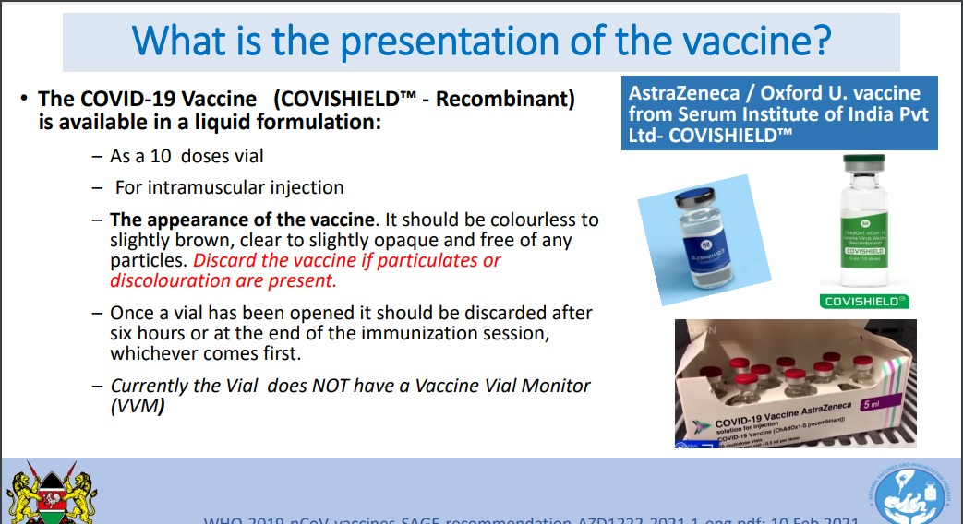

COVID19 vaccines should be stored between +2 oC and +8 oC. It is freeze sensitive, light sensitive and therefore store it in original box till ready to use. Currently NO Vaccine Vial Monitor (VVM) and has no preservative. DO NOT Shake the Vaccine

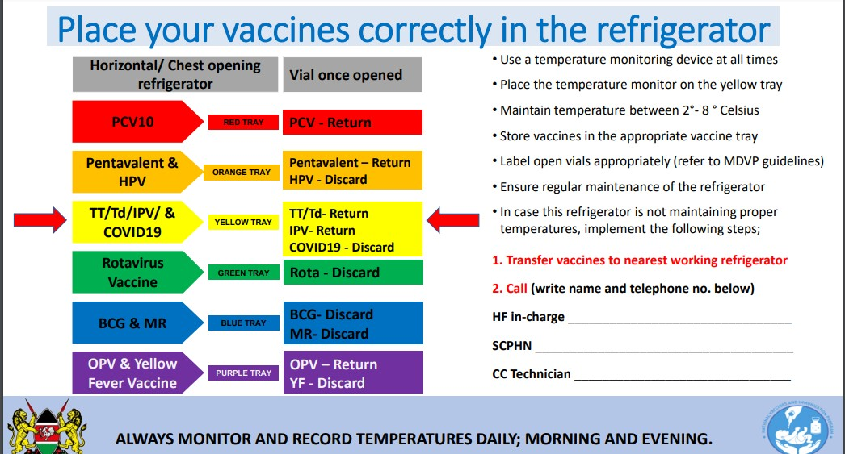

# IPC Principles for COVID-19 Vaccination

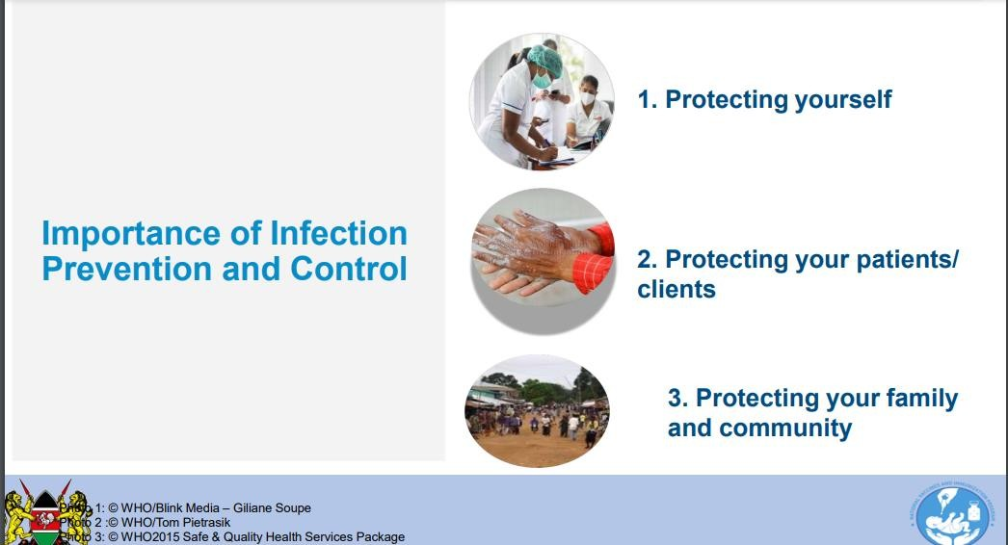

Healthcare facilities including vaccination sites are ideal settings for the transmission of SARS- Cov 2. Transmission can occur to other patients and healthcare workers. Sick patients are more susceptible to acquiring infections and procedures increase patients’ risk of infection. IPC measures helps reduce the risk of transmitting infections to patients, HCWs and to the environment

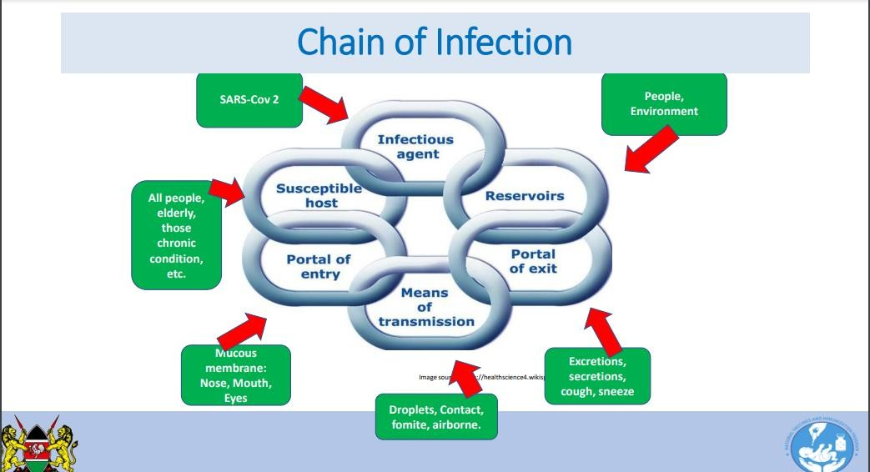

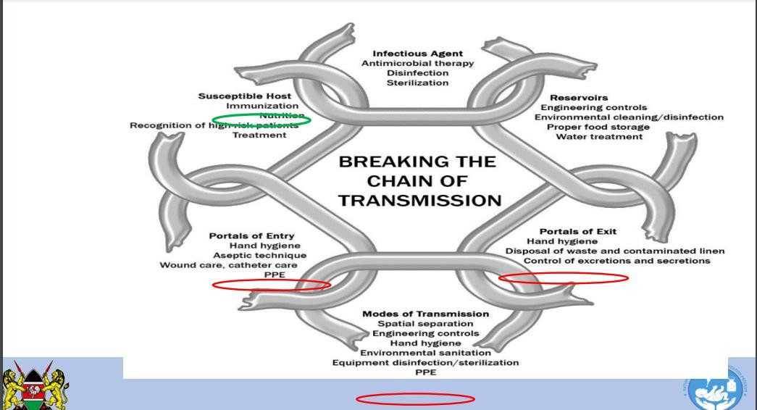

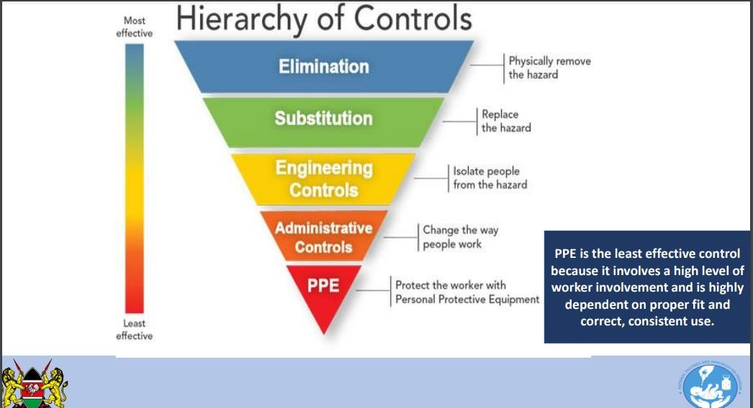

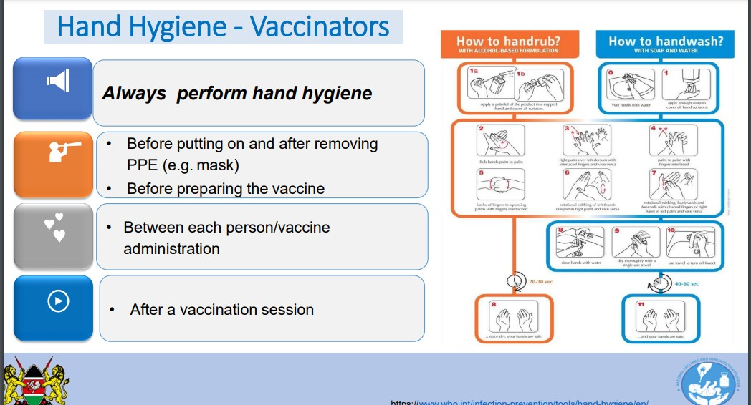

# Environmental Cleaning and Disinfection

Cleaning is physical removal of foreign material (e.g. dirt, blood or microorganisms). Removes rather than kills microorganisms. Disinfection is a thermal or chemical process for inactivating microorganisms on inanimate objects. Cleaning and disinfection procedures should follow MOH IPC guidance on COVID-19 and should be performed frequently at least twice daily

with special attention to high-touch surfaces in screening/triage areas e.g desktops, doorknobs, switches etc Minimize clutter to aid cleaning.

Environmental cleaning and disinfection solution includes; **Cleaning agents**: Detergents (liquid or powdered). **Disinfectants:** 0.5% Chlorine solutions made from chlorine products: oSodium hypochlorite oCalcium hypochlorite oSodium dichloroisocyanurate tablets. Ethyl or isopropyl alcohol (70-90%) (used on items that might react to water). Improved hydrogen peroxide and Quaternary Ammonium Compounds e.g Benzalkonium chlorides.

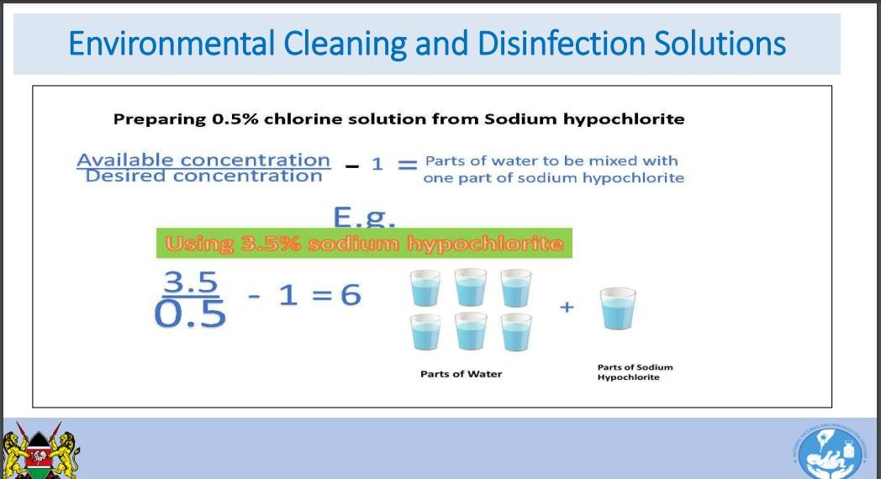

# Health Care Waste Management

Health care waste management is the process of collection, treatment and disposal of the health care waste. Management of waste related to COVID-19 requires special attention due to the infectious nature of the virus and usage of PPE, large volumes of immunization waste will be generated. Safe collection and final disposal of health care waste will eliminate the potential risk to health workers, the public and protect the environment.

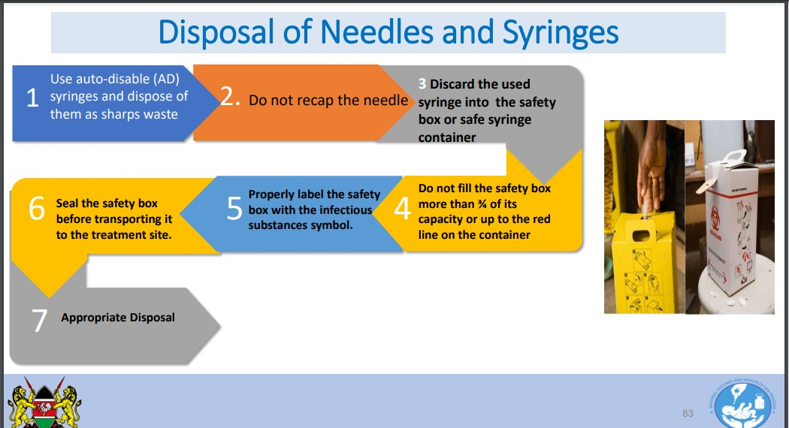

# Disposal of Vials

Put used vaccine vials and unopened vaccine vials which have expired or suffered heat exposure into a red or yellow puncture proof container for infectious waste, or into a biohazard container. Ensure that the containers are properly labelled with the infectious substances symbol. Seal the containers before transporting them to the disposal site.

# Disposal of PPE

Contaminated PPE is infectious waste and should be disposed as hazardous waste. Use a room/place away from the vaccination area to remove all used PPE. Ensure that container is properly labelled with the infectious substances symbol. Seal the containers before transporting them to the treatment site.

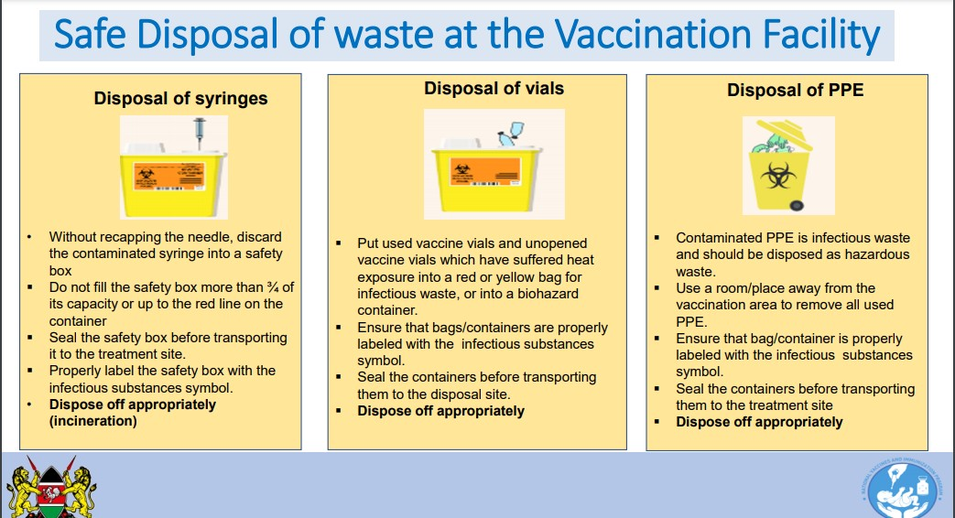

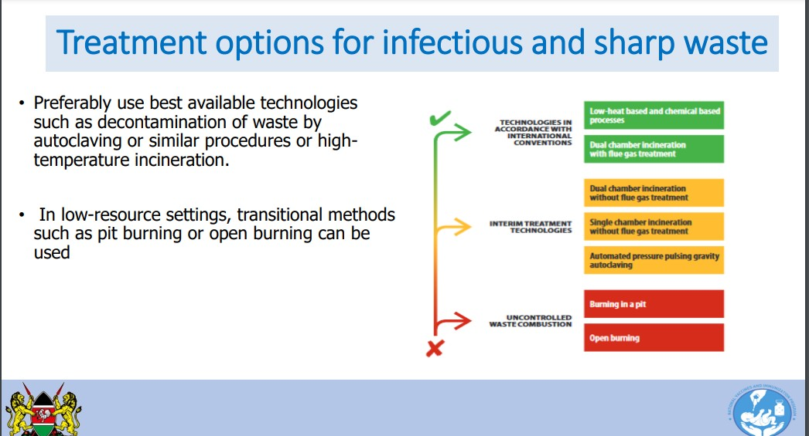

# Handling of Dead bodies

Health care workers or mortuary staff preparing the body (e.g. washing the body, tidying hair, trimming nails, or shaving) should wear appropriate PPE according to standard precautions (gloves, impermeable disposable gown [or disposable gown with impermeable apron], medical mask, eye protection); If the family wishes only to view the body and not touch it, they may do so, using standard precautions at all times including hand hygiene. Give the family clear instructions not to touch or kiss the body; Embalming is not recommended to avoid excessive manipulation of the body; Adults >60 years and immunosuppressed persons should not directly interact with the body.

Safety procedures for deceased persons infected with COVID-19 should be consistent with those used for any autopsies of people who have died from an acute respiratory illness. If a person died during the infectious period of COVID-19, the lungs and other organs may still contain live virus, and additional respiratory protection is needed during aerosol-generating procedures (e.g. procedures that generate small-particle aerosols, such as the use of power saws or washing of intestines);

If a body with suspected or confirmed COVID-19 is selected for autopsy, health care facilities must ensure that safety measures are in place to protect those performing the autopsy; Perform autopsies in an adequately ventilated room, i.e. at least natural ventilation with at least 160L/s/patient air flow or negative pressure rooms with at least 12 air changes per hour (ACH) and controlled direction of air flow when using mechanical ventilation; Only a minimum number of staff should be involved in the autopsy; Appropriate PPE must be available, including a scrub suit, long sleeved fluid-resistant gown, gloves (either two pairs or one pair

autopsy gloves), and face shield (preferably) or goggles, and boots. A particulate respirator (N95 mask or FFP2 or FFP3 or its equivalent) should be used in the case of aerosol-generating procedures.

# Teaching strategies

Interactive lectures

Small group demonstrations Small group discussions Role plays

Case scenarios Simulations

# UNIT 5: Surveillance of COVID-19 What is public health surveillance?

Ongoing systematic collection, analysis, and interpretation of health-related data essential to the planning, implementation, and evaluation of public health practice, closely integrated with the timely dissemination of these data to those responsible for prevention and control (**WHO** Definition). Regardless of the type of surveillance, remember that surveillance is information that is used for action!

# Purpose of Surveillance

The aim of surveillance for COVID-19 is to limit the spread ofdisease,enablepublichealthauthoritiestomanagetherisk of COVID-19, and thereby enable economic and social activity to resume to the extent possible.

Surveillance is also necessary to monitor the longer-term trends of COVID-19 transmission and the changes in thevirus.

# Standard Case definition for surveillance of COVID-19

This is used in routine **Integrated Disease Surveillance and Response (** IDSR

)surveillance to detect priority diseases and conditions .During the threats of COVID-

19 outbreaks, routine severe acute respiratory infection (SARI) surveillance is strengthened.

**SARI standard case definition:** Severe acute respiratory illness with fever of ≥38°C plus cough or sore throat or difficulty in breathing that require hospitalization. Any detected clusters of SARI is evaluated using COVID-19 working case definition

# Working case definition

During a threat or an outbreak of a particular disease/condition, the Ministry of Health develops working case definition to enhance surveillance of that disease/condition .

The working case definition takes into account the context of the disease/condition such as clinical info, person, place and time characteristics

The COVID-19 working case definition developed by the MOH considers suspected, probable and confirmed cases

# Working case definition for COVID-19

**A suspected case:** Any person with any acute respiratory illness (fever or cough or difficulty in breathing) AND at least one of the following:

PLUS

* A history of travel from China in the 14 days prior to illness
* Close contact* with a confirmed or probable case of COVID-19 in the 14 days prior to illness onset
* Close contact* with an individual with a history of respiratory illness and travel to China within the last 30 days
* Visited a health care facility where COVID-19 case had been reported 14 days prior to illness

*Close contact can be a workmate, classmate, fellow traveler, household member, care giver, etc.

# Identifying cases using COVID-19 working case definition

* + **Probable case:** A suspect case for whom testing for COVID-19 is inconclusive** or for whom testing was positive on a pan-coronavirus RT-PCR assay
  + **Confirmed case:** A person with laboratory confirmation of COVID-19 infection, irrespective of clinical signs and symptoms

**Inconclusive being the result of the test reported by the laboratory

# Signals in event based surveillance (EBS)

Signals are pre-defined by the Ministry of Health (MOH).A signal a set of observations used in EBS as an indicator of a possible public health threat in the population. Signals are the equivalent to standard and lay case definitions used in indicator based surveillance. Detection of signals will be done by the HWs, CHVs and community networks/members

COVID-19 signals include; any person with a history of travel or contact (visited, lived, worked, travelled, attended a function or provided care) with a person who has travelled from China (or any country reporting COVID-19 cases) and /or any person who reports/presents with fever, cough, sore throat or difficulty in breathing which has not responded to therapy **Application of the COVID-19 signals**

All HWs, CHVs and community networks/members must monitor the COVID-19 signals Once a signal is detected, it MUST be reported to either the CHA, HF Surveillance focal person (SFP) or the MOH. The CHA, SFP or the MOH with the support of the SCDSC immediately undertakes the following:

* + - Verification: Establishing whether the signal is factual or false.
    - Assessment: If the signal is factual, assess it against the COVID-19 working case definition
    - If the signal meets the COVID-19 working case definition, consider it a suspected case

Key considerations for comprehensive COVID-19 surveillance include:

* + - Use, adapt and strengthen existing surveillance systems
    - Include COVID-19 as a mandatory notifiable disease
    - Implement immediate reporting wherefeasible
    - Conductsurveillanceatdifferentlevelsofthehealth caresystem
    - Establish population denominators to aid in data interpretation
    - Establish laboratory testingdenominators

Type of Surveillance and Surveillance Sites forCOVID-19

|  |  |  |  |  |  |  |
| --- | --- | --- | --- | --- | --- | --- |
| **Type of**  **Surveillance** | **Surveillance Sites** | | | | | |
| Individuals  i n theCommunit y | Primary  C  are Sites (  non- sentinel ILI/SARI  ) | Hospitals (non- sentinel ILI/SARI  ) | Sentinel ILI/SAR  I Site | Residentia l Facilities and Vulnerabl e Groups | Vital Statistic s Offices |
| Immediate Case notification  system | X | X | X | X | X |  |
| Contact  Tracing System | X |  |  |  |  |  |
| Sentinel  virus surveillance |  |  | X | X |  |  |
| Sentinel case  surveillance |  |  | X | X |  |  |
| Cluster  investigation s | X | X | X | X | X |  |

|  |  |  |  |  |  |  |
| --- | --- | --- | --- | --- | --- | --- |
| Special settings |  |  | X |  | X |  |
| Mortality | X |  | X | X | X | X |

# Standard case notification Individuals in the community

Individuals in the community can play an important role in the surveillance of COVID-19.

These include individuals who have signs and symptoms of COVID-19 should be able to access testing at the primary care level. Sometimes testing may not be possible hence community- based surveillance, whereby the community participates monitors and reports health events to local authorities, may be helpful.

**Contact tracing** is the identification of all persons who may have had contact with an individual with COVID-19. A contact is also defined as a person involved in providing direct care for COVID-19 patients, working with health care workers infected with novel coronavirus, visiting patients or staying in the same close environment of a COVID-19 patient,working together in close proximity or sharing the same classroom environment a with COVID-19 patient ,traveling together with COVID-19 patient in any kind of conveyance or living in the same household as a COVID-19 patient within a 14‐day period after the onset of symptoms in the case under consideration.

By following such contacts daily for up to 14 days since they had contact with the source case, it is possible to identify individuals who are at high risk of being infectious and/or ill and to isolate them before they transmit the infection to others.

Contact tracing can be combined with door-to-door case-finding or systematic testing in closed settings, such as residential facilities,orwithroutinetestingforoccupationalgroups. See Appendix I contact tracing form and Appendix II contact follow up form

# Managing contacts

The contacts should be self-quarantined and observed daily. Monitor body temp at least once daily for 14 days from LAST date of contact. Symptomatic contacts should be evaluated immediately by the clinician responsible for contact-tracing. Any contact having fever of

≥38.0, cough or difficulty in breathing MUST be considered a suspected case and isolated. The person handling a contact should observe the following safety measures asfollows; Immediately don PPE (universal + transmission based), Isolate the patient in a well-ventilated single room and give supportive care (consider cohorting depending on the number of cases),Provide the suspected case with a face mask,Restrict/limit the HWs and relatives visiting the patient. Any one allowed to visit the patient MUST use personal protective equipment,Create a room where staff will change their clothes and aAvoid contact with your

body parts e.g. through rubbing eyes

# Surveillance at the primary care level

Where possible, testing should be available at primary care clinics; a complementary option is to establish dedicated COVID-19 community testing facilities, such as fixed sites in community buildings.

Patients with probable and confirmed COVID-19 cases should be notified within 24 hours of identification.

Fast data reporting and analysis is critical to detect new cases and clusters. The most important number of data variables should be collected (e.g., age, sex, dateofillnessonset,dateofsampletaken,testresult,location of testing site).

Data reporting to local or national public health authorities could be done online, through a mobile phone app, via SMS text message, or over the telephone. Dailyzeroreportingbyallsitesattheprimarycarelevel–the reporting of zero cases when none are detected – is crucial to verifying that the surveillance system is continuously functioning.

# Risk communication

Residents in the affected areas must be taught to avoid high-risk behaviors during the outbreak, including:

* + - Observe cough etiquette – use mask, tissue or flexed elbow
    - Avoid close contacts with those unwell
    - Hand hygiene
    - Avoid unnecessary contacts with animals
  + Communities should also be urged to report any suspect case immediately to the nearest HF or to the command centre

It is important that an alert desk (command centre) be established at the national, county or HF levels with (toll free) telephone lines and manned by a trained team. Members of the public should be encouraged to call in when they have suspect/ alert cases or when they have any query

All in-coming alert calls should be registered and the information passed on to the relevant team for appropriate verification/ investigation. The numbers used in reprting the cases should be toll free.

# Hospital-based surveillance

Patients with probable or confirmed COVID-19 diagnoses in hospitalsshouldbenotifiedwithin24hoursofidentification. All COVID-19 deaths should be reported within 24 hours of death.

The minimum essential data from hospital settings should include:

* + age, sex/gender and place ofresidence
  + date of onset, date of sample collection, date of admission
  + laboratory test result
  + severity on admission: admitted to intensive care unit (ICU), treated withventilation
  + if case is a health careworker
  + outcome (discharge or death) – usually requiring a follow- upreport,asoutcomeisgenerallynotknown within 24 hours of identification of case identification.

# Enhanced Surveillance for Residential Facilities and Vulnerable Groups

Enhanced surveillance for high-risk groups is necessary to ensure the prompt detection of cases and clusters, faster than through primary-care or hospital-based surveillance. People who live in closed environments, such as prisons, or residential facilities, such as retirement communities or care homes for persons with disabilities, can be especially vulnerable because they may not be able to seek help themselves.

Vulnerable groups may also live in settings where the probability of transmission is higher than in the general population or have health conditions or predisposing factors that increase their risk of severe illness.

Enhanced surveillance includes the use of active case finding, as through daily screening of signs and symptoms, including

* + dailytemperaturemonitoring,
  + dailyzero-reportingforall individuals in high-risk groups undersurveillance.

Infections in health workers should, at a minimum, be systematically integrated into the national surveillance system.

In refugee camps and among displaced population and other humanitarian or low-resource settings, additional considerations are warranted.

# Mortality Surveillance

* + The number of COVID-19 deaths due to COVID-19 in hospitals should be reported on a daily basis
  + . The number of deaths due to COVID-19 occurring in the community should ideally be reported daily or at least weekly.
  + It may be helpful to also monitor death due to non-specific respiratory causes (un- specified pneumonia).
  + For both hospital and community deaths, the age, sex, and location of death should be reported for all persons who die from COVID-19.
  + A medical death certificate of death for COVID-19 deaths should be issuedas described in [International guidelines for certification andclassification (coding) of OCVID-19 as cause of death HYPERLINK "https://www.who.int/classifications/icd/Guidelines_Cause_of_Death_COVID- 19.pdf"](https://www.who.int/classifications/icd/Guidelines_Cause_of_Death_COVID-19.pdf)and reported to vital statistic offices as normally required.
  + In communities where death registration and reporting are limited, other approaches for mortality surveillance may be considered, such as reports from religious centres or burial sites.Mortalitysurveys can be helpful for retrospectively estimating the total mortality burden due toCOVID-19.

# Laboratory testing data

* + Data on the number of tests conducted for SARS-CoV-2 should be collected from all relevant laboratories.
  + While surveillance systems will typically capture the number of COVID-19 cases, it is also important to collect information onthetotalnumberoflaboratorytestsconductedforCOVID- 19 virus. Knowing the testing

denominator can indicate the level of surveillance activity and the proportion of tests positive can indicate the intensity of transmission among symptomatic individuals.

* + Today, polymerase chain reaction (PCR) testing is the most common laboratory diagnostic method. If other diagnostic methods are used, the number of tests conducted and cases confirmed by different laboratory diagnostic methods used need to berecorded.

# Reporting and analysis of surveillance data

* + The data for COVID-19 described aboveshouldbereported,compiled,andanalyseddaily,with zero reporting when there are no cases.
  + Data should be compiled either nationally or at an appropriate government administrativelevel(e.g.,district,province,prefecture).
  + More in-depth analyses on age, sex-gender, testing patterns, comorbiditiesandriskfactors,symptomatologyandseverity, etc. should also be analysed on a periodic basis.
  + Routine analysis reports should be distributed to every reporting site inthesurveillancesystemandideallymadepubliclyavailable via a government website.
  + Relevant data should be reported to the World Health Organization in line with the global surveillance guidance available

# Additional surveillance approaches for COVID- 19

Surveillance approaches such as theuseofserologictestingandsurveillanceofenvironmental samples from waste water are beingexplored.

Event-based surveillance

* + Robust event-based surveillance (EBS) mechanisms captures unstructured information from formal and informal channels such as online content, radio broadcasts and print mediaacrossallrelevantsectors,tocomplementconventional public health surveillance efforts.
  + There should be dedicated humanresource and clear processes to sift through large volumes of information to filter, triage, verify, compare, assess and communicate relevant content.

# Participatory Surveillance

* + Participatory disease surveillance enables members of the public to self-report signs or symptoms, without laboratory testing or assessment by a health care provider.

# Telephone hotlines

* Telephone hotlines made available to the public for advice and referral to health care services may provide an early indication of disease spread in a community. Effectively running a telephone hotline service requires dedicated resources and trained staff to triage calls and appropriately refer callers to the relevant healthcare or other service.

# Unit 6: COVID-19 RISK COMMUNICATION AND COMMUNITY ENGAGEMENT

Outline

* Define what is risk communication
* Understand what is the Main Objective of COVID-19 risk communication
* Learn why we need Risk Communication
* Discuss the Goals of Risk communication
* Outline key steps of Risk Communication

# Corona Virus Risk Communication Risk Communication

It is the real-time exchange of information, advice and opinions between experts, community leaders, or officials and the people who are at risk. Risk communication is an integral part of any emergency response. During epidemics and pandemics, humanitarian crises and natural disasters, effective risk communication allows people most at risk to understand and adopt protective behaviors

# Main Objective of COVID 19 Risk Communication

To provide real time information, create awareness and increase knowledge that will generate action towards prevention, treatment and control of COVID-19 by all stakeholders

# Importance of Risk Communication in COVID19 Response

* To provide accurate and timely information
* To ensure essential coordination
* To inform the public of potential risks and steps being taken
* To aid those at risk to make the best possible decisions
* To prevent or contain the spread of COVID-19 and minimize social and economic disruption Goals of risk communication

# Goals of risk communication in COVID-19

* Provide meaningful, relevant and accurate information, in clear and understandable terms targeted to a specific audience.
* Communicate about preparedness measures and the public health advice.
* Share information vital for saving life, protecting health and minimizing harm to self and others; to change beliefs; and/or to change behavior.
* To create awareness and increase knowledge among the population

Note: Failure to communicate well, lead to a loss of trust and reputation, economic impacts, increased disease burden and − in the worst case – loss of lives.

# Action Steps of Risk Communications in COVID-19

1. Early first announcement is essential to build and maintain public trust
2. Create awareness among HCWs and the populations at risk
3. Be proactive in information dissemination with frequent updates
4. Use a mix of 4 tactics and approaches for risk communication
5. Identify and manage rumors and misinformation quickly
6. Develop simple IEC materials in languages and preferred channels of affected population

# Community Engagement

Outline

* + Define Community engagement
  + Undertake Community engagement practice
  + Develop key Messages Related to COVID-19
  + Develop Information, Education and Communication (IEC)

# Definition

Community engagement' is a strategic process with the specific purpose of working with identified groups of people, whether they are connected by geographic location, special interest, or affiliation to identify and address issues affecting their well-being.

# Community Engagement Practice

* Establish methods for understanding the concerns, attitudes and beliefs of key audiences
* Identify the target audiences and gather information about their knowledge and behaviors
* Engage through radio programs so that people can call in and ask questions
* Identify community influencers (e.g. community leaders, religious leaders, health workers, traditional healers, alternative medicine providers)
* Identify community Networks (e.g. women’s groups, community health volunteers, youth associations, religious groups, and social mobilizers) that can help with community engagement
* Anticipate special information and engagement needs for people who are disabled or illiterate.

# Key Messages Related to COVID-19

‘COVID 19 awareness specially for children’, ‘When to get tested for COVID 19’, ‘Protection measures from COVID -19’, ‘Do’s & Don’ts’, ‘Avoid close contact’, ‘Hand wash’, ‘stay at home’, ‘cover your mouth’, ‘Use of mask’, ‘Fact sheet about COVID 19’, ‘What you need to know about COVID 19’, ‘What to do if you are sick’, ‘Stop the spread of germs’, ‘Symptoms of COVID 19’, ‘Stay healthy, wash your hands’, ‘Awareness on handshaking’ etc.

# Information, Education and Communication (IEC)

This set of information, education and communication (IEC) materials aims to educate different gender, age and social groups (such as internally displaced persons, host communities, persons infected with COVID-19 and their caregivers, front-line workers fighting COVID-19 and people with disabilities) on the specific nature of stressors and mental health and psychosocial support implications induced by the COVID-19 environment. These IEC materials encourage individuals with diverse social roles and functions to resort to positive coping strategies while experiencing restrictions posed by COVID-19, promotes practice of daily self-care, and simultaneously calls on to be supportive to others regardless of required physical distancing. Moreover, IECs include specific psychosocial considerations aimed at sensitization of general public with regards to stigma and discrimination towards persons infected with COVID-19, as well as front-line workers who deliver services to them and fight COVID-19 on the front lines (such as health-care personnel, law enforcement officials, counsellors and humanitarian service providers).

# Teaching strategies

Interactive lectures

Small group demonstrations Small group discussions Role plays

Case scenarios Simulations **Learning Resources** Handouts

Online learning materials Web conferencing

IEC materials **Assessment Strategies** Pre and post tests

# Appendices

* IEC materials
* Sample pre and post tests
* Teaching slides
* Learners manual
* Trainers manual

# Unit7; OCCUPATIONAL HEALTH AND SAFETY

**Outline**

* Definition of occupational health and safety
* Describe of occupational health and safety
* Outline the objectives of occupational health and safety
* Outline the roles and responsibilities of various players in occupational health and safety
* Community health care workers responsibilities
* Health worker rights
* Exposure risk category

# cdn2.vectorstock.com/i/1000x1000/15/41/occupati...Definition

Occupational health and safety is the field of public health that studies trends in illnesses and injuries in the worker population and proposes and implements strategies and regulations to prevent them.

Community health workers are at the front line of any outbreak response and as such are exposed to hazards that put them at risk of infection with an outbreak pathogen (in this case COVID-19).

The Occupational Safety and Health Act, 2007. Is an ACT of Parliament that was to provide for the safety, health and welfare of workers and all persons lawfully. The Act is designed to

provide a broad framework for improving standards of workplace health and safety to reduce work-related injury and illness. It allows duty-holders to determine their approach to achieving compliance with the Act.

The aim of the ACT was to:

* Secure the health, safety and welfare of employees and other people at work;
* Protect the public from the health and safety risks of business activities;
* Eliminate workplace risks at the source; and
* Involve employers, employees and the organizations that represent them in the formulation and implementation of health, safety and welfare standards.

Utmost duty of care should therefore be exercised by: Employers, Management and the community health workers.

# Goal of occupational health and safety in COVID-19

The goal of occupational health and safety is to foster a safe and healthy work environment. OHS may also protect co-workers, family members, employers, customers, and many others against any form of harm or injury emanating from workplace environment.

# Objectives of Occupational Health and Safety in COVID-19

* Ensure that all workers are inducted and are aware of the health and safety practices
* Ensure Zero injury or life loss at work places
* Develop, implement and continue improving occupational health and safety standards at workplace in line with ISO standards

# Roles and Responsibilities of Employers and Government in COVID-19

* Ensure that all necessary preventive and protective measures are taken to minimize occupational health and safety risks. i.e.
  + Provide a workplace free from serious recognized hazards
  + Employers must provide safety training in a language and vocabulary workers can understand.
  + Display standard operating procedures (SOPs) on health and safety in a designated area where all workers can access
* Regular provision of technical updates and appropriate tools
* Advise workers on self-assessment, symptom reporting and staying home when ill (Use of exposure risk assessment tool periodically)
* Consult with health workers on occupational health and safety aspects of their work and notify the management of cases of occupational related diseases
* Provide quality and adequate infection prevention and control (IPC) and personal protective equipment (PPE) supplies in sufficient quantities. i.e.
  + Masks
  + Gloves
  + Goggles
  + Gowns
  + Hand sanitizer
  + Soap and water
  + Cleaning supplies

NB: No health worker should incur expenses for occupational safety and health requirements.

* Allow workers to exercise the right to remove themselves from a work situation (HCW to inform employer/management for arrangement for continuity of the service) if they have reason to believe that the situation presents an imminent and serious danger to their life or health.

# Community Health Care Workers Responsibilities in COVID-19

* Follow established occupational safety and health procedures – *maintain social distance, wear face mask, regular handwashing, sanitize*. Etc.
* Avoid actions or omissions that may expose yourself and others to health and safety risks and participate in employer-provided trainings.
* Use provided protocols to assess, triage and treat patients;
* Treat patients with respect, compassion and dignity;
* Maintain patient confidentiality;
* Provide or reinforce accurate infection prevention and control and public health information;
* Put on, use, take off and dispose of personal protective equipment appropriately in a way they do not contaminate the environment;
* Self-monitor for signs of illness and self-isolate or report illness to managers, if it occurs; e.g. Cough, sore throat, headache, fever Etc.
* Inform management if you are experiencing signs of undue stress or mental health challenges that require support interventions; and
* Report to the immediate supervisor any situation which you have reasonable justification to believe presents an imminent and danger to your health e.g. close contact with COVID-19 positive patient without face mask and failure to sanitize

# Health Worker Rights in COVID-19

The health worker rights include;

* The right to compensation and treatment (curative and rehabilitation) if infected with COVID-19 following exposure in the workplace
* Access to psychosocial support and counseling; and
* Right to exercise their rights and entitlements without infringement of other people’s rights

# Exposure Risk Category

1. **High-risk exposures:**

Community Health Worker (CHW) who have had prolonged close contact with patients with COVID-19 who were not wearing a facemask while health care worker (HCW) nose and mouth were exposed to material potentially infectious with the virus causing COVID-19

* + Being present in a room that generate aerosols or during which respiratory secretions are likely to be poorly controlled

# Medium-risk exposures:

CHW who had prolonged close contact with patients of COVID-19 who were wearing a facemask while HCW nose and mouth were exposed to material potentially infectious with the virus causing COVID-19.

* + Some low-risk exposures are considered medium-risk depending on the type of care activity performed e.g. wearing a gown, gloves, eye protection and a facemask (instead of a respirator) during an aerosol-generating procedure.

# Low-risk exposures:

Brief interactions with patients with COVID-19 or prolonged close contact with patients who were wearing a facemask for source control while CHW were wearing a facemask or respirator

# Teaching strategies

Interactive lectures

Small group demonstrations Small group discussions Role plays

Case scenarios Simulations

# Learning Resources

Handouts

Online learning materials Web conferencing

IEC materials

# Assessment Strategies

Pre and post tests

# Appendices

* IEC materials
* Sample pre and post tests
* Teaching slides
* Learners manual
* Trainers manual

# References/Further Reading

Abrams, E. M., & Greenhawt, M. (2020). Risk Communication During COVID-19. *Journal of Allergy and Clinical Immunology: In Practice*. https://doi.org/10.1016/j.jaip.2020.04.012

Ataguba, O. A., & Ataguba, J. E. (2020). Social determinants of health: the role of effective communication in the COVID-19 pandemic in developing countries. *Global Health Action*. https://doi.org/10.1080/16549716.2020.1788263

Husnayain, A., Fuad, A., & Su, E. C. Y. (2020). Applications of Google Search Trends for risk communication in infectious disease management: A case study of the COVID-19 outbreak in Taiwan. *International Journal of Infectious Diseases*. https://doi.org/10.1016/j.ijid.2020.03.021

Fang Li (2016), Structure, Function, and Evolution of Coronavirus Spike Proteins. Annual Review of Virology. doi: 10.1146/annurev-virology-110615-042301

<https://www.healthdirect.gov.au/about-coronaviruses>[Accessed 16th March 2020]

[https://www.who.int/news-room/commentaries/detail/modes-of-transmission-of-virus-](https://www.who.int/news-room/commentaries/detail/modes-of-transmission-of-virus-causing-covid-19-implications-for-ipc-precaution-recommendations) [causing-covid-19-implications-for-ipc-precaution-recommendations](https://www.who.int/news-room/commentaries/detail/modes-of-transmission-of-virus-causing-covid-19-implications-for-ipc-precaution-recommendations) [Accessed 16th March 2020]

<https://www.bbc.com/news/world-51235105> [Accessed on 16th March 202]

<https://www.who.int/healthtopics/coronavirus>[Accessed on 16th March 202]

MA-Jun. (2020). Key messages and actions for coronavirus peneumonia prevention and control in education institutions TT - 中国学校卫生. *Chinese Journal of School Health*.

Malecki, K. M. C., Keating, J. A., & Safdar, N. (2020). Crisis Communication and Public Perception of COVID-19 Risk in the Era of Social Media. *Clinical Infectious Diseases*. https://doi.org/10.1093/cid/ciaa758

MoH Kenya Interim Guidelines on Human Resource for Health during COVID-19 response, May 2020, Available from:[https://www.health.go.ke/wp-content/uploads/2020/06/Interim-](https://www.health.go.ke/wp-content/uploads/2020/06/Interim-Guidelines-on-Human-Resource-for-Health-during-Covid-19.pdf) [Guidelines-on-Human-Resource-for-Health-during-Covid-19.pdf](https://www.health.go.ke/wp-content/uploads/2020/06/Interim-Guidelines-on-Human-Resource-for-Health-during-Covid-19.pdf)

MoH Kenya Comprehensive Guide on Mental Health & Psychosocial Support during the COVID-19 Pandemic June 2020 Available from:[https://www.health.go.ke/wp-](https://www.health.go.ke/wp-content/uploads/2020/04/Final-Comprehensive-Guide-on-Mental-Health-and-Psychosocial-Support-For-COVID-19-Pandemic-4.pdf)

[content/uploads/2020/04/Final-Comprehensive-Guide-on-Mental-Health-and-Psychosocial-](https://www.health.go.ke/wp-content/uploads/2020/04/Final-Comprehensive-Guide-on-Mental-Health-and-Psychosocial-Support-For-COVID-19-Pandemic-4.pdf) [Support-For-COVID-19-Pandemic-4.pdf](https://www.health.go.ke/wp-content/uploads/2020/04/Final-Comprehensive-Guide-on-Mental-Health-and-Psychosocial-Support-For-COVID-19-Pandemic-4.pdf)

MOH/MOPHS. (2010). *National infection and control guidelines for health services in kenya.*

Nairobi: GOK.

Occupational Safety and Health Administration. (2020). Guidance on Preparing Workplaces for COVID-19. *Osha*.

Pan Zhai, Yanbing Ding, Xia Wu, Junke Long, Yanjun Zhong and Yiming Li, (2020), The epidemiology, diagnosis and treatment of COVID-19. International Journal of Antimicrobial Agents, Volume 55, Issue 5, 2020

Parasher, Anant (2020), COVID-19: Current understanding of its pathophysiology, clinical presentation and treatment. Postgraduate Medical Journal <http://pmj.bmj.com/content/early/2020/10/06/postgradmedj-2020-138577>

U.S. Department of Labor: Occupational Safety and Health Administration. (2020). Guidance on Preparing Workplaces for COVID-19. *Osha*.

World Health Organization. (2020). Rights, roles and responsibilities of health workers, including key considerations for occupational safety and health: Interim guidance-2. *World Health Organization*.

World Health Organization, -. (2019). Coronavirus Disease ( Covid-19 ) Outbreak : Rights , Roles and Responsibilities of Health Workers , Including Key Considerations for Occupational Safety. *World Health Organization (WHO)*.

WHO. (2020). The COVID-19 Risk Communication Package For Healthcare Facilities. *Who*.

WHO, IFRC, & Unicef. (2020). Key Messages and Actions for Prevention and Control in Schools. *Key Messages and Actions for COVID-19 Prevention and Control in Schools*.

World Health Organization. Critical preparedness, readiness and response actions for COVID-

19 (Interim Guidance) ([https://www.who.int/publications-detail/critical-HYPERLINK "https://www.who.int/publications-detail/critical-preparedness-readiness-and-response- actions-for-covid-19" preparedness-readiness-and-response-actions-for-](https://www.who.int/publications-detail/critical-preparedness-readiness-and-response-actions-for-covid-19) covid-19,

WHO. Mental health and psychosocial considerations during the COVID-19 outbreak, May 2020 Available from:[https://www](https://www/). [who.int/docs/default-source/coronaviruse/mental-health-](http://who.int/docs/default-source/coronaviruse/mental-health-considerations.pdf) [considerations.pdf](http://who.int/docs/default-source/coronaviruse/mental-health-considerations.pdf)

Occupational health and safety for health workers in the context of COVID-19 Course, Available from : <https://openwho.org/courses/COVID-19-occupational-health-and-safety>

Velavan, T. P., & Meyer, C. G. (2020). The COVID-19 epidemic. *Tropical medicine & international health : TM & IH*, *25*(3), 278–280. <https://doi.org/10.1111/tmi.13383>[Accessed on 16th March 202]

Yuki, K., Fujiogi, M., & Koutsogiannaki, S. (2020). COVID-19 pathophysiology: A review. Clinical immunology (Orlando, Fla.), 215, 108427.

<https://doi.org/10.1016/j.clim.2020.108427>

# APPENDIX I: Contact listing Form

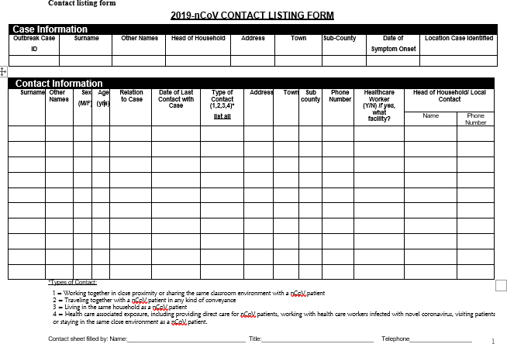

**List of Contributors**

|  |  |
| --- | --- |
| **Name** | **Title** |
| Prof. Michael Kiptoo | Chief Executive Officer |
| Dr. Lucy Waweru | Academic Registrar, |
| Dr. Solomon Kilaha | Deputy Registrar Curriculum |
| Dr. Jebichi Maswan | In Charge of Short Courses |
| Rosemary Wanjiku | Lecturer Public Health |
| Leonard Ng’eno | Lecturer Public Health |
| Kennedy Kinyua | Lecturer Clinical sciences |
| Evans Nyambega | Lecturer Nursing |
| Ahatha Abdi | Lecturer Diagnostic Sciences |
| Dr. Rose Wainaina | Lecturer Pharmaceutical Sciences |
| Francis Gachanja | Lecturer Public Health |
| Jotham Munala | Lecturer Rehabilitative Sciences |
| Charity Ngugi | Secretariat |
| Caroline Kiprop | Secretariat |