
AMREF VIRTUAL NURSING SCHOOL
SEPTEMBER 2009 COLLEGE FINAL PAPER 1
DATE: MONDAY 10TH OCTOBER 2011
TIME ALLOWED: 3 HOURS TIME: 9:00AM - 12:00 NOON
INSTRUCTIONS TO CANDIDATES:
- Read the questions and answer only what is asked.
- ENTER YOUR ADMISSION NUMBER AND QUESTION NUMBER IN THE on each sheet of paper used.
- All questions are compulsory.
- For Part 1 (M.C.Qs)
- Each M.C.Q is 1 mark
- For Part II (SHORT ANSWER QUESTIONS)
Answers to these questions should follow each other on the provided sheets of paper.
- For Part III (ESSAY/LONG ANSWER QUESTIONS)
Answers to each question must be on a separate sheet of paper.
- Omission of wrong numbering of examination papers, questions or parts of the question will result in 10% deduction of the marks scored from the relevant part.
- Each candidate MUST sign the examination return form after handling in ALL the scripts

PART ONE; MCQs (20mks)

- Hypotension in acute pancreatitis is mainly caused by;
- Profuse vomiting
- Loss of large amounts of protein rich fluid into tissues and peritoneal cavity.
- Bleeding into the tissues and peritoneal cavity.
- Profuse sweating and anxiety

- Clinical manifestations of neurogenic shock include;
  - Tachycardia, hypotension and dysrythmias.
  - Hypotension, hyperthermia and tachypnea.
  - Warm dry skin, bradycardia and hypothermia.
  - Hypothermia, warm dry skin and tachycardia.

- Hysteroscopy is indicated in ;
- Cases of infertility and cervical carcinoma.
- Endometrial carcinoma & infertility.
- Unexplained per vaginal bleeding & recurrent early pregnancy loss.
- Retained intra-uterine device & acute pelvic inflammation.

- Abnormal findings on Breast examination includes;
- Longstanding nipple inversion, breast tenderness before menses.
- Unilateral venous prominence, skin dimpling.
- Lumpiness before menstruation, skin dimpling.
- Longstanding nipple inversion, edema

- Early signs of cervical cancer include;
- Bleeding between menstrual periods, dyspareunia and prolonged bleeding.
- Heavy bleeding post intercourse, pelvic pain and unusual discharge.
- Pelvic pain, unusual vaginal discharge and increased urinary frequency.
- Prolonged bleeding, dyspareunia and bleeding between menstrual periods.

- The primary outcome of the assessment component of the nursing process is;
- Complete data base
- Comprehensive system review.
- Detailed nursing history
- Nursing diagnosis.

- Fracture immobilization is meant to achieve the following;
- Pain relieve, reduced movement and correction of malunion
- Prevention of displacement, pain relieve and reduced deformities.
- Prevent muscle spasms, bone alignment and increased circulation.
- Reduce malformations, restore circulation and relieve pain

For questions 8 and 9 match the drugs in column A with the descriptions in column B.

Column A. Column B.
8. a. Ethambutol ii i) causes smooth muscle contraction

b. Vasopressin ii) causes peripheral visual loss.

9. c. Neostigmine iv iii) used for staphylococcal septicaemia

d. Flucloxacillin iii iv) Is a cholinergic drug.

v) Causes hepatitis & cardiac toxicity

10. The stratified epithelium lines the following;
- Kidney tubules, buccal cavity and the throat.
- Lungs, trachea and inner lining of blood vessels.
- Eye conjunctiva,vagina and oesophagus
- Inner lining of blood vessels, buccal cavity and lungs.

11. A third degree burn involves;
- The epidermis and a portion of the dermis.
- Epidermis, upper dermis & a portion of deeper dermis.
- Epidermis, entire dermis, subcutaneous & connective tissue.
- Muscles and the bones only.

12. The common causative bacterial pathogens for otitis media are;
- Staphylococcus aureus, pneumococci.
- Klebsiella spp., pseudomonas spp.
- Staphylococcus aureus, pseudomonas spp.
- Streptococcus spp. Neisseria menengitidis

13. The stages of urine formation are in the order of:-

a) Filtration, urine concentration, secretion and reabsorption.
b) Secretion, urine concentration, filtration and reabsorption.
c) Filtration, reabsorption, secretion and urine concentration.
d) Urine concentration, filtration, secretion and reabsorption.

14. While caring for a patient in the recovery room after an operation under general anaesthesia, the nurse should notify the physician if the;
- Patient pushes out the airway.
- Respiration is regular but shallow.
- Systolic pressure drops from 130mmhg to 100mmhg.
- Patient has snoring respirations.

15. Contact dermatitis is initially suspected if the rash appears;
- Erythematous with raised papules.
- Dry & scaly flaking skin.
- Inflamed with weeping and crusting lesion
- Excoriated with multiple fissures.

16. Prior craniotomy the nurse should;
- Rule out facial oedema, shave the surgical site & restrict fluid intake.
- Ensure the patient is on antiseizures, shave the head & stop all other medications.
- Rule out neurological deficits, ensure patient is well hydrated and insert indwelling urinary catheter.
- Relieve pain, obtain results for all investigations & restrict fluid intake.

17. To assess the level of consciousness using the Glasgow coma scale, the nurse should check;
- Pupil size, orientation and muscle tone.
- Eye opening, motor and verbal response.
- Grasp strength, pupil size and response to commands.
- Flexing of limbs, muscle strength and orientation.

18. Indicate whether the following statements are true (T) or false (F) in the provided answer sheet.
- The skin should be cleaned with an alcohol swab before insulin injection is administered. F
- The onset of action for glucagon injection is 8-10min. T

19. The 24 hr urine collection is meant for the following investigations;
- Glomerula filtration rate and creatinine clearance.
- Blood urea nitrogen (BUN) and conjugated bilirubin levels determination.
- Analysis of adrenaline metabolite levels and blood urea nitrogen (BUN).
- Glomerula filtration rate (GFR) and serum potassium levels.

20. Clinical manifestations of retinal detachment include;
- Pain, luminous rays and floaters in the field of vision.
- Painless changes in vision, flashing lights & floaters in field of vision.
- Pain in the affected eye, headache & reduced visual acuity for near objects.
- Painless changes in vision, excessive lacrimation & photophobia.

PART B; SHORT ANSWER QUESTIONS (40MRKS)

- In order of priority explain the interventions a nurse should initiate on suspecting a blood transfusion reaction (6mks)

- a) Define high level disinfection (HLD) (1mk)
b) State two methods of high level disinfection (2 mks)
- Describe the process of fracture healing (6mks)
- Draw and label a diagram illustrating the relationship between the pituitary gland & the hypothalamus (5mks)
- List four (4) pre- renal causes of renal failure (2mks)
- Describe the pathophysiology of Asthma (5mks)
- Outline five (5) specific nursing responsibilities for a patient with Hyperglycaemic hyperosmolar non-ketotic syndrome (5mks)
- Assess signd of dehydration
- Assess neurological function
- Assess blood sugar levels
- Monitor pts vital signs
- State four (4) indications for a 12 lead ECG test on a patient (4 mks)
- Heart block
- Dysrarrythmia
- Cardiomyopathy
- arrythmias
- Outline the four (4) phases of menstrual cycle (4 mks)
- Proliferative
- Menstrual
- Secretory

PART C; LONG ANSWER QUESTIONS (40MKS)

- Mrs. Quiz. 45 yrs old is admitted in a medical ward having been diagnosed to have Hypertension.
  - List four (4) predisposing factors to hypertension (2mks)
- Obesity
- Lifestyle
- Age
- Diabetes mellitus
- Stress
- Genetic
  - State any two actual nursing diagnosis a nurse is likely to formulate for Mrs. Quiz( 2 mks)
- Impaired body comfort
- Deficient knowledge regarding the treatment regime

  - Describe the medical & nursing management for Mrs. Quiz from admission till discharge (14mks)

  - List four (4) complications of hypertension (2mks)
- Myocardial infarction
- CVA
- Renal failure
- Retinal haemorrhage
- Left ventricular hypertrophy

- Mr. Rocky. 56yrs old is admitted in a surgical ward with benign prostatic hyperplasia (BPH) and is scheduled for Trans-urethral incision of the prostate (TUIP).
- Draw and label a diagram illustrating longitudinal section of the male reproductive system & its associated structures (6mks)

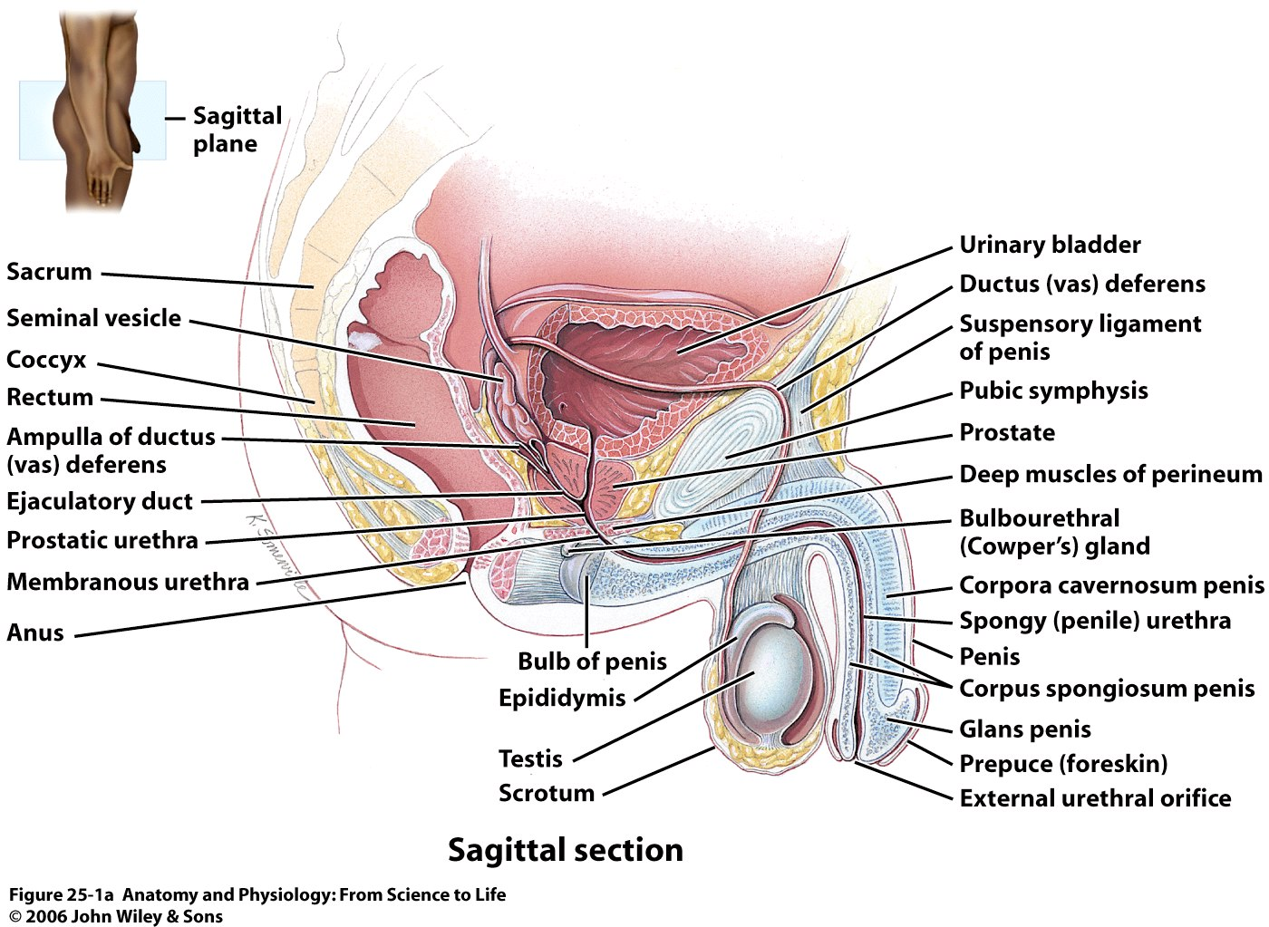

- Describe the pre and post operative care for Mr. Rocky (12mks)
- State two (2) complications of Trans-urethral incision of the prostate (TUIP) (2mks)
- Haemorrhage
- Infections

