***DIAGNOSTIC AND IMAGING TECHNIQUES***

*BROAD OBJECTIVES*

* *Demonstrate understandings of ;*
* *diagnostic imaging in management of orthopedic and trauma conditions*
* *understanding of effect of ionizing radiation.*
* *Relate radiological findings with clinical presentation of the patient*

*Module unit*

* *Introduction to diagnostic imaging*
* *Principles and concept of radiology and imaging*
* *Identify musculoskeletal abnormalities*

*RADIOLOGRAPHIC PROJECTION OF LOWER EXTREMITY*

IMAGE INTERPRETATION

It is a process of studying and examining diagnostic images to identify and explain findings viewed.

Principles (basics) of radiographic images interpretation

Systematic approach

1. checklist

* Patient and image details
* Bone and joint alignments
* Joint spacing
* Cortical outline
* Bone texture
* Soft tissue

2. viewing principles

* 2 views are better than 1
* Check all available images
* Compare with the other side (if imaged)
* If available always compare with old image

**Patient and mage details**

Key points;

Positively identify patient

Date and time of examination

Correct identification of side examined

**Bone and joint alignment**

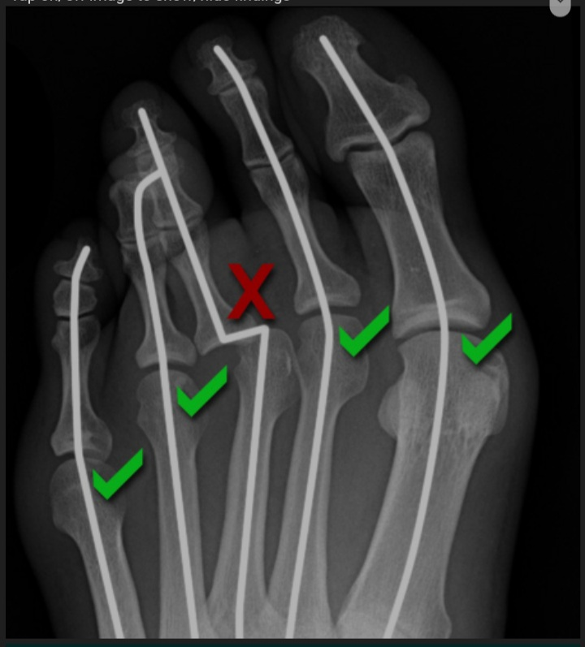

Loss of alignment maybe due to bone fracture or joint dislocation, both associated with soft tissue injury which may not be directly visualized

Joint spacing

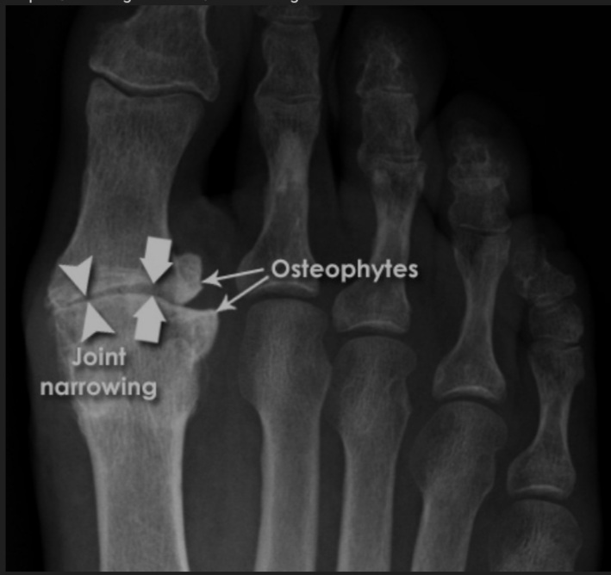

Narrowing of joint maybe due to cartilage loss or widened due to dislocation or dissociation

Cortical outline

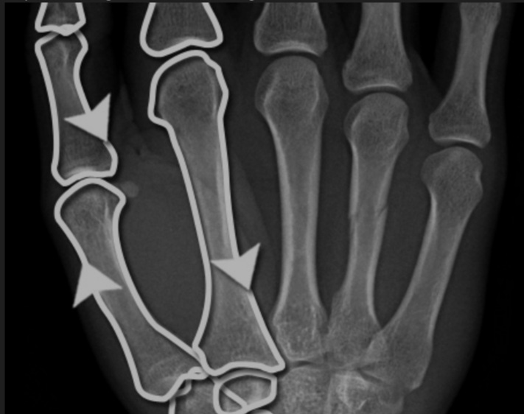

Bone cortex requires careful scrutiny i.e too brief will lead to incorrect or incomplete diagnosis

Bone texture

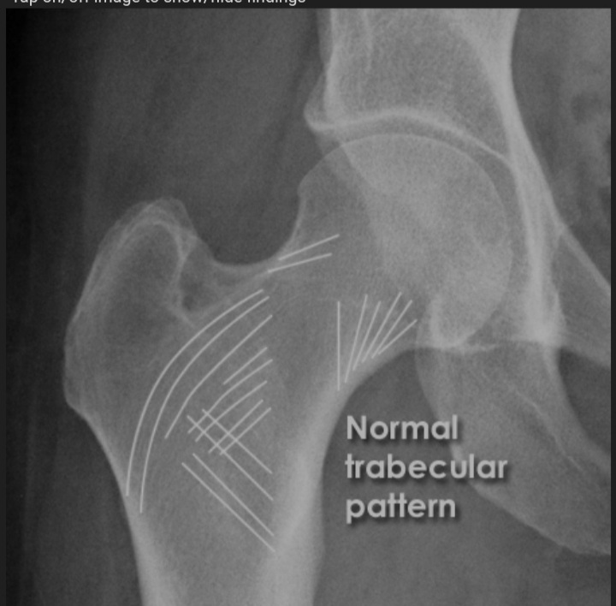

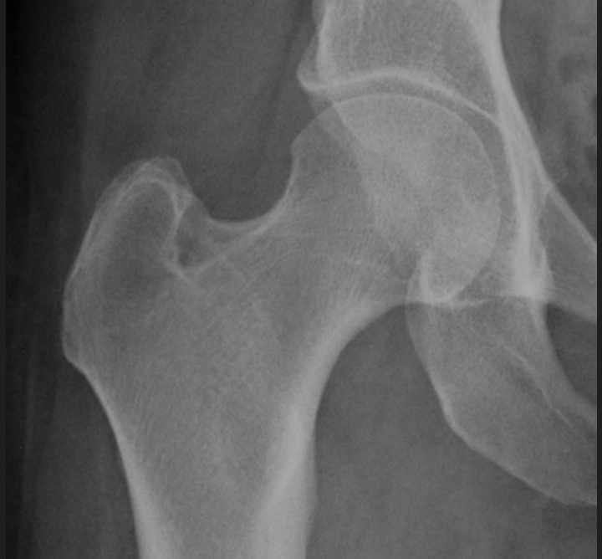

**Soft tissue**

Abnormalities of soft tissue is more obvious than a bone injury or may even imply a bone injury than not visible at all

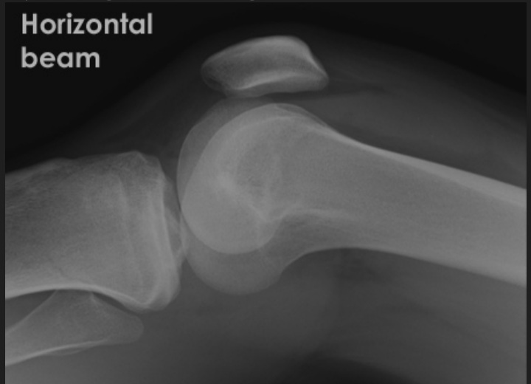

KEYPOINTS

* Plain radiographs provides information about bones, soft tissue and joints
* Be systematic
* Look at all views available
* If available compare with old images
* Look for the unexpected
* Assess image quality and if clinically inappropriate consider repeat x-ray

Note: **KEEP YOUR EYES ON THE BALL**