**DIGESTIVE SYSTEM**

**Role:** It provides the cells of body with nutrients.

**Introduction**

**Digestion:** The process by which insoluble food consisting of large molecules is broken down into soluble compounds having smaller molecules.

The smaller molecules in solution form pass through the walls of the intestine and enter the blood stream.

Digestion and absorption take place in the alimentary canal.

Digestion is brought about by means of active chemical compounds called enzymes.

Juices are secreted in the alimentary canal from glands in its lining or are poured into it through ducts from glandular organs outside it.

As food passes through the alimentary canal it is broken in stages until the digestible material is dissolved and absorbed.

The indigestible residue is expelled through the anus.

1. **The oral cavity (Mouth, Buccal cavity)**

It consists of the following parts;

* The cheeks- they form the cavity’s side walls.
* The tongue and its muscles- they form the cavity’s floor.
* The palate- this is the roof of the mouth. It is divided into anterior part called the hard. Palate and posterior part called the soft palate. The bones forming the hard palate are the maxilla and the palatine bones.

**The soft palate is muscular**

* The ovula is a curved fold of muscles covered with mucous membrane which hands from the middle of soft palate.
* Vestibule is that part of mouth outside the gums and teeth.
* Palatine tonsils- These rests on the floor of the oral cavity.
* Pillar of faunces. Form the sides of arm formed by soft palate.

**Structures in the oral cavity**

**The teeth-** discussed under skull

**The salivary glands**

Three pairs of salivary glands are located in the oral region.

* Parotid glands- situated one on each side of the face. Each gland has a parotid duct opening into the mouth.
* Sub mandibular glands- these glands lie on each side of the face under the angle of the jaw. The two submandibular ducts open on the floor of the mouth.
* Sublingual glands – these glands lie under the mucous membrane of the floor of the mouth in front of the submandibular glands.

**NB:** The whole of the oral cavity is lined with mucous membrane.

**Diagram of the oral cavity**

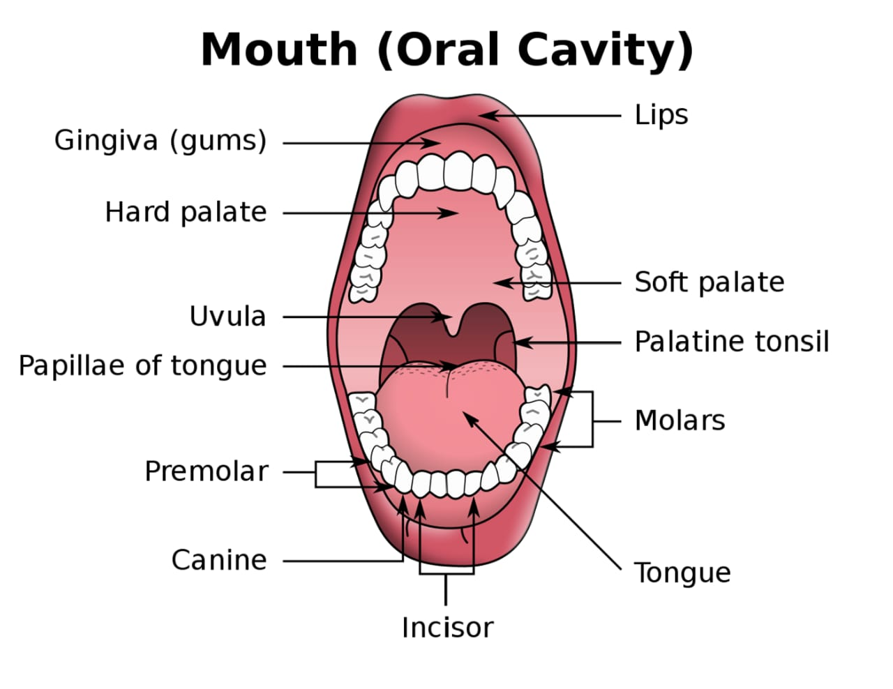

**Swallowing of food**

* The soft palate- closes the opening between the nasal cavity and the pharynx.
* The epiglottis- is a flap of cartilage which directs food over the opening of larynx. In this way, food is able to pass over the trachea without entering it.

1. **The oesophagus (Gullet)**

* The oesophagus is a muscular tube which connects the throat (Pharynx) with the stomach.
* The oesophagus is about 8 inches long and is lined by moist pink tissue called mucous.
* The oesophagus runs behind the wind pipe (trachea) and heart.
* It runs in front of the spine.
* Before entering the stomach, it passes through the diaphragm.

**Oesophagus sphincters**- Two sphincters play a crucial role in the passage of food. These includes;

**Upper oesophagus sphincter.** This is a bundle of muscles at the top of the oesophagus. They keep food and secretions from going down the wind pipe.

**Lower oesophagus sphincter.** This is a bundle of muscles at the lower end of the oesophagus where it meets the stomach. It prevents acid and stomach contents from travelling backwards from the stomach (A process called **regurgitation**).

**Parts of the oesophagus**

Oesophagus is anatomically divided into three parts.

* Cervical oesophagus- lies at level of cervical spine.
* Thoracic oesophagus – lie at level of thoracic spine
* Abdominal oesophagus – lies at the abdominal cavity.

**Layers of the abdomen**

The walls of the oesophagus consist of four layers from the inner most layer to the outermost layers as follows;

* Mucosa (inner moist layer)
* Sub mucosa
* Muscularis propria
* Tunica adventitia (outermost layer)

**Diagram of oesophagus**

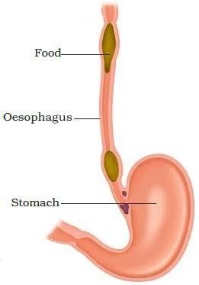

1. **The stomach**

This part of the alimentary canal has flexible walls and can be extended by the accumulation of large amount of food.

* It is a J shaped organ
* It is located in

**Parts of the stomach**

The stomach has four main anatomical dimensions.

* The cardia – This sis the superior opening of the stomach.
* Fundus- the rounded superior part of the stomach.
* Body – the large central portion of stomach.
* Pylorus/atrium- the lower opening of the stomach.
* Stomach has two curvatures (greater and lesser curvatures)

**Layers of the stomach**

The stomach consists of three layers

* The peritoneum (outermost)
* The muscle layer
* The mucous membrane lining (innermost)

The peritoneum- this fold of peritoneum attaches the stomach to the posterior abdominal wall.

The muscle layer – this consist of three layers of smooth muscle fibres.

* The outer layer has longitudinal fibres
* The middle layer has circular fibres.
* The inner layer has obligue fibres.

This arrangement allows for the churning motion as well as peristaltic movement of food. (Helps in the mixing and breaking of stomach contents and propel it into the duodenum).

The mucous membrane lining – within the mucous membrane there are numerous gastric glands which secrete gastric juice.

**Diagram of the stomach**

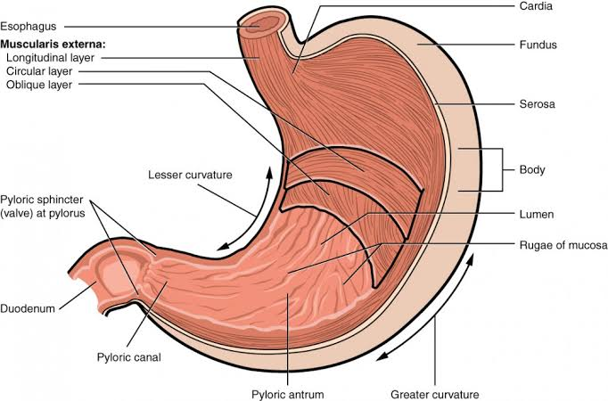

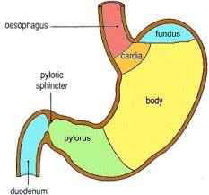

1. **The small intestine**

The small intestine (small bowel) lies between the stomach and the large intestine (large bowel).

The small intestine consists of the following parts;

* Duodenum
* Jejunum
* Ilium
* Its lumen diameter is smaller than that of the large intestine.
* It is longer in length than the large intestine.
* It begins at the lower end of the stomach. The opening between the two organs is the pyloric orifile and is guarded by the pyloric sphinater muscle.

**Duodenum**

* It is the first segment of the small intestine.
* It is a C shaped segment.
* It is a continuation of the pylorus part of the stomach.
* Distally it is continuous with the jejunum and the ileum.
* It is positioned inferiorly to the stomach and is approximately 25cm to 30cm long.

**Jejunum**

* Jejunum make up two fifth (2/5) the total length of the small intestine.
* It is larger in diameter than the ileum.
* There is no clear border between the jejunum and the ileum.

**The ileum**

* It is a U-shaped fold.
* The ileum is the longest part of the small intestine.
* It makes up about 3/5 of the total length of the small intestine.
* It is thicker and more vascular than the jejunum.

**Diagram of the small intestine**

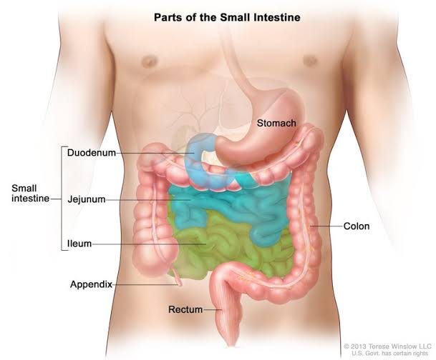

**5. The large Intestine**

* It is approximately 1.5m long and comprise of;
* The caecum
* Colon
* Rectum
* Anal canal
* Anus

1. **Caecum**

* It is a pouch or large tube-like structure in the lower abdominal cavity that receives undigested food material from the small intestine.
* It is the first region of the large intestine.

**Appendix** – is a small tube extending from the lower part of caecum.

1. **Colon**

* This is the largest part of the large intestine. The colon is divided into four parts;
* The ascending colon
* Transverse colon
* Descending colon
* Sigmoid colon

1. **Rectum**

* It is the most distal segment of the large intestine.

1. **Anal canal**

* It is a tube at the end of the rectum that measures about 4cm.
* There are several sphinater muscles that surround the anal canal which keep it closed.
* These include;
* Internal anal sphinater muscles (intrinsic muscles)
* External anal sphinater muscles (Extrinsic muscles)

The external anal sphinater muscles are striated muscles and can be controlled voluntarily.

The internal anal sphinater muscles are smooth muscles and can be controlled involuntarily.

**Hemorrhoids**

* Hemorrhoids, also called piles are swollen veins in the anus and lower rectum, similar to varicose veins.
* Hemorrhoids can develop inside the rectum and are called internal hemorrhoids.
* They can also develop under the skin around the anus and are called external hemorrhoids.

**Diagram of large intestine**

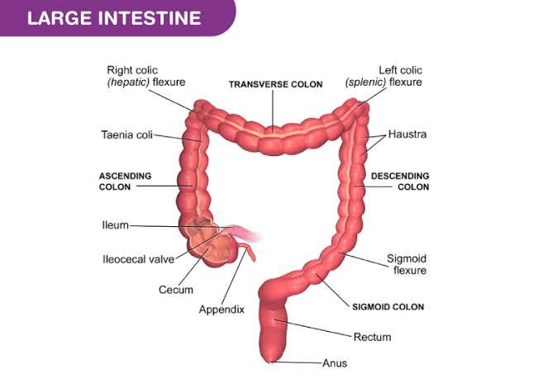

**Accessory organs of digestion**

These organs are;

* The liver
* The gall bladder
* Pancrease
* The three pairs of salivary glands
* Teeth
* Tongue

1. **The liver**

* The liver is a large, dark reddish-brown organ.
* It weighs about 3kgs.
* It is shaped like a cone.
* It is located in the right hypochondriac epigastric and rt lumbar regions of abdomen.

**Diagram of liver**

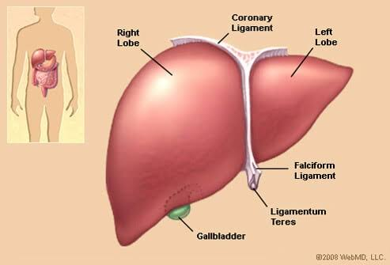

1. **The gall bladder**

* It is a pear- shaped organ below the liver.
* It can also be defined as a sack-like structure.
* It is located in the right hypochondriac regions of abdomen and right lumbar.
* It is the reservoir of bile, a yellow-brown digestive enzyme produced by the liver.
* The gall bladder is part of the biliary tract.

NB: The duct from liver merge with the duct from gall bladder to form the common bile duct.

**Diagram of billing tract (tree)**

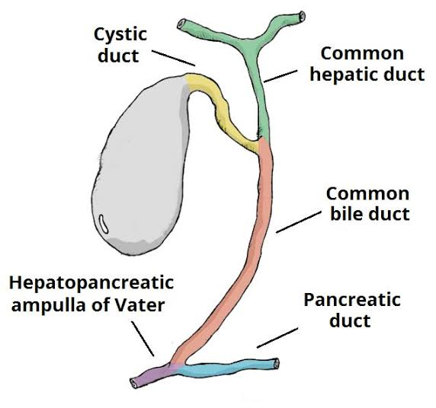

**Pancrease**

* It is shaped like a flat peer, leaf or a fish like structure.
* The pancrease is a pale grey organ.
* It is located in the epigastric and left hypochondriac regions of abdomen.
* It consists of;
* A broad head
* Neck
* Body
* A narrow tail

Head – the widest part of pancrease

Neck- the thin section of the gland between head and body.

Body – the middle part of pancrease between neck and tail.

Tail- The thin tip of pancrease in the left side of abdomen near the spleen.

**Diagram of pancrease**

