FRACTURES OF LOWER LIMB

Objectives
By the end of the lecture, student should be able:
- 1)To know common fractures of lower limb
- 2)To diagnose the fractures of lower limb
- 3)To examine immediate complications and their treatment

Fractures of Lower Limb

Classified according to bones of lower limb
1)Femur
2)Patella
3)Tibia
3)Fibula
4)Tarsal bones
5)Metatarsal
6)Phalanges

Fractures of Femur

It can be classified as:
i) Fractures of upper end of Femur
i) Fractures of Shaft of Femur
iii) Fractures of lower end of Femur

Fractures of Upper End of Femur

It can be divided into following according to parts of bone
a) Fracture Neck of Femur
b) Intertrochanteric fracture
c) Subtrochanteric fracture

Fracture Neck Femur

- Commonest fracture of lower limb in the elderly
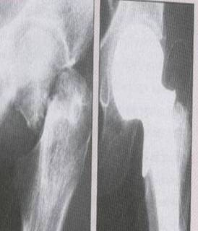
- Chances of nonunion is very high due to its peculiar blood supply
- A trivial injury might cause this fracture due to osteoporosis.

It is classified radiologically into four types according to Garden in 1961
Type1 incomplete impacted fracture
Type2 complete but undisplaced fracture
Type3 complete with moderate displacement
Type4 severely displaced fracture

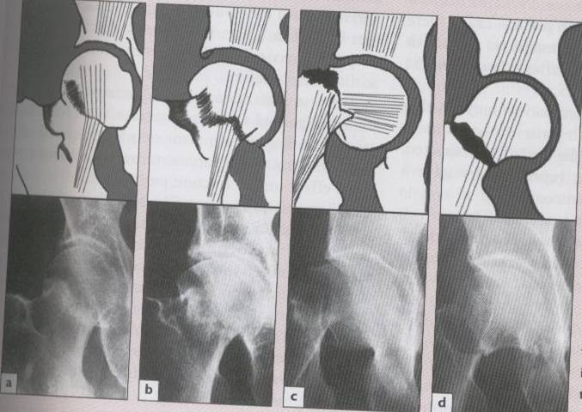

Clinical features
- The affected limb is short and externally rotated
- Pain and swelling at fracture site
- Can’t lift the affected leg
- Severe pain on movement
- Cant stand or put weight on affected limb( except impacted fracture)

Complications:
- Nonunion
- Avascular necrosis of head of Femur
- Osteoarthritis of hip

Treatment:
- Almost always surgical
- It depends upon age and type of fracture
- If age is above 60 the treatment is hemiarthroplasty, whatever the type of fracture
- If age is between 40 and 60 and it is type 3 or 4 fracture, treatment is hemiathroplasty
- If age is between 40 and 60 and it is type 1 or 2 fracture, treatment is to reduce the fracture and fix with cannulated screws, sliding screw or pin and plate(DHS). Aim is to try to retain its original head
- If age is below 40 whatever the fracture type may be, try to retain the head and after reducing the fracture, fix it with the implant described above. Reduction may be closed or open under anaesthesia

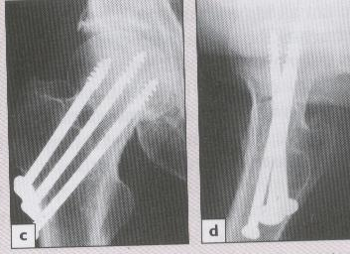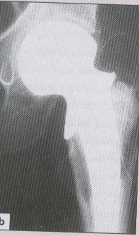

Intertrochanteric Fracture

- As name indicates the fracture is in the trochanteric region (greater and lesser trochanters)
- 2nd commonest fracture of lower limb in elderly
- Greater force is needed to cause this fracture (as compared to neck Femur)

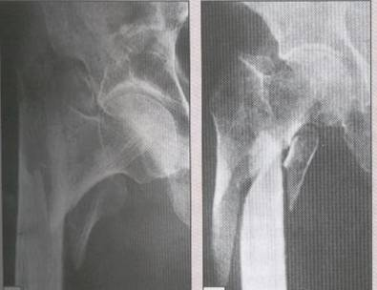

Classified into four types
- Type1 Undisplaced and uncommunited
- Type2 Displaced with minimal comunition
- Type3 Displaced with severe comminution
- Type4 Severely communited with subtrochanteric extension
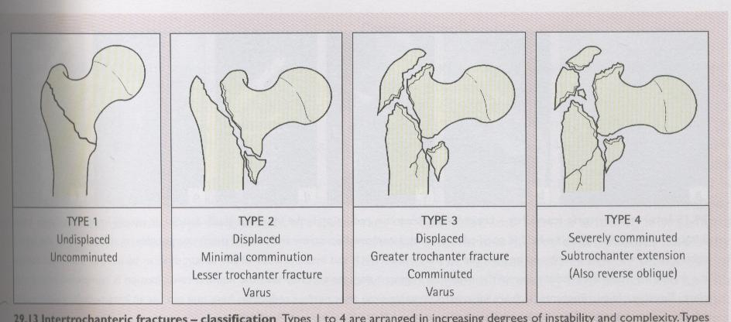

Clinical feature:
- The affected limb is shorter and externally rotated
- Pain and swelling at fracture site
- Pain on movement of leg
- Cant stand or put weight on affected leg

Complications:
- Failed fixation
- Malunion
- Nonunion

Treatment
In any type treatment is almost always internal fixation with pin and plate(DHS) preceded by closed or open reduction of fracture under anaesthesia.

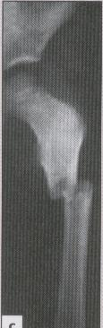
Subtrochanteric Fracture

- As name indicates the fracture is just below the trochanters
- This fracture may occur with trivial injury
- The fracture is always considered as pathological fracture until and unless proved otherwise

Clinical features:
- The affected limb is shorter and externally rotated.
- Excruciating pain is noted
- Swelling is evident
- Movement of leg causes severe pain

Complications:
- Failure of implant
- Delayed union
- Malunion
- Nonunion

Treatment:
- Is almost always surgical.
- Open reduction under anaesthesia and internal fixation with Pin and plate(DHS), DCS, Condylar plate or intramedullary nail with or without a locking screw into the neck and head.

Fracture of Shaft of Femur

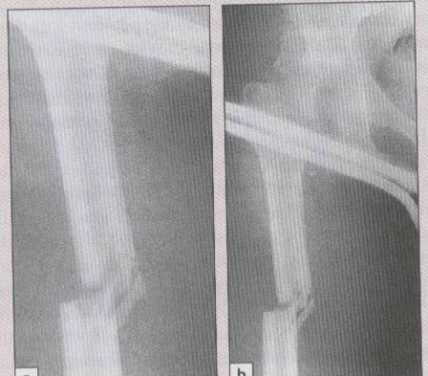
- Commonly occurs in young adults
- Blood loss is severe

Clinical features
- Pain and swelling at fracture site
- Patient may be in shock
- There may be associated injury

Complications
- Shock
- Fat embolism
- Thromboembolism
- ARDS
- Infection
- Delayed union
- Malunion
- Nonunion
- Joint stiffness
- Implant failure and refracture

Treatment
- Usually surgery
- Immediate blood transfusion
- Treat shock if any
- Immobilize the limb in a splint (Thomas splint)
- Definitive treatment is ORIF
- Implant used may be
- Interlocking Nail
- Broad Dynamic Compression Plate(DCP)
- K-nail

Supracondylar and Condylar Fracture

- May occur in adults as well as in elderly people
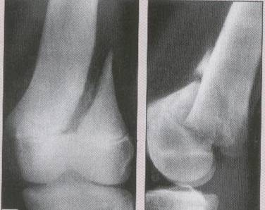
- In adults it needs a great force while in elderly it can happen following a trivial injury due to osteoporosis
- Pain and massive swelling at knee
- Danger of neurovascular injury, so always look for distal pulses and nerves

Treatment
- may be conservative or operative
- conservative treatment may be in the form of traction and braces
- operative treatment in the form of ORIF and the implant used may be Condylar plate or Dynamic Condylar Screw(DCS)

Complications
- Neurovascular injury
- Joint stiffness
- Delayed union
- Nonunion

Fracture of Patella

- Patella is a sesamoid bone
- Fracture is usually transverse, it may be undisplaced, displaced or communited

Treatment
- is usually ORIF with wires in the form of tension band wiring
- If it is communited, partial or total patellectomy is advisable
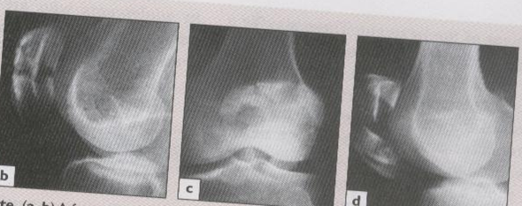

Fracture of Tibia

It can be classified into three regions:

- Fracture of upper end Tibia (Tibial plateau fracture)
- Fracture of shaft tibia
- Fracture of lower end tibia

Fracture Upper End Tibia

- Sometimes called bumper fracture
- It ranges from a simple to a very complicated fracture
- It has been classified into 6 types according to schatzker
- This fracture is notorios for neuvascular injury, so it is always assessed thoroughly (distal pulse should be palpated)

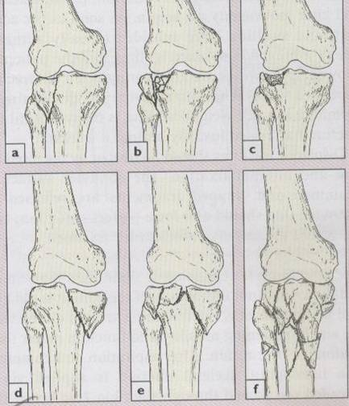

Clinical Features:
- Pain and massive swelling noted at knee
- Tissue has a doughy feeling
- Popliteal artery, tibial and common peroneal nerves should be examined

Treatment:
- Complete anatomical reduction and early movement at knee is mandatory
- Generally ORIF is done by means of L-plate, screws or K-wires, but rigid fixation is required

Complication:
- Compartment syndrome
- Stiffness of joint
- Deformity
- OA Knee

Fracture Shaft Tibia and Fibula

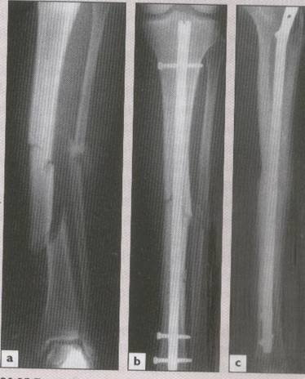
- Commonest fracture in young adults
- Commonest fracture in motor bike drivers
- Compartment syndrome is common
- Open fracture is common
- Fracture Tibia is almost always associated with Fibula

Clinical features
- Pain and swelling at fracture site
- Neurovascular injury is common

Treatment
- Conservative is recommended
- If conservative treatment fails, ORIF is done by means of Interlocking Nail or Plate
- Use of External fixator is common in this fracture, esp if it is an open fracture

Complications
- Vascular injury
- Compartment syndrome
- Infection
- Malunion
- Delayed union
- Nonunion
- Joint stiffness

Fracture of Lower End Tibia and Fibula
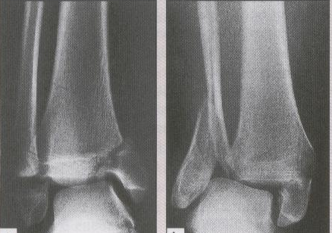
- Most important fracture at lower end of tibia and fibula is called Pott’s fracture
- It is the fracture of both malleoli or fracture of Medial Malleolus and shaft of Fibula

Treatment
- Almost always surgical
- ORIF is indicated by means of Malleolar screw for Medial Malleolus and plate or Rush-nail for Fibula

Fracture of Fibula alone

- It is non-weight bearing bone
- Usually no immobilization is needed

Treatment:
- Analgesic and rest for few days

Fracture of Tarsal and Metatarsal bones
Treatment:
- Except Talus all these bones fracture generally unite by conservative treatment (POP for 4-6 weeks)
- Talus due to its peculiar blood supply usually needs operative treatment

Fracture of Phalanges
Treatment:
- Only strapping is needed for 3-4 weeks

