**HEALTH LEADERSHIP AND MANAGEMENT**

**TRAINERS MANUAL ON HEALTH SYSTEMS MANAGEMENT IN KENYA**

University of Nairobi Egerton University

Kenya Medical Training College

**July 2014**

# FOREWORD

The Government of Kenya has identified leadership and management development as key to strengthening health systems and services in the country. Basic management and administrative systems are required to ensure that health services can consistently provide acceptable levels of quality.

Leadership and management (L&M) competencies are prerequisites for health professionals in the 21st century irrespective of their level of operation within the health system. L&M is recognised as the foundation stone for WHO’s six building blocks of the health system. However, in developing countries, these competencies have primarily been acquired through in-service courses taken over a period of one to 24 weeks.

Successful implementation of the National Health Sector Strategic Plan and other policies require a strong health system managed by competent health managers. Accordingly, health care professionals need not only be experts in their chosen clinical discipline but also competent professionals with leadership and management skills that would enable them to be more actively involved in the planning, delivery and transformation of health services.

The Leadership Management and Sustainability (LMS) project, funded by USAID/Kenya under Management Sciences for Health (MSH), has been working with the University of Nairobi, Egerton University, Kenya Medical Training College, the Medical Practitioners and Dentist Board, the Nursing Council of Kenya, Pharmacy and Poison’s Board, and the Laboratory Board among others to integrate leadership and management content into the pre- service curricula for all cadres of health workers.

This trainer’s manual is a reference for lecturers delivering the leadership and management unit. It should be used together with other relevant leadership and management training materials.

# ACKNOWLEDGEMENTS

This Leadership and Management Trainers’ Manual was prepared by the Leadership Management and Sustainability (LMS) project funded by the United States Agency for International Development (USAID) under the Management Sciences for Health (MSH).

The main contributors of this publication were Patrick Gichira, MBA, Caroline Gathii, MBA, Salome Gitoho, MBA, and Josephine Mbiyu-Kinyua, MPH. Other contributors included Dr. Ndinda Kusu, MPH, MSc., Dr. Mabel Nangami Nyarango, PhD, Dr. John Wagai, MPH, Mary Cheruiyot, MBA, and Peter Kibunga, MSc. Ruth Omondi, MA, coordinated the editing of this publication.

LMS Kenya is grateful to the College of Health Sciences of the University of Nairobi,, Egerton University, and Kenya Medical Training College (KMTC) for their participation and input during the pre-testing of this manual.

# TABLE OF CONTENTS

FOREWORD i

ACKNOWLEDGEMENTS ii

TABLE OF CONTENTS iii

LIST OF ABBREVIATIONS AND ACRONYMS viii

LIST OF TABLES xiii

LIST OF FIGURES xv

MODULE 1: ORGANISATION OF THE HEALTH CARE SYSTEM IN KENYA 1

* 1. Health Systems 2
  2. The Functions of a Health System 2
  3. Health Systems Management 4
  4. The Kenya National Health System 6

MODULE 2: LEADERSHIP AND MANAGEMENT OF HEALTH SYSTEMS 13

* 1. Leadership and Management in Health Management 14
  2. Management and Leadership in the Health Care System 16
  3. Management and Leadership Practices 17
  4. Team Management in Health Care Settings 21
  5. Managing Conflict within Health Teams 32

MODULE 3: MANAGING HUMAN RESOURCE FOR HEALTH 40

* 1. Human Resource Management 41
  2. Human Resource Management Functions 43

MODULE 4: LEADING ORGANISATIONAL CHANGE 70

* 1. Organizational Change 71
  2. Leading and Managing Change 73
  3. Change Models 77
  4. Managing Reactions to Change 83

MODULE 5: COMMODITY AND SUPPLIES MANAGEMENT 88

* 1. Supply Chain Management 89
  2. Internal Organisation of Health Facilities in Supplies Management 90
  3. Procurement Processes 92
  4. Procurement Methods 94
  5. Essential Medicines 96
  6. Commodity Management Cycle 97

Source: Management Sciences for Health (1997) 100

* 1. The Inventory Management Cycle 100

MODULE 6: HOSPITAL INFRASTRUCTURE AND FACILITIES MANAGEMENT 104

* 1. Health System Physical Facilities, Infrastructure and Equipment 105
  2. Role of Information Technology 106
  3. Managing Health Facility Assets 107
  4. Planned Preventive Maintenance (PPM) 111

MODULE 7: QUALITY ASSURANCE IN HEALTH SERVICES DELIVERY 114

* 1. Quality Management Principles and Concepts 115
  2. Components of a Total Quality Management (TQM) System 118
  3. Quality Assurance and Risk Management in the Health Care Setting 119
  4. Risk Management in Health Care Settings 120
  5. Methods and Tools of Measuring Quality 121
  6. Standards in Quality Management 125
  7. The Kenya Quality Model for Health 128
  8. Measuring Client Satisfaction 130

MODULE 8: FINANCIAL MANAGEMENT AND RESOURCE MOBILISATION 134

* 1. Financial Management 135
  2. The Government Accountant General and Treasury 138
  3. The Budget Preparation Process 140
  4. County Financial Management 142
  5. Government Accounting Documents 143
  6. Expenditure 144
  7. Facility Improvement Fund (FIF) 148
  8. Financial Statements 149
  9. Resource Mobilisation 156

MODULE 9: COMMUNICATION IN HEALTH SERVICES DELIVERY 164

* 1. Nature of Communication 165
  2. Communication Barriers 170
  3. Alternative Forms of Communication 176
  4. Skills for Effective Communication 178

MODULE 10: HEALTH SECTOR POLICY AND REFORM 182

* 1. Aim of Health Policy and Reforms 183
  2. Health Indicators 183
  3. Structure of the Health Care System 185
  4. Health Policies and Objectives 185
  5. Health Policy and the Constitution of Kenya 2010 187
  6. Kenya Health Policy Framework 2012-2030 187

MODULE 11: LAW AND ETHICS IN HEALTH CARE 190

* 1. Health Professionals Legal Responsibilities 191
  2. Ethical Issues and Theories in Modern Health Care 199
  3. Basic rules of medical ethics 201

MODULE 12: HEALTH INFORMATION SYSTEMS 206

* 1. Health Information System 207
  2. Objectives of HIS 208
  3. The Need for Strong Health Information Systems 208
  4. Health Sector Information Needs 209
  5. Components of a Health Information System 209
  6. Structure of the Health Information System in Kenya 212
  7. Sources of Health Information 213

MODULE 13: PROJECT MANAGEMENT 216

* 1. Project Management 217
  2. Principles and Concepts of Project Management 217
  3. Project Planning and Design 219
  4. Project Cycle Management 220
  5. Planning Methods and Tools 223

MODULE 14: GOVERNANCE IN HEALTH SYSTEM 232

* 1. Definition of a Health System 233
  2. Health System Governance 233
  3. Policy Framework 234
  4. The Legal Framework of the Health Sector 238
  5. Governance Responsibilities in the Health System 242

MODULE 15: ENTREPRENEURSHIP FOR HEALTH PROFESSIONALS 255

* 1. Entrepreneurship 256
  2. Types of Business Ventures 258
  3. Business Plans 264
  4. Managing Business Finances 265
  5. Principles of Business Management 266
  6. Raising Business Capital 268

MODULE 16: DISASTER MANAGEMENT 275

* 1. Concepts, Terminologies and Types of Disasters 276
  2. Policy Framework in Disaster Management 288
  3. National Policy for Disaster Management in Kenya 290
  4. Handling Emergencies at the Health Facility Level 291

MODULE 17: HEALTH SERVICES MONITORING AND EVALUATION 293

* 1. Purpose of Monitoring and Evaluation (M&E) in a Health System 294
  2. Goal and Objectives of the Kenyan National M&E System 295
  3. Monitoring and Evaluation Framework 295
  4. M&E Indicators 296
  5. Types of Evaluation 298
  6. Monitoring Process 299
  7. Evaluation Process 299

16.8 M&E Conceptual Framework 300

* 1. Evaluation Terms of Reference (TOR) 300
  2. Monitoring and Evaluation Tools 302
  3. Work Plans 304
  4. Evaluation Reports 307

APPENDICES 311

Appendix 1 – Form S11 – Counter Requisition and Issue Voucher 311

Appendix 2 – Form S12 – Issue and Receipt Voucher 312

Appendix 3 – S13 Form – Counter Receipt Book 313

Appendix 4 – S20 – Local Purchase Order 314

Appendix 5 – S21 - Local Service Order 315

Appendix 6 – The Vote Book 316

Appendix 7 – Imprest Request Form 317

Appendix 8 – Surrender of Imprest 318

Appendix 9 – Sample Payroll 319

Appendix 10 – Sample Payslip 320

Appendix 11 – Sample Muster Roll 321

Appendix 12 – Sample Cash and Bank Book 322

Appendix 13 – Summary Expenditure Report 323

Appendix 14 – Bank Reconciliation Statement 324

Appendix 15 – Sample Ledger 325

Appendix 16 – Sample Trial Balance 325

Appendix 17 – Appropriation Accounts 326

Appendix 18 – Sample Cash Flow Forecast 327

Appendix 19 – Sample Fund Account Statement 328

Appendix 20 – Sample Income and Expenditure Statement 329

Appendix 21 – Sample Balance Sheet 330

# LIST OF ABBREVIATIONS AND ACRONYMS

|  |  |
| --- | --- |
| AG | Accountant General |
| AIA | Appropriation in Aid |
| AIDS | Acquired Immunodeficiency Syndrome |
| AIE | Authority to Incur Expenditure |
| AMREF | African Medical and Research Foundation |
| ANC | Ante Natal Clinic |
| ARR | Accounting Rate of Return |
| ARR | Accounting Rate of Return |
| ARV | Antiretroviral Therapy |
| BADEA | Arab Bank for Economic Development |
| CBEF | County Budget and Economic Forum |
| CBEF | County Budget and Economic Forum |
| CDRR | Consumption Data Report and Request |
| CEO | Chief Executive Officer |
| CIDP | County Integrated Development Plans |
| CPA | Critical Path Analysis |
| CPM | Critical Path Method |
| CSO | Civil Society Organisation |
| CT Scan | Computed Tomography Scan |
| CU | Community Unit |
| DHIS | District Health Information System |
| DMS | Director of Medical Services |
| DPOA | Durable Power of Attorney |
| EAD | Economic Affairs Department |
| EBM | Evidence Based Medicine |

|  |  |
| --- | --- |
| EFT | Electronic Transfer of Funds |
| EML | Essential Medical List |
| EML | Essential Medicines list |
| EMU | Efficiency Monitoring Units |
| EOI | Expressions of Interest |
| ETF | Electronic Transfer of Funds |
| FBO | Faith Based Organisations |
| FIF | Facility Improvement Fund |
| FIF | Facility Improvement Fund |
| GRV | Goods Received Voucher |
| HDU | High Dependency Unit |
| HFC | Health Facility committee |
| HIV | Human Immunodeficiency Virus |
| HMC | Health Management Committee |
| HMC | Hospital Management Committee |
| HMIS | Health Management Information Systems |
| HMT | Hospital Management Team |
| HRD | Human Resource Development |
| HRH | Human Resources for Health |
| HRIS | Human Resources Information System |
| HRM | Human Resource Management |
| HRMIS | Human Resources Management Information System |
| HSM | Health System Management |
| HSSF | Health Services Support Fund |
| ICU | Intensive Care Unit |
| IFMIS | Integrated Financial Management Information System |

|  |  |
| --- | --- |
| IMCI | Integrated Management of Childhood Illnesses |
| IPPD | Integrated Personal Payroll Database |
| IRR | Internal Rate of Return |
| ISO | International Standardisation Organisation |
| IT | Information Technology |
| KEMRI | Kenya Medical Research Institute |
| KEMSA | Kenya Medical Supplies Agency |
| KFW | German Federal Government |
| KHPF | Kenya Health Policy Framework |
| KMTC | Kenya Medical Training College |
| KNBS | Kenya National Bureau of Standards |
| KQMH | Kenya Quality Model for Health |
| LCD | Liquid Crystal Display |
| LPO | Local Purchase Order |
| LSO | Local Service Order |
| M&E | Monitoring and Evaluation |
| MDA | Ministries, Departments and Agencies |
| MDG | Millennium Development Goal |
| MEDS | Mission for Essential Drugs and Supplies |
| MOH | Ministry of Health |
| MOMS | Ministry of Medical Services |
| MOPHS | Ministry of Public Health and Sanitation |
| MSH | Management Sciences for Health |
| MTEF | Medium Term Expenditure Framework |
| MTEF | Medium Term Expenditure Framework |
| MTP | Medium Term Plan |

|  |  |
| --- | --- |
| MTP | Medium Term Plan |
| NGO | Non-Governmental Organisations |
| NHIF | National Hospital Insurance Fund |
| NHIF | National Hospital Insurance Fund |
| NHIS | National Hospital Information System |
| NPV | Net Present Value |
| NPV | Net Present Value |
| NQCL | National Quality Control Laboratory |
| NQCL | National Quality Control Laboratory |
| NSSF | National Social Security Fund |
| NSSF | National Social Security Fund |
| OP | Operational Plan |
| PAS | Patient Administrative Systems |
| PAYE | Pay As You Earn |
| PDCA | Plan-Do-Check-Act |
| PERT | Project Evaluation Review and Technique |
| PFM | Public Finance Management |
| PMP | Performance Monitoring Plan |
| POA | Power of Attorney |
| PPB | Pharmacy and Poisons Board |
| PPB | Pharmacy and Poisons Board |
| PPB | Pharmacy and Poisons Board |
| PPM | Planned Preventive Maintenance |
| PPOA | Public Procurement Oversight Authority |
| QA | Quality Assurance |
| QI | Quality Improvement |

|  |  |
| --- | --- |
| QIT | Quality Improvement Teams |
| RBM | Results-Based Management |
| RCA | Root Cause Analysis |
| RTGS | Real Time Gross Transfer |
| SAGA | Semi-Autonomous Government Agency |
| SPA | Service Provision Assessment |
| SWGs | Sector Working Groups |
| SWOT | Strengths, Weaknesses, Opportunities, and Threats |
| TOR | Terms of Reference |
| TQM | Total Quality Management |
| TQMS | Total Quality Management System |
| US$ | United States Dollar |
| USAID | United States Agency for International Development |
| VAT | Value Added Tax |
| WBS | Work Breakdown Structure |
| WEI | Work Environment Improvement |
| WHO | World Health Organisation |
| WIT | Work Improvement Team |

# LIST OF TABLES

Table 1.1 Health Systems Management Objectives 6

Table 1.2 Public Sector Health Service Delivery System 10

Table 1.3 Services Provided in Various Levels of Health Facilities 14

Table 2.1 Leadership Competencies 26

Table 2.2 Comparison of Management and Leadership Competencies 26

Table 2.3 Characteristics of an Effective Team 33

Table 2.4 Leadership Activities at Different Group Formation Stages 40

Table 2.5 Causes of Conflict in Organizations 43

Table 3.1 Benefits of a Strong HRM System 56

Table 3.2 Different ways of Determining Staffing Requirements 58

Table 3.3 Five Steps in Developing a HRM Plan 59

Table 3.4 Strategic HRH Workshop Agenda 65

Table 3.5 Sample of a Summary List of HRH Programmes 67

Table 3.6 HRH Statistics 68

Table 3.7 Classification of Training Methods in Organisations 79

Table 3.8 Examples of employee Relationship Problems 86

Table 4.1 Balanced Score Card Dimensions 102

Table 4.2 Kotter’s 8 steps for Organisational Change 103

Table 4.3 Bruce Tuckman’s Four Stages of Team Development 104

Table 4.4 Common Phases in People’s Reaction to Change. 111

Table 5.1 Public Procurement Act- Categories of Public Entities 115

Table 6.1: Categories of Equipment and Technologies 134

Table 6.2: Responsibility for Managing Health Facility Assets 139

Table 7.1 Examples of Risk Factors in a Hospital Set-up 152

Table 7.2 The Plan-Do-Check-Act (PDCA) Cycle 154

Table 7.3 Sample Check Sheet: Hospital Infections Occurrences Checklist 157

Table 8.1 Submission Dates for Statutory Deductions 187

Table 9.1 Barriers to Effective Communication 217

Table 10.1 Kenya Health Policy 2012-2030 Framework for Policy Directions 238

Table 11.1 Forms of Civil Wrongs in Health Service Provision 247

Table 12.1 Sources of Health Information 271

Table 13.1 Logical Framework Matrix Structure 284

Table 13.2 Activity Scheduling Using Critical Path Analysis 288

Table 14.1 Health Related Millennium Development Goals 297

Table 14.2 Vision 2030: Key Focus Areas in the Health Sector 299

Table 14.3 Kenya Health Policy Objectives and Activities 304

Table 14.4 Roles and Responsibilities in the State Department of Health 308

Table 14.5 Responsibilities and Key Policy Areas of Directorates in the State Department

of Health 309

Table 14.6 SAGAs and their Key Mandates 310

Table 14.7 Structure for County Department Responsible for Health 311

Table 14.8 Other Structural Units at the County Level 313

Table 14.9 Stewardship Responsibilities at the Different Levels of the Health Sector 314

Table 14.10 Governance Responsibilities the Health Sector 315

Table 14.11 Health Sector Partnership, Governance, and Stewardship Processes 317

Table 17.1 Type and Sources of Information Required for Monitoring in the Health Sector 373

Table 17.2 Work Plan Template 382

# LIST OF FIGURES

Figure 1.1 Health Systems Building Block Interactions 4

Figure 1.2 Structure of the Health Care System in Kenya 8

Figure 2.1 Leading and Managing for Results Model 18

Figure 2.2 Leading and Managing Framework… 23

Figure 2.3 Integrated Leading and Managing Process 24

Figure 2.4 The Challenge Model 31

Figure 2.5 Team Development Process 39

Figure 3.1 Human Resources for Health Action Framework… 58

Figure 3.2 Recruitment Processes 70

Figure 3.3 Performance Management’s Five Key Components 73

Figure 4.1 Force Field Analysis 97

Figure 5.1 Commodity Management Framework… 125

Figure 5.2 Good Storage Practices 127

Figure 5.3 Inventory Management Cycle 128

Figure 6.1: The Healthcare Technology Management Cycle 142

Figure 7.1 Pareto Chart 157

Figure 7.2 Sample Control Chart 158

Figure 9.1 Communication Skills 212

Figure 9.2 The Main Elements Involved in Non-Verbal Communication 213

Figure 9.3 The Communication Cycle 215

Figure 9.4: Oral Communicating Skills 220

Figure 9.5: Some Examples of Kenya Sign Language 224

Figure 10.2 Kenya Health Policy 2012-2030 Framework… 239

Figure 12.1: Components of a Health Information system 268

Figure 12.2: Structure and Responsibilities in the National Health Information System 269

Figure 13.1 The Project Cycle 379

Figure 13.2 Fishbone Diagram 287

Figure 13.3 Critical Path Analysis Flow Diagrams 288

Figure 14.1 Vision 2030 Goals and Strategies for Health Care 301

Figure 14.2 Structure of the State Department for Health 307

Figure 16.1 Disaster Management Cycle 357

Figure 17.1 The M&E Conceptual Framework… 376

Figure 17.2 Sample Project Achievements Table 386

# MODULE 1: ORGANISATION OF THE HEALTH CARE SYSTEM IN KENYA



**Purpose**

To enhance students knowledge and understanding of the health care system in Kenya

**Objectives**

By the end of this module, the student should be able to:

1. Explain the concepts of health systems and health systems management;
2. Identify and discuss the structure, roles and responsibilities of the Kenya health system.

**Content**

* 1. Health systems
  2. Functions of a health system
  3. Health system management

2.4 The Kenya national health system

**Methodology**

Lectures, discussions, case studies

**Training materials**

Lecture notes

Laptop and LCD projector Whiteboards

**Duration: 4 hours**



**Lesson Plan Guide Duration: 4 Hours**

|  |  |  |  |  |
| --- | --- | --- | --- | --- |
| **Session** | **Time**  **(Hours)** | **Content/Topic** | **Lesson Objectives** | **Lecturer Evaluation/Remarks** |
| 1 | 2 | Introduction to health systems management | To introduce students to the concepts of health systems and health systems management | Comments regarding time adequacy and students’ understanding and perceptions. |
| 2 | 2 | Kenya national health system | To identify and discuss the structure, roles and responsibilities of the Kenya health system | As above |

* 1. **Health Systems**

A health system can be defined as structured and interrelated work of all agencies contributing to health within a country and “includes efforts to influence determinants of health as well as more direct health improving activities”. A health system is therefore more than the pyramid of publicly owned facilities that deliver personal health services. It includes, for example, a mother caring for a sick child at home; private providers; behaviour change programmes; vector-control campaigns; health insurance organisations; occupational health and safety legislation. It also includes inter-sectoral action by health staff, for example, encouraging the Ministry of Education to promote female education, a well known determinant of better health.

A health system consists of all organisations, people and actions whose primary intent is to promote, restore or maintain health. This definition includes the full range of stakeholders in a health sector, for example, private and not-for-profit service providers, health insurance organisations, public health legislation, community workers, health educators, researchers, patients, and consumers, as well as mothers caring for sick children (Health Systems 20/20).

* 1. **The Functions of a Health System**

According to WHO (2007), a health system can be analysed in its totality by using different groups or blocks. These building blocks are:

* + - Leadership and governance
    - Health financing
    - Service delivery
    - Human resources for health (HRH)
    - Medical products, vaccines and technologies
    - Health information systems (HIS)

The six building blocks contribute to the strengthening of a health system in different ways. A dynamic relationship exists between the various components in a health system. The multiple relationships and interactions among the blocks constitute a functioning health system. Each building block interacts with and influences the others, and is in turn affected by them. These relations and interactions cut across not only the health system building blocks but also the different sectors and stakeholders that constitute the system. **Figure 1.1** below illustrates relationships among the building blocks.

**Figure 1.1 Health Systems Building Block Interactions**

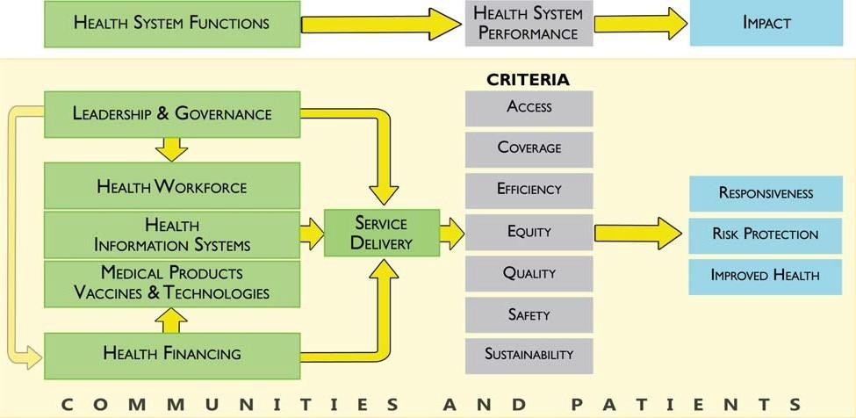

**Source**: WHO (2007).

The six building blocks contribute to the strengthening of health systems in different ways. Some cross-cutting components such as *leadership/governance* and *health information systems* provide the basis for the overall policy and regulation of all the other health system blocks*.* Key input components to the health system include specifically *financing* and the *health workforce*. A third group, namely *medical products and technologies* and *service*

*delivery*, reflects the immediate outputs of the health system, i.e. the availability and distribution of care.

* + - Good **health services** are those which deliver effective, safe, quality personal and non-personal health interventions to those that need them, when and where needed, with minimum waste of resources.
    - A well-performing **health workforce** is one that works in ways that are responsive, fair and efficient to achieve the best health outcomes possible, given available resources and circumstances. This means there are sufficient staff, fairly distributed; they are competent, responsive and productive.
    - A well-functioning **health information** system is one that ensures the production, analysis, dissemination and use of reliable and timely information on health determinants, health system performance and health status
    - A well-functioning health system ensures equitable access to essential **medical products, vaccines and technologies** of assured quality, safety, efficacy and cost- effectiveness, and their scientifically sound and cost-effective use.
    - A good **health financing** system raises adequate funds for health, in ways that ensure people can use needed services, and are protected from financial catastrophe or impoverishment associated with having to pay for them. It provides incentives for providers and users to be efficient.
    - **Leadership and governance** involves ensuring strategic policy frameworks exist and are combined with effective oversight, coalition building, regulation, attention to system-design and accountability.

This unit of study is based on the above Health Systems Framework and relevant Kenya health service delivery frameworks as discussed in other units. Eleven sub-components have been created out of the six WHO components and presented as 17 units of study in order to highlight all areas of relevance in the Kenya context, meet curriculum requirements and to facilitate teaching.

* 1. **Health Systems Management**

Health System Management (HSM) is the coordination of provision of preventive, curative, promotional or rehabilitative health care services through effective management of facilities, HRH, financial and other resources. The WHO defines a health services manager as someone who spends a substantial proportion of his/her time managing:

* + - The volume and coverage of services including planning, implementation and evaluation;
    - Resources such as staff, budgets, drugs, equipment, buildings and information;
    - External relations and partners, including service users.

At the operational or service delivery level, health managers are responsible for converting health systems input and resources such as finance, staff, supplies, equipment, medicines and infrastructure, into effective services that produce health results. At the policy level, health managers provide strategic direction on policy matters; manage overall resource allocation and monitoring policy targets and outcomes (WHO).

The primary objectives of an effective health system management are as outlined in **Table 1.1**:

**Table 1.1 Health Systems Management Objectives**

|  |  |
| --- | --- |
| To ensure adequate numbers of managers | * By establishing appropriate numbers and calibre required at each level of the health system * By identifying the critical levels of HSM in the health system |
| To ensure managers have appropriate competences | * By identifying the knowledge, skills, attitudes and behaviour required at various managerial levels? * By identifying the necessary qualifications and experience at each level |
| Managing critical support systems | Critical support systems include strategic planning and budgeting; financial management; HRH management, infrastructure and logistics management; procurement and distribution of drugs and other commodities; information management and monitoring |
| Creating an enabling working environment | These include clear definition and communication of roles and responsibilities, financial and non-financial incentives, performance and accountability |

**Necessary conditions for effective health systems management**

Effective management and leadership in health is a factor of various conditions (WHO, 2007). These include:

* + - Availability of an adequate number of managers at all levels of the health system; Health managers and other Human Resources for Health (HRH) members need to be selected on merit;
    - Managers have the appropriate competences – knowledge, skills and understanding of the role, tasks and purpose of the services they deliver;
    - Critical management support systems are functional – basic support systems function well – clear administrative rules and regulations; well planned and timely delivery of

supplies, equipment and drugs; functioning infrastructure and health technology; transparent financial and procurement processes;

* + - A working environment which enhances managers' performance;
    - Well planned and monitored activities.
  1. **The Kenya National Health System**

The health care system in Kenya include the National Government Health system and a County Government Health system, national and county government institutions engaged in health services delivery, research for health, health financing institution, health regulations, all health workers both in the public and private sectors, traditional, complementary and alternative health care providers, and all institutions and professional societies (like the Kenya Medical Association) who are involved in ensuring the promotion, prevention, control and treatment of illness, care and or rehabilitation of health.

**Figure 1.2 Structure of the Health Care System in Kenya**

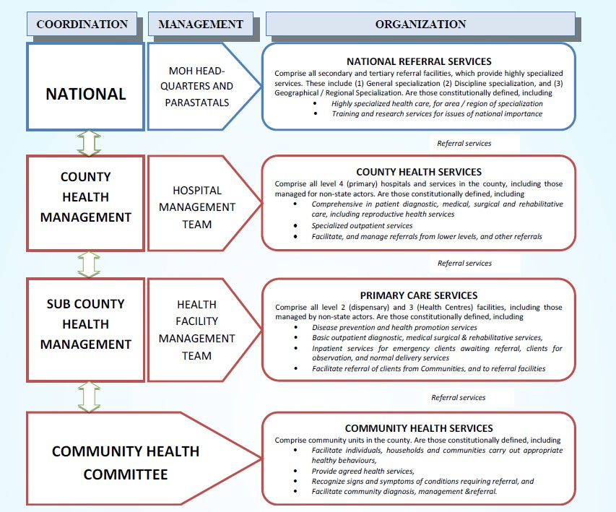

**Source:** Kenya Health Policy: 2012-2030.

*Public Sector Health Service Delivery*

The health sector comprises the public system, with major players including the MOH, MOMS and Parastatal organisations, and the private sector, which includes private for-profit, non-governmental organizations (NGOs) and faith-based organizations (FBO) facilities. Health services are provided through a network of health facilities countrywide, with the public sector system accounting for about 50 per cent of these facilities.

The public sector health service delivery is organised on a six level tier system as outlined below.

**Table 1.2 Public Sector Health Service Delivery System**

|  |  |
| --- | --- |
| **Level** | **Activities** |
| Level 1: Community | This is the foundation of the health service delivery priorities. Through engagement with health workers, communities define their own priorities and thereby develop ownership and commitment to health services. Health behaviour change activities through public health information sharing and skills enhancement. |
| Level 2: Dispensary/ clinic | Dispensaries and clinics primarily handle promotive and preventive care. They are the health system’s first line of contact with patients, but in some areas, health centres or even sub-county hospitals are effectively the first points of contact. They are staffed by enrolled nurses, public health technicians, and dressers (medical assistants).  Services- Curative, rehabilitative, preventive, and promotive services, health census of the population in catchment area, record-keeping and reporting activities, coordinating information flow from facilities in catchment area. |
| Level 3: Health centre, maternity home, nursing home | The network of health centres provides many of the ambulatory health services. They generally offer preventive and curative services, mostly adapted to local needs. Health centres are staffed with midwives, nurses, clinical officers, and occasionally by doctors. They provide a wider range of services, such as basic curative and preventive services for adults and children, as well as reproductive health services. They also provide minor surgical services such as incision and drainage. They augment their service coverage with outreach services, and refer severe and complicated conditions to the appropriate level, such as the County hospital. |
| Level 4: Primary hospital (Sub-  county | Sub-County hospitals provide the first referral level. They form an integral part of the County health system. They provide:   * Curative and rehabilitative services |

|  |  |
| --- | --- |
| **Level** | **Activities** |
| hospital) | * Clinical supportive and supervision, health behaviour change, referral services, logistical support to lower facilities * Co-ordination of collection and dissemination of health information flow |
| Level 5: Secondary hospital (County referral hospital) | Level 5 facilities provide referral services at the county level. They:   * Provide specialised care, involving skills and competence not available at lower level hospitals * Oversee the implementation of health policy at the county level, maintain quality standards, and coordinate and control all county health activities. * Provide training services and internship for health workers, referral for curative and specialised care services, management and coordination support to lower level facilities.   Health professionals working at this level include medical professionals such as general surgeons, general medical physicians, paediatricians, general and specialised nurses, midwives, and public health staff. |
| Level 6: Tertiary hospital (National referral hospital) | National referral hospitals: There are two national referral hospitals in the country: Kenyatta National Hospital in Nairobi and Moi Referral and Teaching Hospital in Eldoret. The equivalent private referral hospitals are Nairobi Hospital and Aga Khan University Hospital.  Specialised hospitals (Psychiatric and Rehabilitation Hospitals): These facilities render specialist psychiatric and rehabilitation hospital services.  National referral hospitals are at the apex of the health care system. They provide sophisticated diagnostic, therapeutic, and rehabilitative services. They also offer training services of specialised health cadres, specialised care services, provision of internship, management and coordination support to the provinces and districts, partnership and linkages activities at MOH level. |

**Source**: Ministry of Health (2006).

The public health service is supplemented by privately owned and operated hospitals and clinics and faith-based organisation’s hospitals and clinics as well as their related community services.

*Linkages and responsibilities in the health care system*

The Constitution of Kenya (2010) assigns the larger portion of delivery of health services to Counties with the exception being the National Referral Services. Counties bear overall

responsibilities for planning, financing, coordinating delivery and monitoring of health services toward the fulfilment of right to ‘the highest attainable standard of health’.

Responsibilities for health services are exercised at three levels:

1. The Ministry of Health (National Directorates for Health).
2. County Health Management Teams (CHMT).
3. County Health Facility Management Teams.

*The Ministry of Health*

Under the devolved system of government, the National Government through the Ministry of Health is responsible for provision of overall direction through policy formulation, national strategic planning, priority setting, budgeting and resource mobilisation, regulating, setting standards, formulating guidelines, monitoring and evaluation, and provision of technical backup to the county level.

Key mandates of the MOH are:

1. Development of national policy;
2. Provision of technical support at all levels;
3. Monitoring quality and standards in health services provision;
4. Provision of guidelines on tariffs for health services;
5. Conducting studies required for administrative or management purposes.

The Chief Technical Officer of the Ministry of Health is the Director of Medical Services (DMS). The role of the MoH is to provide strategic direction through national health planning, development of service and quality standards, health financing, HRH planning, monitoring and evaluation. These national functions are distributed amongst six directorates namely:

* 1. Administrative Services;
  2. Health Standards, Quality Assurance and Regulations;
  3. Curative and Rehabilitative Services;
  4. Policy Planning and Health Care Financing;
  5. Preventive and Promotive Services;
  6. National Quality Control Laboratory.

The role of the National Directorates for Health is to provide overall direction – policy formulation, national strategic planning, priority setting, budgeting and resource mobilisation, regulating, setting standards, formulating guidelines, monitoring and evaluation, and provision of technical backup to the county level.

*County government*

At county level, the Kenya Health Policy 2012-2030 proposes the formation of county health departments whose role will be to create and provide an enabling institutional and management structure responsible for “coordinating and managing the delivery of health care mandates and services at the county level”. In addition to the county health departments, the policy calls for the formation of county health management teams. These will provide “professional and technical management structures” in each county to coordinate the delivery of health services through health facilities available in each county.

The role of the county government is to provide strategic and operational leadership and stewardship for overall health management in the county, including provision of health services, resource mobilisation, creation of linkages with national level referral health services, monitoring and evaluation, coordination and collaboration with state and non-state stakeholders at the county level.

Within each county, the Health Facility Management Teams are charged with the responsibility of providing health services, developing and implementing facility health plans, coordinating and collaborating with stakeholders through County Health Stakeholder Forums, supervising, continuously monitoring and evaluating health service provision and implementing health policies.

**Table 1.3 Services Provided in Various Levels of Health Facilities**

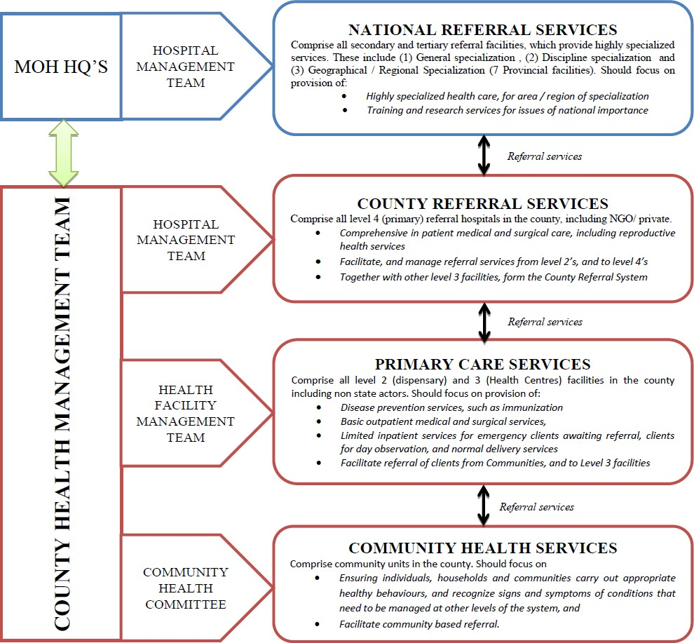

**Source:** Kenya Health Policy 2012-2030.

**References and Recommended Further Reading**

Health Systems 20/20 (2012) *The Health System Assessment Approach: A How-To Manual.*

Version 2.0. Available at <[www.healthsystemassessment.org](http://www.healthsystemassessment.org/)> [Accessed 24 February 2014].

Management Sciences for Health (2005) Managers Who Lead. A handbook for improving Health services (3rd ed). Cambridge: MSH

Management Sciences for Health. Responsibility and Authority Mapping Process (RAMP) tool.

Ministry of Health (2006) Norms and Standards for Health Services Delivery [online]. Available at <[https://www.k4health.org](https://www.k4health.org/)> [Accessed 24 February 2014].

Ministry of Medical Services and Ministry of Public Health and Sanitation. Health Sector Strategic and Investment Plan (KHSSP). July 2013-June 2017.

Ministry of Medical Services and Ministry of Public Health and Sanitation. *Kenya Health Policy.* 2012-1230

WHO (2007) ‘Everybody’s Business. Strengthening Health Systems to Improve Health Outcomes: WHO’s Framework For Action’ [online]. Available at

<<http://www.who.int/healthsystems/strategy/everybodys_business.pdf>> [Accessed 24

February 2014].

# MODULE 2: LEADERSHIP AND MANAGEMENT OF HEALTH SYSTEMS



**Purpose**

To introduce students to Leadership and Management as a practice

**Objectives**

By the end of this module, the student should be able to:

1. Describe the basic concepts and principles of leadership and management;
2. Explain the concepts of strategic leadership and management;
3. Apply the concept of critical thinking in decision making;
4. Discuss good practices in team leadership and management.

**Content**

* 1. Leadership and management
  2. Management and leadership in the health care system
  3. Management and leadership practices
  4. Team management in health care settings
  5. Managing conflict within health teams

**Methodology**

Lectures, discussions, case studies

**Training materials** Lecture notes Handouts

PowerPoint (Laptop and LCD projector) Whiteboards, flip chart, marker pens

**Duration: 8 hours**



Lesson Plan Guide: Time: 8 hours

|  |  |  |  |  |
| --- | --- | --- | --- | --- |
| **Session** | **Time**  **(Hours)** | **Content/Topic** | **Lesson Objectives** | **Lecturer Evaluation/Remarks** |
| 1 | 2 | Introduction to leadership and management | To introduce students to the concepts of leadership and management | Comments regarding time adequacy and students’ understanding and perceptions |
| 2 | 2 | Management and leadership in the health care system | To identify and discuss the role of leadership and management in the health sector | As above |
| 3 | 2 | Team management in health care settings | To identify and discuss approaches to team leadership and management | As above |
| 4 | 2 | Managing conflict within health teams | To identify and discuss approaches to managing conflict within Health Teams | As above |

* 1. **Leadership and Management in Health Management**

Health systems cannot be strengthened without good management and leadership. Leadership and management skills are therefore essential at all levels of the health system. In addition to leadership and management skills, health managers should also embrace leadership and management practices that will lead to improved health outcomes. The key leadership and management practices are critical for the health sector are: scanning, focusing, aligning and mobilising, inspiring, planning, organising, implementing, and monitoring and evaluation.

Managers who lead well use all the leading and managing practices listed in **Figure 2.1** below. Applying these eight practices consistently leads to strong organisational capacity, resulting in higher-quality services and sustained improvements in health.

**Figure 2.1 Leading and Managing for Results Model**

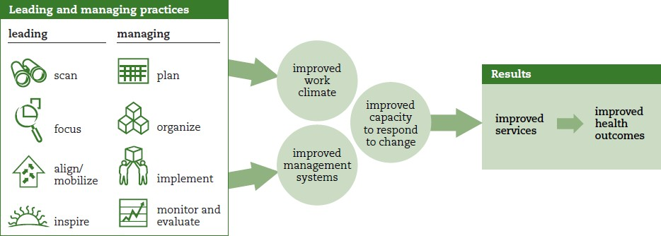

**Source:** Management Sciences for Health (2005).

The Leading and Managing for Results Model can serve as a roadmap to guide individuals, teams, and organisations to improved services and better health outcomes. By following it, health systems managers can transform discouraged, passive employees into active managers who lead.

*Managing and Leading*

Managing and leading are complex concepts which are relevant to many different parts of the health system, including the private and public sectors; health facilities, county and Ministry of Health directorates and support systems related to pharmaceutical, human resources for health, finances and health information. While separate concepts, managing and leading go together, each working toward a common goal but contributing in ways that the other does not. Because the two functions are complementary, the concept of “managers who lead” has gained acceptance as a holistic approach to running a health care programme, organisation or facility.

Managing can be defined as planning and using resources efficiently to produce intended results. Managing is focused on making sure present operations are going well. Leading is mobilising others to envision and realise a better future. While managing is focused on the present, leading is focused the future. Good health management and leadership results in measurable improvements in health services and outcomes. Heath managers’ leadership and management skills therefore not only matter to their teams but also to those who benefit from their team’s improved performance.

Leading and managing skills can be learned or improved by embracing tested practices of challenging, providing feedback and supporting your team. By so doing, you transform yourself into a manager who leads. However, learning to lead and manage takes time and

practice. Leading and managing comprise skills, knowledge, and attitudes that you learn through continued practice.

It follows from the above that health gains can be only sustained by making sure that leadership and management practices are used in all health services and supported by organisational systems and processes for managing governance, planning, human resources, finances, medicines and other health products, and information.

* 1. **Management and Leadership in the Health Care System**

The key general objectives of a health care system needs are to:

* + - Improve the health status of the population (according to certain criteria and targets);
    - Deliver services in the most efficient way possible in order to accomplish the first goal.

The scope and complexities of tasks carried out in pursuit of these objectives are so great that individual health workers operating on their own cannot get the work done. Moreover, the task involved in producing health services require the coordination of many specialised disciplines and support services that must work to together seamlessly. Management and leadership are therefore needed to make sure that tasks are carried out in the best way possible and that appropriate resources are adequate and well managed. Leadership and management is one of the health system building blocks as discussed in Module 1.

Levels of management and leadership responsibilities are:

* + - The health system and institutions therein are complex and dynamic. The nature of the system requires that management and leadership be provided at all levels as well as supervision and coordination of resources. Management and leadership are therefore essential at both the strategic and operational levels of health systems;
    - Management functions and leadership responsibilities differ at each level of the health system – Community, dispensary level, health centre level, sub-county hospital, county referral hospital, national referral hospital and at the various levels at the county and Ministry of Health headquarters;
    - They include provision and or coordination of health services, health planning, financial management, management of HRH, infrastructure management (buildings, equipment, transport, and communication), procurement, monitoring and evaluation, standards and quality assurance, leadership and governance through participation in various health management teams/boards.

The aim of good management in the health sector is to provide services in an appropriate, efficient, equitable, and sustainable manner. This objective can only be achieved if key resources for service provision, including human resources, finances, infrastructure and

process aspects of care delivery are brought together at the point of service delivery and are carefully synchronized.

As in the case of any other type of institution, leadership and management play a central role in health care, especially concerning types of services provided, quality of services and resource use. As noted earlier, there is no universal recipe for successful management and leadership, contextual factors like type and level of facility, location, political leadership, and socio-economic factors play a significant part in the outcomes.

Whether you are in charge of a dispensary, health centre, sub-county hospital, county referral hospital, a member of the county health management team or working in one of the directorates at the Ministry of Health headquarters, your job is to improve the health of the community. Empirical evidence shows that there is a link between managing practices and leading practices and improved health outcomes.

* 1. **Management and Leadership Practices**

Health systems management and leadership practices are strongly related to health outcomes. To lead and manage better, one needs to apply the eight leading and managing practices consistently. The leading and managing practices described in the Leading and Managing Framework (**Figure 2.2**) offer specific behaviours that can be learned and used in many different situations to improve organisational performance and sustain performance over time.

*Managing practices*

When health managers use good management practices, they make sure that operational plans and reporting structures are clear and reflect organisational priorities. Because good managers reinforce the use of management systems and processes to make work easier, staff know what is expected of them, are motivated and are able to carry out their activities more effectively. Staff receive feedback on their work through supportive supervision and monitoring and evaluation systems that provide timely, reliable information.

The objective of good leading and managing practices is to enhance organisational:

* + - Effectiveness- the right services are offered
    - Efficiency- services delivered in the right way
    - Sustainability.

To be effective, a health manager should:

* + - Plan how to achieve results by assigning resources, accountabilities, and timelines;
    - Organise people, structures, systems, and processes to carry out the plan;
    - Implement activities efficiently, effectively, and responsively to achieve defined results;
    - Monitor and evaluate achievements and results against plans, and continuously update information and use feedback to adjust plans, structures, systems, and processes for future results.

*Leading practices*

Good leadership practices are those which focus on achieving results that fulfil client needs and preferences, as well as respond to key stakeholder interests.

To be an effective leader, health managers should:

* + - Scan for up-to-date knowledge about yourself (to be aware how your behaviour and values affect others), your work group, your organisation, and your environment;
    - Focus staff ’s work on achieving organisational mission, strategy, and priorities;
    - Align and mobilise stakeholders’ and staff ’s time and energies as well as the material and financial resources to support organisational goals and priorities;
    - Inspire your staff to be committed and to continuously learn how to adapt and do things better.

*Leading and managing framework*

The Leading and Managing Framework (**Figure 2.2**) presents activities and organisational outcomes associated with each leading and managing practice. By applying the eight practices consistently, health managers, team leaders, supervisors, teams and organisations can systematically make improvements that will strengthen their services and improve health outcomes.

*Integrating leading and managing practices*

Leading and managing occurs simultaneously. They are not distinct, sequential processes that are completed separately. The leading practices are not independent of the managing practices. They complement and support each other. Effective managers move fluidly between leading and managing to support their teams to face challenges and achieve results.

Facing challenges involves scanning, focusing and planning as shown in **Figure 2.3**. The process of scanning the environment to identify challenges is followed by a deliberate effort to focus on a few priority challenges and making a plan to address them. Planning is followed by building stakeholder support, mobilising resources and implementing the plan.

**Figure 2.2 Leading and Managing Framework**

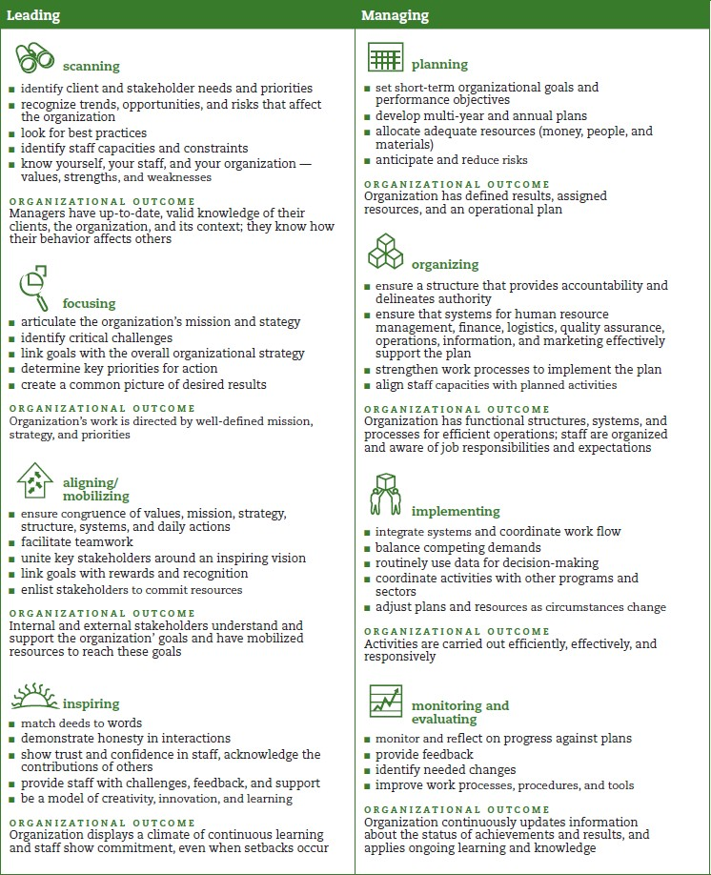

**Source:** Management Sciences for Health (2005).

**Figure 2.3 Integrated Leading and Managing Process**

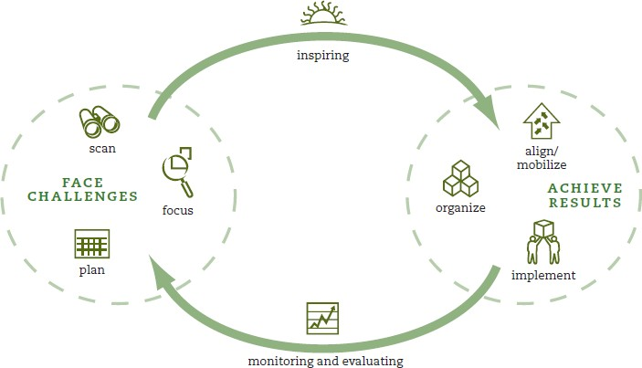

**Source:** Management Sciences for Health (2005).

*Leadership competencies*

Leadership competencies are the specific mindset, skills, and knowledge that help managers lead more effectively. In addition to having the right mindset one needs knowledge and skills in order to be able to empower others to achieve results.

**Table 2.1 Leadership Competencies**

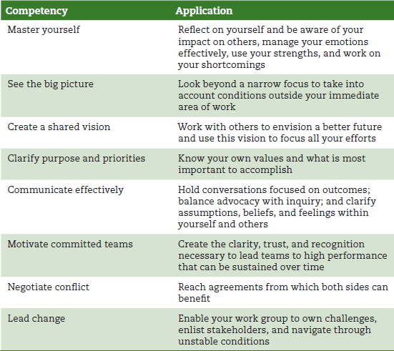

**Source:** Management Sciences for Health (2005).

**Table 2.2 Comparisons of Management and Leadership Competencies**

|  |  |
| --- | --- |
| **Management Produces** | **Leadership Produces** |
| * Planning and budgeting * Establishing agendas * Setting timetables * Allocating resources | * Establishing direction * Creating a vision * Clarifying the big picture * Setting strategies |
| * Organizing and staffing * Provide structure * Making job placements * Establishing rules and procedures | * Aligning people * Communicating goals * Seeking commitment * Building teams and coalitions |
| * Controlling and problem solving * Developing incentives * Generating creative solutions * Taking corrective action | * Motivating and inspiring * Inspiring and energize * Empowering subordinates * Satisfying unmet needs |

**Source:** Kotter (1990).

* 1. **Team Management in Health Care Settings**

Provision of health care and health care management and leadership takes place in a group or team setting. A team is a group of people who work together cooperatively to achieve a common goal. The literature on teams underscores that a team’s structure differs depending upon its purpose, task, setting, the mix of professions on the team, and the formal relationships between health professionals in the team.

A team may be defined as a collection of individuals who are interdependent in their tasks, who share responsibility for outcomes, who see themselves and who are seen by others as an intact social entity embedded in one or more larger social systems and who manage their relationships across organisational borders (Hackman, 1978).

The best and most cost-effective outcomes for patients and clients are achieved when professionals work together, learn together, engage in clinical audit of outcomes together, and generate innovation to ensure progress in practice and service.

**Types of Medical Teams**

There are many types of teams in health care. They include labour and delivery units, ICUs, medical wards, primary care teams in the community, teams assembled for a specific task such as an emergency response team or multi-professional teams such as multidisciplinary cancer care teams that come together to plan and coordinate a patient’s care. Teams can include a single discipline or involve the input from multiple practitioner types including

doctors, nurses, pharmacists, physiotherapists, social workers, psychologists and potentially administrative staff.

The role played by each of these practitioners varies between teams and within teams at different times. Roles of individuals in the team are often flexible and opportunistic such as the leadership changing depending on the required expertise or the nurse taking on the patient education role given they have regular contact with patients.

### Core Teams

Core teams consist of team leaders and members who are involved in the direct care of the patient. Core team members include direct care providers (from the home base of operation for each unit) and continuity providers (those who manage the patient from assessment to disposition, for example, case managers). The core team, such as a unit-based team (physician, nurses, physiotherapist, and pharmacist) is generally based where the patient receives care.

### Coordinating Teams

A coordinating team is the group responsible for:

* + Day-to-day operational management;
  + Coordination functions;
  + Resource management for core teams.

### Contingency Teams

Contingency teams are:

* + Formed for emergent or specific events;
  + Time-limited events (e.g. cardiac arrest teams, disaster response teams, rapid response teams);
  + Composed of team members drawn from a variety of core teams.

### Ancillary Services

Ancillary services consist of individuals such as catering, cleaners and other support staff who:

* + Provide direct, task-specific, time-limited care to patients;
  + Support services that facilitate care of patients;
  + Are often not located where patients receive routine care.

Ancillary services are primarily a service delivery team whose mission is to support the core team. This does not mean that they should not share the same goals. The successful outcome of a patient undergoing surgery requires accurate information on catering and instructions in relation to “nil by mouth” orders so that a patient does not inadvertently receive a meal that may place them at risk of choking. In general, an ancillary services team functions independently. However, there may be times when they should be considered as part of the core team.

### Support Sservices

Support services consist of individuals who:

* + Provide indirect, task-specific services in a health-care facility;
  + Are service-focused, integral members of the team, helping to facilitate the optimal health care experience for patients and their families.

Support services consist primarily of a service focused team whose mission is to create efficient, safe, comfortable and clean health-care environments, which impact the patient care team, market perception, operational efficiency and patient safety.

### Administration

Administration includes the executive leadership of a unit or facility, and has 24-hour accountability for the overall function and management of the organisation. Administration shapes the climate and culture for a teamwork system to flourish by:

* Establishing and communicating vision;
* Developing and enforcing policies;
* Setting expectations for staff;
* Providing necessary resources for successful implementation;
* Holding teams accountable for team performance;
* Defining the culture of the organisation.

**The Challenge Model**

Leading means helping people identify and face challenges. Taking on a challenge requires that all members are committed to working together as a team. The Challenge Model enables people to move from vision to action. It helps in making a careful diagnosis of where you want to go and where you currently are before you decide on a plan of action. The Challenge Model (**Figure 2.4**) offers a systematic approach for working together, as a team, to identify and face one challenge at a time and achieve results. The model leads the user through a

process of forming commitment to a shared vision that contributes to realising their organisation’s mission, defining and owning a challenge, prioritising actions for implementation, and carrying out the work plan to achieve results. The model can be used to address all kinds of management and leadership challenges.

**Figure 2.4 The Challenge Model**

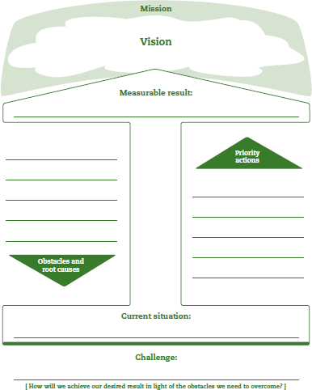

**Source**: Management Sciences for Health (2005).

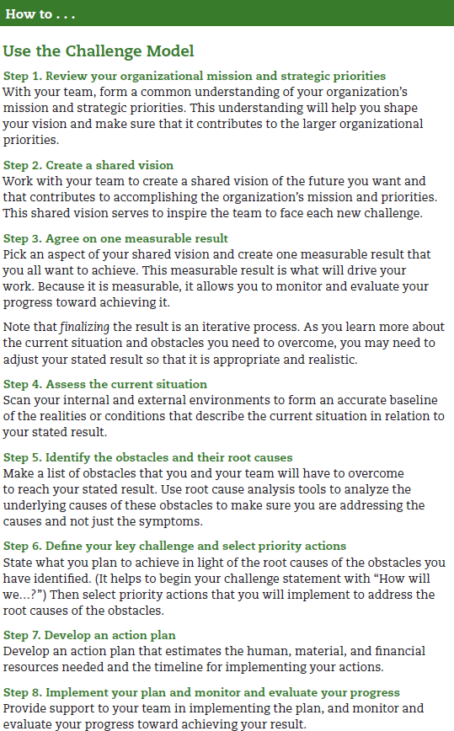

**Characteristics of an Effective Team**

There are many models describing effective teamwork. Mickan and Roger (2005) offer the following six simple characteristics, presented in **Table 2.3** below, that underpin effective health-care teams:

**Table 2.3 Characteristics of an Effective Team**

|  |  |
| --- | --- |
| Common purpose | Team members generate a common and clearly defined purpose that includes collective interests and demonstrates shared ownership. |
| Measurable goals | Teams set goals that are measurable and focused on the team’s task. |
| Effective leadership | Teams require effective leadership that set and maintain structures, manage conflict, listen to members and trust and support members. It is important for teams to agree and share leadership functions. |
| Effective communication | Good teams share ideas and information quickly and regularly, keep written records as well as allow time for team reflection. Some of the most in-depth analysis of inter-professional team communication has occurred in high stakes teams such as are found in surgery. |
| Good cohesion | Cohesive teams have a unique and identifiable team spirit and commitment and have greater longevity as teams members want to continue working together. |
| Mutual respect | Effective teams have members who respect the talents and beliefs of each person in addition to their professional contributions. In addition, effective teams accept and encourage a diversity of opinion among members. |

A health care system that supports effective teamwork can improve the quality of patient care, enhance patient safety, and reduce workload issues that cause burnout among health care professionals. Teams work most effectively when they have a clear purpose; good communication; co-ordination; protocols and procedures and effective mechanisms to resolve conflict when it arises. The active participation of all members is another key feature. Successful teams recognise the professional and personal contributions of all members; promote individual development and team interdependence; recognize the benefits of working together; and see accountability as a collective responsibility. The make-up and functioning of teams varies depending on the needs of the patient. The complexity of the health issue defines the task. The more interdependency needed to serve the patient, the greater the need for collaboration among team members.

Patients and their families are important team members with an important role in decision- making. To enable patients to participate effectively, they need to learn and be told how to participate in the team; how to obtain information about their condition; and how each health

care professional will contribute to their care. Teams function differently depending on where they operate. Teams in hospitals have clearly defined protocols and procedures, professional hierarchies, and shared institutional goals, while teams in community-based primary care practices operate within the community setting.

Teamwork is influenced by organisational culture. A clear organisational philosophy on the importance of teamwork can promote collaboration by encouraging new ways of working together; the development of common goals; and mechanisms to overcome resistance to change and turf wars amongst health workers about scopes of practice. Teams need training to learn how to work together and understand the professional role/responsibility of each member. They also require an effective administrative structure and leadership.

**Collaboration**

Effective teams are characterised by trust, respect, and collaboration. Collaboration in health care is defined as health care professionals assuming complementary roles and cooperatively working together, sharing responsibility for problem-solving and making decisions to formulate and carry out plans for patient care. Collaboration between physicians, nurses, and other health care professionals increases team members’ awareness of each others’ type of knowledge and skills, leading to continued improvement in decision making (O’Daniel and Rosenstein, 2008).

When considering a teamwork model in health care, an interdisciplinary approach should be applied. Unlike a multidisciplinary approach, in which each team member is responsible only for the activities related to his or her own discipline and formulates separate goals for the patient, an interdisciplinary approach coalesces a joint effort on behalf of the patient with a common goal from all disciplines involved in the care plan. The pooling of specialised services leads to integrated interventions. The plan of care takes into account the multiple assessments and treatment regimens, and it packages these services to create an individualised care programme that best addresses the needs of the patient.

**Components of Successful Teamwork**

* + Open communication
  + Non-punitive environment
  + Clear direction;
  + Clear and known roles and tasks for team members
  + Respectful atmosphere
  + Shared responsibility for team success
  + Appropriate balance of member participation for the task at hand
  + Acknowledgment and processing of conflict
  + Clear specifications regarding authority and accountability
  + Clear and known decision making procedures
  + Regular and routine communication and information sharing
  + Enabling environment, including access to needed resources
  + Mechanism to evaluate outcomes and adjust accordingly

**Common Barriers to Inter-Professional Collaboration**

* + Personal values and expectations
  + Personality differences
  + Hierarchy
  + Disruptive behaviour
  + Culture and ethnicity
  + Generational differences
  + Gender;
  + Historical inter-professional and intra-professional rivalries
  + Differences in language and jargon
  + Differences in schedules and professional routines
  + Varying levels of preparation, qualifications, and status
  + Differences in requirements, regulations, and norms of professional education
  + Fears of diluted professional identity
  + Differences in accountability, remuneration, and rewards
  + Concerns regarding clinical responsibility
  + Complexity of care
  + Emphasis on rapid decision making

**Stages of Team Development**

Team formation takes time, and usually follows some easily recognisable stages, as the team journeys from being a group of strangers to becoming a united team with a common goal.

According to leading experts in group dynamics, teams go through predictable phases. Psychologist Bruce Tuckman first came up with the memorable phrase “forming, storming, norming, and performing” back in 1965. He used it to describe the path to high-performance that most teams follow. In 1975, he added a fifth stage he called “adjourning”.

### Stage 1: Forming

In the ***Forming*** stage, personal relations are characterised by dependence. Group members rely on safe, patterned behaviour and look to the group leader for guidance and direction. Group members have a desire for acceptance by the group and a need to know that the group is safe. They set about gathering impressions and data about the similarities and differences among them and forming preferences for future sub grouping. Rules of behaviour seem to be to keep things simple and to avoid controversy. Serious topics and feelings are avoided.

### Stage 2: Storming

The ***Storming*** stage is characterised by competition and conflict in the personal relations within the group. As the group members attempt to organise for the task, conflict inevitably results in their personal relations. Individuals have to bend and mold their feelings, ideas, attitudes, and beliefs to suit the group organisation. Because of “fear of exposure” or “fear of failure”, there is an increased desire for structural clarification and commitment. Although conflicts may or may not surface as group issues, they do exist. Questions will arise about who is going to be responsible for what, what the rules are, what the reward system is, and what the criteria for evaluation are. These reflect conflicts over leadership, structure, power, and authority. There may be wide swings in members’ behaviour based on emerging issues of competition and hostilities. Because of the discomfort generated during this stage, some members may remain completely silent while others attempt to dominate.

### Stage 3: Norming

In the ***Norming*** stage, interpersonal relations are characterised by cohesion. Group members are engaged in active acknowledgment of all members’ contributions, group building and maintenance, and solving of group issues. Members are willing to change their preconceived ideas or opinions on the basis of facts presented by other members, and they actively ask questions of one another. Leadership is shared, and cliques dissolve. When members begin to know and identify with one another, the level of trust in their personal relations contributes to the development of group cohesion. It is during this stage of development (assuming the group gets this far) that people begin to experience a sense of group belonging and a feeling of relief as a result of resolving interpersonal conflicts.

### Stage 4: Performing

The ***Performing*** stage is not reached by all groups. If group members get to stage four, their capacity, range, and depth of personal relations expand to true interdependence. In this stage,

people can work independently, in subgroups, or as a total unit with equal facility. Their roles and authorities dynamically adjust to the changing needs of the group and individuals.

Stage four is marked by interdependence in personal relations and problem solving in the realm of task functions. At this stage, the group should be most productive. Individual members become self-assuring, and the need for group approval is past. Members are both highly task-oriented and people-oriented. There is unity: group identity is complete, group morale is high, and group loyalty is intense. The task function becomes genuine problem solving, leading towards optimal solutions and group development. There is support for experimentation in problem-solving and emphasis on achievement. The overall goal is productivity through problem-solving and work.

### Stage 5: Adjourning

The final stage, ***Adjourning,*** involves break-up of the group, hopefully when the task is completed successfully and its purpose fulfilled. Everyone can move on to new things, feeling good about what has been achieved. From an organisational perspective, recognition of, and sensitivity to people's vulnerabilities is essential, especially if members have closely bonded and feel a sense of insecurity or threat from this change

**Figure 2.5 Team Development Process**

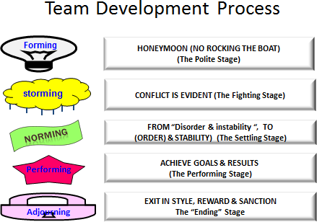

**Source**: Tuckman (1965).

**Table 2.4 Leadership Activities at Different Group Formation Stages**

|  |  |
| --- | --- |
| **Stage** | **Activity** |
| **Forming** | Direct the team and establish objectives clearly. A good way of doing this is to negotiate a team charter.Team Charters are documents that define the purpose of the team, how it will work, and what the expected outcomes are. They are ‘roadmaps’ that the team and its sponsors create at the beginning of the journey to make sure that all involved are clear about where they're heading, and to give direction when times get tough. |
| **Storming** | Establish process and structure, and work to smooth conflict and build good relationships between team members. Generally provide support, especially to those team members who are less secure. Remain positive and firm in the face of challenges to your leadership or the team’s goal.  Perhaps explain the ‘forming, storming, norming and performing’ idea so that people understand why conflict is occurring, and understand that things will get better in the future. And consider teaching assertiveness and conflict resolution skills where these are necessary. |
| **Norming** | Step back and help the team take responsibility for progress towards the goal.  This is a good time to arrange a social, or a team-building event. |
| **Performing** | Delegate as far as you sensibly can. Once the team has achieved high performance, you should aim to have as ‘light a touch’ as possible. You will now be able to start focusing on other goals and areas of work. |
| **Adjourning** | When breaking up a team, take the time to celebrate its achievements. After all, you may well work with some of your people again, and this will be much easier if people view past experiences positively. |

**Barriers to Effective Teamwork**

A number of specific barriers exist to establishing and maintaining effective teamwork in health care. These include:

### Changing roles

There are currently considerable change and overlap in the roles played by different health- care professionals. Examples include radiographers reading plain film X-rays, nurses performing colonoscopies and nurse practitioners having prescribing rights. These changing roles can present challenges to teams in terms of role allocation and acknowledgement.

### Changing settings

The nature of health care is changing including increased delivery of care for chronic conditions into community care and many surgical procedures to day-care centres. These changes require the development of new teams and the modification of existing ones.

### Medical hierarchies

Medicine is strongly hierarchical in nature and this is counterproductive in terms of establishing and effectively running teams where all members’ views are accepted and the team leader is not always a doctor. While there has been a growing acknowledgement that teamwork is important in health care, this has not necessarily been translated into change practices, especially in environments where cultural norms of communication may mitigate against teamwork.

### Individualistic nature of medicine

The practice of medicine is based on the autonomous one-on-one relation between the doctor and patient. While this relationship remains a core value, it is challenged by many concepts of teamwork and shared care. This can be at many levels including doctors being unwilling to share the care of their patients through to medico-legal implications of team-based care.

### Instability of teams

As already indicated, health-care teams are often transitory in nature, coming together for a specific task or event (such as cardiac arrest teams). The transitory nature of these teams places great emphasis on the quality of training for team members, which raises particular challenges in medicine where education and training is often relegated at the expense of service delivery.

* 1. **Managing Conflict within Health Teams**

We experience conflict in our everyday lives and probably have many feelings about it. Conflict situations are an important aspect of the workplace. Webster’s Ninth New Collegiate Dictionary defines conflict as a fight, battle, war meaning:

1. Competitive or opposing action of incompatibles: antagonistic state or action (as of divergent ideas, interests, or persons).
2. Mental struggle resulting from incompatible or opposing needs, drives, wishes, or external or internal demands.

The opposition of persons or forces that gives rise to the dramatic action in a drama or fiction. This definition expresses what people usually mean by ‘conflict’. As implied in the second part of the dictionary definition, conflict is not bad. Conflict involves: competing or opposing forces. The conflict may be about ideas, interests, or just differences between people. Conflict is therefore an outgrowth of diversity (Dudley, 1994).

**Types and Sources of Conflict**

Conflict can be classified as constructive or destructive. Constructive (functional) conflict helps a group achieve its objectives. Destructive (dysfunctional) conflict hinders achievement

of objectives. A manager's job is to eliminate destructive conflict or change it into constructive conflict.

Conflict may also be classified in terms of the people involved:

1. Individual conflict when faced with contradictory priorities;
2. Interpersonal conflict between two people;
3. Conflict between an individual and a group when the individual breaks the group's norms;
4. Conflict between groups or departments;
5. Conflict between stakeholders in a health system.

**Table 2.5 Causes of Conflict in Organisations**

|  |  |
| --- | --- |
| Personal differences | These often arise from different needs, beliefs, values, perceptions, and expectations. |
| Information | Arises from the use of different sources of information or different interpretations of the same information. |
| Different objectives | Individuals and groups can have different or incompatible objectives. |
| Environmental factors | Arises from competition for organisational resources. |

**Source**: Spaho (2013).

**Conflict Management Techniques**

A conflict is a situation when the interests, needs, goals or values of involved parties interfere with one another. A conflict is a common phenomenon in the workplace. Different stakeholders may have different priorities; conflicts may involve team members, departments, projects, organisation and client, boss and subordinate, organisation needs vs. personal needs. Often, a conflict is a result of perception. Conflict is not necessarily a bad thing. In a workplace situation, it can present opportunities for improvement. Therefore, it is important to understand (and apply) various conflict resolution techniques.

### Forcing

Also known as competing. An individual firmly pursues his or her own concerns despite the resistance of the other person or party. A user of the forcing conflict style attempts to resolve

the conflict by getting his or her way. It is an assertive, uncooperative, autocratic style that attempts to satisfy one’s needs at the expense of those of others. It creates a win-lose situation.

Examples of when forcing may be appropriate include are:

* + In certain situations when all other, less forceful methods, do not work or are ineffective;
  + When you need to stand up for your own rights, resist aggression and pressure;
  + When a quick resolution is required and using force is justified (e.g. in a life- threatening situation, to stop an aggression);
  + As a last resort to resolve a long-lasting conflict. Possible advantages of forcing are:
  + May provide a quick resolution to a conflict;
  + Increases self-esteem and draws respect when firm resistance or actions were a response to an aggression or hostility.

Some caveats of forcing include:

* + May negatively affect your relationship with the opponent in the long-run;
  + May cause the opponent to react in the same way, even if the opponent did not intend to be forceful originally;
  + Cannot take advantage of the strong sides of the other side’s position;
  + Taking this approach may require a lot of energy and be exhausting to some individuals.

### Win-win (Collaborating)

Also known as problem-confronting or problem-solving. Collaboration involves an attempt to work with the other person to find a win-win solution to the problem in hand – the one that most satisfies the concerns of both parties. The win-win approach sees conflict resolution as an opportunity to come to a mutually beneficial result. It includes identifying underlying concerns of the opponents and finding an alternative which meets each party's concerns. Examples of when collaborating may be appropriate are:

* + When consensus and commitment of other parties is important;
  + In a collaborative environment;
  + When it is required to address the interests of multiple stakeholders;
  + When a high level of trust is present;
  + When a long-term relationship is important;
  + When you need to work through hard feelings, animosity, etc.;
  + When you do not want to take full responsibility. Possible advantages of collaborating are:
  + Leads to solving the actual problem;
  + Leads to a win-win outcome;
  + Reinforces mutual trust and respect;
  + Builds a foundation for effective collaboration in the future;
  + Shared responsibility of the outcome;
  + You earn the reputation of a good negotiator;
  + For parties involved, the outcome of the conflict resolution is less stressful. However, the process of finding and establishing a win-win solution may be very involved.

Some caveats of collaborating include:

* + Requires a commitment from all parties to look for a mutually acceptable solution;
  + May require more effort and more time than some other methods. A win-win solution may not be evident;
  + For the same reason, collaborating may not be practical when timing is crucial and a quick solution or fast response is required;
  + Once one or more parties lose their trust in an opponent, the relationship falls back to other methods of conflict resolution. Therefore, all involved parties must continue collaborative efforts to maintain a collaborative relationship.

### Compromising

Compromising looks for an expedient and mutually acceptable solution which partially satisfies both parties. This style is an attempt to resolve conflict through give and take and by making concessions. It involves both assertiveness and cooperation and attempts to meet a person's needs for harmonious relationships. A win-lose or lose-lose situation may result.

Examples of when compromise may be appropriate are:

* + When the goals are moderately important and not worth the use of more assertive or more involving approaches, such as forcing or collaborating;
  + To reach temporary settlement on complex issues;
  + To reach expedient solutions on important issues;
  + As a first step when the involved parties do not know each other well or have not yet developed a high level of mutual trust;
  + When collaboration or forcing do not work. Possible advantages of compromise are:
  + Faster issue resolution. Compromising may be more practical when time is a factor;
  + Can provide a temporary solution while still looking for a win-win solution;
  + Lowers the levels of tension and stress resulting from the conflict. Some caveats of using compromise include:
  + May result in a situation when both parties are not satisfied with the outcome (a lose- lose situation);
  + Does not contribute to building trust in the long-run;
  + May require close monitoring and control to ensure the agreements are met.

### Withdrawing

This is also known as avoiding. This is when a person does not pursue her/his own concerns or those of the opponent. He/she does not address the conflict, sidesteps, postpones or simply withdraws. Someone using this style attempts to ignore conflict rather than resolve it. It is unassertive and uncooperative and represents an attempt to satisfy needs by avoiding or postponing confrontation. A lose-lose situation is created. Examples of when withdrawing may be appropriate include:

* + When the issue is trivial and not worth the effort;
  + When more important issues are pressing and you do not have time to deal with it;
  + In situations where postponing the response is beneficial to you;
  + When it is not the right time or place to confront the issue;
  + When you need time to think and collect information before you act e.g. if you are unprepared or taken by surprise;
  + When you see no chance of getting your concerns met or you would have to put forth unreasonable efforts;
  + When you would have to deal with hostility;
  + When you are unable to handle the conflict e.g. if you are too emotionally involved or others can handle it better.

Possible advantages of withdrawing are:

* + When the opponent is forcing/attempts aggression, you may choose to withdraw and postpone your response until you are in a more favourable circumstance for you to push back;
  + Withdrawing is a low stress approach when the conflict is short;
  + Gives the ability/time to focus on more important or more urgent issues instead;
  + Gives you time to better prepare and collect information before you act. Some caveats of withdrawing include:
  + May lead to weakening or losing your position; not acting may be interpreted as an agreement. Using withdrawing strategies without negatively affecting your own position requires certain skill and experience;
  + When multiple parties are involved, withdrawing may negatively affect your relationship with a party that expects your action.

### Smoothing

This is also known as accommodating. Smoothing is accommodating the concerns of other people first of all, rather than one's own concerns. Someone using this style resolves the conflict by giving in to the other party. It is unassertive and cooperative and attempts to satisfy the other party while neglecting his or her own needs. A win-lose situation is created with the other party winning. Examples of when smoothing may be appropriate are:

* + When it is important to provide a temporary relief from the conflict or buy time until you are in a better position to respond/push back;
  + When the issue is not as important to you as it is to the other person;
  + When you accept that you are wrong;
  + When you have no choice or when continued competition would be detrimental. Possible advantages of smoothing are:
  + In some cases smoothing will help to protect more important interests while giving up on some less important ones;
  + Gives an opportunity to reassess the situation from a different angle. Some caveats of smoothing include:
  + There is a risk to be abused, i.e. the opponent may constantly try to take advantage of your tendency toward smoothing/accommodating. Therefore it is important to keep the right balance and this requires some skill;
  + May negatively affect your confidence in your ability to respond to an aggressive opponent;
  + It makes it more difficult to transition to a win-win solution in the future;
  + Some of your supporters may not like your smoothing response.

**References and Recommended Further Reading**

Bennis, W. (1989) *On Becoming a Leader*. Reading, MA: Addison-Wesley.

Blake, R. R. and Mouton, J. S. (1985) *The Managerial Grid III: The Key to Leadership Excellence*. Houston: Gulf Publishing.

Bolton, R. (1986) *People Skills: How to Assert Yourself, Listen to Others, and Resolve Conflicts.* New York: Simon & Schuster.

Burns, J. M. (1978) *Leadership*. New York: Harper and Row Publishers. Conger, J. A. (1992) *Learning to Lead*. San Francisco: Jossey-Bass.

Dorros, G. L. (2006) *Building Management Capacity*. Geneva: WHO.

Drucker, P. F. (2001) *Management Challenges for the 21st Century*. New York: Harper Collins.

Dudley, W. (1994) *The Eight Essential Steps to Conflict Resolution*: *Preserving Relationships at Work, at Home, and in the Community*. New York: J.P. Tarcher/Perigee.

Goodwin, N. (2006) *Leadership in Health Care: A European Perspective*. London: Routledge.

Katz, R. L. (1955) ‘Skills of an Effective Administrator’. *Harvard Business Review*, 33(1), 33-42.

Kotter, J. (1990) *A force for Change: How Leadership Differs from Management*. New York: Free Press.

Lorsch, J. W. (ed.) (1987) *Handbook of Organisational Behavior*. Englewood Cliffs, NJ: Prentice-Hall.

Management Sciences for Health (2005) *Managers Who Lead: A Handbook for Improving Health Services*. Cambridge, MA: Management Sciences for Health.

O’Daniel, M. and Rosenstein, A. H. (2008) ‘Professional Communication and Team Collaboration’ in Hughes, R. G. (ed.) *Patient safety and Quality: An Evidence-based Handbook for Nurses.* Rockville, MD: Agency for Health care Research and Quality.

Mickan, S. M. (2005) ‘Evaluating the Effectiveness of Health Care Teams’, *Australian Health Review*, 29(2), 211–217.

Mickan, S. M. and Rodger, S. A. (2005) ‘Effective Health Care Teams: A Model of Six Characteristics Developed from Shared Perceptions’, *Journal of Interprofessional Care*, 19(4), 358-370.

Northouse, P. (2007) *Leadership Theory and Practice*. Thousand Oaks, CA: Sage.

O’Daniel, M. and Rosenstein, A. (2008) ‘Professional Communication and Team Collaboration’ in Hughes, R. (ed.) (2008) *Patient Safety and Quality: An Evidence-based Handbook for Nurses.* Rockville, MD: Agency for Healthcare Research and Quality. Also online. Available at <<http://www.ahrq.gov/professionals/clinicians-> providers/resources/nursing/resources/nurseshdbk/index.html> [Accessed 20 August 2014].

Spaho, K. (2013) ‘Organizational Communication and Conflict Management’, *Management,*

18, (1), 103-118.

Tuckman, B. W. (1965) ‘Developmental Sequence in Small Groups’, *Psychological Bulletin*, 63, 384-399.

Yukl, G. (1989) ‘Managerial Leadership: A Review of Theory and Research’, *Journal of Management*, 15, 215-289.

# MODULE 3: MANAGING HUMAN RESOURCE FOR HEALTH



**Purpose**

To introduce students to the concepts, principles and practice of human resource management in the health care system

**Objective**

By the end of this module, the student should be able to:

1. Explain the key concepts, principles and practices of human resource management;
2. Explain various human resource management functions.

**Content**

* 1. Introduction
  2. Human resource management
  3. Human resource functions

**Methodology**

Lectures, discussions, case studies

**Training materials** Lecture notes Handouts

PowerPoint (Laptop and LCD projector) Whiteboards, Flip charts, Marker pens

**Duration: 6 hours**



Lesson Plan Guide: Time: 6 hours

|  |  |  |  |  |
| --- | --- | --- | --- | --- |
| **Session** | **Time**  **(Hours)** | **Content/Topic** | **Lesson Objectives** | **Lecturer Evaluation/Remarks** |
| 1 | 2 | Introduction to human resource management | To introduce students to the role of the human resource and HRM in health services delivery | Comments regarding time adequacy and students’ understanding and perceptions. |
| 2 | 2 | Human resource for management functions | To introduce students to various HR functions: Planning, recruitment, performance management, training and development, and managing employee relations | As Above |
| 3 | 2 | Human resource for management functions | To introduce students to various HR functions: Planning, recruitment, performance management, training and development and managing employee relations | As Above |

* 1. **Human Resource Management**

Human resource management (HRM) is a critical area of management that is responsible for an organisation’s most important asset, its people. When an organisation manages its investment in people wisely, the result is a satisfied and motivated workforce that delivers quality health services, an organisation that is able to fulfil its mission, meet its health objectives, and enhance its competitive advantage (MSH, 2009).

The human resource is the foundation of a health care system. Health services depend critically on the size, skills, and commitment of the health workforce. Human resource for health is therefore at the heart of health services delivery. A well-performing health workforce should have sufficient numbers of trained staff fairly distributed throughout the

country, and supported by appropriate policies and systems (Health Systems Approach, 20/20 (2012). The World Health Report (2006) defines human resources for health (HRH), or the health workforce, as “all people engaged in actions whose primary intent is to enhance health”. According to WHO, this includes “those who promote and preserve health as well as those who diagnose and treat disease. Also included are health management and support workers – those who help make the health system function but who do not provide health services directly”. Human resource for health therefore includes doctors, nurses, hospital attendants, technologists, clinical assistants and pharmacists who are directly involved in providing outpatient and ward care services. They also include administration, catering, laundry, transport, security, engineering (electrical and civil) and air conditioning maintenance staff involved in supporting the former to provide safe and efficient health care delivery.

It is the responsibility of all managers and supervisors at every level in the health system to understand and continually practise the principles of effective HRM. Indeed, it is the collective effort of all managers that will build a human resources for health (HRH) strategy and the HRM infrastructure needed to carry out the strategy. In practice, there is an inherent overlap between the role of people with HRM responsibilities and health managers/supervisors in the health sector. In many settings, there is no designated HR professional so the management of human resources is primarily left to health managers and supervisors.

Good supervision includes key aspects of human resource management along with other roles. Supervision is also closely related to effective monitoring and evaluation covered in Module 17. The content of this module is therefore important to anyone with HRM responsibilities in the health sector, be they HR professionals, health managers, supervisors or administrators.

**Definition of Human Resource Management**

According to Armstrong (2010), Human Resource Management (HRM) is the integrated use of policies, systems, and management and leadership practices to plan for necessary staff and to recruit, motivate, develop, and maintain employees so that an institution or organisation can meet its goals. When HRM functions effectively, staff members’ skills, job satisfaction, and motivation will improve and, over time, lead to a high level of performance.

HRM is a strategic and systematic approach to managing people in a way that would maximise their motivation and contribution towards meeting a health system’s objectives at the facility, county and national levels. HRM in health is an organisational function that effectively develops and uses the skills of the people who work in the health care system. It is important because it addresses the system’s need for a competent, stable, and motivated workforce that allows the system to perform optimally i.e. have the right number of service providers with the right skills in the right locations at the right time.

According to the Health Systems 20/20, a human resource management system comprises of three key elements:

* + 1. Planning the workforce: Accurately estimating HRH needs based on data;
    2. Developing the workforce: Training, recruiting, selecting, and deploying HRH;
    3. Managing the workforce: Retaining workers through good performance management (setting performance expectations and appraising), compensation (including benefits), career development, and related activities such as employee relations and labour relations programmes.

A good HRM system provides answers to the following questions which are always at the back of an employees’ mind even if they are not verbalised (MSH, 2010):

* + - * Am I being treated fairly?
      * What am I supposed to do?
      * How well am I doing it?
      * Does my work matter to the organisation?
      * How can I develop myself within the organisation?

**Table 3.1 Benefits of a Strong HRM System (Health Systems 20/20)**

|  |  |
| --- | --- |
| **Benefits to the organisation** | **Benefits to the employee** |
| * Increases the organisation’s ability to retain staff and achieve its goals * Increases the level of employee performance * Uses employees’ skills and knowledge efficiently * Saves costs through the improved efficiency and productivity of workers * Improves the organisation’s ability to manage change | * Provides clarity regarding job responsibilities * Helps employees understand how their work relates to the mission and values of the organisation * Improves equity between employee compensation and level of responsibility * Helps motivate employees * Increases employees’ job satisfaction * Encourages employees to operate as a team |

* 1. **Human Resource Management Functions**

The key HRM functions are HR planning, recruitment, performance management, training, and development and managing employee relations. The level to which the functions are carried out in the health sector largely depends on the extent to which the functions are centralised or decentralised. For instance, recruitment of health workers is largely centralised at the ministry of health and country governments.

HR

planning

Recruitment

Performance management

Training & development

Managing employee relations

**Workforce Planning for the Health Sector**

An effective health system should have comprehensive and coherent human resources for health (HRH) strategic plans. A HRH strategic plan is the overall plan, which includes the workforce plan to improve the effectiveness of health workers and support staff to deliver health care services. Such plans normally include strategies for strengthening performance of staff, improving staff retention and adapting to any major structural changes that may be occurring e.g. devolution and decentralisation.

A key component of a HRH strategic plan is a workforce plan. Workforce planning is also referred to as manpower or human resource planning. A workforce plan enables those in charge of health services planning and delivery to scan and analyse human resources (HR) data routinely, determine relevant policy questions and institute policies to ensure that adequate numbers of staff with appropriate skills are available where and when they are needed. It is an organised way of estimating how many of what type of additional staff will be needed in workplaces over time, both to fill current vacancies and address future losses. The next step is to decide how those jobs will be filled. This usually has significant implications for training and the planning for training institutions. Most workforce planning is concerned with trying to increase the number of health workers. However, sometimes, the aim of a workforce plan may be to reduce certain groups of staff, perhaps for financial savings. What is important is that workforce planning supports the overall HRH strategic plan within the constraints of available resources ((Health Systems Approach 20/20, 2012)).

The benefits of developing and implementing a comprehensive HRH plan include an adequate supply of well-trained health staff; high levels of teamwork and staff performance; cost savings because of reduced absenteeism and staff turnover; a more motivated workforce; and a healthier population.

**Human Resources for Health Action Framework**

The HRH Action Framework is an HRM tool designed to assist health managers and governments to develop and implement strategies to achieve an effective and sustainable health workforce. By using a comprehensive approach, the Framework helps in addressing staff shortages, uneven distribution of staff, gaps in skills and competencies, low retention and poor motivation among other challenges. The HRH framework can be used as part of developing an HRH strategy to identify constraints in six topic areas, namely policy, finance, education, HR management, partnerships and leadership.

**Figure 3.1 Human Resources for Health Action Framework**

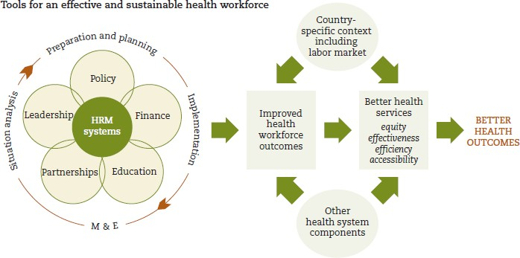

**Source**: Management Sciences for Health (2010).

### Identifying Staffing Requirements

There are various different ways of determining staffing requirements.

**Table 3.2 Different Ways of Determining Staffing Requirements**

|  |  |
| --- | --- |
| **Method** | **Details** |
| Health care demands approach | Based on a forecast of future health service utilisation |
| Health needs approach | Staffing requirements assessment based on demographic and epidemiological forecasts of the health needs of a population |
| Personnel to population ratios approach | Staffing based on ratios – or norms – for health personnel to population e.g. one doctor per 10,000 population. |
| Service targets approach | Staffing based on health service targets. This may be based on expansion of facilities – and staffing per facility – or programmes e.g., staffing required to provide ART services. |

**Developing an HRM plan – A step-by-step approach**

A five-step model for developing a HRM Plan is recommended. While these steps can apply to any facility, department, directorate or national level, the duration and complexity of each step varies from one level to another depending on the situation. The development of the

HRM Plan can be facilitated either by an internal team or outside consultants. In either case, participation of top management and staff representatives is required to ensure the HRM Plan meets the needs of the facility, department, directorate, county or country and is supported by both the management and staff, and can be implemented within the local constraints.

**Table 3.3 Five Steps in Developing an HRM Plan**

|  |  |
| --- | --- |
| **Step** | **Details** |
| 1. Conduct a strategic analysis | The results of this step are an understanding of the facility/department/county/country's vision, mission, values; a strategic review of the situation; and understanding of the challenges being faced. |
| 2. Identify strategic HR issues arising from the strategic analysis | Building on the results of step one, the outcome of this step is an analysis of the strategic HRH issues facing the facility/ department/county/country. |
| 3. Identify on-going HRH issues | In addition to the strategic HRH issues identified in step two, the ongoing HRH issues impacting the facility/department's effectiveness must also be identified. |
| 4. Prioritise the strategic and ongoing HR issues and determine actions: | Once all the HRH issues have been identified through steps two and three, they should be prioritised and key actions required in respect of each issue identified. |
| 5. Draw up the HRM plan | Once all input into the HRH priority issues is obtained and key actions to be taken in step four identified, the HRH Plan and its associated programmes are ready to be formulated. |

**Step 1 - Conduct a departmental strategic analysis**

The goal of the HRH Plan is to support and reinforce the facility/department's objectives and programmes. The first step in developing the plan is to obtain a clear understanding of the facility/department's objectives, programmes and key challenges. This understanding can be obtained by conducting a strategic analysis.

*How*

* Review key facility/departmental, country and country documents. These include the vision, mission, and values, program and other health sector strategic documents. If the vision, mission and values have not yet been formulated, it would be useful to have them worked out at this stage.
* Interview key internal staff and other relevant stakeholders to obtain their views on the direction, critical success factors and challenges.
* Interview relevant stakeholders to obtain their expectations.

**Step 2 - Identify strategic HRH issues**

Once a clear understanding of the facility/department/county's health objectives, direction and key challenges is established, the next step in formulating the HRH plan is to identify the strategic HRH issues. These are the key HRH issues that will affect the ability to achieve set strategic objectives. The HRH plan will need to address how to manage these issues.

*What to do*

* + Assess the HRH implications of the findings of the strategic analysis.
  + Identify the facility/department's strategic HR issues.

*How*

* Review the findings of the strategic analysis and list out potential HRH implications. Some of the key HR issues will naturally become apparent during the strategic analysis.
* Review the following suggested checklist to determine if there are any additional HRH issues tied to the strategic objectives, direction and challenges.

**Identifying the HR issues Arising from the Strategic Analysis**

1. Do people have the competencies to meet the strategic objectives? What new competencies are required?
2. How are superior performers differentiated from average performers? What systems are in place to track their performance?
3. How can below standard performers be guided or developed to upgrade their performance?
4. Are people being developed to meet the challenges of the future? What improvements need to be made?
5. Are people motivated to meet the current and future challenges? What impacts their motivation?
6. Are the right people being attracted and retained to meet the future challenges? If not, what can be done to attract people of the right calibre?
7. Is the current culture aligned with the vision, mission, and values of the facility/department?
8. Where is the misalignment?
9. Is the manpower level sufficient to meet the future health services delivery requirements?

**Step 3 - Identify on-going HRH issues**

In addition to the strategic HRH issues identified in the previous step, the facility/department's key on-going HRH issues (general HRH issues not linked to specific strategic objectives or issues) must be identified. The HRH plan must address the key ongoing HR issues, otherwise these issues may eventually escalate, impacting the morale and effectiveness of the health workers.

*What to do*

Identify the on-going HRH issues facing the facility/department. On-going HRH issues may relate to manpower planning, recruiting, performance management, training and development and staff relations.

*How*

* Conduct interviews. Interviews are a good way for the team developing the HRH plan to begin to identify the on-going HRH issues facing the facility/department. Topics to be covered in interviews include current HRH issues in the areas of manpower planning, recruiting, performance management, training and development, and staff relations.
* Conduct employee focus groups discussions. Focus groups are a good technique for identifying, probing and prioritising HRH issues with different groups of staff.
* Conduct staff opinion surveys. Staff opinion surveys demonstrate commitment to soliciting everyone's input on the HRH plan, provide an objective way to evaluate staff attitude, and the results can serve as a measurable benchmark for improvement. When considering undertaking a staff opinion survey, keep in mind that it is typically more time-consuming and resource intensive than other feedback mechanisms such as interviews and focus groups discussions.

**Step 4 - Prioritise the HRH issues and determine actions**

Up to this point, the strategic and on-going HRH issues facing the facility/department/county have been compiled. Not all the issues will be of equal importance or urgency. They need to be prioritised in order to ensure that the HRM plan focuses on the most critical issues.

*What to do*

* Involve the management team in confirming and prioritising the issues compiled to date. The management team should also give input on the actions that should be taken to address the issues.
* Management involvement in prioritising HRH issues and identifying actions is critical because it:

*How*

1. Reinforces the line management role in human resource management;
2. Helps ensure that HRH recommendations are actionable within the constraints;
3. Develops management commitment to and ownership for the HRH Plan implementation.
   * Collate the research findings up to this point. Analyse them critically with a view to articulating the strategic objectives and direction, critical success factors and strategic challenges.
   * Compile a preliminary list of the HRH issues identified and group according to logical categories, e.g. training, recruitment, etc.
   * Conduct a management strategic HRH workshop. The objectives of the workshop are to:
4. Present findings on the strategic challenges and HR issues;
5. Prioritise the HRH issues;
6. Develop action to address the current and future HR issues;
7. Prepare the ground work for structuring the HRH Plan.

The key activities in the workshop are to discuss, confirm and prioritise the HRH issues (identified from the findings of the strategic analysis and those ongoing HRH issues). The HRH issues should be prioritised according to their:

* + - Relative importance to the effectiveness of the department;
    - Urgency;
    - resources required;
    - Brainstorm recommended actions to address the priority issues.

**Table 3.4 Strategic HRH Workshop Agenda**

Introduction Workshop Objectives Agenda

Overview of Strategic Direction and Challenges Presentation of Strategic / On-going HR Issues Group Discussion

Prioritisation of HR Issues

Develop strategic responses to address HR Issues Develop action plans

**Step 5 - Draw up the HRH plan**

Once the HRH issues have been prioritised and the management team have given their input into the direction of the HRH plan, the plan is ready to be drawn up. The plan is unique and specific to the facility/department. It represents the management team’s collective view on how the identified HRH issues are to be addressed.

*What to do*

Develop the HRH plan consisting of several key programmes. Each programme should represent one of the key HRH areas that need addressing, e.g. training, performance management, staff relations, etc. Each programme within the plan should contain the following information:

* + - *Strategic importance of the programme:* Describe the background of the programme, why it is included as one of the programmes within the HRH plan.
    - *Programme objectives:* List out the aims of the programme. Be as specific as possible in terms of what the programme will achieve for the facility/department/county.
    - *Programme recommendations:* Develop the specific set of actions within the programme that will be carried out. The actions of the programmes, taken together, should be designed to achieve the programme objectives.

*How*

* + After obtaining management’s input on how to address the HRH issues, make additional recommendations, if any, to address the identified and prioritised HRH issues.
  + Group the recommendations into approximately 5-10 programme headings, e.g. training, performance management, staff relations, etc.
  + Draw up various HRH programmes which taken together will form the HRH plan.
  + Each programme should be approximately 2-3 pages. Each programme should contain an explanation of its strategic importance, objectives, and recommendations.
  + Prepare a summary list of HRH programmes covering the programme headings and their key objectives for easy reference.
  + Circulate the HRH plan to concerned parties for comments.
  + Incorporate comments and finalise the HRH Plan.

Upon finalisation of the plan, a good practice is to consider identifying a “driver programme” in implementing proposals in the plan. A ‘driver programme’ is one of the HRH programmes that if implemented will have a major impact on helping the department achieve its strategic objectives. The programme may also serve as the platform for implementing and reinforcing the other related HRH programmes, e.g. performance management can ‘drive’ the development of competencies, identification of training and development gaps, career development and succession plans.

**Table 3.5 Sample of a Summary List of HRH Programmes**

|  |  |
| --- | --- |
| **Programme** | **Key Objective** |
| Performance management | To increase the effectiveness of the appraisal process, and to strengthen the development aspect of performance management using the competency-based approach to training and career development |
| Career development | To expand career development opportunities, engage supervisors in developing the careers of their staff and demonstrate department’s commitment to staff career development |
| Training and development | To establish management development curriculum based on the competency assessment of the target group, and to provide training and development required to bridge identified competency gaps |
| Change management | To develop the mindset and necessary skills to manage and deal with change effectively |
| Staff recognition | To establish systems to recognise staff's performance and reward their contributions |
| Recruitment | To ensure the county makes hiring decisions that best fit the needs of the Department |

**HRH Statistics**

HRH statistics provide quantitative evidence of the HRH situation, e.g the numbers of health care workers, ratios per population, helps a county/country to judge if they have an adequate number of HRH and if not, the severity of the HRH situation. It also allows quick comparisons to other counties/countries. Disaggregating these statistics allows planners to describe the allocation of specific providers across the various levels within the delivery system and the distribution of providers between geographic boundaries (rural/urban). WHO gathers and presents statistics on the number of health care workers per 1,000 population. This is the recommended practice since it allows easy comparisons between countries in a region, and between areas within a country.

**Table 3.6 HRH Statistics**

|  |  |
| --- | --- |
| **Indicator** | **Definition and interpretation** |
| Ratio of different health personnel per 1,000 | This indicator considers:   * Ratio of health cadre per 1,000 people * Total number of physician * Total number of nurses * Total number of midwives * Total number of pharmacists * Total number of laboratory technicians * The number of health care providers, by cadre, is the raw material upon which all other statistics are based. |
| Total number by cadre and sector | This indicator considers:   * Total number of physician by sector * Total number of nurses by sector * Total number of midwives by sector * Total number of pharmacists by sector * Total number of laboratory technicians by sector |
| Ratio of health care worker by geographic distribution | This indicator considers:   * Ratio of health care workers by cadre and by geographic area * If possible, break out geographic distribution by cadre and sector   Use MOH and other HRH data sources to examine HRH distribution by: (1) cadre, (2) geopolitical boundaries, (3) urban/rural split and (4) service delivery level, including the number of CHWs (not attached to any level of facility).This will reveal inequities in service coverage. |
| Trends for the past five years | This indicator considers:   * Ratio of health professionals by population over time * Total numbers by cadre and sector over time |

|  |  |
| --- | --- |
| **Indicator** | **Definition and interpretation** |
|  | * Ratio of health care worker by geographic area over time   This ratio presents evidence about whether the HRH situation is getting better or worse for as many years as there are data available |

**Source:** Health Systems Approach 20/20 (2012).

* + 1. **Recruitment**

This is also known as hiring and deployment. Recruitment is the process of attracting, screening and selecting qualified person for a defined position. The general principles underpinning recruitment within the public service are that recruitment should:

* + - 1. Use procedures which are clearly understood by candidates and which are open to public scrutiny;
      2. Be fair, giving candidates who meet the stipulated minimum requirements equal opportunity for selection;
      3. Select candidates on the basis of merit and ability.

**Figure 3.2 Recruitment Processes**

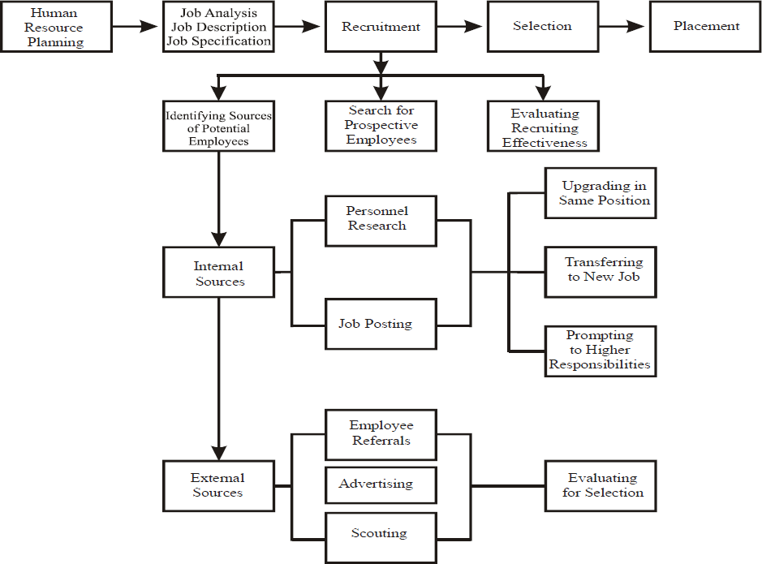

**Source:** Pigors and Myers (1983)

### Job Analysis

Job analysis is a systematic procedure for collecting and analysing job information. In selecting an applicant for a job, the selectors need to know what the job involves in terms of the key tasks, objectives and responsibilities (job description), the attributes (abilities, experience, personality etc.) required for successful performance (person/job specification).

Not only does this aid in getting the right person for the right job but it also helps individuals to identify with and increase their accountability for their role within the health sector.

### Job Description

A job description provides information on what a job involves. In other words, exactly what is it that the person has to *do*. Every job should have its own job description explaining exactly what is involved for the particular role. A job description is intended to give a candidate a clear feel for what they would be doing should they take up the position.

### Job /Person specifications

A person specification or job specification provides information on *what* the person needs to do the job. In other words, a statement of the personal attributes required for successful performance in the job. By personal attributes we mean knowledge, skills, aptitudes and experience; everything which is necessary for doing the job. In order to protect against unfair selection and in line with employment legislation, all the attributes listed must be specifically related to the job. The person specification should also specify which requirements are essential and which are desirable.

Essential skills and abilities refer to those things which, without them, the candidate could not do the job. Therefore essential skills/abilities must be fully matched by candidates. Desirable skills and abilities refer to those which would offer added value if held by candidates. Public sector job descriptions and person specifications are contained in the respective schemes of service for each cadre.

### Recruitment

Recruitment forms a step in the process which continues with selection and ceases with the placement of the candidate. It is the next step in the HRH procurement function, the first being the manpower planning. Recruiting makes it possible to acquire the number and types of people necessary to ensure the continued operation of the organisation. Recruiting is the discovering of potential applicants for actual or anticipated organisational vacancies.

### Selection

This involves matching people and their expectations with the job specifications and career path available within the organisation.

### Placement

After an employee has been recruited he is provided with basic background information about the employer, working conditions and the information necessary to perform his job satisfactorily. The new employee’s initial orientation helps him perform better by providing him with employment information, rules and practices.

According to Pigors and Myers (1983), “placement consists in matching what the supervisor has reason to think the new employee can do with what the job demands (job requirements), imposes (in strain, working conditions, etc.) and offers (in the form of pay rate, interest, companionship with other, promotional possibilities, etc.).” They further state that it is not easy to match all these factors for a new worker who is still in many ways an unknown entity. For this reason, the first placement usually carries with it a probation period.

* + 1. **Performance Management**

Performance management is the process of setting quantifiable performance goals and objectives and assessing individual performance against these measures. It is a deliberate human resource management intervention whose sole purpose is to align every employee’s work efforts with the objectives of the organisation, manage these efforts on a daily basis, measure employees performance, reward them accordingly and stimulate individual development to enhance employees contribution to the organisations’ success (Workforce Compensation and Performance Service, 2011).

According to Armstrong (1998), performance management is the systematic process of:

1. Planning work and setting expectations;
2. Continually monitoring performance;
3. Developing employee capacity to perform;
4. Periodically rating performance in a summary fashion;
5. Rewarding good performance.

**Figure 3.3 Performance Management’s Five Key components**

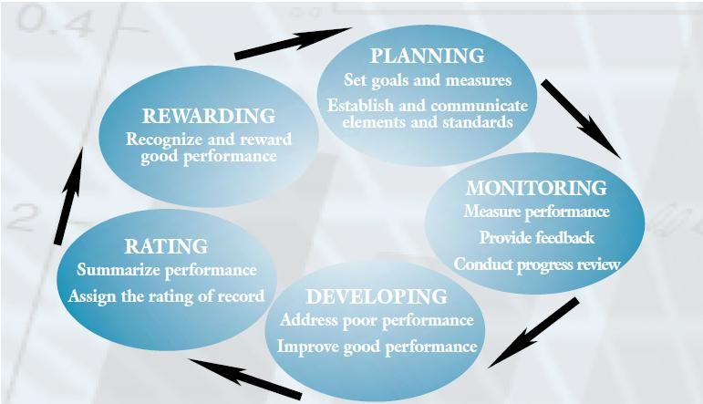

**Source:** United States Office of Personnel Management (2001).

### Planning

Planning means setting performance expectations and goals for groups and individuals to channel their efforts toward achieving organisational objectives. Getting employees involved in the planning process will help them understand the goals of the organisation, what needs to be done, why it needs to be done, and how well it should be done.

Best practice requirements for planning employees’ performance include establishing the elements and standards of their performance appraisal plans. Performance elements and standards should be measurable, understandable, verifiable, equitable, and achievable. Through critical elements, employees are held accountable as individuals for work assignments or responsibilities. Employee performance plans should be flexible so that they can be adjusted for changing program objectives and work requirements. When used effectively, these plans can be beneficial working documents that are discussed often, and not merely paper work that is filed in a drawer and seen only when ratings of record are required.

Planning work and setting expectations is achieved through work planning at the organisational, department and individual levels.

### Monitoring Performance

In an effective organisation, assignments and projects are monitored continually. Monitoring well means consistently measuring performance and providing on-going feedback to employees and work groups on their progress toward reaching their goals. Good practices for monitoring performance include conducting progress reviews with employees where their

performance is compared against their elements and standards. On-going monitoring provides the supervisor with the opportunity to check how well employees are meeting predetermined standards and to make changes to unrealistic or problematic standards. By monitoring continually, supervisors can identify unacceptable performance at any time during the appraisal period and provide assistance to address such performance rather than wait until the end of the period when summary rating levels are assigned.

### Developing Employee Capacity to Perform

In an effective organisation, employee developmental needs are evaluated and addressed. Developing in this instance means increasing the capacity to perform through training, giving assignments that introduce new skills or higher levels of responsibility, improving work processes, or other methods. Providing employees with training and developmental opportunities encourages good performance, strengthens job-related skills and competencies, and helps employees keep up with changes in the workplace, such as the introduction of new technology.

Carrying out the processes of performance management provides an excellent opportunity for supervisors and employees to identify developmental needs. While planning and monitoring work, deficiencies in performance become evident and should be addressed. Areas for improving good performance also stand out, and action can be taken to help successful employees improve even further.

### Performance Appraisal (Rating)

From time to time, organisations find it useful to summarise employee performance. This helps with comparing performance over time or across a set of employees. Organisations need to know who their best performers are. Within the context of formal performance appraisal requirements, rating means evaluating employee or group performance against the elements and standards in an employee’s performance plan and assigning a summary rating of record. The rating of record is assigned according to procedures included in the organisation’ s appraisal programme. It is based on work performed during an entire appraisal period. The rating of record has a bearing on various other HR actions, such as awarding within-grade pay increases and other incentives.

*Performance Plan*

Employees must know what they need to do to perform their jobs successfully. Expectations for employee performance are established in employee performance plans. Employee performance plans are all of the written, or otherwise recorded, performance elements that set forth expected performance. A plan must include all critical and non-critical elements and their performance standards.

*Performance Element*

Performance elements tell employees what they have to do and standards tell them how well they have to do it. Developing elements and standards that are understandable, measurable, attainable, fair, and challenging is vital to the effectiveness of the performance appraisal process.

*Critical Elements*

A critical element is an assignment or responsibility of such importance that unacceptable performance in that element would result in a determination that the employee’s overall performance is unacceptable. Good HRM practices require that each employee have at least one critical element in his or her performance plan. Even though no maximum number is placed on the number of critical elements possible, most experts in the field of performance management agree that between three and seven critical elements are appropriate for most work situations. Critical elements are the cornerstone of individual accountability in employee performance management.

*Non-critical Elements*

A non-critical element is a dimension or aspect of individual, team, or organisational performance, exclusive of a critical element, that is used in assigning a summary level of performance. Failure on a non-critical element cannot be used as the basis for a performance- based adverse action, such as a demotion or removal. Only critical elements may be used that way. Moreover, if an employee fails on a non-critical element, the employee’s performance cannot be summarised as *unacceptable* overall based on that failure.

*Rewarding Performance*

In an effective organisation, rewards are used often and well. Rewarding means recognising employees individually and as members of groups for their performance and acknowledging their contributions. A basic principle of effective management is that all behaviour is controlled by its consequences. Those consequences can and should be both formal and informal and both positive and negative. Good managers and supervisors do not wait for their organisation to solicit nominations for formal awards before recognising good performance. Recognition is an ongoing, natural part of day-to-day experience. A lot of the actions that reward good performance, like saying “thank you”, don’t require a specific regulatory authority. Nonetheless, formal awards regulations provide a broad range of forms that more formal rewards can take, such as bonus, time off and many recognition other items.

Public service employees are required to complete a performance appraisal twice a year and submit the appraisal form to the MoH by the end of the financial year. Certain levels of public service employees work under an annual performance contract which sets out performance plans, performance elements and critical elements.

* + 1. **Training and Developing the Health Workforce**

To deliver high quality care, health workers must possess a high level of knowledge combined with excellence in practical skills. They must also show kindness and compassion and respect for patients. If any one of these elements is missing, then significant problems in health care may occur. The objective of training and development is to enable employees to acquire the knowledge, skills, abilities and attitudes necessary to enable them to improve their performance.

The purpose of training and management development is to improve employee capabilities and organisational capabilities. When the organisation invests in improving the knowledge and skills of its employees, the investment is returned in the form of more productive and effective employees. Training and development programmes may be focused on individual performance or team performance.

**Key Terms**

|  |  |
| --- | --- |
| Training | Systematic approach to affecting individuals’ knowledge, skills and attitudes in order to improve individual, team, and organisational effectiveness |
| Development | The systematic efforts affecting individuals’ knowledge or skills for purposes of personal growth or future jobs and/or roles |
| Human capital | The collective set of performance-relevant knowledge, skills, and attitudes within a workforce at an organisational or societal level |
| Training evaluation | The systematic investigation of whether a training programme resulted in knowledge, skills or affective changes in students |

**Source**: Goldstein and Ford (2002)

To be effective, training and management development programs need to take into account that employees are adult students (Forrest and Peterson, 2006). Knowles’ (1990) theory of adult learning or ‘andragogy’ is based on five ideas, namely:

1. Adults need to know why they are learning something;
2. Adults need to be self-directed;
3. Adults bring more work-related experiences into the learning situation;
4. Adults enter into a learning experience with a problem-centred approach to learning;
5. Adults are motivated to learn by both extrinsic and intrinsic motivators.

Having a problem-centred approach means that workers will learn better when they can see how learning will help them perform tasks or deal with problems that they confront in their work (Aik and Tway, 2006).

At different stages of their careers, health workers need different kinds of training and different kinds of development experiences. Although a first degree or diploma might prepare students for their first job, they will need to gain knowledge and skills through education and experience as they progress through their career. Forrest and Peterson (2006) suggests that there are four stages of management education with different learning outcomes:

1. Functional competence, an understanding of finance, accounting, marketing, strategy, information technology, economics, operations and human resources management;
2. Understanding context and strategy and how organisational processes interrelate, to make sense of health issues, societal changes, social values, global issues and technological change;
3. Ability to influence people, based on a broad understanding of people and motivations; and
4. Reflective skills to set priorities for work efforts and life goals.

To maximise the effectiveness of training and development, organisations must constantly assess their employees’ current training and development needs. They must also identify training and development needs to prepare employees for their next positions. This requires that organisations to recognise that different employees have different needs which change over time as the workers grow in their careers.

**Training**

Training can be examined from different dimensions. Two important dimensions are the degree to which there is interaction with others during training (personal versus interpersonal), and the degree of formality of the training. There are four modes of training based on these two dimensions as seen in **Table 3.7***.*

**Table 3.7 Classification of Training Methods in Organisations**

|  |  |  |  |
| --- | --- | --- | --- |
|  | | Degree of formality | |
| Degree of interaction |  | Informal | Formal |
| Personal | Self- training | E- learning |
| Interpersonal | Peer | Instructor-led |

While both individuals and organisations have preferences for particular types of training modalities, many organisations and individuals use several training methods.

### Types of training

Various types of training are provided in the public service. These include but are not limited to:

* + **Induction:** to familiarise new recruits with job requirements and procedures, departmental objectives and performance standards and the values and norms of the department.
  + **Management development:** to equip managers with the knowledge and skills required and to widen their perspective.
  + **Vocational:** to provide staff with the professional or technical knowledge and skills required for work.

**Staff Development**

The purpose of career development is to identify and develop the potential within staff, to build existing skill levels and to prepare staff to take on greater responsibility during their careers. Career development has to balance the needs and aspirations of the individual with those of the service – where this conflict, the needs of the service should prevail.

There are several methods of facilitating staff development. These include:

1. Posting - Postings for staff should normally take into account the individual’s previous experience and his future needs and potential. Staff can either be developed to have a broad experience across a number of areas. They can focus on a particular area and develop in-depth experience. Determining the most appropriate way to develop staff is a balance between the needs of the organisation and the aspirations of the individual. Future posting aspirations should be discussed with staff on the understanding that in the final analysis the needs of the employer are paramount.
2. Acting appointment - There are three kinds of acting appointments:
   * Acting ‘with a view’ - whereby staff are posted to the acting rank to assess their suitability for substantive promotion.
   * Acting ’with a singling out effect’ – whereby staff who do not merit immediate promotion or an acting appointment with a view to substantive promotion but who are nevertheless assessed to have better potential than other officers to undertake the more demanding duties in the higher rank, are placed in the higher rank to assess their suitability for substantive promotion.
   * Acting for administrative convenience – whereby staff are placed in a higher rank to cover the absence of the normal post holder, e.g. through sickness, long holiday or maternity leave. Staff acting for administrative convenience revert to their substantive rank when the substantive post holder returns.

Apart from acting for administrative convenience which is more ad hoc, the other two types of acting provide opportunities for staff to be exposed to more onerous duties and responsibilities, thereby testing their ability.

1. Secondment - Secondment from departments for attachments in other sections of the organisation are good ways of exposing staff to different work environments while the organisation is at the same time providing technical support.

|  |
| --- |
| **Strategic questions** (This may be turned into a student activity) |
| 1. Why would an organisation be reluctant to invest in training its employees if it makes their employees more capable? Isn’t it better to have more capable employees? 2. If an organisation offered to send you to a management development programme, with the condition that you agree to work for the organisation for 2 years to “pay off” the training, would you accept the offer? 3. If an organisation has a high turnover, should it invest in training programmes? 4. How should an organisation measure the outcome of a training or management development programme? 5. How should an organisation determine the “break-even” point for management development programmes (i.e. where the organisation’s investment is paid for by increased productivity)? 6. Should national and county governments fund training programmes to improve the knowledge and skills of health workers? If organisations are reluctant to invest in training their own employees because those trained might be working for a competitor one day, should the government be reluctant to fund training programmes? |

* + 1. **Managing Employee Relations**

### The Employment Relationship

An employee is someone who has agreed to be employed under a contract of service (open- ended, fixed contract or casual), to work for some form of payment. This can include wages, salaries or commissions. The rights of full-time employees apply equally to part-time employees. These rights also apply to casual employees. However, the way in which annual, sick and bereavement leave are applied may vary for these employees.

1. *Good Faith:* Establishing and maintaining good faith relationships is important for employment relations system for both collective and individual employment arrangements. Good faith involves using practical common sense and treating others in the way you would like to be treated. This means dealing with others honestly, openly and with mutual respect. Acting in good faith reduces the risk of conflict and problems. It is also part of the Employment Act.
2. *Employment Agreements*: Good employment relationships begin with a good recruitment process that ensures everyone has clear expectations about the role, working conditions and employment rights. A clearly written employment agreement can help reduce the risk of misunderstandings. Every employee must have a written employment agreement. This can be either an individual agreement or a collective agreement. Collective employment agreements are negotiated in good faith between an employer and a registered union on behalf of their members. Employers must not unduly influence employees to join or not join a union.

### Types of employment agreements

The Employment Act 2012 sets out most of the rules for forming an employment relationship through employment agreements. The rules differ based on whether there is a relevant collective agreement or not. A relevant collective agreement is in place when: An employer and a union have negotiated a collective agreement under the Employment Act 2012, and Labour Relations Act 2012. The agreement covers the work to be done by a new employee.

If there is no relevant collective agreement, the employer and the employee negotiate an individual employment agreement which indicates the terms and conditions of employment. This agreement must neither fall short of legislative requirements nor be inconsistent with the law. The agreement must be in writing.

*Probation period*

An employer may offer employment with an initial probationary period. This must be writing. A probation period allows a new employee to demonstrate their skills. Such arrangements may be permissible where the duration and tasks are limited and designed to give the employer an opportunity to assess the employee’s skills. Employers must pay for work done during the probation period. A probation period does not limit the legal rights

and obligations of the employer or the employee, and both parties must deal with each other in good faith.

*Induction*

A good induction process and training is important in helping employees understand the job and perform well. Both set the tone and expectations for employment relationship.

*Wages and records*

There are legal requirements governing wages and wage time, holiday and leave records. Legally, wages have to be paid in cash. Other methods need an employee’s written agreement. It is advisable to keep record files up to date. Employees have the right to know everything recorded in their files and have a right to review them.

### Establishing a Performance Management System

Performance management involves a lot more than simply dealing with problems at the work place. Positive performance management should be embedded into employment relationship. This is important in setting expectations and rewarding success as well as dealing with problems.

**Employment rights**

By law, two types of employment rights apply to all employees:

* 1. Minimum pay and emoluments received;
  2. Treatment at work.

Minimum employment rights must be met regardless of whether they are included in agreements. By law, however, some provisions must be included in employment agreements. The employment law also provides a framework for the process of negotiating additional entitlements. Employees cannot be asked to agree to less than the minimum rights.

***Health and safety*** - Employers must provide a safe workplace, with proper training, supervision and equipment. This duty includes identifying, assessing and managing hazards and investigating health and safety incidents. Employees must take reasonable care to keep themselves safe and avoid causing harm to others when working. Employees may refuse work that is likely to cause them serious harm. They also have the right to participate in efforts aimed at improving health and safety at work.

***Minimum pay*** - The adult minimum wage must be paid to employees aged 18 years and above.

***Break entitlements*** - Employees and employers can agree to the timing of rest and meal breaks. If they cannot agree on timing, the rest and meal breaks must be evenly spread

throughout the work period. Employers and employees can agree to more and/or longer breaks.

***Leave and holidays-*** These include:

1. Annual leave- According to the Employment Act 2012, an employee is entitled to a minimum of 21 days paid annual leave at the end of each year. Employers can agree to give employees more than the stipulated leave days.
2. Maternity Leave- A female employee shall be entitled to three months maternity leave with full pay.
3. Paternity Leave- A male employee is entitled to two weeks paternity leave with full pay.
4. Sick leave- After two consecutive months of service with his employer, an employee shall be entitled to sick leave of not less than seven days with full pay and thereafter to sick leave of seven days with half pay, in each period of twelve consecutive months of service.
5. Public holidays- Employees are entitled to a paid day off on a public holiday if it would otherwise be a working day. These public holidays are separate from and additional to annual holidays.

***Equal pay and equal rights*** - Employers cannot pay employees differently based on gender. Employers cannot discriminate in hiring or firing, pay, training or promotion because of race, colour, national or ethnic origin, sex, marital or family status, employment status, age, religious belief, political opinion, disability or participation in certain union activities.

***Union membership rights*** *-* Employees have the right to decide whether they want to join a union and, if so, which union. It is illegal for an employer or anyone else to put unreasonable pressure on someone to join or to not join a union, or to discriminate against someone because they joined or did not join a union.

**Addressing employment relationship problems**

An employment problem includes anything that harms or that may harm an employment relationship. While the most obvious relationship is between an employer and an employee, other examples are relationships among employees, between a union and its members, between a union and an employer and among unions covering employees in the same workplace. Some of these problems may lead to personal grievances requiring specific treatment under the Employment Act. A number of staff in the same workplace may share a common view about a problem. If so, it can help to deal with the problems collectively and to look for a solution that works for everyone.

**Table 3.8 Examples of Employee Relationship Problems**

|  |  |
| --- | --- |
| **Employer’s perspective** | **Employee’s perspective** |
| * Poor performance or unacceptable behaviour * Lateness and absenteeism * Long-term illnesses * Failure to comply with health and safety Procedures * Breaches of organisational policy or the law * Misconduct * Conflict between employees | * Discrimination or harassment * Disagreement about whether a warning should be issued * Problems with health and safety * Disagreement about the meaning of a term in an employment agreement * Misunderstood or poorly managed discipline * Dismissals, redundancies or restructuring * Disputes over holidays or pay, including deductions from pay |

Whether a problem involves an individual or a group, it is important for everyone to:

1. Deal with the issue as soon as it arises;
2. Take the time to get the facts straight;
3. Listen to everyone’s views;
4. Seek solutions;
5. Follow laid down dispute settlement procedures and a fair process that everyone understands as provided for in the organisations’ policies, union agreement or employment law;
6. Record actions and expectations.

### Preventing Employment Relationship Problems

Problems are least likely to arise when everyone in an employment relationship acts in “good faith”. The following are examples of some simple practices that can help make employment relationships smoother and prevent problems:

1. Employees should be well informed about their employment rights and responsibilities;
2. Agreements (and changes to agreements) should be recorded in writing. This helps to prevent misunderstandings and resolve problems if they arise later;
3. It should be clear that the terms of employment being offered are only those recorded in the written agreement, and employers should avoid giving assurances that are inconsistent with the written agreement or that are not recorded in it;
4. Employees also have a responsibility to prevent and clear up confusion;
5. Before any significant change, the people affected should be consulted. Getting everyone’s ideas and perspectives will often lead to better decisions. People also respond better to change when they have some warning and have been listened to;
6. Raising concerns when they first arise can help stop them becoming bigger and harder to resolve. An effective performance management system is a good way of ensuring this;
7. Take time to communicate clearly. Poor communication often causes disputes and misunderstandings.

### Procedures for Resolving Employment Relationship Problems

1. Problems often occur in workplaces. If a problem arises, it’s important to have a clear idea of the issues. To resolve them, check the facts and make sure that both sides have the time and opportunity to take advice and think through the issues.
2. Every collective and individual employment agreement must clearly explain the steps and processes for resolving employment relationship problems. It should tell employees what is required of them, their rights and what happens when a problem occurs.
3. The sooner an issue is dealt with, and the better a process is followed, the less likely it is that outside assistance will be required in resolving problems. It is important that all parties, in good faith, try to resolve any problems directly. Some parties may be able to settle their differences quickly and cheaply using a mediator as a third party.

The Employment Act and union agreements provide for clear dispute settlement procedures.

**Ending the Employment Relationship**

There are several ways in which employment relationships may be terminated. These include resignation, retirement, dismissal or redundancy. If an employee believes that an employer acted unjustifiably in ending the employment relationship, the employee can challenge the employer’s decision.

**References and Recommended Further Reading**

Aik Chong, T. and Tway, D. C. (2006) 'Elements and Principles of Training as a Performance Improvement Solution', *Performance Improvement*, 45 (3), 28-32.

Armstrong, M. (2010) *A Handbook of Human Resource Management Practice*. 10th ed. London: Kogan Page.

Directorate of Personnel Management (2006) *Handbook for Civil Service Staff Induction.*

Nairobi: Government Printer. Employment Act 2012.

Forrest, I., S. P. and Peterson, T. O. (2006) ‘It’s called andragogy’, *Academy of Management Learning & Education*, 5(1), 113-122.

Hernandez, S. R., Fottler, M. D. and Joiner, C. L. (1998) *Essentials of Human Resources Management in Health Service Organisations.* New York: Delmar publishers.

Goldstein, L. and Ford J. (2002). *Training in Organizations*. 4th ed. Belmont, CA: Wadsworth.

Green, A. (1999) ‘Planning Human Resources’ in Green, A. (ed.) *An introduction to Health Planning in Developing Countries.* Oxford: Oxford University Press.

Hall, T. (1998) ‘Why Plan Human Resources for Health?’ *Human Resource Development Journal,* 2 (2), 77-97.

Health Systems 20/20 (2012) The Health System Assessment Approach: A How-to Manual. Version 2.0 [online]. Available at <[www.healthsystemassessment.org](http://www.healthsystemassessment.org/)> [Accessed 24 February 2014].

Hunt, M. and Michael, C. (1983) ‘Mentorship: A Career Training and Development Tool’.

*Academy of Management Review*, 8 (3), 475-485.

Knowles, M. (1977) *The Modern Practice of Adult Education: Andragogy versus Pedagogy*. New York, NY: Association.

Labour Relations Act 2012.

Management Sciences for Health (2010) *Health Systems in Action: An eHandbook for Leaders and Managers.* Cambridge, MA: Management Sciences for Health.

Management Sciences for Health. Managers Who Lead: A Handbook for Improving Health Services [online]. Available at <<http://erc.msh.org/leadernet>> [Accessed 24 February 2014].

Management Sciences for Health (2009) ‘Strengthening Human Resource Management to Improve Health Outcomes’, *E Manager 2009*, No. 9

Philips, J. (1996) *Accountability in Human Resource Management*. Houston, Texas: Gulf Publishing Company.

Pigors, P. and Myers, C. A. (1983) *Personnel Administration. A Point of View and a* Method. London: McGraw-Hill International Book Company.

Pope, M. (2009) ‘Jesse Buttrick Davis (1871-1955): Pioneer of Vocational Guidance in the Schools’, *Career Development Quarterly*, 57, 278-288.

Republic of Kenya (2006) *Public Service Code of Regulations*. Nairobi: Government Printer.

Rock, B. (1991) *The Compensation Handbook: A State of the Art Guide to Compensation Strategy and Design*. 3rd ed. McGraw-Hill USA.

Shipp, P. (1998) *Workload Indicators of Staffing Need (WISN): A Manual for Implementation*. Geneva: World Health Organisation.

The Occupational Health and Safety Act 2007. The Work Injuries Benefits Act 2007.

Ulrich, D. (1996) *Human Resource Champions. The Next Agenda for Adding Value and Delivering Results*. Boston, Mass.: Harvard Business School Press.

United States Office of Personnel Management (2011*) Workforce Compensation and*

Performance Service. A Handbook for Measuring Employee Performance. Revised.

Watad, M. and Ospina, S. (1999) ‘Integrated Management Training: A Program for Strategic Management Development’. *Public Personnel Management*, 28(2), 185-196.

# MODULE 4: LEADING ORGANISATIONAL CHANGE



**Purpose**

To introduce students to theories and perspectives on organisational change and the implication of each for managing and leading the change process

**Objectives**

By the end of this module, the student should be able to:

1. Describe at least three theories of change and the implications of each for practitioners;
2. Apply change management practices.

**Content**

* 1. Organisational Change
  2. Change Management Models and Theories
  3. The Process of Change
  4. Managing Reactions to Change

**Methodology**

Lectures, discussions, case studies

**Training materials** Lecture notes Handouts

PowerPoint (Laptop and LCD projector) Whiteboards, flip charts, marker pens

**Duration: 4 hours**



**Lesson Plan Guide: Time: 4 hours**

|  |  |  |  |  |
| --- | --- | --- | --- | --- |
| **Session** | **Time**  **(Hours)** | **Content/Topic** | **Lesson Objectives** | **Lecturer Evaluation/Remarks** |
| 1 | 2 | Organisational change | To introduce students to organisation change as a necessary activity in organisations | Comments regarding time adequacy and students’ understanding and perceptions |
| Leading and managing change | To explain the process of implementing change in an organisation | As above |
| 2 | 2 | Change management models | To identify and discuss key change models | As above |
| Managing reactions to change | To identify and discuss various forms and causes of resistance to change | As above |

* 1. **Organisational Change**

Change is the coping process of moving from an unsatisfactory present state to a desired state. Individuals, teams, or organisations that do not adapt to change in timely ways are unlikely to survive. Successful individuals, teams and organisations are those that recognise the inevitability of change, learn to adapt, and attempt to manage it (Hunsaker, 2004).

Organisational change is the movement of an organisation from its current state or practices to some future or alternative and hopefully more effective state or processes in order to increase its effectiveness (Lunenburg, 2010). Organisational change is often stimulated by a major external force.. Typically, organisations undertake technical, structural or strategic shifts in the organisation to evolve to a different level in their life cycle, for example changing from a highly reactive organisation to a more stable proactive results-oriented environment.

Organisational change does not occur spontaneously; it takes place when forces encouraging change become more powerful than those resisting it. Organisational change may be occasioned by external or internal forces. Examples of external forces are substantial cuts in funding, change in government policy, technological advancement and increases in demand for services. Sometimes this includes increases in funding for new or expanding areas of

health care. Internal drivers of change include issues like declining effectiveness and productivity, internal strife and crisis and can include increased awareness of health managers or health providers related to new and/or more effective ways to deliver services or improve efficiencies.

In response to demands for change, organisations undertake technical, structural or strategic shifts in the organisation to evolve to a different level in their life cycle such as changing from a highly reactive organisation to a more stable proactive environment.

**Change Management**

Change management is a set of processes employed to ensure that significant changes are implemented in a controlled and systematic manner. One of the goals of change management is the alignment of people and culture with strategic shifts in the organisation to overcome resistance to change in order to increase engagement and achieve the organisation’s goal for effective transformation. Achieving sustainable change begins with a clear understanding of the current state of the organisation, followed by the implementation of appropriate and targeted strategies. Change management is a structured approach to shifting/transitioning individuals or teams from a current state to a desired future state. It is an organisational process aimed at helping employees to accept and embrace change in their current work environment. All leaders and managers must be prepared for changes by being flexible, positive and proactive in their approach.

**Change and Transition**

Bridges (2003) explains there are significant differences between change and transition. Change involves doing things differently while transition is deals with how to move people through the stages to make change work. Change is a shift in the externals of any situation, for example, setting up a new programme, restructuring a hospital, moving to new location, or a promotion. By contrast, transition is the mental and emotional transformation that people must undergo to relinquish old arrangements and embrace new ones.

There are other distinctions too. Change is made up of events, while transition is a continuous process. Change is visible and tangible. Transition is a psychological process that takes place inside people. Change can happen quickly, but transition, like any organic process, has its own natural pace. Change is about the outcome we are trying to achieve; transition is about how we will get there and how we will manage things while we are en route. Getting people through the transition is essential for change to occur. .

It is important to ensure that change management strategies are driven by the changes that need to occur. Nonetheless, do not to lose focus on the more personal transition activities needed to ensure the success of the programme.

### Change and Transformation

Transformation occurs as a result of a well-orchestrated and well-led change strategies and transition plans. The result is a metamorphosis to the desired state in which there is a deep- seated adoption of the changes and associated values, principles and or processes. This leads to an embedded and marked change in organisational culture and reinforces a journey of continuous improvement.

* 1. **Leading and Managing Change**

The implementation of any significant change process usually succeeds or fails because of the leadership of that change process. Management as a discipline focuses on processes and systems that keep the operations of an organisation running smoothly, while leadership engages people to create, adapt and meet the demands of the anticipated future.

Management plays an essential part in making the changes happen; it empowers the ‘doing’. Leadership inspires the transition, it is what energises people and sustains a change in behaviour and approach. Leadership engages the hearts and minds of staff.

### Planning for Change

Before embarking on an organisational change initiative, it is wise to carefully plan strategies and anticipate potential problems. One useful method of planning for change is Kurt Lewin’s Force-Field Analysis **(Figure 4.1).** The term describes a simple analysis that can be used to help plan and manage organisational change. Lewin believed that behaviour within an organisation was a result of the dynamic balance of two opposing forces. Change would only occur when the balance shifted between these forces. Driving forces are those forces which positively affect and enhance the desired change. They may be persons, trends, resources, or information. Opposing them are the restraining forces which represent the obstacles to the desired change. As these two sets of forces exist within an organisation, they create a certain equilibrium. That is, if the weights of the driving and restraining forces are relatively equal, then the organisation will remain static. As changes occur and affect the weight of either one of the forces, a new balance will occur, and the organisation will return to what Lewin called “quasi-stationary equilibrium”.

Force-field analysis assists in planning for change in two major ways:

1. As a way for individuals to scan their organisational context, brainstorming and predicting potential changes in the environment; and
2. As a tool for implementing change.

In (1) force field analysis is used as a method of environmental scanning. The more change can be anticipated, the better individuals and organisations are prepared to deal with the resulting effects. The second use of force-field analysis (in 2) presents a way to systematically examine the potential resources that can be brought to bear on organisational

change and the restraining forces that can be anticipated. This advance planning and analysis assists in developing strategies to implement the desired change.

**Figure 4.1 Force Field Analysis**

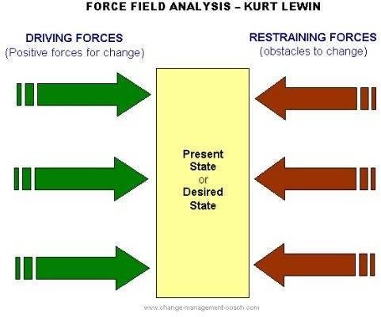

**Source:** Burnes and Cooke (2013).

**Strategies for Implementing Change**

In order to move the change process from the idea stage to implementation, team leaders and health managers must also rally the resources and support of the organisation. Kanter (1983) describes how the following three sets of “basic commodities” or “power tools” or enablers can be acquired by members of an organisation to gain power:

* + Information -data, technical knowledge, expertise
  + Resources- funds, materials, staff, time
  + Support- endorsement, backing, approval, legitimacy.

The first strategy in implementing a change would be to collect as many of these power tools as possible. As this occurs, you can start seeking support for the planned change. This is particularly important in helping others see the critical need for the planned change. It may be possible to generate support before sponsorship of the change is sought so that the sponsor feels he or she is proactively responding to a critical need.

Another strategy is to “package” the change in a way that makes it less threatening and, therefore, easier to sell. For instance, it is easier to implement change of a product or a project when it is:

1. Conducted on a trial basis;
2. Reversible, if it doesn’t succeed;
3. Done in small steps;
4. Familiar and consistent with past experience;
5. Fits in the organisation’s current direction; or
6. Built on the prior commitments or projects of the organisation (Kanter, 1983).

Building coalitions is a strategy that often occurs throughout the entire phase of implementing change. Support must be gathered from all areas which will be affected by the desired change, across different levels of the organisation. It is always advisable to get the support of an immediate supervisor early on, although this may not always be possible. In such instances, other support could be gathered across the organisation to lobby the supervisor to lend support to the change effort.

Effective change masters use their informal networks and deal with any concerns or questions of supporters individually rather than in formal meetings. “Pre-meetings” can provide a safer environment for airing concerns about implementing change. In such settings, an individual may have the opportunity to “trade” some of the power tools that he or she has acquired in order to generate support.

Additionally, some individuals will support a project or change effort for reasons that are fairly reactive: “If so-and-so supports it, then I will, too”, or “If such-and-such hospital is moving in that direction, then we should, too”. Obviously, the more change masters predict how particular individuals may react, the better able they are to plan for ways to garner support.

**Key Role Actors in the Change Process**

### Change Sponsor

A change sponsor is someone who has the authority, seniority, power, enthusiasm and time to lead/carry through/oversee the desired organisational changes. The change sponsor may not get involved with the day-to-day management of the change but should support and monitor progress. Usually, he or she is a senior member of the management team given responsibility for effecting the change.

Within the health sector system, a change sponsor may, for instance, be the Director of Medical Services, the chair of the facility management team or a senior medical consultant. The change sponsor must ensure that the necessary resources are available throughout the change process and accept ultimate responsibility for the successful change implementation. He should endorse the change strategy and approach, be an active champion and role model for the desired state and monitor and communicate change progress to interested parties.

### Change Manager

A change manager is someone with the expertise and credibility to lead the change and can act as a role model for the new reality. One of the top characteristics of successful change leaders is credibility with those making the change. The change manager may be an experienced project or change manager within the organisation or possibly, brought in from outside with the specific responsibility of managing the change. The change manager is responsible for the day-to-day implementation of the change:

* + Designs the change process, strategy and approach and agrees on these with the change team;
  + Takes responsibility and manages the change progress on a day-to-day basis;
  + Designs the communication strategy and contingency plans for the change;
  + Monitors progress;
  + Facilitates key events to build commitment for the change;
  + Liaises up and down the organisational structure.

### Change Advocate

A change advocate is an individual or group that wants to achieve change but does not possess legitimisation power. Doctors, nurses, clinicians, technologists and technicians are often in the position of change advocates. Although they see the need for change and desire and advocate for the change, they do not have the necessary organisational power to implement it.

### Change Agent

Every organisational change, whether large or small, requires one or more change agents. A change agent is anyone who has the skill and power to stimulate, facilitate and coordinate the change effort. The individual or group that undertakes the task of initiating and managing change in an organisation is known as a *change agent*. Change agents can be internal, such as managers or employees who are appointed to oversee the change process. In many innovative-driven companies, managers and employees alike are today being trained to develop the needed skills to oversee change. While change agents can also can be external, internal change agents are known to be the most effective.

The success of any change effort depends heavily on the quality and workability of the relationship between the change agent and the key decision-makers within an organisation.

* 1. **Change Models**

Organisational change may be sporadic or on-going continuous improvement initiatives as a result of organisations responding or reacting to external forces for change. Such changes may be a part of improvement initiatives such as Total Quality Management (TQM), Six Sigma, Kaizen or other organisational development initiatives based on various change models.

There are many different models for the change process. These include the Balanced Scorecard, John Kotter’s Eight Steps in Leading Change, Tuckman’s Four Stages of Team Development and Bridges Three Phases of Transition.

### Balanced scorecard

This is a strategic planning and performance management tool that can be used by team leaders and health managers to keep track of the execution of activities by teams within their control and to monitor the consequences arising from these actions. The Balanced Scorecard presents a mixture of financial and non-financial measures. Each critical indicator is compared to a 'target' value. It articulates the links between leading inputs (human and physical), processes, and lagging outcomes and focuses on the importance of managing these components to achieve the organisation's strategic priorities. The Balanced Scorecard depicts the organisation’s success at aligning organisational improvement efforts to strategies to meet customer needs by focusing on four perspectives as presented in **Table 4.1**.

**Table 4.1 Balanced Score Card Dimensions**

|  |  |
| --- | --- |
| **Dimension** | **Measure** |
| Financial | Encourages the identification of measures that answer the question: “*How do we optimise expenditures for maximum mission effectiveness?”* |
| Customer | Encourages the identification of measures that answer the question:  *“How should we appear to our customers to achieve our vision?”* |
| Internal business Processes | Encourages the identification of measures that answer the question:  *“Which processes must we excel at to satisfy our stakeholders?”* |
| Learning and growth | Encourages the identification of measures that answer the question: *“How can we continue to improve and create value to achieve our vision?”* |

In addition to reviewing past results, the Balanced Scorecard can also utilised as a strategic management system in several ways:

* + *Communication –* Cascading the scorecard;driving it down to all levels of the organisation – gives employees the opportunity to demonstrate how their day-to-day

activities contribute to the organisation’s strategy. This creates a line of sight between the front-line employee and top leaders.

* + *Strategic resource allocation* – The resources necessary to achieve scorecard targets form the basis for the development of the annual budgeting process, thereby directly tying resources to achievement of the organisation’s goals.
  + *Continuous improvement* – Balanced Scorecard results form the basis for reviewing, questioning and refining the strategies and tactics needed to achieve an organisation’s goals.

### John Kotter’s Eight Steps in Leading Change

According to Kotter’s research, 70% of all major change efforts in organisations fail because organisations often do not take the holistic approach required to see change through. By following Kotter’s Eight Step Process, organisations can avoid failure and become adept at change. By improving their ability to change, organisations can increase their chances of success, both today and in the future. Without the ability to adapt continuously, organisations cannot thrive. Kotter’s eight steps for organisational change are widely viewed as the framework for successful change at all levels of an organisation.

**Table 4.2 Kotter’s Eight Steps for Organisational Change**

|  |  |
| --- | --- |
| 1. Create urgency | Kotter suggests that for change to be successful, 75% of a company's management needs to support the change. So one of the key early tasks is to develop a sense of urgency around the need for change. This can involve a full SWOT analysis, scenario planning and full deployment of all the strategic planning tools. Results of analysis and early conclusions should be thoroughly tested with informed third party opinion and a wide cross section of stakeholders. |
| 2. Form a guiding coalition | Managing change is not enough, change must be led. Building the momentum for change requires a strong leadership and visible support from key people within an organisation. The coalition will involve a wide representation of the formal and informal power-base within the organisation. By working as a team, the coalition helps to create more momentum and build the sense of urgency in relation to the need for change. Kotter recognises the importance of the emotional dimension and the energy that is generated by a “mastermind” group all working together. |
| 3. Develop a vision and strategy | A drive for change without a clear focus will rapidly fizzle out unless leaders develop a clear vision of the future that is accompanied by a clear description of how things should look at in the future. The vision must be defined in such a way that it is capable of expression in a short “vision speech” that conveys the heart of the change in less than five minutes. This then needs to be encapsulated in a powerful one or two sentence summary.  All members of the coalition must be fluent in both of these vision |

|  |  |
| --- | --- |
|  | statements and leaders must, with the coalition, develop strategies that will deliver the vision. |
| 4. Communicate the vision | Communication is everything, and Kotter maintains that change leaders must use every means at their disposal to constantly communicate the new vision and key strategies that support that vision. This goes beyond the “special announcement” meetings and involves frequent and informal face- to-face contact with people by all individual members of the coalition. Email is not an appropriate communication vehicle, except where necessary to support prior face-to-face contact. The leaders must also “walk the talk” visibly. They must be available and accessible to people. They must openly and honestly address staff fears and concerns. |
| 5. Enable action and removal of obstacles | In this stage, the change initiative moves beyond the planning and the talking, and into practical action, as leaders put supportive structures in place and empower and encourage people to take risks in pursuit of the vision. This is where the change leader identifies and removes obstacles and obstructions to change. This may also involve addressing resistant individuals and/or groups and helping them to reorient themselves to the requirements of the new realities |
| 6. Generate short- term wins | Success breeds success. Kotter advises that an early taste of victory in the change process gives people a clear sight of what the realised vision look like. This is important as a counter to critics and negative influencers who may otherwise impede the progress of the initiative. It is also important to recognise and reward all those people who make these early gains possible. Change leaders must look for – and create – opportunities for these early wins. |
| 7. Hold the gains and build on change | Kotter argues that many change initiatives fail because victory is declared too early. An early win is not enough. This is the time to increase the activity, change all systems and structures and processes that don’t fit with the change initiative, and bring “new blood” into the coalition. This is mostly about continuous improvement. Each success (and failure) is an opportunity to analyse what worked, what did not, and what can be improved. |
| 8. Anchor changes in the culture | Kotter says that for any change to be sustained, it needs to become embedded in the new “way we do things around here” – that is, the culture. A major part of this is for the change leader to articulate the connections between new behaviours and organisational success. This is where the coalition team talks about progress at every opportunity. Tell success stories about the change process, and repeat other success stories. This is successful if change leaders put forth continuous efforts to ensure that the change is seen in every aspect of the organisation. |

### Bruce Tuckman’s Four Stages of Team Development

Change in leadership or programming affects people as individuals and also as a team. As a change model, Tuchman’s Four Stages of Team Development illustrates how people interact in team situations. Firstly, it illustrates that it is normal for teams to go through stages as they develop or cope with a new situation. Secondly it highlights the need to manage different aspects of team behaviour in a crisis or at each stage of development.

**Table 4.3 Bruce Tuckman’s Four Stages of Team Development**

|  |  |
| --- | --- |
| 1. Forming | In the first stages of team building, the forming of the team occurs. Individual behaviour is driven by a desire to be accepted by the others, and avoid controversy or conflict. Serious issues and feelings are avoided, and people focus on being busy with routines such as team organisation, roles, when to meet, etc. Individuals are also gathering information and impressions about each other, and about the scope of the task and how to approach it. This is a comfortable stage, but the avoidance of conflict and threat means that not much actually gets done.  The team meets and learns about the opportunities and challenges, and then agrees on goals and begins to tackle the tasks. Team members tend to behave quite independently. They may be motivated but are usually relatively uninformed of the issues and objectives of the team. Team members are usually on their best behaviour but very focused on themselves. Mature team members begin to model appropriate behaviour even at this early phase. Sharing the knowledge of the concept of ‘Teams – Forming, Storming, Norming, Performing’ is extremely helpful to the team. Supervisors of the team tend to need to be directive during this phase.  The forming stage of any team is important because it is at this stage that team members get to know one another, exchange some personal information, and make new friends. This is also a good opportunity to see how each member of the team works as an individual and how they respond to pressure. |
| 2. Storming | Every group will next enter the storming stage in which different ideas compete for consideration. The team addresses issues such as what problems they are really supposed to solve, how they will function independently and together and what leadership model they will accept. Team members open up to each other and confront each other’s ideas and perspectives. In some cases, storming can be resolved quickly. In  others, the team never leaves this stage. The maturity of some team |

|  |  |
| --- | --- |
|  | members usually determines whether the team will ever move out of this stage. Some team members will focus on the minutiae to evade real issues.  The storming stage is necessary to the growth of the team. It can be contentious, unpleasant and even painful to members of the team who are averse to conflict. Tolerance of each team member and their differences should be emphasised. Without tolerance and patience, the team will fail. This phase can become destructive to the team and will lower motivation if allowed to get out of control. Some teams will never go past this stage.  In this phase, team may be more accessible, but tend to remain directive in their guidance of decision-making and professional behaviour. Team members will therefore resolve their differences and members will be able to work with one another more comfortably. The ideal is that they will not feel that they are being judged, and will therefore share their opinions and views. |
| 3. Norming | The team manages to have one goal. It develops a mutual plan for the team at this stage. Some may have to give up their own ideas and agree with others in order to make the team function. In this stage, all team members take the responsibility and have the ambition to work for the success of the team’s goals. |
| 4. Performing | It is possible for some teams to reach the performing stage. High- performing teams are able to function as a unit as they find ways to get the job done smoothly and effectively without inappropriate conflict or the need for external supervision. By this time, they are motivated and knowledgeable. Team members are competent, autonomous and able to handle the decision-making process without supervision. Dissent is expected and allowed as long as it is channelled through means acceptable to the team.  At this stage, team supervisors are almost always participative. The team will make most of the necessary decisions. However, even the most high-performing teams will revert to earlier stages in some circumstances. Many long-standing teams go through these cycles many times as they react to changing circumstances. For example, a change in leadership may cause the team to revert to storming as new people challenge existing team norms and dynamics. |

### William Bridges three phases of transition

This is an individual change model. According to Bridges’ theory, change is situational. Transition, on the other hand, is a psychological, three-phase process that people go through as they internalise and come to terms with the details of the new situation that change engenders. Situational changes are not as difficult for organisations to make as the psychological transitions of the people impacted by the change. The three-phase process consists of the following:

1. **Ending, losing, letting go-** This involves helping people deal with their tangible and intangible losses and to mentally move on. Initially, most of the activity in managing the emotional and psychological journey of transition is related to letting go of the past and subsequent investing in and transitioning to the future. Bridges identifies five aspects of the natural ending experience: Disengagement, dismantling, dis-identification, disenchantment and disorientation. The process of letting go of the past can bring up feelings of sadness, grief and loss as well as some relief or anticipation about the possible new future. The starting point for dealing with transition is not the outcome, but the ending the person must make to leave the old situation behind. Endings can be managed by treating the past with respect, helping compensate for losses, giving people plenty of the right information, marking the endings, and helping define what is over and what is not.
2. **The neutral zone-** The neutral zone is that in-between place where one loses the sense of relatedness and purpose. This is because much of one’s identity is tied up in the old way of life. At this stage, there are no new anchors to give any context or meaning although this can be difficult, confusing and painful. Critical psychological realignments and repatterning takes place. This stage involves helping get people through it, and capitalising on all of the confusion by encouraging them to be innovators.

The neutral zone is a place of both risk and opportunity. It is risky because people are unsure of the process being created and may become anxious, during which time productivity may fall. Old weaknesses, compensated for in the old arrangements, may rise to the surface. People may get mixed signals between the old regimen and the new. People may become polarised one way or the other, leading to tension and discord. In addition, until the new regimen becomes embedded, any new arrangements are vulnerable to internal or external shocks.

For all these reasons, transitions through the neutral zone need to be managed carefully. Bridges provides a number of mechanisms for this, including creating temporary support systems and short-term goals, and redefinition of the activity in the neutral zone in terms of more familiar activity or metaphors. However, the neutral zone is alsoa point of creative opportunity. As people and systems “unfreeze” from the old systems, there is tremendous opportunity to identify and realize changes and find new ways of doing things.

1. **The new beginning-** This involves assisting people develop new identities, experience new energy and discover the new sense of purpose that make the change begin to work. Bridges distinguishes between “starts” and “beginnings”. A start occurs when people start doing new things, when they start enacting the changes. However, a beginning occurs only when the personal psychological and behavioural change takes place and people take on new behaviours and identities. Transition managers must identify the “4 Ps” defining the path into the future:
   1. Purpose of the transition
   2. Picture or vision
   3. Plan
   4. Part for each person to play

In addition, being consistent (avoiding conflicting messages), building momentum with “quick successes”, symbolizing the new entity and celebrating successes can all help with successful transitions. Besides providing a set of tools, Bridges proposes the creation of a Transition Monitoring Team. This is a group composed of individuals from across the organisation holding various roles, and whose sole purpose is to provide a feedback on the status of the transition across the organisation.

* 1. **Managing Reactions to Change**

People are generally afraid of the unknown. Many think things are fine the way they are and do not understand the need for change. Recognising the need to change, and acting on it, can be difficult decisions for individuals, leaders and managers to make. However, change, requires the management of people’s anxiety and confusion or conversely their excitement and engagement. These are emotions that most managers find difficult to deal with or address. Managing the change process and transition emotions is fundamental to the success of a change oriented project.

**Individual Resistance to Change**

The primary reason is that people fear change (Bridges 1980). They are not usually eager to forego the familiar, safe, routine ways of conducting their business in favour of unknown and possibly unsafe territory. As humans, we tend to prefer routines and accumulate habits easily; however, fear of change may be attributed to more than a tendency toward regularity. Change represents the unknown. It could mean the possibility of failure, the relinquishing or diminishing of one’s span of control and authority or the possibility of success creating further change. It might be that the planned change has little or no effect on the organisation whatsoever. Any one of these possibilities can cause doubt and thus fear, understandably causing resistance to the change efforts.

Additionally, the transition between the present state and the changed state is difficult for both individuals and organisations. On an individual level, people must be reminded that every transition or change effort begins with an *ending-* the end of the current state. The first step toward change is going through the process of ending. Endings must be accepted and managed before individuals can fully embrace the change. Even if the impending change is desired, a sense of loss will occur. Because our sense of self is defined by our roles, our responsibilities, and our context, change forces us to redefine ourselves and our world. This process is not easy.

Bridges presents the following four stages that individuals must pass through in order to move into the transition state and effectively change:

* + 1. **Disengagement**- The individual must make a break with the “old" and with his or her current definition of self.
    2. **Disidentification**- After making this break, individuals should loosen their sense of self, so that they recognize that they aren’t who they were before.
    3. **Disenchantment-** In this stage, individuals further clear away the “old,” challenging assumptions and creating a deeper sense of reality for themselves. They perceive that the old way or old state was just a temporary condition, not an immutable fact of life.
    4. **Disorientation**- In this final state, individuals feel lost and confused. It’s not a comfortable state, but a necessary one so that they can then move into the transition state and to a new beginning

**Organisational Resistance to Change**

Organisations, regardless of size, are composed of individuals. The extent to which individuals within the organisation can appropriately manage change represents the overall organisational capacity for change. However, there are other factors peculiar to the organisational setting that can act as barriers to implementing change. These include:

* *Inertia-* One of the most powerful forces that can affect individuals and organisations is inertia. The day-to-day demands of work diminish the urgency of implementing the change effort until it slowly vanishes within the organisation.
* *Lack of Clear Communication*- If information concerning the change is not communicated clearly throughout the organisation, individuals will have differing perceptions and expectations of the change.
* *Low-Risk Environmen-.* In an organisation that does not promote change and tends to punish mistakes, individuals develop a resistance to change, preferring instead to continue in safe, low risk behaviours.
* *Lack of Sufficient Resources*- If the organisation does not have sufficient time, staff, funds, or other resources to fully implement the change, the change efforts will be sabotaged.

These factors, combined with others characteristic to the specific organisation, can undermine the change effort and create resistance. A wise change agent will spend the necessary time to anticipate and plan for ways to manage resistance.

**Reasons behind Resistance to Change**

People’s reaction to change depends heavily on their:

* *Perceptions of value*: When we conclude that a proposed change will cause us to lose something of value, we have tend to resist it. The more we expect to gain from change, the more we support it.
* *Understanding of change:* We all fear the unknown, so we are less likely to support change if we do not understand it. If we are confused about the implications of change, we usually assume the worst and react accordingly.
* *Trust in initiators:* If our trust in management is low, our first reaction is to ask what is really going to happen and how it is this going to affect us? When we do not trust the initiators of change, virtually any change tends to be received negatively. When trust is high, we are more likely to support change.
* *Agreement with change: C*hange planners often fail to assess who is likely to agree or disagree with the introduction of a change. It is logical to expect more support from those who think that the change is a good idea than those opposed to it.
* *Personal feelings:* Our personal characteristics determine whether we support or resist change. For example, if we lack confidence in our skills i.e. skills required by change, we will probably be resistant. Cynicism is another key element in our reaction to change.

In addition to the influence of these and other personality attributes (such as dogmatic – closed-mindedness and authoritarian personalities), attitudes toward change itself can also play an important role in shaping our reactions to any specific change.

*Common phases in people’s reaction to change*

Habits are normal part of every person’s life although it is often counterproductive when dealing with change. As humans, we are not good at changing. We see change as a negative thing, something that creates instability and insecurity. A normal change management process often involves eight mental phases (Bridges 1980).

**Table 4.4 Common Phases in People’s Reaction to Change**

|  |  |
| --- | --- |
| Denial | Where we fight change and protect the status quo |
| Frustration and anger | When we realise that we cannot avoid change and become insecure because of lack of awareness quo |
| Negotiation and bargaining | Where we try to save what we can |
| Depression | When we realise that none of the old ways can be incorporated into the new |
| Acceptance | When we accept the change and start to mentally prepare ourselves |
| Experimentation | Where we try to find new ways and gradually remove the old barriers |
| Discovery and delight | When we realise that change will improve our future possibilities |
| Integration | Where we implement the change |

**References and Recommended Further Reading**

Ackerman, L. S. (1986) ‘Change Management: Basics for Training’, *Training and Development Journal,* 40 (4), 67-8.

Arendt, C. H., Landis, R. M. and Meister, T. B. (1995) ‘The Human Side of Change Part 4’,

*IEE Solutions*, 22-6.

Band, W. A. (1995) ‘Making peace with change’, *Security Management*, 19(3), 21-22.

Bridges, W. (2003) *Managing Transitions: Making the Most of Change*. Cambridge, MA: Da Capo Press.

Burnes, B. and Cooke, B. (2013) *‘*Kurt Lewin's Field Theory: A Review and Re-evaluation’,

*International Journal of Management Review,* 408-425.

Cumming, T. G. and Huse, E. F. (1989) *Organisational Development and Change*. 4thed. St. Paul, MN: West Publishing.

Dunphy, D. C. and Dick, R. (1989) *Organisational Change by Choice*. Sydney: McGraw- Hill.

Fernendez, S. and Rainey, H. (2006) ‘Managing Successful Organisational Change in the Public Sector: An Agenda for Research and Practice’, *Public Administration Review,* 66 (2).

Hunsaker, P. L. (2004) *Management: A Skills Approach*. 2nd ed. Upper Saddle River, N.J Pearson Prentice Hall.

IBP/WHO/MSH (2010) ‘A Guide for Fostering Change to Scale Up Effective Health Services, 2007’. *International Journal of Management, Business, and Administration,* 13(1).

Jacobs, J. A. (1995) ‘The Winners Know how to Change: Do You?’ *Hospital Materiel Management Quarterly*, 16 (4), 18-24.

Kotter, J. P. (1996) *Leading Change*. Boston: Harvard Business School Press.

Phillip L. H. (2004) Management: A Skills Approach. 2nd ed. Upper Saddle River, NJ: Prentice Hall.

Steinburg, C. (1992) ‘Taking Charge of Change’, *Training and Development*, 46 (3), 26-32.

Zaltman, G. and Duncan, R. (1977) *Strategies for Planned Change*. New York, NY: John Wiley & Sons.

# MODULE 5: COMMODITY AND SUPPLIES MANAGEMENT



**Purpose**

To introduce students to commodity management in the health sector

**Objectives**

By the end of this module, the student should be able to:

1. To identify and discuss components of the Kenya Health commodity frame work;
2. To outline standards for measuring quality and the Kenya quality mode;
3. To identify and discuss the Kenya Procurement regulatory framework.

**Content**

* 1. Supply chain management
  2. Internal organisation of a health facility
  3. Procurement processes
  4. Procurement method
  5. Essential medicines
  6. Commodity management cycle

**Methodology**

Lectures, discussions, case studies

**Training materials**

Lecture notes

Laptop and LCD projector Whiteboards, Flip charts, Marker pens

**Duration: 6 hours**



**Lesson Plan Guide Time: 6 hours**

|  |  |  |  |  |
| --- | --- | --- | --- | --- |
| **Session** | **Time**  **(Hours)** | **Content/Topic** | **Lesson Objectives** | **Lecturer Evaluation/Remarks** |
| 1 | 2 | * Quality assurance in the health care setting * Commodity Management Framework * Internal organisation   – supplies.   * Procurement methods | * To identify and discuss components of the Kenya Health commodity frame work | Comments regarding time adequacy and students’ understanding and perceptions. |
| 2 | 2 | * Standards in measuring quality | * To outline standards for measuring quality and the Kenya quality model | As above |
| 3 | 2 | * Procurement regulatory framework | * To identify and discuss the Kenya procurement regulatory framework | As above |

* 1. **Supply Chain Management**

Reliable and affordable supplies of commodities are critical for the success of health services. They affect the quality of the services, their availability, cost and influence the uptake of health services. An effective commodity management system must be in place to ensure their accessibility and effective use, both at the service delivery level and in referral services.

Supply chain management encompasses the planning and management of all activities involved in sourcing and procurement and all logistics management activities. It also includes coordination and collaboration with partners, which can be suppliers, intermediaries, third party service providers and customers. In essence, supply chain management integrates supply and demand management within and across parties.

Public procurement in all government entities is governed by the Public Procurement and Disposals Act and the Regulations. The Act has divided the public entities into three categories as indicated in the table below.

**Table 5.1 Public Procurement Act – Categories of Public Entities**

|  |  |
| --- | --- |
| **Class** | **Category** |
| Class A | Ministries and State Corporations |
| Class B | City Councils, Universities, Judiciary, Commissions, Colleges, Cooperative Societies, Parliament, County Hospitals and SAGAs |
| Class C | Municipalities, County Councils, Urban Councils and Schools and Sub-County Hospitals |

The Public Procurement Act was established to achieve the following objectives:

* + 1. To maximise the economy and efficiency;
    2. To promote competition;
    3. To promote integrity and fairness;
    4. To increase transparency and accountability;
    5. To increase public confidence;
    6. To promote of the local industry.

The Medical Superintendent or Officer in Charge has the obligation to ensure that a health facility complies with the provisions of the Act and Regulations.

* 1. **Internal Organisation of Health Facilities in Supplies Management**

All public entities are required to establish the following:

### User Department

The user department is the end user of the purchase or the department that will benefit from the purchase. The user initiates the purchase request, prepares the technical specifications of the purchase, participates in the evaluation of tenders and ensures that the purchase conforms to the requirements amongst other roles provided in the Procurement Act and Regulations. Some of the users in a health facility include: the Nursing Unit, Pharmacy Unit, Catering Unit and Theatre Unit amongst others.

### Procurement Unit

The procurement unit should be staffed with procurement professionals. The professionals should have procurement and supplies management qualifications from recognised institutes in purchasing and supplies. This unit is in charge of supplies management in the health facility. Some of the duties of the procurement unit include: maintaining a database of suppliers, preparing tender documents, maintaining procurement documentation, coordinating the evaluation of tenders and proposals, preparation of contracts, implementing decisions of the tender and procurement committees amongst others.

### Procurement Committee

The members of a procurement committee are appointed by the Medical Superintendent or the Officer in Charge. An Accounting Officer will serve as the chairperson of the committee. The secretary of the committee is appointed by the head of the procurement unit and is a procurement professional. The other three members are appointed by the Medical Superintendent or the Officer in Charge. The procurement committee evaluates tenders that are over KShs. 1, 000,000 in the County Hospitals and over KShs. 200, 000 (or as may be prescribed by the Procurement Act) in Sub-County Hospitals (formerly District Hospitals). The procurement committees’ functions include: approval or rejection of submissions made by the procurement unit. In instances where the procurement committee rejects then reasons shall be provided why such reject was made.

### Tender Committee

A tender committee is established in accordance to the Act. The members of a tender committee are appointed by the Medical Superintendent or the Officer in Charge. They should consist of not less than five members. The Secretary of the Committee should be a Procurement Professional in charge of the Procurement Unit. The tender committee evaluates tenders that are over KShs1,000,000 in the County Hospitals and over Kshs200,000 (or as may be prescribed by the Procurement Act) in Sub-County Hospitals (formerly District Hospitals). The tender committee reviews the report prepared by the Evaluation Committee to make an award. The tender committee can accept or reject the recommendation made by the evaluation committee by providing relevant explanations to their decision.

Some of the roles of the tender committee includes: approving the selection of successful tenders, awarding procurement contracts, approving the list of tenderers, approving the amendments of contracts amongst other roles.

### Evaluation Committee

The health facility establishes an Evaluation Committee for every procurement within the threshold of the tender committee for the purposes of carrying out the technical and financial evaluation of the tenders or proposals. The report of the evaluation committee is presented to the tender committee for consideration of award.

### Inspection and Acceptance Committee

The health facility establishes the inspection and acceptance committee. he committee is composed of a chair and at least two members. The members of the inspection and acceptance committee are appointed by the Medical Superintendent or the Officer-in-Charge. The functions of the committee include the following: ensuring the correct quantities are received, ensuring the services and goods meet the technical specifications, issuing completion certificates amongst other duties.

### Disposal Committee

The health facility establishes the disposal committee. The committee has five members appointed by the Medical Superintendent or the Officer in Charge. Their role is to dispose-off unserviceable, obsolete or surplus stores and equipment in the health facility.

* 1. **Procurement Processes**

The procurement process involves:

* + 1. Identification of a need;
    2. Procurement planning;
    3. Preparation and approval of the specifications;
    4. Publication of the bid;
    5. Receiving and opening documents;
    6. Evaluation of the bid documents;
    7. Notification of award;
    8. Contracting;
    9. Contract management and delivery.

### Identification of a need

The user department is responsible for identifying the needs of their respective department. The needs are then consolidated into a departmental budget. The budgets are presented to the Medical Superintendent for approval and for presentation to the treasury. The annual budgets are drawn based on the one year government financial year.

### Procurement Planning

All health facilities are required to prepare a procurement plan. The procurement plan has a breakdown of goods, services and works. It shows a schedule of planned delivery dates, completion dates, the procurement method to be used for each budget line and the sources of

finance. Procurement planning includes the pre-qualification of suppliers in every government financial year. The health facility invites suppliers to respond to the pre- qualification for various goods and services. The prequalification process identifies suppliers for various categories. The health facility uses the suppliers identified through this process to procure the required goods and services. The tender committee pre-qualifies suppliers and generates a list that should be used in the financial year.

### Preparation and approval of specifications

The various user departments within the health facility are responsible for the preparation of specifications. They prepare specifications based on their needs and submit the specifications to their respective departmental heads. The departmental heads approve the specifications for procurement and submit them to the procurement unit. The procurement unit will commence the procurement process by initiating the identified procurement method in the procurement plan.

### Publication of the bid

The procurement unit upon receiving the technical specifications from the user department is expected to prepare bid documents based on the respective procurement method identified in the procurement plan. The bid templates are prescribed by the Public Procurement Oversight Authority (PPOA). There are specific templates for each procurement method and different timelines (to advertise the bids and evaluate) allocated accordingly.

### Receiving and opening documents

The bids are received in the health facility in either the tender box or through an address provided in the bid document. The tender documents are to be kept under lock and key until the time indicated for the opening sessions. The tenders can be opened in public where the bidders are expected to be present and observe the opening. This happens when dealing with open tenders. The opening of bids and quotation also takes place in the procurement committees. The procurement committee members open the bids and list them prior to evaluation.

### Evaluation of the bid documents

Tenders and quotations are evaluated during procurement and evaluation committee meetings. The health facility sets up the tender committees which are used to evaluate tenders. There are two stages in the evaluation process: Administrative evaluation where the bids are evaluated to confirm compliance to the administrative aspects of the bid including: whether the bids were received on time; whether the bids contain documentation not considered technical but important to the bid. The bids that are successful for the administrative compliance stage are evaluated for technical compliance.

The procurement committee evaluates and awards while the evaluation committee evaluates and recommends for award. The report for the evaluation committee is presented to the

tender committee. The tender committee evaluates the report of the evaluation committee and awards to the most advantageous bidder or rejects and offers recommendations to the evaluation committee.

### Notification of award

The health facility is required to notify all bidders of the procurement process whether they are successful or not. In the open tender method, a period of 14 days is to be adhered to. The bidders are notified by the facility prior to contracting. Once the contracting period expires,; the health facility is supposed to contract the bidders.

### Contracting

The health facility is supposed to contract the bidder who was awarded by the tender or procurement committee. There are different contractual documents: Local Purchase Order (LPO), Local Service Order (LSO) and Contract. The sample LPO and LSO are appended in the Financial and Resource Management Module. The Contract documents are signed by the Medical Superintendent of the hospital or any other signatory as specified in the Act. The contractual documents can be obtained from the PPOA website and are mandatory for use in all government health facilities.

### Contract management

Contract management is a process of managing the contract milestones, managing the obligations and performance of the contract, managing claims and disputes that may arise and renewing the contract, amending the contract and eventually terminating the contract. It includes ensuring all deliverables are made and that they are in good order. The contract management process commences upon the award of contract by the tender committee. The objectives of contract management: minimise risks related to contracting; increase the efficiency of the process of contracting; reduce the costs; maintain good relationship with suppliers; ensuring the delivery of quality goods, services or works; and ensuring compliance with legal requirements and conditions. The health facility establishes an inspection and acceptance committee. The committee is tasked with the task of reviewing the deliverables and ensuring that they comply with the specifications provided. They issue inspection reports and certificates.

* 1. **Procurement Methods**

### Open Tender Method

The open tender method is the default procurement method. It allows all eligible bidders to participate in the tender without discrimination and therefore allows maximum competition. There are no maximum budget ceilings for this procurement method. There are two types of open tender methods: the International Open Tender and the National Open Tender. The International Open Tender is for goods and services that are obtained outside Kenya while the National Open Tender is for goods and services obtained within Kenya. The International

Open Tender is advertised for 30 calendar days while the National Open Tender is advertised for 21 calendar days. A fee of not more that Kshs5,000 is charged for bidders obtaining the tender documents. A tender security is charged to the bidder. Such security should not be more than 2% of the contract value.

The technical evaluation for open tenders is performed by the evaluation committee while the award is made by the tender committee. Open tenders should be evaluated within 30 days from the date of closure.

### Restricted Tendering

This procurement method is used when the goods, services or works are of complex or specialised nature. This method may be used where the time and cost required to examine and evaluate a large number of tenders would be disproportionate to the value of the goods and where there are only a few known suppliers of the goods, works or services. The bidders are given a period of 14 days to respond to the request for bids.

### Request For Proposals (RFP)

This method is also used where the services to be procured are of advisory or otherwise of a predominately intellectual nature. The health facility prepares an expression of interest (EOI). The EOI is to be submitted within fourteen days by the tenderers to the health facility. Successful bidders will be requested to write a proposal for further evaluation. The tender committee evaluates the proposal before an award is made. Upon award, the health facility proceeds to negotiate and contract the successful bidder.

### Direct Procurement

The method may be used where there is only one supplier; there is no reasonable alternative or substitute or there is an urgent need; and because of urgency, other available methods of procurement are impractical. There must be evidence that the circumstances that gave rise to the urgency were not foreseeable. In instances where the health facility uses this method and the procurement is more than Kshs500,000 (or as maybe prescribed by the Procurement Act), the health facility should inform PPOA at least fourteen days after notification of award of contract. However, direct procurement is not encouraged as it does not offer any competition.

### Request for Quotations

This method is used where the procurement is for goods or services (quantifiable) that are readily available and for which there is an established market. The quotation should be delivered in sealed envelopes. The opening of the quotations should be done jointly by the procurement unit and the user department. In instances where the quotations are higher than the prevailing market price then such quotations should be rejected and the health facility obtain fresh quotations.

### Low value procurement

This method of procurement happens when the value of goods, services or works being procured is less than Kshs30,000 (or as may be prescribed by the Procurement Act). This method is used where there is no advantage accrued to the health facility through the request for quotation method. This method should not be used when the health facility is deliberately repetitive or avoiding competition.

* 1. **Essential Medicines**

Access to medicines is part of the fundamental right to health. Provision of health services is incomplete without essential medicines. WHO (2002) defines essential medicines as:

*“Those that satisfy the priority health care needs of the population. They are selected with due regard to disease prevalence, evidence on efficacy and safety, cost comparative effectiveness. Essential medicines are intended to be available within the context of functioning health systems at all times in adequate amounts, in the appropriate dosage forms, with assured quality and at a price the individual and the community can afford.”*

Without the appropriate health commodities, health facilities and health care providers cannot offer the population a full range of comprehensive services and products to meet these goals. Ensuring health commodity availability to meet the needs of its clients is the ultimate goal of a health logistics system – to make certain that clients receive the right goods, in the right quantities, in the right condition, at the right place, at the right time, and at the right cost.

Health commodities include public health commodities, pharmaceutical commodities, medical supplies, vaccines, and non-pharmaceuticals. The objective of commodity and supplies management is to ensure that people have access to essential medicines which are safe, effective, of good quality, and prescribed, dispensed and used properly.

### Essential medicines list (EML)

Health care management and therapeutics are highly dynamic fields with new approaches, treatment protocols and therapeutic products being developed continuously. Therefore, clinical management guidelines and essential medicines lists are developed to guide and standardise health care delivery. According to the WHO EML, inclusion of a medicine on the EML should be considered if the medicine, as far as reasonably possible, meets the following criteria:

* + 1. *Relevance/need:* Public health relevance and contributes towards meeting the priority health care needs of the population.
    2. *Safety:* Scientifically proven and acceptable safety (side-effects and toxicity) in its expected way of use.
    3. *Comparative efficacy*: Proven and reliable efficacy compared with available alternatives based on adequate and scientifically sound data from clinical studies.
    4. *Quality:* Compliance with internationally acceptable quality standards recognised by the Pharmacy and Poisons Board including stability under expected conditions of storage and use.
    5. *Performance:* Sufficient evidence of acceptable performance in a variety of settings e.g. levels of health care.
    6. *Comparative cost-benefit*: A favourable cost-benefit ratio in terms of total treatment costs compared with alternatives.
    7. *Single ingredient*: Unless there is no suitable alternative available, a medicine should have only a single active ingredient.
    8. *Local suitability/appropriateness*: Preference should be given to a medicine which is well known to health professionals, suitable for local use e.g. dose-form, staff training, support facilities and socio-culturally appropriate e.g. method of use/administration.
    9. *Pharmacokinetic profile*: Wherever possible, the medicine should have favourable pharmacokinetic properties- absorption, distribution, metabolism and excretion, drug interactions.
    10. *Local manufacture:* Wherever possible, the medicine should have the possibility of being manufactured locally for improved availability, reduced procurement costs.
  1. **Commodity Management Cycle**

The commodity management framework cycle comprises of all elements required for the establishment and continuity of supplies for health care delivery, including pharmaceutical and non-pharmaceutical commodities. It includes four key stages, namely:

1. Careful choice of medicines according to national or global – World Health Organisation (WHO) – guidelines;
2. Procurement of value-for-money commodities of proven good quality;
3. Effective and efficient distribution systems within a facility;
4. Rational prescription and use of medicines/commodities/supplies.

**Figure 5.1 Commodity Management Framework**

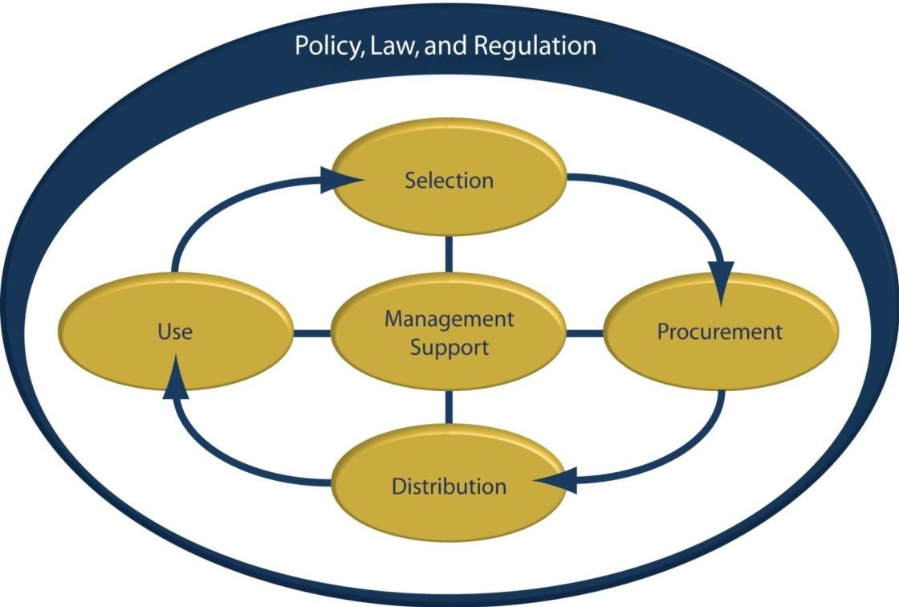

**Source**: Walkowiak, et al. (2008).

### Selection

The rationale for selecting a limited number of essential medicines, commodities and supplies is that it may lead to better supply, more rational use and lower costs. As the selection has a considerable impact on quality of care and cost of treatment, it is one of the most effective areas for intervention.

### Procurement

This process is described under 5.4 above.

*Quality Assurance of Pharmaceutical Products*

Testing medicines for quality is the responsibility of the medicines regulatory authority, the Pharmacy and Poisons Board (PPB) through the national testing body, the National Quality Control Laboratory (NQCL) and various established procurement entities like the Kenya Medical Supplies Agency (KEMSA) and Mission for Essential Drugs and Supplies (MEDS). At national level, the procurement of commodities and supplies for the public sector is carried out by KEMSA. The buyer of non-pharmaceuticals is responsible for ensuring that they are of good quality.

### Distribution and storage

Distribution is a complex process that involves the transferring/transporting of health care commodities from one point to another and the monitoring and follow-up mechanism during and on completion of the distribution process.

The distribution process includes:

* + Stock (inventory) control;
  + Stores management;
  + Delivery to medicine stores and health facilities;
  + Receipt and management of commodities and supplies by facilities.

Distribution of commodities and supplies to public health facilities is mainly carried out by private sector transporters contracted by KEMSA. The distribution cycles are quarterly for dispensaries and health centres and bimonthly for hospitals.

*Good storage practices*

It is important to correctly receive and carefully check deliveries of commodity consignments in order to confirm that the items are the ones required/ordered. This is also done to identify any problems such as missing or short delivered items, breakages or other damages, or short dated/expired items.

**Figure 5.2 Good Storage Practices**

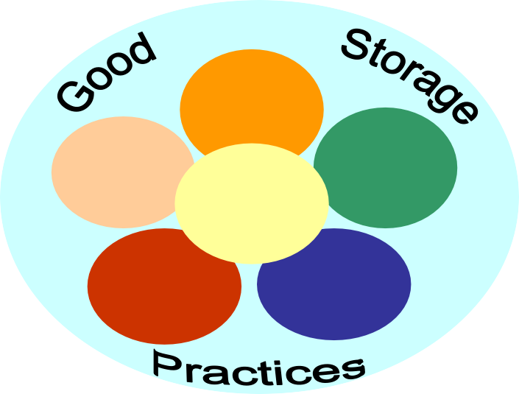

Good Arrangement

Good Control & Rotation

Good Record Keeping

Quality

Maintenance

Right Disposal

Assured Security

**Source***:* Management Sciences for Health (1997).

The aim of good commodity stores management is to ensure that all items are stored systematically, safely and securely and that quality is maintained up to the time of issue/use. This will require:

* + Avoiding product contamination or deterioration;
  + Avoiding damage or disfiguration of item labels;
  + Maintaining packaging integrity;
  + Preventing/reducing theft;
  + Preventing infestation by pests.
  + Store commodities in the designated commodity store only.

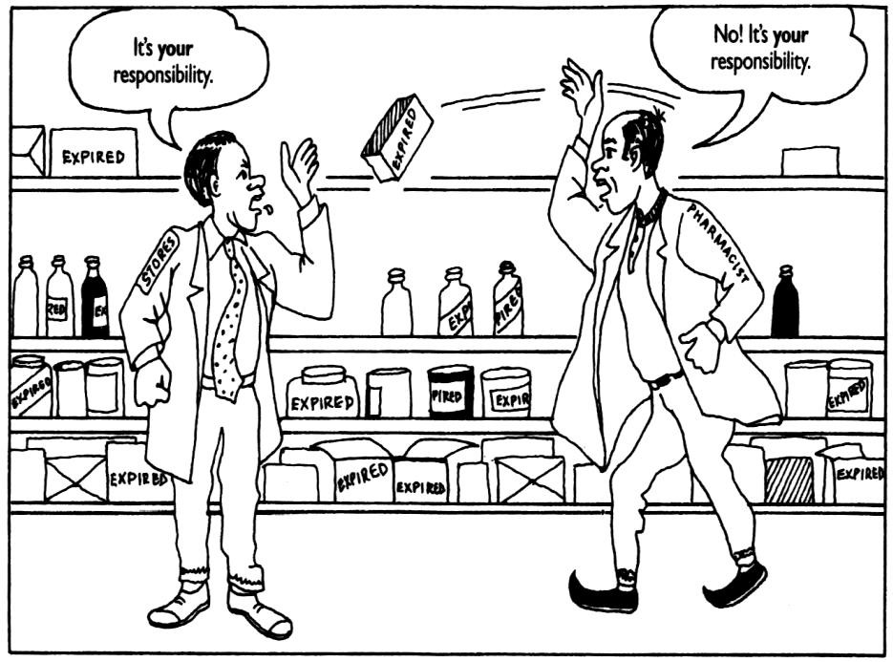

**Source:** Management Sciences for Health (1997).

* 1. **The Inventory Management Cycle**

The inventory management involves ordering, receiving, storing and issuing of consumable and non-consumable products

**Figure 5.3 Inventory Management Cycle**

Issuing Ordering

Storing Receiving

**Source**: Management Sciences for Health (2000).

### Ordering and Re-ordering

Ordering for commodities occurs after quantification is done and whenever commodities fall below the re-order levels. When commodities fall below the re-order levels, re-ordering or requesting is done. Official requisition forms include standard forms for requesting supplies

* 1. Counter Requisition and Issue Voucher (S11) for MoH, Standard Order Forms for KEMSA, Consumption Report and Request Forms e.g. Facility Consumption Data Report and Request (CDRR) forms.

### Delivery and receipt of commodities and supplies (Receiving)

The necessary action on delivery and receipt of commodities and supplies are:

* + 1. Refer to a copy of the original order;
    2. Examine the delivery note and compare with the copy of the original order. If the two documents list the same type and quantity of supplies, then proceed to verify quantity delivered;
    3. Count the actual quantity, paying attention to the product packaging. Look for physical damage, batch numbers, expiration dates and product description;
    4. When satisfied with the physical condition of the packaging, product description, batch numbers and expiration dates, you may then accept the shipment and sign the delivery note.

For medical products, KEMSA prepares specific consignment (facility pack) for every facility based on the order submitted for the three month (rural health facilities) or two month

(hospitals) in every supply cycle. This is then delivered directly to the health facility according to a pre-arranged schedule by contracted transporters.

### Stores Management (Storing)

After receiving stores items, the next step is to record them in the inventory. This is done by starting a new stock card/bin card/ledger book or updating the old stock card/bin card/ledger book. After completing a new stock card or updating existing stock card, the stocks must be stored according to established storage guidelines.

### Issuing

Issuing is the process of transferring of medicines from a storeroom to other locations (e.g., patient ward). Requisition and Issue Vouchers are used to effectively maintain records for the transfer.

**References and Recommended Further Reading**

Health Systems 20/20 (2012) ‘The Health System Assessment Approach: A How-To Manual. Version 1.75’ [online]. Available at <[www.healthsystemassessment.org](http://www.healthsystemassessment.org/)> [Accessed 24 February 2014].

Management Sciences for Health (1997) *Managing Drug Supply* [online]. Available at

<[http://www.msh.org](http://www.msh.org/)> [Accessed 24 February 2014].

Management Science for Health (2000) *Managing Drug Supply Training Series: Participant’s Guide*. 3rd ed. Boston: Management Science for Health.

Ministry of Medical Services and Ministry of Public Health and Sanitation (2010) *Kenya Essential Drug List*. Nairobi: Ministry of Medical Services and Ministry of Public Health and Sanitation.

Ministry of Medical Services (2009) *Kenya National Pharmaceutical Policy*. Nairobi: Ministry of Medical Services.

Ministry of Medical Services and Ministry of Public Health and Sanitation (2009) *Access to Essential Medicines in Kenya.* Nairobi: Ministry of Medical Services and Ministry of Public Health and Sanitation.

Public Procurement and Disposal Act 2006.

Walkowiak, H., Gabra, M., Sangiwa, G. and Mukadi Y. (2008) *A Commodity Management Planning Guide for the Scale-Up of HIV Counseling and Testing Services*. Arlington, VA: Management Sciences for Health

WHO (1999) *Operational Principles for Good Pharmaceutical Procurement: Interagency Guidelines*. Geneva: Department of Essential Drugs and Medicines Policy, WHO.

# MODULE 6: HOSPITAL INFRASTRUCTURE AND FACILITIES MANAGEMENT



**Purpose**

To enhance student appreciation of the role played by physical facilities, equipment and utilities in health service delivery and outcomes

**Objectives**

By the end of this module, the student should be able to:

1. Describe various types of health facilities infrastructure and equipment;
2. Describe the role of health facilities infrastructure and equipment in health promotion;
3. Describe health facilities preventive maintenance and asset management.

**Content**

* 1. Health system physical facilities, infrastructure and equipment
  2. Role of information technology
  3. Managing health facility assets
  4. Planned preventive maintenance

**Methodology**

Lectures, discussions, case studies

**Training materials** Lecture notes Handouts

PowerPoint (Laptop and LCD projector) Whiteboards, flip charts, Marker pens

**Duration: 2 hours**



**Lesson Plan Guide: Time: 2 hours**

|  |  |  |  |  |
| --- | --- | --- | --- | --- |
| **Session** | **Time**  **(Hours)** | **Content/Topic** | **Lesson Objectives** | **Lecturer Evaluation/Remarks** |
| 1 | 2 | Health system physical facilities, infrastructure and equipment | To introduce students to the various types of health facilities infrastructure and role of Information Technology in facilitating health care delivery | Comments regarding time adequacy and students’ understanding and perceptions. |
| 2 | 2 | Managing health facility assets | To introduce students to the various methods of managing health facility assets |  |

* 1. **Health System Physical Facilities, Infrastructure and Equipment**

The management of physical assets impacts on the quality, efficiency and sustainability of health services at all levels, be it in a dispensary, health centre, clinic, sub-county or referral hospital. A critical mass of affordable, appropriate, and properly functioning facilities and equipment is required at each level. Physical resources such as physical facilities and equipment and their attendant consumables are often described as health care technology. They are among the principal types of resource inputs in a health system. Physical facilities and equipment is the platform on which the delivery of health care services rests. Their acquisition and utilisation require high investment. Related decisions must therefore be made carefully to ensure the best match between the supply of physical assets and health system needs, the appropriate balance between capital and recurrent costs and the capacity to manage the asset throughout its life.

Health system physical assets include buildings, plant and machinery, furniture and fixtures, communication and information systems, catering and laundry equipment, waste disposal, and vehicles and medical equipment. The term health care technology as used in this module refers to the various equipment and technologies found within health facilities.

|  |
| --- |
| **Student Activity** |
| 1. Identify the various types of equipment found in health facilities 2. Identify the responsibility for maintenance amongst various cadres of health workers |

Table 6.1 below provides a list of categories of equipment and technologies described as ‘health care technology”.

**Table 6.1: Categories of equipment and technologies**

|  |  |  |
| --- | --- | --- |
| Medical equipment Communication equipment Office furniture  Service supply installations Workshop equipment  Laundry and kitchen equipment | Walking aids Training equipment  Fixtures built into the building Equipment-specific supplies Fabric of the building  Waste treatment plant | Health facility furniture Office equipment  Plant for cooling, heating etc Fire-fighting equipment Vehicles  Energy source |

* 1. **Role of Information Technology**

Health care involves the use and management of an abundance of information that must be collected, managed, reviewed, processed and stored. High-quality patient care relies on careful documentation of every patient’s medical and family history, health status, current medical conditions and treatment plans. A clinical decision based on information that has been efficiently managed and processed lends itself to quality care outcomes.

Computers are a key component in the category of office equipment. They play an important role in the health care system including communication, records management and storage, billing, accounting, budgeting and supplies management and in conducting research.

Today, there are abundant information technology resources available for health care environments. Multimedia that interacts with the user through text, sight, sound and voice are commonly used. These techniques are used to seamlessly integrate technology and information that may be located within a geographical area or even across international boundaries. The use of the Internet has provided the health care sector with an avenue to provide care using virtual technology. However, with advancement of technology and integration across boundaries, ethical and legal issues with regard to control of information should be well managed.

**Health care informatics, medical informatics and nursing informatics**

Health care informatics is a broad term involving the application of computer and information science in all basic and biomedical sciences (Hebda, Czar and Masacra, 2005). Medical informatics refers to the application of informatics to all health care disciplines as well as to the practice of medicine. Nursing informatics is the use of information and computer technology to support all aspects of nursing practice. This may include direct delivery of care, education, research, and management. Nursing informatics facilitates the integration of data, information, and knowledge to support patients, nurses, and other providers involved in the decision-making process.

* 1. **Managing Health Facility Assets**

Effective and appropriate management of health care facilities and technology contributes to improved efficiency within facilities and the health sector. It leads to improved and increased health outcomes and a more sustainable health service. The objective of managing health facility assets is to ensure the quality and safety of health care equipment and facilities and to ensure economical use of all resources- staff, material and funds.

Managing health facility assets also known as Health care technology management (HTM) involves the organisation and coordination of all of the following activities with the objective of ensuring the successful management of physical pieces of hardware:

* + - Gathering reliable information about the equipment;
    - Planning resource needs and allocating sufficient funds for them;
    - Purchasing or developing suitable models and installing them effectively;
    - Providing sufficient resources for their use;
    - Operating them effectively and safely;
    - Maintaining and repairing the equipment;
    - Decommissioning, disposing and replacing unsafe and obsolete items;
    - Ensuring staff have the right skills to get the best use out of the facilities and equipment.

To manage the resources, the health profession in charge of a facility will require having broad knowledge and skills in the management of a number of areas, including:

* + - Maintenance -facilities, infrastructure, equipment;
    - Finance;
    - Procurement and stores management;
    - Workshop management;
    - Staff development.

The responsibility for the management of physical facilities, infrastructure and equipment depends on whether the facility has a maintenance section with technical staff. Systematic and preventive maintenance requires the permanent presence of maintenance staff. However, private maintenance providers are needed for sophisticated repairs and maintaining sensitive equipment such as X-ray apparatus. External and in-house maintenance services complement each other. To ensure good value for money, external services must be monitored by in-house maintenance staff.

### Role of Internal Maintenance Teams

In-house maintenance personnel should cover the daily routine cases. In the case of lower level health facilities (health centres and dispensaries), the condition of the buildings and not health care equipment are the predominant tasks such as leaking roofs and windows, water and cleaning services..

Typical tasks include:

* + - Inspection and servicing of simple items;
    - Simple repairs;
    - Managing the maintenance procedures and the workshop;
    - Training and advising equipment users;
    - Participation in technical planning and purchasing;
    - Reception of new equipment;
    - Monitoring of contractors;
    - Development of appropriate facilities for solid waste disposal.

Complicated maintenance tasks and repairs should be contracted out. Motor vehicle baseline maintenance and repair are generally carried out by the drivers, which usually means providing them with appropriate training in the first place.

### Training for Equipment Users

Equipment users must possess adequate technological skills since a significant proportion of all equipment breakdowns are known to be caused by the users themselves. Equipment users should therefore be trained. Important topics in the training of operators include:

* + - Correct use and handling of equipment;
    - Correct use of manuals;
    - Cleaning;
    - Storage;
    - Calibration to a certain extent;
    - Keeping of records. ***Facilities without workshops*** The facility in charge:
    - Is the contact point for equipment and maintenance;
    - Advises the health management team on asset needs and issues;
    - Supervises private sector artisans when maintenance work is contracted out;
    - Supports and supervises equipment users;
    - Undertakes maintenance and other asset management activities, if they have received the necessary training;
    - Liaises with the next higher level for service support e.g. sub-county facility.

### Facilities with workshops

Facilities with workshops have a specialised department responsible for management and maintenance. It may be referred to as Workshop or Biomedical Engineering unit or department. The work of the maintenance unit includes:

* + - Building operation and maintenance;
    - Mechanical and electrical maintenance and preventive maintenance;
    - Biomedical equipment and electronics maintenance;
    - Landscaping and ground maintenance;
    - Vehicle operation and maintenance;
    - Lift maintenance;
    - Plumbing, water supply and sanitary system;
    - Carpentry, painting and signage;
    - Solid waste disposal and incineration;
    - Fire prevention, fire detection, fire fighting methods and devices;
    - Electrical system including equipment, machinery, lighting, emergency generators;
    - Equipment and instrumentation evaluation.

The in charge for a facility with a workshop is responsible for ensuring that the above responsibilities are carried out efficiently and effectively.

### Responsibility for facilities and equipment maintenance

Management of facilities and equipment maintenance requires the involvement of staff from many disciplines – technical, clinical, financial, administrative, etc. It is the responsibility of all health workers who deal with health care technology.

**Table 6.2: Responsibility for Managing Health Facility Assets**

|  |  |
| --- | --- |
| Government | Provide the regulatory framework for quality health services, including facilities and equipment management |
| Health policy- makers, planners | Ensure that physical assets and equipment management is incorporated into the health management system  Determine the best organisational structure for the maintenance service across the different levels of the health system  Ensure annual goals and plans are set and monitored for the use and improvement of health facility assets |
| Health management teams | Address the practical issues involved with implementing health facility asset management activities  Ensure annual goals and plans are set and monitored for the improvement of health facility asset management activities |
| Finance officers | Allocate sufficient funds for all health facility asset management activities |
| Human resources | Ensure availability of suitably skilled technical staff for the health facility asset management service  Facilitate in-service training to improve the skills required |
| Equipment users | Are key to successful health facility asset management since they greatly affect the life of equipment and form the first level of service  Take good care of equipment  Operate equipment properly and safely  Undertake user planned preventive maintenance, and care and cleaning |

of equipment

Report faults promptly to their section heads Educate new users

* 1. **Planned Preventive Maintenance (PPM)**

Any piece of equipment is made up of moving and non-moving parts. At any time during the life of the equipment, these parts can fail due to wear and tear. Thus, it is very important to give regular attention to the equipment through PPM and corrective maintenance (repair). PPM is any variety of scheduled maintenance to an object or item of equipment. It is a scheduled service carried out to ensure that an item of equipment is operating correctly and avoid any breakdown and unscheduled downtime.

Planned maintenance comprises of preventive maintenance, in which the maintenance event is pre-planned and all future maintenance is pre-programmed. A maintenance plan can be based on equipment running hours, date, or, for vehicles, distance travelled. A good example of a planned maintenance programme is car maintenance, where time and distance determine fluid change.

PPM is important because it enables the maintenance department to:

* + - Catch any problems before they become crises;
    - Prevent breakdowns;
    - Save money, as PPM is cheaper than repairs following breakdowns;
    - Make sure that equipment is fully operational;
    - Guarantee accuracy and reliability;
    - Increase the availability of equipment and reduce down-time;
    - Extend the lifespan of equipment;
    - Reduce equipment running costs;
    - Ensure the equipment is safe for patients, users and maintenance staff.

Depending on how well equipment is looked after, the expected life can either be achieved or reduced. Thus maintenance is crucial to the ‘life’ of the equipment. If maintenance is not carried out regularly and on time, equipment will deteriorate to a state where it is beyond economical repair. In other words, it costs more to repair than to replace it. If maintenance does not occur at all, the equipment will grind to a halt.

### The Health Care Technology Management (HTM) Cycle

The objective is to ensure the successful management of physical pieces of hardware

**Figure 6.1: The Health Care Technology Management Cycle**

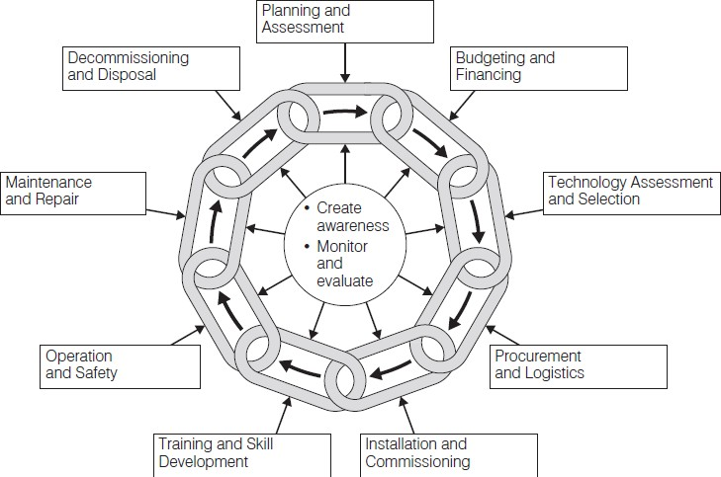

**Source**: Townsend (2005).

*Benefits of effective management of health facility infrastructure and assets*

These include:

1. Health facilities can deliver a full service, unimpeded by non-functioning health care technology;
2. Equipment is properly utilised, maintained and safeguarded;
3. Staff make maximum use of equipment by following written procedures and good practice;
4. Health service providers are given comprehensive, timely and reliable information on the functional status of the equipment;
5. Facility management team is provided with comprehensive, timely and reliable information on:
   * The functional status of facilities, infrastructure and equipment;
   * The performance of the maintenance services;
   * The operational skills and practice of equipment user departments;
   * The skills and practice of staff responsible for various technology related activities including finance, purchasing, stores and human resources;
   * Effective and efficient health care service.

**References and Recommended Further Reading**

Hebda, T., Czar, P. and Mascara, C. (2005) *Handbook of Informatics for Nurses and Health Care Professionals.* 3rd ed. Upper Saddle River, NJ: Pearson Education.

International Labour Organisation (2013) ‘National Profile on Occupational Safety and Health – Kenya’ [online]. Available at <<http://www.ilo.org/.../policy>> [Accessed 24 January 2014].

Kwankam, Y., et al. (2001) ‘Health Care Technology Policy Framework’, WHO Regional Publications, Eastern Mediterranean Series 24: Health care technology management, No. 1.

Lowe, R. (ed.) *Management Procedures for Health Facilities and Health Authorities.*

Hertfordshire: Ziken International.

Lowe, R. (ed.) (2005) *Guide 1: How to Organize a System of Health care Technology Management.* ***‘****How To Manage’ Series For Health care Technology.* Lewes: Ziken International.

Public Health Act (Cap 242) (1986). National Building Maintenance Policy.

Townsend, S. (ed.) (2005) ‘Guide 5: How to Organize the Maintenance of Your Healthcare Technology: Management Procedures for Health Facilities and District Authorities*.* ‘How to Manage’ Series for Healthcare Technology’ [online]. Available at

<<http://www.healthpartners-int.co.uk/our_expertise/HCTGuide5.pdf>> [Accessed 24 January 2014].

# MODULE 7: QUALITY ASSURANCE IN HEALTH SERVICES DELIVERY



**Purpose**

To introduce students to quality management systems and processes in health services delivery

**Objective**

By the end of this module, the student should be able to:

1. To discuss and explain the role of quality management and assurance in health care provision.

**Content**

* 1. Quality management principles and concepts
  2. Components of a total quality management system
  3. Quality assurance and risk management
  4. Risk management in health care settings
  5. Methods and tools of measuring quality
  6. Standards in Quality Management
  7. The Kenya quality model for health
  8. Measuring client satisfaction

**Methodology**

Lectures, discussions, case studies

**Training materials** Lecture notes Handouts

PowerPoint (Laptop and LCD projector) Whiteboards, flip charts, marker pens

**Duration: 6 hours**



**Lesson Plan Guide: Time: 6 hours**

|  |  |  |  |  |
| --- | --- | --- | --- | --- |
| **Session** | **Time**  **(Hours)** | **Content/Topic** | **Lesson Objectives** | **Lecturer Evaluation/Remarks** |
| 1 | 2 | Quality management and assurance in health care provision | To discuss quality management assurance principles, concepts and practices in health care provision | Comments regarding time adequacy and students’ understanding and perceptions. |
| 2 | 2 | Health service delivery risk management | To identify and discuss risks associated with health service management, delivery and mitigation | As above |
| 3 | 2 | Measuring customer satisfaction | To identify purpose and methods of measuring quality in health care delivery | As above |

* 1. **Quality Management Principles and Concepts**

### Quality Management

Quality management focuses on the means and processes of ensuring that the products or services offered in a health facility are consistent and are also referred to as Total Quality Management (TQM).

### Quality Management Principles

The key principles of quality management are: Customer focus; leadership; involvement of people; process approach; systems thinking; continuous improvement; informed decision making and establishment of mutually beneficial relationships. These principles are described further below:

*Principle 1: Customer focus*

A customer focus approach to quality management seeks to ensure that the objectives of the health facility or organisations are linked to customer (patients) needs and expectations at all times. Measures to sustain customer focus include:

* + - Researching and understanding customer needs and expectations;
    - Communicating customer needs and expectations throughout the organisation;
    - Measuring customer satisfaction and acting on the results of the measurement;
    - Systematically managing customer relationships;
    - Ensuring a balanced approach between satisfying customers and other interested parties such as MOH, employees, suppliers, financiers, local communities and society as a whole.

*Principle 2: Leadership in quality management*

Leadership in quality management involves considering the needs of all interested parties including customers, owners, employees, suppliers, financiers, local communities and society as a whole. Below are several aspects of leadership that can be considered:

* + - Establishing a clear vision of the organisation’s future;
    - Setting challenging goals and targets for the institution;
    - Creating and sustaining shared values, fairness and ethical role models at all levels of the organisation;
    - Establishing trust and eliminating fear within the institution;
    - Providing people with the required resources, training and freedom to act with responsibility and accountability;
    - Inspiring, encouraging and recognising people’s contributions.

*Principle 3: Involvement*

This principle involves motivating the staff at all levels and promotion of and recognition of creativity and innovativeness. This ensures that staff members feel involved and hence makes the process easier to implement and make part of daily tasks.

*Principle 4: Process approach*

Process approach in quality management involves paying attention to the processes that are supposed to produce the intended result(s). It means looking at ‘how’ things are done, and how inputs are turned into outputs. Examples of resource inputs/outputs include staff,

finances and supplies. Services inputs/outputs may include decisions, authorisations, feedback comments, solutions and proposals among others.

*Principle 5: System approach to management*

Systems approach to management also referred to as systems thinking. It involves identifying, understanding and managing interrelated processes as a system. System thinking ensures that a manager acknowledges that an improvement in one area of a system can adversely affect another area of the system. The principle of systems approach is closely related to the principle of process approach.

*Principle 6: Continuous improvement*

Continuous improvement is a sustained and on-going effort aimed at improving services, products or processes through incremental improvement over time. Within a health care setting, the following can be used as guidance to continuous improvement:

* + - Health institutions/facilities should make continuous improvement of the overall performance as a permanent objective;
    - Inculcate a culture of continuous improvement of all the processes and systems within every individual. The institutions should employ organisation-wide approach to continuous improvement;
    - Provide staff with training in the methods and tools of continuous improvement;
    - Establish goals to guide and measures to track continuous improvement
    - Recognise and acknowledge improvements.

*Principle 7: Informed decision making*

At the management level, informed decision making involves using a systematic approach in researching and analysing available evidence on the policy making process. At the patient care level, it involves having systems that ensure that care provided to patients adheres to best practices.

* + - This principle ensures that effective decisions are based on the analysis of current and meaningful data and information;
    - Evidence based decision making also involves ensuring that data and information is sufficiently accurate and reliable and making sure that this data is available and accessible to those who need them;
    - Evidence based decision making is underpinned by analysing data and information using valid methods and making decisions and taking action based on factual analysis, balanced with experience and intuition.

*Principle 8: Establishment of mutually beneficial relationships*

This principle acknowledges that an organisation and its suppliers are interdependent and that mutually beneficial relationships enhance the ability of both to create value. Within health care, the largest supplier is the labour workforce. This principle requires a balance between short-term and long-term gains considerations when establishing relationships, there is establishment of joint development and improvement activities and that there is continuous encouragement and recognition of improvements and achievements by suppliers.

* 1. **Components of a Total Quality Management (TQM) System**

The following are components of a TQM: quality assurance; quality assessment; quality control; quality improvement and quality planning/design.

### Quality Assurance

Quality assurance is a series of management activities to ensure that processes, items or services are of the type and quality needed by the users and includes all actions taken to establish, protect, promote and improve quality. Quality assurance includes setting and communicating standards and identifying indicators for performance monitoring and compliance to standards. These standards can come in different forms e.g. protocols, guidelines and specifications. The two main principles in quality assurance are:

1. Fit for purpose – that the goods or services produced should be for the intended purpose;
2. Right first time – mistakes are eliminated.

### Quality control (QC)

Quality control is a procedure or set of procedures intended to ensure that a manufactured product or performed service adheres to a defined set of quality criteria or meets the requirements of the client or customer. QC is similar to but not identical with quality assurance (QA).

### Quality improvement (QI)

Quality improvement is defined as an organised, structured process that involves identification of improvement teams to achieve enhancements in product or services.

### Quality planning/design

Quality planning or quality design is a systematic process that translates quality policy into measurable objectives and requirements and lays down a sequence of steps for realising them within a specified timeframe.

* 1. **Quality Assurance and Risk Management in the Health Care Setting**

### Dimensions of Quality

Quality of care has several dimensions. Quality assurance activities address one or more of these dimensions. These dimensions of quality are a useful framework that assists health teams to define and analyse their problems and to measure the extent to which they are meeting programme standards. The dimensions of quality include: technical competence; access to service; effectiveness; interpersonal relations; efficiency; continuity; safety and amenities. The eight dimensions are explained below with their application in the health care setting provided.

### Technical Competence

Technical competences include skills, performance and ability of health care workers and support staff to deliver services. Itrelates to how well providers execute practice guidelines and standards in terms of dependability, accuracy, reliability and consistency for clinical and non-clinical services. Technical competence also relates to the use of materials and equipment required in delivering health care.

### Access to Service

This refers to the fact that health services are unhindered by structural, physical, geographic, economic, social, cultural, organisational or linguistic barriers.

### Effectiveness

Effectiveness deals with two main issues in the health setting. The first issue is whether the kind of treatment given by the health service leads to desired outcomes and the second one is whether the treatment or care provided is appropriate for the setting it is being provided in.

### Interpersonal Relations

The concept of interpersonal relations refers to the nature of interactions between the provider and the clients, the management team and the junior staff, the health system and the community among others.

### Efficiency

Efficiency deals with the ability of the health care system to provide best returns for the resources provided.

### Continuity

Continuity means that the client receives the complete range of health services that he or she needs without interruption, cessation, or unnecessary repetition of diagnosis or treatment.

### Safety

Safety means minimising the risks of injury, infection, harmful side effects, or other dangers related to service delivery both to the provider and to the client. This deals with prevention of injuries to providers, clients or visitors and prevention of hospital acquired infections.

### Amenities

Amenities relate to the physical appearance of facilities, personnel and materials as well as to comfort, cleanliness, and privacy. Other amenities may include features that make the wait at the service point more pleasant such as relaxing music, educational or recreational videos and reading materials.

* 1. **Risk Management in Health Care Settings**

Risk is defined as the possibility of a loss or other adverse events that have the potential to interfere with an organisation’s ability to fulfil its mandate. Risk management proactively reduces identified risks to an acceptable level by creating a culture founded upon assessment and prevention, rather than reaction and remedy.

Risk management forms an important component of informing and supporting decisions in providing a safe and secure environment for staff and patients. It involves identifying and addressing sources of risk and loss (clinical and operational) and continuously evaluating an organisation’s processes, functions and facilities so as to identify potential risks. In the health care setting risk management saves lives, protects patients, visitors and staff and protects the organisation’s resources and reputation.

**Table 7.1 Examples of Risk Factors in a Hospital Set-up**

|  |  |
| --- | --- |
| * Credentialing – checking whether health care practitioners are properly qualified * Informed consent * Fraud and abuse * Billing and medical record documentation * Infection control * Readmissions * Security * Fire safety * Slip and falls * Medical errors classification – technical errors, diagnosis errors, failure to prevent injury and misuse or maladministration | * Visitor’s access to facility * Complaints * Medical staffing * Employees * Patient deaths * Safety assessment for medical applications of radiation * Treatment errors – treatment misadministration’s, treatment incidents, treatment accidents * Occupational hazard to staff: musculoskeletal loads, chemical substance, radiation hazard, violence from patients and members of public |

* 1. **Methods and Tools of Measuring Quality The PDCA (Plan-Do-Check-Act) cycle**

The PDCA is a four-step model for assessing problems and enacting solutions with the goal of improving quality. The PDCA is also referred to as the plan-do-study-act (PDSA), Deming’s cycle or Deming’s wheel. The PDCA is considered a continuous improvement process represented by a circular graphic and emphasises on processes that incorporate continuous feedback loops to identify sources of error on an on-going basis and provide the data needed to make the necessary changes and improvements.

PDCA follows the concept of the scientific method of first establishing a hypothesis, developing and executing a plan to test the hypothesis, analysing the results and then making modifications to the hypothesis. The cycle is then repeated to continue to assess and improve the quality process. PDCA provides a blueprint for quality assurance managers to properly identify the goals, construct accurate metrics for measuring the goals, evaluate the outcome, and then implement the solutions.

The four steps of PDCA include:

1. ***Plan -*** This is an analysis that establishes the objectives or the expected results and creates a plan of action. By starting from the end result and working backwards, each step of the process can be included in the analysis and in the solution. The plan is a critical step in the process of achieving quality outcomes. This stage deconstructs the entire process and allows for the identification of problems and the acknowledgement of what works. Once problems are identified, specific steps can be outlined to address them. The process is repeated with gradual improvements made in each of the iterations. Incremental changes made with each cycle, instead of a one-time approach to attaining perfection, avoid the analysis-paralysis that can ensue when trying to attain perfection on the first pass.
2. ***DO-*** Implementation of the plan
3. ***Check:*** (study) Measurement of the objectives to see how closely they meet expectations. This is an important step as it allows for the adjustment of the plan where necessary.
4. ***Act-*** Implementation of changes identified in the CHECK phase.

The DO and CHECK phase should provide data that shows trends and patterns that can be used to devise a list of solutions that will be carried out in the ACT phase. All change ideas should be tested in a small way first before they can be rolled out. This ensures that there is minimal disruption to the system if the ideas do not work. If the initial small set works then there is confidence to roll it into the whole system.

**Figure 7.1 The Plan-Do-Check-Act (PDCA) Cycle**

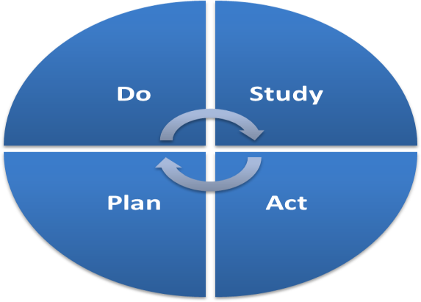

Continuous

**Data collection tools**

### Cause and effect diagrams

Cause-and-effect analysis is sometimes referred to as the Ishikawa, or fishbone diagram. In a cause-and-effect diagram, the problem (effect) is stated in a box on the right side of the chart, and likely causes are listed around major headings (bones) that lead to the effect. They can assist in organising the contributing causes to a complex problem Cause-and -effect diagrams do not have a statistical basis but are excellent aids for problem solving and trouble-shooting. They reveal important relationships among various variables and possible causes and provide additional insight into process behaviour.

**Figure 7.1 Fishbone Diagram**

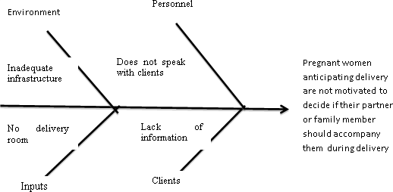

**Source:** USAID, 2012

### Check sheets

These are structured forms designed for collection and analysis of data. A check sheet can be modified for various situations.

*How to use a check sheet:*

* + Decide what event or problem will be observed and develop operational definitions;
  + Decide when data will be collected and for how long;
  + Design the form. Set it up so that data can be recorded simply by making check marks or Xs or similar symbols and so that data do not have to be recopied for analysis;
  + Label all spaces on the form;
  + Test the check sheet for a short trial period to be sure it collects the appropriate data and is easy to use;
  + Each time the targeted event or problem occurs, record data on the check sheet.

**Table 7.2 Sample Check Sheet: Hospital Infections Occurrences Checklist**

|  |  |  |  |  |  |  |  |  |
| --- | --- | --- | --- | --- | --- | --- | --- | --- |
| **Infection by unit** | **Mon** | **Tue** | **Wed** | **Thu** | **Fri** | **Sat** | **Sun** | **Total** |
| **Delivery** | III | I | IIII | IIII | IIII | I | I | 20 |
| **Intensive Care** | II | III |  |  |  |  |  | 6 |
| **Coronary Care** | I | II | IIII |  |  | IIII | IIII | 18 |
| **Respiratory Care** |  |  |  |  | IIII |  |  | 5 |
| **Surgical** | IIII |  | IIII |  |  |  |  | 10 |
| **Total** | 11 | 6 | 14 | 5 | 10 | 6 | 6 | 59 |

### Pareto diagrams

A Pareto chart is a display of the frequency of occurrences that helps to show the “vital few” contributors to a problem so that management can concentrate resources on correcting these major contributors (American Society for Quality, 2000). The Pareto Principle states that: “Not all of the causes of a particular phenomenon occur with the same frequency or with the same impact”. Such characteristics can be highlighted using Pareto Charts. Pareto charts show the most frequently occurring factors.

Analysis of Pareto charts help to make best use of limited resources by targeting the most important problems to tackle. Concentrate on reducing defects A, B and C (salaries, equipment and transport) since they make up 75% of all defects.

**Figure 7.2 Pareto Chart**

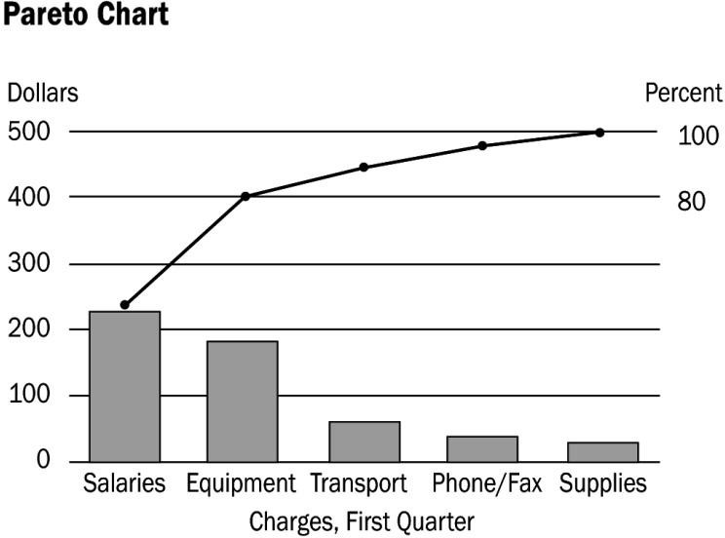

**Source**: USAID (2012).

### Control charts

*Run chart-* Run charts are plots of data, arranged chronologically, that can be used to determine the presence of some types of signals of special cause variation in processes. A centre line (usually the median) is plotted along with the data to test for shifts in the process being studied.

*Control chart-* A control chart consists of chronological data along with upper and lower control limits that define the limits of common cause variation. It is used to monitor and analyse variation from a process to determine if that process is stable and predictable (comes from common cause variation) or unstable and not predictable (shows signals of special cause variation).

**Figure 7.3 Sample Control Cart**

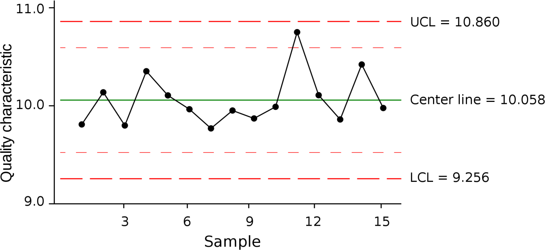

**Source**: USAID (2012).

**Quality Assessment**

Quality assessment is a component of continuous quality improvement. It is a systematic, on- going cycle of collecting and analysing evidence of a programme’s effectiveness. The information collected is used to evaluate how well the programme’s goal is being achieved, and decide what may be done to better achieve the goal. The main purpose of quality assessment is to improve health care quality. Quality assessment should be conducted routinely as part of integral provision of health services.

Types of quality assessment

* + Internal – carried by individual working in an organisation. The individual has better understanding of the system but may be biased.
  + External – should be thoroughly oriented concerning the realities of the system.
  1. **Standards in Quality Management**

### Definition

Standards are a means of describing the level of quality that health care organisations are expected to meet or to aspire to. The performance of organisations can be assessed against this level of quality.

### Setting Standards

Standards are set for comparison of indicators. For example, at least 80 % of all pregnant women attending the antenatal clinic should have their height, blood pressure, HIV status and urine tested.

### Characteristics of Standards

1. Should have a scientific basis i.e. their application should ensure application of a certain level of efficiency in health care.
2. Standards should be relevant for the specific region that they are applied to be realistic to implement and measure.
3. Should be dynamic – changed when it is necessary;
4. Should be measurable;

### Levels of Standardisation

When formulating standards, a critical decision that must be made is the level at that the standards should be set- minimal, optimal, and achievable. Minimal standards specify what level must be met for quality to be considered acceptable. The implication is that if care does not meet a minimal standard, remedial action is called for. For example, minimum standards

of quality specified in terms of nurse staffing levels, a structural measure of quality. In this case, hospitals that do not meet minimum staffing levels by definition cannot deliver care of acceptable quality (“safe care”). Optimal standards denote the level of quality that can be reached under the best conditions, typically conditions similar to those under which efficacy is determined. Achievable standards represent the level of performance that should be reached by everyone to whom the standards are being applied

### Domains of Standards

The following are domains of standards: Safety; clinical and cost effectiveness; governance; patient focus; accessible and responsive care; care environment and amenities and public health

*Domain 1: Safety for patient, staff and visitors*

This domain includes measures aimed at reducing adverse drug reactions, reduction of hospital acquired infections, and prevention of Methicillin Resistant *Staphylococcus Aureus* (MRSA) infections, prevention of needle pricks, waste disposal and falls in the facility among others. There are standards for hospital safety which should be continuously and systematically reviewed and effort should be applied to adhere to the standards.

*Domain 2: Clinical and cost effectiveness*

This domain includes operating within the laid down or agreed clinical guidelines and best practice. This domain also includes ensuring that health workers have up-to-date information on their specialties through regular audit, supervision and continuous education.

*Domain 3: Governance*

This domain deals with the management style and organisation culture so that quality improvement, quality assurance and patient safety are promoted within the health care institution. On the management style, this includes ensuring that there is accountability.

*Domain 4: Patient focus*

This domain focuses on ensuring that health care is delivered in partnership with patients, their relatives and also ensuring that their needs are accommodated during care.

*Domain 5: Accessible and responsive care*

This domain focuses on provision of care promptly and prevention of unnecessary delay e.g. waiting, registration, ambulance, payment procedures, unnecessary screening and tests). It also deals with creating mechanisms for ensuring that all members of the population can access health care.

*Domain 6: Care of environment and amenities*

This domain involves provision and maintenance of environments designed to offer comfort and privacy for the patients and safe working environment for health workers.

*Domain 7: Public health*

This domain includes efforts and collaborations that promote and improve health of populations but also help bridge health inequalities among different populations by preventing disease i.e. the promotion of good sanitation, environmental management/cleanliness, health seeking behaviour as well as responding to outbreaks swiftly

* overlap with infection control.

### International Standardisation

The International Standards Organisation (ISO) 9000 family of standards is related to quality management systems and designed to help organisations ensure that they meet the needs of customers and other stakeholders. The ISO 9001 is the internationally recognised standards for quality management and deals with the requirements that organisations wishing to meet the standard have to fulfil. It specifies requirements for a quality management system that can be used for internal application by organisations or for certification or for contractual purposes. It focuses on the effectiveness of the quality management system in meeting customer requirements and looks at:

* + Processes that create and control products and services within the organisation;
  + Prescribes certain requirements to ensure that client’s needs are met.

ISO 9001:2008 is the key internationally agreed standard for quality management systems. It has four elements:

* 1. *Management responsibility:* This element ensures that the top management has commitment to quality systems and develops the business objectives to meet customers’ quality requirements.
  2. *Resource management:* This element ensures that the human resource, work environment and infrastructure needed to implement quality are in place.
  3. *Product realisation:* This element ensures that the organisation delivers goods and services that the customers want.
  4. *Measurement, analysis and improvement:* This element considers that the institution has in place mechanisms to measure customer satisfaction and effectiveness of the whole system.
  5. **The Kenya Quality Model for Health**

The Kenya Quality Model for Health envisions improving overall livelihoods of Kenyans through provision of efficient and high quality health care systems. Its development was spearheaded by the Department of Standards and Regulatory services of the Ministry of Health in 2001 as the Kenya Quality Model. The Kenya Quality Model was later reviewed and renamed KQMH. KQMH integrates evidence-based medicine (EBM) with total quality management and patient partnership.

### Principles of KQMH

The principles of KQMH are similar to principles of quality management. These are: Leadership; customer orientation; involvement of people and stakeholders; systems approach to management; continuous quality improvement (CQI); and evidence-based decision- making.

### Integration of KQMH principles into the Kenyan health system

Successful implementation is based on the Plan-Do-Check-Act (PDCA) methodology. The following steps are applied:

* + - Health managers use KQMH checklists to assess performance of the health system against KQMH standards and opportunities for improvement are identified;
    - The science of improvement is used to ensure realisation of KQMH standards.

### Dimensions of the Kenya health systems

KQMH is anchored on twelve (12) dimensions which are the resources, processes and outcomes that are vital to ensuring that quality service is delivered. The KQMH dimensions are based on the Donabedian Model of structure process and outcome listed above.

### Structure

In the KQMH structure, dimensions are: Leadership, human resource, policy standards and guidelines, facilities, supplies, equipment, transportation, referral systems, hospital records and health management information systems (HMIS) and financial management

### Process

Process dimension is divided into four other sub-dimensions namely: The client-provider interaction, continuous quality improvement, programme management for reproductive health, extended programme for immunisation, HIV/AIDS, tuberculosis and IMCI (integrated management of childhood illnesses) and management of none communicable disease.

### Outcome (results)

Outcome dimension is also divided into four other sub-dimensions namely user-client satisfaction, performance of facility and primary health care, staff satisfaction and societal satisfaction.

### Implementation of KQMH

KQMH has five implementation phases:

Phase 1: Preparation

Phase 2: Introduction

Phase 3: Implementation

Phase 4: Expanding

Phase 5: Sustaining / Maintenance Elements of KQMH include:

1. *Work environment improvement (WEI)*

This is a structured programme that seeks to achieve cleanliness, organisation and standardisation at the work place. WEI uses the 5S approach which is a Japanese model and includes: Seiri – Sorting, Seiton – Set, Seiso – Shining, Seiketsu – Standardising and Shitsuke – Sustaining.

1. *Setting up of quality improvement teams (QIT)*

QITs are teams formed in a health facility to take the lead in implementing quality improvement activities. The QIT includes members of the health facility management team and individuals from middle management. The QIT is responsible for the following:

* + Training health facility staff on KQMH tools and methods;
  + Conducting situation analysis;
  + Implementation of KQMH;
  + Conducting periodic monitoring of improvement activities;
  + Feeding back to the work improvement team (WIT);
  + Documentation of KQMH activities;
  + Reviewing of progress and action plans;
  + Provision of quarterly reports to the hospital management team.

1. *Work improvement teams (WIT)*

These are composed of small groups of first-line facility employees who continually control and improve quality of their networks, products and services. The following are the main roles of WIT:

* + Promote improvement activities in the health facility;
  + Identify, analyse and solve work improvement problems;
  + Train others on quality management;
  + Monitor the progress of quality improvement.

1. *Tools for implementation of continuous quality improvement in KQMH*

The following tools/ processes are used in KQMH either alone or in combination for promotion of quality improvement:

* + *Alignment:* Hospital equipment, tools, files etc. are arranged in an orderly manner.
  + *Numbering/alphabetical coding:* Files and equipment are indexed for easy retrieval.
  + *Sorting:* All the items in a facility are grouped into three categories namely necessary, maybe necessary or unnecessary items. Unnecessary items are often discarded.
  + *Safety signs:* Signs are installed in all the areas to warn workers or visitors about hazardous materials. International or national safety standardised signs are used. Signage is also recommended for identifying different places in a facility.
  + *Colour coding* is used to distinguish hazardous from non-hazardous waste. Waste is also segregated into separate bins.
  + Use of labelling and symbols.
  + *Zoning:* This is whereby positions for storing specific items are marked so as to easily identify when these items are missing or out of place.
  1. **Measuring Client Satisfaction**

Client satisfaction is a measure of the proportion of customers whose reported experience with the goods or services provided by an organisation exceeds a pre-specified approval rating. Client satisfaction assessment in a hospital setting is conducted through patient surveys. They are important in assessing hospital outcomes and for assessing the human/interpersonal aspect of health care quality. Simply put, client satisfaction surveys measures the gap between expected service and the experience of the service.

### Advantages of client satisfaction assessment

* + - They can provide information on the effectiveness of the service process or other processes;
    - They can give a measure of the facility’s performance in the past and a guide to changes for the future;
    - They can be used as a marketing tool by making clients aware of the range of services available;
    - They have the potential to reduce the chance of complaints;
    - They are part of the service process itself, i.e. they establish or reinforce contact.

### Ways of conducting client surveys

* + - Interview existing patients;
    - Conduct interviews on patients who have been discharged from hospital before they leave;
    - Observation of clients. We often see good and bad actions such as clients being left waiting in the reception. Take note of the details. Use them as examples, adopting a remedial preventative style with colleagues and fee earners rather than a punitive approach;
    - Interview occasional clients if and when opportunities arise;
    - Reflect carefully on complaints to remedy not to punish. Remember you want to know about these;
    - Listen to client comments whether good or bad. Repeat them to your colleagues and consider the implications.

### Factors that influence what clients expect of a service are:

* + - Past experience – previous encounter with the hospital;
    - External influences – such as the media;
    - Personal needs –some clients might have special needs such as religious dietary requirements which are beyond the standard requirements;
    - Word of mouth – experiences, especially negative ones, are easily shared amongst communities. This might influence the expectation of a client.

### Factors that influence how patients experience the service are:

* + - Tangibles – the quality of equipment and of the physical surroundings;
    - Reliability – the ability to accurately perform the service offered;
    - Responsiveness – willingness to assist clients;
    - Assurance – ability of the service provider to be knowledgeable and to inspire confidence and trust;
    - Empathy – ability to care and display compassion towards clients;
    - Access – the cost and time for patients to use a service as well as hospital hours.

**References and Recommended Further Reading**

Deming, W. E (986) *Out of the Crisis*. Cambridge, MA: MIT Press.

Langley, G., Nolan, K. and Nolan, T. (1994) ‘The Foundation of Improvement’, *Quality Progress*, June.

Brown, L. D., Franco, L. M., Rafeh, N., and Hatzell, T. Quality Assurance of Health Care in Developing Countries. Bethesda: Quality Assurance Project.

Donabedian, A. (1996) ‘The effectiveness of Quality Assurance’. I*nternational Journal for Quality in Health Care*, 8(4), 401-407.

Donabedian, D. (1988) ‘The Quality Care: How can it be assessed?’ *JAMA*, 260(12), 1743- 1748.

Institute of Medicine (2001) *Crossing the Quality Chasm: A New Health System for the 21st Century.* Washington, D.C.: Committee on Quality of Health Care in America.

International Organisation for Standardisation (2008) ISO 9001:2008 Quality Management Principles.

Mainz, J. (2004) ‘Quality indicators: Essential for quality improvement’. *International Journal of Quality Health Care*, 16(1), 11-2.

Management Sciences for Health (2005) *Managers Who Lead A Handbook for Improving Health Services.* Cambridge, MA: Management Sciences for Health.

Ministry of Medical Services and Ministry of Public *Health* and Sanitation (2011) *Implementation Guidelines for The Kenya Quality Model for Health*. Nairobi: Government Printer.

USAID. (2012) ‘Health Care Improvement Project’ [online]. Available at

<[http://www.hicproject.org](http://www.hicproject.org/)> [Accessed 24 January 2014].

Watkins, R., Meiers, M. W. and Visser, Y. L. (2012) *A Guide to Assessing Needs*. Washington DC: International Bank for Reconstruction and Development / International Development Association or the World Bank.

World Health Organisation (2000) Workbook 6: Client Satisfaction Evaluations. Geneva: WHO.

World Health Organisation (2009) *Systems Thinking for Health Systems Strengthening*. Geneva: WHO.

Nursing Council of Kenya (2012). URL: <http://www.nckenya.com/>.. Radiation Protection Board. (2012). URL: [http://www.rpbkenya.go.ke](http://www.rpbkenya.go.ke/).

# MODULE 8: FINANCIAL MANAGEMENT AND RESOURCE MOBILISATION



**Purpose**

To introduce students to financial management and resource mobilisation

**Objectives**

By the end of this module, the student should be able to:

1. Define public financial management;
2. Identify various processes involved in financial management;
3. Identify and discuss financial recording keeping at the health facility level;
4. Identify and discuss various forms of resource mobilisation for health service provision.

**Content**

* 1. Financial management
  2. The Government Accountant General and Treasury
  3. The budget preparation process
  4. Government accounting documents
  5. Expenditure
  6. Facility Improvement Fund (FIF)
  7. Financial statements
  8. Health care financing
  9. Resource mobilisation

**Methodology**

Lectures, discussions, case studies

**Training materials** Lecture notes Handouts

PowerPoint (Laptop and LCD projector) Whiteboards, flip charts, marker pens **Duration: 6 hours**



**Lesson Plan Guide: 6 hours**

|  |  |  |  |  |
| --- | --- | --- | --- | --- |
| **Session** | **Time**  **(Hours)** | **Content/Topic** | **Lesson Objectives** | **Lecturer Evaluation/Remarks** |
| 1 | 2 | Financial management in the Kenya public health sector | Define financial management  Discuss government financial accounting systems | Comments regarding time adequacy and students’ understanding and perceptions. |
| 2 | 2 | Public Sector Accounting processes, procedures and documentation | Discuss various public sector accounting processes, procedures and documentation | As above |
| 3 | 2 | Health financing | Describe public health financing in Kenya and identify various sources of funds | As above |

* 1. **Financial Management**

Financial management entails planning, organising, controlling and monitoring the financial resources of an organisation to achieve objectives. Financial management in the public sector is governed by:

* + - The Public Financial Management Act. The objective of this Act is to ensure that public finances are managed both at the national level and the county level in accordance with the constitution of Kenya.
    - Government financial regulations and procedures. This contains financial regulations and procedures that govern government finances.

**Principles of Financial Management**

It is useful to identify a series of good practice principles which can be used as a standard in developing proper financial management systems. These principles provide a high-level guide for staff members.

*Consistency*

The financial policies and systems must be consistent over time. This promotes efficient operations and transparency especially in financial reporting. This does not mean that systems may not be refined to cope with a changing organisation. Inconsistent approaches to financial management could be a sign that the financial situation is being manipulated.

*Accountability*

The organisation must explain how it has used its resources and what it has achieved as a result to all stakeholders, including beneficiaries. All stakeholders have the right to know how their funds and authority have been used. Organisations have an operational, moral and legal duty to explain their decisions and actions, and submit their financial reports to scrutiny. Accountability is the moral or legal duty placed on an individual, group or organisation to explain how funds, equipment or authority given by a third party has been used.

*Transparency*

The organisation must be open about its work, making information about its activities and plans available to relevant stakeholders. This includes preparing accurate, complete and timely financial reports and making them accessible to stakeholders, including beneficiaries. If an organisation is not transparent, then it may give the impression of having something to hide.

*Viability*

To be financially viable, a health facility’s expenditure must be kept in balance with incoming funds, both at the operational and the strategic levels. Viability is a measure of financial continuity and security. The HMT and HMC should prepare a financing strategy to show how the organisation will meet all of its financial obligations and deliver its strategic plan.

*Integrity*

On a personal level, individuals must operate with honesty and propriety. For example, members of the HMT and HMC members are expected to lead by example in following policy and procedures and declare any personal interests that might conflict with their official duties. The integrity of financial records and reports is dependent on accuracy and completeness of financial records.

*Stewardship*

The HMC is expected to take good care of the financial resources it is entrusted with and make sure that they are used for the purpose intended, this is known as financial stewardship. The HMC has overall responsibility for this. In practice, financial stewardship is achieved

through careful strategic planning, assessing financial risks and setting up appropriate systems and controls.

**Accounting Terminology**

1. *Break-even analysis*

Break-even analysis is a technique widely used by production management and management accountants. It is based on categorising production costs between those which are ‘variable’ (costs that change when the production output changes) and those that are ‘fixed’ (costs not directly related to the volume of production).Total variable and fixed costs are compared with sales revenue in order to determine the level of sales volume, sales value or production at which the business makes neither a profit nor a loss (the ‘break-even point).

1. *Differential analysis*

Differential analysis involves analysing the different costs and benefits arising from alternative solutions to the situation. Relevant costs and revenues are those that differ between alternatives. Differential cost is the amount by which relevant costs differ between two alternatives. Differential revenue is the amount by which relevant revenues differ between two alternatives. The alternative resulting in the greatest positive difference between future revenues and future expenses (costs) should be selected when using differential analysis.

1. *Capital investment decisions*

The objective of making capital investment decisions is to maximise wealth. To do this we need to invest in those projects that will give the correct rate of return for the risk involved. The process of making an investment decision entails the following: identifying suitable investment opportunities, deciding on the best selection method, identifying the cash flows that will be generated by those investments, discounting them at the correct cost of capital and choosing the best one or ones from those available.

Discount the cash flows at the appropriate market determines opportunity cost of capital. There are various methods for evaluating projects: payback, accounting rate of return (ARR), internal rate of return (IRR) and the net present value (NPV). The NPV is the best method among all of them. The NPV is the net difference between the present value of the investment’s net cash inflows and the investment’s cost (cash outflows) discounted at the company’s required rate of return (hurdle) rate. The investment must meet or exceed the hurdle rate to be acceptable.

1. *Financial Controls*

A system of controls, checks and balances is collectively referred to as internal controls. It is put in place to safeguard an organisation’s assets and manage internal risk. It’s purpose is to

deter opportunistic theft or fraud and to detect errors and omissions in the accounting records. An effective internal control system also protects staff involved in financial tasks.

* 1. **The Government Accountant General and Treasury**

The Accountant General (AG) is a department which facilitates planning, developing and implementing government accounting policies, systems and procedures. It monitors revenue collection in liaison with the Economic Affairs Department (EAD) and expenditure as approved by Parliament. The two departments are based at Treasury. Treasury is in charge of establishing procedures and systems of effective management of government money and property. It is also responsible for the establishment of accounting procedures and systems. Treasury is supposed to supervise the expenditure of government money to ensure that it is properly accounted for, prepare and submit accounts for each financial year under the Public Audit Act 2003 for audit by the Controller and Auditor-General and ensure that the accounts are prepared. Treasury issues circulars to the Ministries, Departments and Agencies on guidelines, definitions and updates on annual reporting and financial matters. Treasury has the powers to access to all books, records, returns, reports and other government documents including electronic documents or to any government property. Treasury may request or require any government officer to provide explanations, information and assistance.

### Medium Term Expenditure Framework (MTEF)

The government prepares an annual budget and submits it to Parliament. The budget includes government revenue and expenditure and is prepared under the Medium Term Expenditure Framework (MTEF). MTEF is a three-year rolling budget framework. It is a transparent planning and budget formulation process that attempts to improve the decision making process so as to link with government policy, priorities and requirements within limited resource constraints.

The government introduced MTEF in order to:

* + - Provide a comprehensive and realistic framework for planning and management of public resources;
    - Increase predictability of resources through structural budget planning process that provides realistic estimates of revenues and expenditure over a three year period;
    - Link resource allocation to government policy and programme priorities;
    - Improve the basis of budget by moving away from incremental budgeting;
    - Timely preparation of audit reports by the National Audit Office.

### MTEF Budgeting cycle

There are five clear stages of the MTEF budgeting cycle as indicated below:

1. Policy development
   * National development plans
   * Economic Recovery Strategy
   * Poverty Reduction Strategy
   * Medium Term Plan of Vision 2030
2. MTEF Budget process
   * Macro-economic forecasts
   * Fiscal and budgeting framework
   * Development of sector proposals
   * Allocation between sectors and Ministry, Department and Agency (MDA)
   * Budget documentation
   * Budget approval by National and County Governments
3. Budget implementation
   * Collection of revenue
   * Cash management rules
   * Cash allocation and release of funds
   * Management of services, human resources
   * Procurement
4. Accounting and monitoring
   * Capturing expenses in the accounting system
   * Recording and use of management information on outputs
   * Internal audit
5. Evaluation and audit
   * Oversight and audit by national and county assemblies
   * Measurement of achievement of objectives
   * Evaluation and adjustment of policies
   1. **The Budget Preparation Process**

The following depicts in summary the budget preparation process:

* Preparation of national and county development plans i.e. the macro economic framework for projection of revenues and expenditure over three years. This is done by the Ministry of Finance, and the Ministry of Devolution and Planning. These policies are contained in various government documents and party manifestos. The policies set the platform on which the budgets are made. The documents used to ensure that the budget links to policy include the Vision 2030 and the Medium Term Plan (MTP). The MTP covers a period of three years. It focuses on the attainment of the Millennium Development Goals (MDGs).
* Undertaking sector review to provide the basis for the allocation of resources. The government also uses the Sector Working Groups (SWGs). These help in developing the ministerial ceilings in line with the various classifications. The SWGs are used to ensure that the sector priorities are consistent with the national development agenda. They are supposed to ensure that expenditure is adequate on the high priority areas to meet the desired goals of the Kenya Vision 2030.
* The state corporations, semi-autonomous agencies and government entities prepare annual budget proposals and submit those to their respective parent ministries. The ministries are supposed to consolidate the budget proposals and submit them to Treasury.
* The Ministerial Public Expenditure Reviews will take place where each MDA is expected to undertake a detailed appraisal of the composition, allocation and utilisation of its expenditure in realisation of their strategic plans.
* Treasury is supposed to involve the public in the budget preparation process through consultations with stakeholders at county levels. The consultation is supposed to cover all the forty-seven (47) counties. Each county is expected to provide a report on county sector issues and priorities.
* The Public Sector Hearings then deliberate and validate the national budget proposal prepared by the SWGs and county governments. The Public Sector Hearings stakeholders are drawn from both national and county levels. The output of the Public Sector Hearings form the budget proposals used to inform the MTEF budget.
* The Ministry of Finance reviews the estimates based on priorities and costs established in their sector review and consistent with the allocation of the sectoral ceilings. The budgets are thereafter presented in Parliament for approval. Once approved, MDAs can proceed to implement the budgets.
* The MDAs can request for additional allocation above their printed estimates through the supplementary budgets. The supplementary requests must be approved by respective accounting officers. The supplementary estimates are approved by Parliament.

**Budget Controls**

This involves the implementation of programmes/ projects control as approved by the national and county assemblies and collection of revenues. Once the budget has been approved, the MDAs are supposed to open a vote book and record each of the budgetary line items against which all allocations are entered and commitments plus subsequent payments made from. All expenditure should be in line with the approved budget. The accounting officer should ensure availability of funds within the budget before approval or disbursement of payment requests.

All commitment and payments are recorded in the Vote Book to allow comparison of the budget and the actual expenditures. Regular analysis of actual and expenditure should be carried out and any variances highlighted and explained. Deviations from the budget is reported on a timely basis and prior approvals obtained for any budget reviews/reallocations.

There is a Budget Monitoring Unit in the Ministry of Finance. This is required to prepare quarterly budget reviews which monitor and report on implementation of budget through a budget policy matrix. The Budget Monitoring Unit also monitors reporting and tracks adherence to government priorities. There is an Efficiency Monitoring Unit (EMU) which is also mandated to undertake systems and management audit of government MDAs.

**Government Revenue and Income**

All government revenue is paid into the Consolidated Fund in the Exchequer Account. The exchequer account is maintained by the Central Bank of Kenya and cannot be overdrawn at any time. There are various sources of government funds, namely:

* + Income tax
  + Import duty
  + Exercise duty
  + Value added tax (VAT)
  + Investment income
  + Donations, grants and loans
  + Government charges

Any revenues generated in MDAs should be collected and remitted to the Exchequer in the Consolidated Fund. MDAs who receive any revenue from the sources identified should issue receipts and record the receipts in their respective vote books. MDAs collect revenue in form of taxes, fines, other charges or receive donor funds for direct financing of a project. MDAs can request to spend this money instead of waiting for disbursements from the Exchequer. When this happens, the amount is deducted from the approved budget. The amount allowed to be spent is referred to as Appropriations-in-Aid (A-I-A).

* 1. **County Financial Management**

The following legal framework governs the county financial management:

* + - County Government Act 2012;
    - Public Financial Management Act 2012;
    - Government Financial Management Act 2004;
    - County Government Public Finance Management Transition Act 2013;
    - Appropriation Act 2012;
    - Constitution of Kenya 2010.

**County Budgeting Process**

The County government will prepare its own budget based on their County Integrated Development Plan (CIDP). County governments have established the County Budget and Economic Forum (CBEF). The CBEF is mandated by the Public Finance Management (PFM) Act to create forums to provide a means for consultation by the county government on:

* + - Preparation of county plans, the County Fiscal Strategy Paper and the Budget Review and Outlook Paper for the county
    - Matters relating to budgeting, the economy and financial management at the county level.

County governments prepare budget estimates and appropriation bills. They then make public pronouncements on revenue raising measures in the county. The approval of the finance bill is done within the county structures.

**Treasury management and budget executions**

County governments operationalise the county revenue fund. The have a single treasury account. They open a county emergency fund and provide for the establishment of other county public funds. They are obligated to prepare a cash flow plan and forecast and provide a process of budget allocations and supplementary estimates. They should establish an internal audit function. There should be revenue collectors within counties.

**Accounting, Reporting and Audit**

Counties prepare consolidated annual and quarterly financial statements of accounts for the county. They are required to prepare an annual report of revenue received and collected. They are also supposed to report on waivers, variations in taxes, fees and charges.

**The Role of County Treasuries**

The county treasuries have the following roles:

* Facilitate standard financial management including budgeting, accounting and reporting;
* Coordinate county planning activities;
* Coordinate the implementation of the budget;
* Mobilise resources for funding;
* Act as a custodian of all county government assets;
* Ensure compliance with county accounting standards.
* Maintain proper accounts and records for the county revenue fund and county emergency fund;
* Manage funds effectively, efficiently, prudently and transparently. Properly account for expenditure of funds;
* Issue circulars on financial matters;
* Advice the county executive committee on county matters;
* Prepare reports for submission to parliament and county assemblies.
  1. **Government Accounting Documents**

There are many accounting documents that are used in the accounting department. They include:

1. **S11 Form** – Requisition and Issue Voucher. This is a stores request formused to request for items from the stores department. They are normally filled in by the requester of the item. The S11 is in triplicate and is issued as follows: the original is kept by the storeman issuing out the goods in a safe file, the duplicate is kept by the user receiving the goods in a safe file too and the triplicate is retained in the pad. See the form in Appendix 1.
2. **S12 Form** - Issue and receipt voucher. This form is used to issue items from the stores. It is filled in by the stores personnel. See form in Appendix 2.
3. **S13 Form** – Once an item has been purchased, the item is presented to the stores department for commissioning as a government asset. Upon receipt of the item, the stores department issues form S13. See form in Appendix 3.
4. **S20 Form** - Local Purchase Order (LPO). This is a contracting document raised in case of goods being procured. See form in Appendix 4.
5. **S21 Form** - Local Service Order (LSO). This is a contracting document raised in case of services being procured. See form in Appendix 5.
6. **Vote book-** This is a record of all financial transactions of a ministry, department or agency detailing the balances available for each of the budget lines. Each page in the vote book represents an item in the Printed Estimates. See form in Appendix 6.
7. **Imprest Request Form**- This is a form used by staff members to request for imprest. It should be filled by the staff member and relevant documents attached to the form. It is then approved by the Authority to Incur Expenditure (AIE) holder or authorised representatives. The imprest should be surrendered within 48 hours after completion of the purpose of the imprest. See form in Appendix 7. A copy of the imprest surrender form is in Appendix 8.
   1. **Expenditure**

Government expenditure is divided into:

1. *Recurrent expenditure*

Recurrent expenditure is on-going expenditure incurred every financial year e.g. personnel costs. These are also known as mandatory expenses which must be paid from the Consolidated Fund.

1. *Development expenditure*

Development expenditures are provisions made for the creation of new assets. These include expenses such as construction of roads, rehabilitation and construction of water installations and the transfers from government to other agencies for capital expenditure.

**Authorization of Expenditure**

The AIE holders fill responsibility for the approval of all expenditure incurred under their respective expenditure heads. The AIE holders should also have delegated officers who act in their absence. In cases where there is an emergency expenditure and both the AIE holder and delegate are absent, then such expenditure should be brought to the attention of the AIE holder for information and endorsement within two days of his/her return. The absence of both the AIE holder and his/her alternate should be brought to the attention of the Accounting Office in writing before the signing of any documents. Any persons signing such documents

without such notice will be held personally accountable for any loss or problem arising from the transaction.

The procurement department always makes available all copies of committed and duly signed LPOs, LSOs for filling and safe keeping in the finance department pending the delivery of goods/services before payment. The invoices received in the finance department should be subsequently booked in the Invoice Register before being released for payment. All the invoices and staff claims should be clearly stamped “received” upon receipt. The stamp shall indicate the date of receipt of the invoice or claim for monitoring purposes.

The mode of payments shall include: cash, cheque, Telegraphic Transfer/Electronic Transfer of Funds (EFT)/Real Time Gross Transfer (RTGS), Letter of credit. All expenditure must be appropriately authorised. Expenditure must be fully supported by genuine or authentic supporting documents from the supplier and from the MDA. The finance department should confirm availability of funds under the respective budget lines before LPOs and LSOs are issued by the procurement department. If the funds are available then the commitment shall be entered in the Vote book and the order endorsed ‘funds available’ and signed by the accountant in charge of the Vote book. Payments shall be approved by the Accounting Officer or his or her authorised representative.

A pre-numbered payment voucher is raised for all payments related to invoiced goods and services and any advance payments. The payment voucher should indicate the date, the payee’s name and address, the description of goods and services, amount in words and figures, budget line code against which the purchase should be charged, signatures of preparing and authorising officers, signature of payee (for cash payment only) and authority for payment in relationship to the requisition.

The cashier draws a cheque for all duly approved payment vouchers. The cheques are signed by authorised personnel. There should be an officer assigned to releasing all cheques to respective payees. Individuals collecting cheques should only do so upon presentation of proper identification documentation. A cheque dispatch register should be maintained in the cash office to register the cheques as they are collected. Payment vouchers and supporting documents should be used to record or post the transactions in the cash book.

**Imprest**

Imprest is a form of cash advance or a ‘float’ which the accounting officer may authorise to be issued to an officer(s) who, in the course of their duty, are required to make payments which cannot be conveniently be made through the normal payment process. Some of the rules applicable in imprest accounting include:

* + AIE holders will scrutinise and approve all task-based budgets upon which imprests are requested;
  + Stationery, transportation fuel and airtime should not be included in imprest budgets. They should be procured through the procurement department;
  + The amount of contingencies should not exceed 10% of the total imprest requested;
  + No officer with outstanding imprest will be granted another imprest without retiring the first one;
  + Application of imprest should be made in advance;
  + All imprests that are granted to respective officers must be surrendered through the respective AIE holders immediately upon return to the office or upon completion of the task which the imprest was approved for. The Assistant Accountant General will return/reject any surrender that does not comply with laid down requirements. Application of imprest is done through an imprest requisition form (Appendix 7).

There are several types of imprests:

1. *Travel imprest***-** There is local travel and international travel imprest. Local travel imprest is for travel expenses within the country. Support documentation for local travel imprest is bus ticket or a work ticket where official means is provided. International travel support documents include copies of the officers’ passport, boarding passes and air tickets.
2. *Petty cash imprest-* This is a cash float held by the Petty Cash Cashier. Petty cash is used to pay for minor or incidental expenses. Petty cash imprest should not be co-mingled with general operation receipts. All payments made from the petty cash should be authorised by the responsible officers. The petty cash cashier fills in a petty cash reimbursement form to enable him reimburse the expenses incurred.

**Payments to Suppliers**

The following documents are required for processing supplier payments:

* + Original invoice;
  + LPOs or LSOs relating to the supply or contract;
  + Goods received Voucher (GRV) where applicable;
  + Certificate of completion or confirmation of receipt of services or goods;
  + Approved lease agreements for rent payments;
  + Duly filled and approved purchase requisition form;
  + A contract for service duly executed.

Payment instructions are issued based on available cash for goods and services rendered. Payments should be made based on commitment posted on the Integrated Financial Management Information System (IFMIS).

The accountant determines that the payments are in order by confirming the GRV attached agrees with the LSO or LPO. He/she also confirms that the invoice price agrees with the price on the LPO, LSO or contract. The accountant shall also confirm that the invoice is correct. A certified true invoice shall be used in case the original invoice is not available based on a clear letter from the supplier. The finance department should confirm the availability of funds from the Vote book prior to signing of the cheque.

**Salaries**

Once the payroll is approved, the period is closed. Journals for any changes are drawn to update respective ledgers. Salaries are processed through a system known as the Integrated Personal Payroll Database (IPPD). The system generated payroll reports include payslips, files for bank payments, payroll control summaries, statutory and other deduction reports. Payslips are printed and distributed to respective officers. The following are some of the deductions made on salaries:

* + Statutory deductions;
  + Registered savings and credit cooperative societies;
  + Recognised tenant purchase housing schemes or staff mortgage schemes;
  + Life insurance;
  + Loan repayments e.g. car loans and personal bank loans.

No salary deductions can be effected without a valid and properly authorised letter from the officer. The payment deadlines for payroll deductions are shown in **Table 8.1** below.

**Table 8.1 Submission Dates for Statutory Deductions**

|  |  |
| --- | --- |
| **Deduction** | **Statutory deadline** |
| Pay As You Earn (PAYE) | 9th of the subsequent month |
| National Social Security Fund (NSSF) | 9th of the subsequent month |
| National Hospital Insurance Fund (NHIF) | 9th of the subsequent month |

See a sample payroll in Appendix 9 and a sample payslip in Appendix 10.

**Casual Employee Payments**

These payments are made based on valid written appointment letters. A muster roll is prepared and signed by each casual employee. The human resource office must endorse the

muster roll confirming the number of days worked. A payment certificate should be prepared to support cash payments made for casual wages. Casual workers who are paid over the taxable threshold of Kshs10,164 are supposed to be deducted PAYE. All casual workers should also pay NHIF and NSSF based on their tax brackets as indicated in the muster payroll. A casual worker employed for more than three months continuous is considered to be a permanent employee by law and should therefore accrue the benefits of an employee. See a sample muster roll in Appendix 11.

**Allowances**

Allowances are regulated by government in accordance with Job Groups Bands. They stipulate the rates applicable for each job group and the location one is visiting. There are several types of allowances as seen below:

1. *Accommodation allowance* - This shows the amount of allowance payable for a night-out of the permanent duty station. These amounts are presented in Kenya shillings.
2. *Meal allowances* - Paid to officers travelling within the country but who will not be required to spend a night away from the permanent duty station. There are two allowances under the meal allowance: the breakfast allowance and the meal allowance. These amounts are presented in Kenya shillings.
3. *Subsistence allowance for overseas travel* - These are rates payable to public officers who travel outside the country and capture various countries and the amount payable in each country. These amounts are presented in United States dollars (US$). The rates are daily rates.
4. *Leave allowance*- This is an allowance payable once a year for qualifying employees.
5. *Sitting allowances* - These are allowances paid to various officers for sitting in meetings.
   1. **Facility Improvement Fund (FIF)**

The basic goal of the FIF is to generate money for improving the quality of care at facilities. This can be done by improving physical facilities by doing the following: painting the buildings; providing functional equipment; making available adequate supplies and maintaining a friendly attitude toward patients. When patients are asked to pay for services they expect better services and higher quality of care. The patients contribute to the FIF through: daily inpatient fees; outpatient treatment fees and laboratory fees. As part of implementing FIF, officers in charge of health centres should prepare a plan of action for improving quality care. Some of the steps to do this include:

* + - Holding regular meetings to create awareness of patient care issues;
    - Cleaning toilets and washrooms and ensuring they are cleaned and checked regularly;
    - Improving the confidentiality and privacy of patients at all times;
    - Reducing back door or corridor consultations;
    - Keeping patients informed at all times on matters requiring their attention.
  1. **Financial Statements**

Districts and ministries are required to operate one bank account for recurrent and development expenditure. Heads of accounts unit are expected to maintain a detailed register of all bank accounts under their ministries. The summary should shows bank, branch, account number and Treasury authority reference. Ministries should directly request for a bank statement from their banks.

**Cash Books and Bank Accounts**

The cashbook is one of the major books of original entry since it captures all the payments and receipts. A cashbook is maintained for each and every bank account. The entries in the cashbook originate from the following sources:

* + - Cheques and electronic transfer payments;
    - All receipts;
    - Direct bank credits (inter-bank transfers);
    - Direct bank debits e.g. bank charges;
    - Any cash book adjustments e.g. cheque cancellations;

The debits and credits of the cash book should be added and balanced daily and bank reconciliations should be done on a regular basis and at least once monthly. A sample cash and bank book can be seen in Appendix 12.

**Summary of Expenditure Report**

District accountants are required to submit, through the district department head or AIE holder, a summary of expenditure which includes all payments for its respective ministry as captured in the Vote book Management System. The report should be accompanied by a reconciliation of the actual cash received and the actual expenditure. The return should be signed by the District Accountant. The District Internal Auditor is required to audit and certify that the statement is correct. Any unspent balances from the District Offices should be surrendered to the Exchequer. A sample of a summary expenditure report can be seen in Appendix 13.

**Revenue/Appropriation In Aid (AIA) Returns**

District Accountants are required to maintain a record of all revenue and or AIA collected. Any discrepancies between the ledger and the district returns should be reconciled.

**Bank Reconciliations**

Accounting units are supposed to carry out bank reconciliations on a daily basis. The reconciliations should be completed and submitted to Central Bank according to set timelines. A sample bank reconciliation statement can be seen in Appendix 14.

**Ledgers and Trial Balances**

Ministries and departments are responsible for the production of their own ledgers from the IFMIS system. The heads of accounting units are required to submit copies of the ledger statements to the respective district accountants to obtain confirmation of their correctness. A sample of a ledger can be seen in Appendix 15 and asample of a trial balance can be seen in Appendix 16.

**Appropriation Accounts**

The appropriation accounts are prepared on an annual basis by the MDAs. They show the services for which the appropriated money was spent, the actual amount spent on each service, the status of each vote compared with the appropriation for the vote, a statement explaining any variations between the actual expenditure and the sums voted and any other information specified by Treasury. These accounts are then transmitted to Treasury. The appropriation accounts are attached in Appendix 17.

### Cash Flow Statements

A cash flow statement provides information on liquidity. It indicates the amount, timing and probability of future cash flows. Every county government is required to prepare an annual cash flow projection for the county for the each financial year, and submit the cash flow projections to the Controller of Budget and a copy to the Intergovernmental Budget and Economic Council and Treasury.

For each item of income and expenditure on the budget, you need to predict and plot on the forecast sheet when cash will come in and go out. This is dependent on when activities are planned to take place. However, some activity is more predictable than others, e.g. monthly, such as salaries or annual, such as insurance. Other transactions are unpredictable, e.g. repairs. A sample of a cash-flow statement can be seen in Appendix 18.

### Fund Accounts

Some grants are given for a specific purpose – these are known as restricted funds because they may only be used for a particular activity rather than for general purposes. Such funds must be accounted for separately so that the organisation can demonstrate to the donor how the funds have been utilised. This is known as fund accounting and requires care when setting up accounting systems to identify and separate the necessary information. In such circumstances, it may be appropriate to identify activities by cost centre (or activity or budget centre). Cost centres are typically applied to projects, functions or departments which have

their own budget and funding sources.A sample fund account statement can be seen in Appendix 19.

**Income and Expenditure Statements**

This is a statement that shows the income and expenditure for a given period of time compared with the budget. Such statements are prepared on a monthly or quarterly basis and are very important for decision-making. They also present any variances to budget which are explained by the accounting department. A sample income and expenditure statement can be seen in Appendix 20.

**Balance Sheet (Statement of Assets and Liabilities)**

The balance sheet is a list of all the assets and liabilities on one particular date. This provides a snapshot of the organisation’s financial position. The balance sheet is in two parts. One part records all balances on assets accounts. The other records all balances on liabilities accounts plus the income and expenditure account balance. The balance sheet will either be presented with the assets listed on the left and the liabilities presented on the right of the page, or more commonly nowadays, listed down the page with assets presented first then liabilities deducted from them.

* + - *Fixed assets*

These are the tangible long-term assets such as buildings, equipment and vehicles, having a value lasting more than one year. Fixed assets are shown on the balance sheet after an allowance for wear and tear – or depreciation – has been made.

* + - *Current assets*

These are the more ‘liquid’ assets such as cash in the bank, payments made in advance and stocks. These, in theory at least, can be converted into cash within 12 months.

* + - *Liabilities*

Liabilities are also divided into current liabilities and long-term liabilities. There are current or short term liabilities – including outstanding payments, and short-term borrowings to be paid within 12 months. It also includes long-term liabilities such as loans that need to be paid after 12 months.

See a sample balance sheet in Appendix 21.

* 1. **Health Care Financing**

These regulations may be cited as the Government Financial Management (Hospital Management Services) Regulations 2009.

**Health Care Financing Sources**

The Act specifically mentions the establishment of a Hospital Management Services Fund to consist of health care sources of funds as follows:

1. ***Government of Kenya budgetary allocation***- In the financial year 2010/11, the allocation was Kshs41.5 billion which was approximately 6.5% of the total government budget. These allocations were made to the two ministries: MOPHS and MOMs.
2. ***Appropriation in aid (AIA)* -** This includes grants and loans from development partners. The main development partners in health care in Kenya include the German Federal Government (KFW), Arab Bank for Economic Development (BADEA), and the African Development Bank (ADF) among others. AIA also includes user charges collections made in the various public health centres in the country.
3. ***National Health Insurance Fund (statutory insurance)-*** This is a fund for formally employed individuals and those in the informal sector. Formal sector employees' contributions are deducted and remitted to the Fund by their employers. For members, under the voluntary category, they pay Kshs.160 per month (Kshs.1920 per annum). For those in formal employment, contributions are made as per their income. This also includes income generated from the proceeds of the services, i.e. services rendered in hospitals.
4. ***Private Insurance***- This is a fund contributed by corporates and individuals for various insurance products to the health sector.

**Health Care Financing Principles and Regulations**

The following are some of the most important financing principles and regulations:

* + The expenditure incurred by a medical facility on the services shall be on the basis of and limited to the annual allocation or grants and authority to incur expenditure;
  + The receipts, earnings, accruals and the balance of the services at the close of each financial year shall not be paid into the Consolidated Fund but shall be retained by the respective hospitals or medical facility for the purpose for which the service is established.

*The objectives and purposes of the Hospital Management Services Fund*

* + Provide financial resources for medical supplies, rehabilitation and equipment of hospitals in the country;
  + Support capacity building in management of hospitals;
  + Give more powers to hospitals and medical facilities to plan and manage the resources under them;
  + Improve the quality of health care services in the hospitals.

**Health Facilities Management Committees**

These committees are established at Provincial, District and Sub-District Hospital Management Committees.

### Provincial Management Committees

The total membership of the committee is seven although they can have up to nine members. The composition of the committee is a chairman nominated by members of the committee from among themselves and appointed by the Minister. The area County Commissioner or his representative duly nominated by him/her in writing, the area County Director of Medical Services or his representative duly nominated by him/her in writing, the person in charge of a provincial hospital who shall be the secretary, the person in charge of a local authority provincial hospital or its equivalent and the following persons, who shall be residents of the area of jurisdiction, appointed by the Minister:

* + One person who shall have knowledge and experience in finance and administration matters;
  + One person nominated by women groups;
  + One person nominated by the faith-based Organisations; and
  + Not more than two persons nominated by recognised community-based development organisations of whom one shall be a woman.

The Committee is supposed to meet four times a year and is expected to maintain records of its deliberations. The following are their functions:

* + Supervising and controlling the administration of the funds allocated to a provincial hospital;
  + Opening and operating a bank account at a bank to be approved by the Minister of Finance;
  + Preparing work plans based on estimated expenditures;
  + Ensuring that the basic books of accounts and records of accounts of the income, expenditure, assets and liabilities of a provincial hospital are maintained as prescribed by the officer administering the Fund;
  + Preparing and submitting certified periodic financial and performance reports;
  + Ensuring that permanent record of all its deliberations are maintained.

### District or Sub-District Hospital Management Committee

The total membership of the committee is at least seven and not more than nine members. The committee consists of a chairman nominated by the committee from among themselves and appointed by the Minister; the area District Commissioner or his representative duly nominated by him in writing; the District Medical Services Officer or his representative duly nominated by him in writing; the person in charge of a district or sub-district hospital is the secretary; the person in charge of the local authority district or sub district hospital or its equivalent and the following persons, who shall be residents of the area of jurisdiction, appointed by the Minister:

* + One person who shall have knowledge and experience in finance and administration matters;
  + One person nominated by women groups;
  + One person nominated by faith-based organisations;
  + Not more than two persons nominated by recognised community-based development organisations of whom one shall be a woman.

The Committee meets at least four times a year and is expected to maintain records of its deliberations. The functions of committee are:

* + Supervising and controlling the administration of the funds allocated to a district or sub-district hospital;
  + Opening and operating a bank account at a bank approved by the minister for the time being responsible for finance;
  + Preparing work plans based on estimated expenditures;
  + Ensuring that basic books of accounts and records of accounts of the income, expenditure, assets and liabilities of a district or sub-district hospital are maintained as prescribed by the officer administering the Fund;
  + Preparing and submitting certified periodic financial information;
  + Preparing performance reports as prescribed;
  + Ensuring that permanent record of all its deliberations are maintained.

### National Hospital Services Committee

The National Hospital Services Committee consists of a chairman (not public officer) appointed by the Minister, the Permanent Secretary of the Ministry for the time being responsible for matters relating to Medical Services or his representative duly nominated by him in writing; the Permanent Secretary of the Ministry for the time being responsible for

finance or his representative duly nominated by him in writing; the Director of Medical services who is the secretary and three persons of whom two shall be women appointed by the Minister and of whom:

* + One who shall be appointed by virtue of his knowledge or experience in financial management;
  + One who shall be appointed by virtue of his experience in medical care delivery management; and
  + One who shall be appointed by virtue of his expertise and experience as a medical practitioner;
  + One person nominated by a health non-governmental organisational network in Kenya appointed by the minister; and
  + One person nominated by religious hospital association or network in Kenya appointed by the Minister.

The functions of National Committee include:

* + Approving the work plans prepared by the facilities;
  + Ensuring equitable distribution of resources to the medical facilities; and
  + Reviewing and approving annual expenditure statements.

*Administration of the Hospital Management Fund*

The officer administering the Fund has the following roles:

* + Preparing, signing and transmitting to the Controller and Auditor-General in respect of each financial year and within three months after the end thereof, a statement of account relating to the Fund specifying all contributions to the Fund and the expenditure incurred from the Fund and such details as the Treasury may from time to time direct, in accordance with the provisions of the Public Audit Act;
  + Furnishing any additional information as he may be required that is proper and sufficient for the purpose of examination and audit by the Controller and Auditor- General in accordance with the provisions of the Public Audit Act;
  + Developing criteria for the allocation of funds for approval by the National Committee;
  + Preparing annual distribution of resources by hospitals;
  + In consultation with the National Committee, impose conditions on the use of expenditure authorised by him or on his behalf and may impose any reasonable prohibition, restriction or other requirement concerning such use of expenditure;
  + Instituting prudent measures for the proper utilisation for monies deposited in the Fund using suitable internal controls and appropriate mechanism for accountability including audit of accounts by internal auditors of the Ministry responsible for matters relating to finance;
  + Ensuring that proper books of accounts and records relating to all receipts, payments, assets and liabilities of the Fund and to any other activities and undertakings financed by the Fund are maintained.
  1. **Resource Mobilisation**

A resource is a source or supply from which a benefit is produced. The resources applied in a hospital setting include finance, human resources and materials. Resource mobilisation in the health sector is the act of seeking for resources to meet health provision needs

### Process of Resource Mobilisation

There are basic steps in undertaking resource mobilisation including:

* + - Defining the situation by undertaking a needs assessment and SWOT analysis;
    - Determining the inputs e.g. funds, human resources, materials etc,;
    - Conducting the appraisal of resources situation in terms of adequacy and sustainability;
    - Evaluating the resources appraisal;
    - Developing resource mobilisation plan;
    - Implementing the action plans i.e. convert the inputs to outputs.

### Key Sources of Organisation Resource

Health facilities have various sources that they could mobilise from including the following:

* + - Financial institutions like banks and cooperative societies;
    - Securities exchange;
    - Foundations and trusts;
    - Multilateral funds;
    - Bilateral donors;
    - NGOs and projects;
    - Government;
    - Corporate donors;
    - Consultancy and training.

### Resource Mobilisation Strategies

Health facilities seek funds to improve their services. In order to mobilise resources, health facilities need to be strategic in order to generate more funds. The following are some of the strategies that can be adopted to generate funding:

1. *Bidding as a consortium*

This involves different health care organisations forming consortia to be more competitive when seeking funds. This method can be used to respond to government contracts or donor request for proposals. Health care organisations can form consortia with training or research institutions. They present their uniqueness and complementarity with each other hence making them more desirable to the funding agencies. This is even more important for large programmes that are funded by donors. Bids submitted by a consortium of organisations have better chances of winning than those submitted by individual organisations. This applies to cases where consortium members play a complementarity role.

1. *Developing a reputation for excellence*

Health care organisations should invest in developing a reputation of excellence through several ways. This includes maintaining powerful profiles, promoting their activities through periodic publications that promote their activities, good management of health facilities through proper care of patients amongst others. The profiles of these organisations should focus on their operations. For example, a health care facility with a research centre that conducts different research activities can attract funding. It will demonstrate its capacity to design and execute successful different initiatives that impact positively on the lives of the people that it works with. The good reputation will help attract funding. For example, the Kenya Red Cross receives unsolicited funds from corporates and individuals because they have a reputation of excellence in what they undertake.

1. *In- kind donations*

This is where health care organisations receives donations from individuals and companies. This includes volunteer work or secondment of expert staff. Such donations are a measure of people’s confidence in the health facility. The facility should record these in-kind donations and quantify them in monetary terms.

1. *Income generating activities*

There are many and varied income generating activities. A health care facility can identify areas through which they can generate extra income over and above their daily activities. For example, a health care facility can hold quarterly sessions to train the public on various topics on health care. These activities, based on their experience and expertise, should be offered at a fee.

### Resource Mobilisation Action Plan

A health care facility should develop an action plan on their intention to achieve the goal of resource mobilization. The following determine the success of the planning process:

* + A dedicated resource mobilisation team within the health facility and ideally in the finance section who work in other areas including resource mobilisation;
  + A responsible staff member in the finance section in charge of resource mobilisation;
  + Periodic resource mobilisation work plans to ensure that activities are prepared and monitored on a regular basis;
  + Establishment of a support environment e.g. funding for proposal writing, meetings costs etc.;
  + A monitoring system for the resource mobilisation plans and actions.

**Handouts and Notes**

### Problem Scenario 1: Definition of financial management (the vehicle example)

How do you manage your vehicle to ensure that it is remains as good as new? If we don’t put in good quality fuel and oil and regularly service it, its functioning suffers. It will not run efficiently. If neglected, the vehicle will eventually break down and fail to reach its intended destination. In practice, financial management is about taking action to look after the financial health of an organisation, and not leaving things to chance. (***The lecturer should use this scenario to introduce financial management to students. This may be in form of a question or a brain teaser.)***

### Problem Scenario 2: Payment documentation required (the missing documents)

A supplier of medical equipment has not been paid for six months since he supplied some medical equipment in Madodo hospital. He has been asking the accountant to settle his payment since the contract indicates that he shall be paid 30 days upon supply of the equipment and presentation of a valid invoice. The accountant has informed the supplier that he cannot effect the payment since he has not been issued with certificate of confirmation of receipt of goods and other documents. The supplier has presented a delivery note and claims

that the equipment is already been used in the hospital. What documentation could be missing to enable this supplier receive payment?

### Problem Scenario 3: Facility Improvement Fund (Madodo hospital dilapidated state)

Madodo hospital in located in Madodo County. The county has a population of 5,000 people. It is the only hospital in the entire county. The hospital does not have running water for six months due to unpaid water bills. The toilets used by the patients are very dirty and unusable. The buildings are unkempt and very dirty. The paint is peeling off having been painted almost 15 years ago. The hospital also lacks drugs prescribed by doctors and patients have to buy the drugs from another county hospital. The nurses do not provide all the necessary information to the patients since they are very few and consult patients even on the corridors. The hospital is characterised by long queues and a lot of patient conflict. *The Lecturer will use this scenario to introduce the topic relating to facility improvement fund; the sources and purpose and relate it to Madodo County Hospital.*

### Article 1 – To use in MTEF – critical thinking piece

*The lecturer is supposed to use this piece to explain the MTEF process. The students should read and brainstorm before introduction of the MTEF topic.*

**Uhuru to present Kenya's biggest budget ever -**The Standard, Thursday, 2 June 2011, By David Ochami and Steve Mkawale

*Finance Minister Uhuru Kenyatta will present to the country a Sh1.1 trillion Budget, the largest in the history of the country. The minister submitted to parliament revenue and expenditure estimates for the 2011/2012 financial year but maintained he had not breached the Constitution.*

*"I am proud to report that with the support of my hard working teams, we have already delivered," said Uhuru. Uhuru lamented that he had been compelled to obey a section of the law he believes should not apply under the current Parliament alleging that his critics are unconcerned by Kenya’s obligations to the East African Community and the impact this early publication of estimates will have on overall macro-economic stability.*

*"One aspect of the EAC treaty was to agree on a common Budget date, which is June 8," said Uhuru. He submitted the estimates Tuesday evening to the Budget Committee of Parliament to beat the deadline it set of May 3.The committee had accused Uhuru of breaking the Constitution. Uhuru said it is now up to Parliament to allow him read the Budget Speech before it on Wednesday.*

*"I stand guided by Parliament," he told journalists at a press conference in his Treasury office Thursday in an apparent climb down and gesture to hostile MPs who accuse him of breaking Article 221 of the new Constitution by not submitting the estimates in April. “Whether it is read or not the budget is already here. What normally happens in*

*Parliament is a tradition and is actually the last stage of the lengthy budget making process," Uhuru said.*

*Noting that Chapter 221 of the Constitution was one of the proposals of the Treasury to the Committee of Experts (CoE), Uhuru said the ministry has ensured public and parliamentary participation in the preparation of the Sh1.155 trillion budget, the biggest in the history of the country. He said preparation of the national budget is a process that took between 10 and 11 months and reminded Kenyans that the budget cycle under the old Constitution and the promulgation of the new one have met each other halfway.*

*"Given the length of time it takes to formulate the budget, there probably should have been transitional clauses due to the fact that the budget date had been moved forward by two months," said Uhuru who was accompanied by the permanent Secretary Joseph Kinyua and other senior officials in the ministry. He said under the spirit of the new Constitution, Ministry of Finance officials fast-tracked the budget process and recorded some achievements. " The ministries prepared Budget Proposals based on ten sectors. These proposals were shared with the public during Public Sector Hearings, which were held on January 12-14 at KICC," said the minister.*

**Article 2 – To be used as an example for the imprest topic**

The Standard, Wednesday 19 May 2010, By David Ochami, page 4

*Ministers, assistant ministers and senior staff have not paid back Sh348 million taken from Government coffers as imprest for the 2006/2007 and 2007/2008 financial years. Finance Permanent Secretary Joseph Kinyua has, consequently, threatened to surcharge other ministries' PSs and accounting officers in such ministries to compel them to "become proactive". When Kinyua testified to Parliament's Public Accounts Committee (PAC) in Nairobi Tuesday, it was not clear which ministers and assistant ministers had defaulted.*

*But it was apparent that many were serving in the current regime and Parliament because PAC Chairman Bonny Khalwale urged the PS to seek Parliament's assistance to recover debts from ministers who are also legislators. Dr Khalwale said salaries of defaulting ministers and assistants could be attached to recover the unpaid imprest. "I am concerned that accounting officers have not been able to account for this money," said Kinyua.*

*Returning from trips, he said officers returning from trips and duties for which they requested an imprest were required to repay and account for it within 48 hours after the mission. Kinyua said he issued instructions to accounting officers in ministries including the surcharge threat. He said the threat to surcharge accounting officers would compel them to pursue money lent to the defaulting ministers and senior staff. According to the Auditor and Controller General, Sh200 million has not been accounted for the year 2006/2007 and Sh148 million is missing for the next financial year. Kinyua said the missing money has impacted negatively on Government programmes. Khalwale said*

*Parliament had introduced new strict rules to defeat non-payment of such debts where no one can secure money before repaying an old imprest.*

### Hand-out on differential cost analysis

*Differential cost analysis*

Differential cost is the difference in the total cost that arises from the selection of one alternative instead of another. The alternate choice may arise on account of change in the method of production, sales volume, product mix, price, selection of an additional sales channel, make or buy decisions etc. Characteristics of differential costing

* + In order to ascertain the differential costs, only total cost is needed and not cost per unit;
  + Existing level is taken to be the base for comparison with some future or forecasted level;
  + Differential cost is the economist’s concept of marginal cost;
  + It may be referred to as incremental cost when the difference in cost is due to increase in the level of production and decremental costs when difference in cost is due to decrease in the level of production;
  + It does not form part of the accounting records, but may be incorporated in budgets;
  + It is not necessary to adopt marginal cost technique for differential cost analysis because it can be worked out on the method of absorption costing or standing costing;
  + What is said of the differential cost above, applies to differential revenue also. Uses of differential costing in policy decisions like:
  + The introduction of a new plant;
  + Make or buy decisions;
  + Lease or buy decisions;
  + Discontinuing a product, suspending or closing down a segment of the business;
  + The profitability of a change in product mix;
  + Acceptance of an offer at a lower selling price;
  + Change in the methods of production;
  + The determination of the most profitable levels of production and price;
  + Submitting tenders;
  + The determination of price at which raw materials can be purchased;
  + Equipment replacement decisions;
  + The profitability or otherwise of further processing;
  + The opening of a new sales area or territory;

**Example: Make or Buy Decision**

Suppose a manufacturing company incurs the following costs with respect to producing a product ‘A’ (5,000 units)

|  |  |
| --- | --- |
| **Item** | **Cost (Kshs)** |
| Materials | 500,000 |
| Labour | 250,000 |
| Overheads | 200,000 |
| Indirect expenses | 150,000 |
| **Total Expenses** | **1,100,000** |

Suppose the same product ‘A’ is available from an outsider at Kshs200 per unit. The company will decide to buy rather than make because buying will cost the company Kshs1,000,000, which is lower than the cost of production.

**References and Recommended Further Reading**

Coast Provincial General Hospital (2005) *Antiretroviral Therapy (ART) Standard Operation Procedures for Pharmaceutical Services*. Mombasa: Coast Provincial General Hospital.

Government of Kenya (1989) *Government Financial Regulations and Procedures.* Nairobi: Government Printer.

Government of Kenya (2012) Health Sector Working Group Report. Medium Term Expenditure Framework (MTEF) for the Period 2013/14-2015/16.

Government of Kenya (2001) *Programme Based Budgeting Manual.* Nairobi: Government Printer.

Institute for Economic Affairs (2007) *The Citizens Handbook on the Budget. A Guide to the Budget Process in Kenya.* 2nd ed. Nairobi: Institute for Economic Affairs.

Lewis, T. (2009) ‘Practical Financial Management for NGOs: Getting the Basics Right, Course Handbook for Management Accounting for Non-governmental Organisations (Mango)’ [online]. Available at <[http://www.mango.org](http://www.mango.org/)> [Accessed 24 January 2014].

Ministry of Public Health and Sanitation (2011) *Training Community Health Committees in Kenya: The Trainers’ Manual*. Nairobi: Government Printer.

MTEF Manual (2011) Kenya Budget Process.

Ochami, D. and Mkawale, S. (2011) ‘Uhuru to Present Kenya’s Biggest Budget Ever’. *The Standard,* June 2.

Ochami, D. (2010) ‘Millions Unaccounted Imprest’, *The Standard*, May 19.

Office of the Deputy Prime Minister and Ministry of Finance (2010) Office of the Deputy Prime Minister and Ministry of Finance. Budget Outlook Paper, 2011/12 – 2013/14.

The Government Financial Management Act, 2009.

Treasury circular No. 12, ref: ZZ 81/011, Medium Expenditure Framework (MTEF) Budget Preparation Guidelines For The Period 2009/10-2011/12.

# MODULE 9: COMMUNICATION IN HEALTH SERVICES DELIVERY



**Purpose**

To equip students with knowledge and understanding of the role of communication in health delivery and management

**Objectives**

By the end of this module, the student should be able to:

1. Explain different forms of communication;
2. Identify the barriers to communication and how to overcome them;
3. Explain necessary skills for effective communication;
4. Identify alternative forms of communication.

**Content**

* 1. Nature of communication
  2. Communication barriers
  3. Alternative forms of communication
  4. Skills for effective Communication

**Methodology**

Lectures, discussions, case studies

**Training materials** Lecture notes Handouts

PowerPoint (Laptop and LCD projector) Whiteboards, Flip charts, Marker pens

**Duration: 4 hours**



**Lesson Plan Guide: Time: 4 hours**

|  |  |  |  |  |
| --- | --- | --- | --- | --- |
| **Session** | **Time (Hours)** | **Content/Topic** | **Lesson Objectives** | **Lecturer Evaluation/Remarks** |
| 1 | 1  1 | Nature of communication | To introduce students to the purpose and forms communication | Comments regarding time adequacy and students’ understanding and perceptions. |
| Communication Barriers | To identify and discuss barriers to effective communication | As above |
| 2 | 1  1 | Alternative forms of communication | To identify and discuss alternative forms of communication | As above |
| Skills for effective communication | To identify and discuss the necessary skills to effective communication | As above |

* 1. **Nature of Communication**

Communication can be defined as the act of conveying thoughts or information. It can also be defined as the exchange of information between people. Being able to communicate well is essential to effective health services delivery. Good communication skills are vital for health professionals because they help them to:

* + - Develop positive relationships with people using health services and their families and friends, so they can understand and meet their needs;
    - Develop positive relationships with work colleagues and other professionals;
    - Share information with people using their services by providing and receiving information;
    - Report on the work they do.

**Communication Context**

Context refers to the circumstances in which an event occurs, a setting.

**One-to-one communication**

One-to-one means one person communicating with another person with no other people joining in. It is important to create the right atmosphere by being friendly and showing interest in and respect for the other person. The conversation needs a start, e.g. ‘Good morning’, a middle, when you both discuss what you need to talk about, and an ending, e.g. ‘See you on your next appointment.’

**Group communication**

Group communication is difficult because it only works properly if everyone gets involved. In most groups, there are people who speak a lot and others who rarely speak, if at all, because they feel uncomfortable speaking in front of a group of people or they are just not interested. Groups work best if there is a team leader who encourages everyone to have a say in turn, rather than everyone trying to speak at once.

**Formal and informal communication**

Formal communication tends to start with a greeting such as ‘Good afternoon. How are you feeling today?’ It can be used to show respect for others. Formal conversation is often used when a professional person, such as a health worker, speaks to someone using a service. It is clear, correct and avoids misunderstanding. Communication with a supervisor is usually formal. A supervisor is usually more distant from those they manage so that if they need to, for example, issue a formal warning to someone, it is less awkward for both parties than if they are friends.

Informal communication is often used between people who know each other well, like friends and family is more likely to start with ‘Hi, how are you?’ and allows for more variety according to the area someone lives in or culture. For example, in some places, it is common for people to call other people ‘brother or sister’ even if they have only just met. People usually communicate more informally with friends, including those they work closely with on a day-to-day basis.

**Figure 9.1: Communication Skills Needed by People Working in a Health Environment**

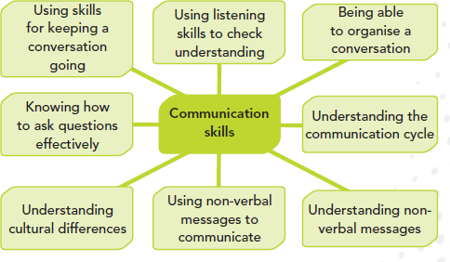

**Source:** Pearson Education (2014).

**Forms of communication**

There are three main forms of communication namely: verbal, non-verbal and written. We can also use technology to communicate.

### Verbal communication

Verbal communication uses words to present ideas, thoughts and feelings. Good verbal communication is the ability to both explain and present your ideas clearly through the spoken word and to listen carefully to other people. This involves using a variety of approaches and styles appropriate to the audience you are addressing.

### Non-verbal communication

This refers to the messages we send out to express ideas and opinions without talking. This might be through the use of body language, facial expressions, gestures, tone of voice, touch or contact, signs, symbols, pictures, objects and other visual aids. It is very important to be able to recognise what a person’s body language is saying, especially when, as a health worker, you are dealing with someone who is in pain, worried or upset. You must also be able to understand the messages you send with your own body when working with other people.

**Figure 9.2 The Main Elements Involved in Non-Verbal Communication**

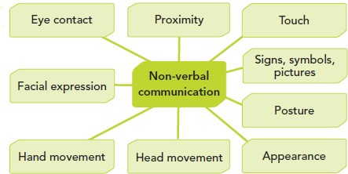

**Source**: Pearson Education (2014).

*Body language* – The way we sit or stand, which is called posture, can send messages. Slouching on a chair can show a lack of interest in what is going on. Folded arms can suggest that you are feeling negative or defensive about a person or situation. Even the way we move can give out messages. For example, shaking your head while someone else is talking might indicate that you disagree with them or waving your arms around can indicate you are excited.

*Facial expression* – We can often tell what someone is feeling by looking at their eyes. Our eyes become wider when we are excited or happy, attracted to, or interested in someone. A smile shows we are happy and a frown shows we are annoyed.

*Touch or contact –* Touching another person can send messages of care, affection, power or sexual interest. It is important to think about the setting you are in and what you are trying to convey before touching a person in a health environment. An arm around a child who is upset about something in hospital or a nursery can go a long way to making them feel better. On the other hand, however, a teenager might feel intimidated by such contact from an older person.

*Signs, symbols and pictures* – There are certain common signs or gestures that most people automatically recognise. For example, a wave of the hand can mean hello or goodbye. Thumbs up can mean that all is well. Pictures of all forms and objects also communicate messages. An X-ray and a model of a knee joint can more easily communicate to someone needing a knee replacement exactly what is involved.

### Written Communication

This is central to the work of any person providing a service in a health environment. This is important for records and writing reports. Different types of communication need different styles of writing but all require literacy skills. A more formal style of writing is needed when

recording information about a patient. It would be unacceptable to use text message abbreviations.

### Technological Aids

Technology is moving so quickly now that we have many electronic aids to help us communicate. For example, mobile phones can be used to make calls. We can also use them to send text messages and emails. We have computers on which we can record, store and communicate health information very quickly and efficiently over long distances. Through video link, a health professional can participate in, or guide an operation taking place in a different physical location.

**Communication Cycle**

Communication is a process. In order to effectively communicate, the parties involved must go through a communication process.

**Figure 9.3 The Communication Cycle**

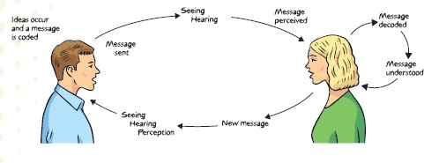

**Source:** Pearson Education (2014).

|  |  |
| --- | --- |
| Idea occurs | Communication starts with an idea. You think of something you want to communicate. Communication always has a purpose. It might be used to pass on information or an idea, persuade someone to do something or to entertain or inspire |
| Message coded | You think about how you are going to say what you are thinking and decide in what form the communication will be. For example, spoken word or sign language, email, letter. You put it into this form in your head. |

|  |  |
| --- | --- |
| Message sent | You send the message. For example, speak or sign, or write what you want to communicate. |
| Message received | The other person senses that you have sent a message by, for example, hearing your words, seeing your signs or receiving your written communication. |
| Message decoded | The other person has to interpret what you have communicated. This is known as decoding. |
| Message understood | If you have communicated clearly and the other person has concentrated, and there are no barriers to communication, the other person understands your ideas. They show this by giving you feedback,  i.e. by sending you a message back. |

The communication cycle happens very quickly and subconsciously because we think three times faster than we speak. In reality, the stages of the communication cycle do not happen in sequence. The communication process is repeated backwards and forwards as long as the conversation goes on. The sender of the message becomes the receiver of a message sent back, the receiver becomes the sender and so on. Each person continues the conversation because they have to check that they have understood what the other person meant. They do this by listening to what the person says and asking questions about it or putting it in their own words and repeating them back, so reflecting what has been said. A conversation can therefore also be called an interaction.

* 1. **Communication Barriers**

Some things stop communication from being effective. People who work in a health environment need to understand the barriers so they can overcome them. It is very important to be able to communicate effectively in a health or social care setting. A service user will not be able to take part in a discussion about their care or planning their future if they do not understand what is being said. Equally, the person providing the service cannot help if they cannot find a way to understand what the service user is trying to ask for. There are many factors that affect communication as illustrated in the table below.

**Table 9.1 Barriers to Effective Communication**

|  |  |
| --- | --- |
| Sensory deprivation | This occurs when someone cannot receive or pass on information because they have impairment to one or more of their senses, most commonly a visual or a hearing disability. |
| Language barrier | When someone speaks a different language or uses sign language, they may not be able to make any sense of information they are being given by someone trying to help them if that person does not speak their language. |

|  |  |
| --- | --- |
| Jargon | When a service provider uses technical language, the service user may not understand. For example, the doctor may say that a patient needs bloods and an MRI scan. That can sound very frightening to someone who has been rushed to hospital. It is better if the doctor explains that they need to take some blood to do some simple tests and then explains what a MRI scan is. Understanding the facts can make something seem less scary. |
| Slang | When a service user uses language that not everyone uses, such as saying they have a problem with their waterworks. This can mean their plumbing system but also having a problem going to the toilet. It may be appropriate to use slang with peers. However, in normal working with colleagues or service users, you should avoid using any language that can be misunderstood or misinterpreted or that which might cause offence. |
| Dialect or pronunciation | When people use different words or pronunciation for everyday objects or feelings depending on the part of the country they come from. Some communities pronounce certain letters of the alphabet differently. It may cause confusion if someone did not listen keenly. |
| Acronyms | When words are shortened to initials. There are lots of acronyms in health and they can be very confusing. Sometimes people do not realise that not everyone knows what they mean and mistakes can be made or people can feel left out if they are not familiar with the terms. A health care professional might say, “you will need to take these tablets TDS” (which means three times a day). This also relates to jargon. |
| Cultural differences | When the same thing means different things in two cultures, communication can be difficult. For example, it is seen as polite and respectful to make eye contact when speaking to someone in some cultures but not in others where this may be taken as being rude and defiant. There are also cultural barriers based on age differences between a service seeker and service provide where an older person cannot expose their private parts for examination by a younger person. |
| Distress | When someone is distressed, they might find it difficult to communicate. They may not listen properly and so misinterpret or not understand what is being said. They might also be tearful or have difficulty speaking. |
| Health issues | When you are feeling ill, you may not be able to communicate as effectively as when you are well. This can affect your colleagues and service users. Similarly, people who are being cared for in hospital because of an illness may not communicate normally. Some long-term (chronic) illnesses such as Parkinson’s disease or Multiple sclerosis also affect an individual’s ability to communicate. You need to be aware of this if you are working with such people. |
| Environmental problems: | When communication is affected by the environment that people find themselves in. For example, someone who does not see very well will |

|  |  |
| --- | --- |
|  | struggle to read written information in a dimly lit room. A person who is in a wheelchair may find it impossible to communicate with the receptionist at the dentist’s if the desk is too high and above the wheelchair user’s head. |
| Misinterpretation of message | When someone reads a person’s body language wrongly. For example, someone with their arms folded and tapping their feet might be impatiently waiting for someone who is late. However, you might assume they are angry with you. This may stop you from asking for help. |

**Student Activity**

Four other factors that affect communication are differing humour, sarcasm, inappropriate behaviour and aggression. Think of an example where each of these may lead to a breakdown in communication.

**More barriers to communication and ways to overcome them**

### Aggression

Aggression is behaviour that is unpleasant, frightening or intimidating. It takes a variety of forms and can be physical, mental or verbal. It can cause physical pain or emotional harm to those it is directed at. It is caused by a range of factors such as substance abuse, mental health, a personality problem, fear or an attempt to dominate someone else. People who are aggressive towards other people are often bullies.

Aggression is a form of communication. It communicates a person’s state of mind, such as annoyance. It is also a barrier to communication. Aggression is often emotion that is out of control. It can be destructive. When someone shouts at someone else, the other person can be afraid and will either shout back or shut the aggressive person out.

If someone working in a health environment is annoyed, frustrated or irritated (breathes quickly, shouts, has a clenched jaw and/or rigid body language) the person they are attending to may feel dominated, threatened and unable to respond. This may lead to poorer service due to a breakdown in communication.

### Assertion

Assertion is the skill of being calm and firm but not aggressive in the way you communicate with others. It helps you to communicate your needs, feelings and thoughts in a clear and confident way while taking into account the feelings of others and respecting their right to an opinion as well.

How to be assertive

* + - Plan what you are going to say. Be polite, state the nature of the problem, how it affects you, how you feel about it and what you want to happen. Make it clear that

you see the other person’s point of view and be prepared to compromise if it leads to what you want.

* + - Control your emotions, such as anger or tearfulness and be calm and authoritative in your interactions with others. You need to be clear and prepared to defend your position and be able to say no. This will not cause offence if it is said firmly and calmly.
    - Use questions such as, ‘*How can we solve this problem*?’ Use the ‘broken record’ technique where you just keep repeating your statement softly, calmly and persistently. At the same time, use body language that shows you are relaxed, e.g. make firm, direct eye contact with relaxed facial features and use open hand gestures.

**Using Verbal Skills to Overcome Barriers**

When you use your verbal skills effectively, you can help overcome barriers that may hinder communication. Some of the skills health service providers need when communicating verbally and assertively when need be, with service users are shown in the diagram below. They are useful tools in checking the understanding part of the communication cycle.

**Figure 9.4: Oral Communication Skills**

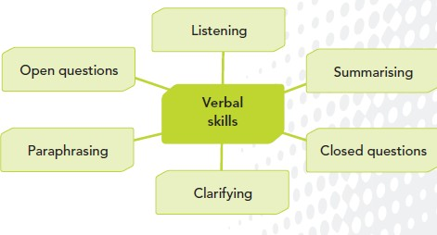

**Source:** Pearson Education (2014).

***Paraphrasing*** means repeating something a person has said in a different way to make sure you have understood the message. For example, someone may say, ‘I have been sick since Sunday’ and you respond by saying, ‘You have been feeling this way for 4 days now?’

***Closed questions*** are questions that can be answered with either a single word or short phrase. For example, ‘Do you like cabbage?’ could be answered, ‘No’ or, ‘No, I can’t stand them.’ Closed questions give facts, are easy and quick to answer and keep control of the conversation. They are useful as an opening question, such as ‘Are you feeling better

today?’; for testing understanding, such as, ‘So you want to go on the pill?’; and for bringing a conversation to an end, such as, ‘So that’s your final decision?’

***Open questions*** may require a longer answer. For example, ‘Why don’t you like cabbages?’ might be answered by, ‘I haven’t liked the taste or smell of them since I was made to eat them all the time when I was a child… .’ Open questions give control of the conversation to the person you are speaking to. They ask the person to think and reflect, give opinions and feelings. They are useful as a follow-up to a closed question, to find out more, to help someone realise or face their problems and to show concern.

***Clarification*** means to make something clear and understandable. ***Summarising*** means to sum up what has been said in a short, clear way. **Overcoming Barriers to Communication**

Communication difficulties can isolate a person, making them feel cut off. So it is particularly important in a health environment to overcome these difficulties. Barriers to communication can be minimised in several ways.

### Adapting the environment

This can be done in a number of ways, such as improving lighting for those with sight impairments and reducing background noise for those with hearing impairments. Lifts can be installed with a voice giving information such as when the doors are opening and closing and which floor the lift is on for those who cannot see. Ramps can be added, reception desks lowered and signs put lower down on walls so that people with physical disabilities can access the people and information they need.

### Understanding language needs and preferences

Service providers need to understand language needs and preferences of the people they are serving. They may have to re-word messages so that they are in short, clear sentences. They should avoid slang, jargon and dialect as much as possible. They should explain details to people who cannot see and encourage them to touch things such as their face.

They should not shout at those who cannot hear very well. They should use normal, clear speech and make sure their face is visible. They should employ a communicator or interpreter for spoken or signed language and show pictures or write messages, depending on what is best for the service user.

### Using individual preferred language

Most leaflets produced by public bodies such as the Ministry of Health are now written in the two official languages in Kenya –English and Kiswahili – so that people who do not speak one of the languages can still access the information. If there is a member of staff who speaks the preferred language of a service user they will help translate. However, it is always

important to ask a service user what their preferred language is for written and verbal communication.

### Timing

It is important to pick the right time to communicate important information to a service user.

E.g. If, a doctor has just told a patient that they have a life threatening illness the patient needs time to absorb the information. If the doctor tells them all about the treatment straight away, chances are the patient may not really hear much of what is said because they are in shock. It may be better to see the patient once they have processed the information and are receptive to hearing additional information.

### Electronic devices

There are many electronic devices that help overcome barriers to communication. These include:

* + *Mobile phones*- These are generally affordable and available to the population at large, making them more accessible than computers. They have many uses in health care. For example, they enable emergency response teams to coordinate their efforts, allow a medical team to contact someone awaiting an operation, coordinate a support group, gather and send information etc.
  + *Telephone amplifiers*- These are devices that amplify, or make louder, the ring tone of a phone so that people who are hard of hearing and those who use a hearing aid can hear the phone more clearly. They also amplify the volume of the person speaking on the other end by up to 100%.
  + *Other devices on telephones* - include flashing lights for those who are hard of hearing to see that the phone is ringing.
  + *Hearing loops*- A hearing loop system helps deaf people who use a hearing aid or loop listener hear sounds more clearly because it reduces or cuts out background noise. At home, for example, one can use a loop to listen to what is on television. You can also set up a loop with a microphone to help you hear conversations in noisy places like public transport vehicles. A hearing impaired student can wear a loop and the teacher a microphone to help the student listen to the teacher.

**Case Study**

Juma has not been in the city for long. He gets a job as a patient attendant in the county hospital but because his Kiswahili is not very good he does not always understand what the other staff or patients have asked him to do. This has caused one or two arguments and almost seen him sacked.

1. Suggest what Juma’s employer can do to resolve this so that Juma can remain a patient attendant.
2. What can Juma do to help himself?
3. How do you think i) the patients (ii) staff (iii) Juma feels when communication fails like this?

**Student Activity**

* 1. List three different ways of adapting the environment to help overcome barriers to communication.
  2. Why is timing important when giving someone information?
  3. Describe how an electronic device such as a mobile phone can help overcome barriers to communication.
  4. **Alternative Forms of Communication**

Sometimes it is not possible to overcome a barrier to communication so an alternative form of communication must be found.

### Sign Language

Sign language uses visual signs. These are made up of the shapes, positions and movement of the hands, arms or body and facial expressions to express a speaker’s thoughts. Sign language is commonly used in communities which include the friends and families of deaf people as well as people who are deaf or hard of hearing themselves.

Kenyan Sign language (KSL) is a visual language comprising specific gestures (signs), hand- shapes and facial expressions. The signs follow grammatical rules. It is the official language of the Deaf community in Kenya.

**Figure 9.5: Some Examples of Sign Language**

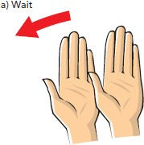

**Source:** Pearson Education (2014).

### Lip Reading

People with normal hearing subconsciously use information from the lips and face to help understand what is being said. Many people misunderstand deafness, thinking that if someone cannot hear very well, they are being rude or stupid. This can leave a deaf person feeling isolated, excluded from everyday activity and conversations, frustrated and lacking in confidence. Lip reading is a technique of interpreting the movements of a person’s lips, face and tongue, along with information provided by any remaining hearing. It is used by someone who is deaf or hard of hearing. It is therefore important that you look directly at someone who is lip reading and stand in a well-lit area when speaking.

### Makaton

Makaton is a method of communication using signs and symbols and is often used as a communication process for those with learning difficulties. It was first developed in the UK in the 1970s. Unlike sign language, Makaton uses speech as well as actions and symbols. It uses picture cards and ties in facial expressions with the word to make the word easily recognisable by those with learning difficulties.

### Braille

The Braille system is a method widely used by blind people to read and write. Braille was devised in 1821 by Louis Braille, a Frenchman. Each Braille character is made up of six dot positions, arranged in a rectangle. A dot may be raised at any of the six positions to form sixty-four possible combinations and these raised dots are read by touch.

### Technological aids

These have already been mentioned earlier as a way of overcoming barriers to communication. They are also alternative forms of communication.

### Human aids

Human aids are people who help people communicate with each other. Examples are:

* + - *Interpreters-* People who communicate a conversation whether it be spoken or signed, to someone in a different language they will understand. This is not easy because they not only have to interpret the words or signs but also have to find a way of expressing the meaning of the words clearly.
    - *Translators-* People who change recorded information, such as the written word, into another language. Again, they have to convey the meaning as well as the words.
    - *Signers-* People who can communicate using a sign language.

|  |
| --- |
| **Student Activity: Signs and symbols** |
| * Do some research to find out the signs for (i) poison (ii) no entry (ii) no smoking (iv) fire exit (v) wet floor. * Find at least five more common signs/symbols that most people will recognise which are used in a health environment of your choice. |

* 1. **Skills for Effective Communication**

This topic introduces students to more skills for effective communication. These include active listening, body language, facial expressions and eye contact. Some of these have already been covered at the beginning of this unit.

### Active Listening and Body Language

Listening to people involves more than just hearing what they say. To listen well, you need to hear the words being spoken, thinking about what they mean and then thinking what to say back to the person. You can also show that you are listening and what you think about what is being said by your body language, facial expressions and eye contact. By yawning or looking at your notes when someone is talking, you give the impression of being bored by what is being said. By shaking your head and frowning, you are showing that you disagree with or approve of what they are saying.

The process of active listening involves:

* + - Allowing the person talking time to explain and not interrupting;
    - Giving encouragement by smiling, nodding and making encouraging remarks such as, ‘that’s interesting’ and, ‘really?’;
    - Asking questions for clarification, such as, ‘can you explain that again please?’;
    - Showing empathy by making comments such as, ‘that must be making life really hard for you’;
    - Looking interested by maintaining eye contact and not looking at your watch;
    - Not being distracted by anything else, such as an interruption on your mobile – switch it off or say you will ring back;
    - Summarising to check that you have understood the other person. You can do this by saying, ‘so what you mean is …?’;
    - Use of appropriate language.

***Ask students***

*How would you feel if your supervisor suddenly started using swear words while they were addressing you? Why would you feel that way?*

We adjust how we speak depending on who we are with and who is listening to us. Things that are said with a group of friends or at a family gathering might not be understood by others because we use different types of language in different situations. People, even unconsciously, change their tone or use of dialect depending on whom they are speaking to. A person’s accent or dialect may become more pronounced when they are speaking to someone from their family or from the area they grew up in.

### Tone of voice

If you talk to someone in a loud voice with a fixed tone, the person you are speaking to will think you are angry with them. On the other hand, if you speak calmly and quietly with a varying tone, the other person will think you are being friendly and kind. So it is important to remember that it is not just what you say, but also the way you say it that matters.

### Pace

If you speak really quickly and excitedly, the person listening to you will not be able to hear everything you say. If you keep hesitating or saying ‘um’ or ‘er’ it makes it harder for people to concentrate on what you are saying. If you speak at a steady pace, however, you will be able to deliver your message more clearly and the other person will be able to hear every word you say.

### Proximity

The space around a person is called their personal space. In a formal situation, such as a doctor talking to a patient, the doctor does not sit close enough to the patient to invade their personal space. In an informal situation, people who are friends or intimate with each other will often sit closer to each other. People usually sit or stand so they are eye-to-eye if they are in a formal or aggressive situation. Sitting at an angle to each other creates a more relaxed, friendly and less formal feeling.

### Written communication

Health workers need to be able to communicate well with the written word. This could be by writing something themselves, such as a letter to refer a client to a different service, a record of a person’s condition and treatment or a prescription. This means they need to be able to use different ways of presenting information, such as letters, memos, emails, reports or forms. They need to make their meaning absolutely clear and structure the information well and in an appropriate manner so that mistakes do not happen. It is also necessary to use grammar, spelling and punctuation correctly. Handwriting should also be legible so that the person the information is intended for can actually read it. It is also important that the language used is

appropriate. Health professionals should not use a lot of technical words, acronyms or jargon if they are writing to someone who will not understand it. They should read information provided by other health workers thoroughly. They need to be able to identify the main points and be able to find other information from a wide variety of sources. They also need ICT skills to update records and access information.

**Knowing the Barriers of Communication**

Effective communication, including active listening, can be hard work. People who work in health care environments tend to enjoy learning about other people and their lives. Things can go wrong, however, if:

* + - The context is wrong, e.g. the surroundings are unsuitable due to lack of privacy;
    - The service provider and service user are mismatched. Sometimes communication breaks down because of factors such as age, education level, gender and ethnic background;
    - A person withholds information because they fear being judged, example.g., because they have taken illegal drugs or procured an abortion;
    - A person fears that confidentiality will be broken even though this should never happen, e.g. about their sexual orientation;
    - The service user thinks that the advice given is too vague and has not asked for clarification;
    - The subject matter is embarrassing, such as talking about sex or intimate body parts;
    - A person fears they are going to hear bad news so avoids going to a service provider until it is too late to help.

If health workers do not develop good communication skills, the effectiveness of their work will be affected and things can go wrong. This will not help service users feel good about themselves, leading to negative consequences. Remember, it is important to overcome problems such as those listed above, communicate effectively, including checking understanding, so that you get the best out of your interactions with colleagues and service users.

**References and Recommended and Further Reading**

Brown, B., Crawford, P. and Carter, R. (2006*) Evidence Based Health Communication*. New York: Open University.

Pearson Education (2014) ‘Communication in Health and Social Care’ [online]. Available at

<https:/[/www](http://www.pearsonschoolsandfecolleges.co.uk/).[pearsonschoolsandfecolleges.co.uk](http://www.pearsonschoolsandfecolleges.co.uk/)>. [Accessed 14 February 2014].

Beck, R., Daughtridge, R. and Sloane, P. (2002) ‘Provider-Patient Communication in the Primary Care Office: A Systematic Review’, *Journal of the American Board of Family Medicine*, January-February, 15(1).

U.S. Department of Health and Human Services (2010) ‘Healthy People 2010 Midcourse Review’ [online]. Available at [<http://www](http://www.healthypeople.gov/data/midcourse/default.htm).[healthypeople.gov/data/midcourse/default.htm.](http://www.healthypeople.gov/data/midcourse/default.htm) [Accessed on 22 July 2013].

# MODULE 10: HEALTH SECTOR POLICY AND REFORM



**Purpose**

To introduce students to the role of policies and reforms in health services delivery

**Objective**

By the end of this module, the student should be able to:

1. To identify and describe the objectives of the current National Health Policy and ongoing reforms.

**Content**

* 1. Aim of Health Policy and Reforms
  2. Health indicators
  3. Structure of the health care system
  4. Health policies and objectives
  5. Health policy and the Constitution of Kenya
  6. Kenya Health Policy Framework 2012-2030

**Methodology**

Lectures, discussions, case studies

**Training materials** Lecture notes Handouts

Power Point (Laptop and LCD projector), Whiteboards, Flip charts, marker pens

**Duration: 4 hours**



**Lesson Plan Guide: Time: 4 hours**

|  |  |  |  |  |
| --- | --- | --- | --- | --- |
| **Session** | **Time**  **(Hours)** | **Content/Topic** | **Lesson Objectives** | **Lecturer Evaluation/Remarks** |
| 1 | 2 | Health policy and reforms | To introduce students to the role of health policy and reforms in the health sector | Comments regarding time adequacy and students’ understanding and perceptions |
| 2 | 2 | Health policy implementation | To identify the various components of current health sector policy objectives | As above |

* 1. **Aim of Health Policy and Reforms**

Health policy refers to decisions, plans, and actions that are undertaken to achieve specific health care goals within a society. The purpose of a broad public health policy is to protect the health of populations. According to the World Health Organisation (1978), health is a state of complete physical, mental and social well-being and not merely the absence of disease or infirmity. WHO has further proclaimed that “the health of all the people is fundamental to the attainment of peace and security and is dependent upon the fullest co- operation of individuals and states”, and that “the enjoyment of the highest attainable standards of health” is one of the fundamental rights of every human being.

On attaining independence, the government committed itself to providing free- health services as part of its development strategy to alleviate poverty and improve the welfare and productivity of the nation. The aim of the health sector policy and reforms is to develop and expand health services and facilities in terms of spatial coverage, training of personnel and tertiary health care delivery services.

* 1. **Health Indicators**

The health status of the population can be assessed by a number of indicators including infant, child and maternal mortality and morbidity rates, crude death rate, life expectancy at

birth, and the number of medical staff and facilities available per unit of population. These are the basic indicators of a country’s health, socio-economic situation and quality of life.

### Infant Mortality Rate

Infant mortality rate is the probability of dying between birth and exactly one year of age, expressed per 1,000 live births. Under-five mortality rate is the probability of dying between birth and exactly five years of age, expressed per 1,000 live births.

### Life Expectancy

Life expectancy at birth is the number of years a new born infant would live if prevailing factors of mortality at the time of birth were to stay the same throughout the child’s life.

### Crude Birth and Death Rates

Crude birth rate is the number of births per 1,000. Crude death rate is defined as the number of deaths per 1,000 and is calculated as follows:

Crude death rate = Number of deaths X 1000

Estimated midyear population

Both crude birth and death rates are important determinants of population size. An increase in crude birth rate may lead to an increase in population size if the crude death rate remains constant.

### Fertility Rates

Total fertility rate is the number of children a woman would have by the end of her childbearing years if she were to pass through those years bearing children. Analysis of fertility rates plays an important role in determining population growth rate, which in turn helps in planning for social provisioning.

### Nutritional Status

The nutritional well-being of young children reflects household, community and national investments in family health and contributes in both direct and indirect ways to the country’s development. The nutritional status of children is summarised using anthropometric indices (height and weight) which reflect past deprivation.

Malnutrition is a major source of ill health and premature death. Undernourished people are those whose food intake is insufficient to meet their minimum energy requirements. Stunting (insufficient height for age) is an indication of cumulative deficient growth linked to long- term deprivation of both food and non-food requirements. Wasting (insufficient weight for height) associated with short-term deprivations changes rapidly and is sensitive to acute food deprivation and morbidity. Low weight for age indicates chronic and acute under nutrition.

* 1. **Structure of the Health Care System**

The level of a nation’s development depends upon the economic and social conditions and the extent and quality of health services provided to the population. Therefore, the health care we have today is a result of policies made some years ago. The development of health care system in Kenya goes back to the pre-colonial era.

In 1901, a medical department was created as one of the civil departments of the central administration. This was the first step towards establishment of colonial medical organisations supported and controlled by the state. In 1903, medical administrators were requested, first, to preserve the health of the European Community, second, to keep the African and Asiatic labour force in good working condition and third, to prevent the spread of tropical diseases.

Medical education in Kenya started in 1967 when the University of East Africa established a faculty of medicine at University College, Nairobi, which in 1970 became the University of Nairobi. After independence, the government continued to expand health facilities in the country. At independence, Kenya inherited a three-tier health system in which the central government provided services at district, provincial and national levels; missionaries provided health services at sub-district levels; and local government provided services in urban areas. This system operated until 1970 when the government established a system of comprehensive rural health services in which health centres became the focal points for comprehensive provision of preventive, promotive and curative services.

Today, alongside government services, non-profit and FBOs organisations and NGOs provide health services at delivery points that range from dispensaries to hospitals. The government’s health care delivery system is pyramidal, with the national referral facilities at Kenyatta National Hospital (Nairobi) and Moi Teaching and Referral Hospital (Eldoret) forming the peak, followed by provincial, district and sub-district hospitals, with health centres and dispensaries forming the base.

* 1. **Health Policies and Objectives**

The main mandate of a health system is to ensure that people enjoy long lives that are relatively free from the burden of disease and ill health. Health policies and strategies are aimed at reducing incidence of disease and improving the health status of Kenyans. Health policy in Kenya revolves around two critical issues, namely: how to deliver a basic package of quality health services to a growing workforce and their dependants and how to finance and manage those services in a way that guarantees their availability, accessibility and affordability to those in most need. The overall goal of the government is to promote and improve the health status of all Kenyans by making all health services more effective, accessible and affordable.

In all its development and sectoral plans, the government’s main objectives for development of health services since independence have been:

* + - Strengthening and carrying out measures for eradication, prevention and control of disease. Such measures include protection of the environment against health hazards, vector disease control, immunisation against disease, early detection and treatment of diseases and health education;
    - Provision for adequate and effective diagnostic, therapeutic and rehabilitative services for the whole population at hospitals, health centres, dispensaries and mobile units;
    - Promotion and development of biomedical and health services’ research as a means of identifying improved and cost effective methods for the protection of the health of the people.

The main health policies in Kenya include:

* + - Increasing coverage and accessibility of health services in rural areas;
    - Further consolidating urban and rural curative and preventive and promotive services;
    - Increasing emphasis on maternal and child health and family planning services in order to reduce morbidity, mortality and fertility;
    - Strengthening Ministry of Health management capacities with emphasis at the county level;
    - Increasing inter-ministerial coordination of health service delivery; and
    - Increasing alternative financing mechanisms.

The Ministry of Health is the main provider of health services in the country. It has the following functions:

* + - Formulation and implementation of a national health policy;
    - Preparation and implementation of national health development plans;
    - Organisation and administration of central health services;
    - Development of health acts and regulations;
    - Training of health and allied personnel;
    - Promotion of medical science and maintenance of medical and health standards;
    - Liaison and coordination with other government departments and NGO agencies; and
    - Internal health regulations.
  1. **Health Policy and the Constitution of Kenya 2010**

The Constitution of Kenya 2010 provides an overarching conducive legal framework for ensuring a comprehensive and people-driven health services delivery. It provides for a rights- based approach to health whereby every person has the right to the highest attainable standard of health. It further indicates that a person shall not be denied emergency medical treatment and that the State shall provide appropriate social security to persons who are unable to support themselves and their dependants.

The Constitution singles out health care for specific groups such as children and persons living with disabilities. In addition, the underlying determinants of the right to health such as adequate housing, food, clean safe water, social security and education are also guaranteed in the Constitution. The current Health Policy therefore seeks to make the realisation of the right to health by all Kenyans a reality.

* 1. **Kenya Health Policy Framework 2012-2030**

This Kenya Health Policy 2012-2030 represents the government’s commitment towards improving the health of the people of Kenya by significantly reducing ill health. The Policy defines the health goal, objectives including strategies, guiding principles and orientations aimed at achieving the health agenda in Kenya.

The Kenya Health Policy 2012-2030 provides guidance to the health sector in terms of identifying and outlining the requisite activities in achieving the government’s health goals. The policy is aligned to Kenya’s Vision 2030 (Kenya’s national development agenda), the Constitution of Kenya and global health commitments and uses a three-pronged framework (comprehensive, balanced and coherent) to define policy direction as shown in **Figure** 10.2.

The goal of Kenya Health Policy 2012-2030 is **‘***attaining the highest possible standard of health in a manner responsive to the needs of the population***’**. The Policy focuses on six objectives, and seven orientations to attain the overall government’s health goals. The implementation of the policy will be done through five-year medium-term strategic plans.

**Table 10.1 Kenya Health Policy 2012-2030 Framework for Policy Directions**

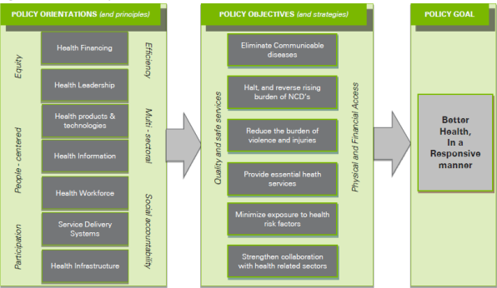

**Source:** Kenya Health Policy 2012-2030.

**Figure 10.2 Health Policy Framework: 2012-2030**

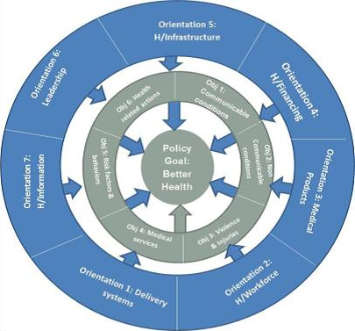

**Source:** Kenya Health Policy, 2012.

**Policy Objectives**

1. Eliminate communicable conditions
2. Halt and reverse the rising burden of non-communicable conditions
3. Reduce the burden of violence and injuries
4. Provide essential health care
5. Minimise exposure to health risk factors
6. Strengthen collaboration with other sectors that have an impact on health

**Policy orientations**

Policy orientations define ‘how’ the health sector will organise itself to facilitate attainment of the health objectives. The orientations are organised around the following Health System Building Blocks:

* 1. *Service delivery systems:* How health service delivery will be organised;
  2. *Leadership and governance:* How health service delivery will be managed;
  3. *Health workforce:* The human resources required for the provision of health services;
  4. *Health financing:* The systems needed to ensure adequate resources for service provision;
  5. *Health products and technologies:* The essential medicines, medical supplies, vaccines, health technologies and public health commodities required in provision of services;
  6. *Health information:* Systems for generation, analysis, dissemination, and utilisation of health related information;
  7. *Health infrastructure:* The physical infrastructure, equipment, transport, and information communication technology needed for delivery of health services.

**References and Recommended Further Reading**

Kenya Institute for Public Policy Research and Analysis (KIPPRA) *Review of the Kenya Health Policy Framework 1994-2010*. Nairobi: KIPPRA.

Ministry of Health Services and Ministry of Public Health and Sanitation. *Kenya Health Policy 2012–2030*.

Ministry of Medical Services and Ministry of Public Health and Sanitation (2010) *Kenya Service Provision Assessment Survey*. Nairobi: Government Printer.

Ministry of Medical Services Strategic Plan 2008-2012

Transparency International-Kenya (2011) *The Kenya Health Sector Integrity Study Report*. Nairobi: Transparency International-Kenya.

# MODULE 11: LAW AND ETHICS IN HEALTH CARE



**Purpose**

To introduce students to the role of law and ethics in health services delivery

**Objectives**

By the end of this module, the student should be able to:

1. Explain health professionals legal responsibilities;
2. Explain ethical and legal issues impacting on health care delivery;
3. Identify conduct with negative legal and ethical consequences.

**Content**

* 1. Health professionals’ legal responsibilities
  2. Ethical issues and theories in modern health care
  3. Basic rules of medical ethics

**Methodology**

Lectures, discussions, case studies

**Training materials** Lecture notes Handouts

PowerPoint (Laptop and LCD projector)

**Duration: 4 hours**



**Lesson Plan Guide: Time: 4 hours**

|  |  |  |  |  |
| --- | --- | --- | --- | --- |
| **Session** | **Time**  **(Hours)** | **Content/Topic** | **Lesson Objectives** | **Lecturer Evaluation/Remarks** |
| 1 | 2 | Health professionals legal responsibilities | To introduce students to health professionals legal obligations and responsibilities | Comments regarding time adequacy and students’ understanding and perceptions. |
| 2 | 2 | Ethical issues and theories in modern Health care | To introduce students to ethics in health service delivery | As above |

* 1. **Health Professionals Legal Responsibilities**

Patients have the right to receive considerate and respectful health care. It is the health care provider’s legal and ethical responsibility to know and respect the patient’s rights. Professionally health care workers have specific legal responsibilities that regulate their particular profession. Adhering to legal regulations is vital for the health care worker’s own protection, the protection of their employer and more importantly, the safety and well-being of the patient. Failure to observe legal and ethical obligations leads to negligence or malpractice.

**Medical Negligence**

Medical negligence, according to Mosby’s Medical Dictionary (8th edition), can be defined as the commission of an act that a prudent person would not have done or the omission of a duty that a prudent person would have fulfilled, resulting in injury or harm to a patient.

**Medical Malpractice**

Medical malpractice means bad, wrong or injudicious treatment of a patient professionally which results in injury, unnecessary suffering or death. Malpractice and negligence may occur through omission of a necessary act as well as commission of an unwise or negligent act. This may be in the form of misdiagnosis, wrong decisions and treatment, prescription errors and medical or surgical complications, all of which may result in suffering, permanent injury or death.

**Regulation**

In Kenya, medical, nursing and midwifery practices are regulated by statutory authorities, including the Medical Practitioners and Dentists Board, the Nursing Council of Kenya, the Clinical Officers Council and the Pharmacy and Poisons Board. These bodies are obliged to protect members of the public by ensuring that medical practitioners including dentists, nurses and midwives, clinical officers and pharmacists are properly qualified, that they perform their services to patients with skill and diligenceand observe at all times high moral and ethical standards. Health care professionals are expected to know and follow the laws regulating their profession, license or registration.

**Applicable laws**

Legal responsibilities in the health sector are interpreted through civil or criminal lawCivil law deals with legal relationships between people and protection of a person’s rights. Criminal law deals with wrongs against a person, property or society, practising without the required licence, theft and murder among others. Many of the wrong doings in health care are civil wrongs. However, they can lead to legal action.

**Compliance**

The following are basic guidelines on how to comply with appropriate laws and procedures:

* + - Protect the patient from exposure (heat or cold);
    - Knock and pause before entering a room;
    - Draw curtains or close door when providing care;
    - Leave while visitors are with the patient;
    - Do not listen when patients make phone calls;
    - Abide by the rules of confidentiality;
    - Do not discuss the patient’s condition with anyone outside of work;
    - Be aware of your surroundings and do not discuss a patient within areas others could overhear (lifts, cafeteria, corridors, parking lot, etc).

**Privileged Communication**

All information given to health personnel by a patient is considered privileged communication, and by law must be kept confidential. However, certain information is exempt by law and must be reported. This includes:

* + - Births and deaths;
    - Injuries caused by violence requiring police intervention (assault and battery, abuse, stabbings);
    - Drug abuse;
    - Chronic diseases.

**Health Care Records**

* + - Belongs to the health care provider;
    - Patient has right to obtain copy of any information in record;
    - Can be a legal record in court of law;
    - Must be properly maintained, kept confidential and maintained for amount of time required by state;
    - When destroyed after time permits, must be burned or shredded to maintain confidentiality.

**Patient Instructions**

### Advance directives

These are a patient’s instructions, usually relating to end-of-life issues regarding what measures should or should not be used to prolong life if their condition is terminal e.g. CPR, ventilator, feeding tube, etc. Advance directives frequently results in a “do not resuscitate” (DNR) order. Advance directives are legally binding documents. They must be signed when the individual is competent and witnessed by two adults who will not benefit from the death. There are two main types of advance directives:

1. Durable Power of Attorney (POA) for health care

This is a document permitting an individual (principal) to appoint another person (agent) to make any decisions regarding health care if the principal is unable to make those decisions. Usually POAs are given to spouses or adult children or another adult. The POA must be signed by the principal, agent, and two adult witnesses.

1. Living will

This is a document allowing individuals to state what measures should or should not be used to prolong life if their condition is terminal e.g. CPR, ventilator, feeding tube, etc. This frequently results in a “do not resuscitate” (DNR) order.

**Professional Standards and Code of Conduct**

Professional standards help meet legal responsibilities, ethics and patients’ rights. By following certain standards at all times, the health care worker can protect themselves, their employer and the patient. Some of the basic standards are:

1. Perform only those procedures for which you have been trained and are legally permitted to do (scope of practice);
2. If asked to perform procedure for which you are not qualified, decline;
3. Use approved, correct methods while performing any procedure
4. Follow procedure manual
5. Obtain correct authorisation before performing any procedure;
6. Identify patient and obtain consent before performing any procedure;
7. Check wrist band if available: State patient’s name clearly and repeat if necessary, ask patient their name and birth date;
8. If patient refuses, do not perform procedure;
9. Obtain written consent where needed;
10. Observe all safety precautions;
11. Keep all information confidential;
12. Think before you speak and watch everything you say;
13. Treat all patients equally;
14. Accept no tips or bribes for care;
15. If error occurs or you make a mistake, report it immediately to your supervisor;
16. Behave professionally in dress, language, manners and actions.

**Table 11.1 Forms of Civil Wrongs in Health Service Provision**

|  |  |
| --- | --- |
| **Type** | **Description** |
| Negligence | * Ordering side rails left down and patient falls from bed * Using or not reporting defective equipment that injures patient * Patient develops infection from poor sterile * Patient burned from bath water that was too hot |
| Assault and battery | * Assault – threatening to injure * Battery – unlawful touch of another without their consent |
| Failure to obtain informed consent | Undertaking procedures without obtaining written or verbal consent – giving an injection, taking a blood pressure, drawing blood for a lab test, starting an IV, performing physical exam; surgery, invasive diagnostic tests, treatment of minors |
| Invasion of privacy | Unnecessary exposure of an individual or revealing personal information about an individual without consent  Examples: Exposing a patient while transporting them to x-ray; sending information to a medical insurance company without patient’s permission; informing third parties of patient’s condition without permission |
| False imprisonment | Restraining a patient or restricting their freedom  Examples: Applying side rails without a doctor’s order and a patient’s permission; placing patient in restraints without order or permission; keeping a patient hospitalised against their will |
| Abuse | Any care that results in physical harm, pain or mental anguish. Types:   * Physical – hitting, forcing persons against their will, restraining movements, depriving food or water * Verbal – speaking harshly, swearing or shouting, writing threats or abusive statements * Psychological – threatening harm, denying rights, belittling, intimidating * Sexual – any unwanted sexual touching or act, sexual gestures or suggested sexual behaviour |
| Defamation | False statements which may damage a person’s reputation. Two types:   * Slander – information is spoken. Example: Stating a person has a drug problem when another medical problem exists * Libel – information is written   Example: Sending inaccurate lab results to a commission of inquiry |

**Student Activity**

Identify the type of civil wrong committed under each of the following fictitious scenarios: Denial of information, action without consent, malpractice, medical negligence

**Table 11. 2 Civil Wrongs**

|  |  |
| --- | --- |
| **Activity** | **Action** |
| Denial of information | Failure to explain the nature of illness or injury and the modality of treatment and its consequences. In particular, there was inadequate information given to the patients before and after surgery. |
| Sterilisation without consent | A mother of three was admitted with abruptio placenta at a Mission Hospital where she was later taken to theatre for Caesarean Section (CS) and, unknown to her, bilateral tubal ligation was carried out. She had not consented and was not informed of the latter. |
| Doctor attended to patient while drunk | A woman was admitted at a public [District Hospital](http://www.wikinvest.com/industry/Hospitals) in early labour. She had previously delivered by CS and so was asked to sign consent for repeat CS which she did. However, a doctor who was drunk saw her in the Labour Ward and asked her to begin pushing the baby, without any success. He then tried unsuccessfully to apply forceps. By the time she eventually was taken to the operating theatre her uterus had already ruptured, the baby had died, and she subsequently developed difficulty in controlling urine (Vesico Vaginal Fistula). She has not conceived since then and she could as well have had a hysterectomy done. |
| Forgotten foreign bodies after surgery | A relative told of the case of a woman who had a CS performed by a doctor during which an abdominal pack was (accidentally) forgotten in the abdomen. When she returned two weeks later complaining of abdominal pain and swelling she was told she needed another operation to remove a foreign body which required further payment. This could not be done because she did not have any more money. The patient died of complications most probably associated with the foreign body. |
| Failure to apply standard procedures | Another case was that of a single mother of two who delivered normally at a health centre (level 3). An episiotomy had been performed and a swab left in the vagina which should have been removed after a few hours. However, the patient was not informed about it and the swab was left in for two weeks. By that time infection had set in and she had also developed faecal incontinence  (RVF). She is now ashamed of her condition and has not mentioned |

|  |  |
| --- | --- |
| **Activity** | **Action** |
|  | it to anyone except her mother. It is possibile that she suffered rectal injury when the episiotomy incision was made. |
| Doctor refused to come to the hospital when summoned | A mother of three was admitted to a public district hospital in labour where she remained for 48 hours without delivery mainly because the only doctor who could do a CS refused to come. When eventually the doctor came she was taken to theatre, delivered of a very depressed child who breathed after prolonged resuscitation, but the mother died on the table. The child is now intellectually handicapped. |
| Failure to provide prescribed medical care | An HIV+ woman was admitted at a public district hospital with ruptured membranes. Her husband, also HIV positive, told the staff that they had been advised by another doctor that the delivery should be by CS, but this was declined. Besides, she was not given ARV therapy as instructed in the PMTCT guidelines. Instead, she was allowed to have a prolonged labour, delivering a fresh stillborn child. |
| Failure to give an essential prophylaxis | A primigravida at term was admitted in a private hospital where she had made several antenatal visits. Her labour was uneventful, delivering a healthy male child. However, although she had been informed at the same hospital that she was Rhesus Negative she was not offered a standard vaccine, anti-D gamma globulin to protect against Rhesus iso-immunisation. In addition, she was not advised what to do in case of a subsequent pregnancy. |
| Hysterectomy performed without consent on a disabled person | A woman with dwarfism (possibly achondroplasia) was diagnosed with uterine fibroids at a provincial hospital and advised she needed an operation to remove the fibroids. She was taken to theatre but afterwards was not told what had been done. When three weeks later she realised that a hysterectomy had been performed she sought explanation from the doctor. She was taken aback when the doctor wondered aloud if in her condition she really expected to get a baby! |
| Hysterectomy performed in a woman diagnosed with an ovarian cyst | A married woman, a mother of four girls had hope that a boy would come someday. She was seen at a provincial hospital complaining of abdominal pain, where an ovarian cyst was diagnosed and confirmed by an ultrasound scan. She was advised to undergo an operation in order to remove the cyst; at no time was possibility of a hysterectomy mentioned. She discovered this on her own when  she read the discharge summary which stated that the uterus had a |

|  |  |
| --- | --- |
| **Activity** | **Action** |
|  | fibroid and a hysterectomy was performed. |
| Hysterectomy | A woman in her first pregnancy was under care of a private |
| performed possibly | obstetrician who saw her several times during pregnancy. When she |
| because of | went two weeks past the due date, he admitted her at a private |
| intractable post- | hospital for induction of labour, but for three days labour did not |
| partum | set in. However, when labour started on the fourth day her doctor |
| haemorrhage | was nowhere to be found; it was not until the next day that he |
|  | appeared in the middle of the night and attempted to deliver her by |
|  | vacuum extraction, but this was abandoned because there was a lot |
|  | of bleeding. She was then taken to theatre and a CS was performed. |
|  | She gave birth to a baby boy weighing 4kg. When she was returned |
|  | to the ward, the bleeding continued and had to be returned to |
|  | theatre again, but was not told what was done there. Details of |
|  | operations done on her were only made known to her husband |
|  | when he went to clear the bills. And then it was not until three |
|  | months later that her husband actually informed her of the loss of |
|  | her uterus. After some years, her husband left her for another |
|  | woman to have more children. |

**Policies and Procedures**

Health care workers must be familiar with their employer’s policies and procedures. Policies and procedures are the guidelines that provide information about employment terms, work place procedures, quality control etc. Technical procedures tell you how to complete tasks the way your employer wants them done. There may be procedures for the following:

* + How to take a temperature;
  + How to give an enema;
  + How to fill out forms;
  + How to package and wrap trays;
  + Standard operating procedures;
  + Treatment protocols.

These guidelines assure that the health care worker performs their jobs correctly. It is important to always follow a health facility’s policies and procedures. Doing this will protect your patients, co-workers, employer and yourself.

* 1. **Ethical Issues and Theories in Modern Health Care**

Ethics is a set of moral principles and a code for behaviour governing an individual’s actions with other individuals and within society. Ethics is a critical reflection about morality – what is believed to be right and good. Medicine and technology are rapidly changing and offering choices to health professionals. Although challenging and even exciting, the choices can be difficult. For example, should medications known to be effective be withheld from a patient because it is thought they are incompetent or do not have the means to store or manage the medication properly?

In modern health care and research, value conflicts arise where there often appears to be no clear consensus as to the “right thing to do”. These conflicts present problems requiring moral decisions that necessitate a choice between two or more alternatives.

Examples:

* + - Should a parent have a right to refuse immunisations for his or her child?
    - Does public safety supersede an individual’s right?
    - Should children with serious birth defects be kept alive?
    - Should a woman be allowed an abortion for any reason?

**Ethical dilemmas and theories**

### Ethical dilemma

This is a value conflict with no clear consensus as to the “right” thing to do. It is conflict between moral obligations that are difficult to reconcile and require moral reasoning. Situations necessitating a choice between two equal (usually undesirable) alternatives. Modern health care technology has created many ethical dilemmas. For example:

* + - Assisted suicide – is it justified in certain patients?
    - Stem cell research – should aborted foetuses be used?
    - Should a patient be permitted to smoke marijuana if it eases pain or effects of chemotherapy?

### Deontology /Non-consequentialism Theory

This is derived from the Greek word “Deon”, meaning duty. Under this theory, some acts are right or wrong independent of their consequences. The theory is based on the concept of duty. It is premised on one’s obligation and on that basis seeks to determine what is ethical by answering the question: What should I do and why should I do it?

|  |
| --- |
| **Illustration: Deontology: A duty** |
| Anita, a practitioner, believes she has a duty to give cardiac clients detailed information on the pathology involved in their condition even though the client has indicated that they are not ready or may be terrified to hear the information causing the client distress. |

**Consequentialism Theory**

Also called Teleological theory. Actions are determined and justified by the consequence of the act. Consequentialists consider all the consequences of what they are about to do prior to deciding a right action. This also answers the question: What should I do and why should I do it?

|  |
| --- |
| **Illustration: Consequentialism: Action** |
| Had Anita respected the wishes of her clients, she would have given them only the information which would have been a benefit to them and not caused them undue stress. She would have been motivated by her desire to do good (beneficence), rather than her sense of duty. This would amount to deontological betrayal. |

**Utilitarian Theory**

Considers the greatest good for the largest number of people. Also answers the question: What should I do and why should I do it? The problem with employing Utilitarian theory is determining who decides the definition of “greatest” and “good”.

**Intuitionism Theory**

Resolves ethical dilemmas by appealing to one’s intuition, a moral faculty of a person which directly knows what is right or wrong. A gut feeling of knowing what is right. The difficulty with intuitionism is in deciding whose moral position is more valid.

**Rights Based Theory**

This theory resolves ethical dilemmas by first determining what rights or moral claims are involved and take precedence. Consider the abortion debate, personal – mom vs. foetus/child, societal- women’s choice vs. potential life of the unborn).

**Virtue Ethics Theory**

Contrary to other ethical theories, virtue ethics tells us what kind of person one ought to be, rather than what they do. The focus is on the character (goodness) of the person.

* 1. **Basic Rules of Medical Ethics**
     + Put saving of life and promotion of health above all else;
     + Make every effort to keep patient as comfortable as possible and to preserve life when possible;
     + Respect patient’s choice to die peacefully and with dignity (advanced directive);
     + Treat all patients equally,avoid bias, prejudice and discrimination;
     + Provide care for all persons to the best of your ability;
     + Maintain competent level of skill consistent with occupation;
     + Maintain confidentiality;
     + Gossiping about patients is ethically wrong;
     + Avoid immoral, unethical or illegal practice;
     + Show loyalty to patients, co-workers and employer;
     + Be sincere, honest and caring.

**Suggested Student Activities**

**Legal Responsibilities**

1. As a future health care professional, how can you avoid a lawsuit?
2. Can you restrain a person against his or her will if it is for his or her own good?
3. Can you be sued if you unintentionally leave a patient’s record open and a visitor sees that the patient has a sexually transmitted disease?
4. What should you do if you see another health care worker make a serious error?
5. What is meant by the statement: ‘It is easier to prevent negligence than it is to defend it’?
6. Why is malpractice also called ‘professional negligence’? Who can and cannot be guilty of malpractice?
7. Could a dental assistant ever be guilty of negligence? Give an example.
8. What is the difference between assault and battery?
9. In your own words, describe invasion of privacy.
10. What type of abuse do you think is the most difficult to prove in court? Why?
11. A teacher who was hospitalised sues a student nurse for defamation. What do you think might have happened?

**Medical Legal Puzzle**



**Across**

2. When false statements damage a person's reputation.

1. For example, a physical therapist treats a child without parental consent.
2. For example, when a dentist writes a letter to a newspaper editor claiming that a patient is a big baby and never pays his bills.

7. False can be charged if a patient is restrained without proper authorisation.

12. A wrongful act that does not involve a contract.

1. Informed is permission granted voluntarily by a person who is of sound mind.
2. Malpractice is often described as bad or professional negligence.
3. An example of abuse when a health care worker swears and shouts at a patient.
4. For example, when a nurse tells the press something about a celebrity patient that is insulting and untrue.

**Down**

1. Any care resulting in physical harm, pain, or mental anguish.

3. Unnecessarily exposing an individual.

6. For example, a doctor cuts into the bladder when removing the uterus.

1. A threat or attempt to injure.
2. For example, nursing assistant used hot bath water and burned patient.
3. Invasion of privacy can be caused by revealing information about a patient.
4. Type of informed consent required for major surgery.

13. Negligence occurs when care that is expected is not given.

**Legal and Ethical Questions**

1. What is a threat or attempt to injure? **Assault**
2. If a nurse assistant forgets to raise the side rails on the bed and the patient falls out of bed, the nurse assistant might be guilty of: **Negligence.**
3. If a physician fails to use the degree of skill and learning commonly expected in that individual’s profession, the physician could be guilty of: **Malpractice.**
4. A person who is under the influence of drugs does not have the legal capacity to form a contract because he/she has a: **Legal disability.**
5. If a laboratory technician sends e-mails to co-workers saying that a particular physician is careless and killed a patient, the lab tech might be guilty of: **Libel.**
6. What term describes the fact that information about a patient must remain private?

**Confidentiality**

1. Before you perform any procedure on a patient, you must have proper: **Authorisation.**
2. What should you do as a health care worker do if you make a mistake? **Report it immediately to your supervisor.**
3. When can a health care worker accept a tip or bribe? **Never**
4. What term describes a standard code of conduct for health professionals? **Ethics or Code of Ethics**
5. A nurse is helping a patient walk and jerks the patient by the arm, causing a bruise. The nurse may be guilty of: **Battery.**
6. What is permission granted voluntarily by a person who is of sound mind after the procedure has been explained in terms the person can understand? **Informed consent.**
7. If a health care worker makes false statements about a patient that cause the patient to be damaged or ridiculed, the health care worker may be guilty of: **Defamation (or slander).**
8. Speaking harshly, swearing or shouting, and using inappropriate words to describe a person’s tribe or nationality are all examples of what kind of abuse? **Verbal.**
9. What kind of contract exists when a nurse is holding a thermometer and says “put this under your tongue” and the patient puts the thermometer under his or her tongue? **Implied contract.**
10. If I have the legal capacity to sign a consent form, I must be: **18-years-old and mentally competent. (Free of legal disability).**
11. What patient’s rights document applies to persons in long-term care facilities?

**Resident’s Bill of Rights.**

1. A document that a person signs to indicate he/she does not want to be resuscitated when he/she stops breathing is a: **Living will.**
2. Health care records are examples of: **Privileged communications**
3. What is an example of physical abuse? **Hitting, forcing people against their will, etc.**
4. Keeping someone in the hospital against their will could be an example of: **Forced imprisonment.**
5. Jane’s father signs a document saying that Jane will make decisions for him once he is unable to make decisions. The document is a: **Durable Power of Attorney.**
6. According to professional standards, before a health care worker performs any procedure on a patient, the health care worker should: **Identify the patient and/or obtain the patient’s consent.**

**Patients’ Rights and Duties**

|  |  |  |  |
| --- | --- | --- | --- |
|  |  | **Circle the correct answer** | |
| 1 | Patients have the right to know whether medical treatment is experimental. | True | False |
| 2 | Patients have the right to smoke in the hospital | True | False |

|  |  |  |  |
| --- | --- | --- | --- |
| 3 | Patient duties imply that they should give a physician all information that may be pertinent to their case, even if this information is strictly personal | True | False |
| 4 | Patients are entitled to receive explanations for medical treatment in order to give informed consent | True | False |
| 5 | Patients have the right to ignore? Or have the duty to follow physician orders | True | False |
| 6 | All patients have the right to confidentiality | True | False |
| 7 | Patients may examine their bills, but cannot expect to have them explained due to the many extraneous charges that are accrued | True | False |
| 8 | Patients have a duty to be considerate and respectful to health providers? | True | False |
| 9 | Patients who are hospitalized cannot expect consideration of privacy due to the intimate nature of many exams and procedures | True | False |

Answers

* 1. True 2. False 3. True 4. False 5. False. 6. True 7. False 8. False. 9. False

**References and Recommended Further Reading**

Constitution of Kenya 2010.

Kenya Medical Practitioners and Dentists Board Code of Professional Conduct and Discipline.

Kenya Medical Practitioners and Dentists Board Guidelines for Medical and Dental Interns. Kenya National Patients’ Right Charter, 2012.

Miller-Keane Encyclopedia and Dictionary of Medicine, Nursing, and Allied Health, Seventh edition.

National Nurses Association of Kenya (2009) *Code of Conduct and Ethics*. Nairobi: National Nurses Association of Kenya.

The Clinical Officers (Training, Registration and Licensing) (Practicing) Regulations, 2009. Transparency International-Kenya (2011) *Kenya Health Sector Integrity Study Report.*

Nairobi: Transparency International-Kenya.

# MODULE 12: HEALTH INFORMATION SYSTEMS



**Purpose**

To enable students to understand the processes and management of health information systems

**Objectives**

By the end of this module, the student should be able to:

1. Define health information systems and identify key components;
2. Explain the structure of the health information system in Kenya;
3. Identify the sources of health information.

**Content**

* 1. Health information system
  2. Components of an effective health information system
  3. Structure of the health information system in Kenya
  4. Sources of health information

**Methodology**

Lectures, discussions, case studies

**Training materials** Lecture Notes Handouts

PowerPoint (Laptop and LCD projector) Whiteboards, flip charts, marker pens

**Duration: 4 hours**



**Lesson Plan Guide:**

**Time: 4 hours**

|  |  |  |  |  |
| --- | --- | --- | --- | --- |
| **Session** | **Time**  **(Hours)** | **Content/Topic** | **Lesson Objectives** | **Lecturer Evaluation/Remarks** |
| 1 | 2 | Definition of HIS and identification of components of the Kenya health information system | To define health information systems and identify key components | Comments regarding time adequacy and stand students’ understanding and perceptions. |
| 2 | 2 | Structure of the Kenya health information system and sources of health information | To explain the structure of the health information system in Kenya  Identify the sources of health information | As above |

* 1. **Health Information System (HIS)**

Health information systems refers to any system that captures, stores, manages or transmits information related to the health of individuals or the activities of organisations that work within the health sector. This definition incorporates national, county, sub-county and health facility level routine information systems, disease surveillance systems and also includes laboratory information systems, hospital patient administration systems (PAS) and human resource management information systems (HRMIS).

Sound and reliable information is the foundation of decision-making across all health system building blocks. It is essential for health system policy development and implementation, governance and regulation, health research, human resources development, health education and training, service delivery and financing. The health information system provides the underpinnings for decision-making and has four key functions:

* + - Data generation;
    - Compilation;
    - Analysis and synthesis; and
    - Communication and use.

The health information system collects data from health and other relevant sectors, analyses the data and ensures their overall quality, relevance and timeliness and converts the data into information for health-related decision-making.

* 1. **Objectives of HIS**

An efficient health information system seeks to ensure that users of health information have access to reliable, authoritative, usable, understandable and comparative data. The key users of health information policy-makers, planners, managers, health-care providers, communities and individuals.

The broad objectives of HIS are to:

* + - Provide data for monitoring and evaluation;
    - Provide an alert and early warning capability;
    - Support patient and health facility management;
    - Enable planning;
    - Provide a basis for research;
    - Facilitate health situation and trends analyses;
    - Facilitate reporting, and reinforce communication of health challenges to diverse users.

|  |
| --- |
| **Student Activity** |
| 1. Identify the various types of health information. 2. What are the correct sources the information you have identified in (1) above? 3. How can the information be collected and by who? |

* 1. **The Need for Strong Health Information Systems**

Sound and reliable health information:

* + - Is essential for health system policy development and implementation, governance and regulation, health research, human resources development, health education and training, service delivery and financing.
    - Gives a clear picture of health and sickness at all level of society – individual, household, community, county, country, regional and global.
    - Helps prevent the spread of disease and improve the health of individuals.
    - Leads to better decisions and better spending.
    - Makes it easier to track and confront threats to health at all levels.
  1. **Health Sector Information Needs**

Health professionals and health workers that deal with health issues everyday need to have essential information that can be used for day-to-day management or long-term planning.

The different kinds of information needed include:

1. ***Health determinants*** -socioeconomic, environmental, behavioural and genetic factors) and the contextual environments within which the health system operates;
2. ***Inputs to the health system and related processes*** - policy and organisation, health infrastructure, facilities and equipment, costs, human and financial resources and health information systems;
3. ***The performance or outputs of the health system****-* availability, accessibility, quality and use of health information and services, responsiveness of the system to user needs, and financial risk protection;
4. ***Health outcomes*** - mortality, morbidity, disease outbreaks, health status, disability and wellbeing; and
5. ***Health inequities****-* determinants, coverage of use of services, and health outcomes, and including key stratifiers such as sex, socioeconomic status, ethnic group and geographical location.
   1. **Components of a Health Information System**

A country’s HIS is made up of all the data and records about the population’s health. The sources of data include civil and vital registration (recording births, deaths and causes of death), censuses and surveys, individual medical records, service records and financial and resource tracking information.

A health system comprises of three components: inputs, processes and outputs.

### Inputs

Inputs or resources are the physical and structural prerequisites of an effective HIS. They include the ability of those responsible to lead and co-ordinate the process; the existence of necessary laws and policies; financial resources and people with the necessary skills to do the work and the infrastructure – everything from office space and desks to filing systems and computer networks.

### Processes

The *processes* used by an HIS include:

* + - Indicators – a set of measures that show changes in health profile;
    - Data sources – an *integrated* HIS brings together data from a variety of sources;
    - Data management needs enable easy access to relevant information for those who need it, while protecting the privacy of individual patients;

### Outputs

The information produced – the HIS outputs – should be relevant, accessible, and useful evidence for decision making.

* + - Information products are collated from a range of sources, and synthesised into usable statistics that can be analysed and compared;
    - Dissemination and use. Through widespread dissemination and use of information products, the HIS provides direct benefit to all those who participate in it, providing an ongoing incentive for users to continue to strengthen the system.

**Figure 12.1: Components of a Health Information System**

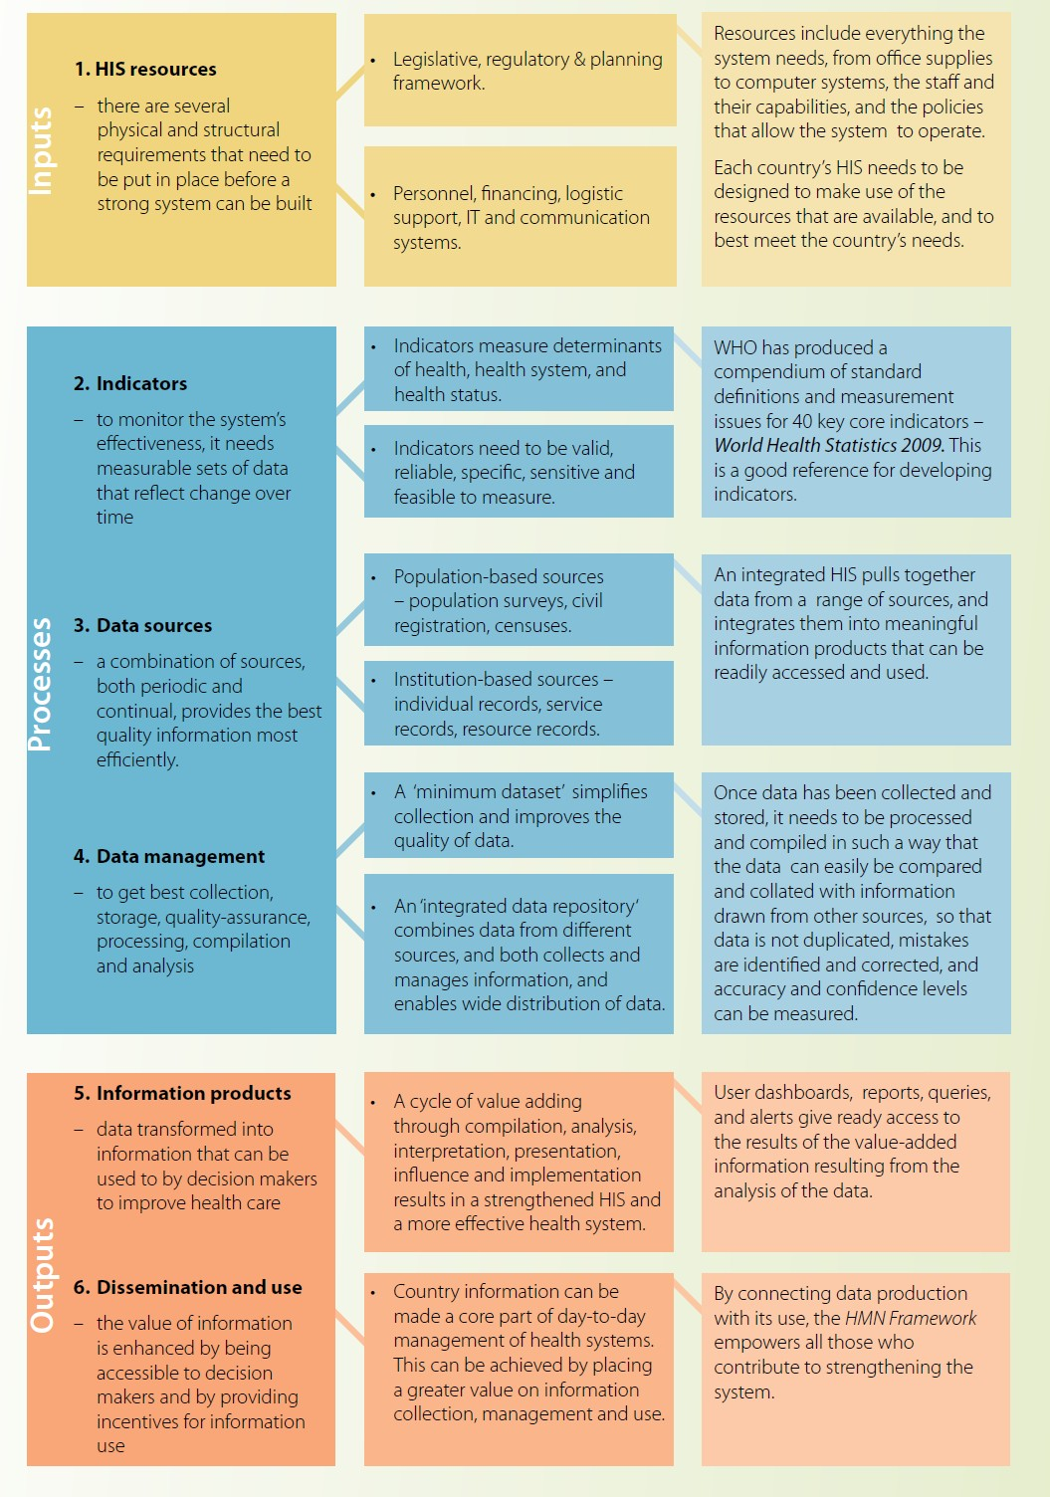

**Source**: Health Metrics Network (2008).

* 1. **Structure of the Health Information System in Kenya**

The Kenya National Health Information system (NHIS) is a comprehensive and integrated structure that collects, collates, analyses, evaluates, stores, disseminates health and health- related data and information for use by all. The NHIS seeks to address such issues as partnership in data collection and information sharing, guidelines on data processing and data warehousing as well as instituting standardised mandatory reporting by all care providers (public and private) and quality in data management in the health sector.

The NHIS is composed of producers of health statistics including Ministry of Health, Kenya National Bureau of Statistics (KNBS), vital registration, private health institutions, research institutions and FBOs amongst others.

**Figure 12.2: Structure and Responsibilities in the National Health Information System**

|  |  |
| --- | --- |
| **NHIS**  **Coordinating Committee (NHISCC)** | The NHISCC is made up of representatives from senior level officers in the Ministry of Health, statistical constituencies and development partners. The role of the NHISCC is to provide technical advisory role for health and social welfare data management in close collaboration with other strategic partners including KNBS and Vital Registration. The committee ensures unified and timely data collection, collation, processing and dissemination. |
| **General public** | The public should ensure that any vital events or other significant health occurrences in the community are reported to the responsible authorities. On the other hand the public is entitled to information on the Ministry’s performance through relevant publications or on specific special requests. |
| **Private sector** | All health service providers in the private sector have a mandatory responsibility to submit their health data regularly including data on all diseases under surveillance. |
| **Non- governmental organisations** | Non-governmental organisations are responsible for ensuring that all health facilities under their respective umbrellas adhere to the NHIS. In collaboration with the Ministry of Health and other partners, NGOs are expected to mobilise resources for NHIS and ensure efficient data and information management in all its satellite facilities. |
| **Ministry of Health - Roles by level** | |
| **Community level** | Every Community Unit (CU) should maintain and update its CHIS that shall be shared regularly with household members in a forum as stated in the health sector community strategy. The community health workers maintain registers recording daily activities and reporting regularly to supervising health facility. |
| **Health facility level** | Health facilities maintain and update HIS data which include records, filing system(s) and registry for primary data collection tools such as registers, cards, file folders, summary forms such as reporting forms, CDs, electronic backups safeguarded from any risks e.g. fire, floods, access by unauthorised person, etc. |

|  |  |
| --- | --- |
|  | Every health facility summarise health and health related data from the community and health facility, analyse, disseminate and use the information for decision-making, provide feedback then transmit summaries to the next level. |
| **Sub-county level** | Sub-county has an oversight responsibility to manage all health and health related data from all service providers within their area of jurisdiction.   * It provides technical, material and financial support to all service providers in HIS. * Creates and maintains a data repository. * Collaborates and work in partnership with other statistical constituencies at the sub-county level to build one HIS. * It should collate, analyse, disseminate, use health and health related data from all health facilities/providers and give feedback to all health care providers. |
| **County government** | The county government has oversight responsibility to manage all health and health related data from all service providers within their area of jurisdiction.   * Provides technical, material and financial support to all sub-county government and service providers in HIS. * Maintains a data repository for the county. * Collaborates and works in partnership with other statistical constituencies at the provincial level to build one HIS. * Collates, analyses, disseminates and makes use health and health related data from all sub-counties and gives feedback to all health care providers in addition to submitting the same to MoH. |
| **MoH** | The MoH have oversight responsibility to manage all health and health related data from all service providers.   * Provides technical, material and financial support to all counties and service providers in HIS. * Develops guidelines and formulates policies. * Coordinates development of minimum data sets and data requirements of the health sector. * Collate, analyse, disseminate and use health and health related data from all counties and service providers and provide feedback to all. * Creates and maintains a national data repository. * Collaborates and works in partnership with other statistical constituencies at the national to build one HIS. |

* 1. **Sources of Health Information**

A reliable country/county health information system provides the best source of relevant, timely and credible health information.

**Table 12.1 Sources of Health Information**

|  |  |
| --- | --- |
| **Type of Information** | **Source** |
| Population based information | Census, household surveys, specials studies, civil/vital registration systems |
| Health service information | Outline service statistics, national health accounts, electronic medical records service |
| Health management information | Financial information system, human resource information system, logistics and supplies information system, service statistics system, electronic medical records system, pharmaceutical procurement |
| Special health information | Academic, research institutions and international organisations for research and survey findings |

**References and Recommended Further Reading**

Health Metrics Network (2008) *Components of a Health Information System.* Geneva: WHO.

Health Metrics Network (2008) *Framework and Standards for Country Health Information Systems*. 2nd ed. Geneva: WHO.

Management Sciences for Health (2010). Health Systems in Action: An eHandbook for Leaders and Managers. Arlington, VA: Management Sciences for Health. Available at

<<http://www.msh.org/> resources/health-systems-in-action-an-ehandbook-for-leaders-and- managers or <http://www.msh.org/> sites/msh.org/files/msh_ehandbook_complete.pdf>. [Accessed 5 May 2014].

Ministry of Medical Services and Ministry of Public Health and Sanitation. Health Sector Strategic Plan For Health Information System 2009-2014.

Ministry of Medical Services and Ministry of Public Health and Sanitation. *Health Sector Information System Policy 2010- 2030.*

Ministry of Medical Services and Ministry of Public Health and Sanitation. National E- Health Strategy 2011-2017

Ministry of Medical Services and Ministry of Public Health and Sanitation (2010) *Standards and Guidelines for* Electronic Medical Records Systems in Kenya

Republic of Kenya (2008) *Health Sector Indicator and Standard Operating Procedures Manual for Health Workers.* Nairobi: Government Printer.

Republic of Kenya. Report for the Assessment of the Health Information System of Kenya

USAID (2009) ‘Measuring the Impact of Health Systems Strengthening. A Review of the Literature’ [online]. Available a <https:/[/www](http://www.k4health.org/).[k4health.org](http://www.k4health.org/)> [Accessed 2 June 2014].

WHO (2010) *Monitoring The Building Blocks of Health Systems: A Handbook of Indicators and their Measurement Strategies.* Geneva: WHO.

# MODULE 13: PROJECT MANAGEMENT



**Purpose**

To equip the student with knowledge and skills to enable them understand and manage projects

**Objectives**

By the end of this module, the student should be able to:

1. Describe the concepts and principles of project management;
2. Discuss the importance of project planning and types of plans;
3. Define project cycle management and outline the various cycles;
4. Describe county planning;
5. Outline the various planning models.

**Content**

* 1. Project Management
  2. Principles and concepts of project management
  3. Project planning and design
  4. Project cycle management
  5. Planning Methods and tools

**Methodology**

Lectures, discussions, case studies

**Training materials** Lecture notes Handouts

Power Point (Laptop and LCD projector) Whiteboards, flip charts, marker pens

**Duration: 4 hours**



**Lesson Plan Guide: Time: 4 hours**

|  |  |  |  |  |
| --- | --- | --- | --- | --- |
| **Session** | **Time**  **(Hours)** | **Content/Topic** | **Lesson Objectives** | **Lecturer Evaluation/Remarks** |
| 1 | 2 | Project management  Principles and concepts of | To define and describe the various components project management  Principles and concepts | Comments regarding time adequacy and students’ understanding and perceptions. |
| 2 | 2 | Project cycle management and project planning methods and tools | To identify and describe the various components of project cycle management and project planning methods and tools | As above |

* 1. **Project Management**

Project management is a methodical approach to achieving agreed upon results within a specified timeframe with available resources. It involves applying knowledge, skills, tools and techniques to a wide range of activities in order to meet the requirements of a project. The focus of project management is to meet the expectations of a project in order to fulfil the needs that have been identified by the people. Project management is accomplished through managerial processes of planning, organising, controlling, leading and motivating human resource to identify resource requirements, establishing clear and achievable objectives, balancing the competing demands for quality, scope, time and cope and adapting the specifications, plans, and approach to the different concerns and expectations of the various stakeholders to generate outputs (deliverables). Project management is often an important role for health managers/supervisors. The concepts, methods and tools described in this module are an important part of a supervisor’s repertoire.

* 1. **Principles and Concepts of Project Management**

### Clearly Defined Goals

A goal is an end point to be achieved by carrying out a project. Every project should have a clear end point expressed in writing as part of the contents of project documents. The project goal is defined during the project design stage.

### Consistency

For any project to succeed, one should keep focused to an end goal. It is important to use various tools to ensure success of the project. This includes schedules, task lists and budgets to keep the project on track. This ensures adherence to the phases of the project cycle (13.4). This principle stipulates adherence to the phases of project cycle and a well-informed decision-making process.

### Effective Stakeholder Management

Stakeholder involvement in project management involves the use of participatory planning workshops at key phases of the project cycle and the formulation of the project purpose in terms of sustainable benefits to be delivered to beneficiaries. Stakeholders can contribute their expert knowledge; offer their political endorsement which is essential to the success of the project, provide access (to power, influential people and or resources).

### Effective Planning, Design and Control

Projects are delivered under constraints of time, cost, scope and quality of uncertain environment. Therefore, projects must be designed with the end (or goal) in mind and involving stakeholders so that control is possible. This will ensure sustainable benefits.

### Effective Change Management

In a project, set-up change is unavoidable. A flexible approach needs to be maintained to absorb any changes that may arise but also not divert completely from the initial plan and intended project objectives. Change management is an approach to shifting or transitioning individuals, teams and organisations from a current state to a desired future state. It is an organisational process aimed at helping stakeholders to accept and embrace changes in their environment. In some project management contexts, change management refers to a process wherein changes to a project are formally introduced and approved. Change management uses basic structures and tools to control any organisational change effort. The goal is to maximise benefits and minimise the change impacts on workers and avoid distractions.

### Sustainability

There should be aspects incorporated for sustainability of the project within the plan at the project design stage. Sustainable development is development that meets the needs of the present without compromising the ability of future generations to meet their own needs. In other words, it ensures that today’s growth does not jeopardise the growth possibilities of future generations.

*The lecturer should ask the students some of the questions that one should ask in the design phase to ensure that the project is sustainable.*

* 1. **Project Planning and Design**

Project planning is the process of developing and maintaining or adapting a project plan that provides supporting details to the project definition in terms of resources, time, cost, scope and quality plan and schedules. It is about constructing a statement that indicates why, what, who, when, where, how much, what standards and so what. The major inputs to project planning process are the scope statement, environmental factor analysis, which include political, economic, technical, social cultural and technological factors and a good understanding of the resource requirements for the proposed activities. The main output for project planning is the project management plan. The planning phase involves scheduling of time, costing and budgeting and risk management. This is a very critical stage of any project.

**Importance of project planning and design**

### Cost-effectiveness

Project management provides a roadmap for the journey of success. It is the greatest resource that allows the manager to understand available resources and their use. . Thus, with a plan in hand, it is easy to utilise the resources in the best possible way. Project planning, prior to launching a project, identifies irrelevant costs, reduces wastage of resources and thus ensures cost-effectiveness in the longer run.

### Better Productivity

Project management keeps the quality of products and services in constant check thus ensuring better productivity in terms of quality and quantity. This not only helps the organisation in earning goodwill for a lifetime but also promises customer satisfaction. Trustworthy quality of products and services is intended to retain existing clientele and attracting new ones.

### Minimisation of Risks

Every organisation faces risks of loss for various reasons. However, identifying risks and solutions is easier with a strategy. This maintains stability in the work. By planning and analysing, a project manager can mitigate risks and be a part of fair competition. Project management helps in identification of loopholes and potential threats. Once these are singled out, the management can then take decisions to change strategies to minimise risks that can negatively affect productivity.

An organisation can prepare a risk management plan detailing how to deal with the various risks that they may encounter during project implementation. For example, during the implementation of the project, one of the common risks is that there may be lack of technical capacity of implementing organisations to manage project resources efficiently and effectively. Therefore, during the planning phase, standards and regulations should be formulated. These standards and regulations should focus on capacities of the organisations, the requirements and actions necessary where such requirements and capacities are not met.

### Accomplishing Predetermined Goals

Every viable organisation has goals and objectives which allow the organisation or institution to fulfil its mission. Project management is the key tool for achieving predetermined targets in a structured way. It decides the strategies that will be used to reach the goal quickly. It is a structured way of getting to your objectives.

* 1. **Project Cycle Management**

The project cycle is a way of viewing the main elements that projects have in common and how they relate to each other in sequence. The precise formulation of the cycle and its phases varies from organisation to organisation. There is no standard cycle, although the basic components are discussed below.

Project cycle management is the systematic process of programming, project identification, project appraisal, financing, implementing, monitoring and evaluation. It is used to guide management activities and decision making procedures during the life-cycle of a project from start to end. It involves regulating and supervising various activities undertaken at each phase of the project cycle.

**Figure 13.1 The Project Cycle**

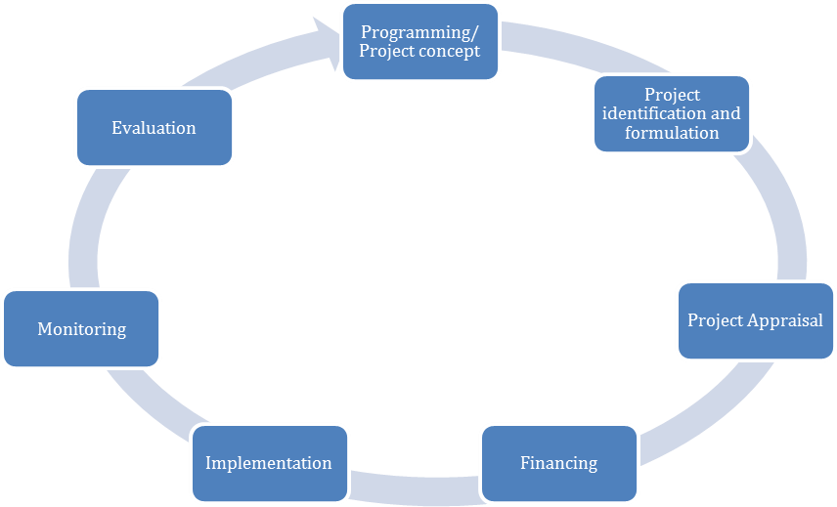

**Source**: Gitonga (2010).

### Programmimg/Project Concept

This is the establishment of the general intervention strategy. This is the stage where the idea regarding the required intervention in a specific area is identified i.e. the problem to be addressed is identified. The idea may be identified through several interactions including focus group discussions, brainstorming and problem inventory analysis, amongst others.

In the public sector in Kenya, during this phase, the situation at national and sectoral level is analysed to identify aspirations, constraints and opportunities which development cooperation could address. This involves a review of socio-economic indicators, and national challenges. The purpose is to identify and agree on the purpose and objectives that should respond ultimately to development priorities and thus to provide a relevant and feasible programming framework within which projects can be identified and prepared. For each of these priorities, the project design teams will formulate strategies that take account of the lessons of past experience as well as opportunities andor emerging needs.

### Project Identification and Formulation

During the identification phase, ideas for projects and other development actions are identified and screened for further study. This involves consultation with the intended beneficiaries of each action, an analysis of the problems they face (given the aspirations) and the identification of options to address these problems. A decision should be made on the relevance of each project idea both to the intended beneficiaries and to the programming framework and which ideas should be further studied during the formulation phase.

At the formulation stage, the relevant project ideas are developed into operational project plans. Beneficiaries and other stakeholders participate in the detailed specification of the project idea that is then assessed for its feasibility (whether it is likely to succeed) and sustainability (whether it is likely to generate long-term benefits for the beneficiaries). On the basis of this assessment, a decision is made on whether to draw up a formal project proposal and seek funding for the project. A monitoring plan should be prepared during this phase to ensure that the project is implemented against proposed resources and timelines.

At this phase, baseline data is collected and the needs assessment carried out. The idea is expressed in a proposal. This process includes documentation, validating, ranking and approving various projects by the project staff or professional consultants.

### Project Appraisal

This is the analysis of a proposed operation to determine its merit and acceptability in accordance with established criteria in the Request for Proposals (RFP). This is the final step before an operation is agreed for financing. It checks that the operation is feasible against the situation on the ground that the objectives set remain appropriate and that costs are reasonable. The proposal is appraised based on the submitted documents-operation proposal and funding request describing the context, the needs and problem analysis, the expected results and impact as well as implementation and resource schedules. During this phase, negotiations are carried out and a final proposal submitted for financing. The negotiations are carried out with funding organisations who could be the Government of Kenya and/or development partners.

### Financing

During the financing phase, project proposals are examined by the government or funding agencies and a decision taken on whether or not to fund the project. The government, and/or development partners agree on the modalities of implementation and formalise these in a legal document which sets out the arrangements by which the project will be funded and implemented. The document could be in form of the following documents: budget sector plans for Government of Kenya funded activities and or financing agreements from partner countries. These are signed between two countries. Further information is in Module 8: Financial Management and Resource Mobilization. The award is made during this phase and relevant contractual documentations signed between the organisation and the funding agency.

### Implementation

During the implementation phase, the project is mobilised and executed. This may require the tendering and award of contracts for technical assistance or works and supplies. During implementation and in consultation with beneficiaries and stakeholders, project management assesses actual progress against planned progress to determine whether the project is on track towards achieving its objectives. If necessary, the project is re-oriented to bring it back on track, or to modify some of its objectives in the light of any significant changes that may have occurred since its formulation.

### Monitoring

Monitoring is a continuous assessment of implementation in relation to agreed schedules and use of inputs based on planned expectations. This phase takes place during the implementation. A monitoring plan is used to monitor project implementation. It ensures that input deliveries, work schedules, targeted outputs and other required actions are proceeding according to plan. Monitoring provides the manager and other key stakeholders with continuous feedback on implementation i.e. identifying actual or potential successes and problems as early as possible to facilitate timely interventions or adjustment to the operations.

Monitoring is a management activity that allows a continuous adaptation of the intervention if problems arise or if changes in the context have an influence on the performance of the operation. During the monitoring, operation managers compare at different moments the actual implementation with what was planned. If activities cannot be implemented as foreseen for some reason, a reflection has to lead to an adaptation of that activity so that the success of the operation remains guaranteed.

Continuous communication with different stakeholders is important. Through periodic reports usually stipulated in the deliverables, they keep the contracting agency whether government or development partner, informed about the progress, results, challenges, lessons learnt and planned activities for the next period. The internal monitoring reports, made by project staff, complete the monitoring procedures. The activity and resource schedules form the basis for a monitoring system.

### Evaluation

Evaluation is a process of determining the relevance, efficiency, effectiveness and impact of activities in light of their objectives. It assists decision makers by providing information about any needed adjustments of objectives, policies, implementation strategies and other project elements. It examines whether the assumptions made during project formulation or appraisal stage are still valid or if changes are required to ensure overall project objectives are achieved. Refer to Module 17 for more detailed information on this area.

There are several ways of categorising project evaluations where: the summative evaluation is also known as end term evaluation and formative evaluations also known as midterm evaluation. Summative evaluations are carried out when the project is over and the aim is to assess its effectiveness and impact. Formative evaluations are usually undertaken early to gain understanding of what is being achieved in order to introduce improvements.

Summative evaluations judge merit and the work; the extent to which the desired goals have been attained; whether measured outcomes can be attributed to observed interventions and the conditions under which goals were attained. Formative evaluations help programmes get ready for summative evaluation by improving programme processes and providing feedback about strengths and weaknesses that appear to affect goal attainment.

* + - *Quantitative and qualitative evaluations*- Quantitative evaluations focus on measurable inputs provided and changes that result from the direct implementation of project activities. Qualitative evaluations are more process oriented and focus on assessment of changes of hard–to-measure factors such as attitudes, behaviour, skills and level of knowledge.
    - *Self-evaluation*-This is an evaluation conducted by people directly involved in the implementation of the project.
    - *Internal evaluation*- An evaluation conducted by people who form part of the staff of the organisation that provided the funding.
    - *External evaluation*- An evaluation conducted by those who are external to funding organisations and project.

During the phase, the government and or development partner assess the project’s accomplishments and identify lessons that have been learned. The final evaluation findings are used to improve the design of future projects or programmes.

* 1. **Planning Methods and Tools**

Planning methods and tools are linear and logical. Others may be more intuitive and creative hence creating a mental picture.

### Types of tools

1. *The Logical Framework Matrix*

The logical frame sets out the intervention logic of the project i.e. if activities are undertaken, results will be achieved and thus project purpose. It describes the important assumptions and risks that underlie this logic. This provides the basis for checking the feasibility of the project. It defines the tasks to be undertaken, the resources required and the management responsibilities. It provides a framework against which progress will be monitored and evaluated.

**Table 13.1 Logical Framework Matrix Structure**

|  |  |  |  |
| --- | --- | --- | --- |
| **Project description** | **Performance indicators** | **Means of verification** | **Assumptions** |
| **Goal:** The broader development impact to which the project contributes to at a national or sectoral level. | Measures of the extent to which a sustainable contribution to the goal has been made. Used during evaluation. | Sources of information and methods used to collect and report it. |  |
| **Purpose:** The development outcome expected at the end of the project. All components will contribute to this. | Conditions at the end of the project indicating that the purpose has been achieved and benefits are sustainable. Used for project completion and evaluation. | Sources of information and methods used to collect and report it. | Assumptions concerning the purpose/ goal linkage. |
| **Component objectives:**  The expected outcome of each component. | Measures of the extent to which components and objectives have been achieved and lead to sustainable benefits. Used during review and evaluation. | Sources of information and methods used to collect and report it. | Assumptions concerning the component, objective/ purpose linkage |
| **Outputs:** The direct measurable results (goods or services) of the project which are largely under project management’s control. | Measures of the quantity and quality of outputs and the timing of their delivery.  Used during monitoring and review. | Sources of information and methods used to collect and report it. | Assumptions concerning the output/ component, objective/ purpose linkage |
| **Activities:** The tasks carried out to implement the project and deliver the identified outputs. | Implementation/ work programme targets. Used during monitoring. | Sources of information and methods used to collect and report it. | Assumptions concerning the activity/output linkage. |

**Source**: Gitonga (2010).

The logical framework is used in the design, monitoring and evaluation of projects. It is used during the entire project implementation cycle. It ensures that the fundamental questions are asked and weaknesses analysed in order to provide decision makers with better and more relevant information. The tool guides systematic and logical analysis of the inter-related key elements; improves planning by highlighting linkages between project elements and external factors; provides a better basis for systematic monitoring and analysis of the effects of projects; facilitates common understanding and better communication between decision makers, managers and other parties involved in the project and ensures systematic monitoring of the project.

The logical framework is considered rigid as the objectives and external factors specific at the onset are over emphasised. The tool is a fairly complex, to obtain full benefits, the implementers should have a thorough understanding of the same.

1. *Gantt Charts*

A Gantt chart is an important project management tool. It is used to keep track of progress for each activity. A Gantt chart breaks the work down into smaller steps, indicates dependencies and defines milestones. It assigns human resources to work on tasks. They are excellent models for scheduling, budgeting, reporting, presenting and communicating project plans and progress easily and quickly. A Gantt chart can be constructed using MS Excel or a similar spreadsheet.

**Figure 13.2 Gantt Chart**

|  |  |  |  |  |  |  |  |  |  |  |  |  |  |  |  |
| --- | --- | --- | --- | --- | --- | --- | --- | --- | --- | --- | --- | --- | --- | --- | --- |
| **Project Name Kick Polio Out of Kenya** | | | | |  |  |  |  |  |  |  |  |  |  |  |
| **Project Description Polio Immunisation Campaign** | | | | | |  |  |  |  |  |  |  |  |  |  |
| **Project Length_10 Days** | | | | |  |  |  |  |  |  |  |  |  |  |  |
| **Start Date 01/07/13** | | | | End Date 17/07/13 | | | | |  |  |  |  |  |  |  |
|  |  |  |  |  |  |  |  |  |  |  |  |  |  |  |  |
|  |  |  |  |  |  | **Week 1** | | | | | **Week 2** | | | | |
| **Leve** | **Task** | **Respn** | **Start Date** | **Finish Date** | **WD** | **Mon** | **Tues** | **Wedn** | **Thur** | **Fri** | **Mon** | **Tues** | **Wedn** | **Thur** | **Fri** |
| **1** | **Product Design** |  | 01-07-13 | 08-07-13 | **7** |  |  |  |  |  |  |  |  |  |  |
| 1.1 | Define Name | JB | 01-07-13 | 02-07-13 | 2 |  |  |  |  |  |  |  |  |  |  |
| 1.2 | Box cover design | CG | 03-07-13 | 08-07-13 | 5 |  |  |  |  |  |  |  |  |  |  |
| 1.3 | User guide | CG | 03-07-13 | 08-07-13 | 5 |  |  |  |  |  |  |  |  |  |  |
| **2** | **Marketing kit** |  | 09-07-13 | 17-07-13 | **8** |  |  |  |  |  |  |  |  |  |  |
| 2.1 | Brochures | JB | 09-07-13 | 17-07-13 | 8 |  |  |  |  |  |  |  |  |  |  |
| 2.2 | Banners | CG | 09-07-13 | 17-07-13 | 8 |  |  |  |  |  |  |  |  |  |  |

The Gantt charts create a picture of complexity of the project and assist to set realistic timeframes. Gantts charts can, however, become extraordinarily complex. The length of the bar does not indicate the amount of work input at every stage. The Gantt chart requires constant updating to provide adequate information to the management.

1. *Brainstorming*

Brainstorming is usually the first crucial creative stage of the project management and project planning process. The brainstorming process is ideally a free-thinking and random technique. Consequently, this stage of the project planning process can benefit from being facilitated by a team member able to manage such a session, specifically to help organise people to think randomly and creatively. The advantages of using brainstorming are that new ideas are generated and problems are better defined. It also helps reduce conflict. However,the brainstorming sessions can generate unworkable ideas.

1. *Fishbone Diagrams*

The fishbone diagram identifies possible causes for an effect or problem. Fishbone diagrams are good at identifying hidden factors which can be significant in enabling larger activities, resources areas or parts of a process. Fishbone diagrams are not good for scheduling or showing interdependent time-critical factors. Fishbone diagrams are also called 'cause and effect diagrams' and Ishikawa diagrams, after Kaoru Ishikawa (1915-89), a Japanese professor specialising in industrial quality management and engineering who devised the technique in the 1960s.

A fishbone diagram has a central spine running left to right, around which is built a map of factors which contribute to the final result (or problem). For each project, the main categories of factors are identified and shown as the main 'bones' leading to the spine. Ishikawa's diagram became known as a fishbone diagram, obviously, because it looks like a fishbone:

**Figure 13.3 Fishbone Diagram**

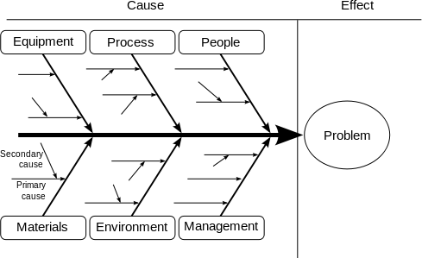

1. *Project critical path analysis (CPA)*

A critical path analysis is normally shown as a flow diagram, whose format is linear (organised in a line), and specifically a time-line. CPA is also called Critical Path Method (CPM). A commonly used tool within CPA is PERT (Programme/Project Evaluation and Review Technique) which is a specialised method for identifying related and interdependent

activities and events, especially where a big project may contain hundreds or thousands of connected elements. PERT is not normally relevant in simple projects, but any project of considerable size and complexity, particularly when timings and interdependency issues are crucial, can benefit from the detailed analysis enabled by PERT methods.

CPA flow diagrams are very good for showing interdependent factors whose timings overlap or coincide. They also enable a plan to be scheduled according to a timescale. Critical Path Analysis flow diagrams also enable costing and budgeting, and help planners to identify causal elements.

**Figure 13.4 Critical Path Analysis flow diagrams**

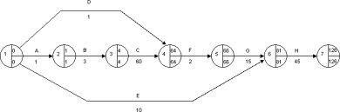

**Source**: Gitonga (2010).

The project above takes 126 minutes to complete. It has a total of eight stages from start to end. It moves from one stage to another as follows:

**Table 13.2 Activity Scheduling Using Critical Path Analysis**

|  |  |  |  |
| --- | --- | --- | --- |
| **Stage** | **Activity** | **No of minutes** | **Cumulative** |
| 1. | A- Registration of patient | 1 | 1 |
| 2. | B- Patient pays | 3 | 4 |
| 3. | C-Patients sees a doctor | 60 | 64 |
| 4. | D-Patient gets laboratory tests | 1 | 65 |
| 5. | E-Patients gets an X-Rays | 10 | 75 |
| 6. | F-Patients goes back to the doctor | 2 | 77 |
| 7. | G-Patient pays for the drugs | 15 | 92 |
| 8. | H-Patient collects drugs | 45 | 45 |
| **Total** |  |  | **137** |

The total cumulative time is 137 minutes. However, from the diagram the time taken is 126 minutes since laboratory and x-rays tests are done concurrently. Often, the patient does one as he is waiting for the results of the other procedure thereby saving on the time. This method therefore helps identify such activities and schedule to minimise the time of the project hence saving on project resources.

### Types of plans

There are several types of plans in organisations. These plans relate to one another. The diagram below shows how each plan informs others. These plans are discussed in the sections that follow.

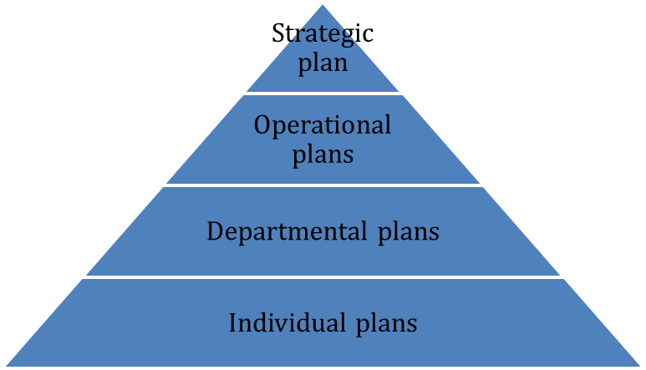

**Source**: Gitonga (2010).

1. *Strategic Plans*

Strategic planning is part of an organisation’s activities. It is used to set priorities, focus energy and resources, strengthen operations, ensure that employees and stakeholders are working towards common goals, establish agreement around intended outcomes/results and assess and adjust the organisation's direction in response to a changing environment. This is done through establishing priorities, making of strategic choices, pulling the entire organisation together and providing an outline on the application of resources. The strategic plan focuses on the following:

* + Where we are now? This is based on a comprehensive assessment of the internal and external environment.
  + Where do we want to be? This is a picture (real or mental) of the desired future x number of years from now.
  + What keeps us or might keep us from moving to where we want to be (obstacles)?.
  + How can we address these obstacles or hindering forces? This is the thrust of the strategic plan.
  + How do we monitor our progress? This set parameters on how to measure gains to be made.

Strategic plans can span anywhere from 3 to 25 years, depending on the level of the aspiration. It is more than a visionary document, broad enough to convey the desired future state, flexible to allow and accommodate changes over time.

1. *Annual Operational Plans*

An operational planning is a sub-set of strategic work planning. It describes short-term ways of achieving milestones and explains how, or what portion of a strategic plan will be put into operation during a given operational period in the case of commercial application, a fiscal year or another given budgetary term. An annual operational plan is the basis for, and justification of an annual operating budget request. Therefore, a five-year strategic plan would need five operational plans funded by five operating budgets.

Annual operational plans describe the activities and required budgets for each part of the organisation for the next 1-3 years. They link the strategic plan with the activities the organisation will deliver and the resources required to deliver them. Annual plans can be tweaked and should especially as circumstances change, compile to the strategic plan.

Annual operational plans draw directly from the strategic plans, programme missions and goals, objectives and activities. The annual operational plan is both the first and last step in preparing an operating budget request. As the first step, the annual operational plan provides a plan for resource allocation. As the last step, the annual operational plan may be modified to reflect policy decisions or financial changes made during the budget development process.

Annual operational plans should be prepared by the people who will be involved in project implementation. There is often a need for significant cross-departmental dialogue as plans created by one part of the organisation inevitably have implications for other parts. Annual operational plans have the following sections:

* + Objectives -sometimes divided among key organisational strategies;
  + Activities to be implemented;
  + Quality standards;
  + Desired outcomes, measurable indicators, deliverables;
  + Staffing and resource requirements;
  + Implementation timetables;
  + A process for monitoring progress (or a monitoring and evaluation plan).

1. *Departmental Plans*

A department plan defines the goals and activities a department will undertake for a specified time period and may be included as a section in the organisation’s overall plan. The department plan is linked to the operation plan. It shows clear deliverables and output for the department. Because different departments have different responsibilities, the particular data needed for and useful in department business plans varies widely. The departmental plan may have the following sections:

* + Mission and vision of the department;
  + The results of a situational analysis that is relevant to the mission of the department;
  + The goals of the department that derive from the mission, vision and analysis.
  + Overall strategies, sometimes called strategic thrusts or directions;
  + Objectives for each strategic direction;
  + Key performance indicators for the department;
  + The budget to support the plan;
  + The long term outlook.

1. *Individual plans*

The individual plan has two component parts: the performance plan and a (professional) development plan. The individual plan, sometimes called a performance agreement, results from periodic conversations between the supervisor and employee for a particular performance management cycle. Once agreed, it is signed off by the functional head (or supervisor) to ensure that resource implications are taken into account (and provided). The individual plan link back to the departmental plan, and ultimately the organisation’s or agency’s strategic plan, with all plans adding up to create progress towards the vision within the confines of the mission. The individual development plan includes the following:

* + Key result areas;
  + Key performance indications and targets;
  + Individual action plans;
  + Professional development (continuing education) plans.

**References and Recommended Further Reading**

Akpan, E. and Carter, R. (2007) *Strategic Alignment: The Business Imperative for Leading Organisations.* Mustang, OK: Tate Publishing.

Bryson, J. M. (2011) *Strategic Planning for Public and Nonprofit Organization*.4th ed. San Francisco: Jossey-Bass.

County Act, 2012.

Gitonga, B. A (2010) *Project Management Simplified: Community Development Approach*. Nairobi: Project Support Information Consultant.

Government of Kenya (2001) Programme Based Budgeting Manual. Nairobi: Government Printer.

Government of Kenya, Medium Term Expenditure Framework (MTEF) Manual. Government of Kenya, MTEF Manual, 2011, Kenya Budget Process.

Hill, C. W. L., and Jones, G. R. (2004) *Strategic management: An integrated approach*. Boston: Houghton Mifflin

Thompson, J and Martin F. (2010) *Strategic Management: Awareness & Change.* 6th ed. South Western: Cengage Learning.

# MODULE 14: GOVERNANCE IN HEALTH SYSTEM



**Purpose**

To introduce students to governance and its application in the health care system

**Objectives**

By the end of this module, the student should be able to:

1. Define and describe health systems governance;
2. Describe elements of effective health systems governance;
3. Describe the various levels of responsibilities of governance in a health system.

**Content**

* 1. Definition of a health system
  2. Health system governance
  3. Policy framework
  4. The legal framework of the health sector
  5. Governance responsibilities in the health system

**Methodology**

Lectures, discussions, case studies

**Training materials** Lecture notes Handouts

PowerPoint (Laptop and LCD projector) Whiteboards, flip charts, marker pens

**Duration: 4 hours**



**Lesson Plan Guide: Time: 4 hours**

|  |  |  |  |  |
| --- | --- | --- | --- | --- |
| **Session** | **Time**  **(Hours)** | **Content/Topic** | **Lesson Objectives** | **Lecturer Evaluation/Remarks** |
| 1 | 2 | Health systems governance and policy framework | To define and describe health system and health systems governance | Comments regarding time adequacy and students’ understanding and perceptions |
| 2 | 2 | Legal framework and governance responsibilities in the health sector | To identify the legal framework and governance responsibilities in the health sector | As above |

* 1. **Definition of a Health System**

A “system” is an arrangement of parts which are connected together for a purpose. A health system is concerned with people’s health. A health system has many parts that include patients, families and communities, Ministry of Health, health providers, health services organisations, pharmaceutical companies, professional societies and health financing bodies, and other organisations. The interconnections of the health system can be viewed as the functions and roles played by these parts.

The World Health Organisation (WHO) defines health systems as all organisations, institutions, and resources that are devoted to producing health actions. This definition includes the full range of players engaged in the provision and financing of health services including the public, private sector, NGO, FBO as well as international and bilateral donors, foundations, and voluntary organisations involved in funding or implementing health activities.

* 1. **Health System Governance**

Governance in health refers the actions and means adopted by a country to organise, promote and protect the health of its population. The governance framework and its functioning can be formal e.g. Public Health Act, International Health Regulations or informal e.g. Hippocratic Oath to prescribe and proscribe behaviour. The health governance framework in Kenya is a

devolved system. Good governance is also closely linked with effective leadership and efficient management which are covered in Module One.

**Objective**

The objective of health governance is to promote and protect the health of a population at the individual, community, county and national level. An effective health governance system is therefore one which competently directs health system resources, performance, and stakeholder participation toward the goal of reducing illness, saving lives and doing so in ways that are open, transparent, accountable, equitable, and responsive to the needs of the people.

**Characteristics of an Effective Health System**

1. Well defined rules, roles and responsibilities of each of the actors in the health system and the relationships, structures, and procedures that connect them;
2. Accountable to citizens, health service users, stakeholders and the wider community within which health care providers work, take decisions and lead their people to achieve their objectives;
3. An enabling environment through which policy makers, county health management teams and hospital management teams and other sectors and actors are able to direct, monitor and supervise the conduct and operation of the health system and its management in a manner that ensures appropriate levels of authority, accountability, stewardship, leadership, direction and control;
4. A responsible leadership which portrays, efficiency, probity, transparency and accountability.
   1. **Policy Framework**

The Kenya health sector operates in the context of a number of policy frameworks and within a policy environment that is subject to both internal and external influences. The MDGs, and other global initiatives, and Vision 2030 Sector Plan for Health comprise the major external influences on the Kenyan health sector system. The health sector strategic plan and the community health strategy are some of the factors within the institutional and organisational context which shape the internal environment.

### Health in the Millennium Development Goals

The MDGs provide a common set of priorities for addressing poverty. Health is represented in three of the eight goals as shown on Table 14.1

**Table 14.1 Health Related Millennium Development Goals**

|  |  |
| --- | --- |
| **Goal** | **Health Indicator** |
| **Goal 4: Reduce child mortality**  Target: Reduce by two-thirds, between 1990 and 2015, the under- five mortality rate | * Under-five mortality rate * Infant mortality rate * Proportion of one-year-old children immunised against measles |
| **Goal 5: Improve maternal health**  Target: Reduce by three-quarters, between 1990 and 2015, the maternal mortality ratio | * Maternal mortality ratio * Proportion of births attended by skilled health personnel experience at each level |
| **Goal 6: Combat HIV/AIDS, malaria and other diseases**  Target: Have halted by 2015 and begun to reverse the spread of HIV/AIDS  Have halted by 2015 and begun to reverse the incidence of malaria and other major diseases | * HIV prevalence among pregnant women aged 15-24 years * Condom use rate of the contraceptive prevalence rate * Ratio of school attendance of orphans to school attendance of non-orphans aged 10-14 years * Prevalence and death rates associated with malaria * Proportion of population in malaria-risk areas using effective malaria prevention and treatment measures * Prevalence and death rates associated with tuberculosis * Proportion of tuberculosis cases detected and cured under DOTS (Directly Observed Treatment Short- course) |

*Implications of MDGs on health systems governance*

From a health perspective, the MDGs are important because:

1. They provide a common set of priorities for addressing poverty;
2. Health is at the heart of the MDGs. This recognition signifies that health is central to the global agenda of reducing poverty as well as an important measure of human well-being;
3. They set quantifiable and ambitious targets against which to measure progress. These provide an indication of whether efforts are on track, and a means of holding decision- makers to account;
4. It is possible to calculate what it would cost to achieve the MDGs. This draws attention to the funding gap between available and needed resources, thus providing support to health sector calls for increased funding;
5. MDGs have helped to crystallise the challenges in health. If a country looks seriously at what it would take to achieve the health MDGs, the bottlenecks to progress become clearer.

The challenges to health brought out in the MDGs are the need to strengthen health systems, ensure that health is prioritised within overall development and economic policies develop health strategies that respond to the diverse and evolving needs of the population, mobilise more resources for health at the national and county level, and improve the quality of health data.

### Student activity

MDGs provide an overarching framework for development efforts, and benchmarks against which to judge success.

* 1. *Identify and discuss the health elements in MDGs 1,2,3,7 and 8*

### Health sector and the Vision 2030

The aim of the Kenya Vision 2030 is to create “a globally competitive and prosperous country with a high quality of life by 2030” through transforming the country from a third world country into an industrialised, middle income country. To improve the overall livelihoods of Kenyans, Vision 2030 provides aspirations and direction on the provision of efficient, integrated and high quality affordable health care. The health sector reform strategy lays particular emphasis on: geographical and financial access to health care services; regional and gender disparities; efficiency; financing; health care policy; and public private partnerships.

**Table 14.2 Vision 2030: Key Focus Areas in the Health Sector**

|  |  |  |
| --- | --- | --- |
| **Area of Focus** | **Issues** | **Indicators** |
| **Access** | * Geographical access * Financial access * Socio-cultural barriers | * Affordability * Availability * Accessibility-distance to facility |
| **Equity** | * Regional disparities * Socio-economic factors * Gender and vulnerable groups * Physically challenged | * Access by gender * Access indicators across regions * Specific information on the vulnerable and physically challenged |
| **Quality** | * Service delivery * Research * Efficiency | * Appropriateness * Level of delivery * Service range * Quality and quantity of Human Resource * Continuity * Effectiveness * Efficiency |
| **Capacity** | * Service delivery systems * Health care inputs * Partnerships * Health care financing * Research | * Procedure -safety * Capacity development -health care personnel * Resources * Health system -curative vs. preventive * Utilisation of health care systems * Equitable allocation of resources |
| **Institutional framework** | * Health care policy * Level and type of autonomy/integration * Incentive structure * Stakeholder involvement   /collaboration | * Level and type of integration * Stakeholder involvement in policy formulation |

**Source**: Kenya Vision 2030.

**Figure 14.1 Vision 2030 Goals and Strategies for Health Care**

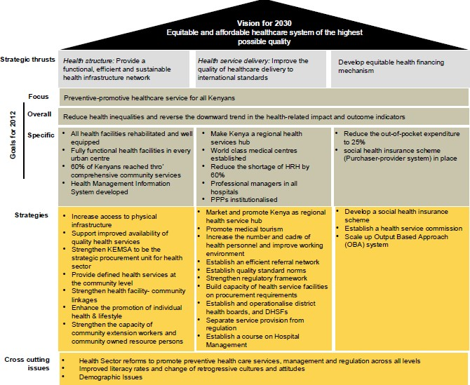

**Source**: Kenya Vision 2030

* 1. **The Legal Framework of the Health Sector**

The legal framework of the health sector in Kenya is governed primarily by Kenya’s Health Policy Framework (KHPF) of 1994. The document in its agenda for reform, identified the strengthening of the central public policy role of the Ministry of Health in all matters pertaining to health as a key priority. In terms of regulation and enforcement, the government has over the years asserted its commitment to continue regulating the health sector by enforcing the following Acts of Parliament pertaining to the health sector:

1. Public Health Act cap 242.
2. Radiation Protection Act cap 243.
3. Pharmacy and Poisons Act cap 244.
4. Dangerous Drugs Act cap 245.
5. Malaria Prevention Act cap 246.
6. Mental Health Act cap 248.
7. Medical Practitioners and Dentist Act cap 253.
8. Nurses Act cap 257.
9. Clinical Officers (Training, Registration and Licensing) Act cap 260.
10. National Hospital Insurance Fund Act cap 255.
11. Food, Drugs and Chemical Substances Act cap 254.
12. Animal Diseases Act cap 364.

The health sector is also impacted upon by other legislation. The following are some of the other statutes that impact on the health sector:

1. The Medical Laboratory Technicians and Technologist Act (1999).
2. The Science and Technology Act cap 250.
3. The Local Government Act cap 265.
4. HIV and AIDS Prevention and Control Act, Act no 14 of 2006.
5. The Anatomy Act cap 249.
6. The Public Procurement and Disposal Act 2005 Act no 3 of 2005 and the Regulations made therein.
7. The Finance Act (enacted every financial year).
8. Education Act cap 211.
9. Kenya Medical Training College Act cap 261.
10. Various public universities’ acts.
11. The Constitution of Kenya 2010 (especially Chapters creating the Public Service Commission and the County Public Service Commission.
12. The Penal Code (1960).
13. The Sexual Offences Act 2006.

All these statutes have an impact on the health sector. For instance, the Finance Act directly affects the budgetary allocation to the Ministry of Health. The Public Procurement and Disposal Act affects the manner in which the Ministry of Health acquires its supplies. The Education Act and various legislation governing public universities affect the quality of training given to health workers in those institutions. The Public Service Commission Act affects the Ministry of Health’s organisational structure, appointments, promotions and staff discipline. The Penal Code provides for criminal liability for health workers who facilitate abortions. The National Commission on Gender and Development is mandated to promote gender equity in health. The Public Health Act, section 3(1) establishes a Central Board of Health whose function is to advise the minister on all matters affecting public health. The Constitution of Kenya 2010 provides for equality and freedom from discrimination (Art 27) and the right to health and reproductive health (Art 43).

In the current legal framework, there are over twenty statutes dealing with the health sector in the country. The legal framework of the health sector is not under a single institution but spread within a number of ministries and departments of the government. Within the Ministry of Health, there are divisions, departments and specialised agencies responsible for different aspects of health regulations. In the devolved system of governance, this scenario is replicated at the county level.

The health sector policy focus is guided by Vision 2030. The strategic focus is well defined and elaborated in the Kenya Health Policy with clear goals on the long-term policy directions the country intends to achieve in pursuit of the imperatives of the Vision 2030, and the 2010 Constitution.

Governance of the health sector is anchored on current key policy, legal and legislative frameworks. The Kenya Health policy 2012-2030, Health Act 2012 and Kenya Health Sector Strategic and Investment Plan 2012-2017 are the key instruments which align the sector with the Constitution of Kenya 2010 and the social pillar of Vision 2030. These and other policy documents guide the two levels of Governments (National and County) and the health sector as a whole.

**Vision:** A healthy and globally competitive nation

**Mission** To deliberately build progressive, responsive and sustainable technologically- driven, evidence-based and client-centred health system for accelerated attainment of highest standard of health to all Kenyans

**Goal** Better health in a responsive manner

To fulfil the vision and mission of the health Sector, those with management and leadership responsibilities are expected to formulate health policies and strategic direction, set standards and ensure provision of health services through public facilities and regulation of all actors/services.

**Health Policy Objectives**

The following six policy objectives provide guidance towards the realisation of the health sector vision and goal.

**Table 14.3 Kenya Health Policy Objectives and Activities**

|  |  |
| --- | --- |
| **Objective** | **Activity** |
| Eliminate communicable conditions | Reduction of the burden of communicable diseases, till they are not of major public health concern. |
| Halt and reverse the rising burden of non- communicable conditions | Ensuring clear strategies for implementation to address all the identified non communicable conditions in the country. |
| Reduce the burden of violence and injuries | Collaboration with stakeholders in other sectors that address each of the causes of injuries and violence at the time. |
| Provide essential health care | Provision of medical services that are affordable, equitable, accessible and responsive to client needs. |
| Minimise exposure to health risk factors | Strengthening health promoting interventions, which address risk factors to health, plus facilitating use of products and services that lead to healthy behaviour in the population. |
| Strengthen collaboration with other sectors | Building partnerships and other integrative approaches which ensures the health sector interacts with and influences design implementation and monitoring processes in all health related sector actions. |

**International Commitments and Obligations**

The country has ratified many global commitments meant to support the health sector implement the various global commitments it has entered signed. These include:

* 1. Implementation of the International Health Regulations – to guide the country on key actions needed to assure adherence to international health regulations;
  2. Implementation of the Global Framework Convention for Tobacco Control – to guide the country on tobacco control activities;
  3. Ouagadougou declaration on Primary Health Care and Health Systems – to guide the overall strategic focus for the health sector;
  4. Millennium Development Declaration (MDGs) – to guide the country in developing national targets towards international development initiatives;
  5. International Health Partnerships( IHP+) on Aid Effectiveness;
  6. UN Secretary Generals’ Global Strategy ‘Every women, every child’;
  7. Abuja Declaration – to support the improvements of health systems in the country by domesticating the provisions through national legislation, the country committed in the Abuja Declaration to allocate 15% of government expenditure budget to health;
  8. International Human Right agreements including International Declaration for Human Rights, Convention on the Elimination of All Forms of Discrimination against Women (CEDAW), Child Rights Convention (CRC), the International Conference on Population and Development programme of action (ICPD), and the Beijing Declaration and Platform of Action (BPFA).
  9. **Governance Responsibilities in the Health System**

Various forms of governance functions and responsibilities exist at each level of the health system structures discussed in Module 1.

* Delivery of efficient , cost effective and equitable health services
* Devolution of health service delivery, administration and management to community level
* Stakeholder participation and accountability in health service delivery, administration and management
* Operational autonomy
* Efficient and cost-effective monitoring, evaluation, reviewing and reporting system
* Smooth transition from current to proposed devolved arrangement
* Complementarity of efforts and interventions

**Objectives of Governance/Management Structure**

**The Role of the State Department Responsible for Health**

The primary role of the National Department of Health is to support counties in delivering health care services as well as to help to lead, shape and support the national health care system. The KHSSP 2013- 2017 outlines the mandate, structure, roles and responsibilities of the state department responsible for health as discussed below.

The principal mandate of the National State Department as stipulated in the Constitution of Kenya 2010 and National Health Policy 2012-2030 is:

* + 1. Establishing a national health policy and legislation, standard setting, national reporting;
    2. Sector coordination and resource mobilisation;
    3. Offering technical support with emphasis on planning, development and monitoring of Health services and delivery standards throughout the country;
    4. Monitoring quality and standards of performance of the county governments in the provision of health services;
    5. Providing national health referral services;
    6. Conducting studies required for administrative or management purposes.

**Figure 14.2 Structure of the State Department for Health**



Directorate of Policy, Strategy and International Health

Directorate of Standards and Quality Assurance

Directorate of Curative and Rehabilitative Services

Directorate of Administration

Directorate of Prevention and Promotive services

Director General

Heads of SAGAs

Principle Secretary

Cabinet Secretary

**Table 14.4 Roles and responsibilities in the State Department of Health**

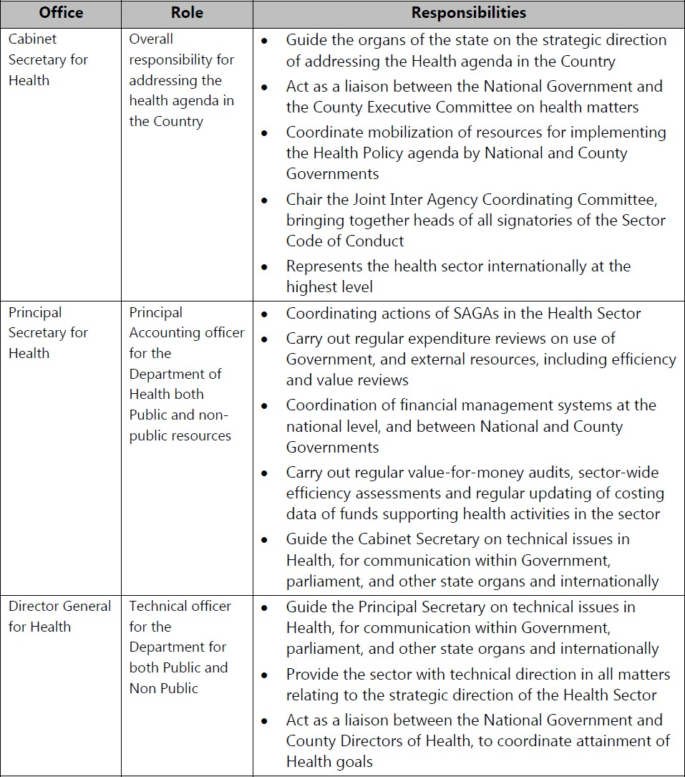

**Table 14.5 Responsibilities and Key Policy Areas of Directorates in the State Department of Health**

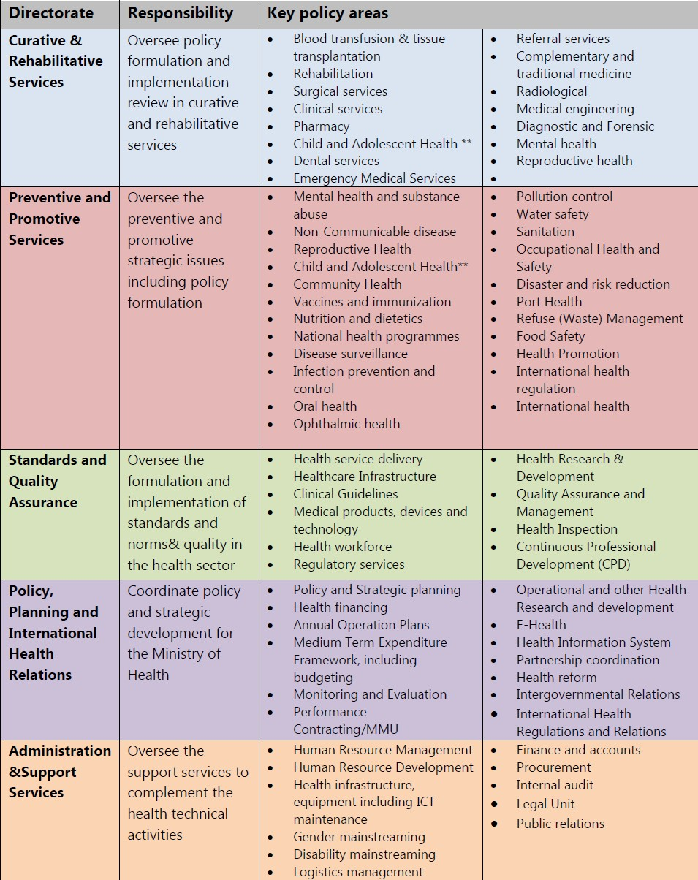

**Semi-Autonomous Government Agencies (SAGAs)**

There are six SAGAs under the state department responsible for health. SAGAs are governed by a board of management (BoM) comprising 8-15 senior officer members representing the public sector (state department responsible for health and other ministries), and private sector and other stakeholders. A chief executive officer (CEO) is responsible for the daily management and implementation of the institutions’ strategic plans which are guided by the sector strategic plan. Each SAGA operates under a performance contract signed with the Principal Secretary in the state department responsible for health. They are partly financed through GOK (state department of finance).

**Table 14.6 SAGAs and their Key Mandates**

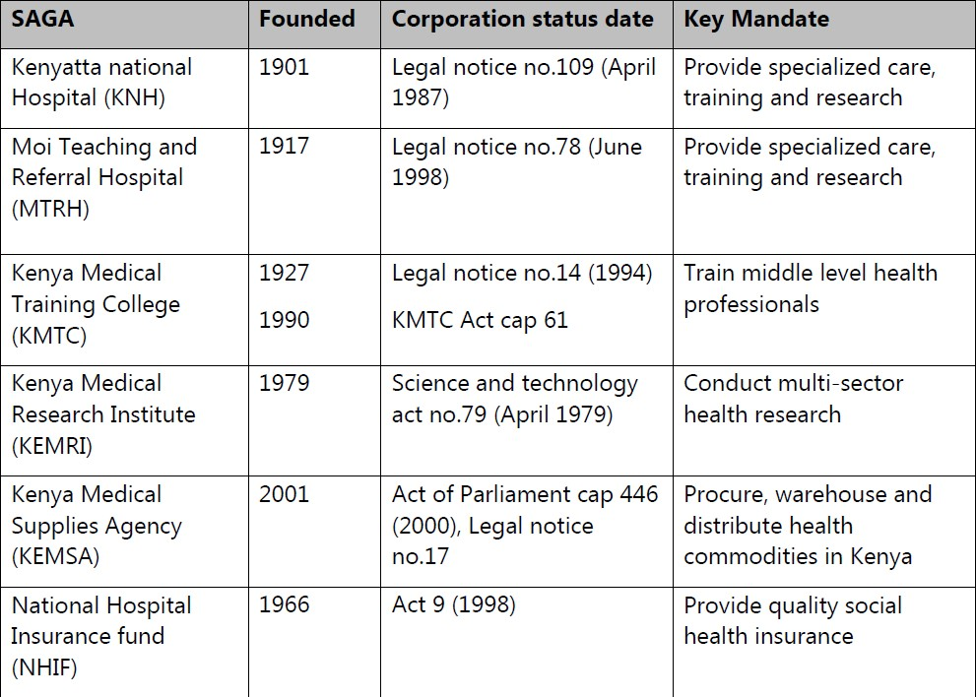

**The Role and Structure of the County Department for Health**

### County Health Management Structure

According to the Constitution of Kenya 2010, county governments are responsible for:

* + - 1. County health facilities and pharmacies;
      2. Ambulance services;
      3. Promotion of primary health care;
      4. Licensing and control of undertakings that sell food to the public;
      5. Veterinary services excluding regulation of the profession;
      6. Cemeteries, funeral parlours and crematoria; and
      7. Refuse removal, refuse dumps and solid waste disposal.

### Structure of County Department Responsible for Health

County health services are managed by a Chief Officer for Health who reports to the County Executive Committee (CEC) member responsible for health.

**Table 14.5 Structure for County Department Responsible for Health**

Chief Officer of Health

County Health Planning and Monitoring Unit

County Director of Health

**Source**: Adapted from Kenya Health Sector Strategic and Investment Plan – KHSSP July 2012-June 2017.

Primary Health Facilities

County Hospitals

Preventive and Promotive Health Services

Clinical Services

**Governance Responsibilities at the County Level**

### Chief Officer for Health

The Chief Officer for Health is responsible for technical coordination and management of County Health Services, focusing on:

1. Overall management and oversight of public health facilities in the county;
2. Guiding implementation of health related issues from the county executive committee;
3. Interpreting, and integrating national government health policy;
4. Coordinating development and implementation of county health strategies and priorities;
5. Coordinating disaster preparedness and response in the county;
6. Management of referral health services, in county, across counties, and with the national government;
7. Act as the accounting officer of the department responsible for health.

### County Director of Health

The County Director of health is the technical advisor for all health matters in the county. Their role shall be:

1. The technical advisor to the County Executive Commissioner and the Governor;
2. To supervise all health services within the County;
3. To promote the public health and the prevention, limitation or suppression of infectious, communicable or preventable diseases within the County;
4. To prepare and publish reports and statistical or other information relative to the public health within the County;
5. To report periodically to the Chief Officer for health on all public health occurrences including disease outbreaks, disasters and any other health matters;
6. To perform any other duties as may be assigned by the appointing authority and any other written law.

The County Director of health is the technical advisor for all health matters in the county. Their role shall be:

1. The technical advisor to the County Executive Commissioner and the Governor;
2. To supervise all health services within the County;
3. To promote the public health and the prevention, limitation or suppression of infectious, communicable or preventable diseases within the County;
4. To prepare and publish reports and statistical or other information relative to the public health within the County;
5. To report periodically to the Director-General for health on all public health occurrences including disease outbreaks, disasters and any other health matters;
6. To perform any other duties as may be assigned by the appointing authority and any other written law.

**Table 14.8 Other Structural Units at the County Level**

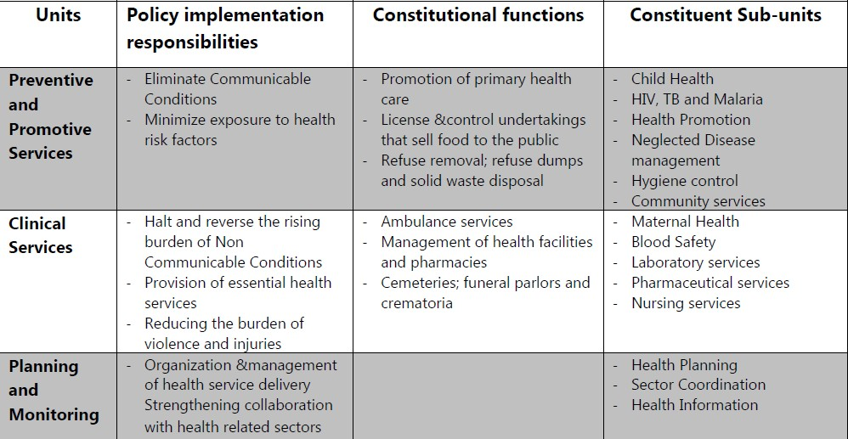

**Source:** Adapted from Kenya Health Sector Strategic and Investment Plan – KHSSP July 2012-June 2017.

**Stewardship Responsibilities at the Different Levels of the Health Sector**

The Constitution reserves the responsibility for health policy to the national government. The state department of health is responsible for shaping policy direction for health in the country, and for facilitating the implementation of a sector-wide approach. The principal mandate of the state department of health is as stipulated in the Constitution and the Health Policy and is further detailed in the table below.

**Table 14.9 Stewardship Responsibilities at the Different Levels of the Health Sector**

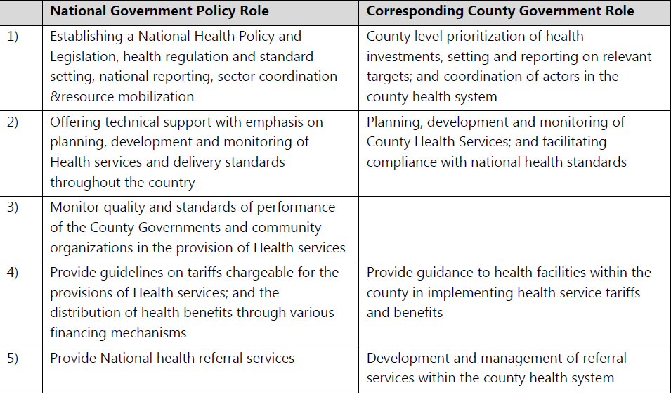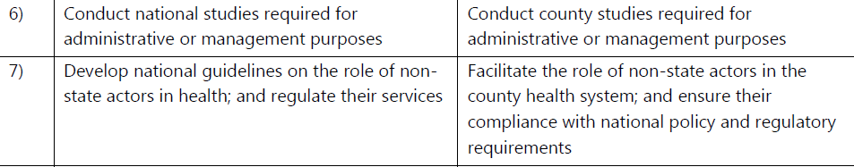

**Source:** Adapted from Kenya Health Sector Strategic and Investment Plan – KHSSP July 2012-June 2017.

**Table 14.10 Governance Responsibilities in the Health Sector**

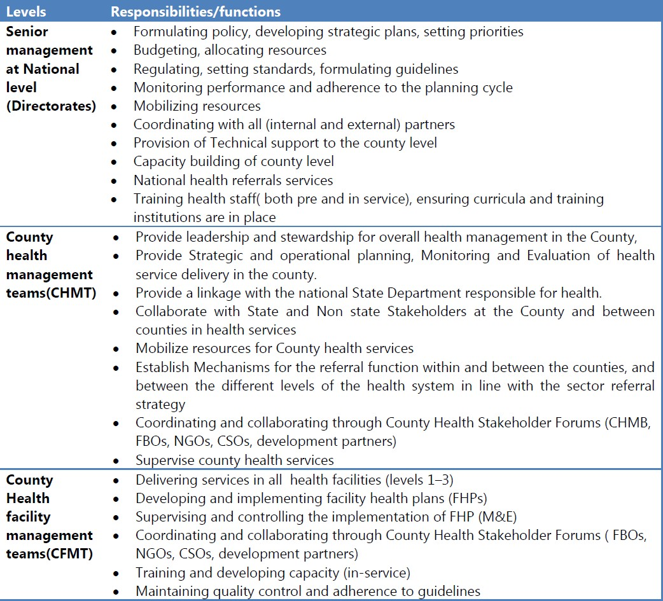

**Source:** Adapted from Kenya Health Sector Strategic and Investment Plan – KHSSP July 2012-June 2017.

**Stakeholder Involvement**

The right to health cannot be achieved without the active involvement of other stakeholders. Health sector stakeholders include:

***Clients-*** The individuals, households, and communities whose health is the focus of this strategic plan;

***State actors-*** The public sector (MoH – National and County, SAGAs, other ministries and the state department responsible for devolution), constitutional Commissions, regulatory bodies (boards and councils) and professional bodies/associations whose mandate is drawn from that of the state, and have an effect on health;

***Non-state actors-*** The Private sector NGOs, Civil Society Organizations (CSOs), FBOs, traditional practitioners, media, and all other persons whose actions have an impact on health, but do not draw their mandate from the state;

***External actors-*** The bilateral, multilateral, or philanthropic actors that draw their mandate from out of Kenya, but support national programmes.

**Health Sector Intergovernmental Relations and Coordination Framework**

Effective governance is achieved through active engagement, consultation, cooperation and mutual accountability between the national department responsible for health and the county departments of health, as well engagement among the county departments of health. The Intergovernmental Relations Act 2012, Kenya Health Policy (2012-2030) and KHSSP 2013- 2017 provide for a sound basis for intergovernmental relations framework in health.

The figure below presents an illustration of how the health sector partnership, governance, and stewardship processes work together to provide overall leadership in addressing the health agenda in the country.

**Table 14.9 Health Sector Partnership, Governance, and Stewardship Processes**

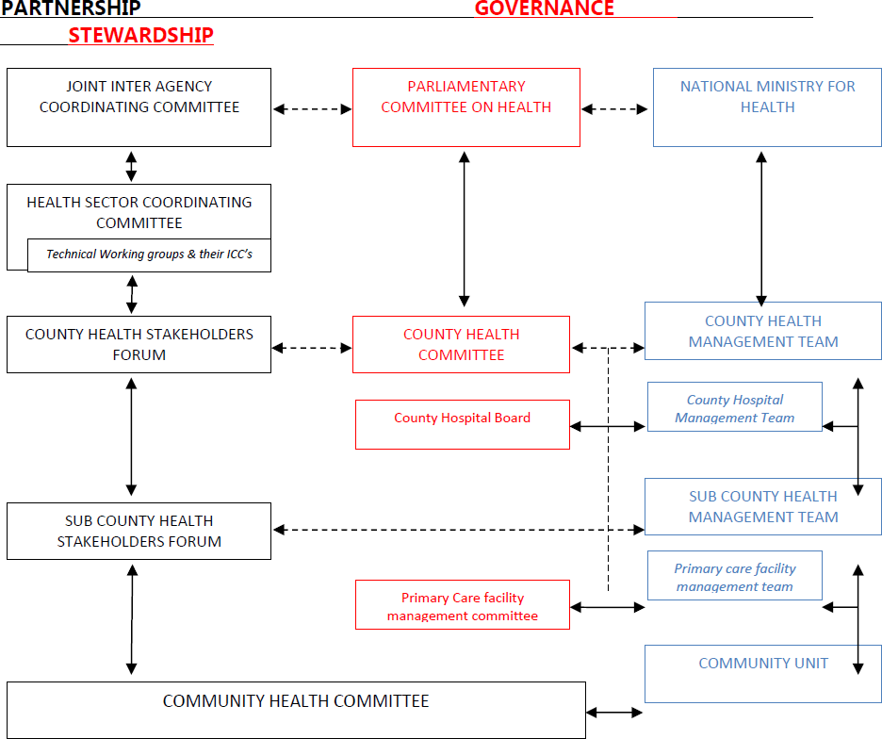

**Source:** Adapted from Kenya Health Sector Strategic and Investment Plan – KHSSP July 2012-June 2017.

**Student Activity Suggestion Group/Class Discussions**

1. Identify and discuss the role played by the various actors in the health system.
2. What ethical principles should guide governance practices in the health sector?
3. In preparation for your practicum, prepare a checklist of indicators of good governance that could guide you in assessing governance at a health facility level, county government and national government levels.

**References and Recommended Further Reading**

African Medical and Research Foundation (AMREF) (2012) *Training Manual in Governance Leadership & Management for Health Systems Strengthening in Africa.* Nairobi: AMREF.

Constitution of Kenya 2010. County Governments Act, 2012

Health Systems 20/20 (2012) ‘The Health System Assessment Approach: A How-To Manual. Version 2.0’ [online]. Available at <[www.healthsystemassessment.org](http://www.healthsystemassessment.org/)> [Accessed 24 February 2014].

Management Sciences for Health (2013) *How to Govern the Health Sector and its Institutions Effectively.* The eManager, No. 1. Arlington, VA. Management Sciences for Health. Also available online at

<[http://www.lmgforhealth.org/sites/default/files/eManager_How%20to%20Govern%20the%](http://www.lmgforhealth.org/sites/default/files/eManager_How%20to%20Govern%20the%25) 20Health%20Sector_4.11.13_FINAL.pdf> [Accessed 24 February 2014].

Management Sciences for Health (2010) *Health Systems in Action: An e-Handbook for Leaders and Managers*. Cambridge, MA: Management Sciences for Health. Also available online at [<http://www.msh.org/](http://www.msh.org/) resource-center/health-systems-in-action.cfm> [Accessed 24 February 2014] and as a CD-ROM.

Ministry of Medical Services and Ministry of Public Health and Sanitation. Accelerating attainment of Health Goals: The Kenya Health Sector Strategic and Investment Plan – KHSSP July 2012 – June 2017.

Republic of Kenya (2012) *Kenya Health Sector Strategic Plan (2012-2017).* Nairobi: Government Printer.

Republic of Kenya (2013) *Health Sector Strategic and Investment Plan (KHSSP) July 2013- June 2017*. Nairobi: Government Printer.

Republic of Kenya (2013) *Training Manual for Sensitizing Public Servants*. Nairobi: Government Printer.

*The Anti-Corruption and Economic Crimes Act 2003*. *The Public Officer Ethics Act, 2003*.

World Health Organisation (2009) *Good Governance in Medicines: A Framework for Good Governance in the Pharmaceutical Sector: GGM Model Framework*. Geneva: WHO.

# MODULE 15: ENTREPRENEURSHIP FOR HEALTH PROFESSIONALS



**Purpose**

To introduce students to entrepreneurship in health services delivery

**Objectives**

By the end of this module, the student should be able to:

1. Explain the basics of business management;
2. Develop a business.

**Content**

* 1. Entrepreneurship
  2. Types of business ventures
  3. Business plan
  4. Managing business finances
  5. Principles of business management
  6. Raising business capital

**Methodology**

Lectures, discussions, case studies

**Training materials** Lecture notes Handouts

PowerPoint (Laptop and LCD projector) Whiteboards, flip charts, marker pens

**Duration: 4 hours**



**Lesson Plan Guide:**

**Time: 4 hours**

|  |  |  |  |  |
| --- | --- | --- | --- | --- |
| **Session** | **Time**  **(Hours)** | **Content/Topic** | **Lesson Objectives** | **Lecturer Evaluation/Remarks** |
| 1 | 2 | Introduction to entrepreneurship  Types of business ventures  Business plans | To introduce students to entrepreneurship  To describe and discuss the various types of business ventures and business planning | Comments regarding time adequacy and students’ understanding and perceptions |
| 1 | 2 | Financing a business venture  Managing business finances | To identify and discuss the various business financing  To introduce students to Business and Financial Management | As above |

* 1. **Entrepreneurship**

### Definitions and Characteristics

The word Entrepreneur is derived from the French word ‘entreprendre’ which means to ‘undertake’. The Merriam-Webster dictionary defines an entrepreneur as one who organises, manages and assumes the risks of a business enterprise.

An entrepreneur is a person who recognises opportunities where others don’t or where others see chaos or confusion, and undertakes to organize, manage and assume the risks in a resulting business enterprise.

An entrepreneur is an innovator who recognizes and seizes opportunities, converts those opportunities into workable /marketable ideas, adds value to them through time, effort, money or skills and assumes the risks of the competitive marketplace to implement these ideas.

**Entrepreneurship Involves**

1. Initiative taking – the creation process, creating something new of value;
2. The organising and reorganising of social economic mechanisms to turn resources and situations to business opportunities. This requires devotion of the necessary time and effort;
3. The acceptance of risk or failure – entrepreneurs are widely accepted as risk takers, and the risks they take could be in various forms, depending on the field of effort of the entrepreneur;
4. Reward seeking – entrepreneurs seek for rewards which are in the form of independence, personal satisfaction, and monetary reward/profit.

**Traits of Successful Entrepreneurs**

The personality traits of successful entrepreneurs have been analysed by many experts. But as many of them are quick to point out, the problem with any formula for success as an entrepreneur is that success relies on a unique ability to see ‘new’ patterns. So, you should be careful about evaluating the entrepreneurial ability based on general established patterns.

The traits that are most often thought to be common in successful entrepreneurs are:

1. *A degree of tough-mindedness-* This enables entrepreneurs to make and stick by decisions that are based on a combination of intuition and logic. Tough-minded entrepreneurs are not frightened by the unknown. They lead the way for the rest to follow.
2. *A willingness to work a little harder and a little longer-* Successful entrepreneurs work not only for rewards, but also for the pleasure of creating the enterprise.
3. *A degree of self-confidence-* This lets entrepreneurs make firm decisions and keeps them from worrying afterwards. Self-confident entrepreneurs feel that the decision is probably right—but if not, adjustments can make it work.
4. *A willingness to take ‘reasonable’ risks-* Entrepreneurs feel that results are controllable, not strictly up to chance.
5. *A high degree of flexibility-* This enables entrepreneurs to meet changing goals, pressures, technologies, and competition. Entrepreneurs feel that their own flexibility will allow a chance to change things if decisions turn out badly.
6. *A finely tuned sense of the needs of the marketplace, along with a curious mind-* Successful entrepreneurs are quick to spot market needs and to supply products to meet those needs in new and profitable ways.
7. *A sense of long-term goals-* Entrepreneurs see needs, possibilities and solutions where others see only problems.
8. *Good problem-solving ability-* This ability uses problems as a roadmap. Each problem solved helps entrepreneurs chart a course for future success.
9. *A desire for profit-* Entrepreneurs use profit to measure their successes. Because of the profit motive, entrepreneurs will tend to find an efficient use of resources.
10. *An underlying enthusiasm-* Enthusiasm keeps up entrepreneurs’ spirits. Enthusiasm helps successful entrepreneurs maintain the level of creative thinking and focused activity necessary to carry out the successful venture.
    1. **Types of Business Ventures**

There are three types of business ventures, mainly classified according to their constitution and the formation process:

* + 1. Sole proprietorships;
    2. Partnerships;
    3. Corporate ventures.

**Sole proprietorships**

Sole proprietorships are by far the most common business form. The businesses are owned by one person and there is no legal distinction between the owner and the business. They are easy to create, operate and terminate since few formalities are involved. Most sole proprietorships are ready for business as soon as they set up operations.

The businesses are usually small in size and require minimal capital to start and operate. Their sponsors are essentially individuals who go into business for themselves. It is the only form where the sponsor is truly independent and is his own boss.

### Advantages

1. The proprietor of a sole proprietorship is independent and is his or her own boss. There can be no arguments about policy and decisions. More and more women are becoming entrepreneurs;
2. Sole proprietorships require relatively low start-up and working capital;
3. There are minimal legal formalities and requirements to start and operate. They are easy to establish and dissolve. Once the owner obtains the start-up funds and necessary licenses and permits, he or she, can start the business. Termination is equally easy;
4. There is limited government regulation in Kenya. Although all businesses are subject to some government controls, sole proprietorships have more freedom than other forms of business;
5. There is greater self-interest and satisfaction due to the sense of ownership associated with this form of business;
6. Decision-making and implementation are fast since the owner is not required to consult others in doing so;
7. Sole proprietorships can respond quickly to changes in the external business environment conditions since the proprietor has direct and total control of decision the making process;
8. The proprietor is in close contact with all stakeholders including employees, customers, suppliers and distributors. The proprietor can easily get essential feedback and address individual needs;
9. The proprietor gets all the after tax profits of the business which serves as an incentive to work hard and be efficient. The harder and more efficient one is, the higher the profits;
10. Sole proprietorships that start out small-scale are an ideal way of testing one’s business idea. Failure does not result in heavy losses as would be the case with large businesses.

### Disadvantages

1. In sole proprietorships, the sponsor has unlimited liability hence they bear all the risks, liabilities and obligations of the business. In law, the proprietor and the business are identical. The owner is therefore personally responsible for all the debts, and other obligations of the business, even when they are more than the business is worth. The owner may have to sell personal property such as cars, houses, or furniture to satisfy claims against the business.
2. Sole proprietorships may not afford to employ experts or professionals. These businesses also have difficulties finding and keeping good employees since professionals prefer employment in businesses where liabilities are limited. Furthermore, small businesses often cannot offer employees the same fringe benefits and opportunities for advancement as large companies;
3. They have difficulties in raising additional capital since their sources of financial resources are more limited. Business lenders view the owner’s unlimited liability as a high risk since business assets are not protected from claims of personal creditors. Owners must use personal funds to finance the business;
4. The inability of sole proprietorships to raise additional funds may curtail the business expansion plans;
5. They may not take advantage of offers and discounts that may arise due to inability to buy in bulk;
6. Sole proprietorships often have limited managerial expertise. Their success depends entirely on the owner’s skills and talents. The owner is fully responsible for all business decisions, and must be a jack-of-all-trades. Not all owners are equally skilled in all areas. An investor who creates a new product may not be a good marketer, production manager, human resource manager, or accountant. Such an investor would have limited range of ideas required for decision-making;
7. Decisions can be hasty due to lack of moderating voices;
8. Running a sole proprietorship requires a huge time commitment and often dominates the owner’s life. The owner must be willing to make sacrifices, often working 18 or more hours a day, six or seven days a week, with little time for leisure;
9. There is no one to fill in when the proprietor is absent due to illness, family or social functions and holidays;
10. Sole proprietorships lack continuity of existence; these businesses have uncertain life. If the owner loses interest, retires, dies, is disabled or becomes a lunatic, the business will cease to exist unless the owner finds a buyer. Sale of the business may result in loss of goodwill.

**Partnerships**

A partnership is owned by between 2 and 20 people or 50 in the case of professional partnership. There is no legal separation between ordinary partners. Some partners may have limited liability if it is a limited partnership. Ordinary partnerships are like sole proprietorships, easy to create, operate and terminate since few formalities are involved. Most of them are ready for business as soon as they set up operations. If one partner makes a business mistake without the knowledge or consent of others, all the other partners too must shoulder the consequences. Personal assets could be taken to pay the creditors even though the mistake was no fault of these other partners.

If your partner goes bankrupt in his or her personal capacity, for whatever reason, his or her creditors can seize his or her shares in the partnership. Even death may not release a partner from partnership obligations and in some circumstances the partner’s estate can remain liable. However, limited partners wouldlose their right to manage the business. Moreover, at least one of the partners must remain an ordinary partner with unlimited liability.

Partnerships are prone to disputes and disagreements hence it would be well advised to negotiate a written partnership agreement or deed that states the terms and conditions for their partnership. Such written contract can avoid confusion disputes, and litigation later. The deed would normally specify issues such as arrangements between the partners, such as their

financial contributions, management, how profits and losses will be shared, method of taking into business future additional partners and issues of dissolution.

The partners’ contribution to the firm may come in various forms: services, skills, property or cash. And since partners are co-owners, the law presumes that they would share profits and losses equally, unless they specify in the deed otherwise.

### Advantages

1. Partnerships are easy to form. Like sole proprietorships, partnerships can be established quickly and cheaply, and with few legal formalities. The partners agree to do business together, and develop a partnership agreement;
2. Most partnerships require relatively low start-up capital. Like sole proprietorships, they are relatively inexpensive to form. Once the owner obtains the start-up funds and necessary licenses and permits, he or she can start the business;
3. They provide additional sources of investment capital. Because two or more people contribute financial resources, partnerships can raise funds more easily for starting, operating and business expansion. The partners’ combined financial strength also increases the firm’s ability to raise funds from outside sources;
4. Synergy. Partners can share the responsibility for managing, and operating the business. The costs of running the business is cheaper for individual partners due to the pooling of resources;
5. There can be diversity of skills and expertise. Ideal partnerships bring together people with complementary backgrounds, rather than those with similar experiences. Combining partner skills to set goals and objectives, manage the overall direction of firm, and solve problems, increases the likelihood of the partnership’s success. Finding the right partners entails looking at your own strengths and weaknesses, and examining what you are looking for in a partner;
6. Discussions are possible whereby new and more ideas may develop as a result;
7. Personal contact with customers, employees, suppliers and other people associated with the business is still possible as in sole proprietorships;
8. There is flexibility since some partners can have limited liability;
9. General partners take active role in managing their firms/ventures, and can respond relatively quickly to changes in the external business environment;
10. Business continuity. Absence due to illness, family and social functions, and holidays can be covered for by other partners;
11. Business losses, liabilities and other obligations are shared by the partners and are not shouldered by one individual;
12. There is limited government regulation. Except for local by-laws, rules for licensing, and permits, the government has little control over partnership activities.

### Disadvantages

1. Some partners have unlimited liability. In fact, any one partner can be held personally liable for all partnership debts and legal judgments, like malpractice, regardless of who caused them. As in sole proprietorships, business failure can lead to loss of the general partners’ personal assets. To overcome this disadvantage, there is provision for the formation of limited partnerships which allows some partners to have limited liability;
2. There are relatively limited sources of capital for expansion hence difficulty in raising large amounts of additional capital;
3. It is hard to find suitable partners;
4. There is potential for conflict between partners. Partners may have different ideas, both business and personal, about such matters as how and when to expand the business, which employees to hire or fire, and how to allocate responsibilities. Such differences of opinion may lead to disharmony and possible business disruption;
5. There can be delays in decision-making due to the need for consensus, or further consultations;
6. Decisions of one partner are binding to all other partners, unless otherwise stated in the partnership deed;
7. Death, retirement, disability or lunacy of one partner may lead to the dissolution of the business;
8. There may be problems getting a buyer who is acceptable to all partners;
9. There is usually little or no reward for partners who work harder than others;
10. Partners have to share profits. Dividing profits is relatively easy if all partners contribute about the same amount of time, expertise, and capital. However, if one partner provides more money, and the others put more time, it is more difficult to arrive at a fair profit- sharing formula.

**Limited companies (corporate ventures)**

A limited company is owned by between 2 and 50 people. The business has a legal identity of its own separate from the people who own it. It can own assets, sue and be sued. Creditors and other claims are restricted to the assets of the business hence a shareholder’s liability is

limited to the amount you have contributed by way of share capital. The business has perpetual life. There is a legal requirement that a chartered or certified accountant audit the business accounts.

### Advantages

1. All shareholders have limited liability. A stockholder’s liability for debts of the firm is limited to the amount of shares owned. This means that, if the corporation goes bankrupt, creditors can look only to the assets of the corporation for payment;
2. The corporation is a legal entity separate from its owners. It can own property, dispose of the property, be sued and sue;
3. It has unlimited or perpetual life. Changes in directors and shareholders do not affect the life of the business. Death, bankruptcy, disability and lunacy would not lead to dissolution;
4. They can employ specialists or professionals to manage the business;
5. Corporations have greater ability to attract financing. They can raise money by selling new shares of stock. They can also raise funds through corporate bonds and debentures. The larger size and stability of corporations further helps them get bank loans. These financial resources allow the corporations to invest in facilities and human resources and grow much larger than sole proprietorships and partnerships;
6. Shareholders of limited companies can transfer their shares in accordance with their articles of association;
7. The business can expand and obtain economies of scale due to stronger capital base;
8. Money raised from issue of shares remains permanently in the business. Shareholders can only transfer their shares.

### Disadvantages

* 1. They require high costs and are complex to form. Forming a corporation takes several steps, each of which requires some expenditure;
  2. They involve greater legal formalities in their creation and dissolution;
  3. They are subject to greater government regulation and reporting requirements. Before selling stock, corporations must register with the Capital Markets Authority. The firm must prepare financial reports on a regular basis and file returns with the Kenya Revenue Authority;
  4. There are reduced self-interest and satisfaction since managers are usually not the shareholders but professional employees. Shareholders lose direct right to manage the business and are usually involved only during annual general meetings;
  5. Profits are shared between the shareholders with each getting only a small portion of the earnings for the period;
  6. There are usually delays in decision-making and implementation due to increased bureaucracy in the management. This makes them be less innovative;
  7. There is lack of personal contact with stakeholders. Stakeholders may not even know who the shareholders are;
  8. There can be possible developments of conflicts between shareholders and executives. Those in management may fail to appreciate the interests of shareholders.
  9. **Business Plans**

A business plan is a management tool used by well-run companies of all sizes and at all stages of growth to set down business objectives and goals and the details as to how these can be achieved.

### The 4M’s of a Business Plan

1. Management – who is going to do it?
2. Marketing – what is the opportunity and how will it be seized?
3. Money – how much money will it take, and who will finance it?
4. Money machine – how will the business operate as a ‘money machine’?

### The Business Plan Content

1. Executive Summary - The executive summary is the first part of the business plan to be read by potential lenders and investors. This section describes the business, and its strategic direction, describes the company’s market and marketing plan, briefly discusses the background of management, and states the company's revenue and profit expectations.
2. Description of proposed business - This section of the business plan provides very detailed explanations about the proposed business. The goods or services that the entrepreneur intends to produce or provide to the market. This section provides details of the goods and services. It defines the business goals that the entrepreneur foresees.
3. Industry analysis - This provides an analysis of the industry that the entrepreneur is venturing into. It defines the customers that are there in the industry, the competitors, and the pricing strategy that the entrepreneur intends to utilise to become successful in their trade.
4. Mission, vision and core values - This provides the mission statement of the business; the vision where the business is projected to be in the future; and the core values that the entrepreneur and/or the partnership/limited company stands for.
5. Management plan - This indicates the organisation structure and the management team. The management team is composed of the senior team members, their roles and responsibilities in the business.
6. Products and services and the process of business - This indicates how the products and or services will flow from production to the market. It shows the stages involved in the process and the resources the entrepreneur will use in the entire chain of the business. It provides clarity to the entrepreneur and any funders interested in investing in the business.
7. Operations - This indicates how the operations of the business shall be performed. The organisation of the daily activities and tasks are also detailed here.
8. Marketing - This indicates the overall industry or market, the competition, and the sales forecasts amongst others.
9. Global issues - This presents global details of the issues and trends of the specific industry.
10. Risk factors and mitigating factors - This indicates the risks foreseen by the business and the strategies to mitigate those risks.
11. Financial plan - This shows the operational cost estimates, indicative income statement, indicative balance sheet, projected cash flow statement and the break-even analysis.
12. Appendices – These include promotional items like fliers and posters, photographs of product or service, product flow charts, financial information like the projected cash flows, and the indicative balance sheet amongst others.
    1. **Managing Business Finances**

Every business deals with money to pay for expenses, buy equipment and stock, receipts from sales and so on. These transactions are either in cash or credit (promise to pay or be paid later). Financial management would therefore involve recording of business activities that are of a financial nature (bookkeeping), organising and summarising this data and presenting it in reports for use by stakeholders. The first and most important user of this information is the owner of the business.

### The Importance of Financial Management

The purpose of financial management is to help in decision making on matters of profitability, investment, cash management, pricing and other aspects of business performance. The cost of making wrong decisions is high and in many cases leads to business

failure. Financial management helps reduce mistakes in decision-making and enhances management effectiveness (making the right decision).

* 1. **Principles of Business Management**

Principles of business management consist of mobilising resources and combining and coordinating them effectively to help meet the goals of the business. To be able to do this, the manager performs the functions of planning, organising, leading, staffing and controlling.

### Planning Activities

Planning is a process of preparing a plan of action to achieve a set target for business activities. This may involve forecasting events, scheduling and re-scheduling of activities and tasks that affect the attainment of a target or goal. Planning is thinking ahead of time. Planning affects all the activities that the business undertakes. The entrepreneur and his or her team should plan for everything in the business including and not limited to finance, marketing, buying of stock and even the people he/she employs in the business.

Planning for the business involves the following:

* + 1. Setting goals, objectives and targets. This involves:
       - Making a decision on what target to achieve after a certain period of time;
       - Developing long term and short term plans for the business.
    2. Deciding on the activities that will be undertaken to help achieve the goals, objectives and targets.
    3. Developing ways of finding out whether the business is achieving its desired targets.

### Organisation

This is the process of identifying activities and tasks which will be carried out in the business and deciding the order in which the activities will be implemented and the people responsible for the activities. There are many activities that could be involved in a particular business such as purchasing of medical equipment or laboratory materials and banking. The complexity and intensity of these activities will depend on the size of the enterprise.

The entrepreneur needs to employ workers to help in carrying out some routine activities. They should identify the tasks and allocate duties and responsibilities to others.

The following are the main functions in organising:

1. Listing down all the activities that must be carried out in the business such as accounting, record keeping and purchasing;
2. Grouping all the activities that are related together. For example for accounting include record keeping, banking and planning finances (budgeting).
3. Deciding which activities must be done by the business owner and those by others thus allowing the business owner to focus on the core business activity of patient treatment or product development etc. depending on the nature of the business. Delegating i.e. allocating duties and responsibility to others. When delegating, the entrepreneur should make sure that others know their full responsibilities.

### Leadership

This is the function of providing strategic direction in the business. In a business there may be people working for or assisting the owner in one way or another. But it is the owner who knows the direction he/she wants to take the business. The business vision may be written or not. To have a successful business, the owner must be prepared to be a leader. Module two in this series covers Leadership and Management in more detail.

### Resource Mobilisation

Resource mobilisation involves looking for required resources to implement the activities identified in the business plan. These resources could be people, money, raw materials, equipment, and so on. It is the responsibility of the business owner to look for these resources. Further details on resource mobilisation can be obtained from the Module on Financial Management and Resource Mobilisation.

### Controlling

Controlling is one of the most important roles for any entrepreneur. Control involves knowing whether what has been planned or invested in the business is going according to plan and schedule. The business owner should take pro-active measures to prevent damages to the business. The following are some of the main control activities:

1. Controlling the budget involves ensuring that spending does not exceed what was budgeted;
2. Controlling cash movement and the way it is spent (used) involves making sure that there is enough cash to meet daily business activities;
3. Controlling credit sales involves reducing the number of debtors;
4. Controlling stock held so that the business does not have too much or too little;
5. Controlling performance of workers so that they are able to meet the targets and that they stick to the work that has been planned.
   1. **Raising Business Capital**

One the most difficult things when starting a business is raising the start-up funds or capital. The entrepreneur might have a great and clear idea of how to run a successful business. However, if sufficient finance cannot be raised, it is unlikely that the business will get off the ground. Raising finance for start-up requires careful planning. The entrepreneur needs to decide:

* How much finance is required?
* When and how long the finance is needed for?
* What security (if any) can be provided?
* Whether the entrepreneur is prepared to give up some control (ownership) of the start- up in return for investment?

The finance needs of a start-up should take account of these key areas:

1. Set-up costs- the costs that are incurred before the business starts to trade;
2. Starting investment in capacity- the fixed assets that the business needs before it can begin to trade;
3. Working capital- the stocks needed by the business, e.g. raw materials and allowance for amounts that will be owed by customers once sales begin;
4. Growth and development- e.g. extra investment in capacity.

### Debt Financing (Borrowing)

This is a financing method which involves an interest bearing loan being advanced to the business. The loan repayment is usually scheduled to be funded directly from the sales and profits of the venture. The financing may be short-term or long-term borrowing. Regular (monthly) interest payments are required to repay the loan and these could be difficult to service in case of poor performance of the business. Interest costs can escalate if loan interest rates are revised upwards by the lender.

The following are some common sources of debt financing:

* 1. Loans from commercial banks - Although some banks will make unsecured short- term loans, most bank loans are secured by receivables, inventories or other assets. The banks require collateral for them to issue a loan and the collateral value will depend on the amount of loan that an entrepreneur is applying for. The loan is payable at an interest that is set by the bank issuing the loan.
  2. Bank overdraft- This is a more short-term kind of finance which is also widely used by start-ups and small businesses. An overdraft is really a loan facility; the bank lets

the business ‘owe it money’ when the bank balance goes below zero, in return for charging a high rate of interest. As a result, an overdraft is a flexible source of finance in the sense that it is only used when needed. Bank overdrafts are excellent for helping a business handle seasonal fluctuations in cash flow or when the business runs into short-term cash flow problems (e.g. a major customer fails to pay on time).

* 1. Trade credit- This is credit given by suppliers who sell goods on account. This credit is reflected on the entrepreneur’s balance sheet as accounts payable, and in most cases must be paid in 30 to 90 days.
  2. Accounts receivable factoring- This is short term financing that involves either the pledge of receivables as collateral for a loan or a future sale where a customer’s order can be produced as proof of the intended sale.
  3. Finance companies- These are asset based lenders that lend money against assets such as receivables, inventory and equipment.
  4. Leasing companies- There are companies that can lease out office space or equipment usually for regular rental payments over a specified period of time.
  5. Loan associations- like cooperative societies, member clubs, self-help groups, and investment clubs among others.

### Equity Financing

This is where a venture reaches out to equity partners for financing in the venture with no legal obligation for entrepreneurs’ to repay the principal amount or pay interest on it. However, it requires sharing ownership and profits with the equity partners. This profit is mostly in form of dividend normally paid after tax. It can be raised through two major sources: public stock offerings and private placements.

### Public Stock Offerings

Going public is a term used to refer to a business raising capital through the sale of securities to the public through the capital markets. In Kenya, initial public offerings, and rights issues are some of the common practices of companies going public or seeking to grow their capital base. The company invites the public or existing shareholders to buy shares and invest in its future. Selling securities is one of the fastest ways to raise large sums of capital in short periods of time. The public market provides liquidity for owners since they can readily sell their shares. Despite the positives that arise, there are expenses involved in going public like accounting and legal fees among others. Detailed disclosures of the company’s affairs must be made public. There are also numerous requirements imposed by the regulating bodies such as Capital Markets Authority and the Kenya Revenue Authority.

### Private Equity

This is another method of raising capital that small ventures often use. The entrepreneur would approach or be approached by potential partners who provide the required financing for specific growth or business needs. Private equity is easier to raise. However, business owners sometimes have to give up controlling interest of their businesses in order to benefit from private equity.

### Internal Sources

The main internal sources of finance for a start-up include:

1. *Personal savings* - These are the most important sources of finance for a start-up business. Most start-ups make use of the personal financial arrangements of the founder. This can be personal savings or other cash balances that have been accumulated. It can be personal debt facilities which are made available to the business. Investing personal savings maximises the control the entrepreneur keeps over the business. It is also a strong signal of commitment to outside investors or providers of finance.
2. *Retained profits* - This is another important source of finance for any business, large or small. This is the cash that is generated by the business when it trades profitably. Retained profits can generate cash the moment trading has begun if the entrepreneur is willing to plough back the profits of early transactions into the business to finance other transactions.
3. *Borrowing from friends and family* - This is also a common way of raising financing where friends and family who are supportive of the business idea provide money either directly to the entrepreneur or to the business. This can be quicker and cheaper to arrange compared with a standard bank loan and the interest and repayment terms may be more flexible than a bank loan. However, borrowing in this way can add to the stress faced by an entrepreneur, particularly if the business gets into difficulties.
4. *Credit cards* - This is a surprisingly popular way of financing a small start-up. Many entrepreneurs who have access to credit card facilities use this as a means of financing small business opportunities/contracts and regular expenses. The entrepreneur pays for various business-related expenses on a credit card and receives a statement from the credit card company 15 days later. The business then pays the statement balance within the credit-free period. The effect is that the business gets access to a free credit period of around 30-45 days.

### Leasing

Many businesses today are being faced with the challenge of financing their fixed assets either through outright purchase or leasing of the asset. Current trends, mainly driven by cash flow pressure in the short term, are opting for flexible payments for the use of an asset as

opposed to outright purchase which will make them set aside cash upfront for purchase of the asset.

*Leasing Verses Buying*

As opposed to an outright purchase, a leasing arrangement offers the opportunity to only pay a portion of the asset every month. - he portion which you ‘use up’ during the time you are using the asset. This arrangement is made to provide for return of the asset to the owner at the end of the lease period.

Some lease arrangements also prefer to monitor the use of the asset to minimise misuse and ensure that maintenance is carried out as required. Essentially, they are the true owners of the asset and it is in their interest to keep track of the asset’s use. In the case of vehicles, some cap the number of kilometres that the vehicle should travel per month. They also keep track of the asset to ensure that the lessee is not misusing the asset. At the end of the lease, you may return the asset or purchase it for its depreciated resale value.

**Handout # 1**

**Advantages and Disadvantages of Using Leasing for Financing Business Assets**

**Advantages**

* + Reduced initial cash outlay- You do not need all the cash up front, you just need the first month’s instalment for a start.
  + Easier credit terms- It is easier to get someone to lease you an asset than sell to you on credit. Furthermore, you may negotiate a longer period for use of the asset. The owner has the title to the asset and therefore his risk is reduced.
  + Avoidance of financial restrictions- Leasing frees your balance sheet to be able to borrow for other purposes.
  + Flexibility in addressing obsolescence- Leasing is flexible enough to enable you keep pace with technology; you do not tie yourself to obsolete technology. You simply let go of the asset and take a fresh lease on the new one.
  + Flexibility in addressing need and suitability- If you are not sure of the suitability of the asset, you can use the lease period to make the assessment without being bound by owning the asset upfront.
  + Maintenance support- Under some leases, the lesser may agree to be responsible for maintaining and repairing the leased equipment at their cost.
  + Current deductibility of rent- Your lease or rental payments are fully deductible for tax purposes if you use the leased asset in your business.
  + Balance sheet appearance- Leasing improves certain financial indicators, such as your debt-to-equity and gives you a positive financial outlook.

**Disadvantages**

* + Overall cost- Your costs over the life of the asset are generally going to be higher than if you purchased the asset. This is because your rental payments must compensate the lesser not only for acquisition and financing costs, but also for the risk of not being in possession of his asset.
  + No ownership interest- Your lease payments do not establish any ownership in your leased equipment. At the end of the lease, you will not have a tangible asset to show for your payments.
  + Lost tax benefits- You lose the tax benefits of depreciation deductions that come with ownership.
  + Commitment to property- Once you sign a lease agreement, you are generally committed to making payments for the entire lease period even if you stop using the property.

**Advantages of buying/upfront purchase of business assets**

* + You retain control- There are restrictions that come with a leased asset that deny you the freedom to make decisions without referring to the lesser.
  + You can consider the long-term cost- There are benefits of purchase that accrue in the long run, especially if the equipment can continue being productive for many years.
  + You want to stay at the same location- In case of business premises, you stand to benefit from strategic locations if you buy upfront since leasing can cause you to lose premises when you are not ready.
  + A purchase may bring you tax savings- There are tax savings that accrue especially with depreciation allowance on assets that you get to enjoy if you own the assets. The savings can be significant if the value of the asset is significant.

**Disadvantages of buying/upfront purchase of business assets**

* + Heavy initial outlay- This could be a challenge especially in hard economic times. Most businesses especially small ones may find it hard to afford the initial outlay required.
  + Associated costs- For a business that may not afford initial cash upfront, loan financing may be another option of purchasing upfront. This raises the related costs of interest and the risk that interest can be adjusted upwards without notice in hard economic times.
  + The owner bears the risk- Any risks such as damage, obsolescence, depreciation or breakdown are solely borne by the owner.
  + Inflexible disposal- It may proof difficult to economically dispose the asset especially if it is used for a while. Some business owners end up getting stuck with old equipment that litters the factories because they cannot identify a possible buyer.

**Handout # 2**

**Major Pitfalls of Entrepreneurship**

There are many pitfalls that face an entrepreneur during start-up and during the course of running an entrepreneurial venture. These increase risk levels and exposure to the entrepreneur. There are some of the factors entrepreneurs need to be aware of beforehand. Below are some of them.

* + - Lack of enough cash for start-up and operations;
    - Failing to collect debt on time;
    - Lacking a clear elaborate business plan;
    - Impatience – shortcuts to success or quitting too soon;
    - Failure to formalise transactions with contracts;
    - Failure to implement systems and keep proper records;
    - Taking on a wrong partner;
    - Hiring cheap incompetent employees;
    - Thinking the business idea will make the company - failure to value employees;
    - Competing on price and price alone;
    - Thinking too small;
    - Focusing on only one area of the business and ignoring the rest – finance/marketing/operations;
    - Trying to cut cost your way to success;
    - Failure to define banking boundaries – mixing personal cash with business cash;
    - Failure to comply with tax laws.

**References and Recommended Further Reading**

Drucker, P. (1993) *Innovation and Entrepreneurship.* New York: Harper Collins. Stutely, R. (2001) *The Definitive Business Plan*. 5th ed. Harlow: Pearson.

USAID Business Growth Initiative Project (2011) ‘The Entrepreneurship Toolkit: Successful Approaches to Fostering Entrepreneurship’ [online]. Available at

*<*[www.gbsnonline.org/resource/collection/0C22350B-578A.../ToolKit.pdf](http://www.gbsnonline.org/resource/collection/0C22350B-578A.../ToolKit.pdf)> [Accessed 15

May 2014].

# MODULE 16: DISASTER MANAGEMENT



**Purpose**

To introduce students to the role of the health sector in addressing disasters

**Objectives**

By the end of this module, the student should be able to:

1. Discuss the various types and classification of disaster and emergency incidents;
2. Describe the impact of disasters on health services delivery;
3. Outline various forms of disaster management;
4. Describe key policies and coordination frameworks for disaster risk reduction in Kenya.

**Content**

* 1. Concepts, terminologies and types of disasters
  2. Policy framework in disaster management
  3. National policy for disaster management in Kenya
  4. Handling emergencies at the health facility level

**Methodology**

Lectures, discussion, case studies

**Training materials** Lecture notes Handouts

Power Point (Laptop and LCD projector), Whiteboards, flip charts, marker pens

**Duration: 4 hours**



**Lesson Plan Guide: Time: 4 hours**

|  |  |  |  |  |
| --- | --- | --- | --- | --- |
| **Session** | **Time (Hours)** | **Content/Topic** | **Lesson Objectives** | **Lecturer Evaluation/Remarks** |
| 1 | 2 | Concepts, terminologies and types of disasters | To identify the various forms of disasters, key concepts and terms used concepts used in; to introduce key approaches to disaster management | Comments regarding time adequacy and students’ understanding and perceptions |
| 2 | 2 | Policy framework in disaster Management | To identify current policy frameworks in disaster management at the public and facility level  To identify ways of handling emergencies at the Health facility level | As above |

* 1. **Concepts, Terminologies and Types of Disasters**

There is no country that is immune from disasters or hazards, though vulnerability varies. Disasters cannot be predicted. When they happen, they create an emergency situation and impact on the health care system through increased demand for essential services, such as the provision of health care or destruction.

For this purpose, health care professionals should understand, be prepared for, and participate in preparing for, responding to, and recovering from the impacts of disasters.

**Definitions and concepts of disaster management**

### Crisis

An event or series of events representing a critical threat to the health, safety, security or wellbeing of a community, usually over a wide area. Armed conflicts, epidemics, famine, natural disasters, environmental emergencies and other major harmful events may involve or lead to a humanitarian crisis.

### Emergency

This is a situation generated by the real or imminent occurrence of an event that requires immediate attention. Paying immediate attention to an event or situation is important as the event/situation can generate negative consequences and escalate into an emergency. The purpose of emergency planning is to minimise those consequences.

### Emergency preparedness

A programme of long-term activities whose goals are to strengthen the overall capacity and capability of a country or a community to manage efficiently all types of emergencies and bring about an orderly transition from relief through recovery and back to normalcy. It requires that emergency plans be in place, personnel at all levels and in all sectors be trained, and communities at risk be educated, and that these measures be monitored and evaluated regularly.

### Hazard

This is the potential for a natural or human-caused event to occur with negative consequences. A hazard can become an emergency, when the emergency moves beyond the control of the population, it becomes a disaster.

1. *Natural hazard*

Natural processes or phenomenon that may cause loss of life, injury or other health impacts, property damage, loss of livelihoods and services, social and economic disruption, or environmental damage.

1. *Geological hazard*

Geological process or phenomenon that may cause lo loss of life, injury or other health impacts, property damage, loss of livelihoods and services, social and economic disruption, or environmental damage.

1. *Technological hazard*

A hazard originating from technological or industrial conditions, including accidents, dangerous procedures, infrastructure failures or specific human activities, that may cause loss of life, injury, illness or other health impacts, property damage, loss of livelihoods and services, social and economic disruption, or environmental damage.

### Disaster

This ss a natural or human-caused event which causes intensive negative impacts on people, goods, services and/or the environment, exceeding the affected community’s capability to respond.

1. *Disaster risk*

The potential disaster losses, in lives, health status, livelihoods, assets and services, which could occur to a particular community or a society over some specified future time period.

1. *Disaster risk management*

The systematic process of using administrative directives, organisations, and operational skills and capacities to implement strategies, policies and improved coping capacities in order to lessen the adverse impacts of hazards and the possibility of disaster.

1. *Disaster risk reduction*

The concept and practice of reducing disaster risks through systematic efforts to analyse and manage the causal factors of disasters, including through reduced exposure to hazards, lessened vulnerability of people and property, wise management of land and the environment, and improved preparedness for adverse events.

### Risk

This is the probability that loss will occur as the result of an adverse event, given the hazard and the vulnerability. Risk (R) can be determined as a product of hazard (H) and vulnerability (V). i.e. R = H x V.

The probability of harmful consequences or expected losses such as deaths, injuries, property, disrupted livelihood and economic activity, or environment damaged resulting from interactions between natural or human-induced hazards and vulnerabilities.

1. *Risk assessment*

A methodology to determine the nature and extent of risk by analysing potential hazards and evaluating existing conditions of vulnerability that together could potentially harm exposed people, property, services, livelihoods and the environment on which they depend.

1. *Risk management*

Consists of identifying threats (hazards likely to occur), determining their probability of occurrence, estimating what the impact of the threat might be to the communities at risk, determining measures that can reduce the risk, and taking action to reduce the threat.

1. *Risk reduction*

Taking measures to either prevent hazards from creating risks or to lessen the distribution, intensity or severity of hazards. These measures include awareness raising and improving public health security.

### Vulnerability

The degree to which a population or an individual is unable to anticipate, cope with, resist and recover from the impact of a disaster.

### Distinguishing Between an Emergency and a Disaster Situation

An emergency and a disaster are two different situations:

* + An emergency is a situation in which the community is capable of coping. It is a situation generated by the real or imminent occurrence of an event that requires immediate attention of emergency resources;
  + A disaster is a situation in which the community is incapable of coping. It is a natural or human-caused event which causes intense negative impacts on people, goods, services and/or the environment, exceeding the affected community’s capability to respond. Therefore the community seeks the assistance of government and international agencies.

**Types of Disasters and Hazards**

There are four main types of disasters:

1. **Natural disasters-** These include drought, floods, hurricanes, earthquakes and volcano eruptions that can have immediate impacts on human health as well as secondary impacts causing further death and suffering from floods causing landslides, earthquakes resulting in fires, tsunamis causing widespread flooding and typhoons sinking ferries.
2. **Environmental emergencies-** These include technological or industrial accidents usually involving hazardous material and occur where these materials are produced, used or transported. Forest fires are generally included in this definition because they tend to be caused by humans.
3. **Complex emergencies-** These emergencies involve a break-down of authority, looting and attacks on strategic installations. Complex emergencies include conflict situations and war.
4. **Epidemics and pandemic-** These emergencies involve a sudden onset of a disease that raises well beyond the expected numbers that the health system can handle. An epidemic is specific to one city, region or country while a pandemic covers a much wider geographical area and goes much further than national borders often worldwide.

A pandemic also infects many more people than an epidemic. These affect and disrupt health t services and businesses leading to economic and social costs.

**Human Induced Disasters**

Some disasters are caused by human factors these include:

### Transport related accidents

The increasing numbers of accidents that take place during road, air and water, and railway transportation are occasionally fatal and hazardous. Currently, road accidents are more frequent because road transportation is used more often than air, railway and water transport. In addition, motorcycle (boda-boda) accidents have become notoriously rampart and fatal. Occasionally, there are reported incidents of boats that capsize. On some occasions, crocodiles attack people who use small canoes.

### Fires

Fire hazards include the unplanned and massive burning which may cause destruction of equipment, settlements, property and life. Among the many factors that cause fire hazards are poor electric wiring, power outage, poor construction standards, accidents, arson and uncontrolled burning of bush or waste materials. Fires are most common in industries and congested human settlements. Road transportation of oil, gas and petroleum resources which are highly inflammable increase the risk of fires in the event of road accidents followed by people trying to illegally siphon the products.

### Terrorism

Terrorism is coordinated crime and brutal aggression against government and civilian establishments. The first major terrorist attack occurred in 1998 targeting the American Embassy. Since then, the country has been under a constant threat of terrorism.

**Impact of Disasters on the Health System**

All forms of disasters and hazards affect human life. They impact on, and can at times compromise public health infrastructure and systems. What may first result in direct injuries and death may rapidly change to excess indirect illness and subsequent death as essential public health resources are destroyed, deteriorate, or are systematically denied to vulnerable populations.

|  |  |
| --- | --- |
| The public health consequences include: | |
| Death | Loss of clean water |
| Injuries | Loss of shelter |

|  |  |
| --- | --- |
| Public concern for safety | Loss of sanitation |
| Panic | Loss of routine hygiene |
| Increased pests vectors | Damage to health care system |
| Worsening of chronic illnesses | Toxic/ hazardous exposure |
| **Student Activity** | |
| 1. Define the following:    1. Disaster management    2. Hazard    3. Emergency    4. Disaster    5. Vulnerability    6. Risk |  |
| 2. What is the difference between an emergency and a disaster situation? | |
| 1. Identify and describe three natural disasters which you are familiar with. 2. Identify and describe three man-made disasters you have learnt about. | |

**Disaster Management Cycle**

Disaster management is a cyclical process. The end of one phase is the beginning of another , although one phase of the cycle does not necessarily have to be completed in order for the next to take place. Often, several phases take place concurrently. Timely decision making during each phase results in greater preparedness, better warnings, reduced vulnerability and or the prevention of future disasters.

A complete disaster management cycle includes the shaping of public policies and plans that either addresses the causes of disasters or mitigates their effects on people, property, and infrastructure.

**Figure 16.1 Disaster Management Cycle**

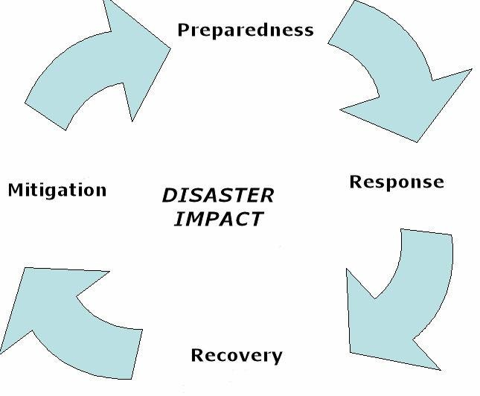

**Source**; National Policy for Disaster Management in Kenya

***Mitigation*-** Measures put in place to minimise the results from a disaster e.g. building codes and zoning, vulnerability analyses and public education.

***Preparedness-*** Planning how to respond e.g. preparedness plans, emergency exercises/training and early warning systems.

***Response-*** Initial actions taken as the event takes place. It involves efforts to minimise the hazards created by a disaster e.g. evacuation, search and rescue, and emergency relief.

***Recovery-*** Returning the community to normal. Ideally, the affected area should be put in a condition equal to or better than it was before the disaster took place e.g. temporary housing, financial support and medical care.

**Disaster Risk Management**

Disaster management is an enormous task that is not confined to any particular location. Neither do they disappear as quickly as they appear. Therefore, it is imperative that there is proper management to optimise efficiency of planning and response. Due to limited resources, collaborative efforts at the governmental, private and community levels are necessary. This level of collaboration requires a coordinated and organised multi-sectoral effort to mitigate against, prepare for, respond to, and recover from emergencies and their effects in the shortest time possible. The health system has a responsibility to protect the

health of affected persons or communities in the event of a disaster or hazard. This function is fulfilled through effective disaster risk management.

Disaster risk management is a proactive and systematic process based on the key management principles of planning, organising, leading, coordinating and controlling. Its aim is to reduce the negative impact or consequences of adverse events. Disasters cannot always be prevented, but the adverse effects can be minimised. As a system, disaster risk management has many components.

**Objectives of Disaster Management**

1. *Reduce damages and deaths*

Effective disaster management reduces or avoids morbidity, mortality, and economic and physical damages from a hazard. The methods used to achieve this include hazard and vulnerability analysis, preparedness, mitigation and prevention measures, and the use of predictive and warning systems.

1. *Reduce personal suffering*

Disaster management reduces personal suffering such as morbidity and emotional stress following a hazard. The methods used to prevent suffering include hazard and vulnerability analysis, preparedness, and mitigation and prevention measures. Examples of efforts to reduce personal suffering include providing safe food supplies and potable drinking water when water supplies become contaminated.

1. *Speed recovery*

The methods to accomplish this objective include effective response mechanisms and the institution of recovery programmes and assistance. Examples of efforts to speed recovery include providing paperwork assistance for insurance claims, and grant or loan applications.

1. *Protect victims*

Disaster management provides protection to victims and or displaced persons. Facilities utilise preparedness, response mechanisms, recovery programmes and assistance to address shelter needs and provide protective services.

**Disaster Risk Management Plan**

An effective disaster risk management plan includes:

### Prevention

Prevention includes activities designed to provide permanent protection from disaster. Disaster prevention plans are designed to provide permanent protection from disasters. Not all disasters, particularly natural disasters can be prevented, but the risk of loss of life and

injury can be mitigated with good evacuation plans, environmental planning and design standards.

### Preparedness

These are activities designed to minimise loss of life and damage e.g.by removing people and property from a threatened location and by facilitating timely and effective rescue, relief and rehabilitation. Preparedness is the main way of reducing the impact of disasters. Community- based preparedness and management should be a high priority in health systems management. Appropriate preparedness results in persons knowing what to do and how to respond after disaster has occurred.

### Mitigation

This is a coordinated multi-sectoral response to reduce the impact of a disaster and its long- term results. Relief activities include rescue, relocation, providing food and water, preventing disease and disability, repairing vital services such as telecommunications and transport, providing temporary shelter and emergency health care.

### Recovery

Once emergency needs have been met and the initial crisis is over, the people affected and the communities that support them are still vulnerable. Recovery activities include rebuilding infrastructure, health care and rehabilitation. These should blend with development activities, such as building human resources for health and developing policies and practices to avoid similar situations in future.

**Disaster Associated Health Issues**

When a disaster occurs, the general population expects the government and other agencies to rapidly mobilise the needed services with urgency. Preservation of life and health are of paramount importance to casualties. Immediately a disaster occurs, medical professionals, first aid and emergency medicine should be made available. As a consequence of disasters, it is also important to identify risk factors for communicable diseases and determine ways of minimising these risks.

*Emergency Health Services in Disasters*

During the first few hours/days following a disaster, the priority is usually to treat casualties and the sick or injured. Disasters like earthquakes, and collapsed buildings often involve the management of mass casualties which normally requires the following activities: Search, rescue and first aid; transport of health facilities and treatment; triage; tagging; and redistribution of patients between hospitals when necessary.

The demand for curative care is highest during the acute emergency stage, when the affected population is most vulnerable in their new environment and before basic public health

measures e.g., water, sanitation and shelter have been provided. Thereafter, the priority should shift toward preventive measures. Any prolonged interruption in routine immunisations and other disease-control measures may result in serious outbreaks of diseases like measles, cholera etc.

Disasters call for a coordinated response between curative and preventive health services, including food supply, water and sanitation, etc. In order to minimise mortality and morbidity it is also necessary to organise the relief response according to three levels of preventive health measures, namely primary, secondary and tertiary prevention.

**Infrastructure and Procedures in Accessing Emergency Situations**

### Managing a Mass Casualty Incident (MCI)

A MCI is any event producing a large number of victims such that the normal capacity of local health services is disrupted. Common causes of an MCI include road accidents, floods, fires, explosions, industrial accidents, or conflict situations.

The response may be delayed after a MCI due to poor communication. Inadequate transportation may decrease the survival of victims in critical condition. Normally, the following groups of patients reach the health facility first:

* + Those nearest to the arriving ambulances;
  + Those who are first to be rescued; and
  + Those who are the most gravely injured.

If there is only one first referral health facility, it may quickly become overwhelmed. Limited resources are used to care for victims arriving first, even though most of them may have minor injuries. As a result, they tie up the personnel, examining rooms, supplies, etc. increasing the risk of death for the critically ill victims whose survival depends on receiving prompt medical attention.

### Triaging

Triage is defined simply as *sorting* and *prioritising* patients for medical attention according to the degree of injury or illness and expectations for survival. Triage is carried out to reduce the burden on health facilities and is normally done by the most experienced health worker assisted by competent staff on the triage team.

Triage is a continuous process that begins when patients arrive at the medical post and continues as their condition evolves until they are evacuated to hospital. By providing care to victims with minor or localised injuries, health facilities are freed to attend to more critical tasks. Triage is necessary where health facilities cannot meet the needs of all victims immediately, particularly following an MCI.

The goal of managing a MCI is to minimise the loss of life or disability of disaster victims by first meeting the needs of those most likely to benefit from services. This goal can be achieved by setting the following priorities for triage:

* + Priority for transportation to the hospital is based upon referrals of priority needs of patients.
  + Priorities for care in the field are often identified by visible colour-coded tags that categorise patient needs.

However it is important to note that different jurisdictions use varying systems and the use of colour-coded tags may cause some confusion (Nocera and Garner, 1999).

Management of MCI begins with being prepared to mobilise resources and follow standard procedures in the field and at the hospital. Hospitals with a limited number of emergency workers may find it difficult to hold regular training sessions on MCI management. Health facilities with limited resources should focus on the following:

* + Improving routine emergency services for sudden-impact, small-scale incidents e.g., car accidents or accidents in the home. To avoid confusion, the same procedures that are necessary to save lives during an MCI should be performed as routine emergency services;

Coordinating activities that involve more than an emergency medical unit e.g. police, fire fighters, ambulances, hospitals etc and ensuring a quick transition from routine emergency services to mass casualty management establishing standard procedures for managing all incidents (small or large scale) such as search and rescue, first aid, triage, transfer to hospital and hospital care.

### Transportation of Casualties

Evacuations of casualties may be organised when they are gathered at a first aid post, a dispensary or any facility of the casualty-care chain, in which case they would have already been triaged and a priority category for evacuation has been assigned to each.

1. Evacuation is contemplated when means are available and reliable, routes and time- frames are known and security has been ensured. Prior to the moving of casualties, it is imperative that personnel at destinations have been informed and are ready to receive the casualty or casualties.
2. Evacuation vehicles assigned for medical purposes must be used exclusively for the latter. Their availability and hygiene should be respected. Other vehicles should preferably be used to transport the dead bodies if at all possible. In all cases, priority should be given to the living casualties.
3. Proper lifting techniques are used to ensure comfort of the casualty and personnel responsible for lifting should be in good physical condition.
4. All departures of evacuation vehicles should be reported to supervisors in charge of managing evacuations providing the following information: departure time, number and condition of casualties, destination, estimated travel time and route, and number of first aiders aboard.
5. The means of transport should ideally be such that emergency and stabilisation measures can continue and should be as safe as possible as it is important that the trip is not traumatic for the casualties.
6. It should also be such that casualty can be accommodated in different lying or sitting positions depending on their condition. Furthermore, it should be able to accommodate for a provider of care or a first-aider to accompany the casualty.
7. The means of transport should provide adequate protection against the elements e.g. extreme temperatures, sun, rain, wind, etc..
8. Driving needs to be smooth and safe. Once a casualty has been stabilised it is unnecessary to drive at high speed and risk a road traffic accident. Extra care should be taken especially if the roads are bumpy or have potholes as hitting into them causes more pain to the casualty, may increase bleeding and displace traumatised limbs hence causing more complications.
9. Casualties found on the roadside should be taken on board only if there is adequate space and no other alternative.
10. On arrival at the hospital, every injured person should be reassessed, stabilised, and given definitive care. The colour-coded tags are strictly for field triage and field use. They should not be used for documenting health care in the hospital.
11. Hospitals should also regularly advise the incident commander about their health care capability and capacity so that the transfer of MCI victims is well organised. If the hospital’s capacity or capability is low, patients and victims may have to wait a long time for treatment in surgical or intensive care units.

**Communicable diseases common in disaster situations**

The main communicable diseases are:

1. Diseases transmitted by contact – Acute respiratory infections (ARI) which are common among people after a disaster especially among the children. These are spread through personal contact or being around people who are infected already. These include the common cold, influenza, bronchitis, diphtheria and pneumonia.
2. Vector transmitted diseases- These include malaria, yellow fever, dengue and leptospirosis. These infections become prominent when the balance of nature is disturbed as is the case in a disaster.
3. Disease can also be transmitted through faecal matter ingested orally as a result of drinking contaminated water or eating food and fruits that are contaminated. These diseases include cholera, typhoid fever, diarrhoea diseases, and leptospirosis. They can also be transmitted through poor personal hygiene or from a contaminated environment.
4. Diseases transmitted through breathing contaminated air or from germs that are airborne can be problematic after a disaster. These diseases include tuberculosis, measles, meningococcal meningitis and whooping cough.
5. Sexually transmitted diseases are on the rise in peaceful times let alone being in disaster mode. These diseases are transmitted through sexual contact with infected people such as HIV andAIDS, gonorrhoea, syphilis, Chlamydia and trichomonas among others.

|  |
| --- |
| **Student Activity** |
| Describe all components involved in emergency medicine and write small notes on each giving examples where possible. |

* 1. **Policy Framework in Disaster Management**

Disaster preparedness is an ongoing multi-sectoral activity. It requires coordination and organisation by different departments of the government to facilitate assessment of a country’s disaster risk, adoption of standards and regulations, and action to ensure that resources can be mobilised rapidly in disaster situations.

The health objectives of disaster preparedness are to:

1. Prevent morbidity and mortality;
2. Provide care for casualties;
3. Manage adverse climatic and environmental conditions;
4. Ensure restoration of normal health;
5. Re-establish health services;
6. Protect staff; and
7. Protect public health and medical assets.

The preparedness process includes policy development, vulnerability assessments, disaster planning, training and education, and monitoring and evaluation.

**Policy development**

National governments must designate a branch of the ministry or organisation with the responsibility to develop, organise and manage an emergency preparedness programme for the country. This group must work with central government, county, provincial and

community organisations and NGOs whether local or international to develop a set of policies agreed upon by all. This process is vital for a well-coordinated response and a sustainable policy. The policies’ endpoint must allow quick decision making, ensure the actions are legal and free from liability and ensure that appropriate pre-defined actions are taken during a state of emergency.

**Disaster Preparedness Process**

### Vulnerability assessment

Potential hazards at all levels of society are identified and prioritised in a vulnerability assessment. The community’s capacity can be determined by the availability of resources of the community and how the community is able to utilise these resources.

### Disaster planning

Planning is only one component of preparedness. A disaster’s outputs plan should provide:

* + Provide an understanding of organisational responsibilities in response and recovery;
  + Provide stronger emergency management networks;
  + Improve society awareness and participation;
  + Effective response and recovery strategies; and
  + Be documented.

### Training and education

An important component of preparedness is to train and educate public health officials and other stakeholders (responders) about the disaster plan.Training at all levels should ensure adequate distribution of important skills and knowledge needed for an effective disaster response.

The County Director of health is the technical advisor for all health matters in the county. Their role shall be:

1. The technical advisor to the County Executive Commissioner and themGovernor;
2. To supervise all health services within the County;
3. To promote the public health and the prevention, limitation or suppression of infectious, communicable or preventable diseases within the County;
4. To prepare and publish reports and statistical or other information relative to the public health within the County;
5. To report periodically to the Director-General for health on all public health occurrences including disease outbreaks, disasters and any other health matters;
6. To perform any other duties as may be assigned by the appointing authority and any other written law.

The objective in monitoring and evaluation is to measure how well the disaster preparedness plan and programme is being implemented and if it achieving its health objectives as discussed.

WHO recommends that an effective risk reduction and emergency preparedness strategy be based on an ‘All-hazard/Whole-health’ concept:

* **All-hazard** entails developing and implementing emergency management strategies for the full range of likely risks and emergencies- natural, biological, technological and societal. Different hazards and emergencies can cause similar problems in a community and such measures as planning, early warning, intersectoral and intrasectoral coordination, evacuation, health services and community recovery should be implemented along the same model regardless of cause.
* A **whole-health** approach should be in place in a country. There should not be parallel planning and coordination systems for each category of health risks. While technical leadership may vary, emergency planning processes, overall coordination procedures, surge and operational platforms should be unified under one emergency preparedness and response unit. Plans of the health sector can then be effectively coordinated with other sectors as well as with the designated national multi-sectoral emergency management agency.

In addition to disaster preparedness, plans must should include common coordination, information tools and support services such as environmental health (water, sanitation and hygiene); management of chronic diseases (e.g. mental health); maternal, newborn and child health; communicable diseases control; nutrition; pharmaceuticals and biological and health care delivery services (e.g. health infrastructure). Other specialised services may be included for preparedness and management of specific risks.

* 1. **National Policy for Disaster Management in Kenya**

Under Policy Objectives 4 and 5, the Kenya Health Policy commits to provide and ensure free access to trauma care, critical care, emergency care and disaster care services and an adequate response to health effects of disasters and emergencies and including putting in place appropriate financing mechanisms for emergency health services. Risk reduction and emergency preparedness are the responsibility of all sectors and stakeholders at all levels of society (country, county, community). At the national level, the Ministry of Health is the lead agency of the health sector.

The National Policy For Disaster Management in Kenya (2010) has four key objectives:

* + 1. To establish a policy/legal and institutional framework for management of disasters, including promotion of a culture of disaster awareness and for building the capacity for disaster risk reduction, at all levels;
    2. To ensure that institutions and activities for disaster risk management are co- ordinated, focused to foster participatory partnerships between the government and other stakeholders, at all levels, including international, regional, sub-regional, national and sub-national bodies;
    3. To promote linkages between disaster risk management and sustainable development for reduction of vulnerability to hazards and disasters.
    4. To mobilise resources, including establishment of specific funds for disaster risk reduction strategies and programmes.
  1. **Handling Emergencies at the Health Facility Level**

An emergency occurs when a health facility does not have enough resources to cope with an abrupt demand for services. In such situations, normal procedures should be abandoned and resources increased to expand capacity. When a hospital receives an overwhelming number of emergency cases, it must plan a simplified treatment system to immediately address prevention of loss of life, complications, deformities, infection and delayed treatment.

All health facilities within the structure of national health system should have an emergency action plan that take into consideration the rank of the hospital within the system based on its size, location and disaster vulnerability.

### Handling Disaster Occurring Inside the Facility

Disasters may occur rendering the facility non-functional. Prior planning is therefore required to ensure the continuity of service during such occurrences. All facilities should have internal disaster plan for fire and other common disasters within the areas should be developed with input from the fire department.

The plan should cover such operational matters as:

* Allocations duties and responsibilities;
* Instruction on the use of alarm and other security systems;
* Instruction on fire fighting methods;
* Location of fire fighting equipment;
* System for notifying trained personnel;
* Specification of evacuation procedures.

All staff should be acquainted with the plan. Fire drills and internal emergency exercises should be carried out at least once a year to ensure staff is trained to carry out assigned duties and assess the efficacy of the plan.

**References and Recommended Further Reading**

Bayntun, C. A (2012) ‘Health System Approach to All-hazards Disaster Management: A Systematic Review’, *PLOS Currents Disasters*, 2012 Aug 22. doi: 10.1371/50081cad5861d [online]. Available at <<http://www.who.int/healthsystems/strategy/everybodys_business.pdf>> [Accessed 21 May 2014].

Kenya National Health Policy 2012-2030.

Ministry of State for Special Programmes (2010) *National Policy for Disaster Management in Kenya*. Nairobi: Ministry of State for Special Programmes.

The Johns Hopkins and the International Federation of Red Cross and Red Crescent Societies (2007) *Public Health Guide for Emergencies*. Geneva: International Federation of Red Cross and Red Crescent Societies.

WHO (2002) *Environmental Health in Emergencies and Disasters: A Practical Guide*. Geneva: WHO.

WHO (2007) Everybody's Business. Strengthening Health Systems to Improve Health Outcomes: WHO’s Framework for Action. Geneva: WHO. Also online at

<<http://www.who.int/healthsystems/strategy/everybodys_business.pdf>> [Accessed February 2014].

WHO (2007) Six Year Strategy for the Health Sector and Community Capacity Development. Geneva: WHO. Also online at

<<http://www.who.int/hac/techguidance/preparedness/emergency_preparedness_eng.pdf>> [Accessed February 2014].

WHO Regional Office for Europe (2012) ‘Strengthening Health-system Emergency Preparedness: Toolkit for Assessing Health System Capacity for Crisis Management’

[online]. Available at <[www.euro.who.int/](http://www.euro.who.int/__data/assets/pdf_file/0008/157886/e96187.pdf) [Accessed February 2014].

[data/assets/pdf_file/0008/157886/e96187.pdf](http://www.euro.who.int/__data/assets/pdf_file/0008/157886/e96187.pdf)>

# MODULE 17: HEALTH SERVICES MONITORING AND EVALUATION



**Purpose**

To introduce students to monitoring and evaluation in health services delivery

**Objectives**

By the end of this module, the student should be able to:

1. Describe the purposes, processes, and components of project monitoring;
2. Describe the purposes, processes and components of project evaluation.

**Content**

* 1. Purpose of monitoring and evaluation (M&E) in a health system
  2. Goal and objectives of the Kenyan National M&E system
  3. Monitoring and evaluation framework
  4. M&E indicators
  5. Types of evaluation
  6. Monitoring process
  7. Evaluation process
  8. M&E conceptual framework
  9. Evaluation terms of reference (TOR)
  10. Monitoring and evaluation tools
  11. Work plans
  12. Evaluation reports

**Methodology**

Lectures, discussions, case studies

**Training materials** Lecture notes Handouts

PowerPoint (Laptop and LCD projector) Whiteboards, flip charts, marker pens **Duration: 6 hours**



**Lesson Plan Guide: Time: 6 hours**

|  |  |  |  |  |
| --- | --- | --- | --- | --- |
| **Session** | **Time**  **(Hours)** | **Content/Topic** | **Lesson Objectives** | **Lecturer Evaluation/Remarks** |
| 1 | 2 | Monitoring and Evaluation; concepts, types, processes.  Monitoring and evaluation tools: terms of reference, monitoring tools, evaluation tools. | To define monitoring and evaluation  To describe concepts, types and processes  To outline monitoring and evaluation tools, terms of reference, monitoring and evaluation tools | Comments regarding time adequacy and student understanding and perceptions |
| 2 | 2 | Health services performance Indicators and targets; concepts, definitions, performance standards, work breakdown schedules (WBS), work plans, | To define and describe health services performance indicators, targets and concepts  To describe performance standards, work breakdown schedules(WBS) and work plans | As above |
| 3 | 2 | Health reports; types, formats, characteristics of a good report | To identify health systems reports prepared at various levels | As above |

* 1. **Purpose of Monitoring and Evaluation (M&E) in a Health System**

Monitoring is a systematic process covering routine collection, analysis, and use of information about how well a project or programme is performing. It involves continuous review of the performance of all the components in the project to ensure that input deliveries, work schedules, targeted outputs, and other required actions are proceeding as per the work plans (MOMS & MPHS, 2011).

Evaluation is the periodic assessment of a project or programme to determine the achievements against clearly set performance targets. The purpose of conducting an evaluation is to assess whether the project is making progress toward achieving its overall goals and objectives, and providing opportunities for mid-course corrections to project implementation, if necessary (MOMS & MPHS, 2011).

Monitoring and evaluation (M&E) are fundamental components of any programme that aims at continuously improving and providing better health outputs and outcomes. Although there are differences between monitoring and evaluation, the two processes work together and lead to the same end result, which is to produce information that can be used to continuously improve the performance of a given facility, department or programme and learn about what is working and what is not working.

* 1. **Goal and Objectives of the Kenyan National M&E System**

The goal of the National M&E is to provide timely and reliable information that will enable tracking of progress and to enhance informed decision-making at all levels in the implementation of interventions under the health sector mandate in the country. The specific objectives are to:

* + 1. Establish a reliable M&E system at National and County level;
    2. Strengthen the M&E capacity of MoHS and Health facilities to collect, analyse and use data for decision making and health system improvement;
    3. Promote importance of M&E, the need for systematic data collection and use of results and lessons learned in the further planning of health interventions by the government and its partners;
    4. Increase understanding of trends and explaining the changes in disease incidences or prevalence overtime as well as morbidity and mortality rates and ratios;
    5. To ensure accountability, transparency and the quality of information to achieve the desired results.
  1. **Monitoring and Evaluation Framework**

Effective M&E is based on a clear logical pathway of results in which results at one level are expected to lead to results at the next level, leading to the achievement of the overall goal. Consequently, if there are gaps in the logic, the pathway will not lead to the required results.

Major levels for M&E framework are: Inputs, process, outputs, outcomes and impacts.

* *Inputs-* The pPeople equipment, materials and resources that are put into a project in order to implement the project.
* *Processes* - The activities performed/involved in delivering the project such as training, meetings, treatment and distribution among others. Processes associated with service delivery are very important and involve quality, unit costs, access and coverage.
* *Outputs-* The first level of results associated with the project e.g. the number of people trained or services delivered in order to achieve outcomes. These are short- term results.
* *Outcomes* – The second level results associated with the project-mid-term results e.g. the changes in health status, behaviour or skills. These must be related to the project goals.
* *Impacts*-The third level results with long-term consequences of a project e.g. decreased mortality and morbidity changes overtime, and usually long-term.
  1. **M&E Indicators**

An indicator is defined as a set of values used to measure against; it is like a sign post that is used to measure against. Valid and measurable indicators are very crucial in an M&E system. Each of the M&E levels – inputs, outputs, outcomes, impacts – has an indicator to verify whether the desired objectives or activities are implemented, achieved or not.

A minimal set of indicators is advisable in any M&E system. The following three golden rules of M&E provide a good basis:

* + 1. Define indicators that can be measured;
    2. Collect data that is useful for decision-making or from which lessons can be learned, and;
    3. It is better to approximate an answer for a few important questions than to have an exact answer for many unimportant questions.

**Table 17.1 Type and Sources of Information Required for Monitoring in the Health Sector**

|  |  |  |  |  |  |  |
| --- | --- | --- | --- | --- | --- | --- |
| **Category of information** | **What to Monitor & Evaluate** | **What records to keep** | **Who collects data** | **Who uses data** | **How to use information** | **What decisions can be made** |
| **Work plan activities** | Timing of activities | Monthly/ quarterly/ annual work plans | Health facility | Project implementa tion team | Ensure staff and other resources are available | Reschedule activities and deployment of resources as needed |
| Availability of personnel, resources | Work schedules | HOD | HMT, HOD |
| **Costs and expenditures** | Utilisation of resources | * Project budget * Accounting records * Receipts * Cash and bank transactions * Reports MOH/ donor | Account ant | * HMT * HMC * Auditor * MoH Headquart ers * Donor partners | * Ensure funds are available to implement activities * Ensure compliance with GoK and funding regulations | * Authorise expenditure s * Make budget and project revisions * Determine need for other funding sources |
| Resources mobilised |
| Expenditure |
| **Staff supervision** | Knowledge, attitudes  and skills of and staff | * Performanc e reviews * Job   description s | * HoD * HRM * Qualit y Teams | * HMC * HRM | * Staff motivation staff * staff   developmen t   * Resolve work place problems | * Task allocation * Training needs * Recruitment * Disciplinary action * Promotion |
| Experience/co mmitment/ education of and staff |  |
| Salaries and  benefits or other forms of |  |

|  |  |  |  |  |  |  |
| --- | --- | --- | --- | --- | --- | --- |
| **Category of information** | **What to Monitor & Evaluate** | **What records to keep** | **Who collects data** | **Who uses data** | **How to use information** | **What decisions can be made** |
|  | compensation |  |  |  |  |  |
| Job performance |  |  |  |  |  |
| **Management of facility assets and other physical materials** | Equipment  e.g. computer, motor vehicle, stock | * Assets and stock registers * Assets and stock movement logs/registe rs * Invoices * Inspection/ service/aud it reports | HoD | * HoD * Supplies & Logistics * Maintena nce | * Ensure availability of required physical resources * Ensure good condition of physical resources | * Authorizati on for utilisation * Minimum quantity to be kept * When to order * Amount to keep in reserve for emergency |
| Procurement regulations |
| **Performance results** | Outputs, outcomes, impact | * Minutes of project review meetings * Minutes of Department al meeting s * Attendance registers | * HMC * Project imple mentat ion team | * HMC * HOD * Project implemen tation team * Donor agency | * Ensure objectives are realistic * Assess quality of services provided * Assess appropriaten ess of intervention s | * Revise   objectives   * Retrain staff * Revise   project strategy and approach |

* 1. **Types of Evaluation**

### Baseline/formative

The evaluation is conducted before implementation of the plan to assess needs and potentials. It can also determine feasibility of the plan.

### Midterm Evaluation

Conducted during the implementation period to identify areas that require change or modifications and in the process detect deficiencies and ensure immediate redesign of intervention strategies to forestall failed implementation.

### Summative/End of Project Evaluation

This is conducted at the end of the project to assess outcomes achieved as an effect of project activity implementation

### Post Project Evaluation

Evaluation conducted to measure programme sustainability after its successful implementation and closure.

### Impact Evaluation

Evaluation to assess long term effects associated with a successful project implementation.

* 1. **Monitoring Process**

The monitoring process will take the logical steps below depending on whether one is looking at the process from accountability perspective, manager perspective or evaluator’s perspective. This involves:

* + 1. Recording data on key indicators as a result of activities carried out;
    2. Analysing and processing data for consumption;
    3. Storing and retrieving information for use by different stakeholders;
    4. Reporting activity results based on activity timeframe;
    5. Providing feedback to appropriate managers and stakeholders internally and externally.
  1. **Evaluation Process**

The evaluation process will entail:

* + 1. Designing evaluation strategy;
    2. Participatory planning meeting;
    3. Developing evaluation plan;
    4. Implement evaluation plan;
    5. Analyse evaluation results;
    6. Participatory reflection on results;
    7. Implementation of improvements.
  1. **M&E Conceptual Framework**

The M&E conceptual framework demonstrates the theory of the sequence of cause and effect that ultimately lead to a particular ultimate result. In the health sector, the ultimate result is positive health impact on clients in any of the health areas.

**Figure 17.1 The M&E Conceptual Framework**



**Input**

-Resources

-Staff

-Supplies

**Process**

-Activities

E.g. Training,

Distribution

**Output**

-Services

-Trainees

**Outcome**

-Knowledge

-Improved services

**Impact**

-Incidences

-Prevalence rates

**Source:** MSH (2013).

The conceptual framework demonstrates the process of monitoring and evaluation. What you need to do at each level:

* + - *Input level:* Monitor whether resources, staff, supplies etc. are being provided.
    - *Process level:* Monitor whether activities are happening.
    - *Output level:* Monitor whether required outputs are generated by activities carried out according to planned schedule.
    - *Outcome level:* Evaluate whether there is gain in the expected areas.
    - *Impact level:* Evaluate or conduct demographic health survey to show impact.

The results at every level are used as feedback to influence the preceding level and gaining lessons learned thereby improving health provision and outcomes as well as effectiveness and efficiency.

* 1. **Evaluation Terms of Reference (TOR) What is TOR?**

TOR refers to the definition and structured description of the scope of work and the schedule that must be carried out by the person, company or evaluation team undertaking an evaluation.

**Characteristics of TORs**

The terms of reference recalls the background and specifies the scope of the evaluation, process, products, technical aspects, and states the main motives for an evaluation and the questions asked. It sums up available knowledge and outlines an evaluation methodology describing the distribution of work, schedule and the responsibilities among the people participating in an evaluation process. It also specifies the qualifications required from candidate teams or individuals as well as the criteria to be used to select an evaluation team.

TOR serves as a ‘contract’ between project/institution and evaluators, outlining key elements and should reflect strategic choices on what to focus on. The optimal type of TOR is one that satisfies the interests of all stakeholders concerned. This is not always possible. However, given the range of motivations for undertaking an evaluation, it requires the TOR to retain enough flexibility for the evaluation team to determine the best approach for collecting and analysing data.

**Components of TOR**

At a minimum, it is expected that ToRs for all evaluations will address the following sections.

1. *Title*
2. *Background and context*

Overview and historical context of project under evaluation, project justification and implementation experiences/challenges, project documents and revisions thereof, project objectives and expected outcomes.

1. *Purpose of the evaluation (objectives)*

Who commissioned the evaluation? Why at this point? What is it expected to accomplish? What decisions might evaluation guide in? Who will use the evaluation results and how do you involve them?

1. *Scope of work for the evaluation*

There is need to determine the unit of analysis to be covered -project, cluster of projects, programme, a process within a project, time period, geographical coverage.

1. *Evaluation criteria and key evaluation questions*

Identify the key evaluation questions to be answered by the evaluate on along with their related evaluation criteria-project relevance, efficiency, effectiveness, impact, and sustainability.

1. *Evaluation methodology*

The methods used to collect and analyse data on which the quality of the evaluation is dependent on i.e. desk reviews, questionnaires, surveys, structured interviews, discussions, workshops, field visits, observations, retrospective baseline construction etc., data sources, and possible references to an evaluation.

1. *Expected deliverables/outputs*

Planned field missions and expected deliverables and respective timeframes including:

* + Inception report -containing a refined work plan, methodology and evaluation tools.
  + Draft evaluation report in line with institution evaluation policy and guidelines.
  + Final evaluation report, including annex with management response.
  + Presentation of evaluation findings, lessons and recommendations to project and stakeholders.

1. *Timeframe*

Evaluation inception to presentation of results.

1. *Evaluation team composition*

Qualified independent and impartial evaluators not involved in project design or implementation, gender balanced, balance geographical representation.

1. *Management of evaluation process*

Roles and responsibilities matrix of all the evaluation stakeholders -evaluators, managers, technical unit, field staff, implementers.

1. *Budget*
2. *Annexes:*
   * Job descriptions of evaluators.
   * List of background documents for the desk review.
   * List of stakeholders.
   * Project/institution standard format and guidelines for evaluation reports.
   1. **Monitoring and Evaluation Tools**

Basic monitoring tools are used to collect input, process and output indicators. The tools and formats should focus on results and progress towards outcomes. These include:

### Work Plan

The work plan is a planning tool that serves as a guide for implementation of action steps (activities) to achieve the stated overall goal and particularly specific objectives of a project. It provides the framework for evaluating progress toward objectives and is the primary document used to monitor on-going progress, to adjust activities as needed and to evaluate outcomes. The work plan is a ‘living’ document and, as such, it may change over the duration of implementation to reflect a more realistic implementation process.

### Monitoring Plan

A monitoring plan is a set of requirements for monitoring and verification of objectives achieved by a project during implementation. These may be:

* + - Monthly service statistics summary registers;
    - Financial reports;
    - Monthly/quarterly institutional reports;
    - Checklists;
    - Questionnaires;
    - Interview guides;
    - Focus group discussion guides;
    - Observation guides;
    - Internet (secondary data).

**Evaluation tools**

Evaluation tools are used for assessing effective indicators (outcome and impact indicators). They focus on assessing program outcomes and impact. These include:

1. *Performance monitoring plan*

A performance monitoring plan (PMP) serves as a roadmap for monitoring and evaluating programme performance throughout its lifespan. It is a detailed plan for managing indicators in order to monitor project performance, outcomes and impact. The PMP contain the performance indicators and their definition, data source, method of data collection or calculation, when data is collected, responsibility, why the data is important, who will use the data and for what purpose.

1. *Evaluation plan*

An evaluation plan is a written document that states the objectives of the evaluation, questions, information to be collected and timeframe of the evaluation. The plan should constitute sections describing the key questions to be addressed related to areas of expected learning from the evaluation as a part of the evaluation framework, programme implementation objectives, outcome objectives and performance measures and procedures for managing and monitoring the evaluation.

* 1. **Work Plans Definition**

A work plan is an annual or multi-year summary of tasks, timeframes and responsibilities that is used to support the implementation and evaluation of programme implementation. It is a valuable tool with a detailed account of how employees propose to accomplish their goals during project implementation-what actions need to happen, who will do them, when they will be completed and what resources will be required. A work plan is also used as a monitoring tool to ensure that production of outputs and progress towards outcomes and impact is timely and reflects project goals.

**Key elements of a work plan**

1. Clearly defined goals, outputs and outcomes;
2. Activities – tasks to achieve outputs, outcomes;
3. Costs (budget) – indication of the activity’s cost;
4. Monitoring and evaluation – ensures that measures to monitor and assess the effectiveness of an activity are included such as recording achievements, collecting data, and assessments.

**Developing a work plan**

The overall process of work planning is a comprehensive tool that helps programme staff to translate project/programme goals into operational terms on an annual basis. Monitoring and evaluation are integral parts of a work plan and will provide a basis for tracking achievements and revising strategies on how to best achieve project goals.

Work plans set out how a project will achieve its clearly defined goals by converting project goals into smaller, manageable outcomes and tasks that will ensure that the skills, experience and resources available are used efficiently and sustainably. A work plan will also help a supervisor know what projects and activities supervisees will be working on over the next several months,

A work plan generally includes a brief introduction or overview of a project and a breakdown of how individual project-related tasks will be accomplished through activities. The detailed breakdown is usually tabulated with columns capturing specific activity descriptions, outputs/outcomes, a timeline for completion, cost projections for implementation and staff responsible (**Table 17.2**). It is mandatory to include monitoring and evaluation activities in the work plan.

**Table 17.2 Work Plan Template**

|  |  |  |  |  |  |  |  |  |  |  |  |  |  |  |  |  |  |  |
| --- | --- | --- | --- | --- | --- | --- | --- | --- | --- | --- | --- | --- | --- | --- | --- | --- | --- | --- |
| **Objective** | **Activity Description** | **Output/ Outcomes/ Deliverables** | **Responsibility** | **Budget Assumptions** | **Budget (Ksh)** | **Progress Remarks** | June | Jul | Aug | Sept | Oct | Nov | Dec | Jan | Feb | Mar | Apr | May |
| **1.1 Provide essential drugs for adults and elderly with common health conditions to increase their survival rate by 10%** | a) Conduct HIV/AIDS testing for adults and elderly facility clients | 10 clients receiving ART every month | Jones Salama | 1000 units testing kits | **200,000** |  | x | x | x | x | x | x | x | x | x | x | x | x |
| b) Conduct outreaches quarterly | 1 outreach every quarter | Cyril Mwema | Transport, Tent hire, brochures | **450,000** |  | x |  |  | x |  |  | x |  |  | x |  |  |

**Implementing Work Plans**

Implementation is the process of taking a work plan and its concepts and putting it into action. The work plan will serve as a guide for what needs to be accomplished, by whom, and in what specific timeframe. However, surprises do come up and changes in the work plan may be necessary. It is critically important that staffs involved in work plan implementation are made aware of such changes and how the changes may affect their role in the implementation process.

Throughout the implementation process, data related to the measures identified should be collected. These data will be important in the monitoring and evaluation process to determine whether or not the programme had the intended outcome.

**Monitoring and Evaluating Work Plans**

Monitoring the work plan will be done by assessing whether activities were implemented as initially planned. This is usually done through monthly/quarterly activity implementation reviews. Enhanced process evaluation will entail an examination of whether activities are being carried out correctly, on time and within budget. Results of the evaluation should be used to enhance or review implementation.

* 1. **Evaluation Reports**

According to the Business Dictionary, a report is a document containing information organised in a narrative, graphic, or tabular form, prepared on ad hoc, periodic, recurring, regular, or on as required basis.

In programme management, a report is:

1. A compilation of descriptive information;
2. A communication tool to present M&E results by presenting raw data and information as knowledge;
3. An opportunity for project implementers to inform themselves and others (stakeholders, partners, donors, etc.) on the progress, problems, difficulties encountered, successes and lessons learned during implementation of programs and activities.

Reports may refer to specific periods, events, occurrences, or subjects, and may be communicated or presented in oral or written form. Some questions to answer before writing a report are:

* + Have you considered the needs/characteristics of the readers? i.e. Executive, technical team, staff, donor, general public).
  + If it is a public health report, does it make health care performance information clear, meaningful, and usable by consumers?

*Why report?*

* + Reporting enables the assessment of progress and achievements and helps focus audiences on the results of activities, enabling the improvement of subsequent work plans.
  + Reporting helps form the basis for decision-making and learning at the programme level.
  + Reporting communicates how effectively and efficiently a programme is meeting its objectives.

*Elements of a good report*

* + Self-explanatory statement of facts relating to a specific subject(s).
  + Systematic and logical presentations of relevant ascertained facts, figures, conclusions and recommendations.
  + Time bound for timely decision making.
  + Concise and objective.
  + Appropriate grammar, language and tone for the consumers (avoid technical jargon).
  + Complete and compact document. **Monitoring and evaluation reports** *Types of reports*
  + Progress report -usually quarterly, semi-annual or annual.
  + Evaluation report- mid-term, end-term evaluation.
  + End of project report.

*Guidelines for writing M&E reports*

* + Provide a 1 page brief summary (executive summary) and ensure it accurately captures the content and recommendations in the report.
  + Be as concise as possible given the information that needs to be conveyed.
  + Focus on relevant results being achieved compared with the expected results as defined in the log frame/performance monitoring plan and check that the expected results are realistic.
  + Specify actions to overcome problems and accelerate performance where necessary. (The basis of this narrative is what you had planned and how you are responding. For example, why something that was planned did not take place and what you plan to do about it).
  + If findings are included in the report, make sure they are objectively verifiable.
  + Be clear on your audience (directors, government, donor, technical persons, staff) and ensure that the information is meaningful and useful to the intended reader.
  + Ensure timely submission of progress reports
  + Be consistent in your use of terminology, definitions and define any technical terms or acronyms.
  + Present data with the help of figures, summary tables, maps, photographs, and graphs.
  + Include references for sources and authorities (if any) and a table of contents.

*Progress report format*

**Cover page**

* + Name of institution;
  + Reporting period;
  + Name of person responsible for reporting/contact person;
  + Table of contents;
  + Acronyms;
  + Executive summary;
  + This section should have one introductory paragraph and major highlights of findings and key lessons learned (1 to 2 pages);
  + Report body.

This section should consist of a table of the hierarchical objectives with a short paragraph describing significant outcome results, why your targets were met/not met and what steps to take, lessons learned (if any) and highlights of activities for the next period. Tables, maps,

photographs, and graphs may be used where appropriate to enhance clarity and results interpretation.

**Figure 17.2 Sample Project Achievements Table**

|  |  |  |  |  |
| --- | --- | --- | --- | --- |
| **Objective** | **Output / Outcome**  **/Deliverable** | |  | |
| **Planned** | **Achieved** | **Remarks on achievement** | **Next period activities** |
|  |  |  |  |

**Indicator achievement (include when these are achieved)**

* + Achievements on outcome indicators;
  + Achievements on milestones;
  + Achievements on impact indicators.

**References and Recommended Further Reading**

Gitonga, B. A. (2010) *Project Management Simplified*: *A Community Development Approach*. Nairobi: Project Support Consultants.

Management Sciences for Health (2013) *Using Evaluation as a Management Tool*. *The Family Planning Manager e-handbook*. Cambridge, MA: Management Sciences for Health.

Ministry of Medical Services, and Ministry of Public Health and Sanitation (2012) *Health Systems Management – A Training Course for Health Managers.* Nairobi: Government Printers.

Ministry of Medical Services, and Ministry of Public Health and Sanitation (2011) *National Monitoring and Evaluation (M&E) Guidelines and Standard Operating Procedures.* Nairobi: Government Printers

# APPENDICES

**Appendix 1 – Form S11 – Counter Requisition and Issue Voucher**

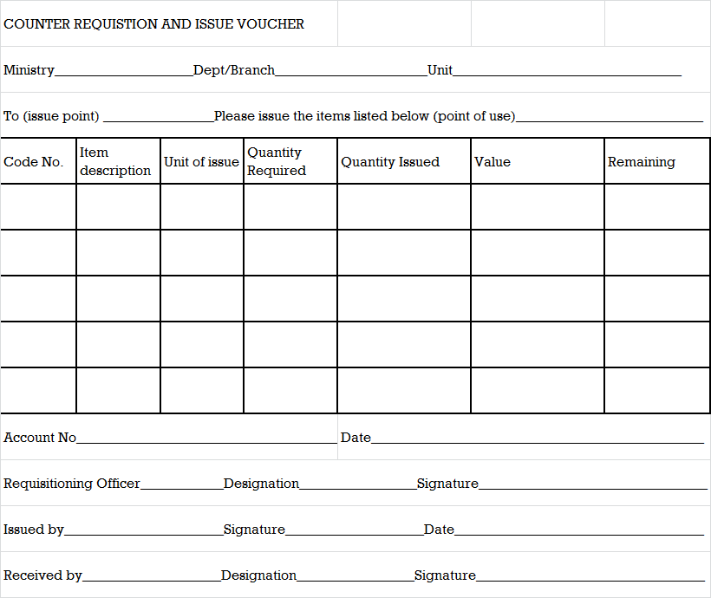

**Appendix 2 – Form S12 – Issue and Receipt Voucher**

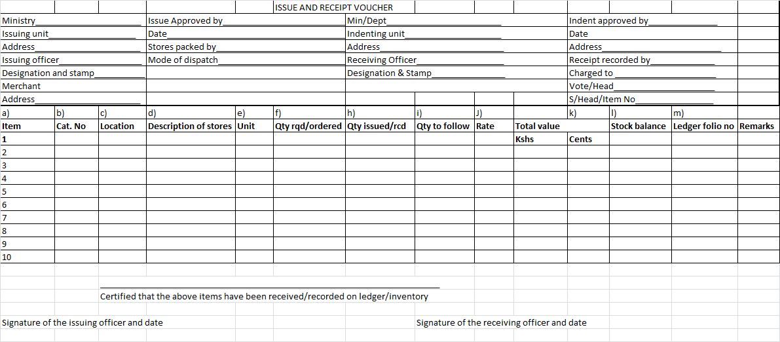

**Appendix 3 – S13 Form – Counter Receipt Book**

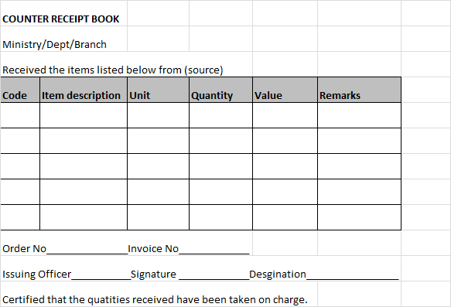

**Appendix 4 – S20 – Local Purchase Order**

|  |  |  |  |  |  |  |  |  |  |
| --- | --- | --- | --- | --- | --- | --- | --- | --- | --- |
|  |  |  | **LOCAL PURCHASE ORDER** | | |  |  |  |  |
| Suppliers are warned that this order is INVALID unless available funds is confirmed herebelow | | | | | | | | | |
| by the Accountant | |  |  |  |  |  |  |  |  |
|  |  |  |  |  |  |  |  |  |  |
| To | | | | Quotation Reference No | | | | | |
|  | | |  | Contract Ref No | | | | | |
|  | | |  | Date | | | | |  |
|  |  |  |  | Requistion No | | | | | |
|  |  |  |  | Date | | | | |  |
|  |  |  |  |  |  |  |  |  |  |
| Please deliver the goods listed here below to (full address) | | | | | |  |  |  |  |
|  | | | | | | | | | |
|  | | | | | | | | | |
|  |  |  |  |  |  |  |  |  |  |
| On terms and conditions stated at the back of the order, on or before | | | | | | | | | |
| and send the invoices immediately to Department/Ministry | | | | | | | | | |
|  |  |  |  |  | P.O.Box | | | | |
|  |  |  |  |  |  |  |  |  |  |
| **Item No** | **Description of goods** | | | **Quantity** | **Unit Cost** | | **Total Cost** | |  |
|  |  | | |  | *Shs* | *Cts* | *Shs* | *Cts* |  |
|  |  | | |  |  |  |  |  |  |
|  |  | | |  |  |  |  |  |  |
|  |  | | |  |  |  |  |  |  |
|  |  | | |  |  |  |  |  |  |
|  |  | | |  |  |  |  |  |  |
|  |  | | |  |  |  |  |  |  |
|  |  | | |  |  |  |  |  |  |
|  |  | | |  |  |  |  |  |  |
|  |  | | |  |  |  |  |  |  |
|  |  |  |  |  |  |  |  |  |  |
| Signature Vote | | | | | | | | | |
|  |  |  |  |  |  |  |  |  |  |
| Designation | | | | | Head | | | | |
|  |  |  |  |  |  |  |  |  |  |
| Station | | | | | Sub-head Item | | | | |
|  |  |  |  |  |  |  |  |  |  |
| Date | | | | | A/C No | | | | |
|  | | | | | | | | | |
| I confirm that the funds are available and that commitment has been made on the vote book | | | | | | | | |  |
|  |  |  |  |  |  |  |  |  |  |
| Signature Date | | | | | | | | | |
|  | Accountant | |  |  |  |  |  |  |  |
|  |  |  |  | Supplier | | | | | |
| Date | | | | |  |  |  |  |  |
|  | I acknowledge receipt | | |  |  |  |  |  |  |
|  |  |  |  |  |  |  |  |  |  |

**Appendix 5 – S21 - Local Service Order**

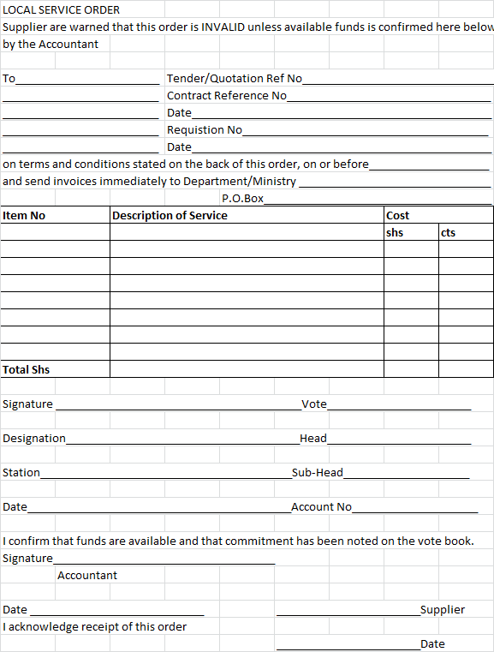

**Appendix 6 – The Vote Book**

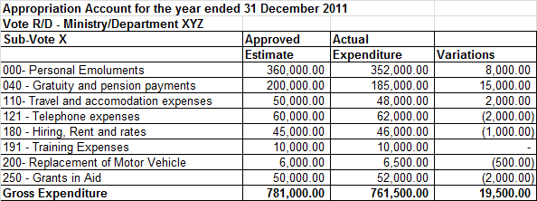

**Appendix 7 – Imprest Request Form**

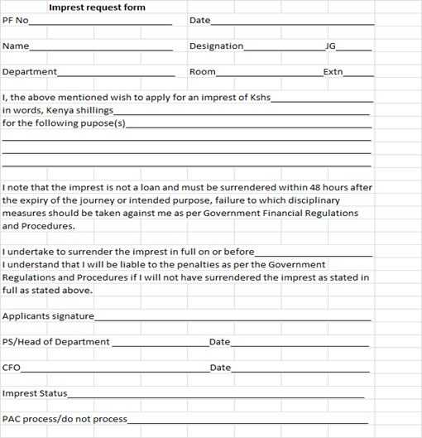

**Appendix 8 – Surrender of Imprest**

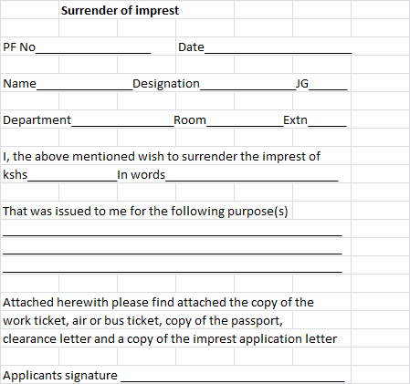

**Appendix 9 – Sample Payroll**

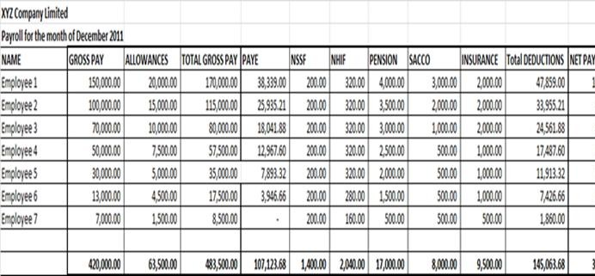

**Appendix 10 – Sample Payslip**

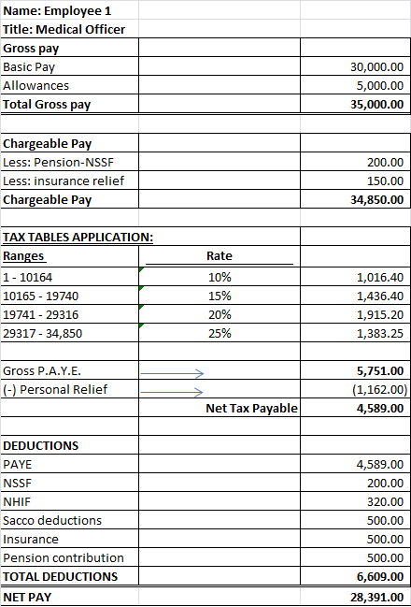

**Appendix 11 – Sample Muster Roll**

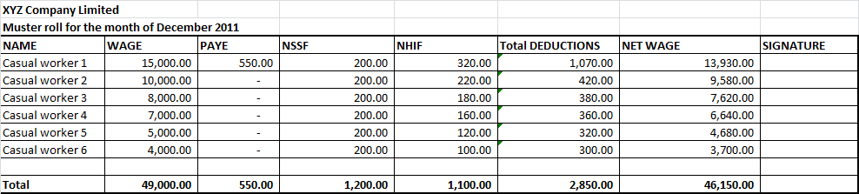

**Appendix 12 – Sample Cash and Bank Book**

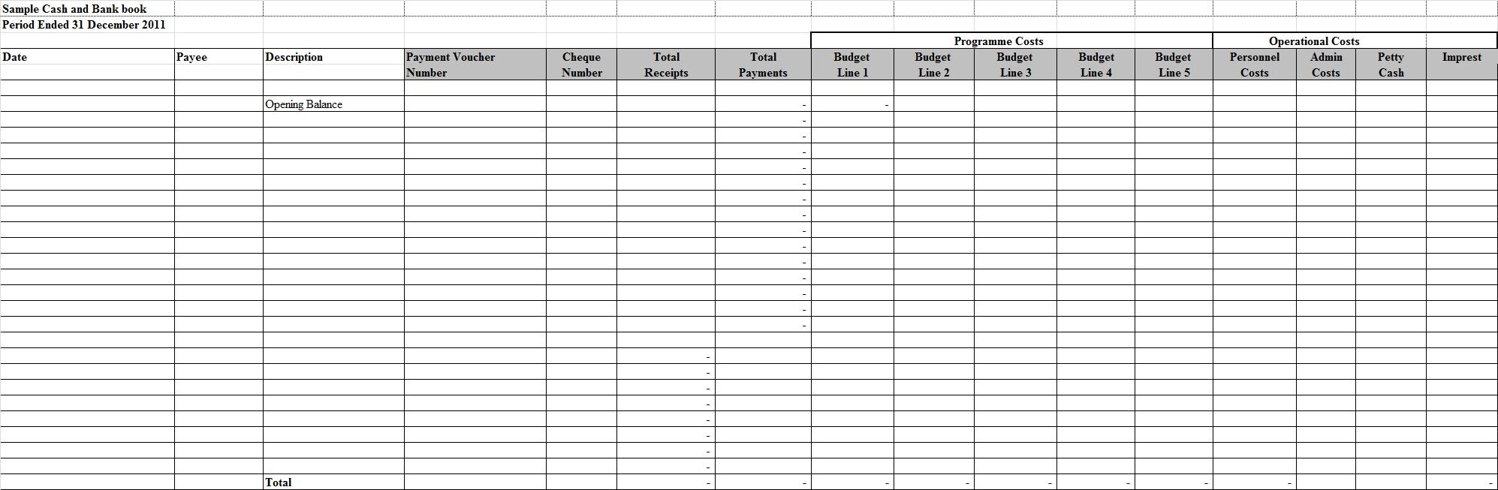

**Appendix 13 – Summary Expenditure Report**

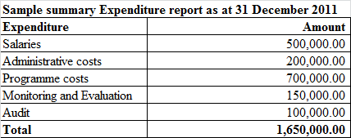

**Appendix 14 – Bank Reconciliation Statement**

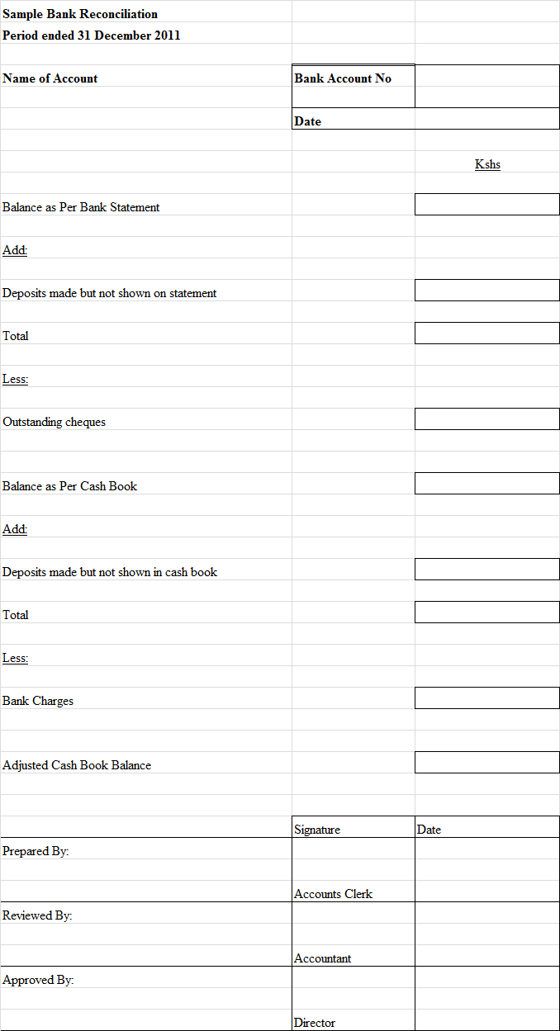

**Appendix 15 – Sample Ledger**

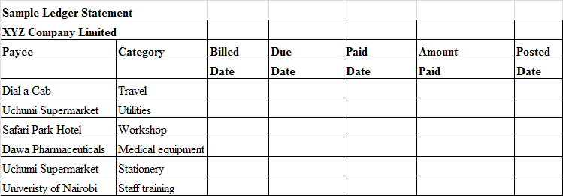

**Appendix 16 – Sample Trial Balance**

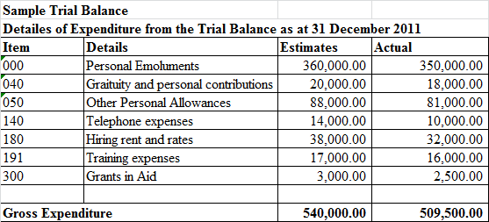

**Appendix 17 – Appropriation Accounts**

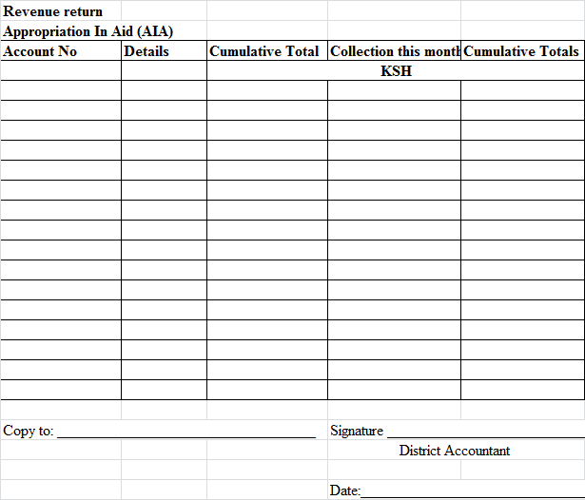

**Appendix 18 – Sample Cash Flow Forecast**

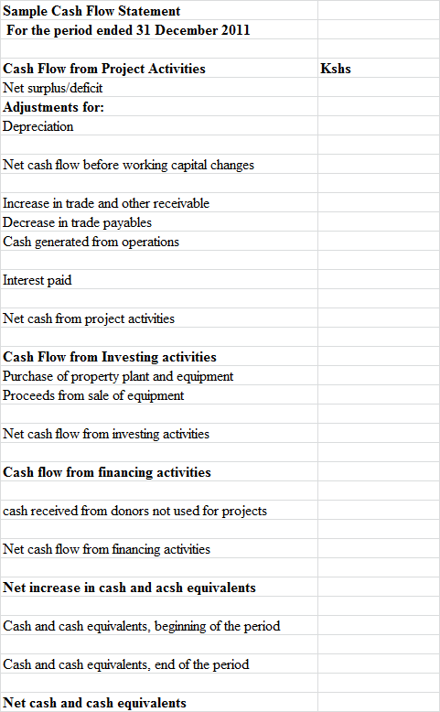

**Appendix 19 – Sample Fund Account Statement**

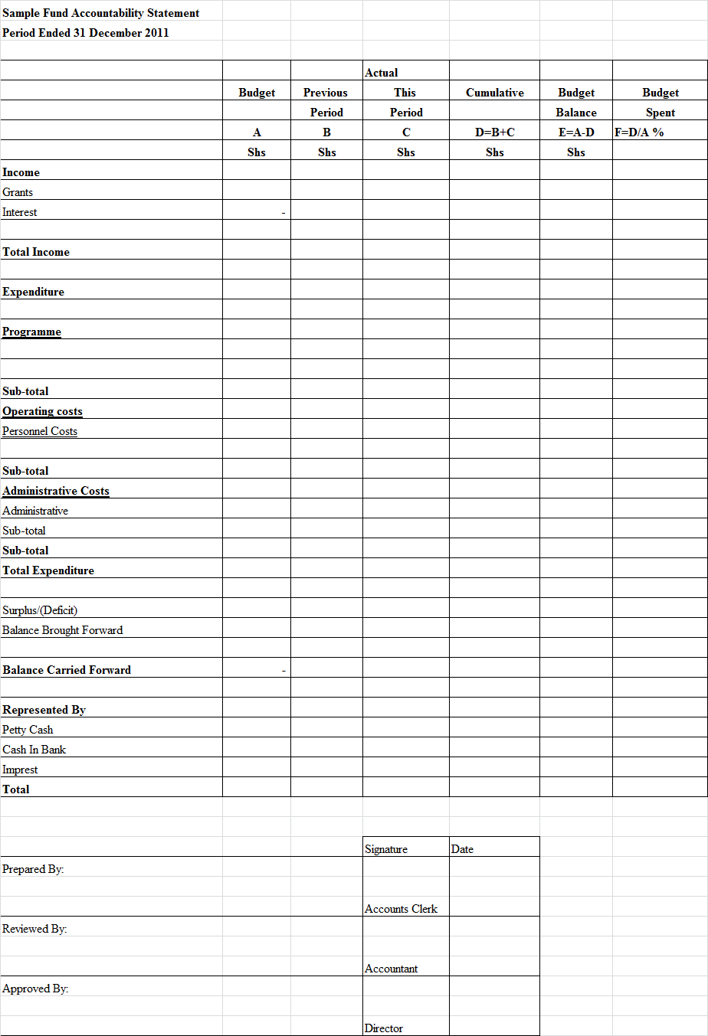

**Appendix 20 – Sample Income and Expenditure Statement**

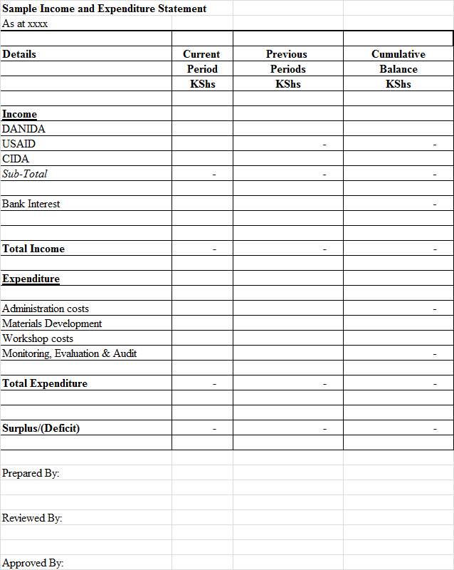

**Appendix 21 – Sample Balance Sheet**

