**Kenya Medical Training College**

**Department of Orthopaedic Trauma Medicine**

**Module: Principles Traction Techniques**

**Facilitator: *Humphrey Sunguti***

**Introduction to Traction Techniques**

**Definition**

* Traction is defined as an act of drawing or exerting a pulling force applied to limbs, bones, or other tissues along the longitudinal axis of the structure to pull the tissues apart, often for realignment.
* When limb becomes painful as a result of inflammation or fracture the controlling muscles go into spasm and can produce deformity which impairs the future function of limb.
* Traction when applied to the injured limb can overcome the effect of original deforming forces.

**Purpose of Traction**

i. Reduce a fracture

ii. Reduce dislocation of a joint

iii. Relieve pain

iv. Rest the limb in functional position

v. Aid in healing of bone.

vi. Overcome muscle spasm and deforming forces.

vii. Correction of soft tissue contractures by pulling them gradually.

**Essential materials for traction**

1. Firm mattress or a bed board.
2. Facility to elevate the head end and foot end of the bed.
3. An overhead frame, trapeze, monkey ropes and side rails to shift the position of the patient.
4. Bars, pulleys, ropes, weight hangers, skeletal traction apparatus and plaster cast materials.

***Note***:

* Traction must always be opposed by counter traction.
* Constant care and vigilance to avoid all the hazards of prolonged bed rest

**History**

* *Hippocrates* (460-360BC) treated fracture shaft of femur and of leg with the leg straight in extension.
* *Percival Pott* (1714-1788) - He taught that the fractured limb should be placed in the position in which the muscles are most relaxed.
* *Josiah Crosby* - First to demonstrate and effectively promote the use of skin traction for the treatment of shaft of femur
* *Thomas Bryant* introduced Bryant's traction for treatment of fracture shaft femur in children.
* *Malgaigne’s in* 1847 introduced the 1st effective traction which grasped the *bone itself.* He *used* Malgaigne's hooks.
* *Steinmann* (1872-1932) in 1907 introduced a method of applying *skeletal traction to the* femur by means of two pins driven into the femoral *condyles.*
* *Lorenz Bohler* - "the father of traumatology" popularized skeletal traction worldwide by means of Steinmann pin after he devised Bohler's stirrup. He modified Braun's splint and developed the multipurpose Bohler Braun splint.

**Principles of traction**

1. Maintain the established line of pull.
2. Maintain continuous traction.
3. Maintain counter traction.
4. Maintain traction equipment.
5. Maintain correct body alignment.
6. Prevent friction to the skin.

**Methods of Applying Traction**

1. Manual traction
2. Skin traction

* Adhesive/ Non-adhesive

1. Skeletal traction
2. **Skin traction**

* Used as a definitive method of treatment as well as a first aid or temporary measure.

***Mechanism***

* Traction force is applied over a large area.
* Load is spread and is more comfortable and efficient.
* Force applied is transmitted from skin to the bones, via the superficial fascia, deep fascia and intermuscular septa.
* For better efficiency, the traction force is applied only to the limb distal to the fracture.

***Maximum weight***

* Recommended is **6.7kg** depending on size and age of patient*.* (1/10th the body weight).

**Methods of Applying skin Traction**

1. **Adhesive skin traction**

* Prepare the skin by shaving, washing and drying
* Use adhesive strapping which can be stretched only transversely
* Avoid placing adhesive strapping over bony prominences
* Leave a loop of 2 inches (5cm) projecting beyond the distal end of limb to allow the movement of finger / foot
* Always leave a free skin between the straps
* Must not be too tight or too loose
* Leave the heels free
* Can be safely used for 4-6 weeks
* It may be pulled down day by day

## **Non-Adhesive skin traction**

* This consists of lengths of soft, ventilated latex foam rubber, laminated into a strong cloth backing.
* These are useful in thin and atrophic skin or when there is sensitivity to adhesive strapping. It is applied in similar fashion as adhesive skin traction
* As the grip is less secure, frequent reapplication may be necessary
* Attached traction weight should not be more than 4.5kg (10 lbs.)

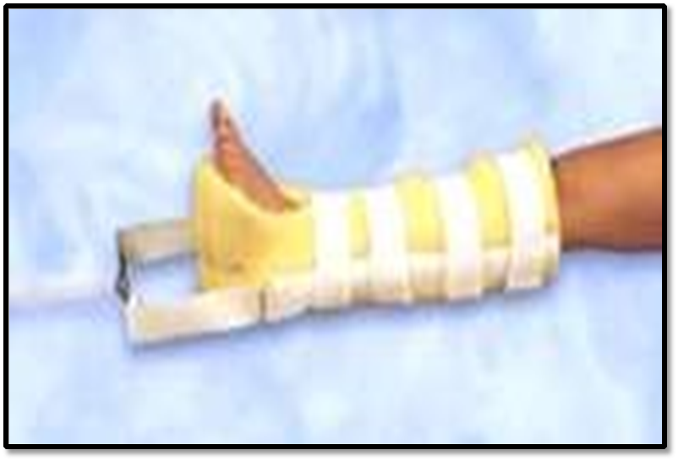

**Indication of skin traction**

1. Temporary management of femoral neck fractures and intertrochanteric fractures.
2. Management of femoral shaft fractures in older and hefty children.
3. Undisplaced fracture of acetabulum.
4. After reduction of a dislocation of the hip.
5. Prevent minor fixed flexion deformities of the hip or knee.
6. Management of low back ache.
7. Post Guillotine amputation to approximate the tissues.

### **Contraindication of skin traction**

1. Abrasion & Laceration to skin.
2. Dermatitis.
3. Any fragile condition of skin.
4. Impairment of circulation-varicose ulcers, Impending gangrene.
5. Marked shortening of bony fragments where more traction weight has to be applied.

### **Complications of skin traction**

1. Allergic reaction to adhesive.
2. Excoriation of skin on slipping.
3. Pressure sores around malleoli & achilles tendon.
4. Common peroneal nerve palsy.

## **Skeletal Traction**

* Traction force is applied directly to the bone by means of pins or wire driven through the bone.
* It is used more frequently in the management of lower limb fractures.
* It may be employed as a means of reducing or of maintaining the reduction of a fracture.
* It should be reserved for those cases in which skin traction is contraindicated.

**Equipment**

* Most commonly used pins are:

1. Steinman pin
2. Denham pin
3. K-wire
4. ***Steinman pin***

* Are rigid stainless steel, pins of varying length, 4 to 6 mm diameter*.*
* After insertion a special, stirrup (Bohler 1929) is attached to the pin.
* The Bohler stirrup allows the direction of the traction to be changed without turning the pin in the bone.

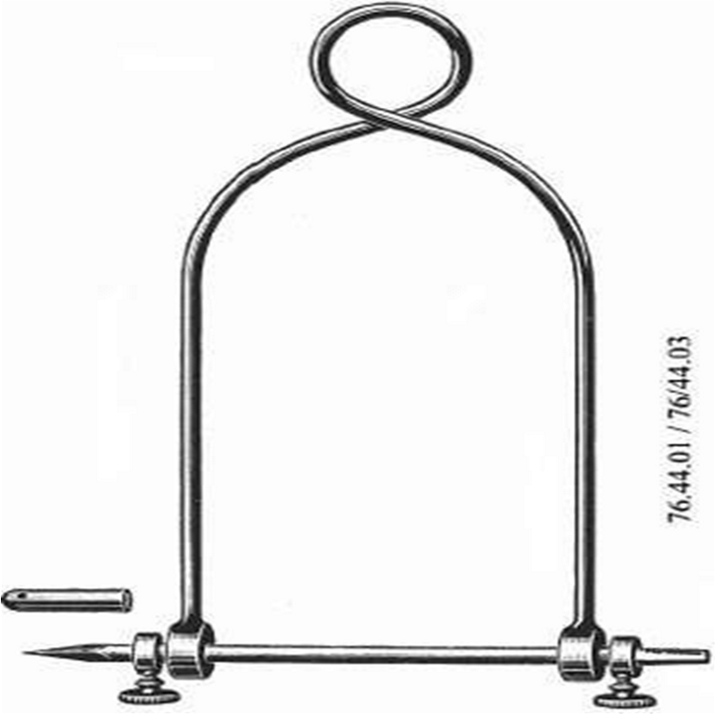

1. ***Denham pin***

* Similar to Steinmann’s pin except for a short-threaded length situated in the center and held in the introducer.
* It engages the bony cortex and reduces the risk of pin sliding.
* Used in a) cancellous bones & b) osteoporotic bones.

1. ***Kirschner wire***

* Is of small diameter and is insufficiently rigid until pulled taut in a special stirrup, rotation of the stirrup is imparted to the wire.
* 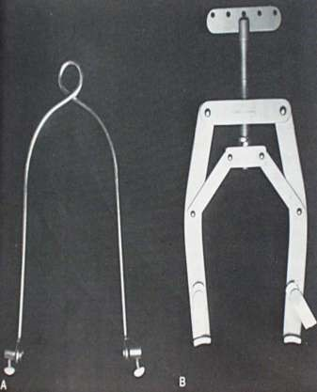Though they are thin but if proper special stirrup is used, they can withstand a large traction force because the stirrup provides a longitudinal tension force which increases the rigidity of the K-wire.

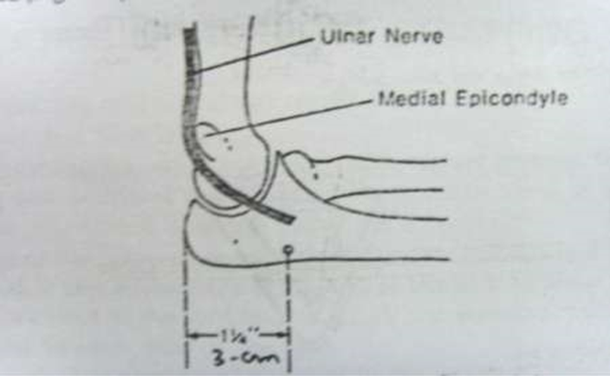

**Common sites for application of skeletal traction**

* 1. **Olecranon**
* k- wire is passed 3cm distal to tip of the olecranon
* Passed medial to lateral at right angle to longitudinal axis of ulna deep to subcutaneous border to avoid injury to ulnar nerve
* For supra condylar and trans condylar fracture humerus
* Also used for unstable fracture shaft of humerus

*Note*: A screw eye can also be used

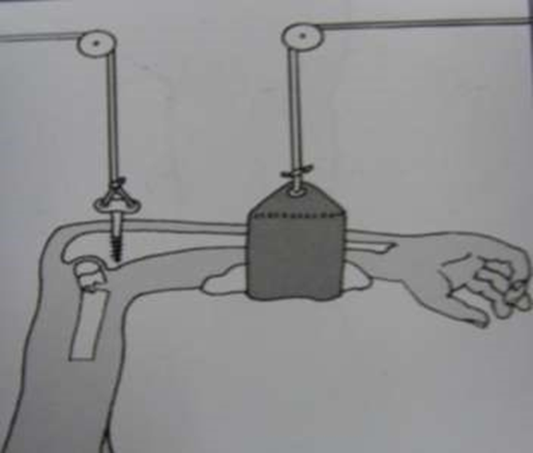

* 1. **Second and Third Metacarpals**
* Proximal to distal end of 2nd metacarpal
* Transverses 2nd and 3rd metacarpal right angle to longitudinal axis of radius.
* Used in comminuted #s of bones of forearm particularly that of lower end of radius.

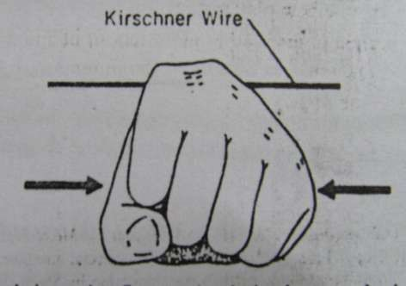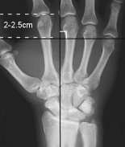

* 1. **Upper end of femur**
* Point of insertion is lateral surface of femur 2.5 cm below the most prominent part of GT midway between anterior and posterior surface
* Used in central fracture dislocation of hip
* Cancellous screw or screw eye is used

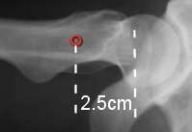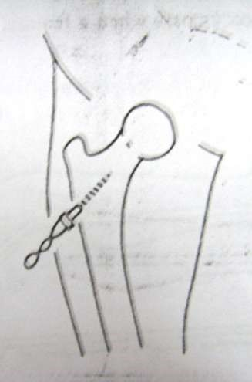

* 1. **Lower end of Femur**
* Point of insertion is determined by 2 ways
* Pin is passed as anteriorly as possible to avoid neurovascular structures.
* Avoid entering the knee joint

**Disadvantages**

* Prolonged traction through lower end of femur predisposes to knee stiffness

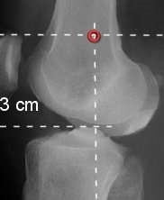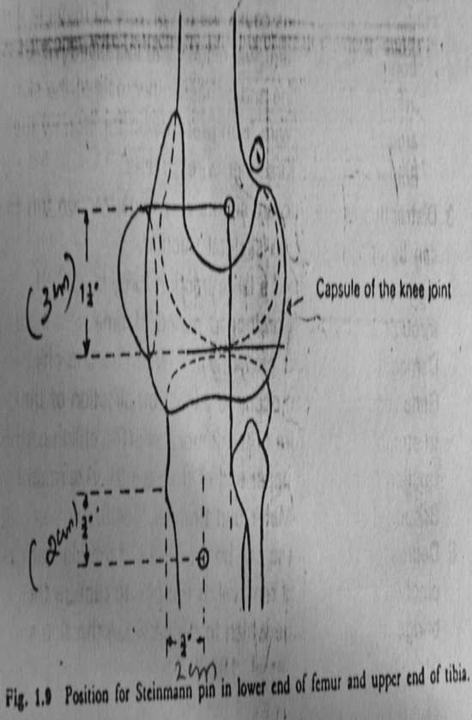

* 1. **Upper end of Tibia**
* Pin is passed lateral to medial to avoid injury to the common peroneal nerve.
* In young patients avoid open epiphysis

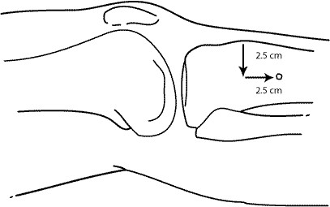

* 1. **Lower end of Tibia**
* Pin is inserted 5cms above the ankle joint mid-way b/n anterior & posterior diameter
  1. **Calcaneus**
* Avoid subtalar joint

**Advantages**

1. Traction force directly in line of the calf muscles and counteract their pull

**Disadvantages**

1. Subtalar joint stiffness
2. Infection
3. Frequent loosening

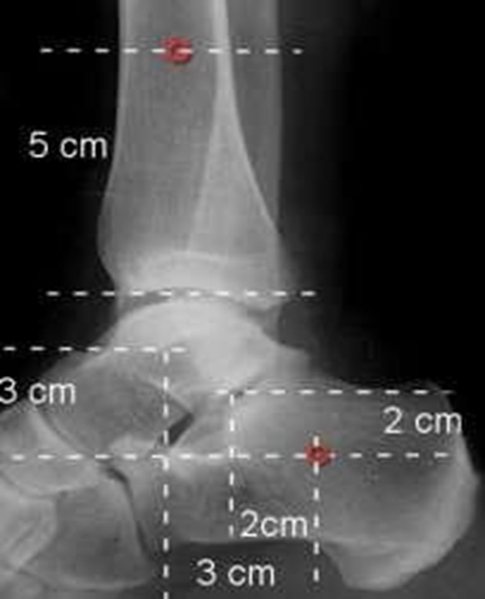

**Complications of Skeletal Traction**

1. Introduction of infection into a bone.
2. Incorrect placement of pin

-Allows pin to cut out of bone.

-Makes control of rotation of limb difficult.

-Makes application of splint difficult.

-Unequal pull causes pin to move in the bone causing ischemic necrosis

1. Large traction force.

-Distraction at fracture site. -Ligament damage.

1. Damage to epiphyseal growth plate in children.
2. Depressed scar and stiffness of joints.

**Counter- Traction**

* Reason for applying traction is to counteract deforming effect of muscle spasm this tends draw body in direction of traction
* To prevent this force is to be used in opposite direction called **Counter-traction**
* It can be done in two methods:

1. Fixed Traction
2. Sliding Traction
3. Combined traction
4. **Fixed Traction**

* 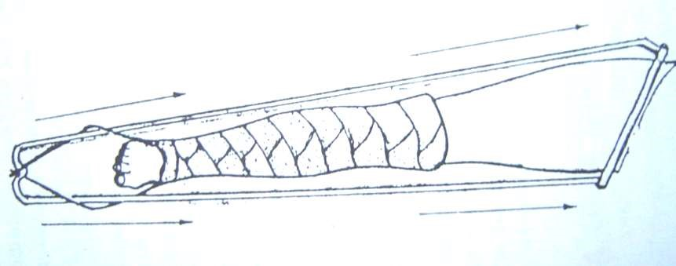When counter traction acts through an appliance which obtains purchase on a part of the body, it’s called a *fixed traction*.

**Methods of Fixed Counter Traction**

1. **Fixed traction in Thomas` splint**

* Maintain but not obtain reduction
* Counter thrust passes up the side bars to padded ring around the root of the limb.
* The malleoli are well padded to avoid pressure sores.
* The outer traction cord passes above and the inner cord passes below its respective side bar, to hold the limb in medial rotation.
* The traction cords are tied over the end of the Thomas splint.
* A traction weight of 5lbs (2.3kg) attached to the Thomas` splint is sufficient.

## **Advantages of Thomas Splint**

1. Distraction at the fracture site less likely to occur
2. No need to tighten the traction cords repeatedly
3. Apparatus is self-contained and can be moved without risk of displacement of fracture
4. **Traction unit**

* Introduced by Charnley.
* For the treatment of # Shaft of Femur.
* Consists of upper tibial Steinman pin incorporated in a below knee cast which is then fit in to a Thomas` splint.

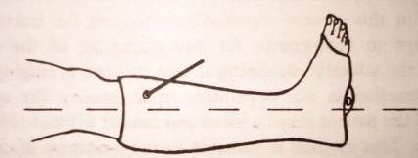

**Advantages**

1. Compression of the tissue of the upper calf including common peroneal nerve does not occur
2. Equinus deformity at the ankle can't occur because the foot is supported by plaster cast
3. The tendo-calcaneus is protected by the padded cast
4. Rotation of the foot and the distal fragment is controlled
5. A fracture of the ipsilateral tibia can be treated conservatively time.
6. **Roger Anderson well-leg traction**

* Originally used in management of #s of pelvis, femur, tibia.
* Skeletal traction being applied to injured leg, while the well leg was employed for counter traction.
* But this method is valuable in correcting either abduction and adduction deformity at the hip.

**Principle**

* With abduction deformity at the hip,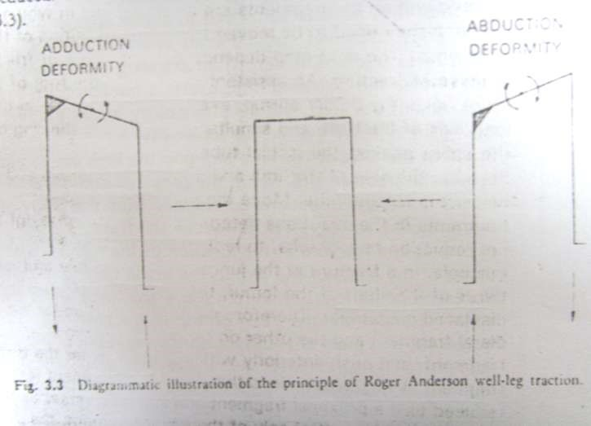 the affected limb appears to be longer.
* When Traction is applied to the whole limb, the affected limb is simultaneously pushed Up (counter traction).
* Abduction deformity is reduced.

REVERSING THE ARRANGEMENT WILL

REDUCE AN ADDUCTION DEFORMITY.

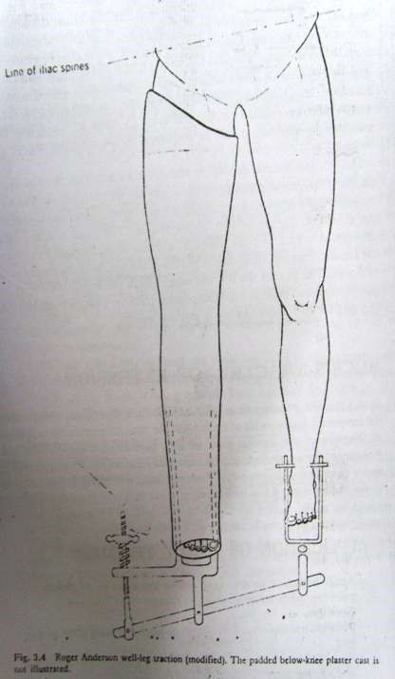

A/K PLASTER CAST

LIMB WHICH WILL

BE PUSHED UP

LARGE STIRRUP IN

PLASTER

STEINMENN PIN

THROUGH LOWER

END OF THE TIBIA OF

THE LIMB WHICH IS

TO BE PULLED DOWN.

BY ALTERING THE

POSITION OF SCREW

THE RELATIVE

POSITIONS OF TWO

STIRRUP CAN BE ALTERED.

* + 1. **Sliding traction**

**Definition**

* When the weight of all or part of the body acting under the influence of gravity is utilized to provide counter traction, the arrangement is called sliding traction.

**Principle**

* The traction force is applied by weight attached to adhesive strapping or a steel pin by a cord acting over a pulley.
* Counter traction is obtained by raising one end of the bed by means of wooden blocks so that the body tends to slide in the opposite direction.

**Types of sliding traction**

**In lower limb**

1. Bucks’ extension skin traction
2. Perkins traction
3. Russel traction
4. Tulloch- Brown Traction
5. 90-90 Traction
6. Gallows/ Bryant’s Traction
7. Bohler – Braun frame
8. Lateral upper femoral traction
9. Pelvic traction

**In upper limb**

1. Dunlop traction
2. Olecranon pin traction
3. Metacarpal pin traction

**Spinal traction**

1. Cervical traction

* Halter or non-skeletal traction
* Canvas or Chamois head halter
* Crile head halter
* Skull or skeletal traction

1. Halo pelvic traction

**Buck`s traction**

* Used in the temporary management of
* Femoral neck fractures,
* Femoral shaft fractures in older and larger children,
* Undisplaced #s of acetabulum,
* In place of pelvic traction,
* Correction of minor fixed flexion deformities of hip
* After reduction of dislocation of hip.

**Application**

* Apply adhesive strapping to above knee or in elderly Vento foam skin traction
* Support the leg with pillow.
* Pass the cord from spreader over pulley.
* Attach 2.3-3.2kgs (5 – 7 lbs.) to the cord.
* Elevate the foot end of bed.
* Lateral rotation of limb is not controlled

**Perkin`s traction (1970)**

* 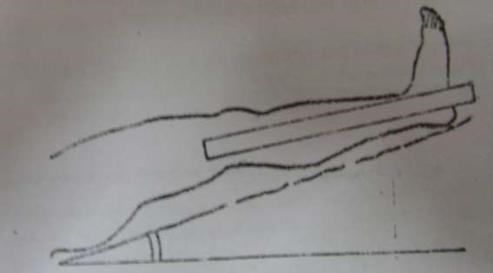Use in treatment of
* Fracture tibia
* # Femur from subtrochanteric region distally in all ages
* fracture Trochanter in <50 yrs.

**Principle**

* It is the use of skeletal traction without any external splintage coupled with active movements of injured limb
* Perkins showed that by encouraging early muscular activity stiffness of joint was prevented by extensibility of muscles by reciprocal innervation.

**Application**

* Under GA and aseptic precautions,
* 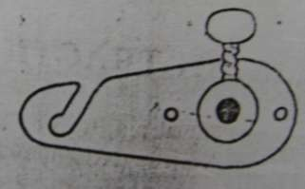Insert Denham pin through upper Tibia
* Attach Simoni’s swivel to each end of pin
* Connect 2 traction cords to each swivel
* Pass each cord over separate pulleys
* Attach wt. (4.6kgs) to each traction cord making total traction wt. of 9.2kgs.
* Elevate foot of bed by 1 inch for every 0.46 kg.
* Place pillows under thigh to maintain normal bowing of thigh.
* Check limb length with tape & increase or decrease the traction weight
* Start active quadriceps exercises immediately.

**Hamilton –Russel Traction**

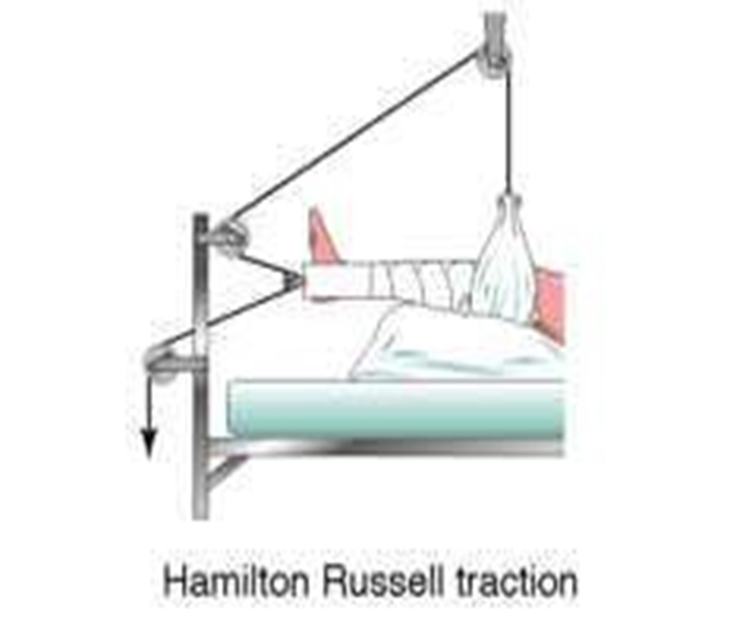

**Indications**

* Management of the fracture shaft of femur
* After arthroplasty operations on the hip

**Application**

* Belo knee skin traction
* Pulley attached to spreader
* Soft sling placed under knee

**Weight**

* Adults – 3.6 kg
* Children – 0.28- 1.8 kg

**Advantage**

* Based on the law of parallelogram of forces that - the 2 pulley blocks at the foot of the bed theoretically doubles the pull on the limb and the resultant traction is in axis of 30° to the horizontal i.e., in line of shaft of femur

**Tulloch Brown Traction.**

**Indications**

1. Management of patients who underwent cup arthroplasty or pseudoarthrosis of hip
2. # Shaft of femur

**Application**

* Steinman pin through the proximal tibia.
* Support legs on slings suspended from light duralumin U-loop which is slipped over the ends of Steinman pin.

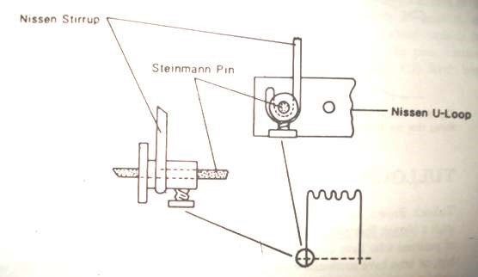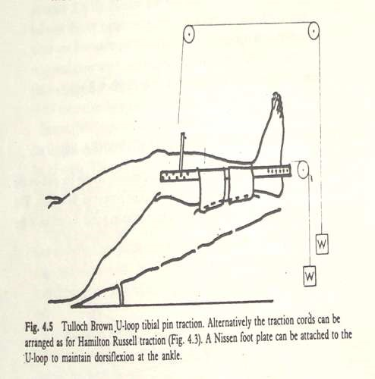

* Attach the Nissen stirrup to the Steinman pin it enables leg to be suspended and rotation of movements controlled.
* Foot supported in Perspex foot plate & foot end elevated.

**Ninety/Ninety Traction**

* Devised by Obletz (1946)
* Used in # femur with wounds over post aspect of thigh (operative & post op management)
* Subtrochanteric and proximal third # femur
* Used in both children and adults
* Here both hip and knee are flexed to 90*
* Skeletal traction is applied through lower femur or upper tibia
* 3 methods of supporting leg in 90/90 traction

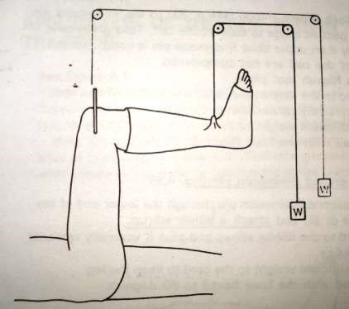

USING B/K CAST

* 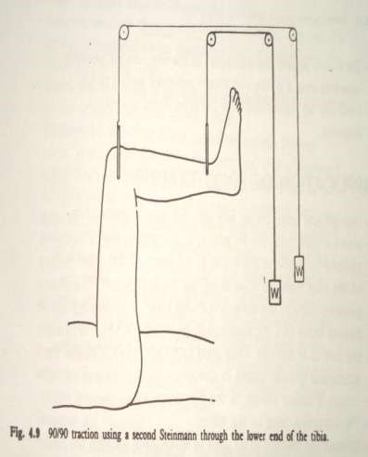USING A SECOND STEINMAN PIN
* 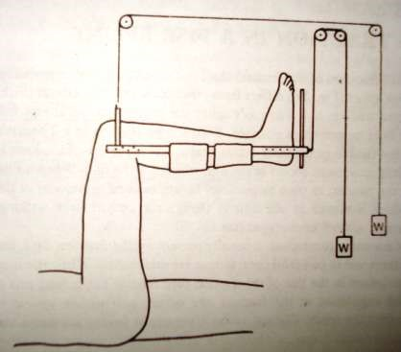USING TULLOCH BROWN U LOOP
* Varus /valgus angulation at fraction site is controlled by moving the pully,over which the traction cord passes,in a plane across the width of the bed.
* Rotation is controlled by the knee being flexed.

As the union of fracture occurs, encourage active hip and knee exercise-extension , gradually lower the limb into a more **Horizontal Position.**

**Dangers Of 90/90 Traction**

* 1. Those of skeletal traction.
  2. Stiffness and loss of extension of the knee.
  3. Flexion contracture of hip.
  4. Injury to the lower femoral or upper tibial epiphyseal growth plates in children.
  5. Neuro vascular damage.

**Bryant’s / Gallows Traction (1880)**

* # Shaft of femur in children <2 yrs.
* Apply adhesive strapping to both lower limbs
* Tie traction cords to an overhead beam
* Tighten the traction cord to raise the buttocks just clear the mattress
* Counter traction obtained by weight of pelvis

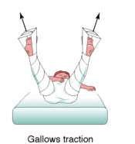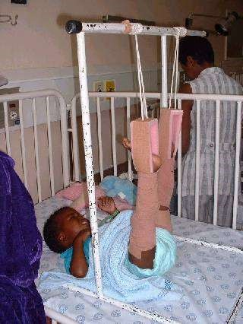

* Vascular complication of Bryant’s traction may occur in either the injured or normal limb.
* A careful check must be done in both limbs during first 24-72 hrs.

-By checking color and temp of limbs. -Dorsiflexion of both ankles passively.

* Bryant’s traction in:
  + children under 2yrs - safe
  + 2-4yrs - vascular complications more (can be prevented by using posterior splint).
  + Over 4yrs - absolutely contraindicated.

**Modified Bryant`s traction**

* In the initial management of CDH when diagnosed over the age of 1 year.
* After 5 days abduction of hip is started
* Abduction is increased by 10* on alternate days
* By 3wks hips should be fully abducted

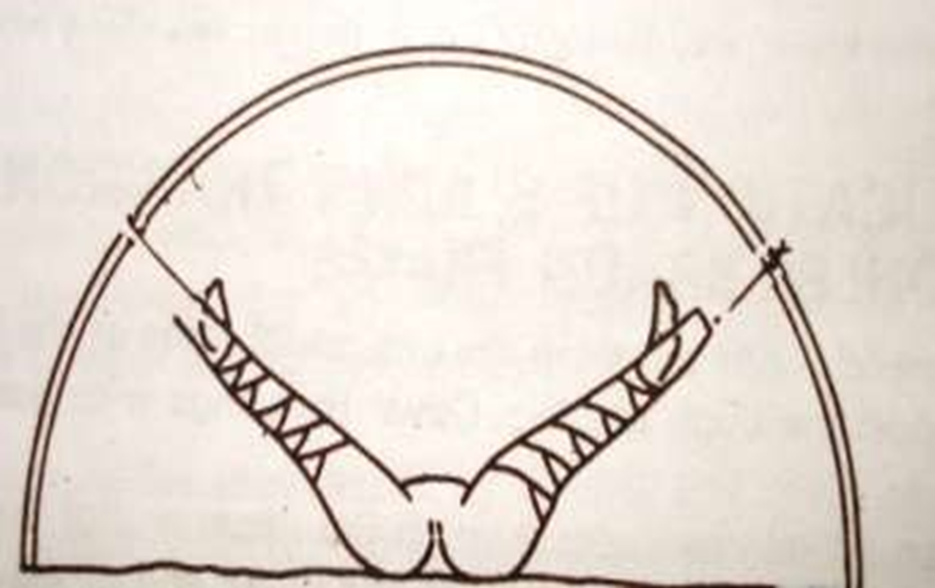

**Complication**

1. The child will become restless and scream repeatedly with pain.
2. The pain is due to stretching of capsule and impingement of femoral head on superior lip of acetabulum.

**Sliding Traction in Bohler-Braun frame**

* In management of tibia and femoral fractures.

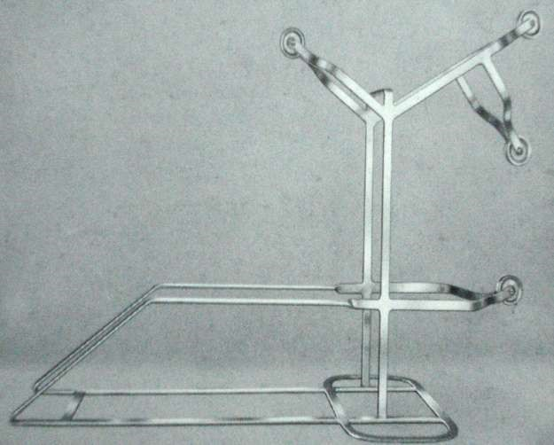

**Disadvantages**

1. Bohler Braun frame rests on pts bed and cannot move with the patient.
2. Nursing care is more difficult.
3. Movement of proximal fracture fragments in relation with distal fragment which is cradled in the splint.
4. This predisposes to deformity.

**Lateral upper femoral traction**

* Used alone or along with traction in long axis of femur in management of central fracture dislocation of Hip.
* If only superior rim of acetabulum is fractured combined with Buck's Russell traction
* If posterior rim of acetabulum is fractured and if reduction of dislocated femoral head is unstable, combined with vertical skeletal traction in lower end of femur or upper end of tibia.
* Maximum attachable weight - 4.5-9kg

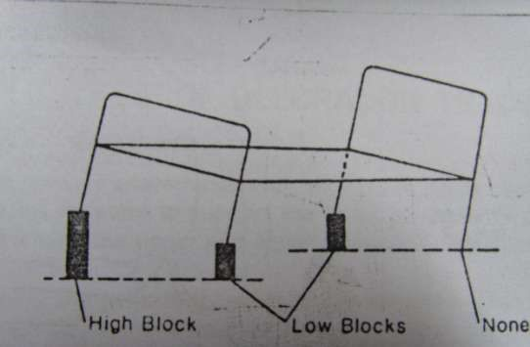

**Pelvic Traction**

* In pelvic traction special canvas harness is buckled around the patient’s pelvis.
* Long cords attach the harness to the foot of the bed.
* Foot end of the bed raised-provides sliding traction. Used in conservative management of IVDP. To ensure that the pt lies quietly in bed rather than to distract the vertebral bodies.
* Buck`s traction may also be employed

V BN N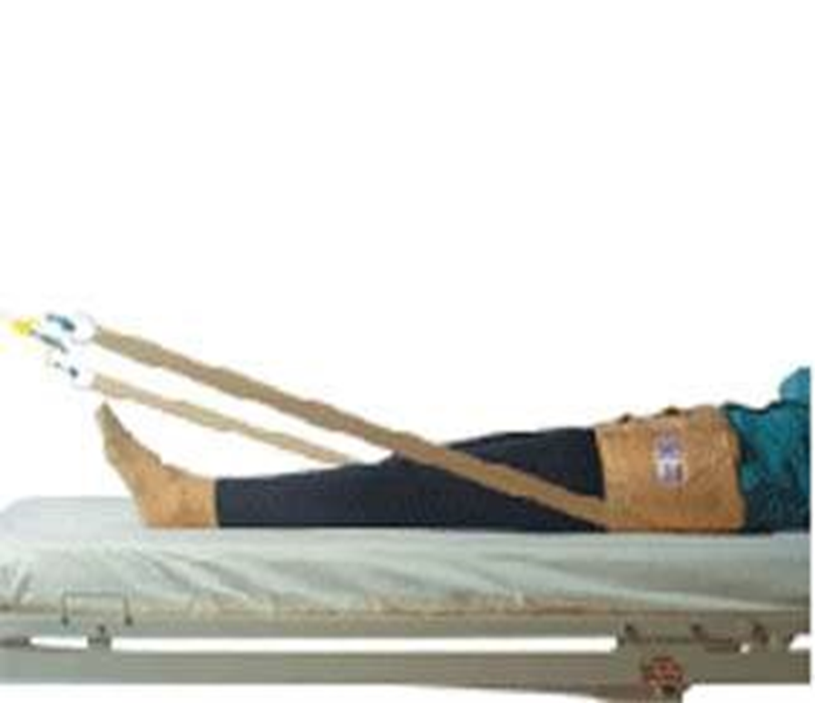

**Dunlop's traction**

* Used in management of Supracondylar and transcondylar fractures of Humerus in children.
* This method is useful if flexion of the elbow causes circulatory embarrassment with loss of radial pulse
* Apply skin traction to fore arm
* Place the patient supine
* Abduct the shoulder to 45*
* Pass the traction cord over a pulley so that elbow flexed to 45*
* 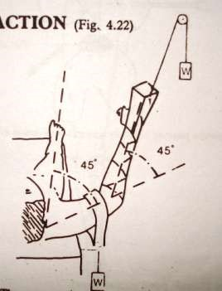Place padded sling over distal humerus
* Attach 1-2 lb. of wt. to traction cord and padded sling
* Elevate same side of bed
* Check circulation

**Olecranon Traction**

**Indications**

* Supracondylar fracture of humerus
* Comminuted fracture of lower end of the humerus
* Unstable fracture of the shaft of the humerus
* Weight – 1.3- 1.8 kg

**Metacarpal Pin Traction**

* Comminuted fracture of forearm Bones - Especially for a comminuted of lower end of the Radius
* Maximum attachable Weight Is - 1.3-1.8kg

**Complications**

1. Fibrosis in the interosseous muscles causing stiffness of fingers.
2. General complications of skeletal traction.

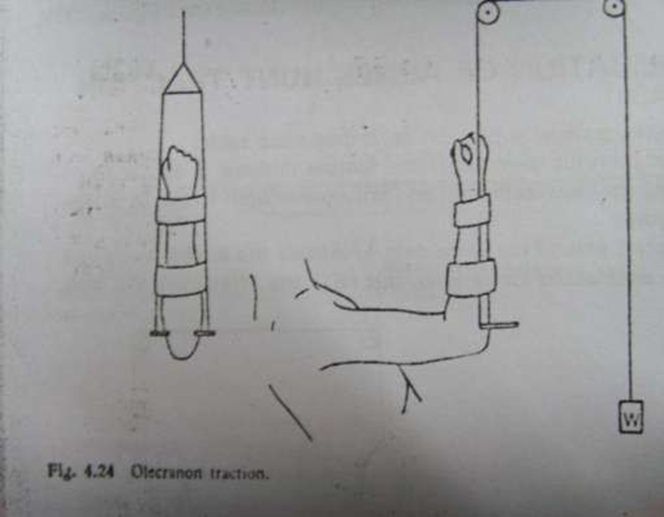

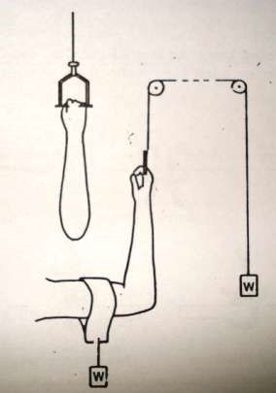

**Spinal Traction**

* Cervical spine

1. Skeletal traction (skull traction)
2. Non skeletal traction (halter traction)

## **Halters Traction**

**Indications**

1. Treatment of Cervical Spondylosis as an out patient

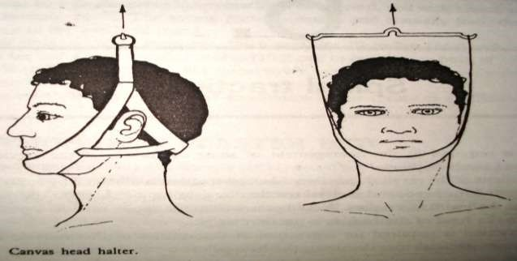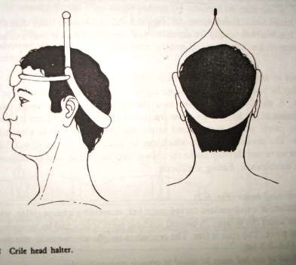

1. Maximum weight is 1.4 to 2.3 kgs
2. Two types – Canvas & Crile head halter
3. Head end of bed should be raised to provide counter-traction

**Skull Traction**

* Applied by gaining purchase on the outer table of the skull with metal pins
* Used in the serious injuries of cervical spine like
* To reduce a dislocation or fracture dislocation - in both case with traction the dislocation is under control and injury to spine does not occur
* To maintain the position of c- Spine before and after operative fusion
* For the treatment of cervical spondylosis with severe nerve root compression
* Maximum applicable weight is 9.1 to 18.2kg
* For skull traction use

1. Crutch field tongs
2. Cone or Barton tongs
3. **Crutch field tongs**

* Fits in **to** parietal bone
* A special drill with a shoulder is used to enable an accurate depth of hole **to** be drilled

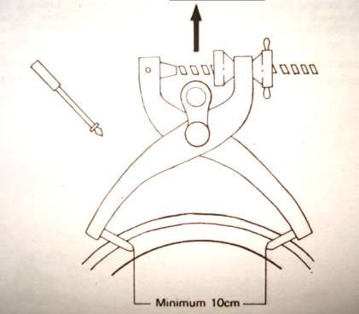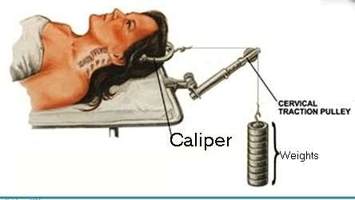

1. **Cone or Barton Tongs**

* A drill is not required for their insertion. The threaded steel points are screwed into the parietal bones behind the ears

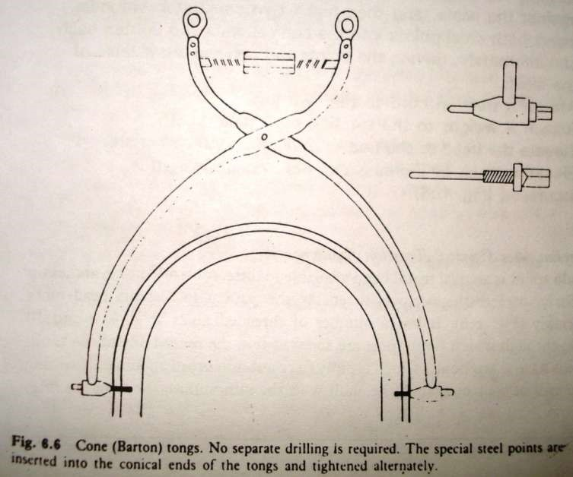

**Complications**

1. Tongs may pull out of skull
2. Tongs may penetrate inner table
3. Osteomyelitis
4. Extradural hematoma
5. Extradural abscess
6. Subdural abscess
7. Cerebral abscess

**Goals of cervical traction in cervical spine injury**

1. To realign spine
2. To prevent loss of function of undamaged neurological tissue
3. To improve neurological recovery
4. To obtain and maintain spinal instability
5. To obtain early functional recovery

**Recommended traction wts**

|  |  |  |
| --- | --- | --- |
| **LEVEL** | **MINIMUM WT** | **MAXIMUM WT** |
| **C 1** | **2.3 kg** | **4.5 kg** |
| **C 2** | **2.7 kg** | **4.5-5.5 kg** |
| **C 3** | **3.6 kg** | **4.5 -6.7 kg** |
| **C 4** | **4.5 kg** | **6.7-9.0 kg** |
| **C 5** | **5.4 kg** | **9.0-11.3 kg** |
| **C 6** | **6.7 kg** | **9.0-13.5 kg** |
| **C 7** | **8.2 kg** | **11.3-15.8 kg** |

**Removal of traction**

* Continue traction until # is stable and then change to another method of supporting the # until union is achieved
* Traction is continued for

- elbow # with olecranon pin-3wks

- tibial # with calcaneal pin-3 to 6 weeks

- trochanteric # - 6wks

- # SOF –6 to 12 weeks

***Thank you!***

***TYPES OF TRACTION***

***By mechanism***

***‘’ method***

***Mechanism- Balanced/SLIDING, FIXED, CoMBINED***

***METHODS- SKIN, SKELETAL, MANUAL***