**GENERAL PATHOLOGY 1**

***-boice kitavi-***

***LECTURE 4***

**CELL REPLICATION //CELL DIVISION**

The **cell cycle**, or **cell-division cycle**, is the series of events that take place in a [cell](http://en.wikipedia.org/wiki/Cell_%28biology%29) leading to its division and duplication (replication). In cells without a nucleus ([prokaryotic](http://en.wikipedia.org/wiki/Prokaryotic)), the cell cycle occurs via a process termed [binary fission](http://en.wikipedia.org/wiki/Binary_fission).

Mitosis and meiosis are both processes of cell division.

Most cells in human body only lasts a few weeks (an exception being brain cells which lacks centrioles for regeneration..hence last our life-time).

So the body must constantly keep on making new cells through mitosis

**MITOSIS**

Mitosis occurs in somatic cells (all cells that are not sex cells), and it’s a process critical for producing new cells and keeping an organism alive and healthy.

All cells go through a process of formation, growth, division, and eventual death.

In cells with a nucleus ([eukaryotes](http://en.wikipedia.org/wiki/Eukaryotes)), the cell cycle can be divided in three periods:- *(Interphase,Mitosis,Cytokinesis)*

**(A).** [**Interphase**](http://en.wikipedia.org/wiki/Interphase);-during which the cell grows, accumulating nutrients needed for mitosis and duplicating its DNA

**(B). Mitotic** (M) phase:- during which the cell splits itself into two distinct cells, often called "daughter cells"

**PMAT***(ACRONYM)*

1. Prophase: - first stage in cell division. Involves condensation of chromatin reticulum and disappearance of nucleolus/membrane.

Prometaphase: - nuclear membranes break down, kinetochore microtubules invade nuclear space

1. Metaphase: - chromosomes line up along metaphase plate
2. Anaphase: - chromosomes break at centromeres & sister chromatids move to opposite ends of the cell
3. Telophase & cytokinesis: - nuclear membranes reforms, nucleoli re-appear, chromosomes unwind into chromatin.

Myosin II & actin filament ring contract to cleave cell into two identical “daughter cells”

**(C). Cytokinesis**, where the new cell is completely divided.

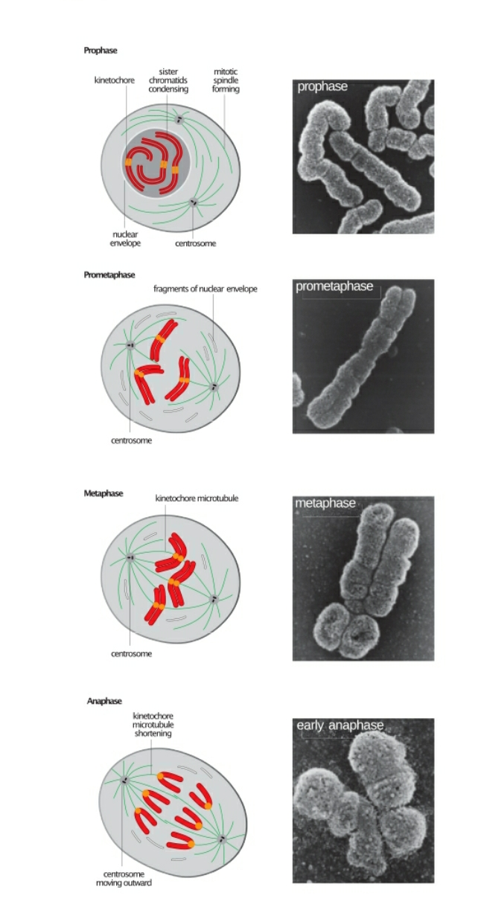

The cell-division cycle is a vital process by which a single-celled [fertilized egg](http://en.wikipedia.org/wiki/Fertilized_egg) develops into a mature organism, as well as the process by which [hair](http://en.wikipedia.org/wiki/Hair), [skin](http://en.wikipedia.org/wiki/Skin), [blood cells](http://en.wikipedia.org/wiki/Blood_cell), and some [internal organs](http://en.wikipedia.org/wiki/Viscus) are renewed.

**MEIOSIS**

Meiosis also involves cell division, however, it occurs in far fewer cells—gametes/ or sex cells. (sperm in male and ova in female)

Meiosis is crucial for sexual reproduction, and each cycle of meiosis creates four daughter cells with exact half the number o chromosomes as the parent cell.

During fertilization, two daughter cells one from each organism will combine to create an embryo with full set of chromosomes.

It’s a type of cell division of germ cells in sexually-reproducing organisms used to produce the gametes, such as sperm or egg cells.

It involves two rounds of division resulting in four cells with only one copy of each chromosome(haploid)

Of importance is that before the division, the genetic material from the patermal and matermal copies of each chromosomes is crossed over, forming new combination of code on each chromosome.

During fertilization, the haploid cells produced by meiosis from male & female fuse creating a cell with two copies of each chromosome –zygote.

**Similarities in mitosis & meiosis**

1. Both produce new cells
2. Both precede with interphase ( period of growth)
3. During cell replication, both follow same phase of prophase,metaphase, anaphase and telophase. (although meiosis goes each step twice while mitosis is once)
4. Both end with cytokinesis

**Difference between mitosis & meiosis**

|  |  |
| --- | --- |
| **mitosis** | **Meiosis** |
| 1. Mitosis includes one division | It involves two |
| 1. Gives two daughter cells | Results to 4 daughter cells |
| 1. Create diploid daughter cells | Creates haploid daughter cells |
| 1. Daughter cells genetically identical | Genetically different |
| 1. Creates body/somatic cells | Creates sex cells |
| 1. Undergoes one cell division 4stages | Two cell divisions 8 stages. |
| 1. Prophase is short | Prophase is long |
| 1. No crossing over/recombination | There is recombination during prophase 1 |

**--------------------------END OF LECTURE 4-----------------**