**MECHANICAL VENTILATION**

* By the end of the lesson, the learner will be able to:
  + Define mechanical ventilation
  + State the indications for mechanical ventilation
  + State the type of ventilators
  + Discuss the types of ventilator modes
  + Describe the common ventilator parameters that are set
  + Trouble shoot common ventilator alarms
* By the end of the lesson, the learner will be able to:
  + Describe the complications of mechanical ventilation
  + Discuss the nursing management of a patient on mechanical ventilation

Structural Plan of the Respiratory system

* Divided into -;
* Upper respiratory tract
* Lower respiratory tract
* Upper: nose, naso-pharynx, oropharynx, laryngopharynx,

and larynx.

* The lower: trachea, all segments of the bronchial tree,

and the lungs.

* Functionally, resp system also includes-; oral cavity, rib cage, and respiratory muscles including the diaphragm.

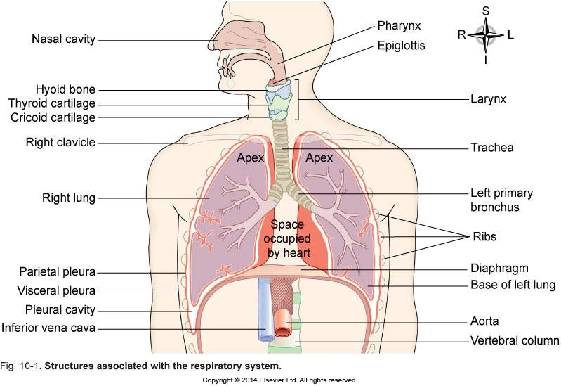

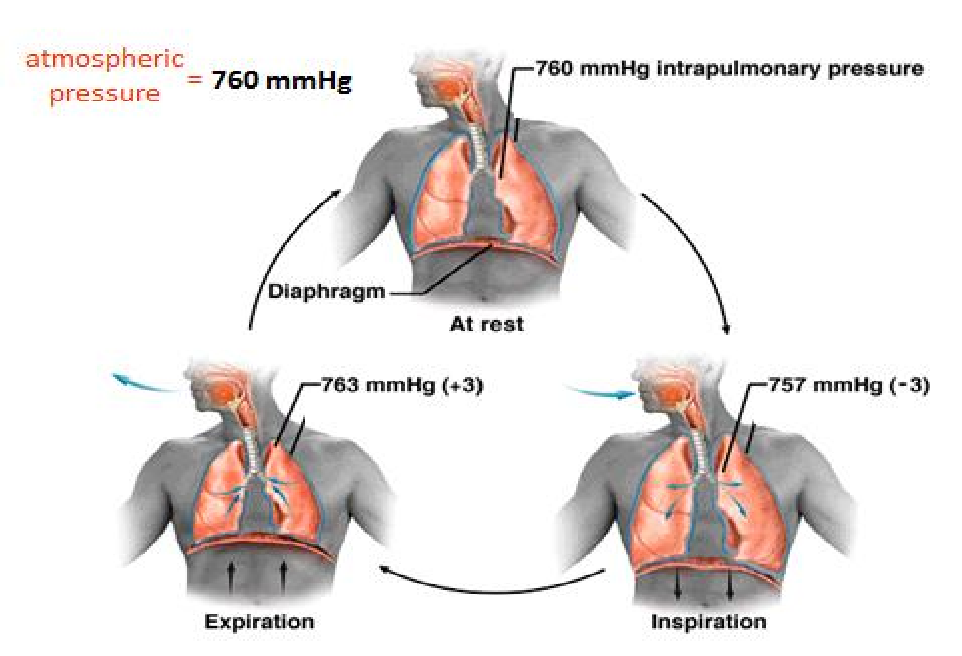

**Inspiration**

Contraction of

1. ***diaphragm***
2. ***external intercostal muscles***

←

The lungs are carried along.

←

✴ Lung volume

←

✵ pressure

←

Air flows in.

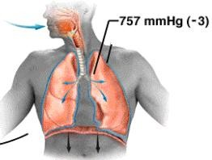

***active***

**Resting Expiration**

Relaxation of

* 1. ***diaphragm***
  2. ***external intercostal muscles***

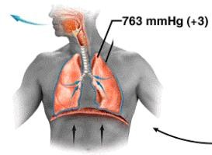

←

The lungs shrink.

←

✵ Lung volume

←

✴ pressure

←

Air flows out.

***passive***

Mechanism of respiration…..

|  |  |
| --- | --- |
| **Inspiration** | **Expiration** |
| Diaphragm contracts and becomes flattened | Diaphragm relaxes and becomes dome shaped |
| External intercostal muscles contract | External intercostal muscles relax |
| Rib cage moves upwards and outwards | Rib cage moves downwards and inwards |
| Thoracic cavity enlarges | Thoracic cavity decreases |
| Alveolar pressure becomes lower than atmospheric pressure | Alveolar pressure exceeds atmospheric pressure |
| Air moves into the lungs | Air moves out of the lungs |
|  |  |

## Lung volumes

* **Tidal volume (TV**): air volume of each breath(500mls at

rest)

* **Inspiratory reserve volume (IRV**): maximum volume that can be inhaled after a normal inhalation( 3.3L)
* **Expiratory reserve volume (ERV)** largest additional volume of air that one can forcibly expire after expiring tidal volume.(1- 1.2L).
* **Residual Volume: (RV):** What can not be forcibly exhaled (1.2L)

## Pulmonary Capacities

* **Capacity:** Sum of one or two volumes
* **Inspiratory capacity:** Total amount of air that can be inhaled(**IC =TV+ IRV)**
* **Functional residue capacity**: Amount of air remaining at air passages at the end of quiet respiration**.(FRC**

**=ERV+RV)**

* **Vital capacity (VC):** the maximum volume of air that can be moved in and out of the lungs**. VC = TV + IRV + ERV.** ( decreased in emphysema, pleural effusion, etc)
* Total Lung capacity: Total volume of air that a lung can hold. (**TV+IRV+ERV+RV)**

## Lung volumes

**FACTORS THAT GOVERN VENTILATION**

* PRESSURE: Inspiration and expiration are realized through negative and positive pressures created by the movement of the respiratory muscles
* RESISTANCE: This is determined chiefly by the size of the airway through which the air is flowing
* COMPLIANCE**:** measure of the elasticity, expandability, and dispensability of the lungs and thoracic structures

## Introduction

* 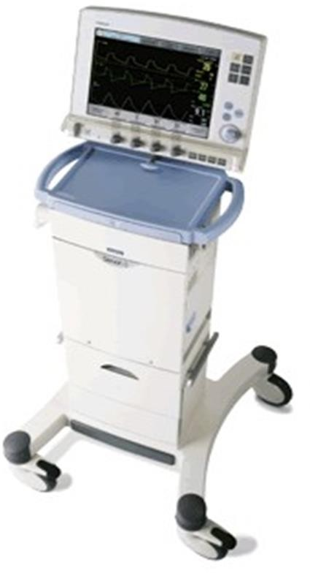Mechanical ventilation is ventilation of the lungs by artificial means usually by a ventilator.
* A ventilator is a device used to provide assisted respiration and positive-pressure breathing

## Mechanical ventilation: can be delivered via:

* 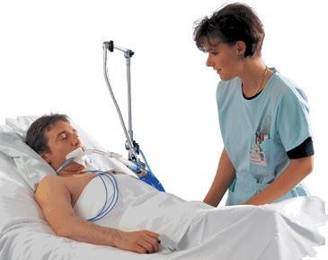Hand-controlled ventilation such as: Bag-Valve-Mask
* A mechanical ventilator

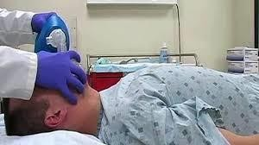

24 May 2018

First Aid

**15**

* + A ventilator delivers gas to the lungs with either negative or positive pressure.
  + Natural Breathing:
    - Negative inspiratory force
    - Air pulled into lungs
  + Mechanical Ventilation
    - Positive inspiratory pressure
    - Air pushed into lungs
  + Purpose of ventilation:
  + To maintain or improve ventilation, & tissue oxygenation.
  + To decrease the work of breathing & improve patient’s comfort.
  + Acute respiratory failure due to:
    - Neuro-mascular conditions e.g. GBS, MG
    - Musculoskeletal abnormalities e.g. flail chest
    - Infectious conditions e.g. pneumonia, Tuberculosis
  + Reverse hypoxemia in conditions like:
    - Obstructive lung disease e.g. asthma, emphysema, chronic bronchitis
  + Conditions such as pulmonary edema, pulmonary fibrosis
  + Prevent or reverse atelectasis
  + Relieve respiratory muscle fatigue
  + Allow sedation and neuromuscular blockade
  + Post cardiac arrest patients
  + Inability to protect the airway associated with depressed levels of consciousness
  + Short term adjunct in management of acutely increased intracranial pressure (ICP)

## Goals of Mechanical Ventilation

* + Relieve respiratory distress
  + Decrease work of breathing
  + Improve pulmonary gas exchange
  + Reverse respiratory muscle fatigue
  + Permit lung healing
  + Avoid complications

## Types of Mechanical ventilators:

* + Negative-pressure ventilators
  + Positive-pressure ventilators
  + High frequency ventilators

# NEGATIVE PRESSURE VENTILATORS

Mechanical ventilation

* + Early negative-pressure ventilators were known as “iron lungs.”
  + The patient’s body was encased in an iron cylinder and negative pressure was generated
  + Non-invasive ventilation first used in Boston Children’s Hospital in 1928
  + Used extensively during polio outbreaks in 1940s

– 1950s

* + The ventilators were applied externally to the patient
  + They decreased the atmospheric pressure surrounding the patient to initiate inspiration

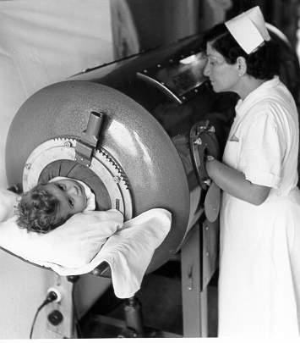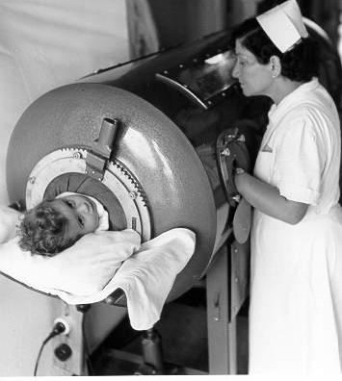

## Iron lung ventilator

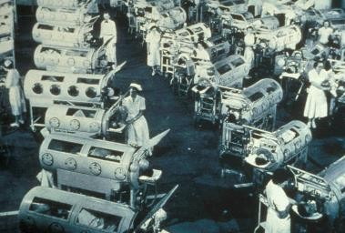

**Iron lung polio ward at Rancho Los Amigos Hospital in 1953.**

# POSITIVE PRESSURE VENTILATORS

Mechanical ventilation

## Positive-pressure ventilators

* + Positive-pressure ventilators deliver gas to the patient under positive-pressure, during the inspiratory phase.
  + Invasive ventilation first used at Massachusetts General Hospital in 1955
  + Now the modern standard of mechanical ventilation

## Positive-pressure ventilators

* + Positive-pressure ventilators require an **artificial airway (endotracheal or tracheostomy tube)** and **use positive pressure to force gas into a patient's lungs**
  + Inspiration can be triggered either by the patient or the machine

## Positive-pressure ventilators

* + Positive pressure ventilators are classified according to how the inspiratory phase ends i.e. the factor which terminates the inspiratory cycle reflects the machine type.
  + There are four types of positive-pressure ventilators:

#### volume-cycled

* **pressure-cycled**

#### flow-cycled

* **time-cycled.**
  + This type delivers a preset tidal volume with each breath then allows passive expiration
  + Inspiration is terminated after a preset tidal volume has been delivered by the ventilator.
  + The amount of pressure required to deliver the set volume depends on:
    - Patient’s lung compliance
    - Patient–ventilator resistance factors.
  + This is ideal for patients with acute **respiratory distress syndrome (ARDS)** or **bronchospasm**, since the same tidal volume is delivered regardless of the amount of airway resistance.
  + This type of ventilator is the most commonly used in critical care environments.
  + Therefore, peak inspiratory pressure (PIP ) must be monitored in volume modes because it varies from breath to breath.
  + With this mode of ventilation, a respiratory rate, inspiratory time, and tidal volume are selected for the mechanical breaths.
  + These ventilators deliver gases at a preset pressure to the patient early in inspiration, and sustains the pressure throughout the inspiratory phase then allow for passive expiration
  + Inspiration is terminated when a specific airway pressure has been reached.
  + By meeting the patient’s inspiratory flow demand throughout inspiration, patient effort is reduced and comfort increased.
  + Pressure cycled ventilators are commonly used in neonates because of the decreased risk of lung damage from high inspiratory pressures (neonates have a small lung that is still developing)
  + Although pressure is consistent, the volume will change with changes in resistance or compliance
  + Hence the tidal volume delivered can decrease if the patient has poor lung compliance and increased airway resistance.
  + Therefore, exhaled tidal volume is the variable to monitor closely.
  + Flow-cycled ventilators deliver oxygen until a preset flow rate is achieved during inspiration
  + Time-cycled ventilators deliver oxygenation over a preset time period
  + Inspiration is terminated when a preset inspiratory time, has elapsed.
  + Time cycled machines are used in pediatric intensive care areas.
  + **N.B:** Time and flow cycled ventilators are not used as frequently used as the volume-cycled and pressure-cycled ventilators

# HIGH FREQUENCY VENTILATORS

Mechanical ventilation

**40**

## High frequency ventilation (hfv).

* + HFV delivers a small amount of gas at a rapid rate (as much as 60-100 breaths per minute).
  + This is used when conventional mechanical ventilation would compromise hemodynamic stability, during short-term procedures, or for patients who are at high risk for lung rupture.
  + Sedation and/or pharmacologic paralysis are required.

# POSITIVE PRESSURE VENTILATOR MODES

Mechanical ventilation

## Ventilator mode

* + Ventilator modes refers to how the machine will ventilate the patient in relation to the patient's own respiratory efforts
  + There is a mode for nearly every patient situation; plus, many different types can be used in conjunction with each other
  + Each mode is different in determining how much work of breathing the patient has to do.

#### Volume Modes

* + **Pressure modes**

#### Volume Modes

* + - Assist control (AC)
    - Synchronized intermittent mandatory ventilation (SIMV)

#### Pressure Modes

* + - Continuous mandatory ventilation (CMV)
    - Pressure-controlled ventilation (PCV)
    - Pressure-support ventilation (PSV)
    - Continuous positive airway pressure (CPAP)
    - Positive end expiratory pressure (PEEP)
    - Noninvasive bilevel positive airway pressure ventilation (BiPAP)
  + The ventilator provides the patient with a pre-set tidal volume at a pre-set rate .
  + The patient may initiate a breath on his own, but the ventilator assists by delivering a specified tidal volume to the patient.
  + Patient can breathe at a higher rate than the preset number of breaths/minute
  + The ventilator delivers a preset volume
  + When patient triggers machine
  + Automatically if patient fails to trigger within selected time
  + In A/C mode, a mandatory (or “control”) rate is selected.
  + Often used as initial mode of ventilation
  + When the patient is too weak to perform the work of breathing (e.g., when emerging from anesthesia).
  + SIMV delivers the **preset volume** or **pressure** and **preset respiratory rate** while allowing the patient to breathe spontaneously.
  + The ventilator initiates each breath in synchrony with the patient's breaths.
  + In between the ventilator-delivered breaths, the patient is able to breathe spontaneously at his own tidal volume and rate
  + Ventilators breaths are synchronized with the patient spontaneous breathes (no fighting)
  + Adding pressure support during spontaneous breaths can minimize the risk of increased work of breathing.
  + The tidal volume of these breaths can vary drastically from the tidal volume set on the ventilator, because the tidal volume is determined by the patient’s spontaneous effort.
  + SIMV is used as a primary mode of ventilation as well as a weaning mode.
  + During weaning, the preset rate is gradually reduced, allowing the patient to slowly regain breathing on their own.

#### Advantages:

* + Synchrony, guaranteed minute ventilation

#### Disadvantages:

* + It may increase the effort of breathing and cause respiratory muscle fatigue. (Breathing spontaneously through ventilator tubing has been compared to breathing through a straw).
  + Sometimes it maybe complicated to set up

## Modes of Mechanical Ventilation

#### Pressure Modes

* + - Continuous mandatory ventilation (CMV)
    - Pressure-controlled ventilation (PCV)
    - Pressure-support ventilation (PSV)
    - Continuous positive airway pressure (CPAP)
    - Positive end expiratory pressure (PEEP)
    - Noninvasive bilevel positive airway pressure ventilation (BiPAP)

## Continuous Mandatory Ventilation (CMV)

* + Also called intermittent positive pressure ventilation (IPPV)
  + Ventilation is completely provided by the mechanical ventilator with a preset tidal volume, respiratory rate and oxygen concentration

## Continuous Mandatory Ventilation (CMV)

* + Ventilator **totally** controls the patient’s ventilation

i.e. the ventilator initiates and controls both the volume delivered and the frequency of breath.

* + Client does not breathe spontaneously and does not initiate a breathe
  + Patient is sedated and paralyzed so they that don't breathe out of synchrony with the ventilator (assist mode)

**55**

## Continuous Mandatory Ventilation (CMV)

#### Advantage

* + - Simple
    - There is guaranteed ventilation
    - Allows patient to rest their respiratory muscle

#### Disadvantages

* + - Inappropriate triggering if patient is not sedated adequately
    - Decreased compliance – high airway pressure
    - Requires sedation for synchrony
  + In pressure controlled ventilation the gas flows under constant pressure into the lungs during the selected inspiratory time.
  + The flow is highest at the beginning of inspiration (i.e. when the volume is lowest in the lungs).
  + As the pressure is constant the flow is initially high and then decreases with increasing filling of the lungs
  + Like volume controlled ventilation PCV is time controlled
  + The inspiratory pressure level, respiratory rate, and inspiratory–expiratory (I:E) ratio must be selected.
  + Tidal volume varies with compliance and airway resistance and must be closely monitored.
  + Sedation and muscle relaxants are used to avoid patient–ventilator dysynchrony
  + Inverse I:E ratios are used in conjunction with pressure control to improve oxygenation by expanding stiff alveoli by using longer distending times, thereby providing more opportunity for gas exchange and preventing alveolar collapse.
  + When the PCV mode is used, the mean airway and intra-thoracic pressures rise, potentially resulting in a decrease in cardiac output and oxygen delivery.
  + Therefore, the patient’s hemodynamic status must be monitored closely.

#### PS is a preset pressure which augments the patient's spontaneous inspiration effort and decreases the work of breathing.

* + The patient completely controls the respiratory rate and tidal volume.
  + The patient breathes spontaneously while the ventilator applies a pre-determined amount of positive pressure to the airways upon inspiration.
  + PS is used for patients with a stable respiratory status and is often used with SIMV during weaning.
  + Helps to overcome airway resistance and reducing the work of breathing
  + The patient’s effort determines the rate, inspiratory flow, and tidal volume.

## Continuous Positive Airway Pressure (CPAP)

* + There is constant positive airway pressure during spontaneous breathing
  + CPAP enables observation of the patient’s ability to breathe spontaneously while still on the ventilator.
  + CPAP can be used for intubated and non- intubated patients.
  + It is a weaning mode

## Positive end expiratory pressure (PEEP)

* + PEEP is a positive pressure that is applied by the ventilator at the end of expiration.
  + PEEP is the amount of pressure remaining in the lung at the END of the expiratory phase.
  + This mode does not deliver breaths but is used as an adjunct to improve oxygenation by opening collapsed alveoli at the end of expiration

## Noninvasive Bilateral Positive Airway Pressure Ventilation (BiPAP)

* + BiPAP is a non-invasive form of mechanical ventilation provided by means of a nasal mask or nasal prongs, or a full-face mask.

# VENTILATOR PARAMETERS

Mechanical ventilation

## Common Ventilator Settings parameters/ controls

* + Fraction of inspired oxygen (FIO2)
  + Tidal Volume (VT)
  + Peak Flow/ Flow Rate
  + Respiratory Rate/ Breath Rate / Frequency ( F)
  + Minute Volume (VE)
  + I:E Ratio (Inspiration to Expiration Ratio)
  + Sigh
  + The percentage of oxygen concentration that the patient is receiving from the ventilator. (Between 21% & 100%)
  + Initially a patient is placed on a high level of FIO2 (60% or higher) and subsequent changes in FIO2 are based on ABGs and the SaO2.
  + PEEP may be required to achieve a decrease in FI02
  + An FiO2 of 100% for an extended period of time can be dangerous (oxygen toxicity)
  + For infants, and especially in premature infants, high levels of FiO2 (>60%) should be avoided.
  + Oxygen toxicity is a concern when an FIO2 of greater than 60% is required for more than 24 hours
  + Usually the FIO2 is adjusted to maintain an SaO2 of greater than 90% (roughly equivalent to a PaO2 >60 mm Hg).
  + The volume of air inspired and expired with each breath.
  + Usual volume selected is between 5 to 12 ml/ kg body weight) (8mls/kg body weight)
  + Large tidal volumes may lead to (volutrauma) and aggravate the damage inflicted on the lungs
  + For this reason, lower tidal volume targets (6 to 8 mL/kg) are now recommended.
  + The tidal volume parameters are set above and below this number, and an alarm sounds if the patient's actual tidal volume is outside the desired range.
  + The speed of delivering the tidal volume, and is expressed in liters per minute.
  + The higher the flow rate, the faster peak airway pressure is reached and the shorter the inspiration
  + The lower the flow rate, the longer the inspiration.
  + Usual setting is 40-100 liters per minute
  + In general, keeping peak pressures below 30 cmH2O is desirable
  + In adults if the peak airway pressure is persistently above 45 cmH2O, the risk of barotrauma is increased
  + In infants and children it is unclear what level of peak pressure may cause damage because of the developing lung
  + The respiratory rate is the number of breaths the ventilator will deliver to the patient over a specific time period.
  + Total respiratory rate equals patient rate plus ventilator rate.
  + The total volume of air expired air moved into and out of respiratory system per minute
  + Respiratory rate multiplied by the tidal volume equals minute ventilation

VE = (VT x F)

## Expiration Ratio)

* + The ratio of inspiratory time to expiratory time during a breath
  + The I:E ratio is normally 1:2 or 1:1.5, unless inverse ratio ventilation(IRV) is desired.
  + The I:E ratio is reversed during inverse ratio ventilation 2:1 or greater (the maximum is 4:1).
  + Used for patients who are still hypoxic, even with the use of PEEP.

## Expiration Ratio)

* + Longer inspiratory time increases the amount of air in the lungs at the end of expiration (the functional residual capacity) and improves oxygenation by re-expanding collapsed alveoli.
  + Sedation and therapeutic paralysis required because it is very uncomfortable for the patient.
  + Defined as a deep breath.
  + A breath that has a greater volume than the tidal volume.
  + It provides hyperinflation and prevents atelectasis.
  + Sigh volume is usually 1.5 –2 times the tidal volume.
  + Sigh rate/ frequency is 4 to 8 times in an hour.
  + The ventilator can be programmed to deliver an occasional sigh with a larger tidal volume.
  + This prevents collapse of the alveoli (atelectasis) which can result from the patient constantly inspiring the same volume of gas.
  + Pressure limit regulates the amount of pressure the volume-cycled ventilator can generate to deliver the preset tidal volume.
  + The usual setting is 10-20 cm H2O above the patient's peak inspiratory pressure.
  + If this limit is reached the ventilator stops the breath and alarms.
  + High pressure limit alarm is often an indication that the patient's airway is obstructed with mucus and is usually resolved with suctioning.
  + It can also be caused by the patient coughing, biting on the endotracheal tube, breathing against the ventilator, or by a kink in the ventilator tubing.
  + The sensitivity function controls the amount of patient effort needed to initiate an inspiration
  + Trigger sensitivity can be set as flow triggering or pressure triggering
  + Flow triggering is preferred as this enables the patient to breathe with less effort
  + In non-invasive ventilation, its not possible to set trigger sensitivity
  + Increasing the sensitivity (requiring less negative force) decreases the amount of work the patient must do to initiate a ventilator breath.
  + Decreasing the sensitivity increases the amount of negative pressure that the patient needs to initiate inspiration and increases the work of breathing.
  + The more negative the number the harder it is to breath.

## thermoregulation

* + All air delivered by the ventilator passes through the water in the humidifier, where it is warmed and saturated.
  + Humidifier temperatures should be kept close to body temperature 35 ºC- 37ºC.
  + The humidifier should be checked for adequate water levels

## thermoregulation

* + As air passes through the ventilator to the patient, water condenses in the corrugated tubing.
  + This moisture is considered contaminated and must be drained into a receptacle and not back into the sterile humidifier.
  + If the water is allowed to build up, resistance is developed in the circuit
  + If moisture accumulates near the endotracheal tube, the patient can aspirate the water.

# VENTILATOR ALARMS

Mechanical ventilation

## Ventilator alarms

* + Mechanical ventilators comprise audible and visual alarm systems, which act as immediate warning signals to altered ventilation.
  + Alarm systems can be categorized according to volume and pressure (high, medium and low).
  + High-pressure alarms warn of rising pressures.
  + Low-pressure alarms warn of disconnection of the patient from the ventilator or circuit leaks.
  + High priority alarm messages include:
  + Apnea
    - Preset or default alarm limit exceeded
  + Check tubing
    - Problems with patient tubing
    - Disconnected or blocked pressure transducer
    - Water in expiratory tubing
    - Wet or clogged bacterial filter
    - Excessive leakage
  + Expiratory cassette disconnected
    - The expiratory cassette is disconnected or not connected properly
  + Expiratory minute volume high
    - Increased patient activity
    - Improper alarm setting
    - Preset alarm limit exceeded
  + Expiratory minute volume low
    - Low spontaneous breathing activity
    - Leakage in the patient’s breathing circuit
    - Improper alarm setting
  + Gas supply pressures low
    - Check gas connection
  + Oxygen cell sensor failure
    - Oxygen cell sensor missing or disconnected
  + High continuous pressure
    - Obstruction leading to a constant high airway pressure
  + Oxygen concentration high
    - Gas supply or air line disconnected
    - No supply from the wall outlet
  + Oxygen concentration low
    - Oxygen sensor is faulty
    - Oxygen cell is uncalibrated
  + Paw high
    - Airway pressure exceeds preset upper pressure limit
    - Kinked or blocked tubing
    - Mucus or secretion in ETT or in airway
    - Patient coughing
    - Ventilator dysynchrony (patient is fighting the ventilator)
    - Inspiratory flow rate is too high
    - Blocked expiratory filter
    - Improper alarm setting

### Medium/ Low priority ventilator alarms

* + Air supply pressure high
  + Air supply pressure low
  + Leakage out of range
    - Used in non-invasive ventilation
    - The nasal cpap mask is not adjusted properly for the patient or it’s the wrong size
  + PEEP high
    - The PEEP is above the preset default alarm limits for 3 consecutive breaths
  + PEEP low
    - Leakage in patient’s breathing circuit
  + If an alarm sounds, respond immediately because the problem could be serious.
  + Assess the patient first, while you silence the alarm.
  + Alarms must never be ignored or disarmed.

•

* + Ventilator malfunction is a potentially serious problem hence perform ventilator safety checks prior to ventilation
  + When a device malfunction is suspected, a second person manually ventilates the patient while the primary nurse looks for the cause.
  + If a problem cannot be promptly corrected by ventilator adjustment, a different machine is used so the defective ventilator can be taken for analysis and repair by technical staff (biomedical staff)
  + Ventilators **are electrical equipment** so they must be plugged in.
  + They have **battery back** up, but not designed for long-term use therefore ensure that they are plugged into an outlet that will receive generator power if there is an electrical power outage.
  + Ventilators are a method of life-support. There should be **a bag-valve-mask device at the bedside of every patient** receiving mechanical ventilation so they can be manually ventilated if needed should the ventilator stop working
  + Infection prevention & control measures should be strictly observed
  + **Many ventilators are computerized**. To activate the various modes, settings, and alarms, the appropriate key on the control panel need only to be pressed.
  + There are windows on the face panel which show

#### settings and the alarm values.

* + The ventilator tubing attaches to the ventilator on one end and to the patient's artificial airway on the other.
  + Most ventilators have clamps that prevent the tubing from draping across the patient.
  + There should be enough slack to prevent accidental pulling out of artificial airway if the patient turns.

COMPLICATIONS OF MECHANICAL VENTILATION

Mechanical ventilation

## Complications of Mechanical Ventilation

1. Airway Complications,
2. Mechanical complications,
3. Physiological Complications,
4. Artificial Airway Complications.

## I- Airway Complications

* + Aspiration
  + Decreased clearance of secretions
  + Nosocomial or ventilator-acquired pneumonia

## II- Mechanical complications

* + Hypoventilation
  + Hyperventilation
  + Barotrauma due to alveolar rupture from excessive airway pressures and/or over distention of alveoli.
  + Failure of alarms or ventilator or alarms turned off may lead to apnea and respiratory arrest
  + Inadequate nebulization or humidification
  + Overheated inspired air, resulting in hyperthermia
  + Fluid overload/ positive water balance due to vagal stretch receptors in right atrium sensing a decrease in venous return and see it as hypovolemia, leading to a release of ADH from the posterior pituitary gland and retention of sodium and water
  + Depressed cardiac function caused by venous return to the right atrium impeded by the increased intra-thoracic pressures during inspiration from positive pressure ventilation
  + Stress ulcers
  + Paralytic ileus
  + Gastric distension
  + Starvation
  + Dysynchronous breathing pattern

## IV- Artificial Airway Complications

* + Further classified as:
    - Complications related to endotracheal tube
    - Complications related to tracheostomy tube
  + Tube kinked or plugged
  + Tracheoesophageal fistula due to pressure of posterior tracheal wall resulting from overinflated cuff and rigid nasogastric tube
  + Tracheal stenosis due to injury from the end/tip of tube, resulting in scar tissue formation and narrowing of airway
  + Right bronchus intubation
  + Lung atelectasis
  + Cuff failure
  + Sinusitis
  + Otitis media
  + Laryngeal edema

### Complications related to Tracheostomy tube

* + Acute bleeding at the site
  + Air embolism
  + Tracheal stenosis
  + Failure of the tracheostomy cuff
  + Laryngeal nerve damage
  + Obstruction of tracheostomy tube
  + Pneumothorax
  + Subcutaneous and mediastinal emphysema
  + Tracheoesophageal fistula
  + Infection
  + Accidental decannulation with loss of airway

# NURSING MANAGEMENT OF A PATIENT ON MV

Mechanical ventilation

## Nursing care of patients on mechanical ventilation

#### Assessment:

1. Assess the patient
2. Assess the artificial airway (tracheostomy or endotracheal tube)
3. Assess the ventilator
   * Maintain airway patency & oxygenation
   * Promote comfort
   * Maintain fluid & electrolytes balance
   * Maintain nutritional state
   * Maintain urinary & bowel elimination
   * Maintain eye and mouth cleanliness and integrity
   * Maintain mobility/ musculoskeletal function via passive exercises
   * Maintain safety:-
   * Provide psychological support
   * Facilitate communication
   * Provide psychological support & information to family
   * Responding to ventilator alarms /Troublshooting
   * Prevent nosocomial infection- rationale use of antibiotic therapy
   * Documentation
4. **Maintain safety:-**
5. **Provide psychological support 10- Facilitate communication**
6. **Provide psychological support & information to family**
7. **Responding to ventilator alarms /Troublshooting ventilator alarms**
8. **Prevent nosocomial infection 14- Documentation**
   * By the end of the lesson, the learner will be able to:
     + Define mechanical ventilation
     + State the indications for mechanical ventilation
     + State the type of ventilators
     + Discuss the types of ventilator modes
     + Describe the common ventilator parameters that are set
     + Trouble shoot common ventilator alarms
   * By the end of the lesson, the learner will be able to:
     + Describe the complications of mechanical ventilation
     + Discuss the nursing management of a patient on mechanical ventilation

*THANK*

*YOU*