**MUSCLES OF UPPER EXTREMITY (CONTINUATION)**

**Dorsal interossei**

They are four in number

Origin: Adjacent sides of metacarpal bone

Insertion: Proximal Phalanges

Nerve supply: Ulna nerve C8, T1

Action:

* Abducts 2nd – 4th digit at M-P Joints
* Flexes M-P Joints
* Extends PIP & DIP joints of 2nd to 4th digits.

**Diagram of Dorsal interossei**

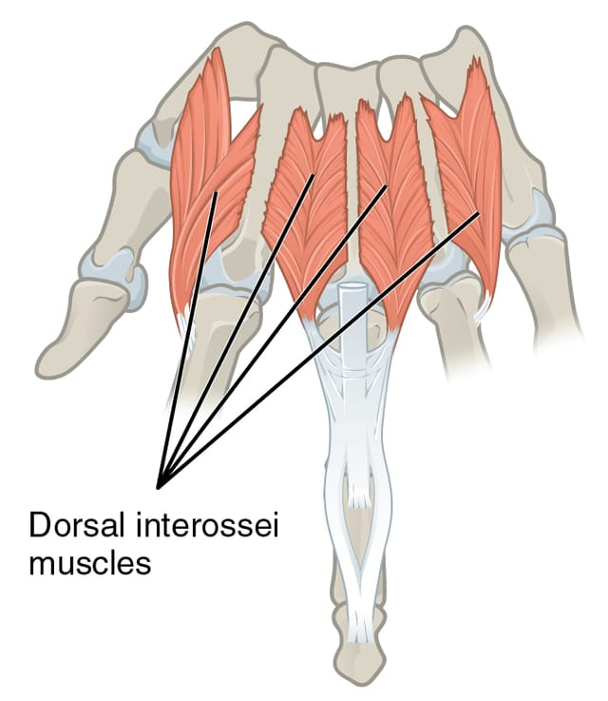

**Palmar interossei**

They are smaller than dorsal interossei

**Origin:** Sides of metacarpal bones

**Insertion:** Proximal phalanges

**Nerve supply**: Ulna Nerve C8, T1

**Action:**

* Adducts 2nd, 4th and 5th digits to midline of hand.
* Flexes M-P joints
* Extends PIP & DIP joints of 2nd, 4th & 5th digits

**Diagram of palmar interossei**

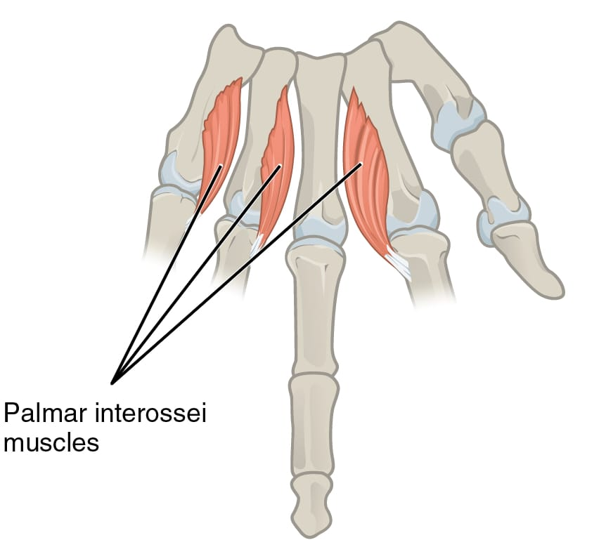

**Diagram of lumbricals muscles**

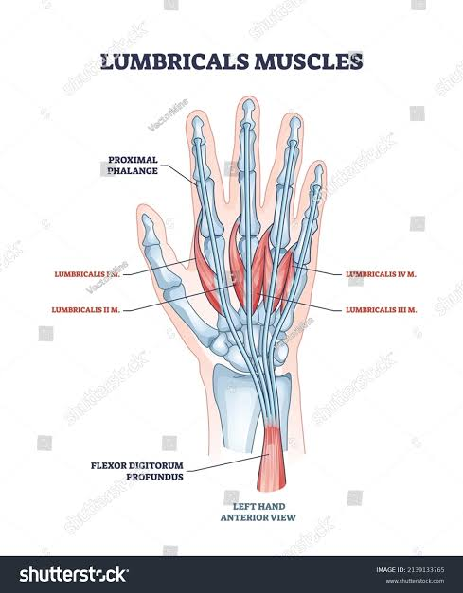

**The special features in the hand**

1. **The flexor retinaculum**

This is a strong band of fibrous tissue which runs across the palmer aspect of the wrist.

This is where flexor carpi ulnaris and palmaris longus muscles are inserted.

Diagram of flexor retinaculum.

1. **The palmar aponeurosis**

This is a dense fibrous tissue which forms the centre part of the deep fascia of the palm. It lies under superficial fascia of the palm. It is triangular in shape. It covers underlying nerves, blood vessels and tendons. This is the insertion point for palmaris longus muscle.

**Diagram of palmar aponeurosis**

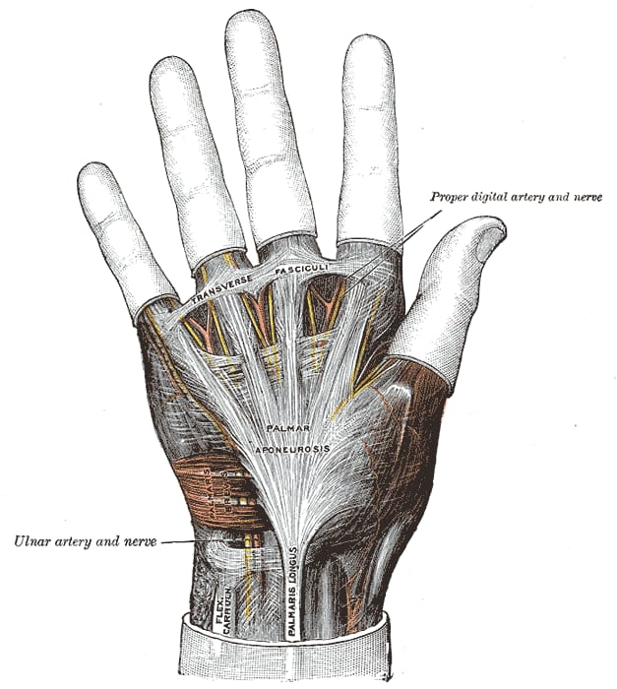

1. **The extensor retinaculum**

This is a strong band of fibrous tissue passing across the dorsal surface of the wrist.

**Diagram of extensor retinaculum**

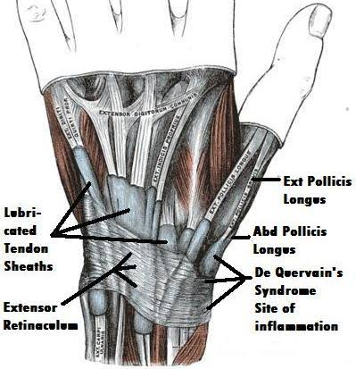

1. **The dorsal digital expansion**

When the extensor digitorum communis tendons reach the metacarpo-phalanged joints of hand, they broaden to cover the dorsal surface of the M-P joints. This broad expansion is called the dorsal digital expansion and it continues to cover the proximal phalanges.

**Diagram of dorsal digital expansion**

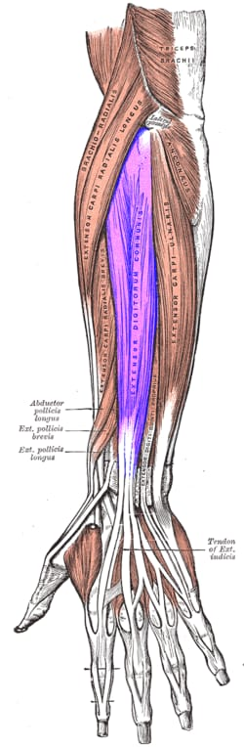

**Diagram of nerve supply to upper extremity**

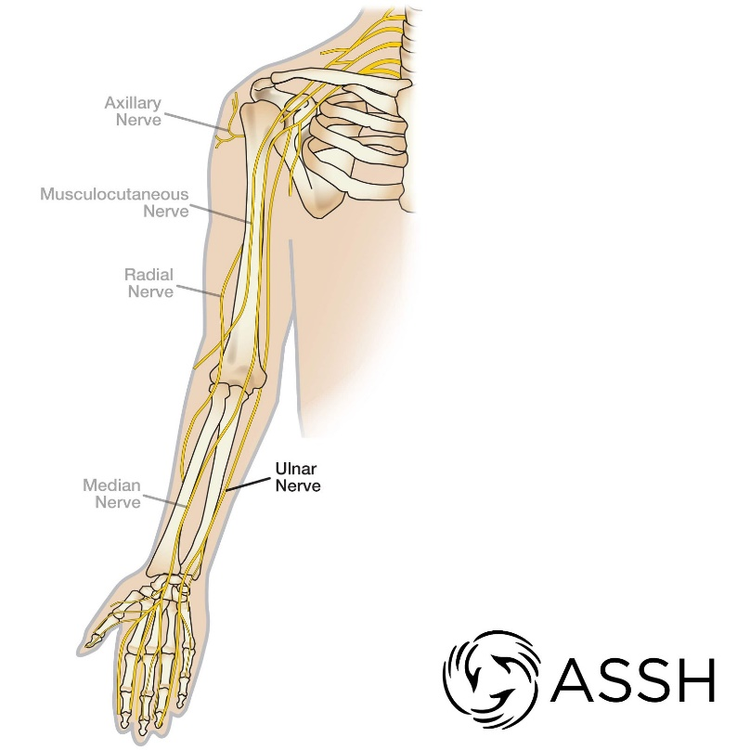

**Diagram of arterial blood supply to upper limb**



**Diagram of venous blood supply to upper limb**

