**THE KENYA MEDICAL TRAINING COLLEGE; SIAYA**

DIPLOMA IN CLINICAL MEDICINE AND SURGERY

SURGERY LECTURE NOTES

YEAR 3 GROUP

BY

OGAI PAUL OTIENO

Phone: 0721 244 629

Email: [paulotienoogai@yahoo.co.uk](mailto:paulotienoogai@yahoo.co.uk)

**UNIT 7: NON TRAUMATIC ORTHOPEDIC DEFORMITIES**

**SEC (i): NON ONFLAMMATORY DEFORMITIES (6 Hrs)**

**Contents**

**Congenital deformities**

* Osteogenesis imperfecta
* Cervical rib
* Spina bifida
* Congenital club foot
* Congenital hip dislocation
* Achondroplasia
* Genus vulgum and varum
* Pes cavum and pes planum
* Genus recarvatum
* Coxa vara and coxa Vulga

**Acquired deformities**

* Bone errors due to metabolism
* Padget’s disease
* Perthe’s Disease
* Slipped upper femoral epiphysis(SUFE)

1. **OSTEOGENESIS IMPERFECTA**

Inheritable disease of bones, teeth, tendons and ligaments are soft and brittle.

* 1. **Clinical presentation**

Child is born with multiple fractures

Fractures immediately after birth

Most Children don’t survive

* 1. **Treatment**

Like other fractures

Intramedulary nails

1. **CERVICAL RIB**

Overdevelopment of the costal process of C7

* 1. **Presentation**

Initially symptomless

Dropping of the girdle

Pain and paresthesia in the forearm on the ulna side, relieved by change of the arm position

Increased arm weakness

Muscle wasting

Cyanosis of forearm

Difficulty of fine hand movement

Finger gangrene

Weak/absent radial pulse

* 1. **Investigations**

Radiograph

* 1. **Ddx.**

Presence of cervical rib doesn’t prove the cause of symptoms

* PID at C7 – T1
* spinal cord tumors
* prolapsed cervical dislocation
* medial nerve pressure
* Osteomyelitis
  1. **Rx:**

Physiotherapy if mild

Operation if neurological and muscular symptoms

1. **SPINA BIFIDA**

Failure of enfolding of the spinal elements within the spinal canal during early embryonic development

Common in thoraco-lumbar or lumbar sacral regions

Maybe a dimple, tuft of hair or dermal sinus

Classified into:

* Spina bifida occulta: defect is not obvious at the skin surface, common at lumbar-sacral region. Tend to be mild.
* Spina bifida asperta: common at thoraco-lumbar regions and has a major defect of unfolding of the nerve elements involving the bony vertebral arches, soft tissues and the meningeal membranes. Usually more severe.
  1. **Clinical pnx:**
* Muscle wasting
* Foot deformities
* Urinary incontinence
* Impaired bowel function
* Limb paralysis
* Sensory paralysis
* May be associated with hydrocephalus
  1. **Treatment**
* Neurosurgery
* Careful nursing and feeding
* Correct orthopedic deformities at 2-3 yrs
* Physiotherapy

1. **CONGENITAL CLUBBED FOOT**

Are two:

* Talipes equinovarus
* Talipes calcanovalgus
  1. **Congenital Talipes equinovarus**

Cause is unknown. Its thought to be associated to malposition in utero or a neuromuscular defect.

There is underdevelopment of the soft tissues medially to the foot which become shorter. There is underdevelopment of calf muscles resulting in supination of the foot. The foot is adducted or inverted at the unkle.

The male-to-female ratio is 2:1. Bilateral involvement is found in 30-50% of cases. There is a 10% chance of a subsequent child being affected if the parents already have a child with a clubfoot.

Diagnosis is done by physically examining the newborn and radiography.

Prognosis and recovery depends on how early intervention is instituted.

* + 1. **Treatment**

Manual pressure applied weekly and retained using a plaster cast, adhesive tape or metal splints

Surgery after 3-4 months then retained by a POP



* 1. **Congenital talipes calcanovalgus**

The foot is everted and dorsoflexed.

Usually a mild deformity and respond better to initial treatment

Treated by repeated manual stretching of dorsum of the foot immediately after birth and retained with a POP.

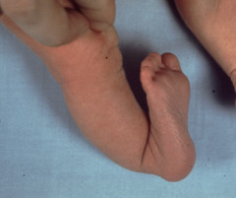

1. **CONGENITAL HIP DISLOCATION**

Spontaneouship dislocation occurring before, during and shortly after delivery

* 1. **Causes**

1. Genetical
2. Hormonal causes

Relaxin hormone from the fetal uterus in response to estrogen and progesterone; it has a role in relaxation of the ligaments

1. Breech malposition

Extension of hip at delivery coupled to ligamental laxity

1. Defective acetabulum development
   1. **Pathology**

The femur’s head is usually upwards and laterally to the acetabulum

The capsule is elongated at the femoral head and displaced upwards

The fibro-cartilage is usually folded into the cavity of the acetabulum

* 1. **Clinical presentation**

*Investigations*

* Plain X-ray at age 4 months
* Ultrasound scanning for the newborn
* Arthrography
* CT scan
* Common in girls
* One limb is commonly affected
* Abnormality may present when child begins to walk
* Shortening of affected limb
* Widening of perineum with marked lumbar lordosis
* Delayed walking or waddling gait
  1. **Treatment**
* Manual reduction and retention with a cast within the first 6 months

The surgeon faces the child when in supine , grasps the upper part of each thigh between the fingers with knees flexed at right angles, abduct steadily till femoral head snaps into acetabulum. POP is applied and a check xray done to monitor.

* Closed reduction by gallows traction between 6 months to 8 yrs

Traction with abducted hip for 3-4 wks. A check xray is done then a cast is applied.

* **Open reduction between 6 months to 8 yrs**

**The ligament is removed to allow the femoral head to fully engage.**

**ORTOLANI’S TEST AND BARLOWS MANOUVER**



**Ortolanis test**

*Indication*: developmental dysplasia of the hip dislocation and evaluation of congenital hip dislocation

*Mechanism*: Attempt to relocate hip into acetabulum. Examine each hip individually

*Preparation*: infant in supine. Hips flexed to 90 degrees

*Technique*:

* Infant's legs placed in frogleg position

Place index and middle finger over greater trochanter

Place thumb medially at inner thigh inguinal crease

* Attempt relocation of femoral head into acetabulum

Gently abduct the hip while applying upward force

Push upward with greater trochanter (away from bed)

Push toward bed and laterally with thumb at knee

*Findings*: hip clunk felt on exam, occurs when femoral head relocates in acetabulum; suggest congenital hip dislocation

A hip click means a benign finding

**Barlow’s test**

*Mechanism*: Attempt to sublux unstable hip. Perform with caution and examine each hip individually

*Preparation*: infant lying supine. Hips flexed to 90 degrees

*Technique*: stabilize pelvis

Place index and middle finger over greater trochanter

Place thigh medially at inner thigh inguinal crease

Gently adduct the hip while applying the downward force

*Findings*: Positive of hip clunk felt on exam. Represent dislocation of hip out of acetabulum

**ASSIGNMENT**

Make short notes on Galeazzi’s sign

1. **ACHONDROPLASIA**

Achondroplasia is the most common skeletal dysplasia

 It affects about 1 in every 40,000 children. Eighty percent of all "little people" have achondroplasia

The primary defect is abnormal endochondral ossification. Periosteal and intramembranous ossification is normal.

Tubular bones are short and broad, reflecting normal periosteal growth.

The iliac crest are normal, giving rise to large, square iliac wings.

The characteristic features of achondroplasia are apparent at birth. The hands and the legs are short. The head is slightly larger than normal with a bulging forehead.

Morbidity associated with achondroplasia may include the following:

* Recurrent [otitis media](http://emedicine.medscape.com/article/994656-overview) (hearing loss)
* Neurologic complications due to cervicomedullary compression (eg, hypotonia, respiratory insufficiency,apnea, cyanotic episodes, feeding problems, quadriparesis, sudden death)[[1]](javascript:showrefcontent('refrenceslayer');)
* Obstructive and restrictive respiratory complications (eg, upper airway obstruction, pneumonia, apnea)
* [Hydrocephalus](http://emedicine.medscape.com/article/247387-overview)
* Spinal deformities (eg, [kyphosis](http://emedicine.medscape.com/article/1264959-overview), lordosis, [scoliosis](http://emedicine.medscape.com/article/1259899-overview))
* Obesity
* Spinal canal stenosis
* [Genu varum](http://emedicine.medscape.com/article/1355974-overview)
* Cardiovascular complications
  1. **Treatment**

Aimed at managing complications

1. **GENU VULGA AND GENU VARUM**

* Genu varum (bow leg)
  + Medial angulation of leg in relation to thigh
  + Q angle is small
  + Femur is abnormally vertical
* Genu valgum (knock knee)
  + Lateral angulation of leg in relation to thigh
  + Q angle is large

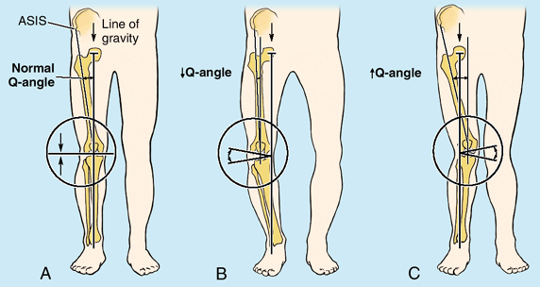

1. **PES CAVUM AND PES PLANUM**
2. **GENU RECARVATUM**
3. **COXA VARA AND COXA VALGA**

**ACQUIRED DEFORMITIES**

1. **PADGETS DISEASE**

Paget disease is a localized disorder of bone remodeling that typically begins with excessive bone resorption followed by an increase in bone formation.

This osteoclastic overactivity followed by compensatory osteoblastic activity leads to a structurally disorganized mosaic of bone (woven bone), which is mechanically weaker, larger, less compact, more vascular, and more susceptible to fracture than normal adult lamellar bone.

Paget disease may involve a single bone but is more frequently multifocal.

It has a predilection for the axial skeleton (ie, spine, pelvis, femur, sacrum, and skull, in descending order of frequency), but any bone may be affected.

After onset, Paget disease does not spread from bone to bone, but it may become progressively worse at preexisting sites.

Sarcomatous degeneration of pagetic bone is an uncommon but often deadly complication. Pagetic sarcoma is malignant, and the course usually is rapid and fatal

Although the etiology of Paget disease is unknown, both genetic and environmental contributors have been suggested. Ethnic and geographic clustering of Paget disease is well described.

Paget disease is common in Europe (particularly Lancashire, England), North America, Australia, and New Zealand.

It is rare in Asia and Africa. In the United States, most, although not all, individuals with Paget disease are white. (See Epidemiology.)

Approximately 70-90% of persons with Paget disease are asymptomatic; however, a minority of affected individuals experience various symptoms, including the following:

* Bone pain (the most common symptom)
* Secondary osteoarthritis (when Paget disease occurs around a joint)
* Bony deformity (most commonly bowing of an extremity)
* Excessive warmth (due to hypervascularity)
* Neurologic complications (caused by the compression of neural tissues)

1. **BONE ERRORS DUE TO METABOLISM**

Includes: hyperthyroidism, osteomalasia, nutritional rickets, osteoporosis etc.

* 1. **Hyperthyroidisma**

**ASSIGNMENT:** Make short notes on orthopedic manifestations of hyperthyroidism.

* 1. **RICKETS AND OSTEOMALASIA**

Rickets is a disease of growing bone that is unique to children and adolescents. It is caused by a failure of osteoid to calcify in a growing person. Failure of osteoid to calcify in adults is called osteomalacia

Vitamin D deficiency rickets occurs when the metabolites of vitamin D are deficient. Less commonly, a dietary deficiency of calcium or phosphorus may also produce rickets. Vitamin D-3 (cholecalciferol) is formed in the skin from a derivative of cholesterol under the stimulus of ultraviolet-B light

In the vitamin D deficiency state, [hypocalcemia](http://emedicine.medscape.com/article/921844-overview) develops, which stimulates excess secretion of parathyroid hormone. In turn, renal phosphorus loss is enhanced, further reducing deposition of calcium in the bone.

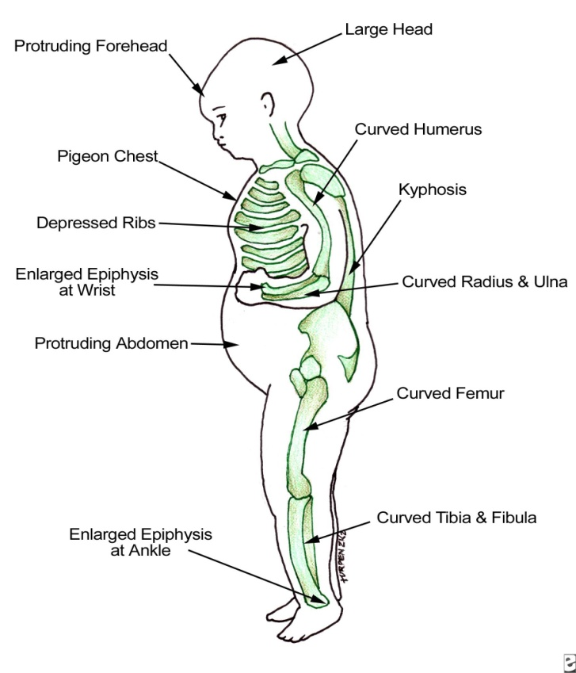 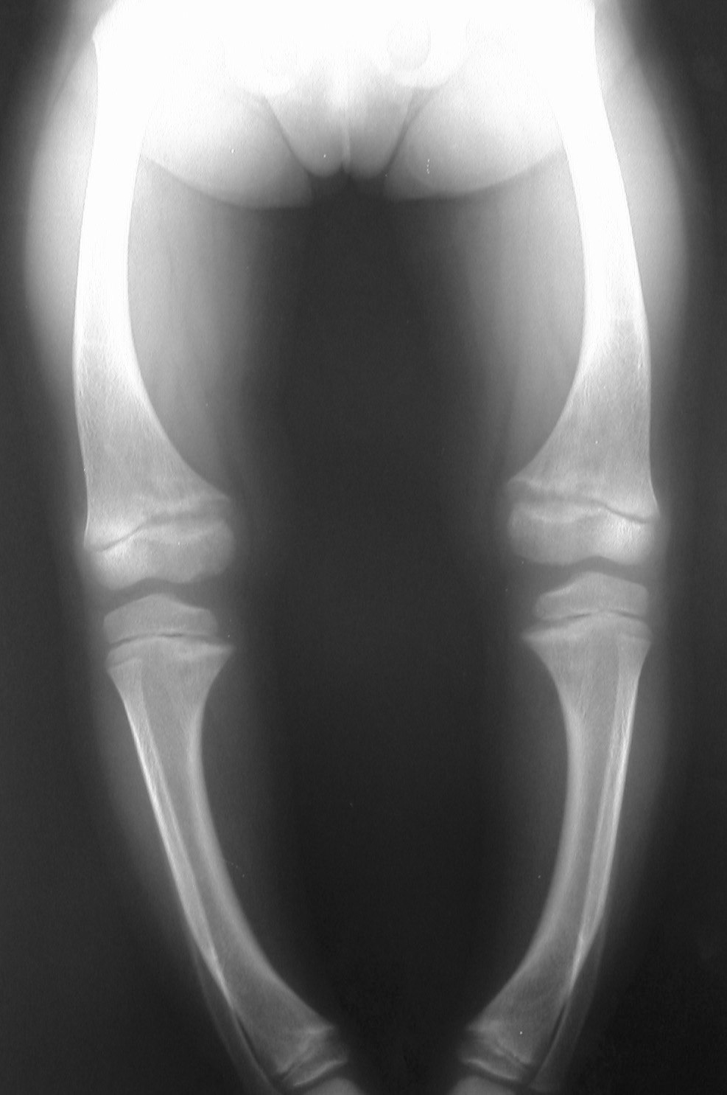

If rickets occurs at a later age, thickening of the skull develops. This produces frontal bossing and delays the closure of the anterior fontanelle. In the long bones, laying down of uncalcified osteoid at the metaphases leads to spreading of those areas, producing knobby deformity, which is visualized on radiography as cupping and flaring of the metaphyses.

Osteomalasia in adults presents with ostealgia, deformed bones and frequent pathological fractures due to lower bone density

*DDx*

Hypophosphatasia

Jansen syndrome

Hereditary hypophosphatemic vit D resistant ricet

Severe calcium deficiency

Severe phosphorus deficiency

*Investigations*

Rediograph: loss of bone density, thin cortices, generalized bone rarefaction, curved long bones

Low plasma phosphate and calcium

*Treatment*

Adequate vit. D and calcium

Osteotomy to correct severe deformity

1. **LEGG, CALVE AND PERTHES DISEASE**

* First described by Legg, Calves and Perthes. The disease arises from an idiopathic osteonecrosis of the capital femoral epiphysis in a child.
* Disorder of the hip in young children
* Usually ages 4-8yo
* As early as 2yo, as late as teens
* Boys: Girls= 4-5:1
* Bilateral 10-12%
  + 1. **Aetiology**
* No evidence of inheritance
* Past theories: infection, inflammation, trauma, congenital
* Most current theories involve vascular compromise
* Causes have been associated by
  + Excessive femoral antiversion.
  + Synovitis.
  + Generalized skeletal disorder.
  + Arterial anomalies

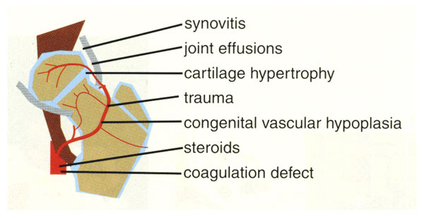

* + 1. **Clinical** **features**
* Stature usually shorter than peers
* Quadriceps and gluteal muscle wasting is common, Trandelenburg test positive (drop of the hip on the unsupported side)
* Acute phase; range of motion at the hip joint is limited due to muscle spasms
* Progressively; limited internal rotation and abduction is likely due to impingement lesions (hence the Roll test, guarding on affected side)
* Later stage; global reduction in all ranges of motion assoc. with pain, indicating joint arthritis

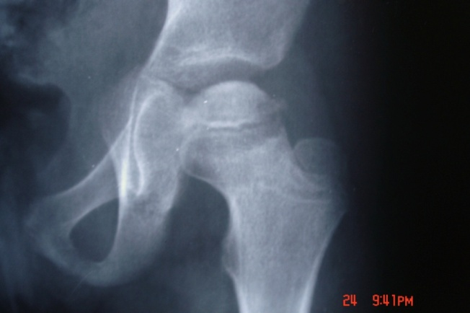 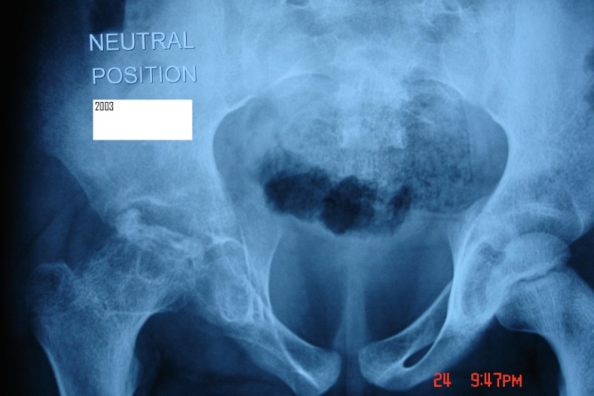

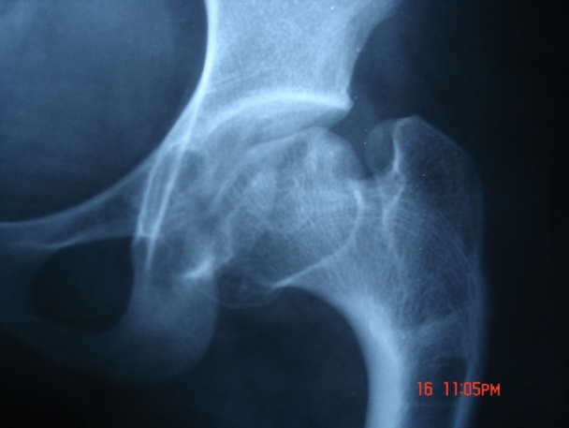 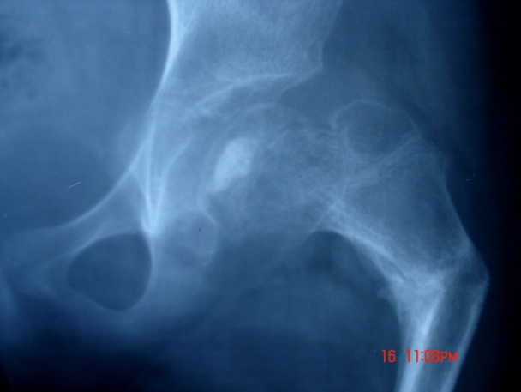

Risk factors

* Age- 4 to 10 years, with peak incidence at 7
* Gender- Boys (5:1 ratio) but it tends to be more severe in girls
* Height
* Passive smoking or maternal smoking at pregnancy
* ADHD? Increased physical activity
* Family Hx of; skeletal dysplasias or thrombotic disease
* Ethnicity; more common in Whites, Eskimos, Japanese
* Social Hx- associated with low socio-economic status
  + 1. **Differentials**
* Unilateral
* Septic hip
* Toxic synovitis
* Slipped femoral capital epiphysis
* Lymphoma
* Bilateral
* Hypothyroidism
* Sickle cell
* Multiple epiphyseal dysplasia
* Spondylo-epiphyseal dysplasia
  + 1. **Investigations**
* Technetium 99 bone scan - Helpful in delineating the extent of avascular changes before they are evident on plain radiographs. The sensitivity of radionuclide scanning in the diagnosis of LPD is 98%, and the specificity is 95%.
* Dynamic arthrography - Assesses sphericity of the head of the femur
* Ultrasonography may provide significant diagnostic clues to differentiate early Perthes' from transient synovitis.
* CT scan, MRI
  + 1. **Treatment**

Overall goal of treatment

* Reduce hip irritability and pain
* Restore/maintain hip mobility
* Prevent femoral head from extruding or collapsing “CONTAINMENT**”**

Below 6 years and Herring A/B

* Mainstay of treatment would be to OBSERVE with 6-12-month reassessment.
* Patients in this age group need bed rest and anti-inflammatory medication at most. NO evidence that abduction splints or surgery beneficial
* Prognosis is good for the majority
* Regain spherical shape of femoral head

Non Surgical treatment

* NSAIDS
* Traction
* Casts and braces

Above 6 and Herring class B

* Containment of the head within the acetabulum is warranted

This is achieved by;

* Abduction bracing
* Femoral varus osteotomy
* Pelvic ostotomy

Age between 6-8 and Herring class C

* Results of intervention have been equivocal.

Above 9 years

1. Often have Herring class B or C
2. Prognosis is poor
3. Early containment is key, by pelvic osteotomy and internal fixation
   * 1. **Compilations**

**Femoral**

* + Shortening
  + stiffness
  + Malrotation
  + Limp
  + Positive trendelenburg

**Pelvic**

* + Lenghtening
  + Stiffness
  + Chondrolysis
  + Failure of containment
  1. **SLIPPED UPPER FEMORAL EPIPHYSIS-SUFE**