**NUCLEIC ACIDS**

**Isolating The Material Of Heredity**

* In 1869, Friedrich Miescher, a Swiss physician and scientist, was the first individual to isolate **nucleic acid**. In his day, he called it nuclein.
* Almost a century later, scientists established a connection between nucleic acids and Mendel’s factors of inheritance.

**The Components Of Nucleic Acids**

* Further research on Miescher’s nuclein found that it was made up of strand-like complexes of nucleic acids and proteins. Today the strand-like structures are called chromosomes.
* In the early 1900s, Phoebus Levene made several discoveries about nucleic acids. He isolated two types of nucleic acids which were distinguished by the different sugars they contained.

1. The first type of acid contained a five carbon sugar called ribose, thus he called it ribose nucleic acid or **ribonucleic acid ( RNA )**.

2. The second type of acid contained another five carbon sugar called deoxyribose, thus he called it deoxyribose nucleic acid or **deoxyribonucleic**  **acid ( DNA )**.

* Levene showed that both RNA and DNA are made up of long chains of individual units called **nucleotides**. Each nucleotide is made up of three parts ;

1. A five carbon sugar

2. A phosphate group

3. A nitrogen containing base

* DNA contains four possible nitrogen bases ;

1. Adenine ( A )

2. Thymine ( T )

3. Cytosine ( C )

4. Guanine ( G )

* RNA contains four possible bases:

1. Adenine ( A )

2. Uracil ( U )

3. Cytosine ( C )

4. Guanine ( G )

* Nucleotides join together to form long chains.

**Evidence For The Role of DNA In Heredity**

* In 1928, Fred Griffith studied the bacteria which was responsible for the London pneumonia epidemic. He was using dead stretococcal bacteria as a control in his experiments, but during his experiments found that dead pathogenic bacteria had passed on their pathogenic properties to non-pathogenic bacteria. He called this the **transforming principle**. However, he had no idea what the transforming principle was.

* In 1944, three scientists, Avery, MacLeod, and McCarty did a series of experiments to attempt to isolate the agent behind the transforming principle. From their experiments they discovered that the transforming principle was DNA.
* In the late 1940s, another scientist, Erwin Chargaff, did further work in this area. He made the following discoveries ;
* The four nucleotides in DNA are not present in equal amounts.
* The nucleotide composition of DNA varies from one species to another.
* The nucleotide composition of DNA within a species is constant.
* In any sample of DNA, the amount of Adenine is equal to the amount of Thymine and the amount of Cytosine is equal to the amount of Guanine. This constant relationship is called **Chargaff’s** **rule**.
* In 1952, Hershey and Chase did an experiment in which they used radioactive labeling techniques in an experiment with a virus or phage which infects bacterial cells. They performed two different experiments; the first contained viruses with radioactive DNA while the other contained viruses without radioactive DNA but with a radioactive protein coat. In the first experiment, the infected bacteria contained radioactive material while in the second experiment the infected bacteria did not contain any radioactive material. They concluded that only the DNA was transferred from the virus to the bacteria, not the protein coat. This provided proof that DNA was the transforming principle just like Griffith suggested.
* Throughout the 1940s and 50s further evidence was found to support the idea that DNA was a main factor of heredity.

**The Structure Of Nucleic Acids**

* By the late 1940s it was known that DNA was made up of nucleotides and each nucleotide was made up of three parts including:
* Sugar
* Phosphate
* Nitrogenous base
* However, scientists were unsure of how the DNA strand was arranged.
* Two British scientists, Rosalind Franklin and Maurice Wilkins used X-rays to photograph the DNA molecule and from their photographs concluded that DNA had a helical structure. They also concluded that the nitrogenous bases were located on the inside of the DNA structure while the sugars and phosphates were located on the outside of the molecule.
* In 1953, two scientists James Watson and Francis Crick produced a structural model of DNA which today we call the **double helix model**. This is the model which we accept today.

**The Double Helix**

* DNA is a molecule which is made up of two long strands of nucleotides which are joined together in the shape of a **double helix**. { See Fig. 17.12, P. 574 }
* In its unwound state, the DNA molecule resembles a ladder and is thus called a Ladder Structure. { See Fig. 17.13, P. 575 }
* The four nitrogenous ( nitrogen ) bases which are located in the center of the model fall into two categories ;

1. Adenine and guanine are from the family of

nitrogenous compounds known as **purines**.

2. Thymine and cytosine are from the family of

nitrogenous compounds known as **pyrimidines**.

Watson and Crick concluded that a purine base always

joins with a pyrimidine base.

* The pairing of the nitrogenous bases in the center of the DNA molecule is called **complementary base pairing**. The possible pairings which exist between the bases are:

Adenine – Thymine

Thymine – Adenine

Cytosine – Guanine

Guanine – Cytosine

**The base pairs are held together by hydrogen bonds, the cytosine – Guanine bond ( C – G ) forms three hydrogen bonds while the Adenine – Thymine bond ( A – T ) forms two hydrogen bonds.**

* The two strands of the DNA molecule are not identical to each other. They are called **anti-parallel strands**.

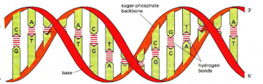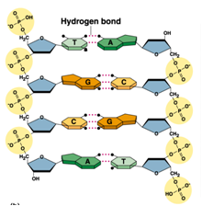

**NUCLEOTIDES AND NUCLEIC ACIDS**

INFORMATION FLOW IN CELLS = “Central Dogma of Molecular Biology”  
DNA→ RNA→ PROTEINS

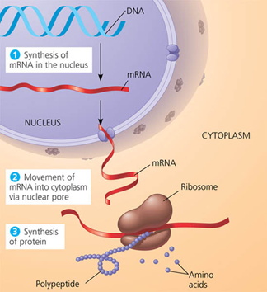

**FUNCTION**

DNA- genetic code contains info that programs cell activities

RNA-carries message from DNA to cell; protein synthesis

**BASIC STRUCTURE**

NUCLEOSIDE = nitrogenous base + sugar

NUCLEOTIDE = nitrogenous base + sugar + phosphate group  
PURINES = 2 rings; Adenine (A), Guanine (G)

PYRIMIDINES = 1 ring; Cytosine (C), Thymine (T), Uracil (U)

**Nitrogenous bases**

**Both the purines and pyrimidines.**

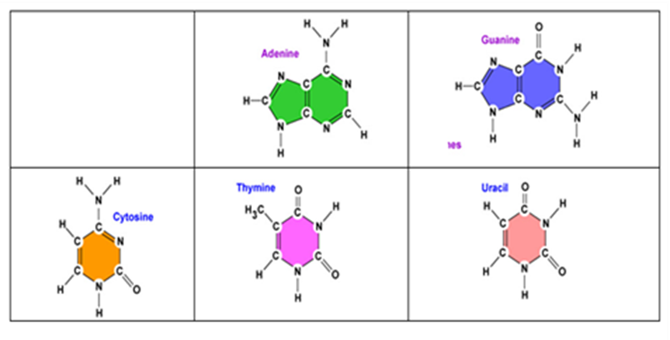

**Sugar**

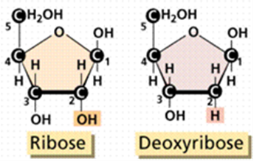

**PHOSPHATE GROUP**

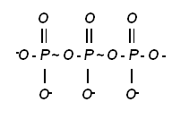

**NUCLEOSIDE**

Contains a nitrogenous base and sugar

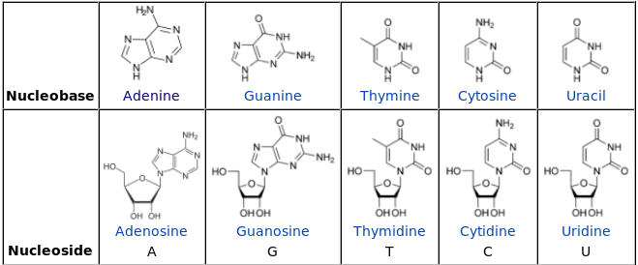

**NUCLEOTIDE**

Can have one, two, or three phosphate groups   
 (mono, di, tri-phosphates)

High energy bond between phosphate groups   
 is important energy transport

Named for nitrogen base and number of phosphate groups  
EX: adenosine triphosphate (ATP)  
 cytosine diphosphate (CDP)  
 guanosine monophosphate (GMP)

IMPORTANT NUCLEOTIDES  
ADENOSINE TRIPHOSPHATE (ATP) = main energy currency in ALL living things   
 (GTP & UTP also used)

CYCLIC AMP (cAMP)- “Second messenger”

Important in cell signaling and response to hormones

COENZYMES- Many coenzymes are nucleotides or their derivatives (vitamins)

EX: Flavin adenine dinucleotide (FAD) & nicotinamide adenine dinucleotide (NAD) used in cellular respiration

nicotinamide adenine dinucleotide phosphate (NADP) used in photosynthesis

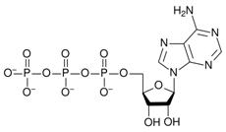

**DNA**

* Stands for **DEOXYRIBONUCLEIC ACID**
* The structure of DNA is a **DOUBLE HELIX (2-stranded spiral)**
  + “Deoxy” means ONE oxygen has been **WITHOUT OXYGEN**
  + Deoxyribose – the type of 5-carbon **SUGAR** found in DNA (remember sugars end in **-OSE**).
* Where is DNA found? **NUCLEUS**
* Can DNA leave the nucleus? **NO** WHY or WHY NOT? **TOO LARGE**

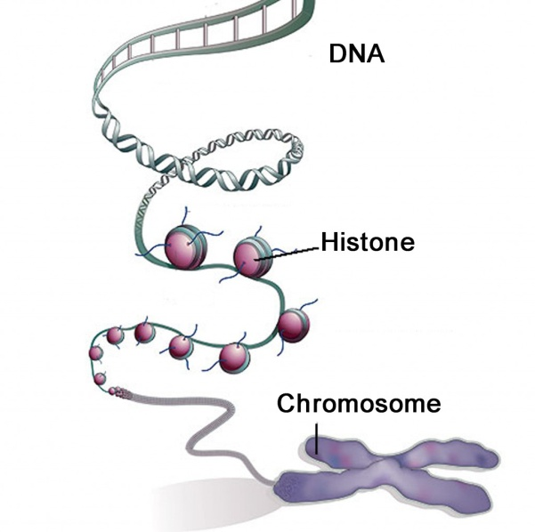

* In the **NUCLEUS** of the cell, **CHROMOSOMES** are structures that are made of **DNA** wrapped tightly around **PROTEINS** called **HISTONES**.

**One Strand of DNA**

* DNA is a **DOUBLE** stranded molecule.
* One strand of DNA has **millions** of nucleotides.
* The backbone or **SIDES** of the molecule is alternating **SUGARS** and **PHOSPHATES**.
* In the center, the **RUNGS** are the **nitrogenous** **BASES**

**SUGAR**

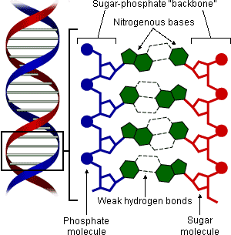**Label the DNA strand (phosphate, sugar, nitrogen base)**

**Four Nitrogenous bases**

**DNA has 4 different bases**

* A - **ADENINE**
* **T - THYMINE**
* **C - CYTOSINE**
* **G - GUANINE**

**Two kinds of bases in DNA**

* **PYRIMIDINES** are the single ring bases
* **PURINES** are double ring bases

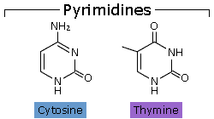**The pyrimidines**

* 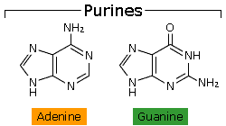 **CYTOSINE and THYMINE** each have one ring  
   of carbon and nitrogen atoms

**The purines**

* **ADENINE** and **GUANINE** each have 2 rings of carbon and nitrogen atoms

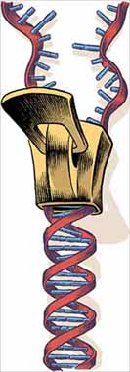**Chargaff’s Rule:**

* **ADENINE – A** and **THYMINE - T** always join together
* **CYTOSINE - C** and **GUANINE - G** always join together

**Two Stranded DNA**

DNA has 2 strands that fit together something like a **LADDER or ZIPPER**.

* The “teeth” or rungs are the **NITROGEN BASES** but why do they stick together? **HYDROPHOBIC CHARGES**

**Hydrogen Bonds**

* The bases attract each other because of **HYDROGEN BONDS**.
* Hydrogen bonds are **WEAK** but there are millions of them in a single molecule of DNA.
* When making hydrogen bonds, cytosine always pairs up with **GUANINE**.
* Adenine always pairs up with **TYHMINE**.

**Why do we study DNA?**

We study DNA for many reasons:

* Its central importance to all life on earth because it codes for all **PROTEINS**.
* Medical benefits such as cures for **DISEASES**.
* Better **AGRICULTURAL** crops.

**RNA**

* Stands for **RIBONUCLEIC ACID**
* Composed of **NUCLEOTIDES**
* Has only **URACIL** instead of **THYMINE** like DNA
* RNA **COPIES** the codes from **DNA** and **MAKES** the protein.
* Adenine bonds with **URACIL** on RNA
* Is made of **ONE** strand of nucleotides
* The 3 types are **mRNA, rRNA, and tRNA**
* RNA is involved in the process of **PROTEIN SYNTHESIS**

**RNA Structure**

* Also has 4 nitrogen bases like DNA
  + **ADENINE**
  + **URACIL**
  + **CYTOSINE**
  + **GUANINE**
* Has the sugar **RIBOSE** instead of deoxyribose

**RNA**

* RNA or ribonucleic acid is similar to DNA, but it has three differences ;
* The sugar molecule in RNA is ribose while the sugar in DNA is deoxyribose.
* RNA contains the base Uracil instead of the Thymine which is found in DNA.
* RNA is a single strand while DNA is a double strand.

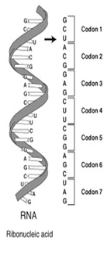

**Organization of Genetic Material**

* Scientists examine cells to determine how DNA is organized within a cell.
* There are two main types of cells, including prokaryotes and eukaryotes. The structure of the DNA molecule varies in each type of cell.

**Genetic Material in Prokaryotes**

* Most prokaryotic cells have a single, double - stranded DNA molecule.
* Since these cells have no nucleus, the DNA does not remain in a particular location inside the cell.
* Proteins within the cell cause the DNA molecule to coil tightly together in a specific region called a **nucleoid**.
* As well, the cell may have one or more small circular pieces of DNA floating around in the cytoplasm of the cell. These are called **plasmids**.

**Genetic Material In Eukaryotes**

* Eukaryotic cells contain double stranded DNA.
* This DNA is organized into a number of separate **chromosomes** within the nucleus of the cell.
* Each chromosome contains a double - stranded DNA molecule as well as a protein called **histone**.
* A typical chromosome contains

60 percent protein

35 percent DNA

5 percent RNA

* The chromosomes are joined together to form a long, fibrous material called **chromatin**.

**Genes & the Genome**

* Studies of DNA from different organisms have shown that there are a number of patterns in how the hereditary information is organized at the molecular level. These patterns are shared by different organisms.
* There are similarities in ;

1. How individual genes are organized.

2. How the individual’s entire genome is organized.

**Genes**

* A gene is a sub-unit of DNA.
* Chromosomes in a cell carry genes.
* Different species have their own unique arrangement of genes, but they also carry some similar genes.
* A gene can be defined as the portion of inherited information that defines one particular trait of an organism’s physical characteristics.
* Today, we know that genes are responsible for coding for proteins and some other non-protein products.

**Arrangement Of The Genome**

* Each chromosome has its own unique arrangement of genes. In fact, the density of genes varies from one chromosome to another.
* For example, in humans chromosome 4 has about 200 genes while chromosome 19 has about 1450 genes.
* As well, different organisms have different numbers of genes. A protozoan called *Amoeba dubia* has less than 7000 genes, but humans have approximately 35000 genes.
* In eukaryotic organisms, a gene is made up of two different regions including **exons** and **introns**.

