**PROTEINS**

Proteins are the major components of any living organism.

Proteins are natural substances with high molecular weights ranging from 5,000 Daltons to many millions. The major Proteins constituents are Carbon, Hydrogen and Oxygen, however some may contain Nitrogen, Sulfur or Phosphorous.

**General formula of protein**

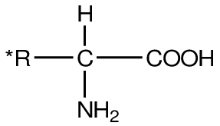

**Function of proteins**

1. Proteins are most important constituent of cell membranes and cytoplasm.
2. Muscle and blood plasma also contain certain specific proteins.
3. Building up and maintenances of the structure of body
4. Provision of energy in deficiency of carbohydrates
5. Proteins are the molecular instruments in which genetic information is expressed
6. Proteins form

Hormones,

Enzymes,

antibodies,

transporters,

muscle,

the lense protein,

antibiotics,

mushroom poisons,

and a myriad of other substances having distinct biological activities.

**Classification of protein**

Proteins may be classified on the basis of their composition, solubility, shape, biological function and on their three dimensional structure.

I. **Composition**:-

**A. Simple protein:**

Yields only amino acids and no other major organic or inorganic hydrolysis products i.e. most of the elemental compositions.

**B. Conjugated Proteins**

Yields amino acids and other organic and inorganic components E.g. Nucleoprotein (a protein containing Nucleic acids) Lipoprotein (a protein containing lipids) Phosphoprotein (a protein containing phosphorous) Metalloprotein (a protein containing metal ions e.g. Fe2+) Glycoprotein (a protein containing carbohydrates)

**II. Solubility**

1. Albumins:

These proteins such as egg albumin and serum albumin are readily soluble in water and coagulated by heat.

b) Globulins: these proteins are present in serum, muscle and other tissues and are soluble in dilute salt solution but sparingly in water.

c) Histones: Histones are present in glandular tissues (thymus, pancreas etc.) soluble in water; they combine with nucleic acids in cells and on hydrolysis yield basic amino acids

**III**. **Overall Shape**

1. **Fibrous proteins**

In these protein, the molecule are constituted by several coiled cross-linked polypeptide chains, they are insoluble in water and highly resistant to enzyme digestion. The ratio of length to breadth (axial ratio) is more than 10 in such protein.

A few sub groups are listed below.

1. Collagens: the major protein of the connective tissue, insoluble in water, acids or alkalis. But they are convertible to water-soluble gelatin, easily digestible by enzymes.

2. Elastin: present in tendons, arteries and other elastic tissues, not convertible to gelatin.

3. Keratins: protein of hair, nails etc.

**B. Globular proteins:**

These are globular or ovoid in shape, soluble in water and constitute the enzymes, oxygen carrying proteins, hormones etc. the axial ratio is 3 to 4 or less. Subclasses include: - Albumin, globulins and histones.

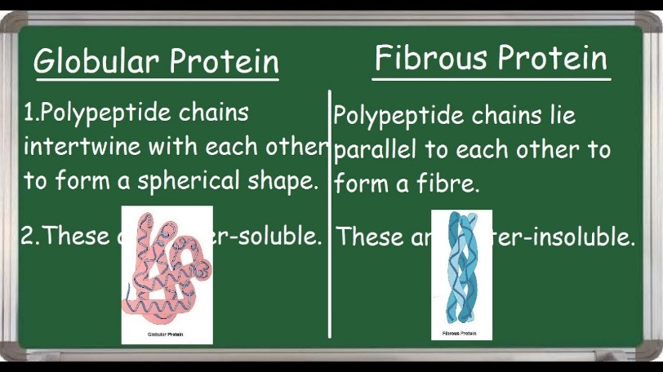

**IV. on their Biological Functions:**

1. Enzymes: kinases, transaminases etc.
2. Storage proteins myoglobin, ferritin
3. Regulatory proteins peptide hormones, DNA binding proteins
4. Structural protein collagen, proteoglycan
5. Protective proteins blood clotting factors, Immunoglobins,
6. Transport protein Hemoglobin, plasma lipoproteins
7. Contractile or motile Proteins Actin, tubulin

**V. On their level of organization (Primary, secondary, tertiary and quaternary)**

**a) Primary Structure of Proteins**

The primary structure of a protein is defined by the linear sequences of amino acid residues. Protein contain between 50 and 2000 amino acid residues. The molecular mass of most proteins is between 5500 and 220,000 Da. The amino acid composition of a peptide chain has a profound effect on its physical and chemical properties of proteins. Protein rich in polar amino acids are more water soluble. Proteins rich in aliphatic or aromatic amino groups are relatively insoluble in water and more soluble in cell membranes (can easily cross the cell membrane).

**Diagram**

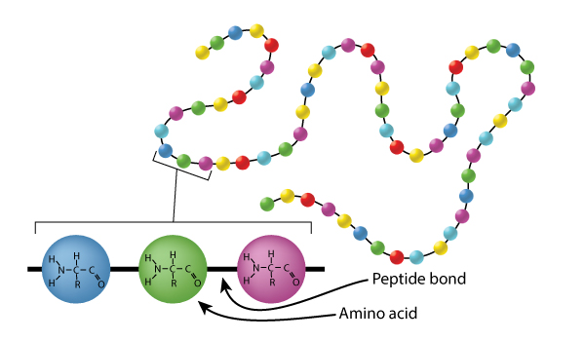

1. **Secondary Structure**

The secondary structure of a protein refers to the local structure of a polypeptide chain, which is determined by Hydrogen bond. The Interactions are between the carbonyl oxygen group of one peptide bond and the amide hydrogen of another nearby peptide bond.

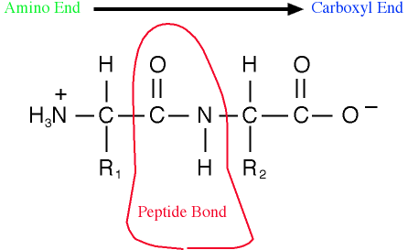

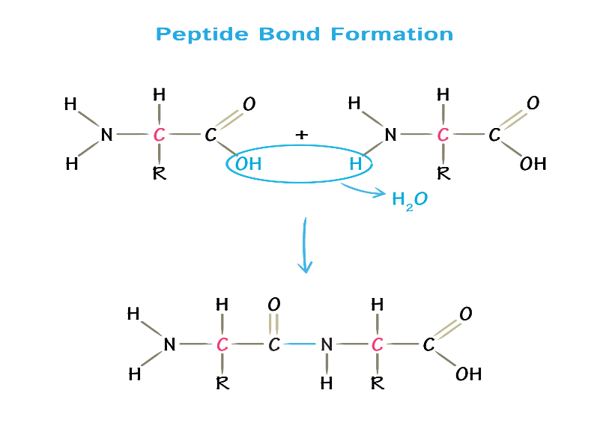

There are two types of secondary structure, the ∝ - helix and the β- pleated sheet.

The α - helix

The α - helix is a rod like structure with peptide chains tightly coiled and the side chains of amino acid residues extending outward from the axis of spiral. Each amide carbonyl group is hydrogen bonded to the amide hydrogen of a peptide bond that is 4 - residues away along the same chain.

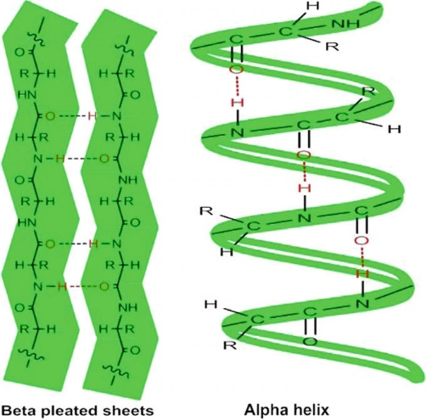

**Diagram of the α helix (a) and the β-pleated sheet (b)**

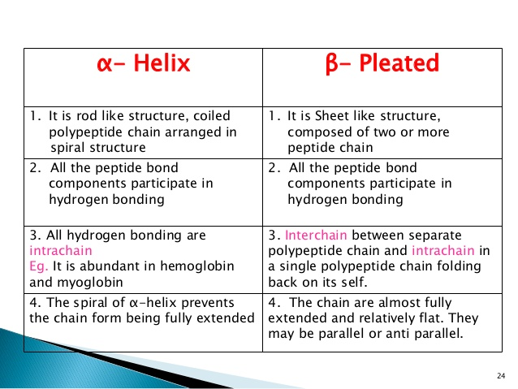

1. Tertiary Structure

The three dimensional, folded and biologically active conformation of a protein is referred to as tertiary structure. The structure reflects the overall shape of the molecule. The three - dimensional tertiary structure of a protein is stabilized by interactions between side Chain functional group, covalent, disulfide bonds, hydrogen bonds, salt bridges, and hydrophobic interactions.

**Diagram of the tertiary structure of a protein**

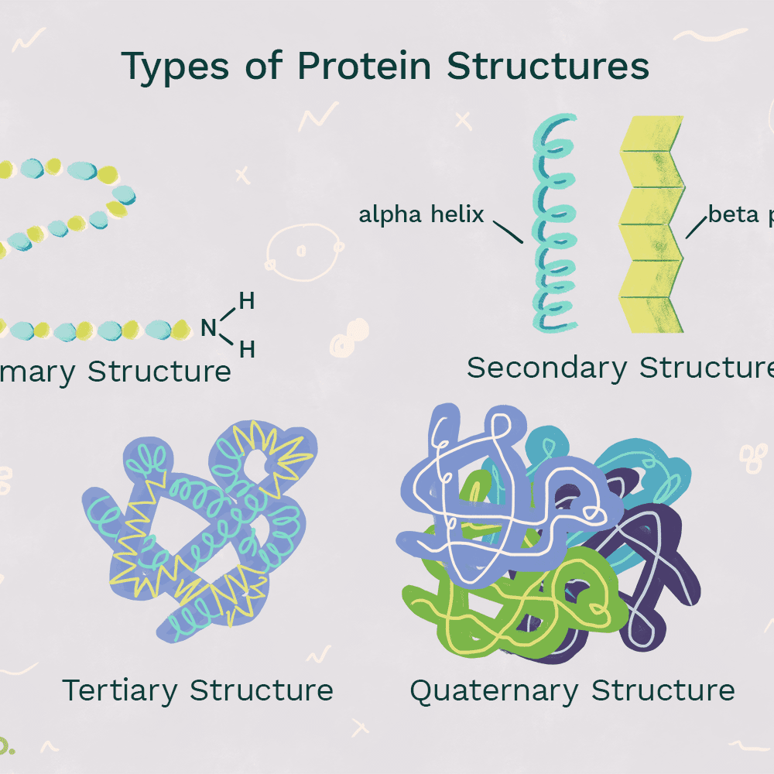

1. **Quaternary Structure**

Quaternary structure refers to a complex or an assembly of two or more separate peptide chains that are held together by non- covalent or, in some case, covalent interactions.

If the subunits are identical, it is a homogeneous quaternary structure; but if there are dissimilarities, it is heterogeneous. For instance insulin consists of A and B chain which are different. Hemoglobin has 4 chains, two of them are α and two are β. these, the polymers may be dimers, trimers, tetramers and so on.

**Essential and non-essential amino acids**

* Essential: amino acids required for protein synthesis but not synthesized by the body – must be obtained from the diet
* Humans can synthesize only 10 of the 20 amino acids
* The other 10 must be obtained from food
* Essential amino acids
  + Isoleucine
  + Leucine
  + Valine
  + Phenylalanine,
  + Tryptophan,
  + Threonine
  + Lysine
  + Methionine
  + (Histidine, arginine)

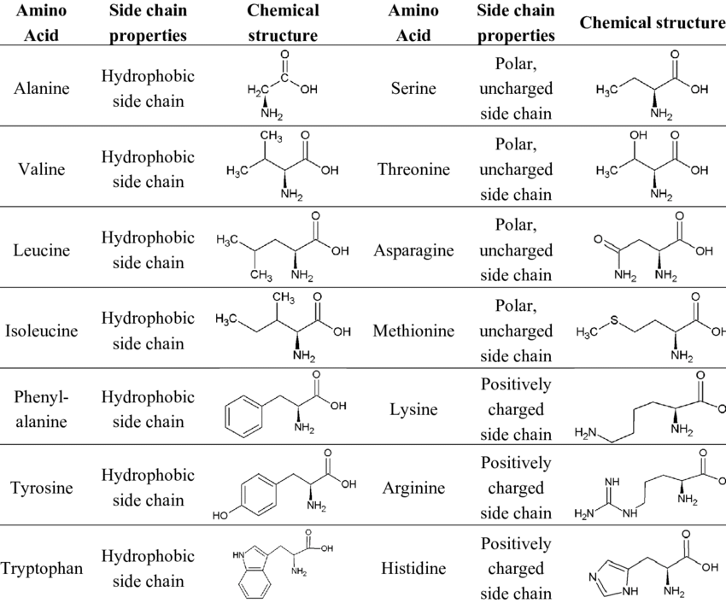

**Denaturation of Proteins**

Denaturation involves reduction of proteins from higher level structures(quaternary/tertiary) to lower level structures by use of denaturation agents.

The bonds holding the structures together are broken down hence the polypeptide chain unfolds itself and remain unfolded in solution.

The denatured protein may retain its biological activity by refolding (renaturing) when the denaturing agent is removed.

**Factors that Affect Denaturation**

1. Physical factors like Temperature/heat, pressure, mechanical shear force, ultrasonic vibration and ionizing radiation causes the protein to lose its biological activity.

2. Chemical factors like Acids and alkalis, organic solvents (acetone, ethanol), detergents (cleaning agents), certain amides urea, guanidine hydrochloride, alkaloids, and heavy metal salts (Hg, Cu, Ba, Zn, Cd…) Cause the denaturation.

* **Heat/temperature:**This disrupts hydrogen bonds and non-polar hydrophobic interactions.
* **Alcohol:** This affects the hydrogen bonds that are formed between the amide groups of the secondary level and it also affects the hydrogen bonding between the side chains of the tertiary level.
* **Acids and Bases and Heavy Metals:** Strong acids and bases and heavy metals denatures the protein the same way by disrupting the bonds in the protein molecules.
* **Urea:** Destabalizes internal bonds and unfolds the protein because it (urea) is a chaotrophe.
* **UV:** The effects are similar to heat
* **Organic solvents:**They interupt the intracovalent interactions of proteins. example Acetone.
* **Detergents:** Breaks up positive and negative interactions in the protein chains.

**Properties of a Denatured Protein**

A. an increase in number of reactive and functional group in the composition of the native protein molecule (side chain group of amino acids, COOH, NH2, SH, OH … etc)

B. Reduced solubility and pronounced propensity for precipitation this occurs due to loss of the hydration shell and the unfolding of protein molecules with concomitant exposure of hydrophobic radicals and neutralization of charged polar groups.

C. Configurational alteration of the protein molecule.

D. Loss of biological activity evoked by the disarrangement of the native structural molecular organization.

E. more accessible to proteolytic enzymes in comparison with the native protein

**Clinical Application of Denaturation**

The amounts of proteins found in the urine, serum, CSF are utilized to asses various pathological conditions. The appearance of proteins like Albumin and Globulin in the urine can be detected by precipitating them using ammonium sulphate. This could be used to assess the degree of kidney impairment and glomerular permeability.

In some disease, abnormal proteins may be present in plasma and be filtered at the glomeruli. The most important is Bence-jones’ protein which is most often associated with multiple myeloma. So recognition of such protein in the urine may be useful in the diagnosis of the disease.

This could be done by treating few ml of urine with few ml of hydrochloric acid giving a white ring at the junction of the two fluids.

**Digestion and Absorption of Proteins**

The digestion of proteins involves the gradual breakdown of this protein molecule by enzymatic hydrolysis in to amino acid molecules which are absorbed in the blood stream.

The protein load received by the gut is derived from two sources 70-100g dietary protein which is required daily and 35 - 200g endogenous protein (secreted enzymes and proteins in the gut or from intestinal epithelia cell turnover)

1. **Gastric Digestion**

Entry of a protein in to stomach stimulates the gastric mucosa to secrete a hormone gastrin which in turn stimulates the secretion of HCL by the parietal cells of the gastric glands and pepsinogen by the chief cells.

The HCL thus produced lower the pH of stomach to (pH1.5 – 2.5) and acts as an antiseptic and kills most of the bacteria and other foreign cells ingested.

The acid denatures the protein and the whole protein becomes susceptible to hydrolysis by the action other proteolytic enzymes.

**Proteases** are endopeptidases which attack the internal bonds and liberate large fragments of peptides.

Then pepsinogen is converted in to active **pepsin** in the stomach itself which then cleaves the ingested protein at their amino terminus of aromatic amino acids.

The major products of pepsin action are large peptide fragments and some free amino acids.

1. **Pancreatic Digestion**

The acidic stomach contents pass in to the small intestine, a low pH triggers the secretion of a hormone **Secretin**.

Secretin stimulates the pancreas to secrete bicarbonate, which in the small intestine neutralizes the gastric HCL and changes the pH to 7.0.

The entry of large peptide fragments and some free amino acids in the upper part of the small intestine (Duodenum), excites the release of a hormone **cholecytokinin** (CCK) which

1) Stimulates gall bladder contraction.

2) Stimulate secretion of several pancreatic enzymes whose activity is between pH 7and 8 in proenzyme forms.

By the sequential action of these proteolytic enzymes and peptides ingested proteins are hydrolyzed to yield a mixture of free amino acids which can be transported across the epithelial lining of the small intestine.

**C. Intestinal Digestion**

The end products of the cell surface digestion are free amino acids and di and tripeptides.

These are passed in to the interior of the epithelial cell where other specific **peptidases** convert almost all of them to single amino acids that are transported to the blood stream by the opposite side of the cell membrane and carried to liver (primarily) and other tissues for oxidative degradation. This process completes the absorption of 99% of digested proteins.

**II. Transport of Amino Acids in to Intestinal Epithelial cells.**

The mechanism of active transport of amino acids are similar with that of glucose uptake

From both genetic and transporters studies at least six specific symporter systems have been identified for the uptake of L-amino acids from the intestinal lumen.

1. Neutral amino acid symporters with short or polar side chains. Ser, Thr, Ala,

2. Neutral amino acid symporter for aromatic or hydrophobic side chains. Phe, Tyr,

3. lmino acid symporter Pro,and OH – Pro

4. Basic amino acid symporter Lys, Arg and Cys.

5. Acidic amino acid symporter. Asp, Glu

6. β amino acid symporter β-Ala , Tau.

These transporter systems are also present in the renal tubules and defects in their constituent protein structure can lead to disease called Hartnup disease.

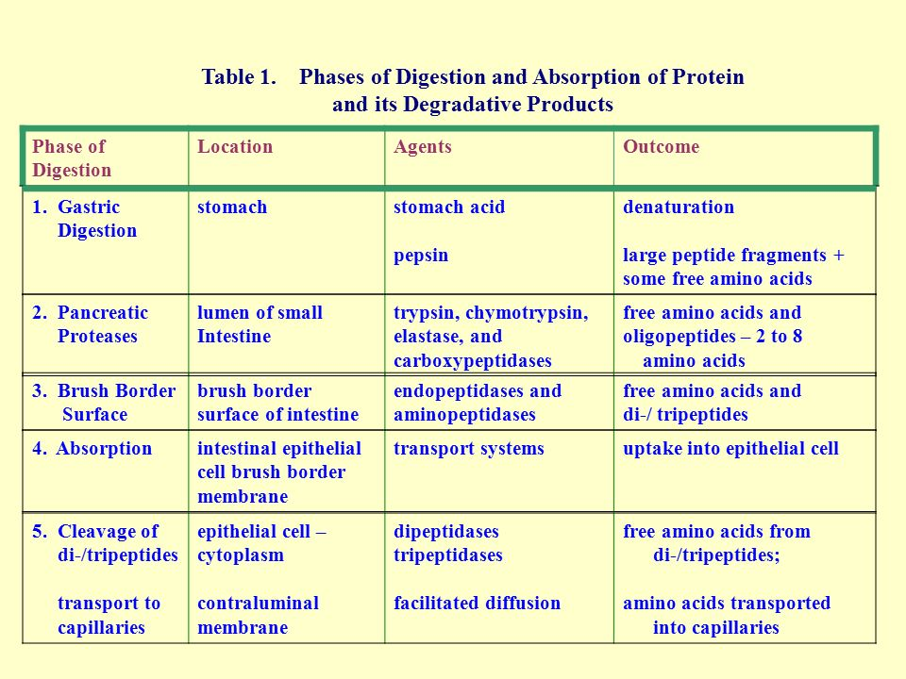

**Amino Acid Catabolism**

**Transamination**

The nitrogen component of amino acids must be removed before the carbons can be used in other metabolic pathways. There are several ways that this can be achieved.

The first step in the catabolism of most amino acids is the transfer of their α - amino group to α - ketoglutarate where the products are α - ketoacids and glutamate.

This transfer of amino groups from one carbon skeleton to another is catalyzed by a family of transaminases which are also called as aminotransferases. Most of the amino acids undergo these reaction except lysine and threonine

**Transamination of amino acids diagram**

**Transminase of Clinical Importance**

Transaminase is a name for a category of enzymes involved in exchange of an oxygen from an α-keto acid (such as α-ketoglutarate) and an amine from an amino acid

The two most important transminase reactions of high clinical important are Alanine transaminase and Aspartate transaminase catalyzed reactions.

Alanine + α-Ketoglutarate <-> Pyruvate + Glutamate

Oxaloacetate + Glutamate <-> Aspartate +-ketoglutarate (Urea cycle)

In addition to their roles as building blocks of proteins, the carbon skeletons may be used to produce energy in oxidative metabolism by the end stages of glycolysis (such as pyruvate from Alanine) and tricarboxylic acid (such as oxaloacetate from Asparate) thereby providing a metabolic fuel for tissues that require or prefer glucose. In addition, the carbon skeletons of certain amino acids can produce the equivalent of acetyl-CoA or Acetoacetate termed Ketogenic, indicating that they can be metabolized to give immediate precursor of lipids or ketone bodies.

Alanine transaminase (ALT) also called as glutamate pyruvate transaminase (GPT) and Aspartate transaminase (AST) also called as glutamate oxaloacetate transaminase (GOT) are the two most important transaminases of clinical importance. These enzymes are abundant in heart and liver they are released as part of cell injury that occurs in myocardial infarction (MI),hepatitis and damage to either organ. An elevated level of both SGOT and SGPT (S=Serum) indicates damage to the Liver. However a rise in SGOT accompanied by only a moderate rise in SGPT suggests damage to heart muscle, skeletal muscle, kidney etc. Assays of these enzyme activities in blood serum can be used both in diagnosis and in monitoring the progress of a patient during treatment.

Aminotransferases utilize a coenzyme - pyridoxal phosphate - which is derived from vitamin B6.

**Dehydration Mechanism**

A second means of deamination is possible only for hydroxyamino acids (serine and threonine), through a mechanism that involves a dehydration followed by the readdition of water and loss of the amino group as ammonia

**Diagram Dehydration of amino acids**

**Nitrogen Balance:**

“Normal Nitrogen Balance” is a state where the amount of nitrogen ingested each day is balanced by the amount excreted.

In negative nitrogen balance more nitrogen is excreted than ingested. This occurs in starvation and certain diseases. During starvation the carbon skeleton of most amino acids from proteins is fed in to gluconeogenesis to maintain the blood glucose level.

Negative Nitrogen balance occurs in injury when there is net destruction of tissue and in major trauma or illness.

Positive nitrogen balance occurs in growing children who are increasing their body weight and incorporating more amino acids in to protein than they breakdown.

Cysteine and Arginine are not essential in adults but essential in children because they are synthesized from Methionine and ornithine. These amino acids are readily available in adults but limited in children.

**Nitrogen Excretion and the Urea Cycle:**

Excess Nitrogen from amino acids is removed as ammonia, which is toxic to the human body. Some ammonia is excreted in urine, but nearly 90% of it is utilized by the liver to form urea, which is highly soluble and is passed in to circulation and excreted by the kidneys

The urea-cycle starts in the mitochondrial matrix of hepatocytes and few of the steps occur in the cytosol: the cycle spans two cellular compartments. The first amino group to enter the cycle is derived from ammonia inside the mitochondria. Some ammonia also arrives at the liver via the portal vein from the intestine, when it is produced by bacterial oxidation of amino acids.

**Diagram The Urea Cycle:**

The reactions are as follows:

Step 1. CO2 from bicarbonate and NH3 from the two sources mentioned above combine together in the liver mitochondria to form carbamoyl phosphate in presence of ATP and Mg2+ by the enzyme Carbamoyl phosphate synthetase I (CPSI).

Step 2. Carbamoyl phosphate reacts with ornithine transferring the carbamoyl moiety to produce citrulline by the enzyme i.e. ornithine transcarbomylase.

Step 3. Argininosuccinic acid is formed by the reaction of Aspartic acid and citrulline: the NH2 group of the former is linked to – CO group of the latter. The enzyme required is argininosuccinic acid synthase.

Step 4. Argininosuccinic acid is cleaved to form Arginine and fumerate by the enzyme Arginiosuccinate lyase. Fumerate goes to the pool of TCA-cycle.

Step 5. Arginine gets cleared off to urea and ornithine by the cytosolic enzyme arginase. Ornithine is thus re-generated and can be transported in to the mitochondrion to initiate another round of the urea - cycle.

**Diagram of the TCA cycle**

**Energetics of the urea cycle**

If the urea cycle is considered in isolation, the synthesis of one molecule of urea require four high energy phosphate groups

1. 2 ATPs used up to make up carbamoyl Phosphate

2. 1 ATP and two High- energy bonds to make up Arginosuccinate

• Any reaction that creates a new C-N bond costs one ATP.

However, the urea cycle also cause a net conversion of oxaloacetate to fumarate via Aspartate and regeneration of oxaloacetate produces NADH in the malate dehydrogenase reaction. Each NADH molecule can generate up to 3 ATPs during mitochondrial respiration.

**Regulation of the urea cycle:**

The changes in demand for urea cycle activity are met in the long term by regulation of the rates of synthesis of the four urea-cycle enzymes and carbamoyl phosphate synthetase I in the liver.

All the five enzymes are synthesized at higher rates in starving animals and in animals on a very high protein diet than well fed animals eating primarily carbohydrates and fats.

Animals on protein free diets produce lower level of urea cycle enzymes

**Ammonia Toxicity (encephalopathy)**

Ammonia accumulation (> 25 – 100 μg/dl) becomes toxic to the central nervous system (CNS). The reasons for toxicity of ammonia to CNS are as follows:

1) Changes in cellular PH and depletion of certain TCA cycle intermediates.

2) More and more ammonia might deplete α-ketoglutarate an intermediate in TCA cycle to form Glutamate.

3) More and more glutamate might undergo decarboxylation to form γ-amino butyric acid (GABA) an inhibitory neurotransmitter that inhibits ATP Synthesis and accounts for the slurred speech and bizzare behaviors.

4) If the concentration of ammonia builds up it creates osmotic pressure by combining with H2O leading to coma.

**Acquired and Inherited defects in the Urea-Cycle.**

Ammonia intoxication can be caused by inherited or acquired defects and the defects occur at a rate of 1 in every 30,000 births. Inherited defects in the urea –cycle enzyme result in mental retardation.

**Disease Hyperammonomia**

|  |  |  |
| --- | --- | --- |
| Disease  Hyperammonomia | Defective Enzyme | Produce excessive amounts of |
| Type I | CPS I | Ammonia |
| Type II | Orinithinetranscarb- amoylase | Ammonia |
| citrullinemia | Arginosuccinate Synthase | Citrulline |
| Arginosuccinic | Arginosuccinatelyase | Arginosuccinate aciduria |
| Argenemia | Arginase | Arginine |

N.B. Ammonia intoxication caused by inherited defects in the urea cycle can be treated by a diet low in protein and amino acid and supplemented by Arginine and citrulline.

Treatment with sodium benzoate can produce additional disposal of non-urea nitrogen by combining with glycine to form hippuric acid, which is excreted in the urine.

Sodium phenyl lactate is even more effective, since it condenses with glutamine, the major carrier of excess Nitrogen. The resulting Compound phenylacetylglutamine is excreted carrying two nitrogen’s with it.

**Acquired defects in urea–cycle**

Any disease or condition that adversely affects liver mitochondria can also produce an increased level of ammonia in the blood such condition include liver cirrhosis, alcoholism, hepatitis, and Reye’s syndromes.

**The Glucose-Alanine Cycle**

Alanine also serves to transport ammonia to the liver via the Glucose-Alanine Cycle

The use of Alanine to transport Ammonia from a hard working skeletal muscles to the liver is an example of the intrinsic economy of living organisms, mainly because vigorously contracting skeletal muscle operate anaerobically producing not only Ammonia but also large amounts of pyruvate from Glycolysis.

**Diagram Glucose-Alanine Cycle**

**Phenyl alanine**

Deficiency of phenylalanine hydroxylase is responsible for Phenylketonuria (PKU), an Autosomal recessive disease that results in the accumulation of too much phenylalanine, because the synthesis of tyrosine is blocked. When untreated, this metabolic defect leads to excessive urinary excretion of phenyl pyruvate and phenyl lactate, followed by severe mental retardation, seizure, psychosis and eczema. Clear diagnosis requires measurement of plasma phenylalanine, which may be raised above 300mg/d. (normal 30mg/dl).

**Tyrosinemia**

It is also called (richner-Hanhrt syndrome) caused due to the failure of tyrosine transaminase giving a raised level of tyrosine in blood and urine.

Clinical symptoms include moderate mental retardation, characteristic eye and skin lesions and disturbance in fine coordination. Other metabolites excreted in urine are called tyramine, N-a cetyl tyrosine, P-OH- phenyl acetate PO4 - phenyl pyruvate.

**Alkaptonuria (Black urine disease)**

A second inherited defect in the phenyl alanine – tyrosine pathway involves a deficiency in the enzyme that catalyses the oxidation of homogentisic acid (an intermediate in the metabolic breakdown of tyrosine and phenyalanin). This condition occurs 1 in 1,000,000 live birth homogentisic acid accumulates and gets excreted in urine where the urine turns black on standing. There is a form of arthritis in late cases and generalized pigmentation of connective tissues; this is believed to be due to the oxidation of homogentisic acid by polyphenol oxidase forming benzoquinone acetate that polymerises and binds to connect tissues molecules.

High doses of ascorbic acid have been used in some patients, to help reduces the deposition of pigment on collagen, but progress of the disease has not been significantly affected by this strategy. Patients usually lead a normal life.

**Maple syrup urine disease (MSUD)**

The normal metabolism of the branched chain amino acids Leucine, Isoleucine, and valine involves loss of the α-amino acid by transamination followed by oxidative decarboxylation of the respective keto acids. The decarboxylation step is catalyzed by branched chain α keto acid decarboxylase. In approximately 1 in 300,000 live birth in the general US population are affected by this enzyme defect leading to ketoaciduria. When untreated this condition may lead to both physical and mental retardation of the newborn and a distinct maple syrup odor of the urine.

This defect can be partially managed with a low protein or modified diet. In some instances, supplementation with high doses of thiamine pyrophosphate is recommended.

**Amino acid derived Nitrogenous compounds.**

**Creatine and creatine phosphate:**

Creatine is produced by the liver, kidney and pancreas and is transported to its site of usage principally muscle and brain. Creatine is derived from glycine and Arginine by the enzyme Amidinotransferase where ornithine and Guandioacetate are generated.

By creatine kinase, creatine undergoes phosphorylation to form creatine phosphate. Creatine phosphate is an important energy reservoir in skeletal muscles. Where at the site of muscle contraction, creatine phosphates prevents the rapid depletion of ATP by providing a readily available high energy phosphate which can be used to re generate ATP from ADP.

● High levels of ADP formed in the myofibrils during contraction favors the reverse reaction namely formation of ATP at the expense of creatine phosphate cleavage to creatinine.

● Creatinine is an end product of nitrogen metabolism, and as such, undergoes no further metabolism, but excreted through the urine.

**Serotonin**

Serotonin is synthesized from Tryptophan. It is a Neurotransmitter that helps the body control satiety, the feeling of fullness after eating. It plays multiple roles in the nervous system, including neurotransmission and a precursor of melatonin, which is involved in regulation of sleepiness and wakefulness, vegetative behaviors like feeding, mood, sexual arousal etc.

In the intestine, serotonin regulates intestinal peristalsis. It is also a potent vasoconstrictor, which helps regulate blood pressure.

**Catecholamines**:

The term catecholamine comes from the aromatic dialchol, catechole. Tyrosine gives rise to a family of catecholamines that include Dopamine, Norepinephrine and epinephrine. The levels of these catecholamines are related with changes in the blood pressure of animals.

**Dopamine**

The importance of Dopamine in neural transmission is emphasized by the number of major neurological disease that is associated with improper Dopamine regulation.

• Dopamine levels are abnormally low in a particular region of the brain of patients with Parkinson’s disease

• Parkinson’s disease commonly occurs in elderly, it can occurs in younger individuals. It is a progressive disease caused by the death of dopamine-producing cells in the substantia nigra and locus ceruleus. This disease is associated with tremor of arm, occasional muscle cramping. The drug, which usually alleviates the disorder that contains L. dihydroxyphenylalanine and monoamine oxidase inhibitor.

**Epinephrine**

Epinephrine, also known as adrenaline is the principal hormone governing the fight or flight response to various stimuli. In addition it stimulates glycogenolysis (breakdown of glycogen), and a variety of physiological event, such as increasing depth and frequency of heartbeats.

**Norepinephrine (nor-adrenaline)**

It is a precursor of epinephrine. It causes greater constriction of the blood vessels of muscles, as a result of which the arterial pressure is raised higher than is caused by adrenalin. It acts as a neuro transmitter between synthesis of catecholamines in nervous system and smooth muscles.

**Histamine**

Histamine is a decarboxylation product of histidine that be performed by a specific decarboxylase, or by the general L- amino acid decarboxylase. It is formed in the gut, injured tissues, and apparently in the normal tissue continually.

Histamine is released in large amounts as part of allergic response and it also stimulates acid recreation in the stomach being released by Basophils.

In the stomach, histamine promotes secretion of hydrochloric acid and pepsin as digestion aids. Histamine is a potent vasodilator, released at sites of trauma, inflammation, or allergic reaction. Reddening of inflamed tissues is a result of local enlargement of blood capillaries. Antihistamines block binding of histamine to its receptors.

It also acts as a neurotransmitter in brain, and perhaps, may be considered as a local hormone. The action of histamine is terminated by histaminase.

**Melanin**:

Conversion of Tyrosine to Melanine requires Tyrosinase, a copper containing Enzyme. The two step reaction uses DOPA as a cofactor internal to the reaction and produces Dopaquinine, commonly called as Melanin.

During Melanogenesis following exposure to UV light, tyrosinase is post transcriptionally induced along with a tyrosine related protein.

Mealnin is a dark pigment found on hair, eyes and skin.

A deficiency of Tyrosinase enzyme leads to a disorder known as Albinsism.