|  |
| --- |
| **Chapter 1: Introduction to pathology** |

Pathology is derived from two Greek words –pathos meaning suffering and logos meaning study. This implies that pathology is the scientific study of structure and function of the body in disease. It consists of the abnormalities that occur in normal anatomy and physiology owing to disease, whereas the study of disordered function is called pathophysiology.

The understanding of pathology is essential for all clinicians and medical practitioners including specialists since unless they know the causes, and understand the language spoken by the pathologist in the form of laboratory reports, they will not be able to institute appropriate treatment or suggest preventive measures to the patients.

For any student of medicine, the discipline of pathology forms a vital bridge between initial learning phase of preclinical sciences and the final phase of clinical subjects as stated by ( Mohan 2010). He further quotes the eminent founder of modern medicine Sir William Osler and summarizes the function of pathology by saying “*your practice of medicine will be as good as your understanding of pathology. Once one masters pathology then by extension one would have mastered medicine.”*

Pathology is derived from a Greek word,

Pathos – suffering study of disease and disease processes.

Logos - study

Pathology is therefore defined as the scientific study of the body in disease and deals with

* Causes
* Effects
* Mechanisms
* Nature of disease

It involves observation of abnormal structural and functional changes

|  |
| --- |
| **Clinical application**  ***Unless you know the causes and mechanisms of disease and understand the language spoken by the pathologists in form of laboratory reports; you won’t be able to institute appropriate treatment nor suggest preventive measures to the patient*.** |

**Terminologies used in pathology**

1. Disease – -It entails what is not healthy (so what entails to be healthy?)

-It is abnormal function and structure

**OR.**

-Abnormal variation in structure and or function of any part of the body.

2. Patient – Is a person affected by disease

3. Lesion – characteristic changes in tissues of cells.

4. Pathologic changes/Morphology – consists of diseased tissues by gross appearance or microscopic appearance.

5. Aetiology – Factors responsible for the lesions or causes of disease

“Why of the disease?

6. Pathogenesis – Mechanism by which the lesions are produced “how”

7. Symptoms – functional implications of the lesion felt by the patient and those discovered by the clinician are called signs.

|  |
| --- |
| ***Application***  ***The clinical significance of the morphologic and functional changes investigations help to arrive at an answer to what is wrong (diagnosis) What is going to happen (prognosis) and what can be done about it ( treatment ) and how to avoid complication/spread (prevention)*** |

**Evolution of pathology**

Pathology has evolved over the years as a distinct discipline from anatomy medicine and surgery. It evolved from religious beliefs and magic to rational approach ( Hippocrates firmly believed in study of patients symptoms in the methods of diagnosis. End of medieval period was marked by backward steps in medicine with re introduction of supernatural concepts where dissection of human body was strictly forbidden as that will mean hurting the soul (Mohan, 2010).

The medieval period was followed by revival of learning (Renaissance). There was emphasis of philosophical and rational attitudes again. Morbid anatomy gained root by Car F. Von Rokitansky a German pathologist who performed over 30,000 autopsies ( Mohan, 2010).

Up to the middle of the 19th century correlation of clinical manifestations of disease with gross pathological findings at autopsy became the major method of study of disease. Pathology started developing as a diagnostic discipline with the evolution of cellular pathology which was closely linked to technology, advancements in machinery and improvement in microscope. The strides made in the latter half of 20th century have made it possible to study diseases at molecular level and provide an evidence based and objective diagnosis which enabled the physician to institute appropriate therapy. This advance is in the field of molecular biology and diagnosis, treatment of genetic disorders, immunology and in cancer.

Initially disease was thought to be due to religious curse or evil spirit ( evil eyes) Hippocrates introduced a rational way of looking at disease and ethical concepts in the practice of medicine.

Since 377 BC evolution of pathology has involved

* Cardinal features of inflammation
* Humoral theory and body fluid imbalance
* Dissection of human body
* Microscopy
* Histology
* Introduction to morbid anatomy
* Discovery of stethoscope
* Introduction to cellular pathology
* In 21st century (Watson and crick introduced DNA pathology ( molecular)

|  |
| --- |
| ***Application***  ***Currently pathology has helped in the diagnosis and management of patients including forensic pathology and evolution has taken a big milestones towards medical practice.*** |

**Summary of evolution**

Pathology as the scientific study of disease processes has its deep roots in medical history since the beginning of mankind, there has been desire as well as need to know more about causes, mechanisms and nature of disease.

Generally in pathology, the patient is the person affected by disease while lesions are the characteristic changes in tissues and cells produced by disease in an individual or experimental animal. Morphological changes or pathological changes consist of examination of diseased tissues which can be seen microscopically or macroscopically. The factors responsible for the lesions is the aetiology and pathogenesis of disease is the mechanisms by which disease is produced.

The functional implications of the lesions felt by the patient are symptoms whereas those discovered by the clinicians are the physical signs.

Clinical significance of the morphological and functional changes together with the results of other investigations help to arrive at the diagnosis, prognosis treatment and prevention.

|  |
| --- |
| **Chapter 2: Divisions of pathology** |

Human pathology

Systemic pathology general pathology

Study of disease pertaining to specific Deals with general Body systems and organs principles of disease

**Figure 1**

**Subdivisions of pathology include**

A. Histopathology: - Also called anatomic pathology or pathologic anatomy or morbid anatomy.

It includes the study of structural changes observed by naked eye exam (gross and those observed by microscope with numerous special methods.

It is further divided into:-

1. Surgical pathology- Study of tissues removed from the living body
2. Forensic pathology – autopsy (study of organs and tissues removed at post mortem.

It is a study where the dead delight in teaching the living

1. Cytopathology – Study of cells shed off from the lesions ( Exfoliative cytology) and fine needle aspiration cytology of superficial and deep seated lesions for diagnosis

B. Hematology: - Deals with disease of blood (laboratory hematology and clinical hematology

C: Chemical pathology - Involves analysis of biochemical constituents of blood urine semen, CSF etc.

D: - Immunology: - Detection of abnormalities in the immune system of the body.

E: Experimental pathology ; Study that involves introduction of disease in animals and ascertain the effects

F: Geographic pathology / Environmental pathology

The study of differences in distribution of frequency and type of disease in populations in different parts of the world.

G: Medical genetics - this is the branch of human genetics that deals with the relationship between hereditary factors.

H: - Molecular pathology

The detection and diagnosis of abnormalities at the level of DNA of the cell is included in molecular pathology.

**Techniques for the study of pathology**

**I. Autopsy pathology**

The purpose is due to:

**i) Quality assurance of a patient care through**

a)Confirmation cause of death

b) Establishing final diagnosis

c) Study of therapeutic response to treatment

**ii) Education of the entire team involved in patient care by**

1. Autopsy diagnosis of conditions often missed clinically
2. Discovery of newer disease at autopsy
3. Study of demography and epidemiology of disease
4. Affords education to students and staff of pathology

|  |
| --- |
| *Application*   * ***There is declining autopsy rate which has been associated with*** * ***Higher diagnostic confidence made possible by advances in imaging techniques*** * ***Physicians fear of legal liability on being wrong*** |

**II surgical pathology (histopathology/morbid anatomy)**

Anatomic pathology and cellular pathology (Is a form of tissue diagnosis made on gross and microscopic study of tissues

* Surgical pathology protocol consist of
* Request forms
* Tissue accession ( identification)
* Gross examination
* Histopathological laboratory examination
* Surgical report.

|  |
| --- |
| ***Application***  ***Students have to understand the protocol aspects of surgical pathology in which case how the specimen are prepared and examined plus reporting.*** |

**III Other modes of pathology techniques**

For students to study on

* Special stains
* Enzyme histochemistry
* Basic microscopy
* Immunoflorescence
* E lectron microscopy
* Cytogenetic
* Molecular pathology
* Flow cytometry
* Computers in pathology

**Pathological classification of causes of diseases**

A) Congenital - Diseases that develop during foetal life

Acquired e.g. TORCHES and HIV

Genetic determined - Diseases that develop as a result of abnormal inheritance materials e.g. SCD Down’s syndrome, haemophilia.

B) Acquired diseases

These are diseases that develop as a result of exposure to injuries or infections and environmental effects.

1. Deficiency diseases - inadequate diet or excess (nutritional)
2. Physical agents - Mechanical injuries e.g. Heat, cold, irradiation etc.
3. Chemical e.g. alcohol and other drugs
4. microbial agents

Parasitology

Microbiology - Bacteria, fungi, Viruses, Ricktsiae

v) Immunological cause’s e.g. allergic reactions

vi) Psychogenic factors - mental diseases

Vii) Environmental factors

|  |
| --- |
| **Chapter 3: General principles of microbial infections** |

Despite availability and use of effective vaccines and antibiotics, infectious disease remains an important cause of death.

**New and emerging infectious diseases**

These diseases include;

1. Ebola virus =1977
2. Hepatitis c virus =1989
3. Sars-corona virus =2003
4. H1N1 infection
5. HIV infection

**Agents of bioterrorism**:

Anthrax-bacillus anthracis

Botulinism- clostridium botulinium

Plague ( yersinia pestis)

Small pox- varicella major virus

Tularemia

Viral haemarrhagic fevers

**Categories of microbial agents**

* **Prions**: consist of abnormal forms of a host cell protein called prion protein. These agents transmits spongiform encephalitiss, creutzfeld.jakob disease (CJD, bovine spongiform encephalopathy(mad cow disease)
* **Viruses**: obligate intracellular parasites that depend on the host cells metabolic machinery for their replication. They consist of nucleic acid genome surrounded by a protein coat (capsid) that is sometimes enclosed in a lipid membrane (DNA/RNA)
* **bacteria**

Bacterial cells are prokaryotes, have a cell membrane but lack membrane bound nuclei and other membrane- enclosed organelles.

Bacteria are gram-positive or gram-negative. Most bacteria synthesize their own DNA/RNA and proteins but depend on the host for favourable growth conditions.

**chlamydia/rickettsiae, mycoplasma**

Grouped together because like bacteria they divide by binary fission and are sensitive to antibiotics but lack certain structures e.g. cell wall and metabolic capabilities

**fungi:**

Fungi are eukaryotes that possess thick chitin containing cell walls and ergosterol containing cell membranes. They grow budding yeast cells or hyphae

**protozoa:**

Parasitic protozoa are single celled eukaryotes that are major cause of disease and death e.g. plasmodium, leishmania, trichomonas, entomoeba, girdia lambia, trypanasoma, toxoplasma gondii.

**Helminths**

Parasitic worms are differentiated multicellular organisms e.g ascaris lumbricoids

**Ectoparasites**

These are insects like Lice and bedbugs

**How micro-organisms cause disease**

Infectious agents establish infection and cause damage to tissues in 3 ways:

* Enter or contact the host cells and directly cause cell death
* They may release toxins that kill cells at a distance, release enzymes that degrade tissue components or damage blood vessels and cause ischaemic necrosis.
* They can induce host cellular responses that although directed against the invader cause additional tissue damage usually by immune mediated mechanisms

**Mechanisms of viral injury**

Viruses directly damage host cells by entering them and replicating at the host expense.Once the viruses’ one in the hosts cell, they cause tissue damage in a number of ways.

1. Inhibit host cell DNA,RNA or protein synthesis e.g. polio virus
2. Viral protein may insert into the host cells plasma membrane and directly damage its integrity or promote cell fusion (e.g. HIV, measles viruses and herpes virus.
3. Viruses may manipulate programmed cell death.(HIV)
4. Viruses may lyse host cells, e.g. influenza virus replication, yellow fever, neurons by polio, rabies virus.
5. Host cells may induce immune system leading to attack the virus- infected cells
6. Viruses may damage cells involved in host antimicrobial defense leading to secondary infections e.g. damages to epithelial cells
7. Viral killing of one cell type may cause death of other cells e.g. polio
8. Some viruses can cause cell proliferation and transformation leading to development of carcinoma e.g. Ebstein burr virus and hepatitis B virus

**Bacterial mechanism of causing cell injury**

**Bacterial virulence:**

Bacterial damage to host tissues depends on the ability of the bacteria to adhere to host cells, invade cells and tissue or deliver toxins. This is done through:

* Bacterial adherence to host cells
* Virulence of intracellular bacteria
* Bacterial toxins

**Pathogenesis is through:**

1. Bacteria secrete a variety of enzymes (proteases, hyluronidases, coagulases fibrinolysins that act on their respective substance in vitro.
2. Toxins that alter intracellular signaling or regulatory pathways work by affecting many pathways e.g. bacillus anthracis and vibrio cholerae
3. Neurotoxins produced by clostridium botulinium and clostridium tetani inhibit release of neurotransmitters leading to paralysis.
4. Super antigens are bacterial toxins that stimulate large numbers of T lymphocytes that may result into shock

**Severe acute respiratory syndrome (sars)**

Def: acute respiratory is a human form of bird flu or a virus influenza having similar symptomatology

**Pathogenesis**

* Aetiology- influenza viruses type A Subtype –H5N1
* Mode of infection- contaminated nasal, respiratory and faecal material from infected birds
* Humans are ant protected and no human to human transmission occurs

**Clinical features**

Fever, cough, viral pneumonia, ARDS, kidney failure.

|  |
| --- |
| **Chapter4: Cellular responses to stress and noxious stimuli and apoptosis** |

**Normal cell homeostasis**

**Stress and increased demand Injurious stimulus**

**Adaptation inability to adapt cell injury /death**

**Figure 2**

**A diagrammatic representation of the process of cell homeostasis**

Irreversible cell injury

Reversible cell injury

Adaptation

E.g. a trophy, hypertrophy, Degenerations, sub cellular Inability to a

Hyperplasia, Metaplasia, dysplasia alterations & intracellular accumulations adapt.

Stress removed and adaptations stress is removed cell death

Normal cell Repair and Healing

**Figure 3**

**Normal cell homeostasis an illustration of the expected results of cell injury**

The above flow chart shows clearly the normal cell homeostasis that occurs whenever there is increased functional demand of the cell, mild to moderate stress and severe stress that is persistent.

|  |
| --- |
| **Applicability**  *It is essential to know how the cells control themselves and their response to stress in order to apply to the clinical practice in identification of various pathological processes in the body. The importance of stress removal from the cells is quick as possible.* |

**Pathogenesis of cell injury**

These depends on

i) The type of the cell duration and severity of injurious agents.

ii) Type, status and adaptability of the target cells.

iii) Underlying intracellular phenomena to distinguish between inability to reverse mitochondrial dysfunction by reperfusion or re-oxygenation and disturbance in cell membrane function in general. These eventually results into morphologic changes like Hydropic swelling.

**Apoptosis**

Apoptosis means falling off in Greek. It is a form of well coordinated and internally programmed cell death which is of significance in a variety of physiologic and pathologic conditions. Some cells in the cell cycle do not survive and stop growing so these results into death but programmed by the normal body mechanisms.

**Cell cycle**

Most cells live according to an internal clock. That is, they proceed through a sequence of phases called the cell cycle. DNA is duplicated during the synthesis (s) phase and the copies are distributed to the opposite ends of the cell during mitotic (m) phase and progress through the cycle is controlled at key checkpoints which monitor the status of the cell. Cell death follows an internal programme of events called apoptosis in which all traces of a cell vanish.

* **G0**
  + **Quiescent (not a very long or dominant phase)**
* **G1**
  + **Pre-synthetic, but cell growth taking place**
* **S**
  + **Cells which have continuous “turnover” have longer, or larger S-phases, i.e., DNA synthesis**
  + **S-phase of tumor cells can be prognostic**
* **G2**
  + **Pre-mitotic**

**M (Mitotic:, P,M,A,T, Cytokinesis)**

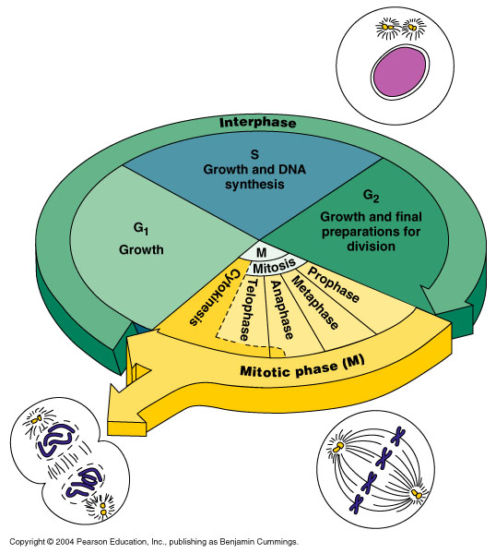

**Figure 4 Four Phases of the Cell Cycle: Growth (G1), DNA synthesis (S-phase), Premitotic (G2), and Mitotic (P, M, A, T)**

**Pathologic changes of an apoptosis**

Apoptosis involves single cells or small clusters of cells in the background of viable cells. The cytoplasm contains condensed or fragmented nuclear crenation characteristically unlike necrosis; inflammatory response around apoptosis is absent. Shrinkage of cell with dense cytoplasm and almost normal organelles are features encountered. Convolutions of cell membrane with formation of membrane band near spherical bodies called apoptotic bodies that has compacted organelles are seen. Chromatin condensation around the periphery of nucleus is often observed. There is no acute inflammatory reaction in apoptosis and Phagocytosis of apoptotic bodies by macrophages is present (Muir, 2005)

**Note: Main difference between apoptosis and necrosis is that in apoptosis histologically, there are no signs of inflammation whereas in necrosis there are signs of inflammation with an acute inflammatory reaction.**

Identification of apoptotic cells is done through:-

i) Staining of chromatin condensation

ii) Flow cytometry

In between technique to see changes of the DNA or through gel electrophoresis annexin vas a marker for apoptotic cell membrane.

**Molecular mechanisms of apoptosis**

1. Both physiologic and pathologic processes initiate apoptosis. They include

a) Absence of stimuli for normal cell survival like hormones and growth factors like cytokines

b) Presence of activators of programmed cell death e.g. tumour necrosis factors is very essential against proliferation of malignant tumours.

c) Intracellular stimuli, heat, radiation or hypoxia.

2. Regular proteins bcl -2 and others

3. Pathways of programmed cell death FAS receptor activations, ceramide generations and DNA damage

4. Phagocytosis.

|  |  |
| --- | --- |
| ***Application***  ***a) Biological process of apoptosis***  ***1). Organized cell destruction in sculpting of tissues during development of the embryo (embryogenesis –as structures where some tissues are shaped and removed.***  ***A good example is fingers and toes where webs are removed.***  ***2) Physiologic involution of cells in hormone dependent tissues e.g. Endometrial shedding during menstruation, regression of lactating breast after withdrawal of feeding.***  ***3) Normal cell destruction followed by replacement proliferation e.g. the skin sheds off every 28 days and intestinal epithelium is being replaced frequently after injury. There is also involution of thymus in early age.*** | |
| ***b) pathologic death***  ***1)cell death in tumours exposed to chemotherapeutic agents***  ***2) cell death by Cytotoxic T cells in immune mechanisms such as graft versus host disease and rejection reactions.***  ***3) cell death in viral infections***  ***4) pathologic atrophy of organs and tissues***  ***5)cell death by injurious agents as in necrosis***  ***6) In degenerative diseases of CNS e.g. Alzheimer’s disease, Parkinson’s disease and dementias*** |

**The above explanation helps the clinician to explain various processes that seem to occur in our daily lives.**

|  |
| --- |
| **Chapter 5 Tissue response to injury** |

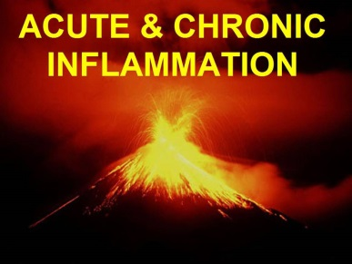

**Inflammation**

This is a local response of body tissues to injury due to any agent. This comes as a result of the body defense reaction in order to eliminate or limit the spread of injurious agent as well as to remove the consequent necrosed cells and tissues

Agents that cause inflammation can be

i) Physical agents like

Heat, cold, radiation or mechanical trauma

ii) Chemical agents, organic or inorganic

iii) Infective agents, bacteria, viruses, toxins

iv) Immunological agents e.g. Lymphocytes like effective killer cells

Inflammation involves 2 basic processes early and late or acute and chronic

This is determined by the capacity of the defense mechanisms and duration of the response.

**Acute inflammation**

It is of short duration and represents the early body reaction usually followed by repair.

**Chronic inflammation**

Is an inflammation that takes a longer duration and occurs either after the causative agent of acute inflammation persists for a long time or the stimulus is such that it includes chronic inflammation from the beginning.

|  |
| --- |
| ***Application***  ***As a clinician you should be able to differentiate between acute and chronic inflammation and the approach of management of patients presenting with either of the 2 clinical variants.*** |

**Acute inflammation**

Celsius described the 4 cardinal signs of inflammation in the 17th century as

i) Rubor –redness –hyperaemia

ii) Tumour- swelling-oedema

iii) Calor – hotness-fever

iv) Dolar-pain-tenderness

And Virchow added the last cardinal sign as

v) Functio laessa –loss of function- Inability to use the affected part of the body.

These then formed the basis of the **five** cardinal features of inflammation as

**-hyperaemia, oedema, fever, tenderness and loss of function**

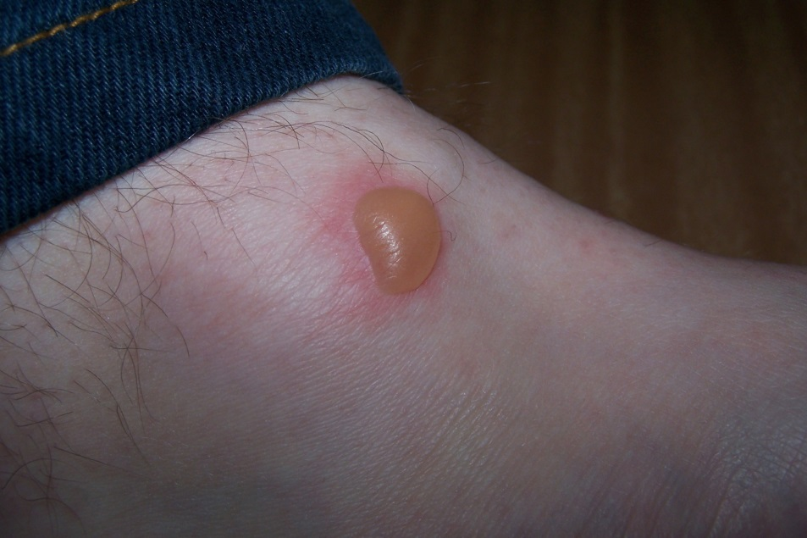

**Figure 5 features of acute inflammation (pathologic basis of disease 2010)**

**Pathological changes in a cute inflammation**

**I Vascular changes**

**a) Hemodynamic changes**

1. Transient vasoconstriction of arterioles

2. Persistent progressive vasodilatation of mainly arterioles

3. Transudation of fluid into the extracellular space

4. Slowing or stasis of micro-circulation

5. Leucocytic margination leucocytes migrate along the vascular endothelium especially neutrophils

|  |
| --- |
| ***Clinical significance***  ***These changes are responsible for the classical signs of inflammation-redness, heat, swelling pain and loss of function.*** |

**b) Altered vascular permeability**

In acute inflammation the non permeable endothelial layer of micro-vasculature becomes more permeable ( leaky) these reactions are initiated by histamine, bradykinin and others initially then later tumour necrosis factor and leucocyte activation comes into play.

**II) Cellular events**

2 processes occur, these are exudation and phagocytosis. In acute inflammations the main cells involved are polymorph nuclear neutrophils which comprises of the 1st line of defense, followed later by monocytes and macrophages.

**a) Exudation**

These are changes in the formed elements of blood. In early stages there is slowing and stasis of blood stream due to increased vasodilatation. It causes the central stream of cells widening and peripheral plasma zone become narrower because of loss of plasma by exudation. This is called margination. As a result of redistribution of the nuetrophils, the central column comes close to the vessel wall leading to pavementing. Rolling and adhesion of neutrophils over the endothelial cells lining the blood vessel wall occur together with emigration where Leucocytes and red blood cells escape through gaps between the endothelial cells. Cells also migrate into the extracellular space through a process of chemotaxis

**b) Phagocytosis**

It is the process of engulfment of solid particulate material by the cells. This process has been tackled well in physiology therefore refer to physiology

**Chemical mediators of inflammation**

**These are substances released from the cells, plasma or damaged tissue itself that are responsible of controlling the process of inflammation.**

**They are classified as acute phase reactants and inflammatory cells**

**a) Acute phase reactants and their effects**

They are divided into two

i) Those that are cell derived from mast cells, basophils, platelets and other inflammatory cells. They include histamine, serotonin, and lysosome enzymes. It is believed that lysosome enzymes and nitric oxide cause tissue damage. Prostaglandins cause vasodilatation whereas Leukotrienes increase vessel permeability. Cytokines are known to increase the temperature and therefore cause fever

ii) Plasma derived reactants

Clotting and fibrinolytic system which include the fibrin split products, Kinin system which produces Kinin , bradykinin and complement systems responsible for anaphylotoxins.

**b) Inflammatory cells and their functions**

These comprise Circulating Leucocytes, Plasma cells and Tissue macrophages

**Polymorphs** – provides initial phagocytosis of bacteria and foreign body (acute Inflammation)

**Monocytes/macrophages** – Provides phagocytosis and chronic inflammation. It regulates Lymphocyte response

**Lymphocytes** – Coordinate humoral and cell mediated immune response. They are the main cells of chronic inflammation. It also regulates macrophage response.

**Plasma cell** – Derived from B cells. They are responsible for anti body synthesis and secretion. The cells are involved in chronic inflammation

**Eosinophil** – Responsible for allergic states of inflammation, parasitic infestations and sometimes chronic inflammations

**Basophil/mast cells** –receptors for IgE antibody molecules which release histamine, leukotriens and platelet activating factors. Responsible for anaphylaxis

|  |
| --- |
| ***Clinical significance***  ***the presence of these inflammatory cells in the peripheral blood stream act as pointers to either chronic or acute inflammation, allergic, parasitic, bacterial, viral or even fungal type of infection. This guides the clinician towards the diagnosis and clinical probability of association*** |

**Regulation of inflammation**

Inflammatory response may lead to damage to the host tissues as in hypersensitivity conditions. Such effects should be kept in check by the host mechanisms so as to resolve inflammation. These factors are

**i)** Acute phase reactants

Cellular protein factors

Coagulation proteins

Transport proteins

Stress proteins

**ii**) Steroids (cortico-steroids) anti-inflammatory

**iii**) Free cytokine receptors – initiates temperature rise

**iv**) Suppressor T cells which suppress inflammation

**v)** Anti – inflammatory chemical mediators

**Factors that determine variation in inflammatory response**

The following are responsible for varying the inflammatory response

1) Factors involving the individual organism i.e. Type of injury and infection, virulence, dose, portal of entry and product of organisms (toxins)

2) Factors involving the hosts general health , immune state, site or type of tissue involved and local host factors.

3) Type of exudation for instance serous, fibrinous, purulent, hemorrhagic or catarrhal

4) Cellular proliferation. The type of cellular proliferatin involved

5) Presence of necrosis –worsens the inflammation.

**Morphology of acute inflammation**

**a) Local features**

i) Pseudo membranous inflammation – inflammatory response of mucous surface

ii) Ulcer that forms local defects

iii) Suppuration (abscess formation)

iv) Cellulitis

v) Bacterial infection of the blood

Bacteraemia

Septiceamia

Pyaemia

**b) Systemic features**

There is release of prostaglandins, interleukins and tumor – necrosis factors that leads to

i) Fever

ii) Leucocytosis

iii) Lymphangitis/Lymphadenitis /lymphadenopathy

iv) Shock

**4 basic results of acute inflammation are**

1) Resolution – Complete return to normal tissue following acute inflammation

2) Healing by scarring – No tissue regeneration but heating by fibrosis after an ulcer formation

3) Suppuration – formation of a cavity with pus in it (abscess)

4) Chronic inflammation

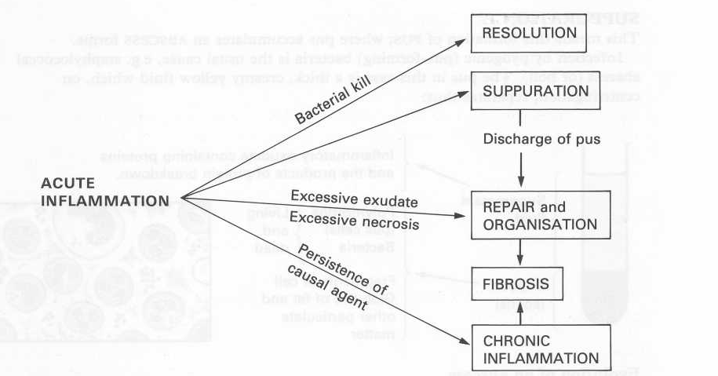

**Figure 6 Illustration of the results of acute inflammation**

**Special types of inflammation**

There are four types

**1) Catarrhal inflammation** – is a surface inflammation that is greatly associated by the secretion of the clear mucus

**2) Exudative inflammation**- It presents with a variety of inflammations. These are as follows:-

i) Serous inflammation where there is excessive clear watery secretion and variable protein is produced without fibrin e.g. burns and pleural effusion. The serous fluid does not impede healing

ii) Fibrinous exudation where there is fibrin deposition on the surface. Most often the fibrin deposit impedes resolution and adhesion may follow. A good example is in pneumonia with pleurisy

**3) Pyogenic inflammation-suppurative** It is an inflammation where there is production of pus and is caused by Pyogenic organisms mainly bacteria for instance appendicular abscess

4**) Haemorrhagic inflammation**. In this inflammation it is so severe that the blood vessels rapture presenting an important feature of haemorrhage for example in severe influenza pneumonia.

Note: in most cases this types of inflammations present across as both mucopurulent inflammations and sero sanguinous in each case therefore overlapping

**Chronic inflammation**

It is a prolonged process in which there is tissue destruction and inflammation occurring at the same time. It is caused by one of the following 3 ways

Chronic inflammation following acute inflammation as recurrent attacks of acute inflammations and chronic inflammation starting de novo (on its own)

**General patterns of chronic inflammation**

Mononuclear cell infiltration (phagocytes Lymphocytes and macrophages)

Tissue destruction and necrosis

Proliferative changes

Fever, anaemia, Lymphocytosis and increased ESR

**Types of chronic inflammation**

It is determined histologically as

Chronic non specific inflammation that is characterized by non specific inflammatory cell infiltration e.g. Chronic osteomylitis and lung abscess or Bronchiectasis

Chronic granulomatous inflammation characterized by formation of granulomas -e.g leprosy, tuberculosis, syphilis, actinomyosis and rheumatic fever.

**Granulomatous inflammation**



**Figure 7 Illustrated pathology -a Granuloma**

The granuloma is a circumscribed tiny lesion , 1mm in diameter composed of predominantly a collection of modified macrophages called epithelioid cells and rimmed at the peripheral by lymphoid cells. Besides the two they have giant cells, necrosis and fibrosis.

2 factors favour formation of granulomas ;

Presence of poorly digestable irritant which may be organisms (e.g. TB, Leprosy)

Presence of cell mediated immunity to the irritant (hypersensitivity delayed type)

**Systemic effects of chronic inflammation**

1) Fever

2) Anaemia

3) Leucocytosis with relative Lymphocytosis

4) E.S.R is elevated

5) Amyloidosis

|  |
| --- |
|  |

|  |
| --- |
| **Chapter6: Response of tissue and cell to injury (Healing of Wounds/ulcers)** |

**Definition**

A wound is any breach in continuity of surface like cuts surgical incisions and others, while an ulcer is a pathological break in the continuity of the surface. Ulcers are local defects on the surface of an organ produced by inflammation (pathological). Pathological implies diseased. This is repaired by regeneration of the parenchyma cells of the organs concerned and growth of the supporting connective tissue ( regeneration). The end result of the repair process will depend largely upon the balance between two factors.

The better the repair the more the regeneration

Fibrosis gives a poor repair tissue

|  |
| --- |
| healing and regeneration |

**Figure 9 A wound/ an ulcer process of healing (Mohan and Harsh 2010)**

Injury to tissue may result in cell death and tissue destruction. Healing is the body response to injury in an attempt to restore normal structure and function.

There are 2 distinct processes in healing.

i)Regeneration – this is when healing takes place by proliferation of parenchyma cells and usually results in complete restoration of the original tissue

ii)Repair – when healing takes place by proliferation of connective tissue elements resulting in fibrosis and scarring. At times both processes take place simultaneously

**Regeneration**

This is the capacity of cells to divide or multiply**.** It involves the proliferation of original cells from the margin of injury with migration so as to cover the gap followed by proliferation of migrated cells with subsequent differentiation and maturation so as to reconstitute the original tissue. Some parenchyma cells are short-lived while others have a longer lifespan. To maintain proper structure of tissues the cells have regulatory control of the cell cycle. These include epidermal growth factor, fibroblast growth factor, platelet-derived growth factor, endothelial growth factor, and trans trimming growth factor.

**Cells**

Depending upon the capacity of cell to divide the cells of the body can be divided into 3 groups , Labile cells, stable cells and permanent cells.

**Explanation**

**Labile cells** –these are cells that continue to multiply throughout life under normal physiologic conditions e.g. surface epithelial cells of epidermis, alimentary canal, respiratory tract, urinary tract, vagina , cervix, uterus, endometrium, haemopoetic cells of bone marrow, lymph nodes and spleen.

**Stable cells**- these cells lose their ability to proliferate after adolescence but retain the capacity to multiply in response to stimuli for instance cells of the liver pancreases kidney, adrenal and thyroid, mesenchyma cells like smooth muscle cells fibroblasts vascular endothelium, bone and cartilage.

**Permanent cells**- these are cells that lose their ability to proliferate around the time of birth. Examples include Nervous system, skeletal muscle and cardiac muscles

**Repair**

Replacement of injured tissue by fibrous tissue involves two processes, these are

**Granulation tissue formation**

**Contraction of wounds**

|  |
| --- |
| ***Clinical importance***  ***A clinician should be able to identify a wound that is healing by repair and that it is healing by regeneration***  ***The possible cells or organs that are more likely to heal well and those with poor healing power*** |

**Healing by first intentions (Primary union**)

**Condition** – minimum loss of tissue e.g. In surgical incision healing takes a very short period of time.

**Stages**

1) **Exudation** of blood into the space between the cut but closely opposite tissues.

2**) Coagulation** of fluid with formation of fibrin strands.

3) **Invasion** of this coagulation by capillary loops and fibroblasts derived from marginal tissues.

4) **Maturation of fibroblasts** whose fibrils lay down collagen which mature and decrease in vascularity to result in to avascular scar tissue.

5) **Proliferation** of the marginal surface epithelial cells to restore the surface continuity (in 7 days continuity is restored.)

|  |
| --- |
| ***Clinical importance***  ***Clean wounds heal faster***  ***The need for aseptic technique*** |

**Healing by secondary intention (granulation tissue formation)**

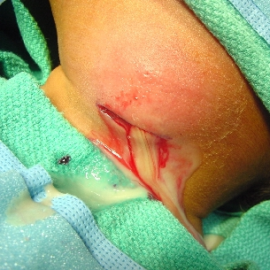

**Figure 10 An abscess cavity that requires a large reparative tissue for repair and infection (an example of healing that will occur by secondary intention)**

**Conditions**

There is sufficient loss of tissue so that the edges are separated by a defect for example an ulcer or abscess cavity, large wound. A large bulk of reparative tissue is required and the process takes longer than healing by 1st intention. In such circumstances cleaning and stitching may produce primary union

**Stages of healing**

**1)** If there is wound infection, this has to be overcome first by inflammation response and the debris removed by macrophages.

**2)** Repair starts from the floor of the defect with invasion of a surface by proliferating capillary loops and fibroblasts. This is continued in ever increasing arcades of capillaries and their accompanying fibroblasts. Fibroblastic maturation continues towards the surface until the whole area of tissue is red in colour with a granular surface due to the capillary loops – granulation tissues

**3)** The surface epithelial cells at the margins proliferate and grow over the surface of the granulation tissue until the wound is covered.

**4)** The vascular granular tissue mature from the base towards the surface until the entire area is covered into a mass of fibrous tissue at first then becomes pale as the scar tissue becomes a vascular the collagens subsequently contracts, this usually results in a depression or puckering of the surface.

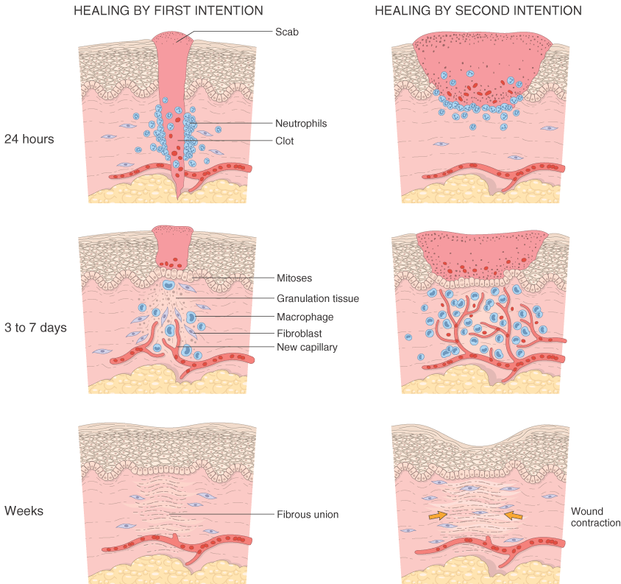

**Figure 11 a comparison of primary and secondary healing- illustrated pathology (2005)**

**Factors affecting healing by granulation tissue**

1) Specialized structures e.g sweat glands sebaceous glands and hair follicles do not regenerate.

2) Presence of infection retards growth of granulation tissue therefore delay healing

3) The presence of dirt, dead tissue or foreign matter produce a foreign body giant cell reaction in the granulation tissue which also delays healing.

**Note:**- where the healing process co –exist with a mild form of active infection, an abundant amount of inflammation occurs with vascular granulation tissue forming to restore the tissue continuity. This is called proud fresh.

**Factors that influence wound healing and repair**

**Local factors**

**1) Type of tissue involved** – some tissues have high powers of regeneration while others have none.

**2) Vascularity** – adequate blood supply is essential for repair but avascular areas do not heal well e.g. neck of femur

**3) Protection** – Protective covering prevents further injury and re-infection of damaged tissues.

**4) Amount of tissue damaged or lost**- the more the tissue loss, the more the difficulty to heal

**5) Foreign bodies**- presence of foreign material within a wound retards healing by causing irritation within the granulation tissue.

**6) Sinuses and fistulae** – a sinus is a blind track in a tissue while a fistula is an opening track forming two epithelial surface for example gut and skin, vagina and rectum stomach and intestines. The presence of the two delays healing totally.

**7) Sensory nerves** - absence of adequate sensory nerve supply delays or may even prevent healing totally.

**General factors**

**1) Infection** - either as a general factor or local factor can delay or prevent healing

**2) Under nutrition** – vitamin and protein associated deficiencies markedly delay healing. this is common with vitamin C deficiency

**3) Age-** repair is better and faster in youth than in the elderly

**4) Endocrinal hormones** – thyroid hormone is essential for healing while steroids like adrenal hormones retard healing. Diabetic heal poorly due to infective and vascular disorders

**5) Temperature excess**, heat or cold retards repair as both may cause tissue damage and vascular thrombosis.

**6) Radiation** –delays healing and repair as it injures soft tissue.

**Review questions**

1. Differentiate between healing by secondary intention and healing by primary intention

2. Compare and contrast factors that promote and retard healing of wounds

3. What is the importance of understanding the type of cells and their regeneration powers?

4. Identify and list the stages of healing of the bone tissue following a fracture

**Stages of bone healing**

a) Stage of hematoma formation

b) Stage of subperiosteal and endosteal proliferation

c) Stage of callus formation

d) Stage of consolidation

e) Stage of modeling (ossification)

|  |
| --- |
| **Chapter 7: Necrosis** |

**Definition**

This is the death of cell or groups of cells while they still form part of the living body and implies permanent ceassation of normal function. Necrosis may be sudden or gradual called necrobiosis.

**Causes**

1. Blood supply:- cells are cut off from oxygen and nutrition ( ischaemia)
2. Toxins e.g. bacterial, plants, snake bites, scorpions, chemical like acid, alkalis, cyanide and carbon tetrachloride are capable of causing necrosis
3. Antibody antigen reactions e.g. TB
4. Severe infections by bacteria or virus e.g. the cytopathic affect of viruses as in poliomyelitis
5. Physical agents e.g. extreme of temperatures as in very cold or hot temperatures
6. Mechanical pressure causes disruption of cells
7. Ionizing radiation destroys nucleic protein (DNA or RNA)

**Characteristics of a necrotic cell**

* Increased membrane permeability
* Hydrolysis of nucleus (karyolysis)
* Nuclear disruption and disappearance
* Loss of all physiological function and processes

**Types of necrosis**

1. Coagulassive necrosis- this is a condition of cell death leaving the tissue hardened or (mumified)
2. Colliquative necrosis- cell death with softening of the tissue affected (liquafactive)

**Special forms of necrosis**

1. **Caseous necrosis** i.e.- a firm cheese like mars of necrotic tissue e.g TB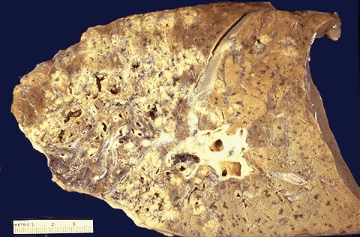

**Cheese like material in caseous necrosis**

1. **Fat necrosis**- traumatic rapture of fat cells with fat getting into tissue to firm a hard nodule. It can either be enzymatic as in acute pancreatitis, enzyme lipase escapes into the peritoneal cavity and splits the omental fat
2. Suppuration- this is a special form of colliquative necrosis; pus itself consists of tissue fluids , dead leucocytes, bacterial, proteolytic enzymes and tissue debris
3. Fibrinoid necrosis,collagen fibres are broken down, amyloid material resembling fibrin that stain pink as seen in connective tissue disease e.g. rheumatic fever, rheumatoid arthritis
4. Gangrenous necrosis

This is necrosis plus infection. Green black change of tissue colour with foul smelling gas hydrogen sulphide is released

**Types of gangrene**

* Dry gangrene is necrosis with mummification of the affected part. This occurs where the tissues are dry with oedema and the infection is little e.g. in the foot- toes.

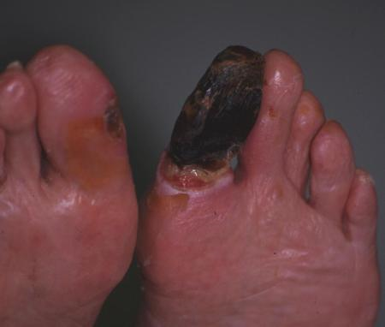

* Wet gangrene is necrosis that occurs in soft tissues with plenty of saprophytic infection e.g. in the intestine

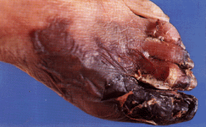

Wet gangrene with production of fluid and gas

**Causes of gangrene**

1. All the causes of necrosis are as above with super added saprophytic infection
2. Primary infection caused by clostridium welchi. This causes the production of gas and green pigment derived from breakdown of haemoglobin. The infection is gas gangrene

**Effects of necrosis to affected part**

* Loss of function of the affected cells, tissues, organs or system, a fact that depends on the number of cells involved.
* Release of cellular enzymes into the blood that may be used to diagnose various diseases e.g. enzymes such as trans aminases SGOT and SGPT that are released into blood when the liver, heart muscles undergo necrosis as in severe hepatitis and myocardial infarction
* Somatic death: death of an individual defined as complete and persistent ceassation of respiration and circulation with extensive and irreversible brain damage.

|  |
| --- |
| **Chapter 8: Cell degeneration** |

**Definition**

This is less than a necrosis form of cell damage in which some less vital cell functions of the cell are lost while others that are vital like respiration and selective permeability remains intact. This is also accompanied. By morphological changes i.e. lessening of cell reality as well as physical alteration

**Nature of degeneration**

There is alteration in the morphology of cells produced by

* Accumulation of metabolites or other substances in cells damaged by proceeding injured referred to as true degeneration
* Overloading of the previously normal cell with materials which are abnormal in either type of quality (infiltrative) change in cells in both cases may appear similar and all indicative of cell derangement short of actual death. Most changes are reversible if the initiating cause is removed. If prolonged or of severe degree, cell death (necrosis) occurs.

**Specific types of cell degeneration**

**Cloudy swelling**

**Causes**

Severe infarction

Toxins

Defective nutrition-ischaemia

Anaemia and anoxia

**Sites**: - any cell can be affected but mostly the paranchymal cells of the liver( hepatocytes) kidney and cells tend to be more commonly and severely affected

**Microscopic appearances**

Cells are slightly swollen and show hazy and granular cytoplasm. This is due to breakdown of filamentous mitochondria. The granules are composed of protein.

**Result**

This is the earliest detectable degenerative changes of a cell and is completely reversible

**Hydropic degeneration**

* **Nature**

There is increased fluid (water in the cell that may be due to increased osmotic pressure within the cell or due to alterations in the permeability of the cell membranes by toxin agents

* **Causes**

1. Severe water and electrolyte disturbances e.g. depletion of potassium
2. Physical and chemical agents e.g. burns, scalds chloroform and carbon tetrachloride
3. Infections
4. Prolonged cloudy swelling

* **Sites**: liver cells and convoluted tubular cells of the kidney

**Microscopic appearance**

There are multiple vacuoles of clear fluid within the cell. They coalesce in severe cases to form a single large vacuole which displaces the nucleus

**Drawing of hydropic swelling of the renal tubules**



**Hyaline degeneration:**

**Definition**

This is the pink staining homogenous glassy appearance of the cytoplasmic protein of the cell. It is due to severe cell damage and representation of a type of protein coagulation quantitatively less than Coagulative necrosis.

**Sites**

Renal tubules are the sites following mercury poisoning or nephritis or in cells infected with virus. It may also occur in voluntary muscles in severe bacterial infections like typhoid fever, severe nutritional deficiencies e.g. protein and vitamin lack.

**Glycogen infiltration**

This is a condition of excessive amount of intracellular glycogen

**Causes**

1. Diabetes mellitus-this leads to excess cellular glycogen especially prominent in the renal and liver cells. The cells are distended and show nuclear ballooning or clear vacuoles of glycogen
2. Tumour- some tumour cells are rich in glycogen e.g. seminoma, renal cell carcinoma, Squamous cell carcinoma and chondroma
3. Glycogen storage-disease e.g. von Gierkes’ disease inherited genetic disorders of glycogen metabolism

**Fatty change**

This is the presence of demonstrable fat within paranchymal cells especially those of the liver, kidney and head. Usually excess fat in the body is stored in special storage tissue cell called adipose tissue. It is due to imbalance of fat and fatty acid entering the cell and the rate of utilization or release of fat by the cell. All paranchymal cells that accumulate an abnormal amount of fat are injured.

**Microscopic appearance**

Fat may be seen in the form of multiple small droplets or in a single fat globule that may displace the nucleus.

**Causes:**

1. Hypoxia e.g. chronic venous congestion as in anaemia
2. Starvation and wasting diseases
3. Clinical and bacterial toxins e.g. phosphorus, carbon tetrachloride and alcohol

iv. Fatty change is also a feature of severe infections e.g. typhoid fever, small pox, septicaemia

**Microscopic appearance**

The affected organs show pallor and on cross section give a greasy feel especially the liver; the kidney shows linear pallor streaks due to fat in the renal tubules.

**Results**

Fatty change is a reversible process and if the cause is removed, the cells usually revert to normal but prolonged fatly change with evidence of nuclear degeneration eventually becomes irreversible and progresses to necrosis and fibrous replacement.

**Amyloid degeneration (amyloidosis)**

**Nature**

Amyloids are predominantly extracellular fibrillar material which is due to a number of diseases. Extensive deposits are visible by the naked eye and cause enlargement of the affected tissue or organ.

**In histological: examination**

Haematoxylin and Eosinophil sections of amyloid show homogenous pink material.On electron microscopy, amyloid is seen to consist of filaments twisted together in pairs

**Demonstrations of amyloid in gross specimen of tissues using lugol’s iodine method**

Amyloid has a high affinity for lodine. This forms the basis for useful macroscopic test when lugols lodine solution is poured over a tissue the amyloid is stained deep brown in contrast to normal tissues that is stained very lightly.

**Types:**

1. Primary amyloidosis It has no known cause
2. Secondary amyloidosis- occurs as a complication to certain disease like

* Any chronic suppurative infections e.g. TB, Osteomylitis, Syphilis, Bronchiectasis
* Rheumatoid arthritis
* Multiple myeloma and Hodgkin’s disease

**Sites**

Heart, tongue, skin, skeletal muscle, gut, spleen, kidney, liver and lungs are the common sites. In secondary type- liver, kidney, spleen and gut that are severely affected.

**Effects**

* Pressure effects on adjacent structures interfere with the transfer of water and solutes across the walls of the affected small blood vessels and capillaries.
* Clinically it causes enlargement of organs affected e.g. liver, spleen, heart and kidney.