Pyridoxine (Vitamin B6) deficiency

Vitamin B6 is a type of B vitamin. Pyridoxine, pyridoxal, and pyridoxamine are all forms of vitamin B6. It's found in certain foods and also made in a lab.

Vitamin B6 is needed for the proper function of sugars, fats, and proteins in the body. It's also necessary for the development of the brain, nerves, skin, and many other parts of the body. It's found in cereals, legumes, and eggs, and often used with other B vitamins in vitamin B complex products.

Deficiency symptoms include:

can cause peripheral neuropathy, seborrheic dermatitis, glossitis, and cheilosis, and, in adults, depression, confusion, and seizures.

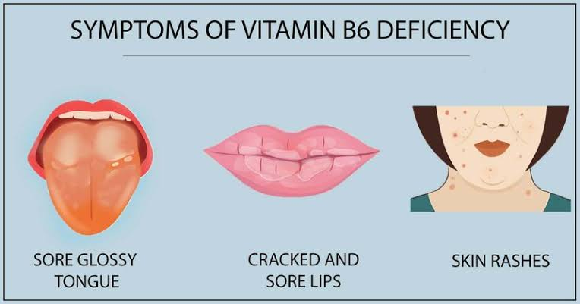

B6 deficiency is generally easy to avoid as long as you have healthy eating habits that include a variety of fruits, vegetables, nuts, meats and fish.