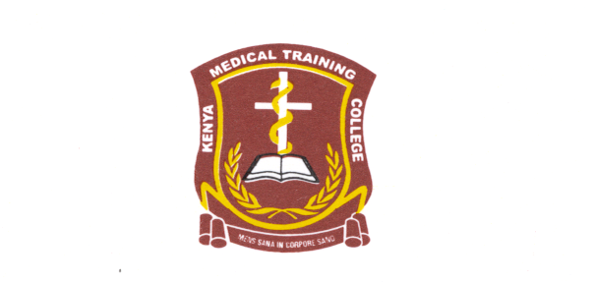**KENYA MEDICAL TRAINING COLLEGE-VOI CAMPUS**

STUDENTS REPRESENTATIVE COUNCIL ELECTION NOMINEES

**THE APPLICANTS LISTED BELOW HAVE BEEN CLEARED TO VIE FOR THE ELECTIVE POSTS THEY APPLIED FOR AND CAN PROCEED WITH THEIR CAMPAIGNS CULMINATING TO THE BALLOT ON FRIDAY 1ST OCTOBER 2021.**

**SRC PRESIDENT**

1. TOM MBOYA AWINDA
2. OUMA DAVID OTIENO
3. PETER KIPKOECH

**VICE PRESIDENT**

1. MERCY WANGARI MAINA
2. EUPHEMIA A. GOGO
3. CECILIA NJUMWA MAKITIRO

**TREASURER**

1. KEVIN NYABUTO MORURI
2. CLINTON DARYL
3. ROBERT KIPKOECH

**ORGANIZING SECRETARY**

1. VICTOR CHERUIYOT RONO
2. ALFRED SAVATIA BULUKU

**SECRETARY GENERAL**

1. JAMES WAIGWA MWANIKI
2. FRANK OMUSE

ALL THE BEST IN YOUR CAMPAIGNS.

**G. NGETICH**

**DEAN OF STUDENTS/SRC PATRON.**