STOMACH CANCER

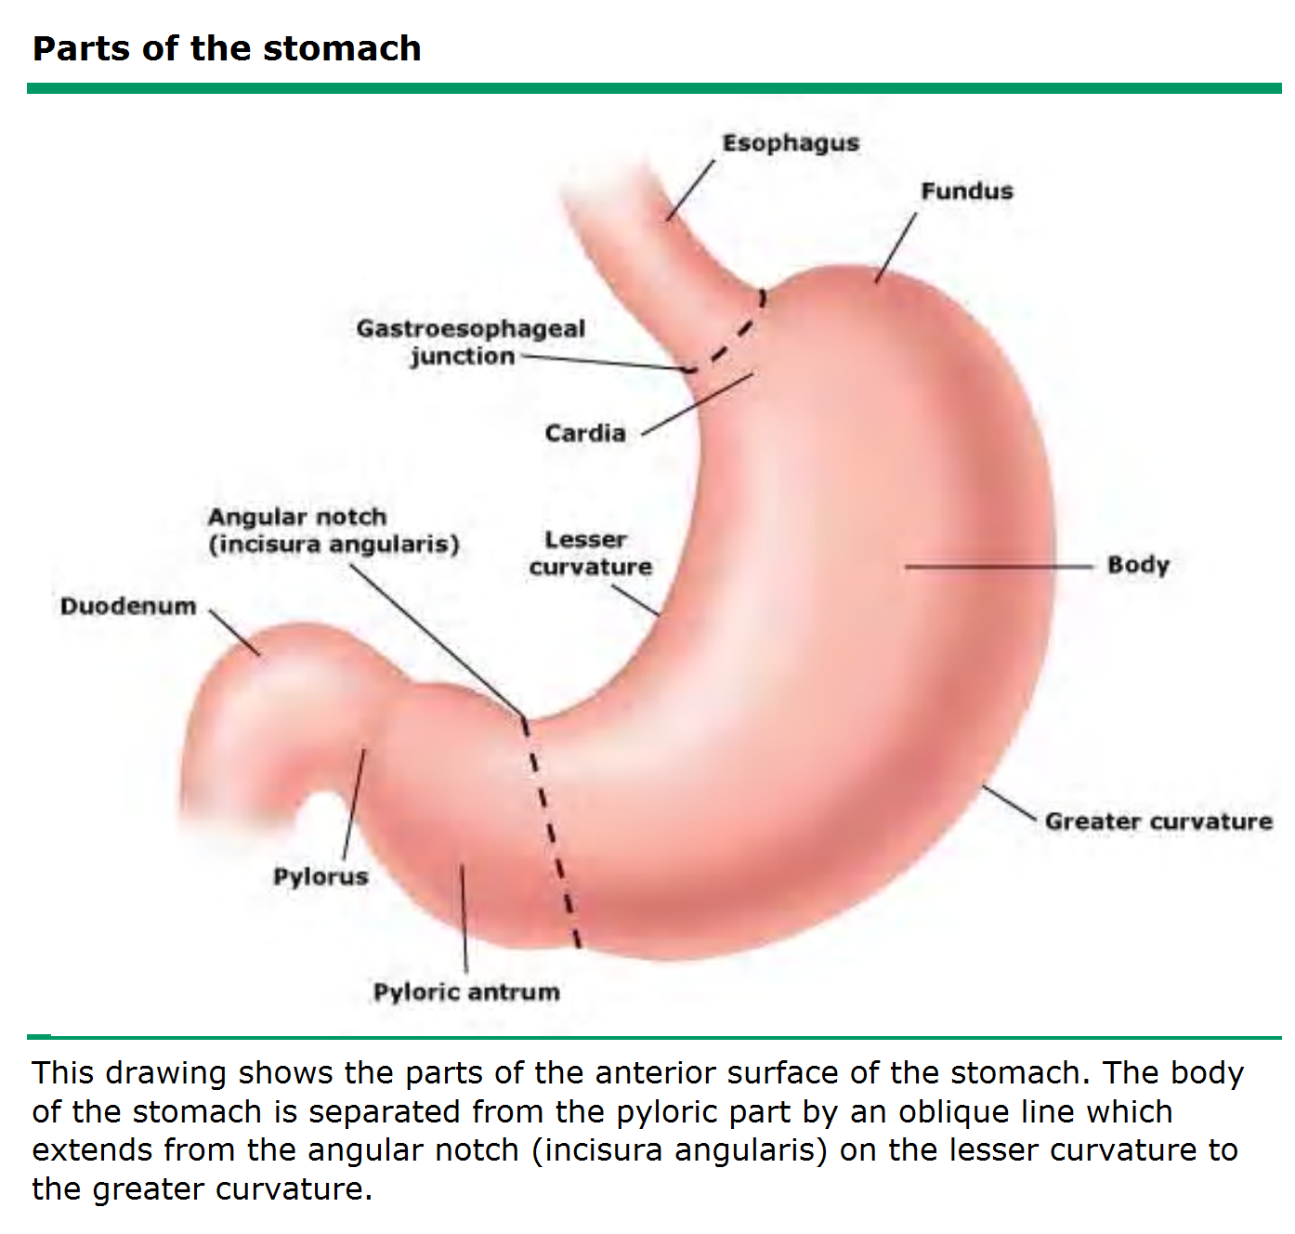
Anatomy

Definitions:

- Gastric adenocarcinoma accounts for 95% of malignant tumors of the stomach; less common are lymphomas (which may be localized primarily in the stomach) and leiomyosarcomas.
- There are two main histologic variants of gastric adenocarcinoma.
- The most frequent is the "intestinal type", so called because of its morphologic similarity to adenocarcinomas arising in the intestinal tract.
- The less common diffuse type gastric cancers are characterized by a lack of intercellular adhesions, which leaves them unable to form glandular structures.
- In patients with inherited form of diffuse type gastric cancer, the absence of intercellular adhesions is caused by a germline mutation in the cell adhesion protein E-cadherin.

Epidemiology

- Gastric cancer is one of the most common causes of cancer mortality worldwide.
- Gastric cancer used to be the leading cause of cancer deaths in the world until the 1980s when it was overtaken by lung cancer
- Overall, it has the third highest annual cancer incidence worldwide, behind only lung and breast cancer
- The incidence of stomach cancer varies worldwide; for example, it is extremely high in Japan, Chile, and Iceland.
- In the USA, gastric cancer is most common in northerners, the poor, and blacks
- However, in Japan, where the incidence has also decreased, stomach cancer is still the most common malignancy.
- Its incidence increases with age; > 75% of patients are > 50 yr.
- The incidence of gastric cancer varies with different geographic regions.
- Approximately 60 percent of gastric cancers occur in developing countries.
- The highest incidence rates are in Eastern Asia, the Andean regions of South America, and Eastern Europe while the lowest rates are in North America, Northern Europe, and most countries in Africa and South Eastern Asian
- There is also substantial difference in the incidence among different ethnic groups within the same region
- Gastric cancer is more common in men in both developed and developing countries

Etiology

- The cause is unknown but various risk factors have been described.

Environmental risk factors

- Diet

- Nitroso compounds: Dietary exposure to N-nitroso compounds (compounds containing an -NO group)
- Salt: High salt intake damages stomach mucosa and increases the susceptibility to carcinogenesis in rodents

- Smoking

- Approximately 18 percent of gastric cancer cases were attributed to smoking.

- Alcohol

- A consistent association between alcohol consumption and the risk of gastric cancer has not been demonstrated
- A study from Europe suggested that daily intake of wine may be protective

- Socioeconomic status

- The risk of distal gastric cancer is increased by approximately twofold in populations with low socioeconomic status
- By contrast, proximal gastric cancers have been associated with higher socioeconomic class

- Gastric surgery

- There is an increased risk of gastric cancer after gastric surgery, with the risk being greatest 15 to 20 years after surgery and then increasing with time
- The Billroth II procedure (gastrojejunostomy) carries a higher risk than the Billroth I (gastroduodenostomy).
- Although the exact cause of the increased risk is unknown, it is thought to be due to regurgitation of alkaline bile and pancreatic juice (which is greater after a Billroth II compared with a Billroth I).

- Reproductive hormones

- Reproductive hormones in women have a protective role in gastric cancer risk.

- Epstein-Barr virus

- The Epstein-Barr virus (EBV) is associated with a number of malignancies, especially nasopharyngeal carcinoma.

- Helicobacter pylori

- The World Health Organization's International Agency for Research on Cancer classified Helicobacter pylori as a Group 1 or definite carcinogen
- Intestinal type gastric carcinoma is believed to evolve as a progression from atrophy to metaplasia, dysplasia and then carcinoma.
- The most common cause of gastritis is Helicobacter pylori

Host-related factors

- Blood group

- Individuals of blood group A have been known for decades to show an approximately 20 percent excess of gastric cancer than those of group O, B, or AB
- They also show a similar increase in the rate of pernicious anaemia

- Familial predisposition

- A genetic predisposition to gastric cancer has been repeatedly confirmed

- Genetic polymorphisms

- Certain polymorphisms have been associated with gastric cancer:

- Gastric polyps

- Gastric polyps are typically found incidentally when upper gastrointestinal endoscopy is performed for an unrelated indication; only rarely do they cause symptoms or other clinical signs.
- Nevertheless, their discovery can be important since many polyps have malignant potential

- Hypertrophic gastropathy and immunodeficiency syndromes

- Hypertrophic gastropathy (including Menetrier's disease) and various immunodeficiency syndromes have been linked with gastric cancer.

- Gastric ulcer

- An association between benign gastric ulcers and gastric cancers probably reflects common risk factors (i.e. mainly H. pylori infection)

- Pernicious anemia

- Pernicious anemia, a sequela of autoimmune chronic atrophic gastritis directed against hydrogen-potassium ATPase in the gastric parietal cells, is associated with an increased risk of intestinal-type gastric cancer.

Pathogenesis

Intestinal type cancers

- The intestinal type of gastric adenocarcinoma is most common in high-risk populations, more likely to be sporadic than inherited, and related to environmental factors such as diet, cigarette smoking and alcohol use.
- H. pylori and the preneoplastic cascade: Intestinal-type tumors are causally related to H. pylori. While the infection usually starts in infancy or early childhood, there is a long latency period, and cancers are clinically diagnosed four or more decades later.
- During this period, a prolonged precancerous process takes place, represented by a "cascade" of events with the following well-characterized, sequential histopathologic stages: chronic active non-atrophic gastritis; multifocal atrophic gastritis; intestinal metaplasia (complete, then incomplete); dysplasia; and invasive carcinoma
- Non-atrophic gastritis: The first stage, non-atrophic gastritis, predominates in the gastric antrum and is characterized by an interstitial infiltrate of lymphocytes, macrophages, and plasma cells
- Occasionally, lymphoid follicles are formed.
- Atrophic gastritis: Atrophic gastritis is characterized by multifocal loss of the original gastric glands, including mucus secreting glands in the antrum, and parietal and chief cells in the corpus.
- Intestinal metaplasia: Multifocal atrophy involving the gastric mucosa may be followed by the appearance of glands having an intestinal phenotype, termed intestinal metaplasia.
- These glands are first seen at the junction of the antrum and the corpus (i.e. oxyntic) mucosa, especially in the area of the incisura angularis.
- The foci of metaplasia become larger and more numerous over time, extending to the antrum as well as to the corpus of the gastric mucosa.
- The larger the atrophic and metaplastic area, the greater the cancer risk.
- As atrophic and metaplastic glands replace original glands, the normal gastric secretions decrease, leading to hypochlorhydria and low levels of pepsinogen I (produced by the chief cells of the corpus) and gastrin 17 (produced by antral G cells).
- These markers can be measured in the serum and can be used as an indicator of gastric atrophy and cancer risk
- The first metaplastic glands seen in the gastric mucosa phenotypically resemble those of the small intestine, with eosinophilic absorptive enterocytes with a brush border (multiple microvilli), alternating with mucus-producing goblet cells.
- This is the type I, complete, or small intestinal metaplasia
- More advanced stages are characterized by phenotypic changes that are more similar to colonic mucosa with the glands becoming lined by irregular goblet cells (type III, incomplete or colonic metaplasia)
- Colonic metaplasia is frequently found around small (early) gastric carcinomas.
- Some consider colonic metaplasia to represent an early stage of dysplasia, deserving closer endoscopic surveillance than type I (small intestinal) metaplasia
- Dysplasia: Dysplasia is the next step in the progression of the precancerous process.
- Dysplasias are classified as low-grade or high-grade, according to the degree of nuclear and architectural atypia and disorganization.
- Rates of progression to invasive carcinoma from low-grade dysplasia are 0 to 23 percent, while the corresponding rates for high-grade dysplasia are 60 to 85 percent
- Invasive carcinoma: Grossly, most intestinal-type carcinomas are ulcerated masses that are located in the region of the incisura angularis and its neighboring antral and corpus mucosa
- Some have their epicenter in the antrum or the corpus, away from the antrum-corpus junction.

Diffuse type cancers

- Like intestinal-type cancers, diffuse-type gastric carcinomas can be induced by H. pylori infection
- Diffuse carcinomas have a greater tendency to invade the gastric wall, sometimes extending to the lower esophagus or to the duodenum.
- Occasionally, a broad region of the gastric wall or even the entire stomach is extensively infiltrated, resulting in a rigid thickened stomach, termed "linitis plastica"
- Histologically, individual tumor cells are seen to invade the surrounding tissues, and there is no gland formation.
- When intracellular mucin is abundant, it pushes aside the nucleus of the individual cells, resulting in the so-called signet ring carcinoma.
- Diffuse carcinomas display a prominent molecular abnormality: defective intercellular adhesions. In most cases, this results from loss of expression of the cell adhesion protein E-cadherin.
- The E-cadherin gene (CDH1) encodes a homodimeric transmembrane cellular adhesion protein. Its cytoplasmic tail interacts with catenins, assembling the cell:cell adhesion complex

Classification:

- Gastric adenocarcinomas can be classified according to gross appearance:
- Protruding--The tumor is polypoid or fungating.
- Penetrating--The tumor has a sharp, well-circumscribed border and may be ulcerated.
- Spreading--The tumor shows superficial spread along the mucosa or infiltration within the wall. If an ulcer is present, its edge tends to be ill-defined or heaped up. Tumor infiltration of the stomach wall and an associated fibrous reaction may produce a "leather bottle" stomach (linitis plastica).
- Miscellaneous--The tumor shows characteristics of two of the other types; this is the largest classification.
- Histologic classification correlates moderately with gross appearance and prognosis
- The Japanese Society for Gastroenterological Endoscopy (1962) developed a classification for early gastric cancer, i.e. cancer limited to the mucosa and submucosa.
- Identification is based on gross morphology: type I--protruded; type II--superficial (elevated, flat, or depressed); type III--excavated.

Clinical features

- Weight loss and persistent abdominal pain are the most common symptoms at initial diagnosis
- Weight loss usually results from insufficient caloric intake rather than increased catabolism and may be attributable to anorexia, nausea, abdominal pain, early satiety, and/or dysphagia.
- The abdominal pain tends to be epigastric, vague and mild early in the disease but more severe and constant as the disease progresses.
- Dysphagia is a common presenting symptom in patients with cancers arising in the proximal stomach or at the esophagogastric junction
- Patients may also present with nausea or early satiety from the tumor mass or in cases of an aggressive form of diffuse-type gastric cancer called linitis plastica, from poor distensibility of the stomach.
- They may also present with a gastric outlet obstruction from an advanced distal tumor
- Patients may also present with nausea or early satiety from the tumor mass or in cases of an aggressive form of diffuse-type gastric cancer called linitis plastica, from poor distensibility of the stomach.
- They may also present with a gastric outlet obstruction from an advanced distal tumor.
- Occult gastrointestinal bleeding with or without iron deficiency anemia is not uncommon, while overt bleeding (i.e. melena or hematemesis) is seen in less than 20 percent of cases.
- The presence of a palpable abdominal mass is the most common physical finding and generally indicates long-standing, advanced disease
- A pseudoachalasia syndrome may occur as the result of involvement of Auerbach's plexus due to local extension or to malignant obstruction near the gastroesophageal junction.
- For this reason, gastric cancer needs to be considered in the differential diagnosis for older patients presenting with achalasia
- Approximately 25 percent of patients have a history of gastric ulcer.
- All gastric ulcers should be followed to complete healing, and those that do not heal should undergo resection

Signs of tumor extension:

- More unusual presentations, related to the propensity of gastric cancer to spread by direct extension through the gastric wall, can also alert the clinician to the diagnosis.
- Feculent emesis or passage of recently ingested material in the stool can be seen with malignant gastrocolic fistula, although this is extremely rare.
- More commonly, colonic obstruction may occur.
- Since gastric cancer can spread via lymphatics, the physical examination may reveal a left supraclavicular adenopathy (Virchow's node) which is the most common physical examination finding of metastatic disease, a periumbilical nodule (Sister Mary Joseph's node), or a left axillary node (Irish node).
- Peritoneal spread can present with an enlarged ovary (Krukenberg's tumor) or a mass in the cul-de-sac on rectal examination (Blumer's shelf).
- Ascites can be the first indication of peritoneal carcinomatosis.
- A palpable liver mass can indicate metastases, although metastatic disease to the liver is often multifocal or diffuse.
- Liver involvement is often, but not always, associated with an elevation in the serum alkaline phosphatase concentration.
- Jaundice or clinical evidence of liver failure is seen in the preterminal stages of metastatic disease

Paraneoplastic manifestations:

- Dermatologic findings may include the sudden appearance of diffuse seborrheic keratoses (sign of Leser-Trelat) or acanthosis nigricans, which is characterized by velvety and darkly pigmented patches on skin folds.
- Neither finding is specific for gastric cancer.
- Other paraneoplastic abnormalities that can occur in gastric cancer include a microangiopathic hemolytic anemia, membranous nephropathy, and hypercoagulable states (Trousseau's syndrome)
- Polyarteritis nodosa has been reported as the single manifestation of an early and surgically curable gastric cancer

Investigations

Endoscopy

- It permits direct inspection and biopsy of suspicious areas.
- Tissue diagnosis and anatomic localization of the primary tumor are best obtained by upper gastrointestinal endoscopy
- Although more invasive and more costly, upper endoscopy is also more sensitive and specific for diagnosing a variety of gastric, esophageal and duodenal lesions than alternative diagnostic strategies
- Cytology on gastric washings is helpful in some institutions; special techniques (eg, spraying the surface of the tumor with a jet of water during endoscopy, using devices that abrade the tumor surface) may increase the yield of positive washings

Barium studies

- By using double-contrast techniques that involve coating the mucosa with barium and inflating the stomach to bring out mucosal details
- Barium studies can identify both malignant gastric ulcers and infiltrating lesions, and some early gastric cancers also may be seen
- The one scenario in which a barium study may be superior to upper endoscopy is in patients with linitis plastica.
- The decreased distensibility of the stiff, "leather-flask" appearing stomach is more obvious on the radiographic study, and the endoscopic appearance may be relatively normal

Abdominopelvic CT scan

- Dynamic computerized tomography (CT) scan imaging is usually performed early in the preoperative evaluation after a diagnosis of gastric cancer is made.
- It is best suited to evaluating widely metastatic disease, especially hepatic or adnexal metastases, ascites, or distant nodal spread.

Staging (TNM)

Tumor (T) stage

TX: Primary tumor cannot be assessed
T0: No evidence of primary tumor
Tis: Carcinoma in situ: intra-epithelial tumor without invasion of the lamina propia
T1: Tumor invades lamina propria or submucosa
T2: Tumor invades muscularis propria or subserosa
T2a: Tumor invades muscularis propria
T2b: Tumor invades subserosa
T3: Tumor penetrates serosa (visceral peritoneum) without invasion of adjacent structures
T4: Tumor invades adjacent structures

Nodal (N) stage

NX: Regional lymph node(s) cannot be assessed
N0: No regional lymph node metastasis
N1: Metastasis in 1 to 6 regional lymph nodes
N2: Metastasis in 7 to 15 regional lymph nodes
N3: Metastasis in more than 15 regional lymph nodes

Metastasis (M) stage

Mx: Presence of distant metastasis cannot be assessed
M0: No distant metastasis
M1: Distant metastasis

Treatment

- Palliative treatments for advanced gastric cancer can be either local or systemic.
- While cytotoxic chemotherapy is the most effective treatment modality for patients with metastatic disease, it is frequently inadequate for palliation of local symptoms such nausea, pain, obstruction, perforation, or bleeding from a locally advanced or locally recurrent primary tumor, which require multidisciplinary management using endoscopic, surgical, radiotherapeutic or other approaches
- Therapeutic options to control symptoms of local disease progression such as nausea, pain, bleeding and obstruction include palliative surgical resection, surgical bypass (gastrojejunostomy), radiation therapy, and endoscopic techniques.

Palliative resection:

- Palliative gastrectomy may provide symptomatic relief of pain, nausea, bleeding, obstruction, and perforation, and possibly prolong survival

Nonsurgical palliation:

- A variety of nonsurgical measures have been evaluated for palliation of obstructive symptoms or uncontrolled bleeding, which may be acute or chronic.
- Endoscopic stent placement: In centers with experience with this approach, endoscopic stent placement, either alone or in conjunction with other types of therapy, may successfully palliate obstructive symptoms.
- Radiation therapy: External beam radiation therapy (RT) has a well-defined role in the control of pain, bleeding, or obstruction in patients with localized but unresectable gastric cancer
- Endoscopic laser therapy: Endoscopic laser treatment can effectively palliate dysphagia due to obstruction in 75 to 93 percent of patients with esophageal or gastric cardia tumors

Surgical treatment for localized disease

- Complete surgical eradication of a gastric tumor with resection of adjacent lymph nodes represents the best chance for long-term survival.
- Since resection of the primary lesion also offers the most effective means of symptom palliation, abdominal exploration with curative intent should be undertaken unless there is unequivocal evidence of disseminated disease, a neoadjuvant approach is considered, or there are other contraindications to surgery.
- The choice of operation for gastric cancer depends upon the location of the tumor within the stomach, the clinical stage, and the histologic type.
- The major surgical considerations include the extent of luminal resection (total versus subtotal gastrectomy) and the extent of lymph node dissection

Prognosis

- The prognosis is good if the tumor is limited to the mucosa and submucosa.
- Results with primary lymphoma of the stomach are better than those with gastric adenocarcinoma.
- There may be long survivals and even cure, particularly with malignant lymphoma.
- Combined chemotherapy and radiotherapy may also be curative in gastric lymphoma.
- Gastric adenocarcinoma patients with malignant ulcers have the best results, possibly because symptoms bring them to the physician earlier

