**Skull**

Definition: It is the skeletal framework of the head of vertebrates.

**Composition of the skull**

The skull consists of 22 bones. The bones are divided into two sets.

* Cranial bones
* Facial bones

**Cranial bones**

There are 8 cranial bones namely;

* Frontal - 1
* Parietal – 2
* Temporal – 2
* Occipital – 1
* Sphenoid – 1
* Ethmoid – 1

**Facial bones**

The face consists of 14 bones namely;

* Nasal bones – 2
* Maxillae – 2
* Zygomatic – 2
* Mandible – 1
* Lacrimal – 2
* Palatine – 2
* Inferior nasal conchae – 2
* Vomer – 1

**Diagram showing skull bones**

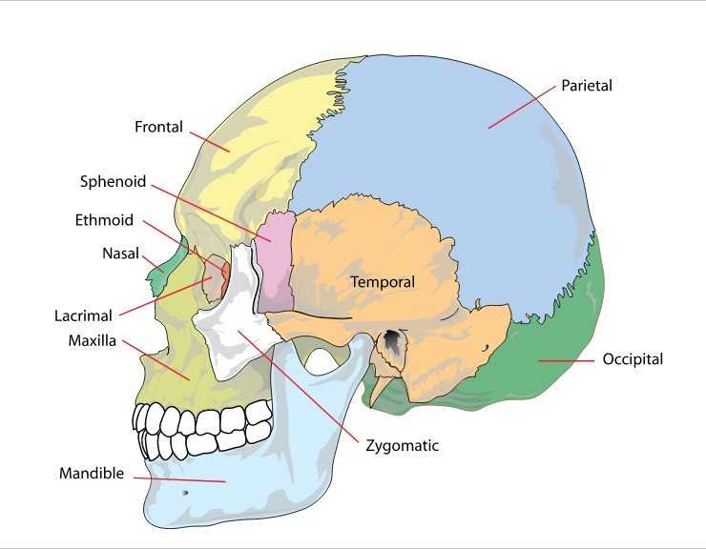

**Functions of the skull**

* Protects delicate tissue of the brain.
* Bony eye sockets protect the eye
* Temporal bone protects the ear.
* Bones of the face give resonance to voice (increase voice volume)
* Face bones keep the air passages open thus helping in breathing.
* Maxillae and mandible give attachment to teeth
* Mandible which is the movable bone of the skull helps in chewing food and coordinating muscles of the face.
* It give attachment to muscles of head and neck.

**The sutures**

**Definition:** These are immovable joints found between skull bones.

**NB:** The lines along which individual bones meet one another are shaped like the edge of a sew.

**Four prominent skull sutures are recognized.**

* **Coronary suture-** It is between frontal bone and 2 parietal bones.
* **Squamous suture-** It is between parietal bones and temporal bones.
* **Sagittal suture-** Between the two parietal bones.
* **Lambdoidal suture**- Between parietal bones and occipital bones.

**Diagrams showing skull sutures**

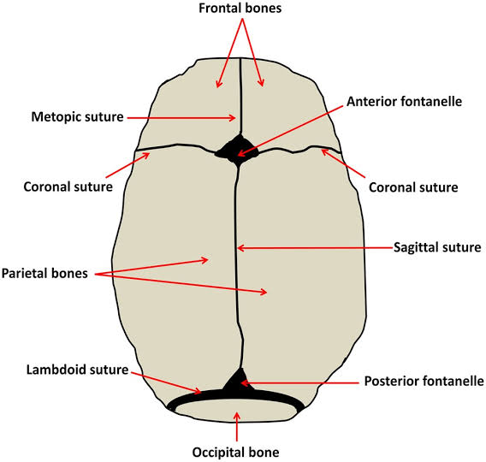 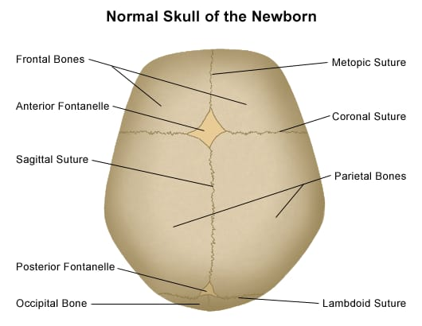

**Skull fontanelles**

**Definition:** These are membrane filled spaces (soft spots) found between cranial bones at birth where bone making process is not yet complete.

* It can also be defined as the space where three or more bones meet.

**NB:** The skeleton of newly formed embryo consist of cartilage or fibrous membrane structures shaped like bones. Gradually the cartilage is replaced by bone.

**Function of fontanelles**

* They allow the skull to be compressed during birth in order for infant to pass through the birth canal.
* They help physicians/gynecologists in determining the position of the infants head before delivery.

**Types of fontanelles**

Four types of fontanelles are recognized.

**Anterior fontanelle**

* Found between parietal and frontal bones.
* It is the largest fontanelle
* It closes between 12 -18 months after birth.

**Posterior fontanelle**

* Found between occipital and parietal bones.
* It is the second largest
* It closes between 2 -3 months after birth.

**Sphenoid fontanelle**

* This is paired
* It closes 3 months after birth

**Mastoid fontanelle**

* This is paired
* It closes between 1 month until after one year.

**Diagram showing skull fontanelles**

(See diagrams above on sutures and the one below)

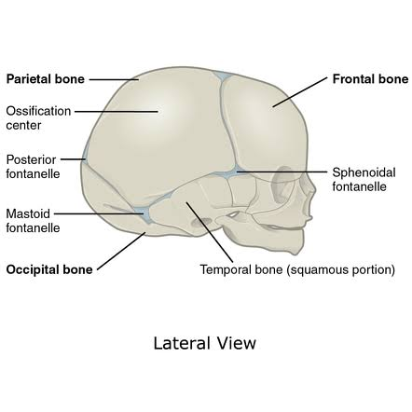

**Paranasal sinuses**

**Definition:** These are a group of four paired air-filled spaces surrounding the nasal cavity.

NB: They are located in certain bones near the nasal cavity. They are line with mucous membranes that are continuous with the lining of nasal cavities.

**Cranial bones containing paranasal sinuses**

* Frontal bone
* Sphenoid bone
* Ethmoid bone
* Maxillae bone

NV: The maxillary sinus is the largest paranasal sinus and it lies inferior to the eye.

**Functions of paranasal sinus**

* They lighten the weight of head
* They support immune defense mechanism of nasal cavity.
* They humidify inspired air
* Increase resonance of voice (volume of voice)

**The hyoid bone**

It is a single U-shaped bone which is a unique component of the axial skeleton because it does not articulate with any other bone.

It is suspended from the styloid process of temporal bone by a ligament.

The hyoid bone is located in the neck between the mandible and pharynx.

**Functions**

* It supports the tongue
* It provides attachment for some of its muscles.

**Skull cavities**

These are five large cavities found on the skull as follows;

* Nasal cavity – houses the nose.
* Orbital cavity – houses the eyeballs.
* Cranial cavity – houses the brain
* Oral cavity – Houses the mouth
* Middle ear cavity – houses the middle part of ear.

**Teeth**

The teeth are embedded into the socket of the mandible and the maxilla. Each individual has two sets of teeth.

* The temporary
* The permanent teeth

At birth temporary teeth are present in immature form in the mandible and maxilla.

**Temporary teeth**

* The temporary teeth are 20 in number.
* 10 in the upper jaw and 10 in the lower jaw.
* The incisors and canine teeth each have one root.
* The molar in the upper jaw has three roots.
* Those in the lower jaw have two roots
* These teeth begin to erupt when the child is about 6 months old and should all be present by end of 24 months.

**The permanent teeth**

They begin to replace the temporary teeth in the 6th year of age.

* Permanent consists of 32 teeth.
* They should all be complete by the 24th year of life.
* The incisors and canines have one root.
* The upper premolars have two roots and lower one root.
* The upper molars have three roots and lower two roots.
* Incisors and canine teeth are the cutting teeth.
* They are used for biting off pieces of food.
* Premolars and molars teeth with broad flat surfaces are used for chewing food.

**Structure of a tooth**

A tooth consists of the following parts

* The crown
* The root
* The neck
* Enamel
* Dentine
* Pulp cavity
* Gum
* Blood vessels
* Nerves
* Cementum

**Assignment: Explain functions of all parts of a tooth.**

**Diagram of a tooth**

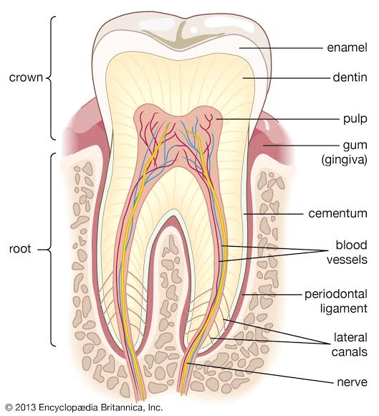

**The scalp**

**Definition:** It is the skin covering the head excluding the face.

**Layers of the scalp**

The scalp consists of five layers from the outermost to the innermost. They include the following

* Skin (outer layer)
* Dense connective tissue
* Aponeurosis (Galeo aponeurotica, epicranium)
* Loose areolar connective tissue and the
* Pericranium (inner layer)

NB: Below the scalp we have the skull and brain respectively.

**Diagram of the scalp**

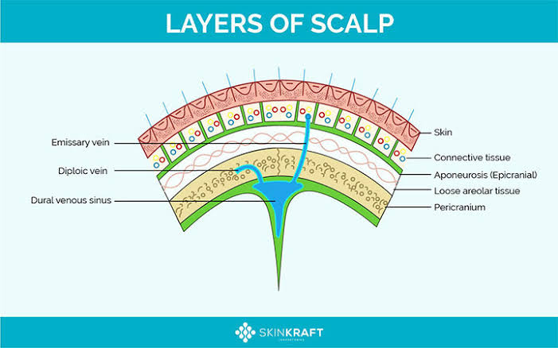

**Blood supply to the scalp**

**Arteries**

* Internal and external carotid artery
* Ophthalmic artery

**Veins**

* Supraorbital vein and Supratrochlear vein drain scalp anteriorly.
* Temporal artery, occipital artery and posterior articular auricular drain scalp posteriorly

**Nerve supply to scalp**

Supratrochlear nerve and supra orbital nerve all from ophthalmic nerve which is a branch of the trigeminal nerve