THE POWER OF PRAYERS 🙏

Prepared and ministered by

**Ezekiel Musyoka**

**Coordinator: Virginia Akisa**

**What is prayer? Private time between God and the worshipper.**

**A devout petition to God or an object of worship( supplications, Thanksgiving,**

**Adoration, repentance etc Philippians 4: 6_7)**

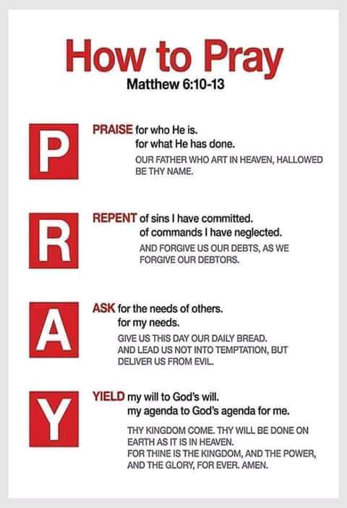 **Importance and power of prayers**

1. **Receiving the Holy spirit .(Acts 2)**
2. **Deliverance from trouble and distress ( psalm 107:28_30)**
3. **Receiving desires of your heart ( Matthew 21:22, Mark 11:24, John 14:13_14)**
4. **Healing and Forgiveness (James 5: 14-16)**
5. **Seeking the Lord Jesus (Psalm 27:8)**

**POWER OF PRAYERS BIBLICAL EXAMPLES**

1. **Hannah is infertile and she prays desperately for a son (1 Sam 1:"11")**
2. **Jerusalem is under siege so Hezekiah prays to save his people (2 kings 19: 14-19)**
3. **Jairus asks Jesus to heal his daughter so she won't die . (Mark 5:21-43)**
4. **Moses asks God to see him (Exodus 33:18 )**
5. **Hezekiah prays to God after tells him he is about to die (2 kings 20:1-11)**
6. **Paul and Silas in prison ( Acts 16 -40)**
7. **Shadrack, Massack and Abednego ( Daniel 3:16 - 28)**
8. **Daniel in den of lion ( Daniel 6)**

