TRACTION TECHNIQUES ASSIGHNMENT

DIPLOMA CLASS 2016

**DEPERTMENT OF ORTHOPAEDICS AND TRAUMA MEDICINE**

**CO NO:D/DOTM/17001/017**

**CIRVICLE TRACTION**

**Traction is commonly used in the cervical spine to relieve pressure on the cervical nerve roots in patients with disc herniations, degenerative disc disease and spinal stenosis.**

**Cervical traction can be applied manually by a trained health care professional, and there are many different types of home traction units that can be purchased to provide temporary relief of symptoms for patients who show benefit in the clinic.**

**Cervical traction is done either lying flat or sitting and uses weights to add distraction pressure to the neck.**

1. **Halter traction**

**Halter traction is used for short term cervical traction. Uses include minor neck injuries without obvious fractures e.g. Whiplash injury, neck muscle spasm, conservative treatment of cervical disk lesions.**

**Children with cervical fractures can also be treated without skeletal pins as their skull is too fragile to withstand**

* ***Problems with Halter Traction***
* **Uncomfortable**
* **Tempero-mandibular pain**
* **Contraindicated in mandible fractures**
* **Difficult to control flexion –extens**

**2. Skull Traction**

* **In more serious cervical injuries skull tongs such as Cones calipers are indicated. Indications include the conservative treatment of cervical fractures and dislocations.**
* **Cervical fracture treated with Traction via Cone's Calipers**
* ***Application of Cones Calipers***
* **Shave the hair above the ear region**
* **Local anaesthetic**
* **Avoid masseter**
* **Avoid Temporal artery**
* **Small incision above ear in line with auditory meatus**
* **Screw in pin until it just perforates outer table skull**
* **Tie on rope**
* **Attach weights**

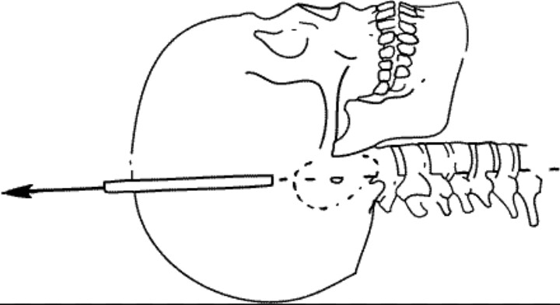

* **Direction and Weights**
* Force - 2.5 kg for head and 1/2 kg for each vertebra*
* Direction Neutral In line with Auditory meatus
* Flexion needed - raise pulley
* Extension needed - use double mattress ending @ shoulders

Complications of Cervical Tractio

* Bleeding - temporal artery
* Pressure sore on skull - avoid downwards vector to rope
* Sepsis - from skin to subural abscess
* Worsening neurological status
* Squint from 6th craneal nerve fallout
* **Contraindications Skull Tongs**

1. Children
2. Local sepsis
3. Skull fracture

* The double mattress method is an effective way to extend the neck
* Never place the head pulley too low as a pressure sore can result on the occiput, especially in the unconscious or neurologically compromised patient.
* Cone's calipers are commonly used.
* The Crutchfield tongs are another caliper that fit higher on the skull vault and allow easierturning of the paralised patient.
* Never place the head head pulley to low as a pressure sore can result on the occipital expeccially in the uncosciuos or neurologically compromised patient
* Cones calipers are commonly used
* Crutchfield tons allow easier turning of the palalysed patient
* Xray are taken to determine reduction , attending doctors checks for neurological signs

TRACION IN PELVIC

Pelvic traction is for providing correct degree of traction at the lumbosacral region in case of soft tissue contractures or displaced vertebral fracture.

It refers to treating the lower back problems including sciatica, nerve root disorders, minor fractures of lower spine.

Steps of performing traction

* Set the bed according to the recurement of the treatment.
* Check and adjust the pelvic straps to avoid any inconvenience and fixing them tightly
* Briefing the patient about the procedure
* Ensure that the belt is not too high or on the waist as the pull of the weight back has to be the pelvis

INDICATIONS

1. Pathology and inflammatory diseases of the lumber spine E.g. Prolapsed lumbar diseases, chronic low back pain
2. Soft tissue contractures.
3. Displaced vertebral fructures