**TROPICAL DISEASES & CLIMATIC DISORDERS.**

TROPICS…is the area around the Equator where prevailing trade winds blow from east to the west .Trade winds are caused by the sun heating the Equator more than the North and South poles. When the sun heat land and the ocean around the Equator , worm, moist air rises creating clouds ,storms and rain .

Tropical diseases encompass diseases that occur solely in the Tropics.

In practice the term is often taken to refer to infectious diseases that thrive in hot, humid, conditions such as malaria, leishmaniasis schistosomiasis, onchocerciasis, lymphatic filariasis, Chagas disease, African trypanosomiasis and dengue.

Many factors affect the patterns of **Diseases** around the world.

Important among them is;-

1. Climate :- Helps to determine the range of pathogenic microbes in the environment.
2. Wealth :- Provides the means to avoid and control the microbes i.e - Education.

* Sanitation
* Development
* Health Services

CLIMATIC-

Majority of the tropical countries are

* Hot
* humid

-Cosmopolitant diseases like

* Measles
* Diarrhoea / May take on special significance

While others like:

* Malaria
* Sleeping sickness / Are confined to certain areas for climatic reasons.

WEALTH Majority of countries along the tropics are adversely stricken by Poverty / Poor

*NB* *Infectious diseases and malnutrition are rife; especially, amongst children especially in poor regions.*

**FACTORS INFLUENSING THE DISEASES IN TROPICS**

Background to Diseases in Tropics.

1. **CLIMATE** – A large number and variety of microbial agents and parasites flourish in the moist, heat of the tropics & subtropics regions

* Deserts and mountain people suffer fewer infectious diseases.
* Heat and attitudes impose special physiological demands on the body

1. **GENES AND RACE** – Example of genetically determined diseases are:
2. Sickle cell anemia – In which **homozygous** (producer of hemoglobin S ) becomes anaemic and often die of anaemia

* While the  **heterozygous** ( carrier of Hb S) is healthy and enjoys a measure of protection against complications of malaria.

1. Leprosy – is worse on Caucasians and Mongolians than on blacks.
2. Tuberculosis– Indians have more glandular and intestinal lesions than Europeans.
3. **NUTRITION AND AGRICULTURE**  - Presence/ Absence of malnutrition depends on availability of food.

* Dietary toxins are found in some areas and produce conditions eg
  + - * Tropical spinal ataxia from cassava in Africa.
      * Veno-occlussive liver diseases from Seneccio alkaloids in Jamaica.
      * Hepatoma from aflatoxins in badly stored cereals.

1. **INFECTIONS** – Acute infectious diseases like measles, respiratory Tract infections and G/enteritis –Still accounts for high infant mortality in some parts of the tropics where up to 40% of the children die before the age of 5yrs.
2. **EPIDEMIOLOGICAL FACTORS** – The distribution prevalence, incidence and endemicity of a disease, especially if it is infectious determines its pattern in the community.

* In many places esp in urban slums, - lack of hygienic systems for disposal of sewages and refuse ensures the prevalence of infections transmitted orally from feaces
* Worms eg **H|worms** affects the bare-footed where sanitation is non-existent.

1. **IMMUNITY AND AUTOIMMUNITY** – Most human infections are terminated or controlled by an efficient immune response. When the response is inefficient the organism multiply un-checked causing either death or chronic: lepromatous leprosy or onchocerciasis.

* In sharp contrast with their response prevalence in the temperate countries, autoimmune diseases are relatively uncommon in the tropics.

1. **POVERTY, POLITICS, AND PROGRESS** – Poverty in the tropical countries is often tragically deepened. Development itself may bring new health problems. Eg
   * 1. Construction of dams and irrigation canals may create breeding sites for vectors of malaria, schistosomiasis and yellow fever plus onchocerciasis.
2. **VARIATIONS WITHIN THE TROPIC** – There are many variations ­­­­within the tropics.

A certain condition may be present in only one climatic belt, continent or even community; but very important examples are:

- Loiasis, in the West African rain forest (Loa loa)

- Chagas disease in South America (Trypanosomiasis cruzi)

**END OF INTRODUCTION**

**PARASITIC INFECTIONS**

**HELMINTHIASIS**

**1] ASCARIASIS [ ROUND WORM INFESTATION]**

This refers to infestation of the GIT by **Ascaris lumbruicides** /round worms

EPIDEMIOLOGY

It causes about ¼ of cases of worm infestation

They are usually pale yellow worms and are about 20 to 25 cms long

Human are infected by eating food contaminated with mature ova

LIFE CYCLE

Once the mature ova are swallowed, they hatch in the duodenum into Larvae

The larvae penetrates the mucus membranes and migrates through the lungs via portal circulation where they moult

In heavy infestation the Larva may cause Pneumonia and Eosinophilia

|  |
| --- |
| EGGS  ( In soil or contaminated  Food) |

|  |
| --- |
| SWALLOWED  (contaminants) into small  Intestines |

|  |
| --- |
| Infects man  [ contaminated food] |

|  |
| --- |
| GIT  1st Larval stage |

|  |
| --- |
| Portal circulation |

|  |
| --- |
| LUNGS  2nd Larval stage |

Diagrammatic expression of Asaris life cycle

TRANSMITION

Transmit ion is by ORAL FAECAL route via ingestion of

- Contaminated food

- soil

PATHOPHYSIOLOGY

1] GIT Infestation -can cause Protein Calories Malnutrition-because the worms ingest the food products in the intestine

2] lungs –During migratory phase, reaction to the foreign proteins [larva] cause Pneumonitis and can lead to fibrosis

3]Liver-May cause liver fibrosis and abscess[not always]

CLINICAL SIGNS AND SYMPTOMS

1. Abdominal discomforts/- adult worms **(Abdominal Colic)**
2. Abdominal Distension.
3. Fever = 380c
4. Cough during lung (migration) phase.
5. Passage of Adult worms in stool/Per rectum
6. Vomiting

* Passage of worms in vomits

**Complications**

1. Intestinal Obstruction

* In children & sever infection a tangled mass of worms may cause Obstruction

1. Malnutrition

* Heavy infestation

1. Blockage of bile or pancreatic duct
2. Obstruction of the appendix by adult worms.

**INVESTIGASIONS | DX**

1. Description of adult worms in stool
2. Stool 0/c (ova)
3. Barium examination – occasionally the worms nay be demonstrated radiographically

**N/B:**  *A solely male infection may be revealed only after giving A’helminthics to a patient with unexplained Oesinophilia.*

**TREATMENT**

1. Mebendazole 100mgs BD x 3/7  or..
2. Piperazine Hydrochloride 4 gms as a single dose. (Sonys/Kgbdust)
3. Others

* Levamisole
* Pyrantel Pamoate

**Surgery** – Is required in case of Obstruction especially when it fail to respond to N\G suction sedation

**PREVENTION MEASURES**

1. Proper Disposal of human bacteria.

* Use of proper sewage disposal
* Use of pit latrine

1. Proper handling of food

* Hands cleaning + well cooked food

1. Personal Hygiene.

**2] HOOKWORM DISEASE(ANCYLOSTOMIASIS)**

Is an infection of the GIT by Ancylostoma Duodenale or Necator Americanus.

Usually affecting small intestines.

**AETIOLOGY | EPIDEMIOLOGY**

Necator Americanus is the commonest in Kenya although Duodenale is found along the coast and lake region.

The Larvae requires warm, moist environment = 28 – 320c

The Adult worms Greyish-whit Nematodes about 1 cms long.

They live often in large numbers in the Duodenum and upper Jejunum.

**Life cycle**

EGGS [Passed in soil]

EGGS [Passed in soil]

LARVA {in soil}

[rhabditiform]

Mature in upper

Small intestine

Swallowed in GiT

FILARIFORM IN SOIL

PENETRATES SKIN OF MAN

LUNGS

* Eggs are passed in faeces
* In worms, moist, shady soil the Larvae develop and reaches Filariform infection stage
* They Penetrate Human skin – Reaches the lungs through blood stream
* Then from ALVEOLI – they ascend the Bronchi – then swallowed and develop in the small intestine- Reaching maturity 4-7/52  after the infection.

**Pathophysiology**

SKIN: At the site of Entry, May cause local initiation and inflammation (Allergic)

LUNG: There may be some Coughing and Eosinophilia

GIT: Adult worms produce some Enzymes which destroy the Mucosa and Anticoagulants causing Hemorrhage

* Blood loss leads to anemia.

There is Evidence that Hook-worm manifestation directly causes Malabsorption and Malnutrition.

Worms attach themselves by their Buccal capsule and withdraw blood.

*A duodenale (one) is capable of taking about 0.15mls of blood /day (mean).*

*N. Americanus – 0.03mls/day/per worm => of blood.*

**CLINICAL FEATURES**

1. Ground itch:-

* Local pruritus + Inflammation usually on the feet.

1. Lung - Paroxysmal cough with blood stained sputum

* Patchy pulmonary Consolidation

1. Small intestine – Vomiting

* Epigastric pains mimicking PUD
* Abdominal Distension – in children
* Occ frequent loose stool – mimicky Giadiasis.

1. Systemic => Anemia (pallor)

* Fatigue |Dizziness
* Edema | ccf

1. CNS – Mental + physical Development of children may be petered

**N|B:** *Most well-nourished with light infection person are Asymptomatic.*

**DIAGNOSE:-**

1. Clinical S|s
2. Stool – Microscopy – ova

* Occult blood +ve (ova will be present in large number)

1. Adult worms in stool approximately 10-15 mm

**DDX**

1. Other Helminths
2. Other causes of Anemia
3. PUD | Gastritis
4. Sprue or Giadiasis.

**TREATMENT:**

1. CHEMOTHERAPY
2. Mebendazole 100mgs BD X 3/7 (Vermox)
3. Pyrantel pamoate (combation) 10 mgs/ kg bwt
4. Thiabendazole 25mgs bd x 5/7
5. Albendazole400mgs stat
6. Levamisole 5 mg/kg bwt
7. Bephenium Hydroxynaphthoate 5 mgs OD X 3/7

**N|B ;** *When treating mixed infection it is important to treat Ascaris first – because medicine used in treating hook-worm may irritate Ascaris and cause Obstruction.*

1. SUPPORTIVE
2. Oral Iron
3. Good Nutrition and vitamins
4. In case of CCF due to anemia

* Transfuse with packed cells
* Or Transfusion whole blood slowly giving Lasix in each unit given at (20mg /kg bwt)

**PREVENTION:**

1. Proper Sanitation
2. Proper waste disposal
3. Mass Deworming
4. Avoid Contact with contaminated water/soil
5. Use of protective wear/gear – shoes/boots , glove etc.

**3] ENTEROBIASIS (THEAD WORM)**

It is an infection of the GIT by an u=intestinal nematode called Enterobius vemicularis (Thread worm)

They usually affect the large intestine (colon)

**EPDERMIOLOGY**

This helminth is common throughout the world

It affects especially children

**SIZE:** The male worm is about 2-5 mm long

The female worm is about 8-13 mm long

**LIFE CYCLE**

-The adult worms are found chiefly in the colon

-The gravid female worm lay eggs around the anus and cause intensive itching, especially at night

-The ova are usually carried to the mouth on the fingers (of the affected person) and so the reinfection takes place

- In the females the genitalia may be involved

After the ova are swallowed, development takes place in the small intestine. The ova hatch and produce thin worms which grow into adult worms

**CLINICAL FEATURES**

1] Intensive itchiness around the anus—especially at night

2] In female patients--the genitalia may be involved (causing itchiness around the genitalia)

3] Adult worms may be seen moving on the buttocks

4] Passage of adult worms in the stool –( Adult worms may be seen moving in stool)

ADULT WORM IN COLON

**INVESTIGATIONS**

* Ova are detected by applying the adhesive cellophane tape on the peri-anal skin in the morning, This is then examined on a glass slide under the microscope
* A peri-anal swab ,moistened with saline is also an alternative method for diagnosis

**TREATMENT**

1] Mbendazole 100mgs BD x 3/7

2] Pyrantel pamoate 10 mgs base/ kgbwt **\***

3] Piperazine salt 4 gms is given as single doze (100 mgs/kgbwt)**\***

4] Pyvinium 5mgs /kgmbwt**\***

5] Thiabendazole at 25mgs /kgbwt**\***

6] Levamisole5mg/kgbwt stat *

***N/B******..\*****Repeat after 2 weeks to avoid reinfection*

***NOTE:*** **PREVENTIVE MEASURES**

When reinfection constantly recurs in the family

A] All members should be treated with mebendazole 100 mgs BD X 3/7—then reapeat after 10/7

B] During this period –all night clothes and bed linen are laundered

C] Finger nails MUST be cut / kept short

D] Hand washed carefully before meals

E] Finger nails are scrubbed before meals

4] TRICHURIASIS [TRICHURIS TRICHIURA]

(WHIP WORM)

This is a GIT infection by an intestinal nematodes called Trichuris trichiura (WHIP WORM)

**GEOGRAPHICAL DISTRIBUTION**

Under an hygienic condition, infection with whipworm are common all over the world.

**MODE OF TRANSMISSION**

Mainly Feacal-0ral route

-Infection takes place by the ingestion of contaminated earth foodwith ova which have become infective after lying for three weeks or more in moist soil

**SHAPE, SIZE AND SITE OF INFECTION**

The adult worm ha a coiled anterior end resembling a whip

The adult worm is about 3-5cms long

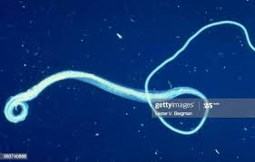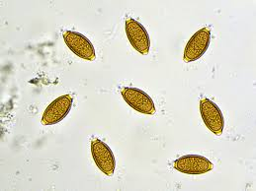

Adult whipworm Ova of whipworm

Once inside the intestine whipworm inhabits :

* The colon
* The lower ileum
* The appendix
* The colon and
* The anal canal

**CLINICAL FEATURES**

There are usually no symptoms but intense infection in children may cause:- diarrhea

-Rectal prolapse

-Stunting growth

DIAGNOSIS

Is made by identifying ova in faeces (stool examination)

The size of the ova is about 50x 22 microm.

TREATMENT

1. Mebendazole 100mgs BD x 3 days
2. Oxantel pamoate salt 10mgs/kgbwt ==single doze
3. Albendazole and thiabendazole---but usually not very effective

5] STONGYLOIDIASIS

[STRONGYLOIDES STERCORARIS]

This is an infection of man by a very small nematode called Strongyloides stercoraris.

SIZE: It is usually about 2mm x0.4 mm .

They usually parasitize the mucosa of the upper part of small intestine in large numbers.

**LIFE CYCLE**

After invasion of the small intestine in large numbers, they lay eggs which hatch in the bowel and only the larvae are passed in the faeces to the soil

In soil they [larvae] moults and becomes the **infective filariform larvae** which can penetrate the skin

After penetrating the skin, they undergo a development similar to that of the hookworms

The female worms burrow into the mucosa and the submucosa

In the intestine some larvae may develop into **filariform larvae** and may penetrate the mucosa or the peri-anal skin and lead to an **auto-infection** and a very persistent infection.

HOSTS

Man –is the natural host.-but

Dogs ---may also be infected

**PATHOLOGY**

1] SKIN: ***Dermatitis*** –Usually at the site of entry of the larval worms

2] INTESTINE-***Inflammatory reaction***(set up by the female worms which burrows into the mucosa)

***Malabsorption***:-In very heavy infestations mucosa may be severely damaged leading to malabsorption

***Granulomatous changes*** of the intestines

***Necrosis*** of the intestine may also

***Perforation*** of the intestine occur

3] PERITONEUM- ***Peritonitis***-following perforation of the

intestine –and leakage of the intestinal contents into the

peritoneum

4] LUNGS—***Eosinophilia*** commonly persist

5] SYSTEMIC-with immunosuppression may lead to fatal

***systemic strongyloidiasis***

*N/B.: Active motile larvae are passed into the stool / faeces*

**CLINICAL FEATURES**

A] Itchy rash- This may be produced during invasion of the skin by the filariforms

B]Abdominal pain

C] Diarrhoea

D] Steatorrhoea (passage of fat in stool)

E] Urticaria plaque and papules

F] Wheezes

G] Arthralgia

H] Weakness and emaciation may be present as well as signs of malarbsorption

I] Penetration of the skin around the anus and the intestinal wall by the filariform larvae may lead to **extremely itchy, linear, urticarial weals** that may travel 3-4cm in an hour**.**These are known as **Larva currens.**

**The weals subsides in few hours then recurs in a new site.**

J] Systemic strongyloidiasis-cause diarrhea, pneumonia and sometimes meningoencephalitis and it is rapidly fatal unless diagnosed and prompt treatment is made

***N/B: Skin lesion may be the only sign of infection***

DIAGNOSIS

1] **Stool for ova and cyst**-Motile Rod Shaped larvae can be seen

on the microscopic examination of the faeces ( collect

stool intermittently to repeat examination)

2] **Sputum-** as in stool—occasionally

3] J**ejunal aspiration**-may show the larvae

4**] Serology**-ELISA- Is helpful. But definite diagnosis depends on

the finding of the larvae

Filarial serology is positive in 15% of the patients.

**TREATMENT**

**1]** ***THIABENDAZOLE-*** Given at 25mgs/kgbwt twice daily for 2-4 days –according to the tolerance .A second course may be required

**2]** ***IVERMECTINE*** 200microgram/kg as a single dose or BD dose on successive days is effective

**3]** For the STRONGYLOIDES Hyper- infection Syndrome….. ***IVERMECTINE*** is given at 200 microgram /kg bwt on days 1st, 2nd. 15th, ang 16th. Or ***THIABENDAZOLE*** given by N/G TUBE for a long period

**6] ECHINOCOCCUS GRANULOSUS (TAENIA ECHINOCOCCUS)**

**AND HYDATID DISEASE**

**DESTRIBUTION:** The disease is common in Middle East , North and East Africa Australia and Argentina

Dogs and certain canines are the definitive hosts of the tinny tapeworm, E. granulosus

**LIFE CYCYLE**

The larval stage, a hydatid cyst normally occurs in the sheep, cattle and other animals including camels that are infected from contaminated pasture or water.

Man by handling a dog or drinking infected water may ingest the eggs.

The embryo is liberated from the ovum in the small intestine and gains access into the blood stream and reaches the liver the result is a cyst that starts to grow very slowly

The cyst may calcify or may rupture giving rise to multiple cyst.

***N/B***: In man cyst may be acquired in childhood and it may present after growing for some years causing pressure symptoms

-this will vary according to the organ or tissue involved.

* About 75% of patients with hydatid cyst the right lobe of the liver is invaded and contains a single cyst.
* In others the cyst may be found in bones, lungs or elsewhere.

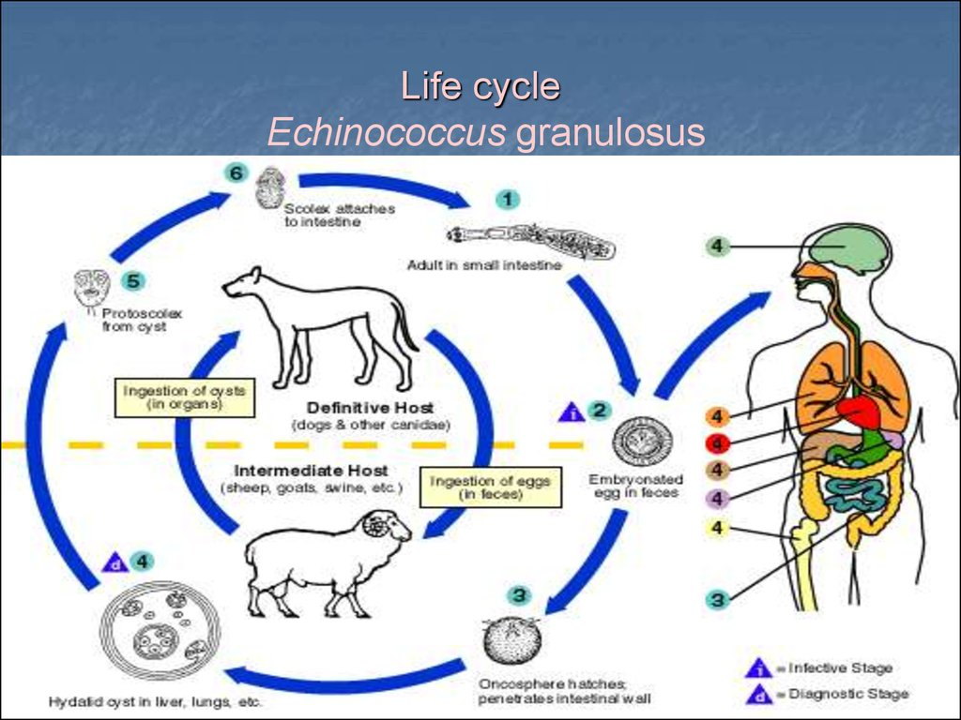

SIGN AND SYMPTOMS

1. Abdominal distention –gradually growing over some years.
2. Pressure symptoms –depending on the organ affected.
3. Malnutrition –especially if the liver is affected

O/E patient is weak and presents with swollen abdomen and palpable huge liver.

Other symptoms depend on the organ affected

**INVESTIGATIONS**

Diagnosis depends on;

1 .the clinical findings

2. radiological findings

3 .ultrasound findings

In a patient with history of living with dogs in endemic areas.

1. Complement fixation and ELISA/immunofluorescent tests usually give diagnosis to 70-90% of patients (positive)

TREATMENT

Treatment is usually surgical intervention. Hydatid cyst should be excised wherever possible

Great care I taken to avoid spillage and cavities are sterilized with 0.5%silver nitrate or 2.7% sodium chloride.

Albendazole( 400mgs 12 hrly for 3 months)is used for inoperable disease and to reduce the infectivity of the cyst pre-operatively.

Praziquantel 20 mg/kg 12 hrly for 14 days kills proscolices perioperatively.

**PREVENTION**

Prevention is difficult where there is a close relations with dogs and sheep.

However—Personal hygiene

---Satisfactory disposal of carcasses

--Meat inspection and

--Deworming of dogs

can greatly reduce the prevalence of disease.

7]CESTODES (TAPEWORMS)

Cestodes are ribbon-shaped worms which inhabit the intestinal tract. They have no alimentary system and absorb nutrients through the tegumental surface.

**MORPHOLOGY**

The anterior end, or **scolex**, has **suckers** for attaching to the host.

From the scolex arises a series of progressively developing segments, the **proglottides,** which when shed may continue to show active movements.

**LIFE CYCLE**

Cross-fertilisation takes place between segments. Ova, present in large numbers in mature proglottides, remain viable for weeks and during this period they may be consumed by the intermediate host. Larvae liberated from the ingested ova pass into the tissues.

Humans acquire tapeworm by *eating undercooked beef infected* ***with Cysticercus bovis*,** the larval stage **of Taenia saginata (beef tapeworm**), ***undercooked pork*** containing the larval stage **of T. solium (pork tapeworm),** or undercooked **freshwater fish** containing larvae of **Diphyllobothrium latum (fish tapeworm).**

*N/B Usually only one adult tapeworm is present in the gut but up to ten have been reported.*

**TAENIA SAGINATA**

Infection with T. saginata occurs in all parts of the world. The adult worm may be several metres long and produces little or no intestinal upset in human beings,

**DIAGNOSIS**

A] Knowledge of its presence, by noting segments in the faeces or on underclothing, may distress the patient.

B] Ova may be found in the stool. The ova of T. saginata and T. solium are indistinguishable microscopically.

**TREATMENT**

Praziquantel is the drug of choice,

PREVENTION

depends on efficient meat inspection and the thorough cooking of beef. Niclosamide is an alternative (see below).

**TAENIA SOLIUM**

T. solium, the **pork tapeworm**, is common in central Europe, South Africa, South America and parts of Asia. It is not as large as T. saginata. The adult worm is found only in humans following the eating of undercooked pork containing **cysticerci**.

**CYSTICERCOSIS**

**M.O.I**

Human cysticercosis is acquired by **ingesting** tapeworm ova, either by ingesting ova from contaminated fingers or by eating contaminated food .

**LIFE CYCLE**

The larvae are liberated from eggs in the stomach, penetrate the intestinal mucosa and are carried to many parts of the body where they develop and form cysticerci,[ *0.5-1 cm cysts that contain the head of a young worm*]. They do not grow further or migrate.

SITE OF INFECTION: Common locations are :

* the subcutaneous tissue,
* skeletal muscles and
* brain.

**CLINICAL FEATURES**

***Cyst*** -When superficially placed, cysts can be palpated under the skin or mucosa as pea-like ovoid bodies. Here they cause few or no symptoms, and will eventually die and become calcified.

***Brain infection***: Heavy brain infections, especially in children, may cause features of **encephalitis**. More commonly, however, cerebral signs do not occur until the larvae die, 5-20 years later.

Epilepsy,

personality changes,

staggering gait or

signs of internal hydrocephalus

are the most common features.

**INVESTIGATION**

Cysticercosis. Life cycle of Taenia solium.

**INVESTIGATION**

A] RADIOLOGY

* Calcified cysts in muscles can be recognised radiologically. In the brain, however, less calcification takes place and larvae are only occasionally demonstrated radiologically; usually CT or **MRI** will show them.
* Epileptic fits starting in adult life should suggest the possibility of cysticercosis if the patient has lived in or travelled to an endemic area.
* The subcutaneous tissue should be palpated and any nodule excised for histology.

Radiological examination of the skeletal muscles may be helpful.

B] LABORATORY INVX

Antibody detection by fluorescent antibody test, ELISA or immunoblotting is available for serodiagnosis.

**MANAGEMENT AND PREVENTION**

1] **Niclosamide**, followed by a mild laxative (after 1-2 hours) to prevent retrograde intestinal autoinfection, is useful only for the intestinal infection.

**2] Praziquantel** improves the prognosis of cerebral cysticercosis; the dose is 50 mg/kg in three divided doses daily for 10 days.

**3]Albendazole,** 15 mg/kg daily for a minimum of 8 days, has now become the drug of choice for parenchymal neurocysticercosis.

**4] Prednisolone,** 10 mg 8-hourly, is also given for 14 days, starting 1 day before the albendazole or praziquantel.

***N/B*** *In addition, anti-epileptic drugs should be given until the reaction in the brain has subsided*.

**SURGERY**

Operative intervention is indicated for hydrocephalus.

*Studies from India and Peru suggest that most small solitary cerebral cysts will resolve without treatment.*

**PREVENTION**

* Cooking pork well will prevent infection with T. solium.
* Cysticercosis is avoided if food is not contaminated by ova or segments.
* Great care must be taken by nurses and other adults while attending a patient harbouring an adult worm.