**Introduction to medical biochemistry one**

**lesson objectives.**

By the end of the lesson the learner should be able to:

1. define biochemistry
2. state the importance of biochemistry in relation to clinical medicine
3. understand the scope of biochemistry one.
4. Explain the type of chemical bonds

**What is biochemistry?**

It is a branch of science that combines the science of matter (chemistry) and the science of living matter (biology) that is bio-chem.

This is a branch of science that deals with the study of the chemical processes in the living body. It mainly deals with studying how chemical reactions and chemical structures give rise to life and its processes. It deals with molecules and cells and how they interact with each other.

The chemical structures studied include carbohydrates, fats, proteins, vitamins, enzymes etc.

Biochemists seek to understand the molecular structures, mechanisms and chemical processes in living organisms.

**Importance of biochemistry**

Understanding biochemistry is important because it helps clinicians in diagnosing various diseases through the estimation of biomolecules like enzymes, hormones, lipids and proteins in the body. Their levels increase or decrease depending on the condition of the body. This in turn helps to understand the root cause of various diseases and taking the right treatment strategies.

People take a lot of supplements like minerals, vitamins and proteins to improve their health. Proper intake of these is well understood by studying medical biochemistry.

We study biochemistry to gain knowledge of the normal body processes and therefore be in a better position to understand any abnormalities in the body. Our understanding of these would help us diagnose and treat diseases.

It helps us to gain knowledge of drug development, therapies and diagnostic tools.

Helps us to gain knowledge relevant in research of both drugs and diseases

Helps us understand better chemical structures and processes in the body

Help us understand the pathology of various diseases in the body such as diabetes, hypertension etc.

In addition, biochemistry help to explain all diseases in molecular terms.

**What do we study in biochemistry?**

We study biomolecules and there are about five major classesi.e. carbohydrates, vitamins, proteins, nucleic acids and lipids

Major chemical processes in the body e.g. cell development, enzyme activity, transport mechanisms like nerve transmission etc.

Nutrition and metabolism of minerals and vitamins in the body

Biochemical sequences in the body and how they interact with each other in order for cell to survive under various conditions.

Biochemistry knowledge is required in order to diagnose and treat diseases which is the reason as to why it forms one of the units in clinical medicine

**Nature of biomolecules**

Most biomolecules are made up of six compounds namely carbon, hydrogen oxygen nitrogen phosphorous and Sulphur. Basically, all organisms have similar biochemical pathways and share the same genetic codes

About 31 chemical elements occur naturally in plants and animals

**Chemical bonds**

Matter is made up of ions, atoms, molecules elements and compounds.

**Discuss the terms as applied in chemistry.**

Atoms and molecules are held together in elements and compounds by linkages known as chemical bonds.?

When the atoms combine in chemical reactions, they do so by either gaining or losing electrons to achieve the stability of the noble gases in terms of electron configuration. This is known as the octet-duet rule and ensures that an electron configuration with the right number of electrons is achieved i.e. 2 or 8 electrons on the outermost energy level.

Atoms are held together by single, double or triple bonds. A single bond involves a single shared electron as exists in the hydrogen molecule.

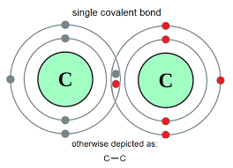

Atoms may similarly be held by a double bond as exists in the oxygen molecule where the oxygen atoms share two electrons in their structure.

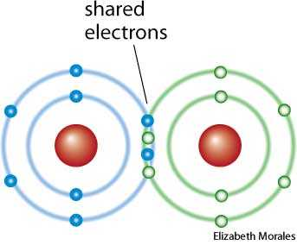

A triple bond is formed when atoms share three electrons as is present in the nitrogen molecule.

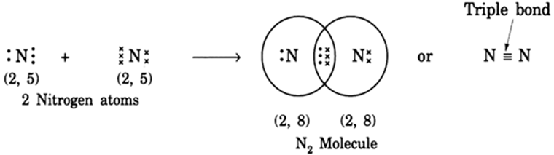

This sharing of electrons is known as **covalent** bonding and occurs in nonmetals. In this type of bond none of the elements wants to lose or gain any electron and therefore they share the electrons. Each pair of the shared electron constitute one chemical bond

**Ionic bonds** are formed when there is transfer of electrons between metals to non-metals. This is the case between sodium and chlorine in sodium chloride (common salt).

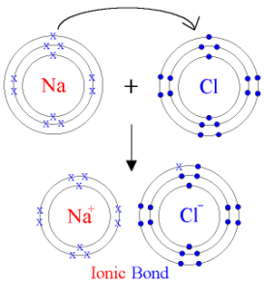

**Polar** **bond** if formed when there is **unequal** sharing of electrons. In this bond the electrons are not shared equally. This is the bond that exists in the water molecule. In a polar bond, one of the atoms is held closer than the other because of the unequal sharing of electrons.

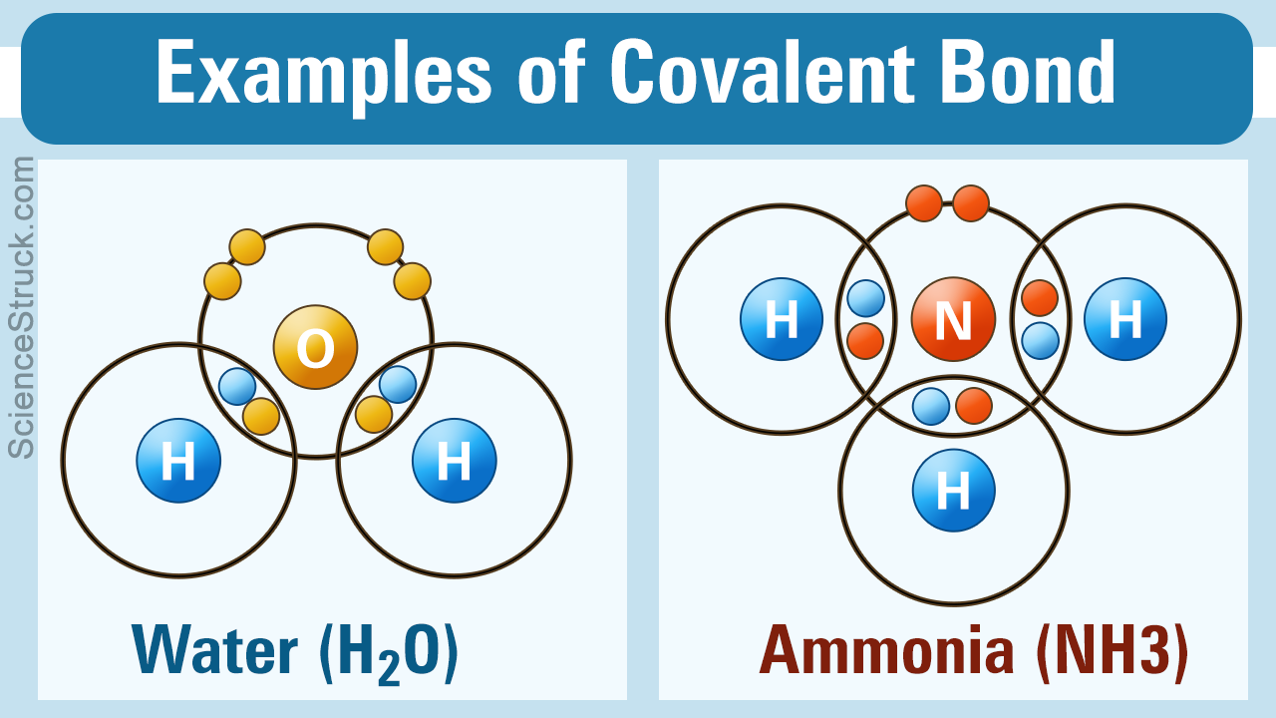

**Electronegativity** is the ability of an atom in a molecule to attract electrons to itself. Polar bonds have atoms that have differences in electronegativity.

The electrons that have participated in the formation of the bond are known as **bonding electrons**.

The electrons that have not been shared or transferred are known as the **non-bonding** electrons.

It is important to note that the strength of the bond increases with the number of bonding electrons as the atoms are held much stronger together.

**Biochemical basis of life**

Water being a polar molecule is able to form hydrogen bonds which has led to its many properties. This has made water a solvent that is able to dissolve both ionic and polar molecules.

Carbon on the other hand has the ability to bond with many elements such as hydrogen, oxygen, sulfur and nitrogen to form molecules of life al so known as macromolecules. The function of these macromolecules depends on their chemical structure.

Carbohydrates is the main source of energy for both plants and animals but is also a structural component.

Lipids on their part are used as a form of stored energy and important in formation of membranes.

Nucleic acids are the carriers of genetic information.

Proteins have several functions including regulation of cell processes, building body tissues, transportation of substances in the body as well as fighting diseases in the body.

The chemical reactions involve changes in the bonds within the molecules and is usually accompanied with both gain and loss of energy.

Enzymes speed up the rate at which the reactions are taking place in the body without them being used up in the reactions they catalyze. Its good to note that rate of enzyme activities is affected by the temperature, PH. and some regulatory molecules.

**Review questions**

1. Explain the role of biochemistry in clinical medicine
2. Explain the what is meant by chemical bonds and discuss three types of chemical bonds
3. Discuss the polar bond in a water molecule and explain why water is regarded as a universal solvent
4. Explain what is meant by electronegativity in relation to a water molecule