Word mail merge: A walk through the process
This is the introduction to the basic steps in the mail merge process, using form letters as an example. The Process includes:
Step 1: Choose a document type and main document
Step 2: Connect to a data file and select records
Step 3: Add fields to the main document
Step 4: Preview the merge and then complete it

The power of mail merge
You use mail merge when you want to create a set of documents that are essentially the same but where each document contains unique elements. For example, in a letter that announces a new product, your company logo and the text about the product will appear in each letter, and the address and greeting line will be different in each letter.
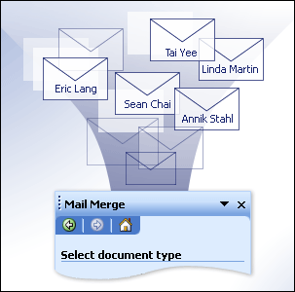

Using mail merge, you can create:
- A set of labels or envelopes The return address is the same on all the labels or envelopes, but the destination address is unique on each one.
- A set of form letters, e-mail messages, or faxes The basic content is the same in all the letters, messages, or faxes, but each contains information that is specific to the individual recipient, such as name, address, or some other piece of personal data.
- A set of numbered coupons The coupons are identical except that each contains a unique number.
Creating each letter, message, fax, label, envelope, or coupon individually would take hours. That's where mail merge comes in. Using mail merge, all you have to do is create one document that contains the information that is the same in each version. Then you just add some placeholders for the information that is unique to each version. Word takes care of the rest.

Start the mail merge process
To start the mail merge process:
- Start Word.
A blank document opens by default. Leave it open. If you close it, the next step won't work.
- On the Tools menu, point to Letters and Mailings, and then click Mail Merge.
Note In Word 2002, on the Tools menu, point to Letters and Mailings, and then click Mail Merge Wizard.
The Mail Merge task pane opens. By using hyperlinks in the task pane, you navigate through the mail-merge process.

Next step
Step 1: Choose a document type and main document
Important notice for users of Office 2003 To continue receiving security updates for Office, make sure you're running Office 2003 Service Pack 3 (SP3). The support for Office 2003 ends April 8, 2014. If you’re running Office 2003 after support ends, to receive all important security updates for Office, you need to upgrade to a later version such as Office 365 or Office 2013. For
This step in the mail-merge process involves two choices. First, you choose the type of document that you want to merge information into. Then, you choose the main document that you want to use. The main document is the document that you start with. It's the model for all of the merged documents that you eventually create.
Note Remember, we're using form letters as the example in this article series. If you are creating a set of merged labels or envelopes, the process is a little different. To go directly to information about labels or envelopes, click a link in the See Also section of this column.

Choose the type of document you want to merge information into
The Mail Merge task pane opens with a question about what type of merged document you are creating. After you choose, click Next at the bottom of the task pane.
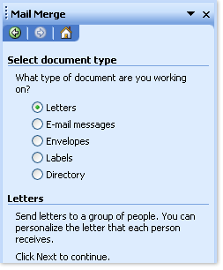
Note If you don't see the Mail Merge task pane, on the Tools menu, point to Letters and Mailings, and then click Mail Merge (or Mail Merge Wizard, if you're using Word 2002).
If you have fax support set up on your computer and a fax modem installed, you will also see Faxes in the list of document types.

Choose the main document you want to use
If your main document (called the starting document in the task pane) is already open, or you are starting with a blank document, you can click Use the current document.
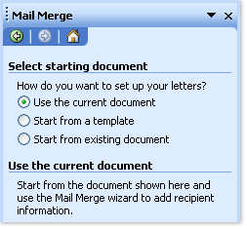
Otherwise, click Start from a template or Start from existing document, and then locate the template or document that you want to use.
Top of Form

Mail merge step 2: Connect to a data file

To merge unique information into your main document, you must connect to (or create and connect to) the data file where the unique information is stored. If you don't want to use all the data in the file in your merge, you can choose the records that you want to use.

Connect to the data file
In this step in the mail-merge process, you connect to the data file where the unique information that you want to merge into your documents is stored.
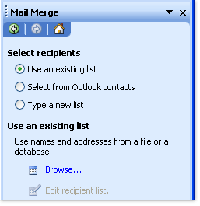
If you keep complete, up-to-date information in your Microsoft Office Outlook® Contacts list, that is an excellent data file to use for customer letters or e-mail messages. Just click Select from Outlook contacts in the task pane, and then choose your Contacts folder.
If you have a Microsoft Office Excel worksheet or a Microsoft Office Access database that contains your customer information, click Use an existing list, and then click Browse to locate the file.
If you don't have a data file yet, click Type a new list, and then use the form that opens to create your list. The list is saved as a mailing database (.mdb) file that you can reuse.
Note If you're creating merged e-mail messages or faxes, make sure that your data file includes a column for the e-mail address or fax number. You will need that column later in the process.

Choose the records in the data file that you want to use
Just because you connect to a certain data file doesn't mean that you have to merge information from all the records (rows) in that data file into your main document.
After you connect to the data file that you want to use or create a new date file, the Mail Merge Recipients dialog box opens. You can select a subset of records for your mail merge by sorting or filtering the list.
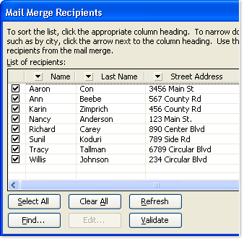
Do any of the following:
- To sort the records in a column in ascending or descending order, click the column heading.
- To filter the list, click the arrow beside the column heading that contains the value on which you want to filter. Then, click the value that you want. Or, if your list is long, click (Advanced) to open a dialog box where you can set the value. Click (Blanks) to display only records that contain no information or (Nonblanks) to display only records that contain information.
Tip
- Clear the check box next to a record to exclude that record.
- Use the buttons to select or exclude all the records or to find specific records.
Tip
After you choose the records that you want, you're ready for the next step.
Top of Form

Mail merge step 3: Add fields to the main document
After you connect your main document to a data file, you're ready to add fields that indicate where the unique information will appear in each copy of the document that you generate when you merge. To make sure that Word can find a column in your data file that corresponds to every address or greeting element, you may need to match fields.

Add fields
If your main document is still blank, type the information that will appear in each copy. Then, add fields by clicking the hyperlinks in the task pane.
Fields are placeholders that you insert into the main document at locations where you want unique information to appear. For example, you can click the Address block or Greeting line links in the task pane to add fields near the top of a new product letter, so that each recipient's letter contains a personalized address and greeting. Fields appear in your document within chevrons, for example, «AddressBlock».
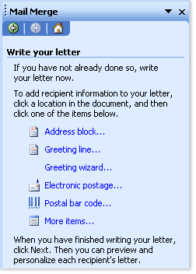
If you click More items in the task pane, you can add fields that match any of the columns in your data file. For example, your data file might include a column called Personal Note. By putting a Personal_Note field at the bottom of a form letter, you can further personalize each copy. You can even customize envelopes by adding a postal bar code — if you are using the English (U.S.) language version of Word — or electronic postage (if you have an electronic postage program installed).

Match fields
If you insert an address block field or a greeting line field into your document, you are prompted to choose the format that you prefer. For example, the illustration shows the Greeting Line dialog box that opens when you click Greeting line in the task pane. You use the lists under Greeting line format to make your choices.
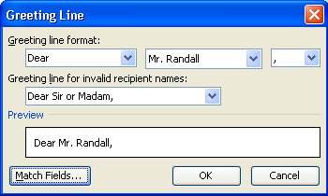
If Word can't match each greeting or address element with a column from your data file, the addresses and greeting lines will not be merged correctly. To help avoid problems, click Match Fields. The Match Fields dialog box opens.
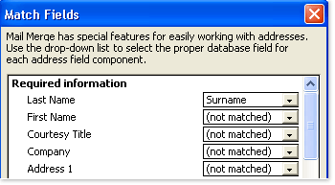
The elements of an address and greeting are listed on the left. Column headings from your data file are listed on the right.
Word searches for the column that matches each element. In the illustration, Word automatically matched the data file's Surname column to Last Name. But Word was unable to match other elements. From this data file, for example, Word can't match First Name or Address 1.
By using the lists on the right, you can select the column from your data file that matches the element on the left. In the illustration, the Name column now matches First Name, and the Address column matches Address 1. It's okay if Courtesy Title, Company, and Spouse First Name aren't matched, because they aren't relevant in the documents that you are creating.
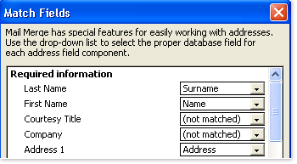
When you finish adding and matching the fields in your main document, you are ready for the next step.

Mail merge step 4: Preview the merge and then complete it

Preview the merge
You can preview your merged documents and make changes before you actually complete the merge.
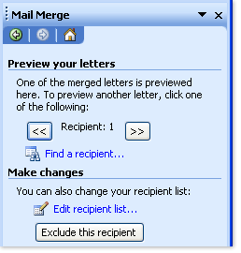
To preview, do any of the following:
- Page through each merged document by using the next and previous buttons in the task pane.
- Preview a specific document by clicking Find a recipient.
- Click Exclude this recipient if you realize you don't want to include the record that you are looking at.
- Click Edit recipient list to open the Mail Merge Recipients dialog box, where you can filter the list if you see records that you don't want to include.
- Click Previous at the bottom of the task pane to go back a step or two if you need to make other changes.
When you are satisfied with the merge results, click Next at the bottom of the task pane.

Complete the merge
What you do now depends on what type of document you're creating. If you are merging letters, you can print the letters or modify them individually. If you choose to modify the letters, Word saves them all to a single file, with one letter per page.
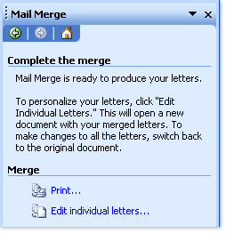
No matter what type of document you are creating, you can print, transmit, or save all or just a subset of the documents.
Tip about e-mail messages
Remember that merged documents that you save are separate from the main document. It's a good idea to save the main document itself if you plan to use it for another mail merge.
When you save the main document, in addition to its content and fields, you also save its connection to the data file. The next time you open the main document, you're prompted to choose whether you want the information from the data file to be merged again into the main document.
- If you click Yes, the document opens with information from the first record merged in. If you open the task pane (Tools menu, Letters and Mailings submenu, Mail Merge command), you are at the Select recipients step. You can click hyperlinks in the task pane to modify the data file to include a different set of records or to connect to a different data file. Then, you can click Next at the bottom of the task pane to proceed with the merge.
- If you click No, the connection between the main document and the data file is broken. The main document becomes a standard Word document. Fields are replaced with the unique information from the first record

