Question 1 ( 10 marks).

Mail Merge

Do a simple mail merge with a simple table as the data source, and a quick note as the main document.

1. Make the Data Source in Microsoft Word.

a) Create the following table in Word (Insert → Table, 8 columns, 6 rows)
First Name | MiddleName | Lastname | Address1 | City | State | Postalcode | Home contact
b) Fill in the table with data about your friends - do this in 5 minutes!!
c) create a folder whose name is ( regno i.e H1234562016) on the desktop
d) Save the table as "friend data" in the folder created in (c).
e) Close the document.

2. Make the Main Document in Microsoft Word

The Main Document should look like this:

Save this as "master note" in the folder created in 1(c )

Mail Merge

Question 2. (20 marks)

1. Enter the following information onto Sheet1. and rename it: East. (It represents sales in $1000.)
2. Enter the following information onto Sheet2. and rename it: West.

3. Enter the following row and column labels onto Sheets 3: Consolidate

4. FORMAT ranges B4:F11. As CURRENCY, . Do this for both the East and West
worksheets.
The worksheet Consolidate should report the sum of the East and West store sales
for each category of music by quarter.

Your worksheet Consolidate should look like the one below.worksheets.
Create a pie chart using the Annual Totals from the consolidated worksheet.

Question 3. (20 marks)

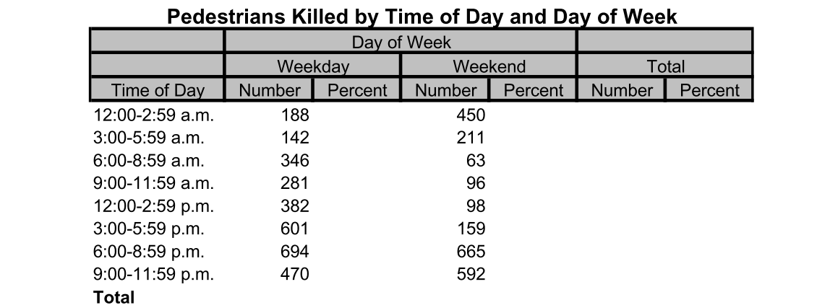

The above table represents data for the number of pedestrians that were killed in the United States during 1994 in motor vehicle crashes.
Perform the following procedures in Excel.
1. Calculate the total number of pedestrian fatalities that occurred during
weekdays.
2.Calculate the percent of all weekday fatalities that occurred during
each of the given times of day.
3. Calculate the total number of pedestrian fatalities that occurred during
weekends.
4.Calculate the percent of all weekday fatalities that occurred during
each of the given times of day.
5. Calculate the total number of fatalities that occurred during each time of day
(i.e., add weekday and weekend fatalities for each time of day). Calculate the
percent of all pedestrian fatalities that occur during each time of day (weekdays
and weekends combined).
6. Format your percentage data so that percentage signs and only one decimal
place is shown.
7. Create a bar graph for the percent of all fatalities by the time of day (i.e., the
figures in column G).

