HBC 107

C A T PRACTICALS

Question 1 ( 10 marks).

Do a simple mail merge with a simple table as the data source, and a quick note as the main document.

1. Make the Data Source in Microsoft Word.

a) Create the following table in Word (Insert → Table, 8 columns, 6 rows)
First Name | MiddleName | Lastname | Address1 | City | State | Postalcode | Home contact
b) Fill in the table with data about your friends - do this in 5 minutes!!
c) create a folder whose name is ( regno i.e H1234562016) on the desktop
d) Save the table as "friend data" in the folder created in (c).
e) Close the document.

2. Make the Main Document in Microsoft Word

The Main Document should look like this:

Save this as "master note" in the folder created in 1(c )

Mail Merge

Question 2. (13 marks)

1. Enter the following information onto Sheet1. and rename it: East. (It represents sales in $1000.)
2. Enter the following information onto Sheet2. and rename it: West.

3. Enter the following row and column labels onto Sheets 3: Consolidate

4. FORMAT ranges B4:F11. As CURRENCY, . Do this for both the East and West
worksheets.
The worksheet Consolidate should report the sum of the East and West store sales
for each category of music by quarter.

Your worksheet Consolidate should look like the one below.worksheets.
Create a pie chart using the Annual Totals from the consolidated worksheet.

Question 3. (7 marks)

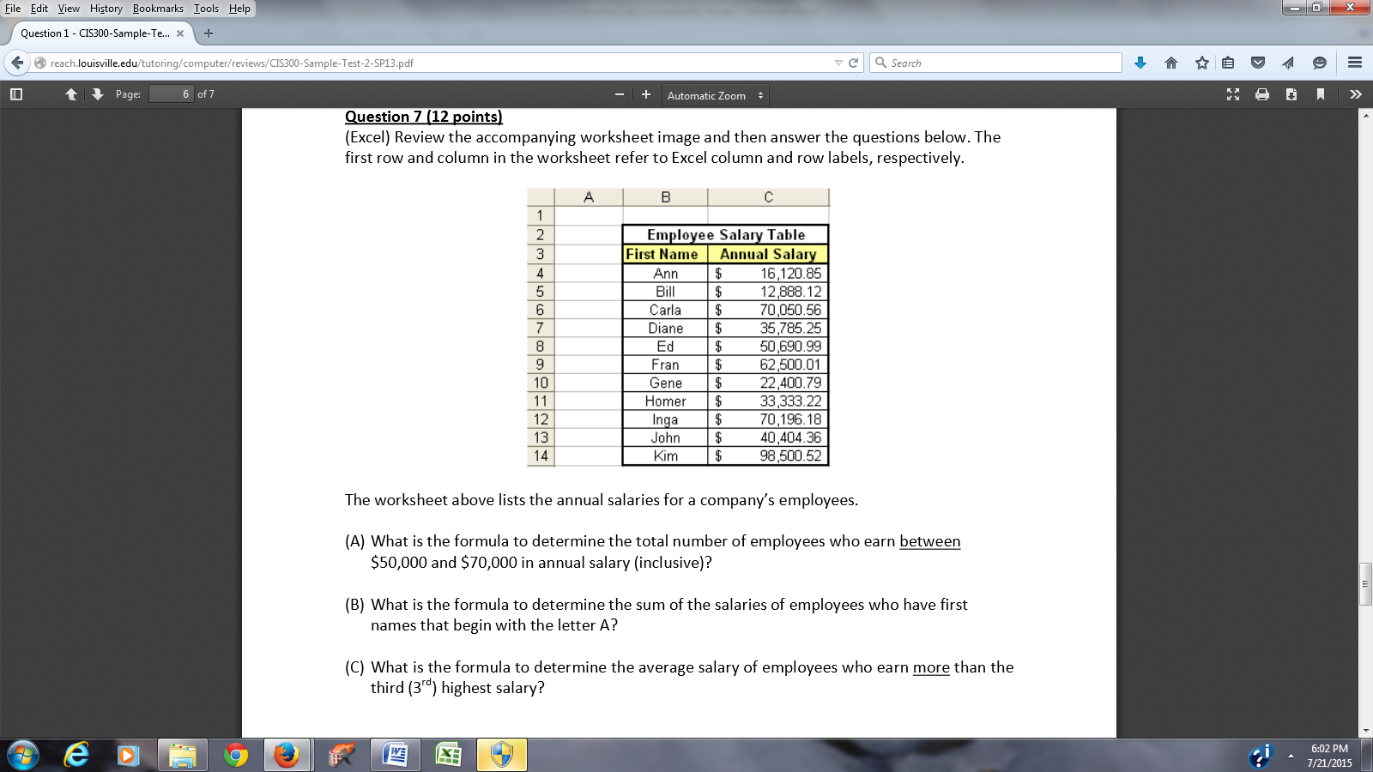
Determine the total number of employees who earn between $50,000 and $70,000
in annual salary

