SANITATION AND HEALTH

By Mary Kinoti

School of Public Health

Class: MBCHB II

Venue: MH2

Date: 10th feb/2011

**REFERENCES:**

1. Sanitation Where There is no Water.
2. McGhee, Terence J. Water supply and sewerage. Sith edition. McGraw-Hill series in Water Resources and Environmental Engineering. 1991.
3. White J.B. WastewasteEngineering. Edward Anold. 1974
4. WHO / UNICEF Joint Monitoring Programme for Water Supply and Sanitation Coverage Estimates Improved Sanitation Updated in June 2006. Kenya wssinfo.org
5. Richard Feachem, McGarry, M and Mara Duncan.Water, Wastes and Health in Hot Climates. John Wiley &Sons. Chichester

**Objectives:**

1. To appreciate the importance of proper excreta disposal
2. to describe structural and functional differences between common rural excreta disposal systems in existence;
3. to explain ways of reducing fly nuisance in pit latrines
4. to discuss difficulties in implementing pit latrine systems

**Introduction**

* The hygienic disposal of human ecreta for the millions villagers in the world is one of the greatest challenges that face public health workers…….
* rural sanitation is not primarily a technical problem because use of pit latrines would be appropriate and fairly cheap. The problem identified by the dual is encouraging the the population to use and maintain the facilities. (Cairncross and feachem(1983).

**The burden of poor sanitation**

**Facts and Figures**

* Every year globally, 2.5 million children die from diarrhea that could have been prevented by good sanitation;
* millions suffer the nutritional, educational and economic loss through diarrhea disease which sanitation can prevent.
* Poor sanitation has led to the infestation of nearly a billion people, largely children, with a variety of worm infections, with corresponding costs in health and energy.
* Poor management of human wastes can lead to direct or indirect disease transmission. Presently, 2.4 billion people have no access to basic sanitation [(WHO/UNICEF, 2000)](http://www.who.int/water_sanitation_health/Globassessment/GlobalTOC.htm).
* Poor water, sanitation and personal and domestic hygiene account for 5.7% of the total disease burden or 84 million life years lost per year expressed as DALYs (Disability Adjusted Life Years)
* Diarrhoea related to poor water supply and sanitation, is estimated to have killed 2.1 million people in 2000 (90% of the deaths occur in children: 85% in children 0 - 4 and 5% in children 5 - 14) [(WHO, 2001; Murray and Lopez, 1996)](http://www.hsph.harvard.edu/organizations/bdu/summary.html).
* Sanitation related diseases affect mostly the young and the poor.
* As early as 1956, a study in Kentucky USA had demonstrated a significant reduction in morbidity rates due to improved sanitation in low communities(Feachem, R. 1986).

This clearly suggests the importance of providing adequate sanitation and the need for preventive measures to combat environmental transmission of pathogens. Sanitation is the primary barrier for preventing the entry of many human pathogens into the environment particularly in developing countries

1. **What types of human excreta disposal systems exist in developing countries(e.g kenya)?**

During year iv medical students do a fieldwork aspect called community diagnosis. During this community diagnosis, the students get information on various aspects on communities of which include Environmental health issues. Sanitation is one of the environmental health investigated.

Table 1 represents 1996 findings by students who did community diagnosis in two locations(Kamirithuand Kiratina) in Kiambu District and found out the following:

a)

Table 1. Types of Facilities for human Excreta Disposal in Kiambu District.

|  |  |  |  |
| --- | --- | --- | --- |
| Type of facility | % in Kamirithu | Kiratina | Average |
| Pit latrine | 92 | 98.8 | 95.4 |
| VIP latrine | 2.5 | 0.4 | 1.45 |
| Flush/septic Tank | 2.0 | 0.6 | 1.3 |
| Bush/none | 3.5 | 0.2 | 1.85 |
| Total | 100 | 100 | 100 |

When the respondents’ knowledge of diseases associated with excreta disposal was assessed, majority(69% in Kamirithu and 75% in kiratina) said they knew and on further probing, 100% in Kamirithu and 99.8% in Kiratina mentioned atleast one that is associated with improper excreta disposal Table 2.

|  |  |  |
| --- | --- | --- |
| Disease | What health problem do you know that are associated with improper excreta disposal? | |
| Kamirithu(%) | Kiratina(%) |
| Typhoid | 16.5 | 17.1 |
| Cholera | 35.1 | 29.7 |
| Dysentery | 2.5 | 3.3 |
| Diarrhoea | 28.4 | 32.2 |
| Bilharzia | 0.4 | 1.9 |
| Vomiting | 0.7 | 0.2 |
| Nusea | 2.8 | 1.0 |
| Helminthiasis | 10.2 | 5.0 |
| Malaria | 0.7 | 2.7 |
| Skin diseases | 0.4 | 0.6 |
| Pollution | 0.0 | 1.5 |
| Eye diseases | 0.7 | 1.5 |
| Cough | 0.0 | 0.2 |
| Tetanus | 0.0 | 0.2 |
| Amoebiasis | 0.0 | 0.8 |
| Abdominal pain | 1.8 | 2.1 |
| Total | 100.0 | 100.0 |

On making observations of the toilet conditions, majority of them were found to be clean,without a cover and with privacyTable 3.

**Table 3. observed conditions of the pit latrines**

|  |  |  |
| --- | --- | --- |
| **Condition** | **Kamirithu(%)** | **Kiratina(%)** |
| **Clean** | 78.3 | 74.5 |
| **Dirty** | 21.7 | 25.5 |
| **Cover present** | 6.6 | 3.19 |
| **Cover absent** | 93.4 | 96.81 |
| **Privacy** | 97.0 | 95.01 |
| **No privacy** | 3.0 | 4.99 |

1. **THE PIT LATRINE**

It is the simplest and cheapest system. The basic pit latrine consists of a pit in the ground that receives and retains excreta which are biologically digested and eventually rendered harmless. The superstructure with either seat or squatting plate is built directly over the plate, generally about 1 metre in height.

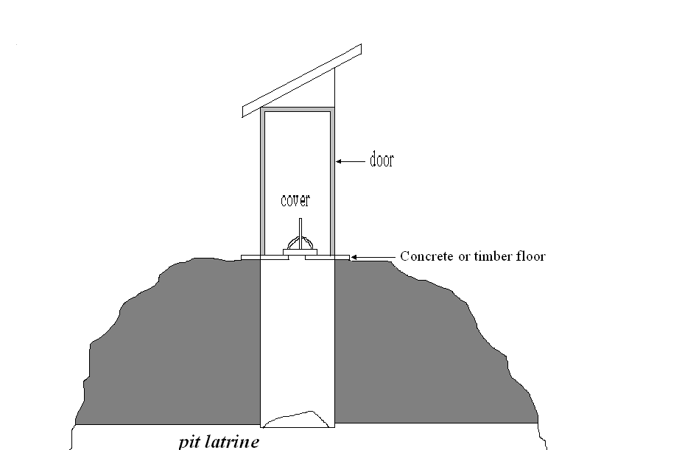

Figure 1. Structure of an Ordinary Pit latrine

Advantages:

* Its function is readily understood
* Ease to construct where soil and ground water conditions are right.

Disadvantages:

* Requires grounds where soil is deep, stable and permeable
* Ground water table should be lo9wer than the depthof the pit
* Impermeable soil would cause accumulation of water which provides breeding ground for flies and cules mosquitoes.
* Smell and fly nuisance.

**NB:**

a) The pit can be strengthened against collapse by building a stone/ concreta lining around the upper part.

The pit should be as large as possible atleast 0.06m3 person/ years of anticipated use not including the top 0.5m which is left for covering with earth when it is full. %0% should be handed where bulky material shall be used for anal cleansing.

1. Fly Control:

Mechanical control -:

* + the latrine should have a lid which self closing
  + A screening trap like in VIp

Thermal control:

* Burning hay or straw IS THROWN INTO THE PIT.(>43oc)- used in military and refugee camps
* Boiling water suddenly thrown into the pit which kills all fly larvae.

Chemical control

* Keeping of the receptacle filled with smoke.g of burning cloth

Use of insecticides not recommended to avoid contamination of underground water.

Biological control:

Allowing lizards and camelions to inhabit the the latrineswhich feed on the flies.

1. **VIP(Ventilated Improved Pit) Latrine**

This is an improved version of the ordinary pit latrine. Structurally similar to the ordinary pit latrine except that there is a vent pipe. The vent pipe is about 150mm in diameter and 2.5m high. The vent pipe should be painted black and be fitted with a fly screen. It should be fitted 6cm into the pit and be fitted on the side of the latrine that receives sunlight most of the day.

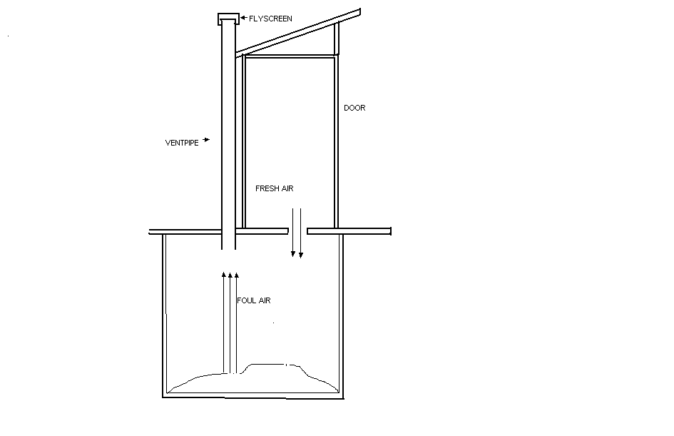

Disads,

Similar to those related to the construction of an ordinary pit latrine.

Ads:

Reduced smell and fly nuisance.

**DIFICULTIES WITH PIT LATRINES**

* + 1. **Rocky ground**

Rocky grounds haqve a temptation of digging shallow pits which are quickly filled.

* + 1. **Sandy Ground**

Pits tend to collapse and are very permeable to faecal. Hence likely to contaminate underground water sources**.**

* + 1. High water Table

Danger of culex mosquito breeding + contamination of underground waters

4. Social constraints

In some cultures, in laws can not use the same pit-latrine and in others bush is preferred to avoid witchcraft.

***3. SEPTIC TANK***

The septic tank is part of a basic waterbourne disposal system and is suitable for individual, family, small communities and institutions. The process can accept all domestic water. It is a lot more expensive to construct than a simple pit. A septic tank is effectively a sewage settlement tank, in which the solids are retained in a quiescent state long enough to be partly broken down by anaerobic action. The tank should be water-tight and constructed of non-corrodible material. Raw sewage enters the tank at one end, bacteria digest and liquefy some of the settled organic material and the resulting effluent passes out of the other end to secondary treatment or disposal in a soakage trench or seepage pit.

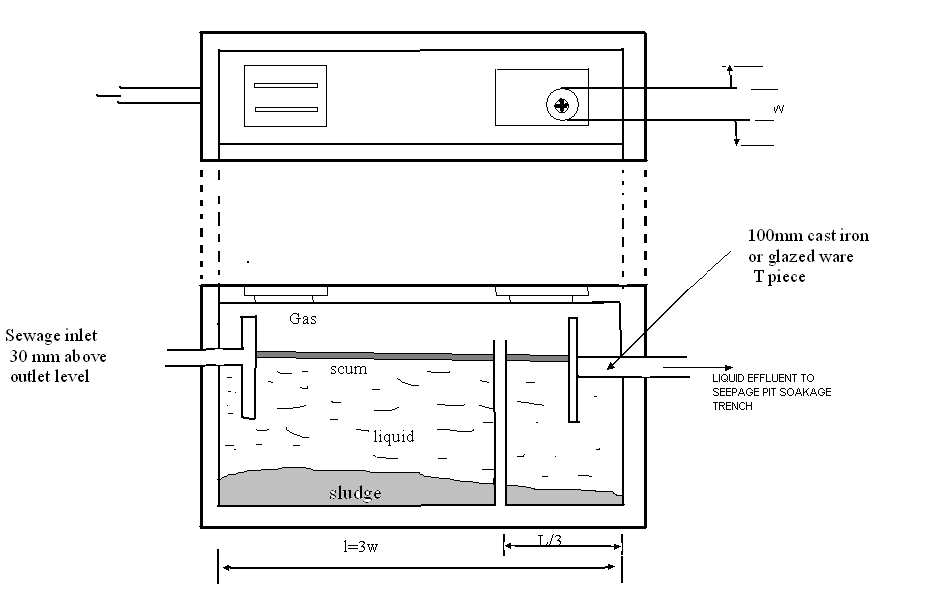

Stores and digest waste from bathrooms and flush toilets

Total vol. = x3 the average amount of water used daily.

Works well in low density areas where population is < 100persons /ha

Can be modified into 2or 3 compartments

Other systems

1. Bucket system
2. Aqua privy
3. Etc etc