ECG CHANGES IN CARDIAC DISEASE.  Normal ECG  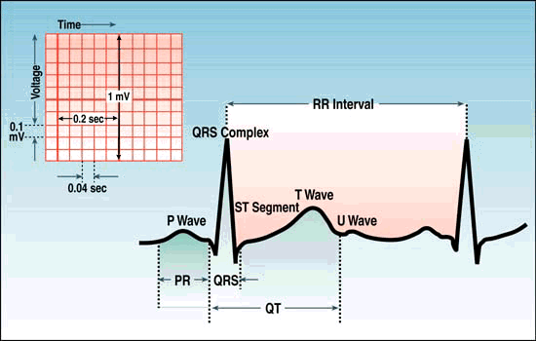  ECG Waves and Intervals:  P wave: the sequential activation (depolarization) of the right and left atria  QRS complex: right and left ventricular depolarization (normally the ventricles are activated simultaneously)  ST-T wave: ventricular repolarization  U wave: origin for this wave is not clear - but probably represents "afterdepolarizations" in the ventricles  PR interval: time interval from onset of atrial depolarization (P wave) to onset of ventricular depolarization (QRS complex)  QRS duration: duration of ventricular muscle depolarization  QT interval: duration of ventricular depolarization and repolarization  RR interval: duration of ventricular cardiac cycle (an indicator of ventricular rate)  PP interval: duration of atrial cycle (an indicator of atrial rate)  Orientation of the 12 Lead ECG  Each of the 12 leads represents a particular orientation in space, as indicated below (RA = right arm; LA = left arm, LF = left foot):  Bipolar limb leads (frontal plane):  Lead I: RA (-) to LA (+) (Right Left, or lateral)  Lead II: RA (-) to LF (+) (Superior Inferior)  Lead III: LA (-) to LF (+) (Superior Inferior)  Augmented unipolar limb leads (frontal plane):  Lead aVR: RA (+) to [LA & LF] (-) (Rightward)  Lead aVL: LA (+) to [RA & LF] (-) (Leftward)  Lead aVF: LF (+) to [RA & LA] (-) (Inferior)  Unipolar (+) chest leads (horizontal plane):  Leads V1, V2, V3: (Posterior Anterior)  Leads V4, V5, V6:(Right Left, or lateral)  Short PR: < 0.12s :  i)WPW (Wolff-Parkinson-White) Syndrome:  An accessory pathway (called the "Kent" bundle) connects the right atrium to the right ventricle, and this permits early activation of the ventricles (delta wave) and a short PR interval.  ii)LGL (Lown Ganong Levine ):  An AV nodal bypass track into the His bundle exists, and this permits early activation of the ventricles without a delta-wave because the ventricular activation sequence is normal.  iii)AV Junctional Rhythms  -With retrograde atrial activation (inverted P waves in II, III, aVF): Retrograde P waves may occur before the QRS complex (usually with a short PR interval), in the QRS complex (i.e., hidden from view), or after the QRS complex (i.e., in the ST segment).  iv) Ectopic atrial rhythms  originating near the AV node (the PR interval is short because atrial activation originates close to the AV node; the P wave morphology is different from the sinus P)  iv) Normal variant.  Prolonged PR: >0.20s  First degree AV block  (PR interval usually constant though’ prolonged and all the P’waves conducted)  - Intra-atrial conduction delay –rare  - Slowed conduction in AV node (most common site)  - Slowed conduction in His bundle (rare)  - Slowed conduction in bundle branch (when contralateral bundle is blocked)  Second degree AV block  (PR interval may be normal or prolonged; some P waves do not conduct)  Type I (Wenckebach): Increasing PR until nonconducted P wave occurs  Type II (Mobitz): Fixed PR intervals plus nonconducted P waves  3rd Degree heart Block  AV dissociation:  Some PR's may appear prolonged, but the P waves and QRS complexes are dissociated (i.e., not married, but strangers passing in the night).  Left ventricular hypertrophy  1)Tall R wave (greater than 25mm in V5 or V6),  or R at V5 plus S wave at V1greater than 35 mm -Leons hypothesis  2)a deep S in V1 or V2  3)if there is significant left ventricular 'strain' then there are also inverted T waves in V5 and V6 and possible ST depression  4)left axis deviation may also be present  5)QRS may be slightly prolonged  Right ventricular hypertrophy include:  1)right axis deviation  2) predominant R wave in lead V1 - in a normal ECG the S wave is dominant in V1 there will be a deep S in V6 - in a normal ECG the QRS complex is predominantly upwards in V6  3)inverted T waves in right praecordial leads - V2, V3 - will be present in severe cases; it is normal to have inverted T waves in V1  4)Peaked P waves may also occur due to right atrial hypertrophy  5)QRS < 0.12s  HYPERKALEMIA  ECG CHANGES  Serum K⁺ 5.5-6.5 mEq/L  - Tall, peaked T waves with narrow base, best seen in precordial leads  Serum K⁺ 6.5-8.0 mEq/L  - Peaked T waves  - Prolonged PR interval  - Widening of QRS, amplified R wave  - Decreased or disappearing P wave  Serum K⁺ greater than 8.0 mEq/L  - Absence of P wave  - Intraventricular/fascicular/bundle branch blocks  - Progressive widening of QRS (eventually merging with the T wave just before cardiac arrest, forming the Sine-wave pattern | LOCATION OF CHEST ELECTRODES IN 4TH AND 5TH INTERCOSTAL SPACES:  Einthoven's Triangle  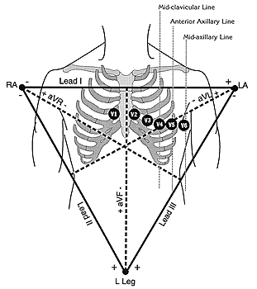V1: right parastenal 4th intercostal space  V2: left parasternal 4th intercostal space  V3: halfway between V2 and V4  V4: left 5th intercostal space, mid-clavicular line  V5: horizontal to V4, anterior axillary line  V6: horizontal to V5, mid-axillary line  ECG Interpretation  - Measurements  - Rhythm Analysis  - Conduction Analysis  - Waveform Description  - ECG Interpretation  - Comparison with Previous ECG (if any)  Measurement  1.Heart Rate  In normal sinus rhythm, a resting heart rate of below 60 bpm is called bradycardia and a rate of above 90 bpm is called tachycardia.  2. PR Interval  (measured from beginning of P to beginning of QRS in the frontal plane)  Normal: 0.12 - 0.20s  3.QRS Duration  Normal: 0.06 - 0.10s  Prolonged QRS Duration (>0.10s):  Incomplete right or left bundle branch block  Nonspecific intraventricular conduction delay (IVCD)  Some cases of left anterior or posterior fascicular block  Complete RBBB or LBBB  Ectopic rhythms originating in the ventricles (e.g., ventricular tachycardia, pacemaker rhythm)  4.QT Interval  (measured from beginning of QRS to end of T wave in the frontal plane)  Normal: heart rate dependent (corrected QT = QT_{c} = measured QT ¸ sq-root RR in seconds; upper limit for QT_{c} = 0.44 sec)  Long QT Syndrome - "LQTS" (based on upper limits for heart rate; QT_{c} > 0.47 sec for males and > 0.48 sec in females is diagnostic for hereditary LQTS in absence of other causes of increased QT)  This abnormality may have important clinical implications since it usually indicates a state of increased vulnerability to malignant ventricular arrhythmias, syncope, and sudden death.  -The prototype arrhythmia of the Long QT Interval Syndromes (LQTS) is Torsade-de-pointes, a polymorphic ventricular tachycardia characterized by varying QRS morphology and amplitude around the isoelectric baseline.  Causes of LQTS include the following:  1.Drugs  - Antiarrhythmics  - Tricyclics  - Phenothiazines  2.Electrolyte abnormalities  - Hypokalemia  - Hypocalcemia  - hypomagnesima  3.CNS disease (especially subarrachnoid hemorrhage, stroke, trauma)  4.Hereditary LQTS (e.g., Romano-Ward Syndrome)  5.Coronary Heart Disease (some post-MI patients  Hypokalemia  - Ventricular dysrhythmia  - Prolongation of QT interval  - ST-segment depression  - T-wave flattening  - Appearance of U waves  -During therapy, monitor for changes associated with overcorrection and hyperkalemia, including a prolonged QRS, peaked T waves, bradyarrhythmia, sinus node dysfunction, and asystole  Hypercalcemia  -QT interval shortening is common, and, in some cases, the PR interval is prolonged.  -At very high levels, the QRS interval may lengthen, T waves may flatten or invert, and a variable degree of heart block may develop. Digoxin effects are amplified.

