**The Pre-Operative Assessment**

The **pre-operative assessment** is an opportunity to identify co-morbidities that may lead to **patient complications** during the **anaesthetic, surgical, or post-operative period**. Patients scheduled for elective procedures will generally attend a pre-operative assessment 2-4 weeks before the date of their surgery.

**Pre-Operative History**

The pre-operative history follows the same structure as typical history taking, with the addition of some anaesthetic and surgery specific topics.

**History of the Presenting Complaint**

A**brief history** of why the patient first attended and what**procedure** they have subsequently been scheduled for. One should also confirm the side on which the procedure will be performed (if applicable)

**Past Medical History**

A full past medical history (PMH) is required, with the following specifically asked about:

* **Cardiovascular** **disease**(including hypertension and exercise tolerance)
  + The risk of an acute cardiac event is increased during anaesthesia
* **Respiratory** **disease**, as adequate oxygenation and ventilation is essential in reducing the risk of acute ischaemic events in the peri-operative period
* **Renal** **disease**, as many features of renal disease (such as anaemia, coagulopathy, biochemical disturbances) can increase the incidence of surgical complications
* **Endocrine** **disease**, specifically diabetes mellitus and thyroid disease
  + Many medications often require [specific changes](https://teachmesurgery.com/perioperative/preoperative/management/) to be made in the peri-operative period

Other specific questions it may be useful to ask themselves the following questions:

* Female of reproductive age – could they be pregnant
* African or Afro-Caribbean descent – could they have undiagnosed sickle cell disease

**Past Surgical History**

Has the patient had any **previous operations**? If so, what, when, and why?

**Past Anaesthetic History**

Has the patient **had anaesthesia before**? If so, were there any issues? Were they well intra- and post-operatively? Specifically, has the patient experienced to any previous [post-operative nausea and vomiting](https://teachmesurgery.com/perioperative/general-complications/nausea-vomiting/)?

**Drug History**

A **full drug history** is required, as some [medications](https://www.teachmesurgery.com/pre-operative/management/) require stopping or altering prior to surgery. Ask about any known **drug** **allergies**.

**Family History**

An important condition to ask about is **malignant hyperpyrexia**\* (also known as malignant hyperthermia), yet any other adverse reactions in surgery of immediate family members should also be documented.

*\*An autosomal dominant condition that characteristically leads initially to muscle rigidity (despite neuromuscular blockade) followed by a rise in temperature (requires senior input and support if present)*

**Social History**

Ensure to ask the patient about **smoking history and alcohol intake**and their **exercise tolerance**.

**Pre-Operative Examination**

In the pre-operative examination, two distinct examinations are performed; the **general examination** (to identify any underlying undiagnosed pathology present) and the **airway examination** (to predict the difficulty of intubation). If appropriate, the area relevant to the operation can also be examined.

Perform a **full general examination**, looking closely for any obvious cardiovascular, respiratory, or abdominal signs. An **anaesthetic examination**, including an **airway assessment,** will also be performed by the anaesthetist prior to any surgery (see Appendix).

**American Society of Anaesthesiologists Grade**

On all anaesthetic charts, a patient will be given an American Society of Anaesthesiologists (ASA) grade after their pre-operative assessment, which has been subjectively assessed and based on the criteria below. A patient’s ASA grade directly correlates with their risk of post-operative complications and absolute mortality.

| **ASA Grade** | **Definition** | **Absolute Mortality (%)** |
| --- | --- | --- |
| **I** | Normal healthy patient | 0.1 |
| **II** | Mild systemic disease | 0.2 |
| **III** | Severe systemic disease | 1.8 |
| **IV** | Severe systemic illness that is a constant threat to life | 7.8 |
| **V** | Moribund, who is not expected to survive without the operation | 9.4 |
| **E** | Suffix added if an emergency operation | – |

**Pre-Operative Investigations**

The nature of the **exact investigations required**depends on a number of factors, including co-morbidities, age, and the nature of the procedure.

Each specific hospital is likely to provide **local guidelines**, however it is useful to understand the tests than could be done pre-operatively and have an appreciation as to why each may be requested. NICE produce a [colour traffic light table](https://www.nice.org.uk/guidance/ng45/resources/colour-poster-2423836189) which can further guide your investigative decisions.

**Blood Tests**

* **Full Blood Count** (FBC)
  + Most patients will get a **full blood count**, predominantly used to assess for any **anaemia or thrombocytopenia**, as this may require correction pre-operatively to reduce the risk of cardiovascular events
* **Urea & Electrolytes** (U&Es)
  + To assess the**baseline renal function**, which help inform any potential IV fluid management intra- and post-operatively
* **Liver Function Tests** (LFTs)
  + Important in the assessing **liver metabolism and synthesising function**, useful for peri-operative management; if there is suspicion of liver impairment, LFTs may help direct medication choice and dosing
* **Clotting Screen**
  + Any indication of **deranged coagulation**, such as iatrogenic causes (e.g. warfarin), inherited coagulopathies (e.g haemophilia A/B), or liver impairment, will need identifying and correcting before surgery
* **Group and Save** (G&S) +/- cross-matching

**Group and Save versus Cross-Match**

Group and Save (G&S) and Cross-Match (X-match) are two tests often cause a great deal of confusion:

* A G&S determines the patient’s blood group (ABO and RhD) and screens the blood for any atypical antibodies; the process takes around 40 minutes and no blood is issued
  + A G&S is recommended if blood loss is not anticipated, but blood may be required should there be greater blood loss than expected
* A cross-match involves physically mixing the patient’s blood with the donor’s blood, in order to see if any immune reaction takes places; if it does not, the donor blood is issued and can be transfused in to the patient, otherwise alternative blood is trialled
  + This process also takes ~40 minutes (in addition to the 40 minutes required to G&S the blood, which must be done first), and should be done if blood loss is anticipated

**Imaging**

**Electrocardiogram (ECG)**

An ECG is often performed in individuals with a **history of cardiovascular disease** or for those **undergoing major surgery**. It can indicate any underlying cardiac pathology and provide a baseline if there are post-operative signs of cardiac ischaemia.

*N.B An echocardiogram (ECHO) may be considered if the person has (1) a heart murmur (2) cardiac symptom(s) (3) signs or symptoms of heart failure.*

**Chest X-ray**

A **plain film chest radiograph** (CXR) should be used only when necessary and should not be performed routinely (Fig. 1). Local guidelines should be available to aid decision-making and indications may include:

* **Respiratory illness** who have not had a CXR within 12 months
* **New cardiorespiratory symptoms**
* **Recent travel** from areas with endemic tuberculosis
* Significant **smoking history**

If a patient has a chronic lung condition, **spirometry** may be of use in assessing current baseline and predicting post-operative pulmonary complications in these patients.

By TeachMeSeries Ltd (2020)

[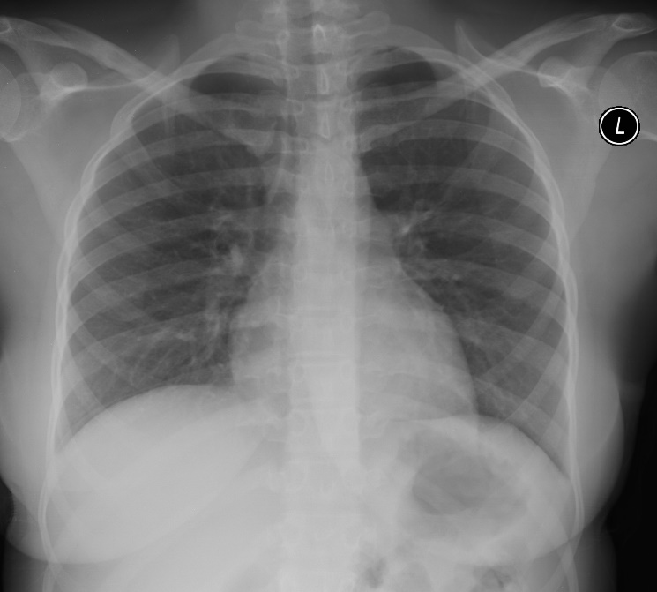](https://teachmesurgery.com/wp-content/uploads/2015/07/Normal-CXR-1024x923.jpg)

Figure 1 – A normal pre-operative CXR

**Other Tests**

**Pregnancy Testing**

Consider pregnancy testing in all women of reproductive age, always ensuring to get the patient’s consent

**Sickle Cell Test**

Do not routinely offer testing for sickle cell disease or sickle cell trait before surgery. If the person has any member of their family with sickle cell disease, or is Africa or Afro-Caribbean descent however, strongly consider performing a sickle cell test.

**Urinalysis**

A urinalysis may be performed if any evidence or suspicion of ongoing glycosuria or urinary tract infection, yet should not be done routinely pre-operatively.

**MRSA Swabs**

All patients will have swabs taken from the nostril ± perineum ± other sites for MRSA colonisation. If this is isolated, antiseptic hair and body wash, along with topical ointment applied to the nostrils, will be given; in some hospitals, this is given for all elective patients pre-operatively, even if this means the operation is delayed.

Special investigations – especially imaging CT SCAN, MRI etc. If already done remind patient to carry them to the hospital on the day of surgery

Order for implants if not in the hospital, or check with hospital store that any special equipment you may need is available.

Orthopaedic - templating

**Appendix – The Airway Examination**

The airway examination will typically be covered during the anaesthetist’s assessment of the patient but is always good practice to assess during the preoperative assessment. Look at the face for any obvious facial abnormalities. Particularly, do they have a receding mandible (retrognathia)? This could cause difficulties during airway insertion.

Ask the patient to open their mouth and assess:

* Their degree of **mouth opening** (favourable if inter-incisor distance is above 3cm).
* Their **teeth**, mainly do they have teeth? If so, what is their dentition like? Are any teeth loose?
* Their oropharynx. Ask the patient to maximally protrude their tongue. A **Mallampati classification**(Fig. 2), which correlates with difficulty of intubation, can be assessed.

Lastly, assess the neck. Ask the patient to flex, extend and laterally flex the neck to see their range of movement. Then ask the patient to maximally extend their neck and measure the distance between the thyroid cartilage and chin (the thyromental distance); if this is less than 6.5cm (~3 finger breadths), it indicates that intubation may be difficult.

By Jmarchn [CC BY-SA 3.0] via Wikimedia Commons

[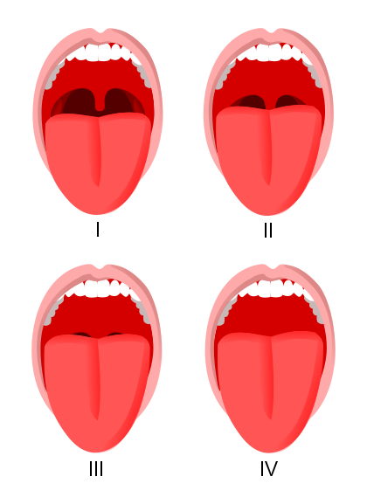](https://teachmesurgery.com/wp-content/uploads/2015/07/The-Mallampati-Classification.png)

Figure 2 – The Mallampati classification

Question 1 of 3

How long before surgery should a patient ideally have a pre-operative assessment?



**2-4 days**



**2-4 weeks**



**2-4 months**



**>6 months**

Question 2 of 3

What is the most important additional test that should be performed for a woman of reproductive age prior to proceeding with surgery?



**Thyroid function test**



**Capillary blood glucose**



**Pregnancy test**



**Full blood count**

What classification is used to assess the potential difficulty of a patient’s airway for intubation?



**Mallampati scoring**



**Garden classification**



**Salter-Harris classification**



**ASA Classification**

**CONSENT**

A legal and ethical obligation

**Informed Consent**

**Definition:**

is the process in which a health care provider educates a patient about the risks, benefits, and alternatives of a given procedure or intervention. The patient must be competent to make a voluntary decision about whether to undergo the procedure or intervention.

The following are the required elements for documentation of the informed consent discussion:

(1) the nature of the procedure,

(2) the risks and benefits and the procedure,

(3) reasonable alternatives,

(4) risks and benefits of alternatives,

(5) assessment of the patient's understanding of elements 1 through 4.

Procedure specific consent.

Consent for elective procedures vs emergency procedures