QUALITATIVE ANALYSIS

1. URINALYSIS

-purpose is to check for glucose, nitrites, blood, urobilinogen, etc

-random urine sample (in universal bottle)

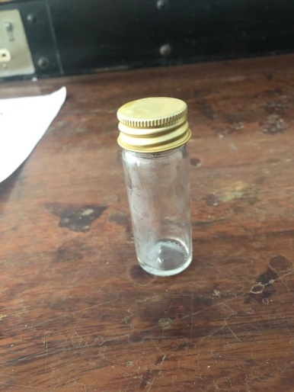

-uses urine strips dipped in the urine sample

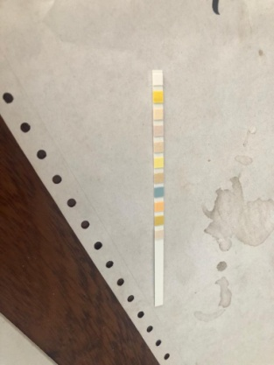

-compare color changes to the chart

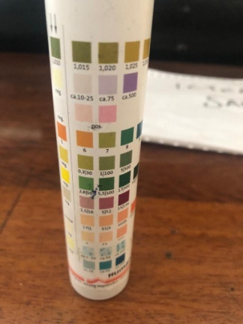

-is a screening test

-confirmatory tests required e.g. urine culture (when nitrites are present), RBS and OGTT (when glucose is present), LFTs (when urobilinogen is present) and UECs (when proteins are present)

1. BRADSHAW TEST

-to check for bence jones proteins

-uses Winchester bottle – also used for creatinine clearance and BMA

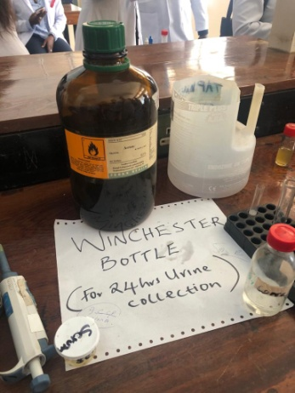

-pipette 1ml of urine, 1ml of HCl

-white rim should form at interface of urine and HCl thus positive for bence jones proteins

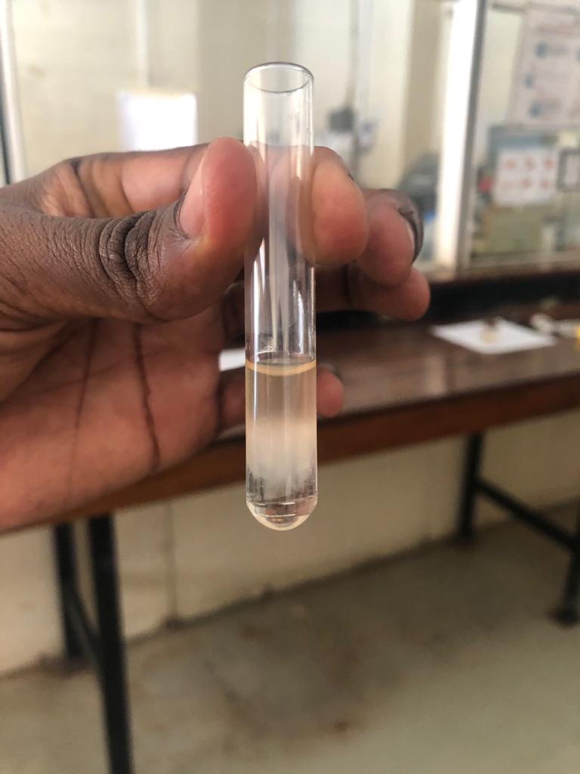

-is a screening test

-confirmatory – between 40-60˚C precipitation appears, >60˚C precipitation disappears

1. VMA

-purpose is to check for presence/absence of catecholamines in 24 hour urine

1. OCCULT BLOOD

-check for hidden blood in random stool specimen

-collected in polypot

-uses test kit – take sample from different spots, smear over position A and B

-add hydrogen peroxide and reduced chromogen

-the hydrogen peroxide is broken down by Hb and gives a dark blue discoloration which is positive

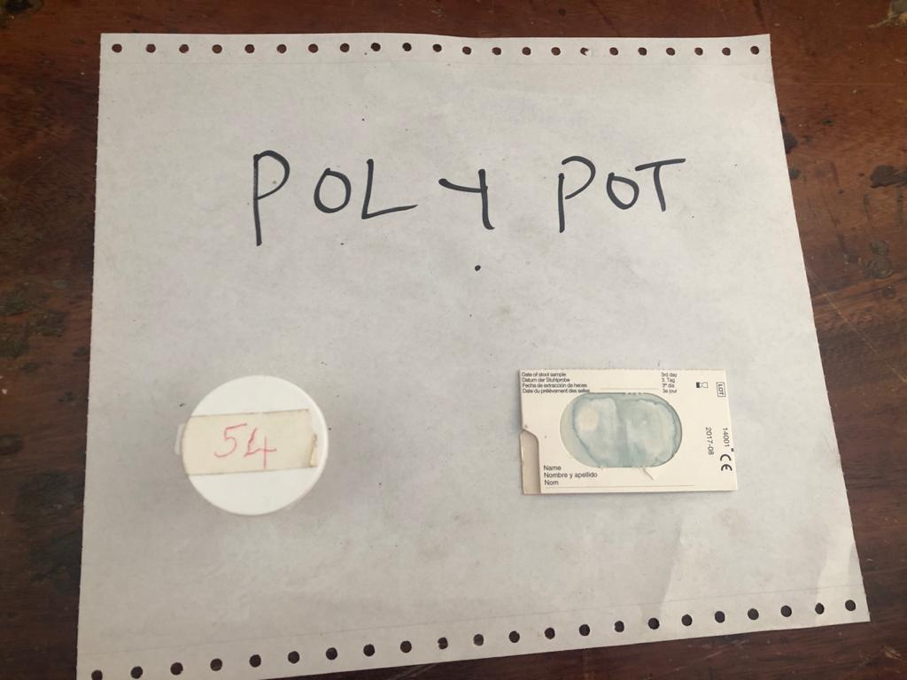

SAMPLES

Lipemic serum – high levels of cholesterol, TG; low levels of LDL

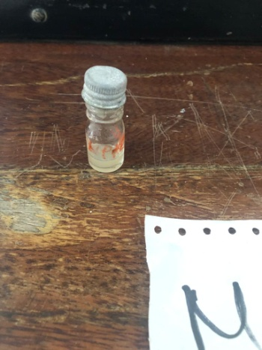

Icteric serum – contains high levels of bilirubin

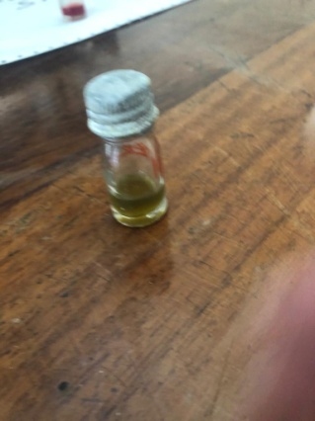

Haemolysed serum – contains high potassium

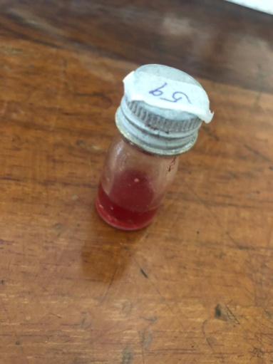

MacCarthey bottles – for collection of CSF and blood; for biochemistry analysis

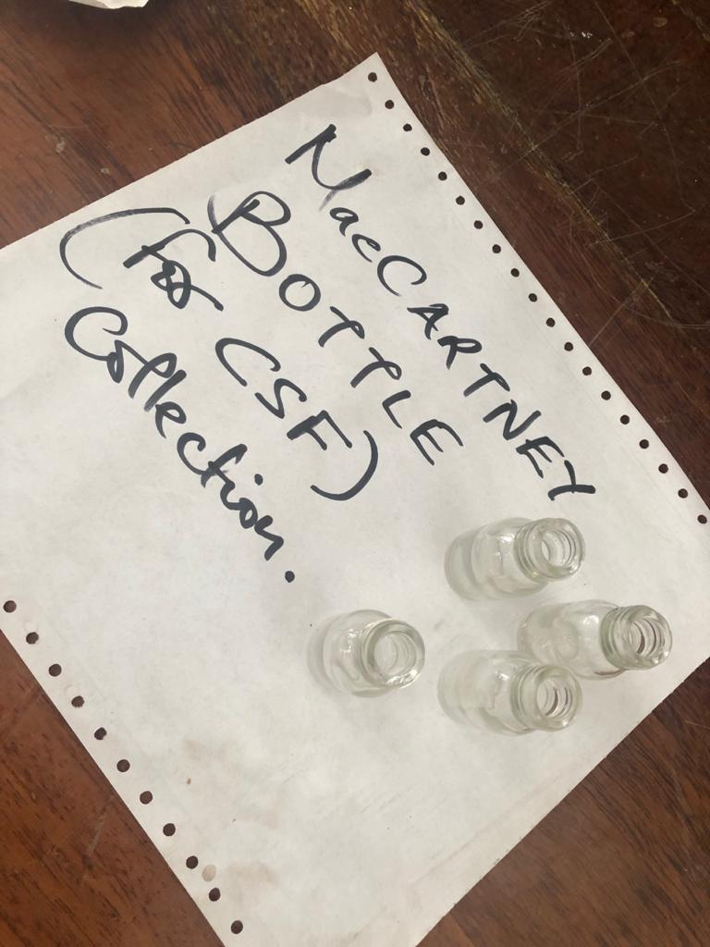

Bijou bottle – for collection of small volumes of blood and CSF; for biochemistry analysis

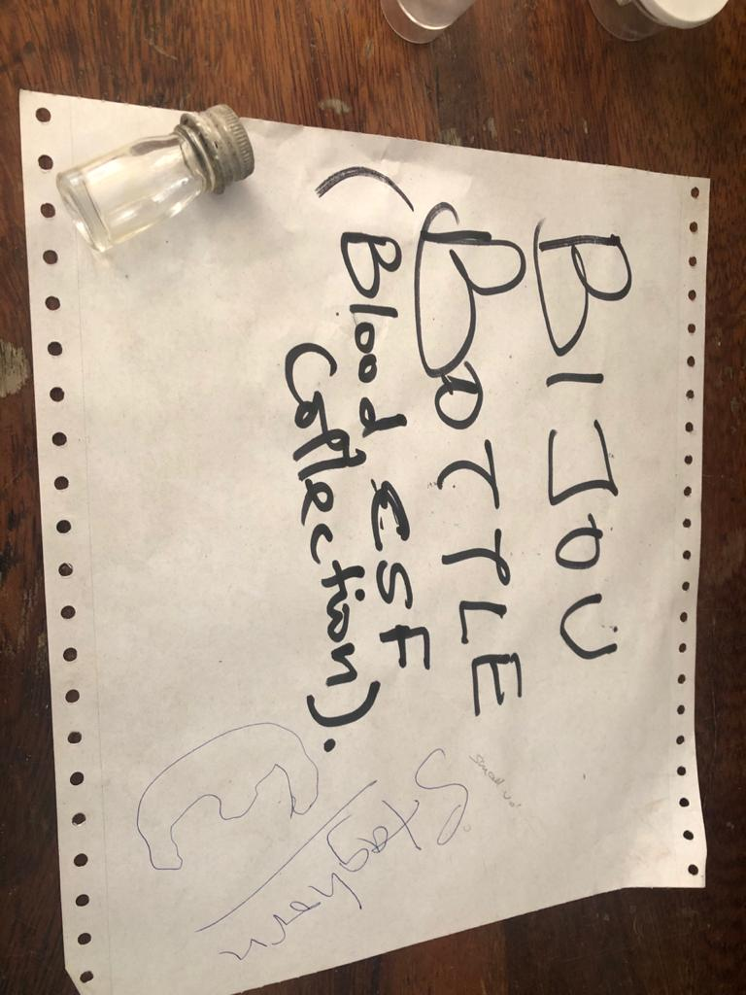

Vacutainers –

