***LATEX AGGLUTINATION TESTS***

1. ***PREGNANCY AGGLUTINATION TEST***

This detects the presence of HCG in urine. On a black metal plate add a drop of the commercially prepared product with anti-HCG antibodies and then add a drop of urine. Also prepare samples with positive and negative control. Mix for 3 minutes. Observe which samples agglutinate.

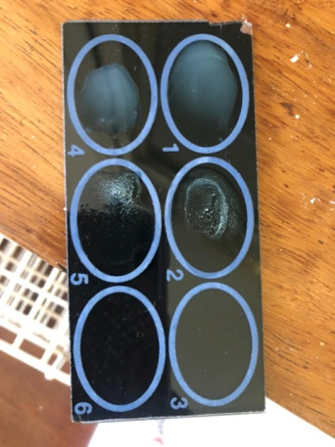

Samples 2 agglutinated.

NOTE:- How to report results: Agglutination was observed, an indication that HCG was present in sample 2.

1. ***ANTI-RHEUMATOID AGGLUTINATION TEST***

This detects the presence of anti-rheumatoid antibodies in serum. On a black metal plate add a drop of the commercially prepared product with anti-anti-rheumatoid antibodies and then add a drop of serum. Also prepare samples with positive and negative control. Mix for 3 minutes. Observe which samples agglutinate.



Sample 5 agglutinated.

1. ***SYPHILLIS AGGLUTINATION TEST***

This has a screening test and a confirmatory test. The confirmatory test is only done once the screening test is positive.

Screening test – This is known as the VDRL test or RPR test. On a white paper plate add one drop of suspended carbon particles; this contains cardiolipin antigen which will react with the antibodies against Treponema pallidum in serum. Also add a drop of serum and mix for 8 minutes. Observe which sample agglutinates.

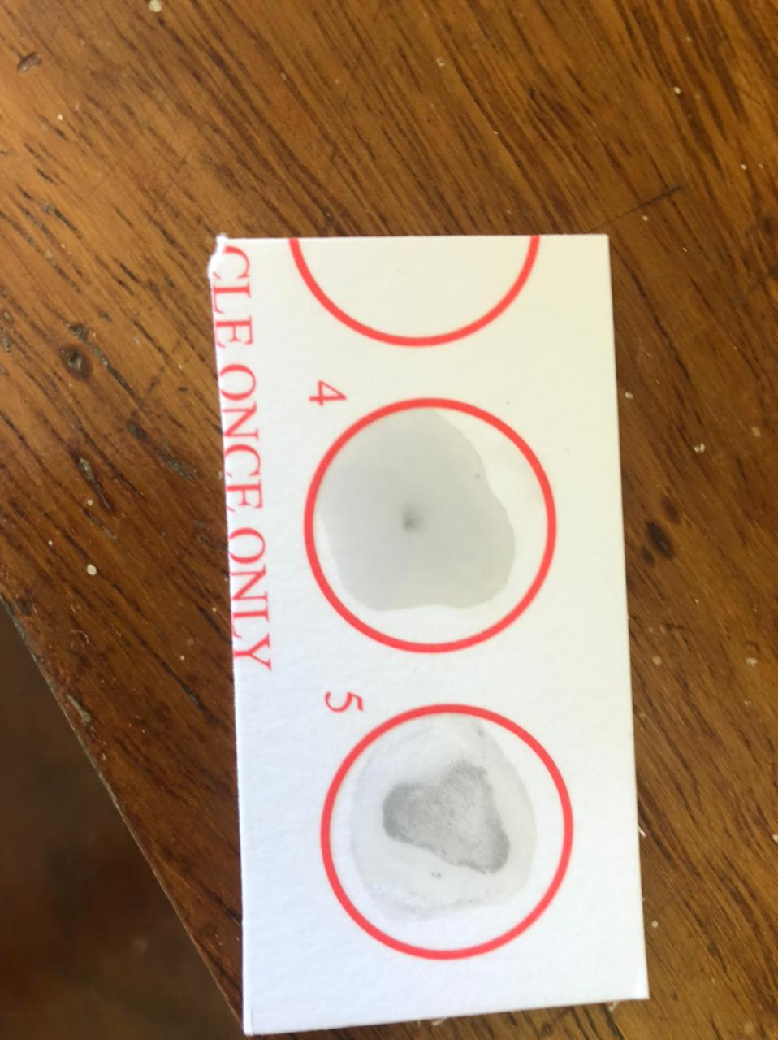

Sample 5 agglutinated.

Confirmatory test – This is known as the TPHA test (treponema pallidum haemagglutination assay). This tests the presence of the IgG antibody against the bacteria. In a microtitre well, for a given patient, add 25ml of the dilutant to the wells 1-10. Do not add the dilutant to wells 11 and 12 as these are for the control. Then add the patient’s serum and dilute. The dilution increases as you move from well 1 to well 10 hence the concentration of the antibodies in serum reduce as you move from well 1 to well 10. Then add the positive and negative control to the wells 11 and 12 respectively. Then add 75ml of commercially prepared suspended RBCs (contains cardiolipin antigen) to all the wells (including wells 11 and 12). Incubate overnight at room temperature.

If there are Abs present in serum then there will be hemolysis but if there are no Abs present then there will be no hemolysis observed.

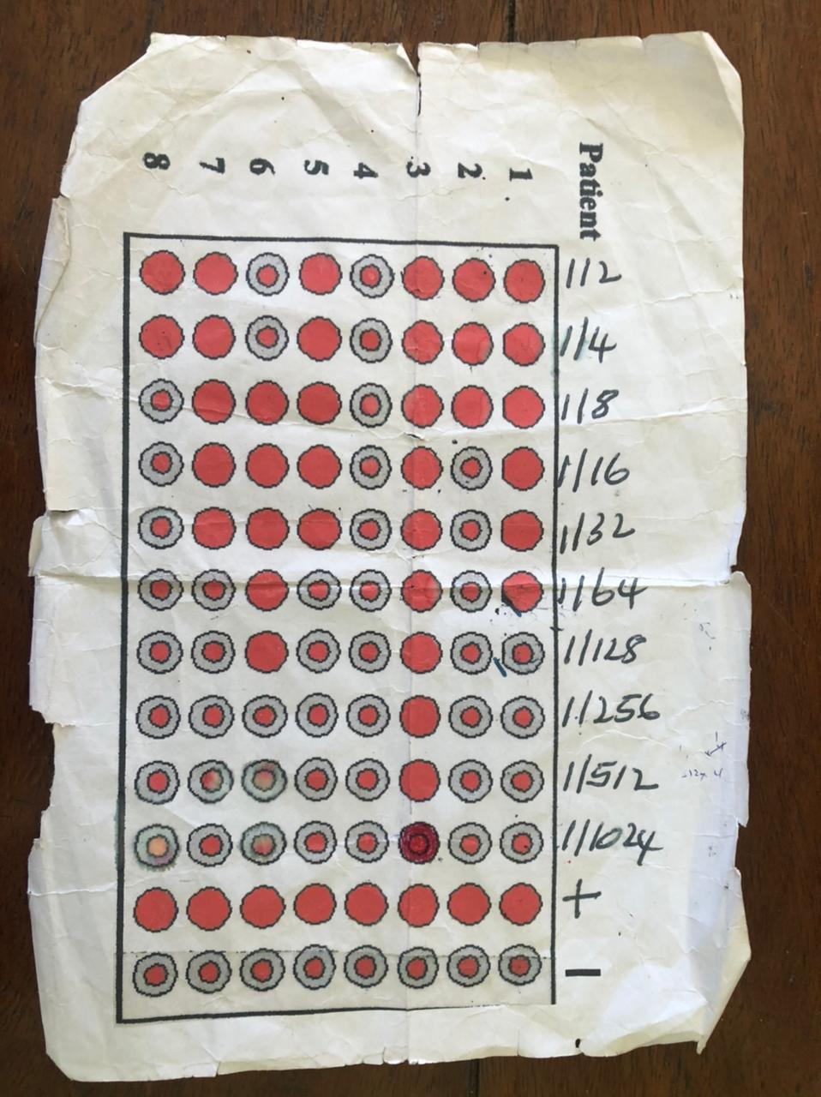

Pt 1 – Highest dilution with a positive result is 1/64

NB:- After 1/64, the patient’s antibodies were no longer detectable

Pt 3 – As for this patient all the wells were filled, we take the patient’s serum and dilute it by a dilutional factor of 4. Then put the serum in the wells and see for the reaction. Where the serum is last positive, use the original dilutional factor and multiply it by 4 e.g. when doing this, the patient’s serum is last positive at 1/64 so multiply by 1/64 to get the value for the highest dilution with a positive result for this patient.

Pt 6 – The first two wells show a negative result while wells 3-7 show a positive result. This is as a result of the prozone effect (also known as the buffering effect). This effect comes about as a result of the very high concentration of Abs which protects the RBCs from haemolysis. However, as the concentration of the Abs reduces across the wells, the buffering effect no longer comes to play and normal results are obtained.

NB:- Ensure that you mention the prozone effect in your results when present.