***HIV***

***HIV SCREENING TEST***

This is done using two methods i.e.

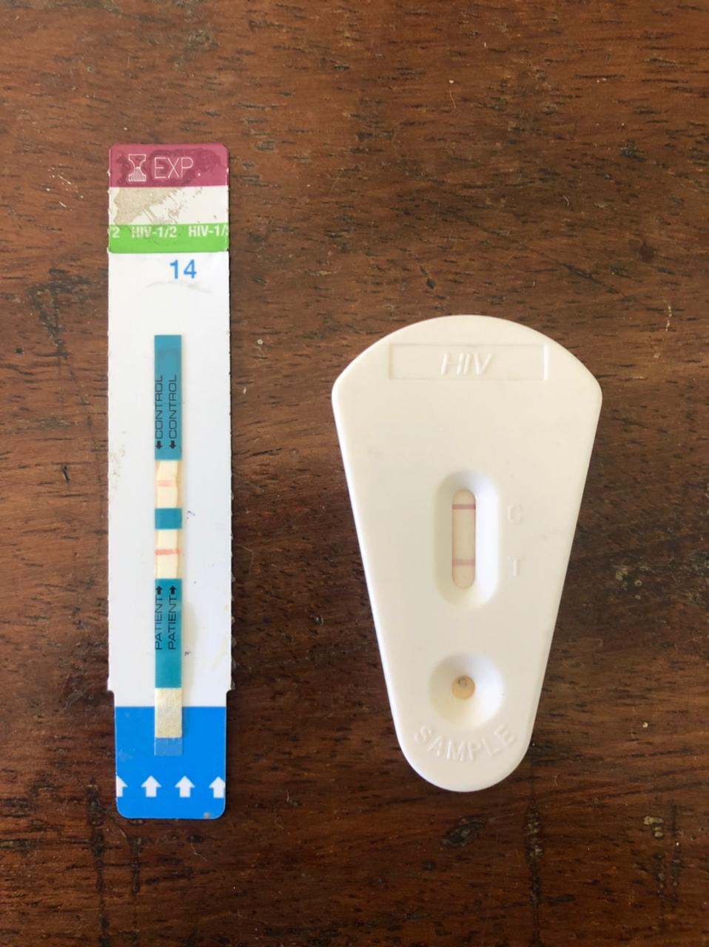

A – Determine strip

B – Unigold

B

A

Samples used:-

1. Serum
2. Plasma
3. EDTA with whole blood and chase buffer (as whole blood is too thick)

This tests for the Abs against HIV present in the sample hence the test itself has the HIV antigen.

There should be a red line for the control – if this is not present then the test is invalid. If the test has a red line then it is positive and if the test does not form a red line then it is negative.

***ELISA***

The samples are plasma and serum.

The test has both a positive and negative control.

ELISA can be used for quantitative or qualitative analysis. For quantitative analysis, it can be used for getting the tumour marker concentration. For qualitative analysis, it gives us a positive or a negative, and can be used to screen HIV, Hep B and C, and CMV.

ELISA is used to detect or quantify substances e.g. proteins and enzymes

*PROCEDURE*

In an antibody/antigen coated well, add 100µl of the sample which causes the immune complex to be formed. Then add a secondary antibody called a conjugate which also has an enzyme that reacts with the formed immune complex. Incubate for one hour. Discard all the wells using a wash buffer under a method called washing. Then add a substrate and incubate for 30 minutes and allow the substrate to react with the enzyme and cause a color change. Then add an acid which acts as a stop solution to prevent any further reaction.

Incubation and temperatures of incubation are varied based on manufacturer kit.

Thereafter, read the absorbance/optical density (OD) using an ELISA reader

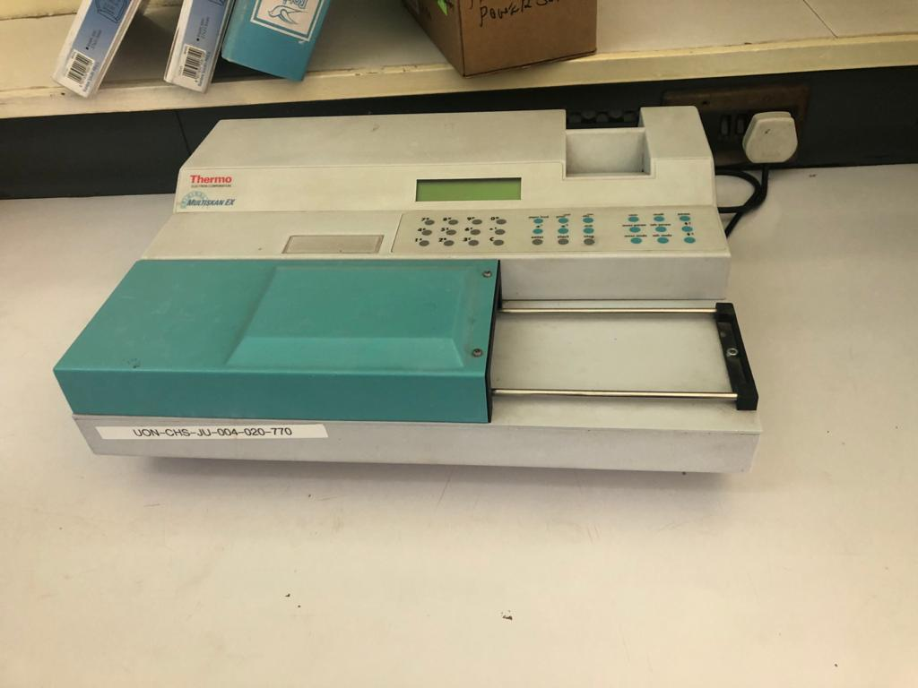

It is important to use two or more negative controls and get a mean (this is the cut off point) and this is done to reduce the clerical error. Anything less than the cut off is a negative, anything more than the cut off is a positive, and if it is the same value as the cut off then it is invalid.

The HIV ELISA kits have p24 Ab and an Ag depending on the kit. If positive then do a CD4 count and viral load.

For the CD4 count, use a flow cytometer and for the viral load use PCR.

The PCR amplifies the nucleic acids. PCR is divided into qualitative and quantitative. Qualitative is for babies born from HIV positive mothers because of maternal antibodies (use whole blood or do a dry blood spot). The viral load measures the number of viruses in circulation. The sample is plasma and it is collected in a purple vacutainer. It is reported in copies/ml of blood hence the machine has a range. The range for the machine at KNH is 40 – 10 million copies.

Viral load checks for the HIV RNA while screening in infants looks for HIV DNA (virus integrated to host DNA)

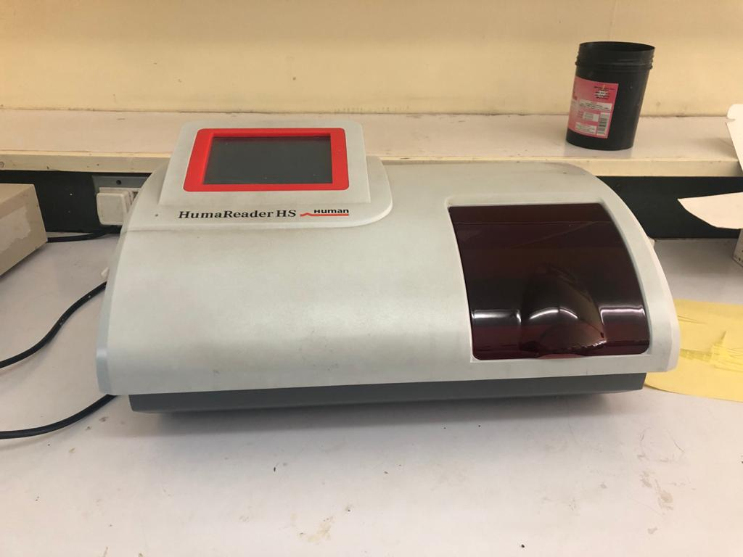

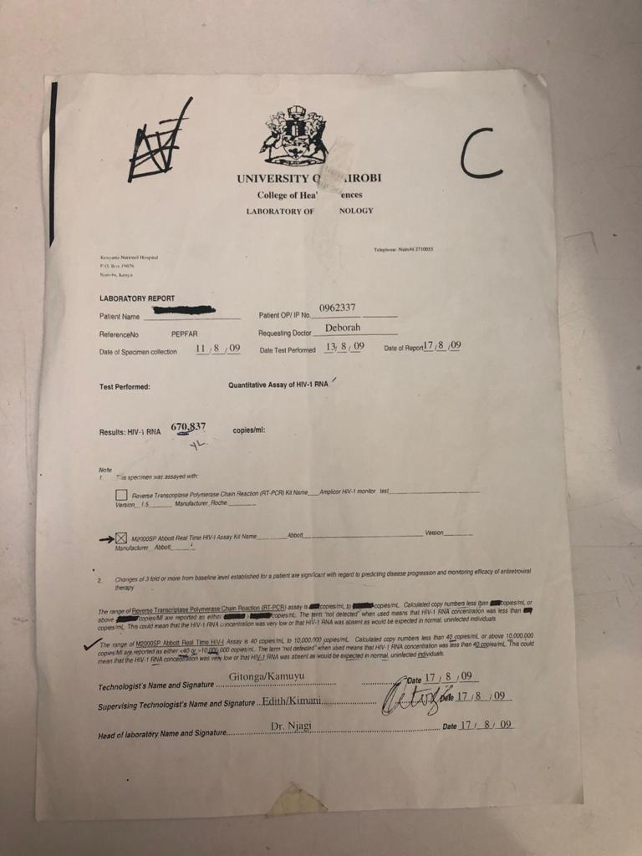

The flow cytometer measures the size, granularity and staining of the cell. It uses mAbs. The sample is whole blood. This measures cells/µl. For CD4 count, do CD45 to get both T and B lymphocytes, then do CD3 for T lymphocytes, then CD4 for T helper lymphocytes.

