**URBAN SANITATION CONT’D**

**LECTURE 3**

**M. KINOTI**

**Time: 3.30- 5.00 P.m**

**Venue: MH 1- Chiromo**

**Date: 18/ 02/ 2010**

**Topic: WASTES WATER TREATMENT SYSTEMS**

**Objective**

**At The end of the lecture students will be able to Describe the three main wastewater treatment systems found in urban areas.**

1. **Treatment works/System**

Sewage treatment systems are designed on the basis of Affluent BOD of 20 mg/l and suspended solids (s.s) 30 mg/l . This effluent standard is acceptable so long as there is a dilution factor of 8 in the river with an upstream BOD of less than 2 mg/l.

Types of sewage treatment /waste water systems found in urban areas are:

* **Conventional treatment workers**- Kariobangi in Nairobi, mombasa and kisumu
* **Oxydation pon**ds- kiambu +other towns
* **Waste stabilization ponds**- Ruai

1. **Conventional treatment works**

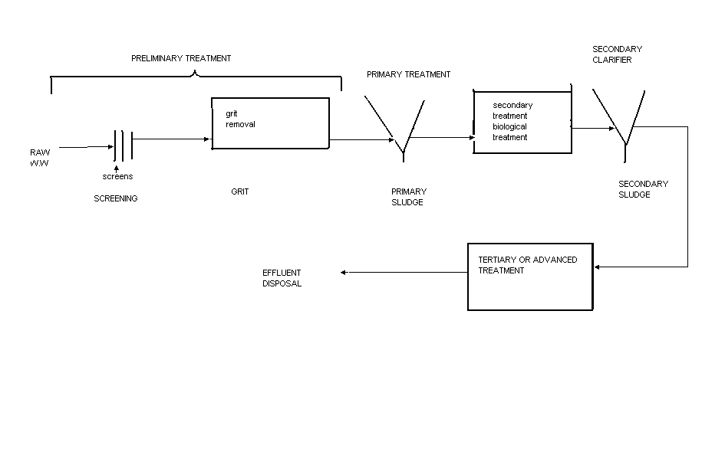

**Figure 1. General layout of a waste water treatment plant**

The treatment system can be classified into 5 stages.

1. **Preliminary treatment**

It is defined as the removal of waste water constituents that may cause maintainance or operational problems such as clogging or abrasion of mechanical equipment e.t.c. examples of preliminary operations are screening, removal of grit and removal of large quantities of oil and grease if present.

1. **Primary treatment**

Involves the removal of suspended solids which are separated as sludge. Primary treatment is usually accomplished with physical operations such as sedimentation tanks. This form of treatment removes up to 60% of the suspended solids and 35% of the B.O.Ds.

1. **Secondary treatment**

Sometimes referred to as biological treatment consists of the biological; conversion of organic matter into biomass which is subsequently removed by sedimentation.the dissolved and colloidal organic matter are oxidized by micro-organisms in the presence of oxygen. There are two main types of secondary treatment processes:

1. Activated sludge process
2. Trickling filter (biological filtration )

Secondary treatment processes can remove up to 90-95% B.O.D if properly designed and operated.

1. **Tertiary treatment or advanced waste water treatment**

Tertiary treatment is inexpensive. In most cases secondary treatment is sufficient to meet effluent standards but in some cases further treatment may be required if the waste water is being discharged into sensitive ecosystem e.g. a lake or enclosed bay. Tertiary treatment is the further treatment of a biologically treated effluent to remove constituents of concern such as nutrients, toxic compounds and also the removal of organic matter and suspended solids.

1. **Sludge treatment**

This is simply the treatment of sludge from primary and secondary clarifiers (sedimentation tanks)

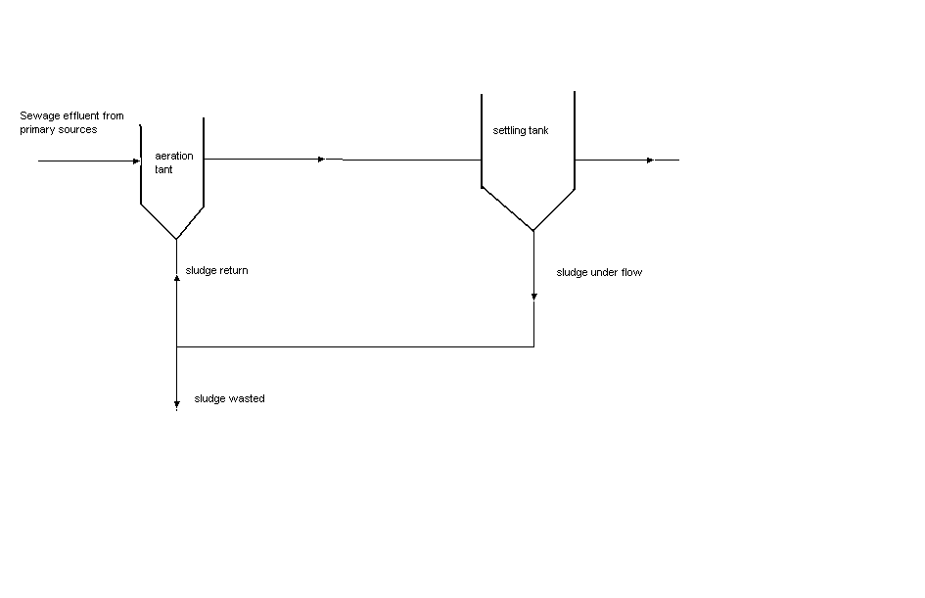

**figure 2. aActivated sludge process**

It consists of three basic units: an aeration tank, a settling tank and a sludge recycle line. The influent sewage and returned sewage are agitated and oxygen is bubbled through pressure to accelerate aerobic axidation of organic matter. It is expensive and sometimes difficult to maintain.

**THE TRICKLING FILTER (percolating filter, bio filter)**

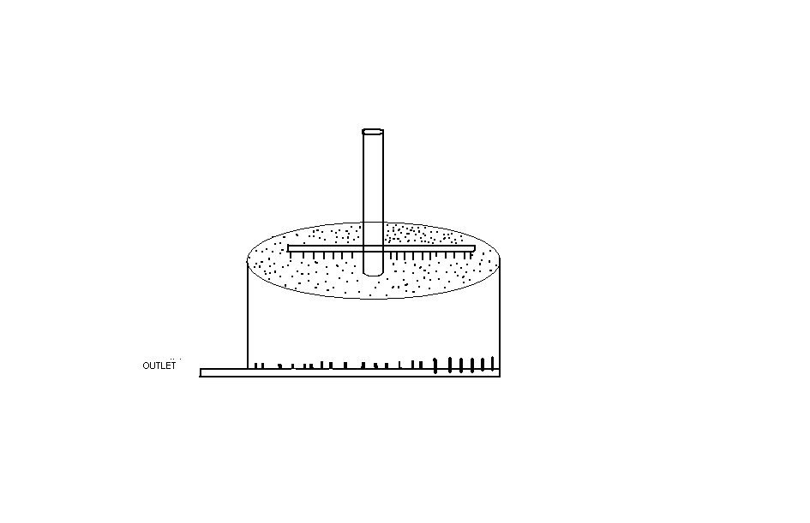

A trickling filter is a reactor of circular or rectangular plan which is filled with a permeable madia. The waste water is distributed mechanically over the media and percolates down to collect in an under drain system at its basement.a microbial film develops over the surface of the medium and this is responsible for the removal of B.O.D.

1. **OXIDATION DITCHES**

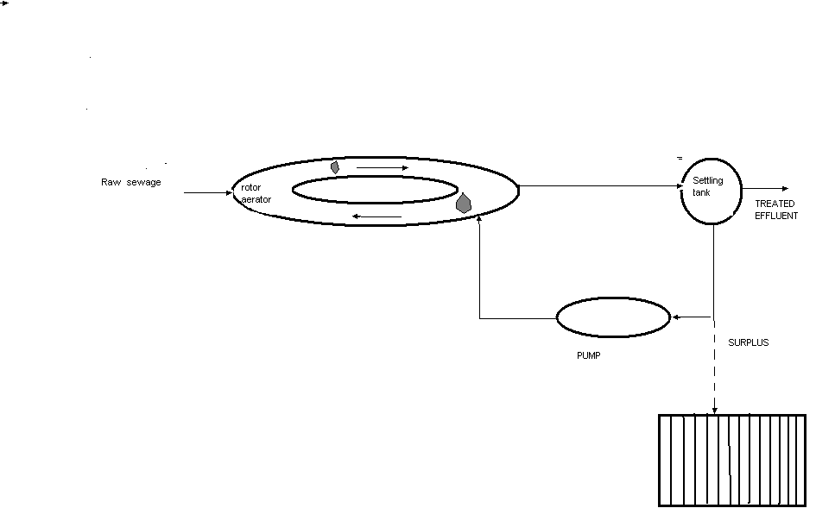

Figure 3. **OXIDATION DITCHES**

The oxidation ditch system consists of a shallow (1.5-2m) deep channel oval shaped. It is fitted with rotating cylindrical ‘brushes’ (aerators) which drive the waste water forward while at the same time providing intense turbulence. B.O.D reduction is typically good (15 mg/l.), but the bacterial removal is poor and the effluent must hence be discharged to a large body of water

1. **WASTE WATER STABILIZATION PONDS**

Waste water stabilization ponds are considered as low cost waste water treatment systems. Conventional sludge like activated sludge systems, trickling filters, e.t.c are expensive to install as well as to operate. They require skilled operation and supervision, good maintenance and constant input of mechanical energy (aeration, pumping costs ). On the other hand, low cost systems like WSP are simple to construct, have the least amount of mechanization and require little skilled supervision for operation. WSP coprise a series of shallow lakes through which sewage flows. Treatment occurs through natural, physical, chemical and biological processes and no machinery or energy input (except the sun ) is required.they are capable of producing very high-quality effluents (reduction of pathogenic organisms- 100 faecal coliform\100ml) the greatest disadvantage of WSP ponds is that they take up a lot of space. Usual requirement of a pond area is 0.3-0.4 ha\1000 persons. The ponds are usually constructed in series incooperating anaerobic, facultative and maturation ponds.

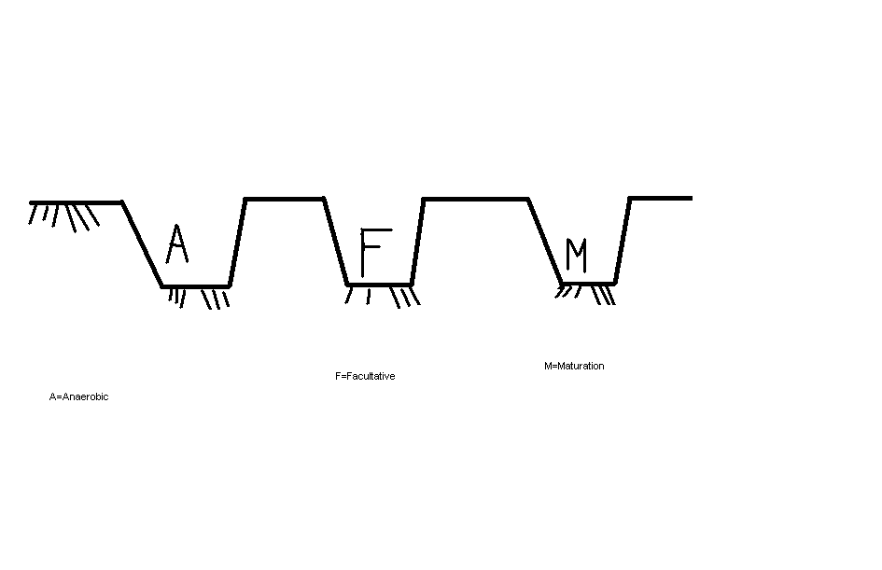

***Figure 4. Waste Stabilization Ponds***

1. **Anaerobic ; F- Facultative M- Maturation**
2. **Anaerobic Ponds**

* **Open septic tanksused to provide pretreatment of large volumes of strong waste water**
* **2-4cm deep**
* **Anaerobic digestion with a thick scum developing at the surface**
* **Retention period is 1-4days**

1. **Facultative Ponds**

* **Largest pond in the system**
* **Oxidation of organic matter takes place in the upper part of the pond, Oxygen provided by the photosynthetic algae**
* **Anaerobi digestion at the base**
* **1-2m deep**
* **Retention period 5 days**

**3) Maturation ponds**

* Wholly aerobic
* 1.0-1.5 m
* Remove the remaining BOD, Faecal Matter and viruse
* Retention perion is about 4 days
* Removes 90% faecal coliforms if rention period increase to 5-7 days

**PUBLIC HEALTH CONCERNS IN EXCRETA DISPOSAL/USE OF RAW SEWAGE**

* **Workers health- increased risk of contracting diarrhoeal diseases. Leptospirosis and intestinal worms.**
* **Agriculture re-use**
  + - **Indian study showed increase in diarrhoeal diseases. intestinal worms.**
    - **Fodder crops- infection from tubercle bacilli that causes TB**
    - **Irrigated Fodder – tansmit beef tapeworms**
    - **Fishing – pathogens adhere mechanically on the fish and then transmitted to people**

**Considerations in Planning a sanitation programme**

1. **Site and service schemes-municipalities**
2. **Squatter upgrading- Developer Viz-avis households**
3. **Choice of system- affected by a composite of technical, social, economic factors**
4. **Social Factors- Community’s cultural values**
5. **Cost**

**Is it affordable? + maintainance and operational costs**