**REPORT ON URBAN VISIT AT NAIROBI WATER AND SEWERAGE TREATMENT PLANT IN RUAI**

Contents

**1.** **INTRODUCTION** 3

**1.1 Background** 3

**2. Methodology** 4

**2.1 Study Design** 4

**2.2 Study site** 4

**2.3 Data Tools & Collection** 4

**2.4 Study Limitations** 5

**3. FINDINGS AND DISCUSSION** 5

**3.1 Physical phase** 5

**3.2 Biological phase** 6

**3.3 Laboratory analysis** 8

**4. Conclusion and Recommendations.** 8

1. **INTRODUCTION**

**1.1 Background**

Waste management are the activities and actions required to manage waste from its inception to its final disposal. This includes the collection, transport, treatment and disposal of waste, together with monitoring and regulation of the waste management process.

Waste can be solid, liquid, or gaseous and each type has different methods of disposal and management. Waste management deals with all types of waste, including industrial, biological and household.

In Kenya the disposal of waste water is tightly guided by various regulations stipulated by NEMA. The objective of the regulations is to prohibit discharge of effluent into the environment contrary to the established standards. The regulations further provides guidelines and standards for the discharge of poisons, toxins, noxious, radioactive waste or other pollutants into the environment in line with the Third Schedule of the regulations.

The regulations have standards for discharge of effluent into the sewer and aquatic environment. While it is the responsibility of the sewerage service providers to regulate discharges into sewer lines based on the given specifications, NEMA regulates discharge of all effluent into the environment.

No person shall discharge any effluent from sewage treatment works, industry or other point sources into the environment without a valid effluent discharge license issued by NEMA.

Once this waste water reaches the sewer lines, it is taken to various sewer treatment plants among them the Nairobi city council plant at Ruai.

Treatment of the sewage water can either be by biological method or physical method. The Ruai sewage treatment plan uses the biological method of sewage treatment and once the whole process is done, the treated water is channeled to the Nairobi River.

We were attached at the plant for half a day with the aim of practically learning and seeing the waste management and treatment process.

# **2. Methodology**

## **2.1 Study Design**

Our Study design was a simple Walk-through observation around the study site.

## **2.2 Study site**

Our study site was at the Nairobi City Water & Sewerage Plant. It is located along Kangundo Road in Ruai, Nairobi. The plant sits on 5000 acres of land but currently only utilizes 2000 acres. Most of the land is taken up by the vast treatment ponds, with the rest housing illegal settlements.

*Figure 1. Map Showing Nairobi Sewerage Treatment Works in Ruai*

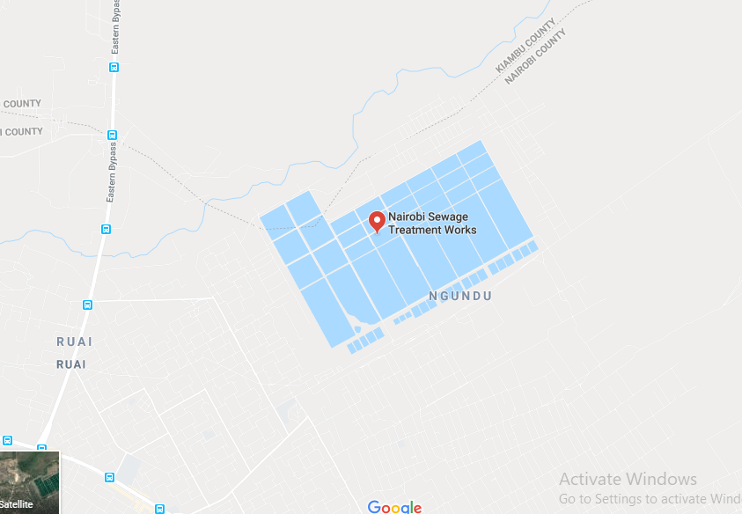

## **2.3 Data Tools & Collection**

The main mode of data collection during the excursion was a Key Informant Interview. Our informant was one of the resident lab technician at the plant. The technician guided us through the tour of the plant, stopping to answer questions and queries.

## **2.4 Study Limitations**

As this was a school-organized trip, the time spent here was limited to the time allocated for the excursion. The study site was also quite a distance from the campus, which ate into the time. Also, due to poor maintenance, a section of the treatment plant was not operational at the time of the study. This limited our actual view and understanding of the process.

# **3. FINDINGS AND DISCUSSION**

They had 90 employees. They have to employ casual laborers to clean the ponds.

They receive 80 to 100 thousand meters cubed of sewage from Nairobi county which covers 80% of the county, from both domestic and industrial sources.

The sewage treatment process is the biological oxidation ponds system which currently occupies 2000 acres of land and takes place in 2 phases;

* Physical phase
* Biological phase

## **3.1 Physical phase**

Incoming raw sewage

Cross bar (removes large solid waste which are then burnt)

Intermediate screen (removes smaller solid waste)

Cap screen (removes finer solid materials)

Grit trap (traps soil and sand particles)



Venturi (narrowed to increase pressure which speeds up water flow)

## **3.2 Biological phase**

There is a total of 55 ponds

Anaerobic pond

4.7 meters deep, 100 by 100 meters (deepest ponds)

Temperatures of 37degrees Celsius

Depth prevents oxygen from penetrating the water thus high, and there’s high production of methane gas hence bubbles are observed.

Treatment at this ponds takes 5 to 10 days and treated water is displaced by the incoming water. Material that is not broken down settles at the bottom of the pond and is known as sludge and is removed when it’s more than 50% of the ponds.

Facultative ponds

Measures 700 by 500 meters and depth of 1.7 meters (largest ponds)

The water is exposed to atmospheric oxygen. At the bottom of pond, there are anaerobic bacteria which also biodegrade organic material.

At the top, there’s aerobic bacteria.

At this stage, the water changes color from grey to green due to growth of algae.

This process takes 35days and water is displaced into the maturation pond.

Maturation ponds

1meter deep and 500 by 350 meters in dimensions. Treatment takes place in a series of 3 maturation ponds, takes 5 days in each pond thus a total of 15 days.

Fish (catfish and mud fish) survival in these ponds indicates that treatment is successful. There were also crocodiles and hippos.

The whole biological process takes 60 days after which the treated water is released to Nairobi river.

## **3.3 Laboratory analysis**

Sewage sampling is done every 24 hours. The pH, temperature and color of the treated sewage are taken and recorded.

The chemical analysis: Chlorides, ammonia, nitrates, sulphate, sulfite, nitrites, phosphate

Heavy metals analysis: 12 metals are analyzed eg. Lead, Mercury etc, presence of any of these is reported to Water Resource Management Authority(WRMA) which follow up with the industries responsible.

Sludge analysis: Analysis of the chemical content is done and if safe, it is sold to farmers as manure.

Fish analysis: Fish from the maturation ponds are analyzed??

Microbiology analysis: They partner with various organizations eg students from JKUAT to do a research on the microbiological content.

Food analysis: Food grown around the ponds is analyzed by various institutions eg KARI to check for their safety.

BOD: amount of Oxygen produced by the breakdown of organic material. The limit is 30mg/l.

COD: Amount of oxygen consumed during the breakdown of organic material.

# **4. Conclusion and Recommendations.**

The treatment plant is doing well considering the inadequate injection of funds for repairs being experienced. The personnel and staff who are currently employed are motivated and working despite the dilapidated conditions that persist. They continue to achieve their goal of treating Nairobi’s waste effluent before dumping it to the river.

We however recommend that the authorities concerned e.g. CEC for Environment in County government, work speedily to expedite the repair of machines for phase one treatment. The land belonging to the sewerage company should be fenced off from general public to avoid grabbing of land and to preserve their own safety from the hippos now living in the ponds

Efforts to expand should also be made so as to capitalize on the copious amounts of methane gas produced. Also, so expansion would allow for absolute treatment of water to make it safe for drinking, thus providing a stable source of water.