**UNIVERSITY OF NAIROB**

**COLLEGE OF HEALTH SCIENCES**

**DEPARTMENT OF OBSTETRICS AND GYNECOLOGY**

**BASIC GYNECOLOGY SKILLS FOR MBCHB V**

**By**

Dr Bosire Alex

**GYNECOLOGY SKILLS**

**Six Gynecology skills:**

1. Pap smear collection
2. VIA/VILI & Counseling for abnormal cervical screen result
3. High vagina swab & endocervical swab
4. Implant insertion/removal
5. IUCD insertion/removal
6. Bimanual examination for pelvic mass/adnexal mass

|  |  |  |
| --- | --- | --- |
| **I) PAP SMEAR COLLECTION** | | |
| **Definition and description:** Pap smear is one of the screening methods for cervical intra-epithelial lesions. It involves collection of cells from the squamo-columnar junction of the cervix, followed by cytology. | | |
| **Environment:** This is a clean procedure ,a Chaperon is required. | | |
| **Requirements and preparation for procedure:**  ***Requirements***   * Examining light * Bivalve speculum * Endocervical broom or Ayre spatula/ endocervical brush * Glass slide * Fixation solution * Pathology request form * Gloves * Cytology request form   ***Prepare patient***   * Counsel for procedure * LMP * Empty bladder | | |
| **Procedure Steps:**   1. Ask patient to lie on couch in lithotomy position 2. Introduce the bivalve speculum and expose the cervical os 3. Obtain cells from the squamo-columnar junction of the cervical os    * For endocervical broom, the central bristles are inserted into the endocervix while the outer bristles will be in contact with the ectocervix. Rotate the broom in the same direction five times    * For Ayre spatula and endocervical brush, start with the spatula to scrape the ectocervix, rotate the spatula 3600 once. Then insert the endocervical brush into the endocervix so that the bristles nearest the examiner are inserted to the level of the external cervical os, rotate the brush 180 degrees      + Start with spatula followed by brush to minimizes blood in the sample 4. Quickly spread the scrapings evenly on the glass slide and fix by dropping, a drop of the fixative solution or spray evenly and allow to air dry    * Speed is key to prevent drying of cells 5. Discard endocervical broom or spatula/brush in waste bin 6. Remove speculum and reposition patient 7. Complete pathology form for Pap smear cytology 8. Counsel and offer contraception 9. Thank client 10. Give return date for cytology result | | |
| ***Endocervical broom***  **http://extww02a.cardinal.com/us/en/distributedproducts/images/H/HW2195.jpg** | | ***Ayre spatula and endocervical brush***  **http://3.imimg.com/data3/UA/QV/MY-584355/endocervical-brush-with-spatula-500x500.jpg** |
| **POSSIBLE PAP SMEAR CYTOLOGY RESULT AND ACTION** | | |
| **The bethesda system-result** | **Action** | |
| * Normal | * Repeat every 3 years, * or 5 yearly if co-HPV DNA test done | |
| * Normal but HIV, immunosuppression, chronic corticosteroid use, hx of hysterectomy after early cervical cancer | * Every 6 months till after 24 months, then can do once every year. | |
| * Low grade squamous intraepithelial lesion (LSIL) * Atypical squamous cells of undetermined significance (ASC-US) (mild) | * Cellular changes could be bacterial vaginosis, counsel the px, treat with antibiotics then; * Repeat Pap smear in 6 months and can do HPV genotyping for type 16 &18. * If after repeat its still LSIL or HSIL, send for colposcopy * If 16, 18 +ve, do colposcopy * If 16,18 –ve, reassure her and let her come back | |
| * High grade squamous intraepithelial lesion (HSIL) * Recurrent LSIL * Atypical squamous cells – cannot exclude HSIL (ASC-H) * Atypical glandular cells of undetermined significance (AGUS) * Carcinoma in situ | * Colposcopy biopsy followed by possible cervical excision procedure by LEEP or cold knife cone | |
| * **? Invasive cancer** | * **Investigations to confirm diagnosis** | |
| ***Please Note: CIN classification is for cervical histology NOT cytology*** | | |

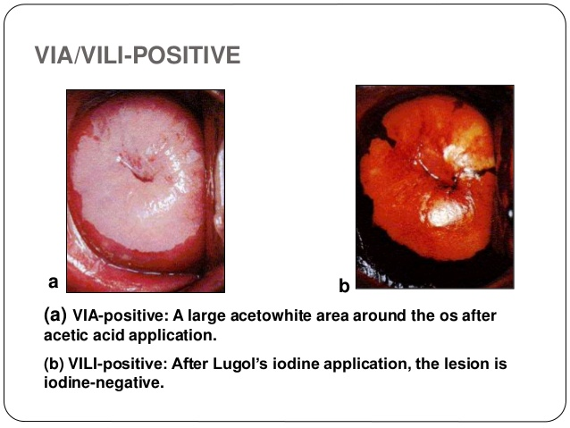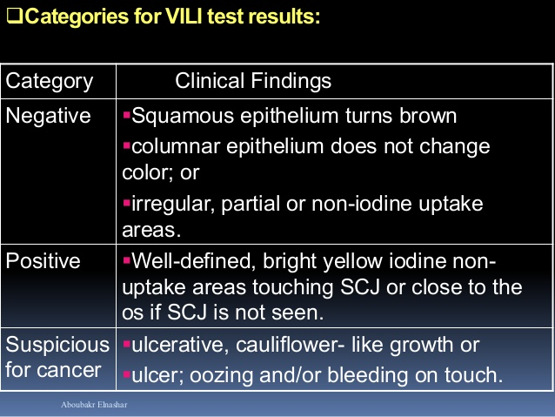

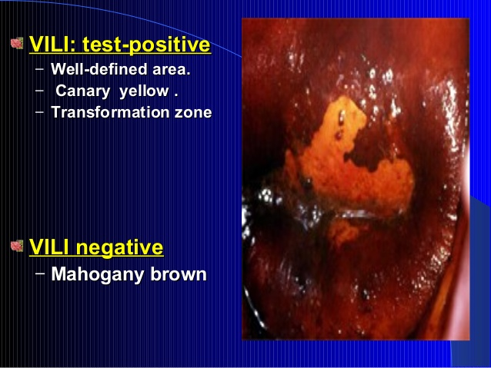 Category Clinical Findings
Negative No acetowhite lesions or
faint acetowhite lesions;
polyp,
cervicitis, inflammation,
Na...

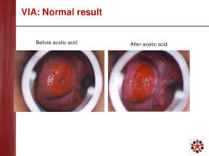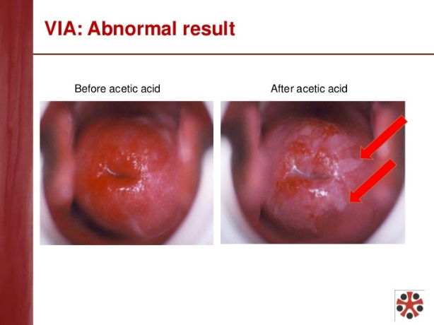

|  |
| --- |
| **II) VISUAL INSPECTION WITH ACETIC ACID AND LUGOLS IODINE (VIA/VILI)** |
| **Indication for procedure:** Screening of cancer of the cervix |
| **Requirements**  ***Supplies***   * 1. 2 gallipots   2. 3-5% acetic acid   3. Lugols iodine in tightly stoppered brown bottle, within 30 days of preparation – light destroys lugols   4. Different sizes of cotton swabs mounted in an applicator sticks   5. Bivalve speculum   6. K-Y gel   7. Clean gloves   8. Infection prevention supplies   9. Documentation form   ***Equipment***   1. Gynecology couch that can offer adequate lithotomy 2. Examining light: white light that can be easily manipulated 3. Instrument and supplies tray/surface   **Arrange the instrument and supplies tray/surface**   1. Arrange all the required instruments and supplies on the tray 2. Do not pour the acetic acid and lugols iodine to the gallipot until the patient is positioned in the lithotomy position    * This is especially for lugols iodine because it gets destroyed by light and it easily evaporates |
| **Preparation for procedure:**   1. Greet the client 2. Reestablish why she wants the test to be done 3. Describe the VIA/VILI and cryotherapy procedure 4. Tell the woman what the findings might be and what follow-up treatment might be necessary 5. Take a reproductive health history: age, parity, LMP, menstrual pattern, if pregnant, contraceptive use 6. Ask about breast exam 7. Check eligibility for VIA/VILI:    * Menopausal women are not eligible for VIA/VILI because the transformation zone is in the endocervix: Do Pap smear or refer    * LMP: If pregnant, screening can be done up to 20 weeks gestation    * Postnatal women: screening is done from the 6th postnatal visit 8. Ask the client to empty bladder 9. Put on an examination apron 10. Ask the woman to undress from the waist down, to remove her underwear, and to pull her dress up 11. Assist to the examination couch and position her to the lithotomy position gently 12. Chaperon needed |
| **Procedure Steps:**   1. Clean hands with a hand sanitizer or water and soap 2. Put on gloves 3. Pour enough for one client of acetic acid and lugols iodine to the gallipots 4. Inform the woman that you are commencing the procedure 5. Start by inspecting the external genitalia for: papules, vesicles, ulceration, warts, discharge, masses and swelling in the inguinal/femoral area 6. Apply K-y gel to the speculum 7. Tell the woman she will feel some pressure 8. Slowly and carefully insert speculum without scraping the cervix; adjust so that the whole cervix is centralized and in view 9. Adjust light to ensure a clear view of the cervix 10. Before applying the acetic acid, look for signs of infection     * Inflamed cervix or vaginal wall     * Greenish-yellow or mucopurulent discharge from the cervical os     * Thick, white, curdy vaginal discharge     * Milky-grey, foul-smelling discharge 11. Start by doing the VIA procedure     * Use a dry cotton swab to wipe away any discharge, blood, or mucus from the cervix very gently to avoid causing bleeing     * Apply 3-5% acetic acid liberally using a cotton mounted swab, ensure the swab covers the entire transformation zone completely     * Tell the woman she might feel a slight burning sensation     * Wait one full minute for the acetic acid to be absorbed (use a watch)     * Check the TZ carefully, close to the squaomocolumnar junction, for any dense, non-moveable acetowhite areas in the epithelium or areas suspicious for cancer     * Interpret the result, which can be VIA negative or VIA positive or suspicious for cancer     * Remove any remaining acetic acid using a dry cotton ball 12. Followed by the VILI procedures     * Use a fresh lugols iodine for each patient-light destroys lugols     * Apply lugols iodine liberally using a cotton mounted swab, ensure the swab covers the entire transformation zone completely     * Check the TZ carefully, close to the squaomocolumnar junction, for any banana yellow lesions in the epithelium or areas suspicious for cancer     * Interpret the result, which can be VILI negative or VILI positive or suspicious for cancer     * Remove any remaining lugols iodine using a dry cotton ball 13. Digital examination     * If there are signs of infection     * Remove the speculum gently while inspecting the vaginal walls for any abnormalities or lesions     * Perform a digital examination, explain to the women before starting the procedure       + Perform a bimanual examination –check for cervical motion tenderness, size shape and position of uterus, any uterine abnormality or adnexal mass or tenderness 14. Explain to the patient that the procedure is complete 15. Remove the speculum gently while inspecting the vaginal walls for any abnormalities or lesions 16. Wipe off any remaining k-gel or discharge 17. Reposition patient make her comfortable 18. Dispose waste and decontaminate equipment as per the infection prevention principals 19. Counsel the client on the result     * VIA/VILI       + If normal, repeat screen yearly for 2 years then every 3 years, but if HIV positive every year       + Positive: if cryotherapy done see net bullet, if not refer       + Suspicious for cancer: refer for diagnosis and management in a tertiary facility       + Infection: treat infection and the partners 20. Counsel and offer contraception or breast examination 21. Thank client and give a return date |

|  |
| --- |
| **III) COUNSELING FOR ABNORMAL CERVICAL SCREEN RESULT** |
| **Procedure Steps:**   1. Greet patient, introduce self, sit squarely, open posture, leans forward, eye contact, relax and explain the following to the patient in lay language 2. Cancer of the cervix is caused by HPV 3. Cancer of the cervix is presided by a pre-cancer stage, with cell abnormalities. Counselling depends on test 4. Pap smear results is reported as normal, mild cell abnormalities (LSIL), severe cell abnormalities (HSIL, ASCUS, ASC-H, AGUS) or suspicion for invasive cancer    * Normal results means there were no abnormal cells seen    * Mild and severe cell abnormalities are precancerous stages and not cancer    * Suspicious for invasive cancer means cancer of the cervix is likely    * If normal another Pap smear test will be done after 1 year for 3 years, if all 3 will be normal then Pap smear will be done after 5 years (yearly in HIV +)    * If mild cell abnormalities, a repeat Pap smear will be done after 6 months    * If severe cell abnormalities colposcopy then treatment will be offered: i) excision of abnormal cells (LEEP or Cold knife cone) or ii) simple hysterectomy. Counselling on the two options will be done to enable you make a choice    * If suspicious for invasive cancer more diagnostic test will be performed to confirm diagnosis    * Allow patient to ask questions    * Thank patient for their time 5. VIA/VILI results is reported as negative, positive and suspicious for invasive cancer    * Normal means there are no abnormal cells    * A positive result is a precancerous stage and not cancer    * Suspicious for cancer means cancer of the cervix is likely    * If normal a repeat VIA/VILI will be done in 3 years (yearly in HIV +)    * For positive result treatment can be done by freezing the abnormal cell (cryotherapy) or doing colposcopy biopsy (using a microscope to visualize abnormal cells and take small tissue for investigations), if biopsy shows abnormal cells treatment will be offered depending on result    * If suspicious for cancer more diagnostic test will be performed to confirm diagnosis    * Allow patient to ask questions    * Thank patient for their time |

|  |
| --- |
| **IV a) IMPLANT INSERTION- JADELLE LEVONORGESTREL SUBDERMAL IMPLANT** |
| **Requirements and preparation for procedure:**   1. **Prepare requirements:**    * Table for the patient to lie on and rest for her arm    * Sterile drape with fenestration    * Sterile tray for the equipment    * Sterile gloves    * Sterile Gauze    * Antiseptic solution for the skin    * Local anaesthetic -1% lidocaine    * Needle gauge 21 and 5 ml syringe    * Jadelle, diposable trocar and cannula    * Elastoplast 2. Prepare patient:    * Counsel client for the method    * Explain the procedure    * Explain that the implant will be inserted in the less dominant arm    * Ask client to lie on her back so that implant arm is turned outwards and bent at the elbow and is well supported, insertion area is in the inner aspect of the upper arm, avoiding the sulcus (groove) between the biceps and triceps due to the neurovascular bundle, about 8-10 cm above the (humeral medial epicondyle) fold in the elbow (measure using your four palm fingers- to be demonstrated) |
| **Procedure Steps:**   1. Prepare clean instrument tray, open sterile instrument pack, open jadelle pouch and drop the rods 2. Wear sterile gloves, clean the insertion area and drape aseptically 3. Infiltrate the local anesthetic under the skin slowly withdrawing to avoid intravascular infiltration. Start by infiltrating the needle entry point to form a small wheal 4. Introduce the trocar under the skin up to the 1st mark with bevel facing up   Image result for jadelle   1. Advance the trocar horizontally under the skin (subdermally) until the 2nd mark 2. Remove cannula 3. Insert 1st rod into the trocar and load it with the cannula by holding the cannula steady and pulling the trocar out up to the level of the 1st mark on the cannula 4. Repeat above and insert 2nd rod in a narrow V shape 5. Remove trocar and cannula 6. Press edges of insertion together and dress with Elastoplast and compress with wrap gauze 7. Check the two rods by cautious palpation, ask the patient to palpate too 8. Answer any questions the client may have, give a return date and thank them |

|  |
| --- |
| **IVb) IMPLANT REMOVAL- JADELLE** |
| **Requirements and preparation for procedure:**   1. **Prepare requirements:**    * Table for the patient to lie on and rest for her arm    * Sterile drape with fenestration and sterile tray for the equipment    * Sterile gloves    * Sterile Gauze    * Antiseptic solution for the skin    * Local anaesthetic -1% lidocaine    * Needle and 5 ml syringe    * 2 mosquito forceps-curved and straight    * Scalpel 22 mm    * Elastoplast 2. **Prepare patient:** counsel on removal, find out if needs the same method or another method or desires to get pregnant, ask client to lie on her back so that implant arm is turned outwards and bent at the elbow and locate the implants 3. Prepare clean instrument tray, open sterile instrument pack |
| **Procedure Steps:**   1. Wear sterile gloves, clean the insertion area and drape aseptically 2. Infiltrate the local anesthetic under the implants 3. Make a 4-mm incision with the scalpel close to the ends of the implants. Keep the incision small 4. Push each implant with your fingers gently towards the incision. When the tip is visible in the incision, grasp it with the curved mosquito forceps. Use a scalpel to very gently open the tissue capsule around the implant 5. Grasp the end of the implant with the second straight forceps 6. Remove the implant gently 7. Repeat the procedure for the second implant 8. Measure the length of the removed implants- the length should be 43 mm 9. After the procedure is completed, close the incision and bandage it as after insertion 10. Show the patient the implants 11. Offer another contraceptive if needed, if jadell reinsert into the same location 12. The arm should be kept dry for about 3 days 13. Answer any questions the client may have, give a return date and thank them |

|  |
| --- |
| **V a: IUCD INSERTION** |
| **Requirements and preparation for procedure:**   1. Prepare requirements: Examining light, Copper T IUCD, Bivalve speculum, Tenaculum, Uterine sound, Sponge holding forceps, Scissors, Sterile gauze, Sterile gloves, Sterile drapes, K-Y gel , Antiseptic solution 2. Prepare patient: counsel for the procedure, LMP, empty bladder, lithotomy position, chaperon needed |
| **Procedure Steps:**   1. Conduct bimanual and speculum pelvic examination to: Screen for eligibility and determine the position of the uterus, rule out infection 2. Sound the uterus:    * Clean the cervix with an antiseptic solution    * Apply a tenaculum to the cervix at 12 o'clock    * Gently pull the tenaculum to align the uterus and cervical opening    * Insert the uterine sound into the cervical opening    * Advance the sound into the uterine cavity until a slight resistance is felt, mark length with sponge holding forceps    * Slowly withdraw the sound and assess the uterine length 3. Load the IUCD:    * Load the IUCD by folding its arms and placing them inside the insertion tube    * Set the depth-gauge to reflect the uterine length as measured by the uterine sound    * Align the depth-gauge and the folded arms of the T so that they are both in a horizontal plane 4. Remove the loaded IUCD from the package, keeping it level 5. Insert IUD to the uterine cavity:    * Gently grasp the tenaculum (still in place from sounding the uterus) and apply gentle traction    * Insert the loaded IUCD, without touching vaginal walls or speculum blades, keeping the horizontal plane    * Gently advance the loaded IUCD into the uterine cavity    * STOP when the depth-gauge comes in contact with the cervix or light resistance is felt    * Hold the tenaculum and white plunger rod stationary, while partially withdrawing the insertion tube - this releases the arms of the IUCD    * Gently push the insertion tube until you feel a slight resistance - this step ensures placement high in the uterus    * Remove the white plunger rod, while holding the insertion tube stationary    * Gently and slowly withdraw the inserter tube from the cervical canal until strings can be seen protruding from the cervical opening    * Use sharp Mayo scissors to cut the IUCD strings at 3–4 cm from the cervical opening    * Completely withdraw insertion tube with cut ends of strings inside 6. Gently remove the tenaculum 7. Observe the cervix for bleeding and remove speculum 8. Reposition patient and make her comfortable 9. Counsel woman on checking of strings, complications and give return date 10. Thank her for her time |

|  |
| --- |
| **V b: IUCD Removal** |
| **Requirements and preparation for procedure:**   1. **Prepare requirements:**     * Examining light    * Bivalve speculum    * Sponge holding forceps    * Sterile gauze    * Sterile gloves    * Sterile drapes    * K-Y gel    * Antiseptic solution 2. **Prepare patient:** counsel for the procedure, LMP, empty bladder, lithotomy position, chaperon needed |
| **Procedure Steps:**   1. Conduct bimanual pelvic exam 2. Insert the speculum : Look for the length and position of strings 3. Swab cervix and vagina with antiseptic 4. Grasp strings close to the cervix and pull gently but firmly to remove IUCD 5. Refer difficult removals 6. Insert a new IUD immediately following removal (if desired) or offer another method 7. Remove speculum 8. Reposition patient 9. Thank the patient |

|  |
| --- |
| **VI: BIMANUAL PELVIC EXAMINATION** |
| **Requirements and preparation for procedure:**   1. **Prepare Requirements**    * Gloves    * K-Y gel    * Gauze or tissue paper 2. **Prepare patient:**    * Great and introduce self to patient    * Explain the procedure    * Ask her to empty bladder    * Chaperon required    * Position the patient in lithotomy position and expose from waist downwards |
| **Procedure Steps:**   1. Put on gloves 2. If right handed: lubricate index finger and middle fingers of right hand, and explain to the patient that you are about to start the procedure 3. Using the thumb and index finger of the left hand, separate the labia majora then insert the index finger followed by the middle finger into the introitus and advance to the cervix 4. Palpate the vaginal walls as you advance the fingers for obvious abnormalities 5. Using finger tips palpate the cervix: feel for size, shape, mobility and observe for tenderness 6. Bimanually palpate the uterus by pressing it between the right and middle index fingers on the cervix and with your left hand placed on the lower abdomen. At this point feel for any masses 7. Bimanually Palpate the left and right adnexa: note masses and tenderness 8. Note uterine masses will move the cervix during bimanual exam while adnexal masses wont 9. Remove fingers, check glove for discharge/blood 10. Wipe the patient’s perineum 11. Remove gloves and dispose gloves 12. Reposition patient and make her comfortable 13. Thank the patient |

|  |
| --- |
| **VII: High Vaginal Swab** |
| **Requirements and preparation for procedure:**   1. **Prepare Requirements**    * Gloves    * K-Y gel    * Sterile speculum    * HVS swab kit 2. **Prepare patient:**    * Great and introduce self to patient    * Explain the procedure    * Ask her to empty bladder    * Chaperon required    * Position the patient in lithotomy position and expose from waist downwards |
| **Procedure Steps:**   1. Put on gloves 2. lubricate the speculum with lubricating jelly and explain to the patient that you are about to start the procedure 3. Using the thumb and index finger of the left hand, separate the labia majora then insert the speculum at an angle into the introitus and advance to the cervix 4. Once 2-3 cm into the vagina rotate the speculum slowly into vertical position. Push the speculum gently up to the area of resistance 5. Open the speculum to identify the cervix. You can ask the patient to cough if the cervix is not properly identified. This helps bring the cervix into view 6. Open the hvs swab and take a sample from the posterior fornix 7. Place the collected swab into the properly labeled specimen container 8. Remove speculum 9. Wipe the patient’s perineum 10. Remove gloves and dispose gloves 11. Reposition patient and make her comfortable 12. Thank the patient |

|  |  |  |
| --- | --- | --- |
| **GYNECOLOGY SKILLS** | | |
|  | **Manual Vacuum aspiration** | 1. MVA kit + cannula 2. Sponge holding forceps 3. Tenaculum 4. Speculum 5. Dilators 6. 10 ml syringe 7. Needle gauge 21-green 8. Kidney dish 9. Gyn pelvic model with open cervix 10. Drapes |
|  | **Pap smear collection** | 1. Bivalve speculum 2. Spatula/Pap smear brush 3. Glass slide 4. Fixation solution 5. Pathology request form 6. Gyn Pelvic model with closed cervix |
|  | **VIA/VILI** | 1. Bivalve speculum 2. 2 gallipots 3. 3-5% acetic acid 4. Lugols iodine 5. Cotton swabs 6. K-Y gel 7. Clean gloves 8. cervicograms 9. Documentation form 10. Gyn Pelvic model with closed cervix |
|  | Counselling for abnormal cervical screen result | None they will roll play |
|  | Implant insertion/removal | **Insertion**   * Arm model * Trocar and cannula * Sterile gauze * 5cc syringe * Lidocaine 1% * Two needles gauge 21 * Elastoplast * Sterile drapes * Gloves * Earbuds with ends cut off   **Removal**   * Arm model * 2 Mosquito artery forceps * Sterile scalpel * Sterile gauze * 5cc syringe * Lidocaine 1% * Two needles * Elestoplast * Sterile drapes * Gloves * Earbuds with ends cut off |
|  | IUCD insertion/removal | **Insertion**   * Copper T * Sponge holding forceps * Bivalve speculum * Sterile drapes * Tenaculum * Uterine sounds * Sharp Mayo scissor * Antiseptic solution * Sterile gauze * K-Y gel * Sterile gloves * Pelvic model for IUCD   **Removal**   * Sponge holding forceps * Bivalve speculum * Sterile drapes * Antiseptic solution * Sterile gauze * K-Y gel * Sterile gloves * Pelvic model for IUCD |
|  | Scrubbing/Gowning/Gloving, Abdominal draping and incisions | **Scrubbing**   * Demo   **Gowning**   * Gown * Gloves   **Abdominal draping**   * Drapes * Abdominal model |
|  | Ectopic Pregnancy- salpingectomy, catheterization & IV access | **Ectopic Pregnancy-clamping of ovarian pedicle**   * Uterine model with fallopian tube * Giving set -tube * Vicryl 2-0 or 3-0 * Needle holder * None tooth forceps   **Female urethral Catheterization**   * Catheterization pack: kidney dish, gallipot, sterile towel, cotton balls * Foleys catheter size 12-14 * Urine bag * Saline * Sterile gloves * K-Y gel * 10ml saline filled syringe   **IV access**   * Alcohol swab * Gloves * Disposable tourniquet * IV cannula * Plaster * Syringe * Normal saline * Sharps disposal * Alcohol sanitizer for hand washing * Arm model for cannula insertion |
|  | High vagina swab & endocervical swab | * Sterile gloves * K-Y gel * Sterile bivalve speculum * Swabs for HVS * Examining light * Pelvic model |
|  | Bimanual examination for pelvic mass/adnexal mass | * Gloves * K-Y gel * Gauze or tissue paper * Pelvic model for bimanual exam |