Emergency Psychiatry

04 May 1994

10:03

Suicide

Suicide is the act or instance of taking one's own life voluntarily & intentionally (the legalistic concept of suicide while of sound mind, which psychiatrically speaking is not possible)

Risk Factors

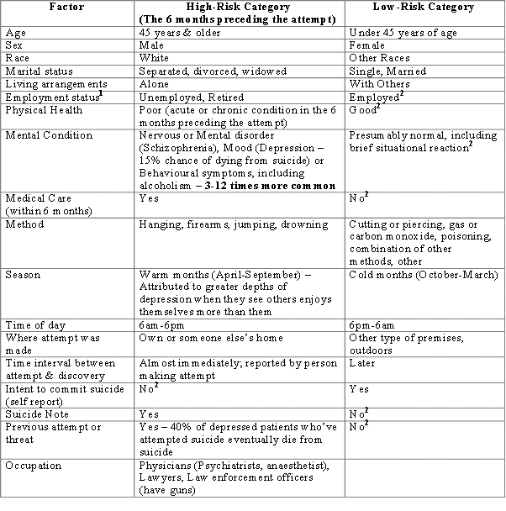

1 Does Not include homemakers & students

2 Includes cases for which information on this factor was not given in the police report

Types;
- Successful suicide;
  - M:F - 3:1
  - ↑ with advancing age
  - Persons who are not married and in those who are isolated, uprooted, or lonely
  - Protestants > Catholics or Jews
  - Foreign-born immigrants
  - Commonly used means in Kenya;
    - Organophosphate poisoning
    - Drugs e.g. Chloroquine (commonly used to induce abortion)
    - Violent methods e.g. guns
    - Jumping from heights - in urban areas
  - Men>women to commit suicide by violent means
- Unsuccessful suicide attempts;
  - M:F - 1:3
  - 20-24 years
  - Involve nonviolent means, such as cutting, poisoning, or carbon monoxide

Suicide in Adolescence

One of the leading cause of death among 15- to 24-year-olds.

Rise in the suicide rates among adolescents may result in part from;
- Changes in our society, including child-rearing practices and loss of stability in the home
- Parental divorce
- Antisocial behaviour
- Substance abuse

Symptoms such as social withdrawal, preoccupation with bizarre ideas, or decline in academic performance may precede a suicide attempt in an adolescent suffering from early symptoms of schizophrenia.

Clues to Suicide

People who are contemplating suicide often provide clues that must be carefully assessed;
- Verbal Clues: The individual may sometimes make direct or indirect statements about wanting to die or "end it all."
- Behavioural Clues: A direct behavioural clue is ingestion of a small amount of some potentially lethal drug. Prematurely or inappropriately "putting one's affairs in order," arranging for a casket, and giving away prized possessions are indirect clues.
- Situational Clues: Situational clues are inherent in life experiences associated with major stress, e.g., an impending surgical procedure, a diagnosis of chronic fatal illness, or a recent loss--the death of a loved one, loss of a job, eviction, retirement, etc.
- Syndromic Clues: Syndromic clues are certain constellations of emotions that are commonly associated with suicide. Depression is the most common one, but there are others. Suicide also occurs in people who are not depressed but are disoriented--e.g., in acute delirium, suicidal behaviour may be an attempt to flee some imagined threat. Individuals with psychotic disorders associated with impaired impulse control may attempt suicide in response to hallucinations commanding them to do so. Suicide also occurs in defiant people, who may view suicide as a means of taking an active, resistive stance in the face of some real or imagined threat to their self-esteem. Suicide by a dependent, dissatisfied individual is often a masked hostile gesture toward some other individual or group perceived as not having fulfilled dependency needs. ("Now you'll feel sorry!")

Assessing the risk of Suicide

The physician must regard suicide attempts or verbalized suicidal thoughts as emergencies, since even so-called "hysterical" and "manipulative" patients may succeed in self-destructive acts.

A number of factors influence the assessment of suicide risk:
- The patient's usual level of functioning
- Past history of suicide attempts and mental illness
- Current social and economic circumstances,
- Cognitive/affective state

Suicide Prevention

Astute observation can almost always uncover clues to suicidal intentions.

Those in high-risk categories should be hospitalized. In doubtful cases, the decision about hospitalization is based on the physician's assessment of the adequacy of the patient's external support system and the integrity of the patient's impulse control mechanism. Lack of an effective support system and poor impulse control in patients otherwise at low risk for suicide may call for hospitalization.

People with suicidal ideas should not be offered the means of acting on them. When such a patient is hospitalized with suicide precautions, there should be no access to an unsecured window, stairwell, etc. Potential instruments of suicide such as shoelaces, belts, coat hangers, caustic cleansers, and cutlery should be kept from the patient. Some patients need constant close observation.

