**UNIVERSITY OF NAIROBI**

**SCHOOL OF MEDICINE**

**DEPARTMENT OF PSYCHIATRY**

**Monday 8th February, 2010 Dr. Kang’ethe Kuria**

**HUMAN INTELLIGENCE**

**What is Intelligence?**

* There is no agreed upon definition
* Ability to think abstractly which is a narrow definition
* Ability to learn? (This is just based on scores on tests not related to the rate/speed of learning new things)
* Ability to adapt to the environment is a broad definition

Intelligence can be defined as a combination of mental competencies and potentialities that includes the ability to;

* Ability to learn from experience
* Apply this knowledge
* Formulate new understandings and
* Construct solutions to novel problems encountered in new challenging situations (Vessels, 2004)

**Intelligence**

Although we all think intelligently, intelligence is hard to define. Some theorists believe that a general ability (g factor) underlies the many specific abilities tapped by intelligence tests whereas others do not

The traditional approach to intelligence, the psychometric approach focuses on how well people perform on standardized aptitude tests. The intelligence quotient or IQ represents how a person has done on an intelligence test, compared to other people

**Psychometric Approach**

* A theoretical perspective that portrays intelligence as a train (or set of traits) on which individuals differ; psychometric theorists are responsible for the development of standardized intelligence tests.

**Dissecting Intelligence: The Cognitive Approach**

* In contrast to the psychometric approach, cognitive approaches to intelligence emphasize several kinds of intelligence and the strategies people use to solve problems, not merely whether they get the right answers.

**Intelligence**

* Intelligence is a set of cognitive abilities
* What comprises intelligence varies with culture
* Theories of intelligence vary widely;
* Spearman: single general ability (g)
* Multiple cognitive abilities
* Cattel: two types of intelligence
* Fluid: Ability to gain new knowledge and solve problems
* Crystallized: accumulated knowledge
* Thurstone proposed that intelligence is a function of seven cognitive abilities
* Sternberg proposed three aspects of intelligence
* Gardner argued for eight distinct types of intelligence

**Charles Spearman**

* Noted that when children were subjected to several different cognitive tests, there weresubjected to several different cognitive test, there were moderate correlations in their performance. Spearman speculated that there must be a general mental factor that explained the consistent performance (g).
* Spearman also noted that there are certain inconsistencies regarding performance in certain areas. He speculated that there were specialized traits that denoted this occurrence (s).

**Spearman’s Intelligence**

* G-factor; intelligence consists of general intelligence
* S – factor; intelligence consists of specific, cognitive skills

**Louis Thurstone**

* Expanded spearman’s theory
* Analyzed 50 mental tests administered to 8-graders and college students. As a result, he came up with seven factors called primary mental abilities which made up Spearman’s g:

**Thurstone Primary Mental Abilities**

* Spatial
* Perceptual speed
* Number
* Verbal meaning
* Word fluency
* Memory
* Inductive reasoning

**Raymond Cattel and John Horn**

* Proposed Spearman’s g and Thurstone’s primary mental abilities can be reduced to two major dimensions of intellect. Fluid and crystallized
* **Fluid intelligence**: The ability to perceive relationships and solve relational problems of the type that are not taught and are relatively free of cultural influences.
* **Crystallized intelligence**: The ability to understand relations or solve problems that depend on knowledge acquired from schooling and other cultural influences

**Fluid versus Crystallized Intelligence**

* Fluid: Refers to mental processes rather than specific information (declines with age)
* Crystallized: A person’s knowledge base (increases with age)

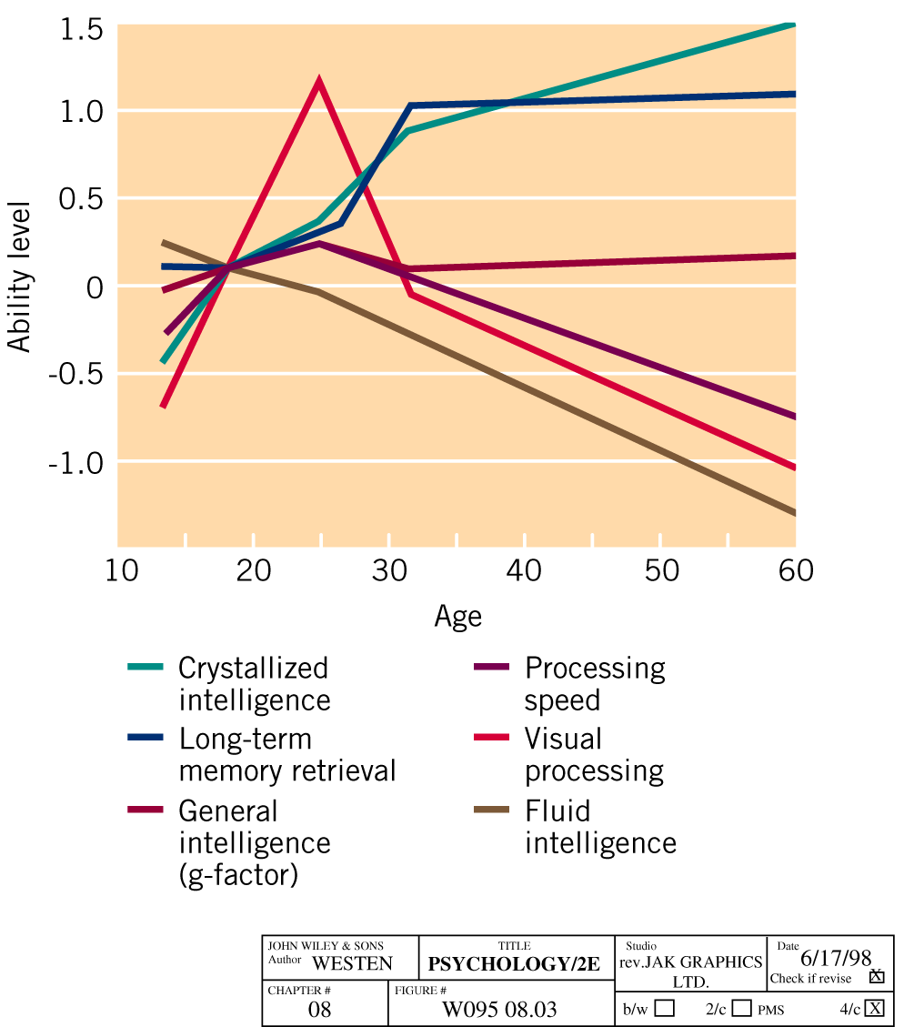

**Sternberg’s Triarchic theory of intelligence**

* Sternberg’s triarchic theory of intelligence proposes three aspects of intelligence; componential (including metacognition), experiental and contextual
* Contextual intelligence allows you to acquire tacit knowledge, practical strategies that are important for success in your personal life, at school, and on the job.
* The theory also emphasizes the importance of *tacit knowledge*, which is important in an individual’s personal and occupational success.

**Theories of Multiple Intelligence: Sternberg’s Triarchic Model**

* Sternberg proposes that intelligence is comprised of three fundamental aspects:
* Factors related to the internal world of the individual e.g. executive processes, performance and problem solving or knowledge acquisition components
* Factors relating to the external world e.g. how we adapt to the external world, how we shape our environment to suit our needs, how we select new environments
* Factors related to experience e.g. difficult tasks may become easy with practice so experience shapes intellectual functioning

**Sternberg’s Triarchic Intelligence Theory**

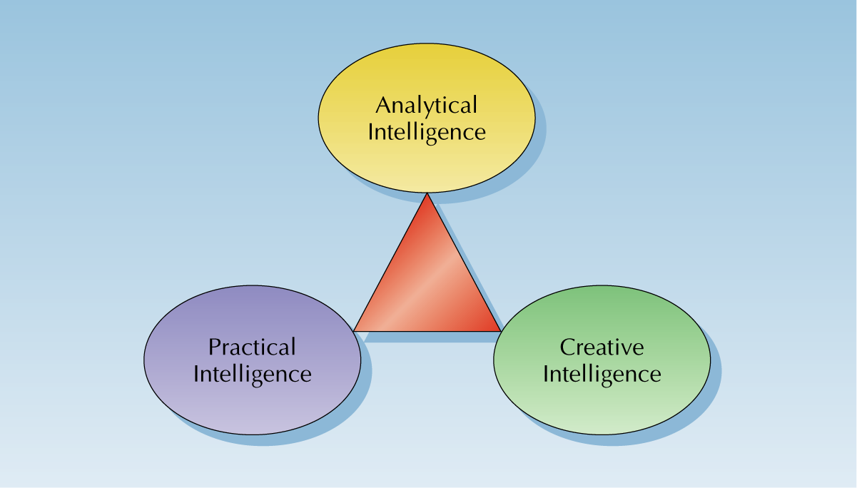

**Gardner’s View of Intelligence**

Gardner argues for atleast 7 different intelligences;

* Musical
* Bodily/kinesthetic
* Spatial
* Verbal
* Logical/mathermatical
* Intra-personal intelligence
* Social

**Howard Gardner’s Eight Intelligences**

|  |  |
| --- | --- |
| **Type of Intelligence** | **Description** |
| Linguistic intelligence | Word smart |
| Logical mathematical intelligence | Number/reasoning smart |
| Spatial intelligence | Picture smart |
| Bodily – kinesthetic intelligence | Body smart |
| Musical intelligence | Music smart |
| Interpersonal intelligence | People smart |
| Intrapersonal intelligence | Self smart |
| Naturalist intelligence | Nature smart |

**Gardner’s Multiple Intelligences Model**

Gardner’s criteria for acceptance as a distinct form of intelligence:

* Potential localization in the brain via brain damage cases;
* Existence of individuals who display the form of intelligence to an exceptional degree;
* An identifiable set of core operations such as the detection of relationships among musical tones;
* A regular developmental progression by way of experience beginning with novice and resulting in mastery;
* An evolutionary history wherein increases in intelligence can be associated with better adaptation to the natural environment;
* Supportive evidence from psychometric tests showing intelligence systems or clusters of abilities (e.g. visual spatial vs. verbal skills);
* Supportive evidence from cognitive psychology showing cross-task performance strengths or information processing strengths (e.g. mental rotation, recall of visual spatial images);
* Possible or actual encoding in a symbol system (e.g. linguistics, math, dance, athletics, music).

**Information Processing Viewpoint**

* Argue that the psychomatic focuses only on what the individual knows (intellectual content) rather that the processes by which this knowledge is acquired, retained and used to solve problems
* In addition, traditional intelligence researchers do not measure other attributes we commonly think of as intelligence (common sense, social and interpersonal skills and talents that underlie creative accomplishments in music, drama and athletics)

**Measuring Intelligence**

**Franz Gall**

* Proposed that measurements of the size and shape of an individual’s skull could be used to estimate an individual’s intelligence; this proposal failed

**Sir Francis Galton**

* Measure intelligence through reaction times
* Initiated the debate over measure of intelligence and whether it is predominantly the result of hereditary or the environment

**Intelligence Tests**

This is general mental ability and the tests measure intellectual potential

**Approaches to Intelligence**

* Psychometric approach: Statistical techniques are used to define intellectual skills and abilities
* Information-processing: Examines mental processes
* Multiple intelligences: Notion that intelligence is a function of multiple systems

**Intelligence Testing**

* Psychometric approach; devise tests to measure a person’s cognitive level relative to others in a population
* First popularized by Sir Francis Galton
* Mass testing at an exposition
* Galton devised correlation procedure to examine relation between simple measures of intelligence
* Did not correlate with social class
* Binet and Simon devised a test to measure intellectual development in children
* Devised ‘mental age’ concept: MA = Average age at which children achieve an actual score

**Information Processing Approach**

* Examines the processes that underlie intelligent behavior
* Speed of processing: how rapidly a person can perform a mental task
* Is a strong correlate of IQ scores
* Knowledge base: persons with a strong knowledge base in an area are better able to perform a mental task
* Ability to apply mental processes: can a person acquire and use new mental strategies?

**The Information – Processing Approach to Intelligence Assessment**

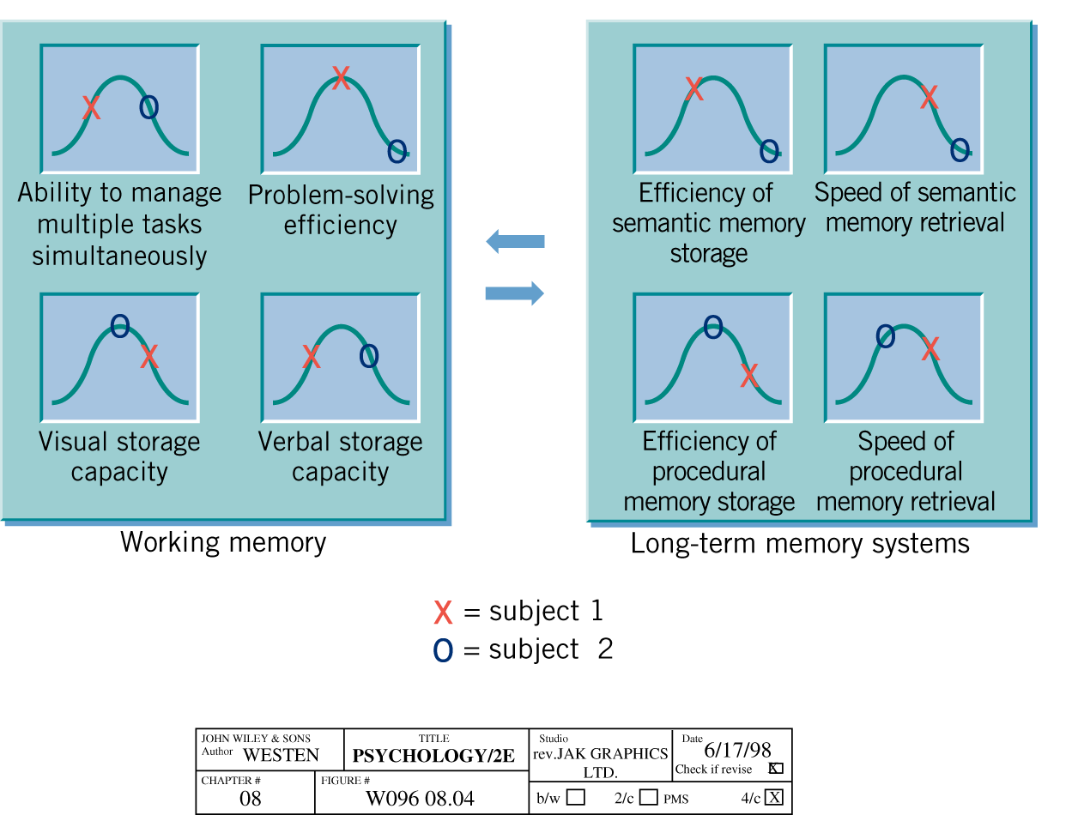

**Factor Analytic Approach to Intelligence Testing**

* Statistical approach in which test items are examined using factor analysis
* Looks for items that correlate together (are a common factor)
* How many factors?
* Thurstone: One common factor ‘g’
* Spearman: Two factors;
* ‘g’ for general intelligence
* ‘s’ for specific intelligence

**Intelligence Quotient**

* To allow for comparison of test scores among persons, L. Terman devised the concept of intelligence quotient (IQ)

IQ = (MA/CA) x 100

MA – Mental Age

CA – Chronological Age

**Frequency Distribution of IQ Scores**

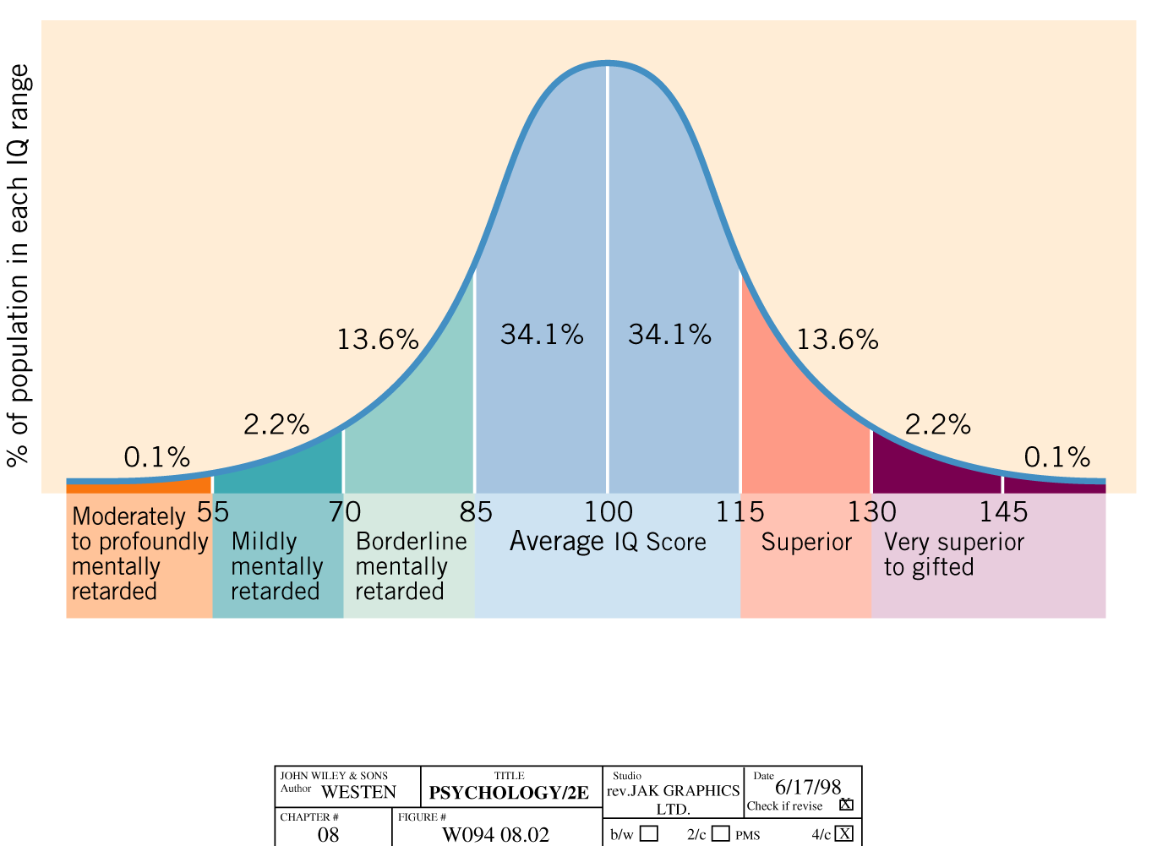

**Intelligence Tests**

* The Stanford – Binet test was devised in 1916;
* IQ score is defined as the ratio of (mental age to actual age) times 100
* The norms for IQ scores
* Mean = 100
* Standard deviation = 16
* 68% of persons have an IQ score within one SD of the mean (84 to 116)
* IQ scores predict school achievement
* The Westler Adult Intelligence Scale measures verbal and non-verbal abilities

**Commonly Used Intelligence Tests**

* Stanford – Binet intelligence scale
* WAIS: Weschler Adult Intelligence Scale (over age 18)
* WISC: Weschler Intelligence Scale for Children (ages 6-17)
* WPPSI: Weschler Preschool and Primary Scale of Intelligence (ages 4-6)

**Weschler Scales**

**Verbal IQ**

* Information
* Similarities
* Artithmetic
* Vocabulary
* Comprehension

**Performance IQ**

* Picture completion
* Picture arrangement
* Block design
* Object assembly
* Coding

**IQ New Sub-Tests**

* Symbol search
* Picture completion
* Cancellation
* Information
* Arithmetic
* Comprehension
* Word reasoning
* Block design
* Similarities
* Digit span
* Picture concepts
* Coding
* Vocabulary
* Letter-number sequencing
* Matrix reasoning

**Examples of IQ Items**

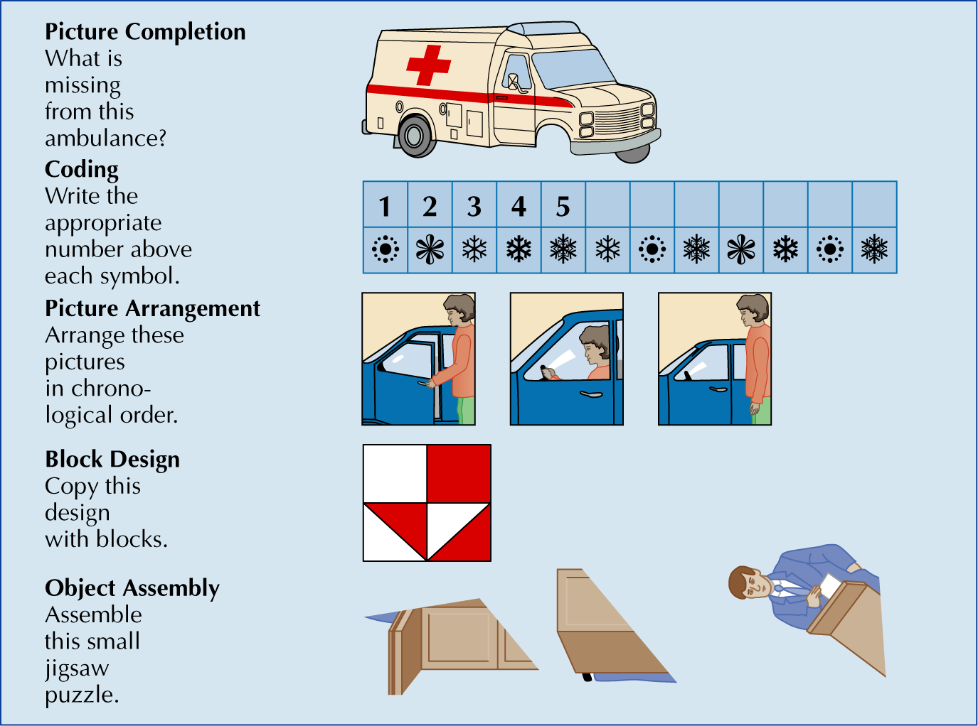

|  |  |  |
| --- | --- | --- |
| **Name of Test** | **Age Tested** | **Description of Abilities Tested** |
| Stanford-Binet Intelligence Scale, Fifth Edition (SBIS-V) | 2 – 90+ | In addition to providing a test composite score, this recent  Revision of the SB assesses Fluid Reasoning, Knowledge,  Quantitative Reasoning, Visual-Spatial Processing, and Working Memory as well as the ability to compare verbal and nonverbal performance. Not all subtests have to be administered in order to obtain composite scores. |
| Wechsler Intelligence Scale for Children, Fourth Edition (WISC-IV) | 6 – 16 | An update of the WISC-III, this test yields a Full Scale score and scores for Verbal Comprehension, Working Memory, Perceptual Reasoning, and Processing speed. This revision includes several new subtests and omits several from earlier versions. |
| Wechsler Adult Intelligence Scale  (WAIS-Revised) | 16 – 89 | An IQ test for teens and adults, the WAIS provides a Verbal,  Performance and Full Scale score as well as scores for verbal  comprehension, perceptual organization, working memory, and processing speed. The structure is very similar to the WISC-IV and was developed by the same people. There is also the WPPSI-R that is designed for children six and below. |
| Comprehensive Test of Nonverbal Intelligence (CTONI) | 6 – 18 | The CTONI is designed to assess children who may be at a disadvantage on traditional tests that put a premium on language skills. It is made up of six subtests that measure different nonverbal intellectual abilities. |
| Universal Nonverbal Intelligence Test (UNIT) | 5 – 17 | Also created to assess children who may be at a disadvantage on traditional tests that put a premium on language skills, this test is completely nonverbal in administration and response style. It may or may not reflect general intellectual ability for each subject. |
| Kaufman Assessment Battery for Children (KABC-II) | 2 – 16 | This test measures simultaneous and sequential processing skills, and has subscales that measure achievement as well. It is an  intelligence-theory-based test based on the work of Das and Lurie |