**Psych SAQs 2020**

**Prab Group Answers**

* 1. **Classification of antidepressants.**

They can be classified according to the Mechanism of Action.

SSRIs- Fluoxetine

SNRIs- Duloxetine and venflaxine

SARIs- Trazodone

MAOs- Selegiline, Tranycypromine

TCAs- Amitryptiline and Imipramine

Nassas

* Check on side effects
* These drugs have other indications aside from being antidepressants
* Symptoms of depression and mania… 2 different spectrums
* Drug refractory therapy- ECT
  1. **3 Factors that affect increased adherence to medication.**

Adherence- Factors not associated with patients…

* Drug factors- cost, availability, dosing frequency, side effects, route of administration
* Disease- insight, the severity,
* Social- family, work,
  1. **6 symptoms of a panic attack**

Cognitive- sense of impending danger, can’t cope, feeling apprehensive

Physiological- symphathetic ish… 4/13 for diagnosis… addd

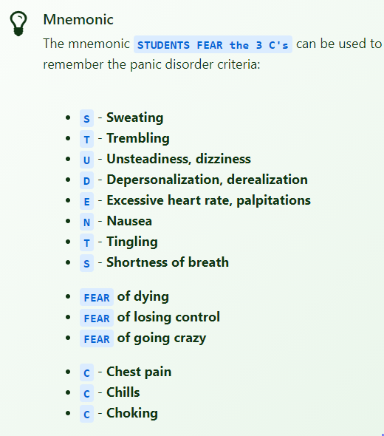

Behavioural response- avoid certain situations and impaired task performance

* 1. **Medical conditions that may produce similar effects.**
     1. CNS- Preclinical Parkinsonism,
     2. CVS- MI, Tachyarrythmias, Pericarditis, Heart failure(PNDs)
     3. Endocrine- Hypethyroidism, Hypoglycemia, Pheochromocytoma, Cushings
     4. Resp- PE, Acute Asthmatic attack
     5. GIT- Acute Abdomen
     6. Substance Use- Alcohol withdrawal/ toxicity, Cocaine use
     7. Drugs- Overdose of symphathomimetics
  2. **Treatment of panic attacks**

Pharmcotherapy- Sympatholytics, anxiolytics, sedative hypnotics

Psychotherapy- Behaviour Therapy

* 1. **4 differential diagnosis of ADHD**

**ADHD DSM**

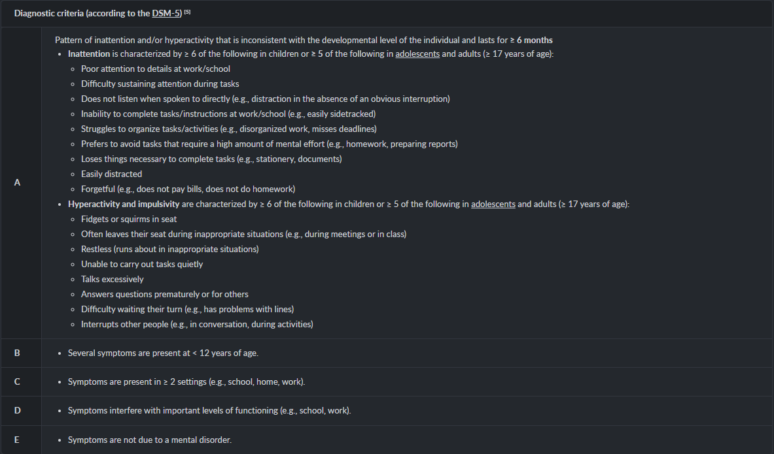

| **Psychiatric Disorders** | **Medical** |
| --- | --- |
| Conduct Disorders | TBIs |
| OCD | Sleeping Disorders |
| Specific learning Disorder | Hyperthyroidism |
| Autism Spectrum Disorder- Autistic, Pervasive Developmental disorder, Asperger Syndrome | Hypoglycemia |
| Substance | Anemia |
|  | Lead Poisoning |
|  |  |

* 1. **Medications used in the treatment of ADHD.**

Methylphenidate: Amphetamine like, MOA- promote release of NE

Dextroamphetamine

Atomoxetine: A selective reuptake inhibitor

Guanfacine

1. **Antipsychotics** 
   1. **Give examples of each. just add guys…. im tayad of typingggg.**

| **a) Typical Antipsychotics** | **b) Atypical Antipsychotics** |
| --- | --- |
| Haloperidol | Olanzapine |
| Chlorpromazine | Clozapine- refractory ish |
| Fluphenazine | quitepine |
| Pimazide | ??? |
| Trifluphenazine |  |
|  |  |
|  |  |

* 1. **Outline examples of neurological side effects of antipsychotic medications**
* Acute dystonia : features include spasm of tongue, throat, face, jaw, eyes, back muscle
* Akathisia : motor restlessness, inability to stay still
* Pseudo-parkinsonism : Bradykinesia, rigidity, resting tremor, stiff gait
* Tardive dyskinesia: involuntary movements of the mouth, tongue, limbs, face anf resp **muscles** 
  1. **What would you do to alleviate above mentioned side effects**
* Acute dystonia : benztropine
* Akathisia : reduce dose of antipsychotic, add Beta-blokers,
* Pseudo-parkinsonism : Add anticholinergics or amantadine, benzodiazepines may also be effective
  1. **Mention other side effects of antipsychotics**

[**https://next.amboss.com/us/article/AN0Rdg?q=antipsychotics#Ze835049c732df10f537fbaa3b64fe88c**](https://next.amboss.com/us/article/AN0Rdg?q=antipsychotics#Ze835049c732df10f537fbaa3b64fe88c)

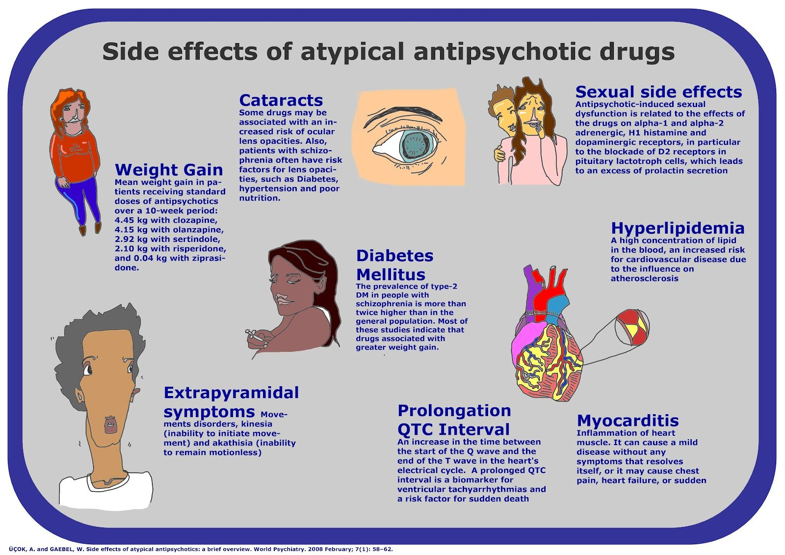

1. **ECT** 
   1. **Give 4 indications of ECT**- refractory to drugs, compliance, tolerating side effects, contraindication of pharmacotherapy, adjunct to treatment

* Major depression disorder
* Schizoaffective disorder
* Bipolar mood disorder : manic episodes not responding to mood stabilizers
* Highly suicidal or pregnant depressed patients
* Neuroleptic malignant syndrome
* Post partum psychosis
  1. **What medications should be withdrawn before ECT and why?**
* Benzodiazepines- anticonvulsant action
* Lithium carbonate- increased post ictal delirium, prolonged seizure activity
* Metformin??
* Anticonvulsants- bcz of their anticonvulsant effect
  1. **What are the steps to be followed in management of patients post ECT**
* Observe and record the vitals of the patient
* Place the patient on the side lying position, clean secretions
* Transfer the patient to the recovery room
* Allow the patient to sleep for 30mins to 1 hour
* Let the patient feed when fully conscious (start with drinks)
  1. **What are the complications of ECT**
* Headache
* Memory loss
* Confusion
* Death

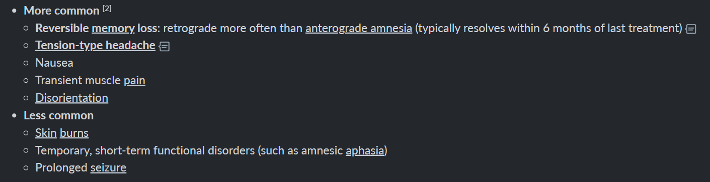

* 1. **Give 5 symptoms of opiod intoxication**
* Resp: Resp depression
* GIT: Constipation, reduced gag reflex
* Cvs: low HR, BP
* Vitals: hypothermia
* Musculosk: rhabdomyolysis, myoclonic jerks
* CNS: Slurred speech, drowsiness, confusion, seizures
* 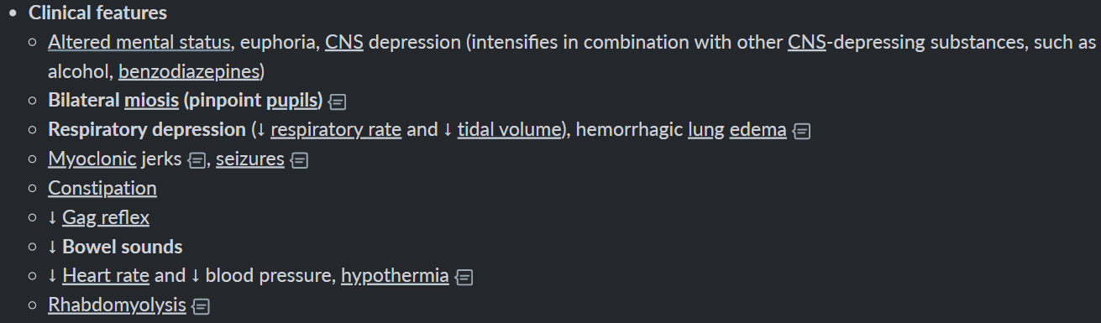
* 
  1. **5 features of alcohol use disorder**
* Persistent desire or unsuccessful effort to cut down or control alcohol use
* Alcohol taken in large amounts or longer periods
* Strong desire, craving or urge to take alcohol
* Developed tolerance: need to increase amount of alcohol to achieve intoxication
* Alcohol is taken to relieve or avoid withdrawal
* Behavioural changes and bad company
* 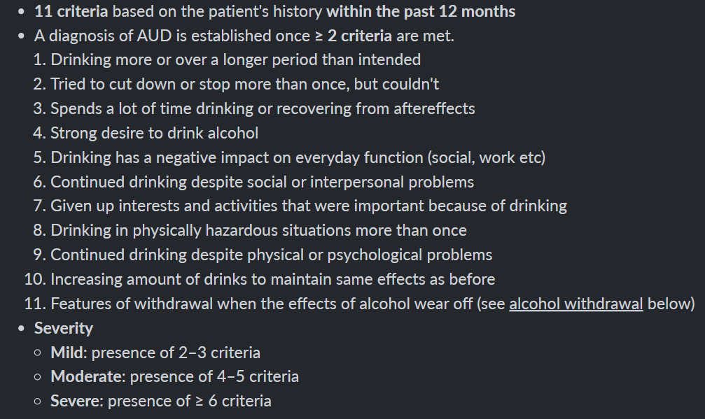
  1. **List two drugs used in the treatment of opiod use disorder**
* Naltrexone
* Buprenophine
* 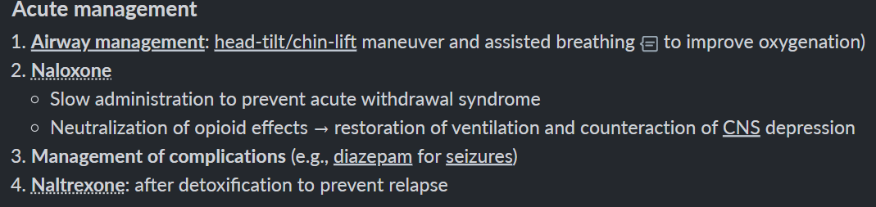
  1. **5 symptoms of alcohol withdrawal**
* Autonomic symptoms: sweating, palpitations, tachycardia
* CNS: Headaches, Anxiety, Insomia & vivid dreams
* GI: Anorexia, nausea, vomiting
* Complicated
* 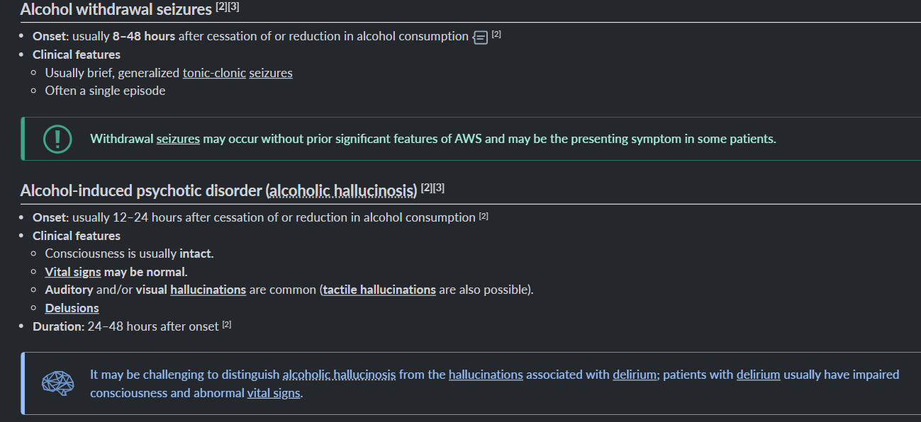
* 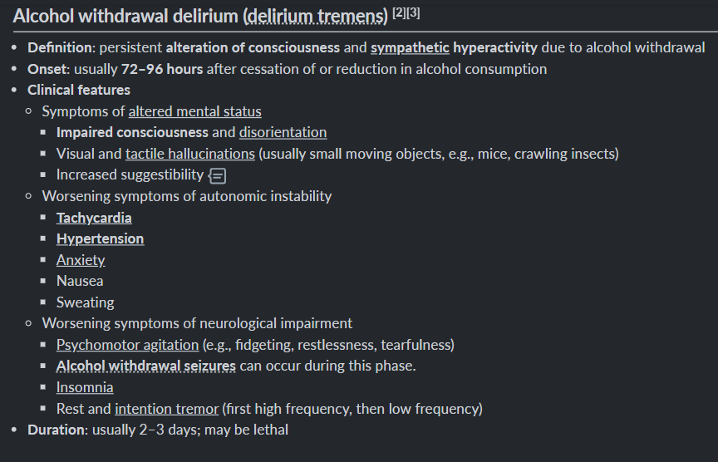

1. 1. **3 indications?? Question not clear**
   2. **List 3 mature and 3 immature defenses mechanisms**

Mature: Suppression, sublimation, altruism

Immature: Regression, Acting out, Denial, Displacement, Projection, Rationalization, Reaction formation

* 1. **What are the benefits of family therapy**
* Just mouth stuff….
  1. **Define the following terms- confirm this answer :(** 
     1. Systemic desensitization- Pt attains a state of complete relaxation and is then exposed to stimulus that elicit anxiety.
     2. Flooding- Pt is encouraged to confront a maximum intensity anxiety provoking stimulus directly or through imagining without initial relaxation.