SKELETON SYSTEM
Is composed of the bones ligaments tendons and cartilages. It is often stated that there are 206 bones in the skeleton,but this is only a typical adult count. At birth there are about 270, and even more bones form during childhood. With age, however, the number decreases as separatebones fuse. For example, each half of the adult pelvis is a single bone called the os coxae (oss COC-see), which results from the fusion of three childhood bones—the ilium, ischium, and pubis. The fusion of several bones, completed by late adolescence or the early 20s, brings about the average adult number of 206.This number varies even among adults. One reason is the development of sesamoid bones—bones that form within some tendons in response to stress. The patella (kneecap) is the largest of these; most of the others are small, rounded bones in such locations as the knuckles.Another reason for adult variation is that some people have extra bones in the skull called sutural (SOO-chure-ul), or wormian,bones

Functions of bones
- To support -the bones the lower lamp the pelvic and the vertebral column they support the body weight.
-The mandible jaw bone and support the teeth
-The upper bone support various organs and tissues
- Protection
- The bones of the skull protect the brain the ribs and the sternum protect the lungs under the heart the vertebral column protect the vertebral cord
- Movement
- Skeletal muscles use the bones to attach themselves then they provide movement to the body

- Is a reservoir -for adipose tissue and minerals
A lot of body calcium is stored in Bones about 83% of the phosphorus mineral is also stored in the bonds in the bone marrow is a type of adipose tissue
- haematopoiesis blood cells formation is done in the bone marrow

Bones classification
There is about 206 bones in the human body
The skeleton is divided into two main regions
- The axial skeleton
- The appendicular skeleton
Axial skeleton
forms the long axis of a body it include the bones of the skull the bones of the vertebral column and the bones of the rib cage
These bones of the axial skeleton protect support and Carry other body parts

Appendicular skeleton
It include the bones of the upper limbs lower limbs and the girdles pectoral (pelvic hip) pectoral (shoulder)
These bones of the appendicular skeleton are used in locomotion and manipulation of the environment

Types of bones
There are four main types of bones
- Long bones
- Short bones
- Flat bones
- Irregular bones

Long bones
- Are much longer than wide
- This includes all the bones of the lower and upper limbs except the the patella (knee cap) and the bone of the wrist and ankle joint
- Long bones consist of a shaft and two ends which are expanded

Short bones
Are cube-shaped they include the bones of the wrist and the ankle joint
Flat bones
- Are flattened
- They are thin
- They are usually curved
- They include the scapula the sternum bone the ribs and most bones of the skull

Irregular bones
They have a wired shape that does not fit none of the short flat or long bones and this one's includes the bones of the vertebrae hip and the two bones of the skull the sphenoid and ethmoid bone

The bone structure
Bonds are organs and they are composed of multiple tissue types
Bones are composed of the following
- The bone tissue (osseous)
- Cartilage
- Vascular tissue
- Lymphatic tissue
- Adipose tissue
- Nervous tissue

There are two main regions of a bone
- Compact bone
- Spongy bone

Compact bone
Is the solid cuter layer
Spongy bone
Is the inner layer of the bone
Hit us a honey curved shape which is flat and has projections, which alcohol trabeculae
the bone tissue is a type of connective tissue and tests consist of several Bones cells
- Osteoblast
- Osteocytes
- Osteoclast

Osteoblast-
- these are bone cells which are used for building the bone
- This cell is synthesized and the decide collagen fibre and other collagen components to form the bone mattress
- List osteoblasts also process and initiate the process of calcification
- This osteoblasts are found in both the periosteum and endosteum f***

Osteocytes
- these are the mature bone cells
- They are formed after osteoblast have become trapped by excretion of The matrix
- These are the cells responsible for maintaining the bone tissues

Osteoclast
- They are cells that digest The Bone matrix in a process called bone resorption and this forms part of the normal bone growth development maintenance and repair
- these cells are derived from white blood cells and B cells are mainly found in the endosteum part of the bone.

Structure of the bone
Long bones
- They have a shaft and two expanded ends
- the shaft is also known as the diaphysis and consist of a thick layer of compact bone around the centre we have a central marrow bone cavity

N/B in adult the bone marrow cavity contains few yellow bone marrow found in the arms legs and feet fingers and toes
- A long bone has expanded ends, and proximal and distal ends which are called epiphysis
- The epiphysis is consist of a thin layer of compact bone covering the interior of the spongy bone
- The epiphysis also contained the red bone marrow
- The ends of the epiphysis there is the covering of the joint in which is made of hyaline cartilage and is known as the articular cartilage whose purpose is to Cobb on the bond and reduce friction
- The external surface of the entire long bone is covered by a double layer membrane known as the periosteum
Assignment
Draw and clearly label a) long bone b) short Bone c) flat bone d) irregular bone
Discuss the bone marrow and the bone marrow distribution
Discuss Bond development Ian intramembranous ossification and endochondral ossification

Metaphysis
Is the region between the diaphysis and epiphysis in a growing baby each metaphysis contains an artificial plate also called the growth plate and the growth plate is made up of a layer of hyaline cartilage that allows the diaphysis of the bone marrow to grow in length

the born stops to grow in length at the age of about 15 in girls and 21 years in boys and that is called bone ossification
then the cartilage in this epiphyseal plate is replaced by a bone and then it forms a bond structure known as epiphyseal line

Medullary cavity
is a hollow cylindrical space within the diaphysis that contains fatty yellow bone marrow in adults

Surface Features of Bones
Bone surfaces exhibit a variety of ridges, spines, bumps, depressions, canals, pores, slits, and articular surfaces. It is important to know the names of these surface markings because later descriptions of joints, muscle attachments, and the routes traveled by nerves and blood vessels are based on this terminology.

GENERAL DESCRIPTION | ANATOMICAL TERM | DEFINITION
Elevation and projection | Process-  Ramus- | Any projection or bump  Extension of a bone marking an angle eith the rest of the structure
Process formed where tendons or ligaments attach | Tronchanter  Tuberosity  Tubercle  Crest  Line  Spine | A large,rough projection  A small’rough projection  A small’rounded projection  A prominent ridge  A low ridge  A pointed or narrow process
Process formed for articulation with adjacent bones | Head  Neck  Condyle  Trochlea  Facet | The expanded articular end of an epiphysis  Narrow connection bten epiphysis and diaphysis  Smooth rounded articular process  Smooth grooved articular process shaped as a pulley  Smooth flat articular surface
Depressions | Fossa  Sulcus | A shallow depression  A narrow groove
Openings | Foramen  Canal  Meatus  Fissure  Sinus | Rounded pathway for bloodvessels or nerves  Duct\channel  Passageway through a bone  Elongated cleft\slit  Chamber with a bone normally filled with air
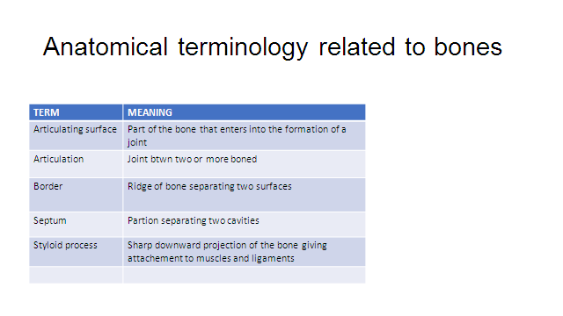

Upper Limb

The upper limb is divided into four regions containing a total of 30 bones per limb:
1. The brachium (BRAY-kee-um), or arm proper, extends from shoulder to elbow. It contains only one bone, the humerus.
2. The antebrachium, or forearm, extends from elbow to wrist and contains two bones—the radius
and ulna. In anatomical position, these bones are parallel and the radius is lateral to the ulna.
3. The carpus, or wrist, contains eight small bones arranged in two rows.
4. The manus or hand, contains 19 bones in two groups—5 metacarpals in the palm and 14phalanges in the fingers.

Humerus
The humerus has a hemispherical head that articulates with the glenoid cavity of the scapula (fig. 8.32). The smooth surface of the head (covered with articular cartilage in life) is bordered by a groove called the anatomical
neck. Other prominent features of the proximal end are muscle attachments called the greater and lesser tubercles and an intertubercular sulcus between them that accommodates a tendon of the biceps muscle. The surgical neck, a common fracture site, is a narrowing of thebone just distal to the tubercles, at the transition from the head to the shaft.

Radius
The proximal head of the radius is a distinctivedisc that rotates freely on the humerus when the palm isturned forward and back. It articulates with the capitulum ofthe humerus and radial notch of the ulna. On the shaft, immediately distal to the head, is a medial rough tuberosity, which is the insertion of the biceps muscle. The distal end of the radius has the following features, from lateral to medial:
1. a bony point, the styloid process, which can be palpated proximal to the thumb;
2. two shallow depressions (articular facets) that articulate with the scaphoid and lunate bones of the wrist.
3. the ulnar notch, which articulates with the end ofthe ulna.

Ulna

At the proximal end of the ulna (fig. 8.33) is a deep, Cshaped trochlear notch that wraps around the trochlea of the humerus. The posterior side of this notch is formed by a prominent olecranon—the bony point where you rest your elbow on a table. The anterior side is formed by a less prominent coronoid process. Medially, the head of the ulna has a less conspicuous radial notch, which accommodates the head of the radius. At the distal end of the ulna is a medial styloid process. The bony lumps you can palpate on each side of your wrist are the styloid processes of the radius and ulna.The radius and ulna are attached along their shafts by a ligament called the interosseous (IN-tur-OSS-ee-us) membrane, which is attached to an angular ridge called the interosseous margin on the medial side of each bone.

- Carpal Bones
The carpal bones, which form the wrist, are arranged intwo rows of four bones each (fig. 8.34). These short bones allow movements of the wrist from side to side and up and down. The carpal bones of the proximal row, starting at the lateral (thumb) side, are the scaphoid (navicular), lunate, triquetrum (tri-QUEE-trum), and pisiform—Latin for boat-, moon-, triangle-, and pea-shaped, respectively. Unlike the other carpal bones, the pisiform is a sesamoid bone; it develops within the tendon of the flexor carpi ulnaris muscle. The bones of the distal row, again starting on the lateral side, are the trapezium, trapezoid, capitate, and hamate.The hamate can be recognized by a prominent hook on the palmar side.
- Metacarpal Bones
Bones of the palm are called metacarpals.Metacarpal I is located at the base of the thumb and metacarpal V at the base of the little finger. On a skeleton, the metacarpals look like extensions of the fingers, so that the fingers seem much longer than they really are. The proximal end of a metacarpal bone is called the base, the shaft is called the body, and the distal end is called the head. The heads of the metacarpals form knuckles when you clench your fist.
- Phalanges
The bones of the fingers are called phalanges (fah-LANjeez);in the singular,
Phalanx (FAY-lanks). There are two phalanges in the pollex (thumb) and three in each of the other digits. Phalanges are identified by Roman numerals preceded by proximal, middle, and distal. For example, proximal phalanx I is in the basal segment of the thumb (the first segment beyond the web between the thumb and palm); the left proximal phalanx IV is where people usually wear wedding rings; and distal phalanx V forms the tip of the little finger. The three parts of a phalanx are the Same as in a metacarpal: base, body, and head. The ventral surface of a phalanx is slightly concave from end to end and flattened from side to side; the dorsal surface is rounder and slightly convex.

Lower Limb
The number and arrangement of bones in the lower limb are similar to those of the upper limb. In the lower limb, however, they are adapted for weight-bearing and locomotion and are therefore shaped and articulated differently. The lower limb is divided into four regions containing a total of 30 bones per limb:
1. The femoral region, or thigh, extends from hip to knee and contains the femur (the longest bone in the body). The patella (kneecap) is a sesamoid bone at the junction of the femoral and crural regions.
2. The crural (CROO-rul) region, or leg proper, extends from knee to ankle and contains two bones, the medial tibia and lateral fibula.
3. The tarsal region (tarsus), or ankle, is the union of the crural region with the foot. The tarsal bones are treated as part of the foot.
4. The pedal region (pes), or foot, is composed of 7 tarsal bones, 5 metatarsals, and 14 phalanges in the toes.
Femur
The femur (FEE-mur)has a nearly spherical head that articulates with the acetabulum of the pelvis, forming a quintessential ball-and-socket joint. A ligament extends from the acetabulum to a pit, the fovea capitis(FOE-veeuh CAP-ih-tiss), in the head of the femur. Distal to the head Is a constricted neck and then two massive, rough processes called the greater and lesser trochanters (tro-CAN-turs), which are insertions for the powerful muscles of the hip. They are connected on the posterior side by a thick oblique ridge of bone, the intertrochanteric crest, and on the anterior side by a more delicate intertrochanteric line.
Patella
The patella, or kneecap is a roughly triangular sesamoid bone that forms within the tendon of the knee as a child begins to walk. It has a broad superior base, a pointed inferior apex, and a pair of shallow articular facets on its posterior surface where it articulates with the femur. The lateral facet is usually larger than the medial. The quadriceps femoris tendon extends from the anterior muscle of the thigh (the quadriceps femoris) to the patella, and it continues as the patellar ligament from the patella to the tibia.
Tibia
The leg has two bones—a thick, strong tibia (TIB-ee-uh) and a slender, lateral fibula (FIB-you-luh) The tibia, on the medial side, is the only weight-bearing bone of the crural region. Its broad superior head has two fairlyflat articular surfaces, the medial and lateral condyles, separated by a ridge called the intercondylar eminence. The condyles of the tibia articulate with those of the femur. The rough anterior surface of the tibia, the tibial tuberosity, can be palpated just below the patella. This is where the patellar ligament inserts and the thigh muscles exert their pull when they extend the leg. Distal to this, the shaft has a sharply angular anterior crest, which can be palpated in the shin. At the ankle, just above the rim of a standard dress shoe, you can palpate a prominent bony knob on each side. These are the medial and lateral malleoli (MAL-ee-OH-lie). The medial malleolus is part of the tibia, and the lateral malleolus is the part of the fibula.
Fibula
The fibula is a slender lateral strut that helps to stabilize the ankle. It does not bear any of the body’s weight; indeed, orthopedic surgeons sometimes remove the fibula and use it to replace damaged or missing bone elsewhere in the body. The fibula is somewhat thicker and broader at its proximal end, the head, than at the distal end. The point of the head is called the apex. The distal expansion is the lateral malleolus. Like the radius and ulna, the tibia and fibula are joined by an interosseous membrane along their shafts.
The Ankle and Foot
The tarsal bones of the ankle are arranged in proximal and distal groups somewhat like the carpal bones of the wrist. Because of the load-bearing role of the ankle,however, their shapes and arrangement are conspicuously different from those of the carpal bones, and they are thoroughly integrated into the structure of the foot. The largest tarsal bone is the calcaneus (cal-CAY-nee-us), which forms the heel. Its posterior end is the point of attachment for the calcaneal (Achilles) tendon from the calf muscles. The second-largest tarsal bone, and the most superior, is the talus. It has three articular surfaces: an inferoposterior one that articulates with the calcaneus, a superior trochlear surface that articulates with the tibia, and an anterior surface that articulates with a short, wide tarsal bone called the navicular. The talus, calcaneus, and navicular are considered the proximal row of tarsal bones. (Navicular is also used as a synonym for the scaphoid bone of the wrist.)

THE AXIAL SKELETON
This is the part of the skeleton that consists of the bones of the head and trunk of a vertebrate. In the human skeleton, it consists of 80 bones and is composed of six parts; the skull (22 bones), also the ossicles of the middle ear, the hyoid bone, the rib cage, sternum and the vertebral column. The axial skeleton together with the appendicular skeleton form the complete skeleton. Another definition of axial skeleton is the bones including the vertebrae, sacrum, coccyx, ribs, and sternum.[1]
Axial skeleton
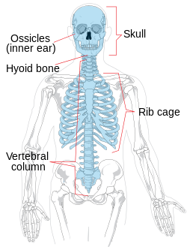

Axial Skeleton (80 bones)

Skull (28)

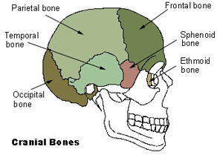
Cranial Bones
- Parietal (2)
- Temporal (2)
- Frontal (1)
- Occipital (1)
- Ethmoid (1)
- Sphenoid (1)

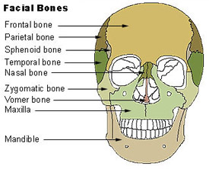
Facial Bones
- Maxilla (2)
- Zygomatic (2)
- Mandible (1)
- Nasal (2)
- Platine (2)
- Inferior nasal concha (2)
- Lacrimal (2)
- Vomer (1)

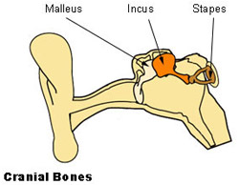
Auditory Ossicles
- Malleus (2)
- Incus (2)
- Stapes (2)

Hyoid (1)

The Skull
The bones of the skull support the structures of the face and protect the brain. The skull consists of 22 bones, which are divided into two categories: cranial bones and facial bones. The cranial bones are eight bones that form the cranial cavity, which encloses the brain and serves as an attachment site for the muscles of the head and neck. The eight cranial bones include the frontal bone, two parietal bones, two temporal bones, the occipital bone, the sphenoid bone, and the ethmoid bone
Skull: The bones of the skull support the structures of the face and protect the brain.
Fourteen facial bones form the face, provide cavities for the sense organs (eyes, mouth, and nose), protect the entrances to the digestive and respiratory tracts, and serve as attachment points for facial muscles. The 14 facial bones are the nasal bones, maxillary bones, zygomatic bones, palatine, vomer, lacrimal bones, inferior nasal conchae, and mandible.
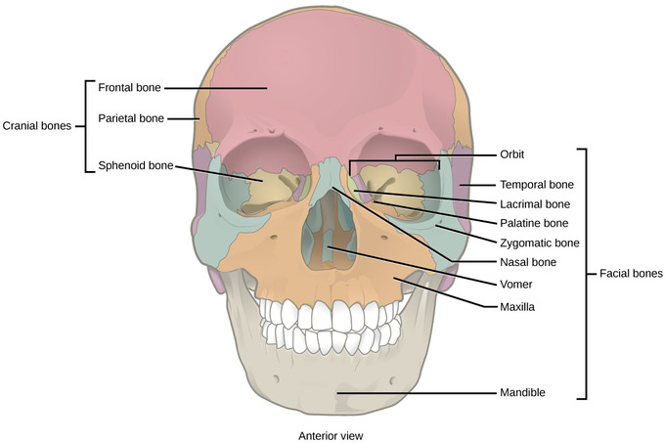Cranial and facial bones: The facial bones of the skull form the face and provide cavities for the eyes, nose, and mouth. The cranial bones, including the frontal, parietal, temporal, occipital, ethmoid, and sphenoid bones.
The auditory ossicles of the middle ear transmit sounds from the air as vibrations to the fluid-filled cochlea. The auditory ossicles consist of six bones: two malleus bones, two incus bones, and two stapes, one of each on each side. These bones are unique to mammals.
The hyoid bone lies below the mandible in the front of the neck. 8It acts as a movable base for the tongue and is connected to muscles of the jaw, larynx, and tongue. The mandible articulates with the base of the skull, controling the opening to the airway and gut. In animals with teeth, the mandible brings the surfaces of the teeth in contact with the maxilliary.
Fontanelles of the skull.
this set (4)
- Sphenoidal. Anterolateral ( on both sides of head.
- Mastoid. Posterolateral (on both sides of head)
- Frontal. Anterior (diamond shaped)
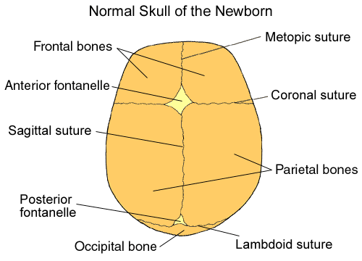
- Occipital. Posterior.

The Vertebral Column
The vertebral column is a series of approximately 33 bones called vertebrae, which are separated by intervertebral discs.
The column can be divided into five different regions, with each region characterised by a different vertebral structure.
In this article, we shall look at the anatomy of the vertebral column – its function, structure, and clinical significance.

Functions
The vertebral column has four main functions:
- Protection – encloses and protects the spinal cord within the spinal canal.
- Support – carries the weight of the body above the pelvis.
- Axis – forms the central axis of the body.
- Movement – has roles in both posture and movement.
By TeachMeSeries Ltd (2021)
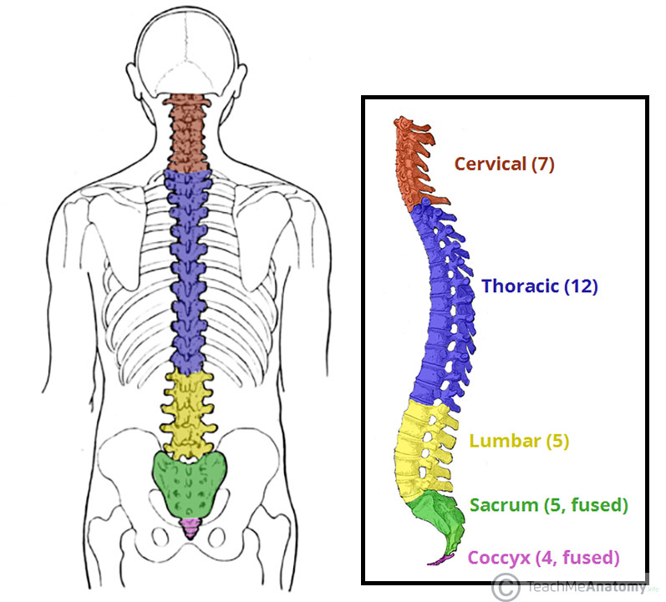
Fig 1 – The vertebral column viewed from the side. The five different regions are shown and labelled.

Structure of a Vertebrae
All vertebrae share a basic common structure. They each consist of an anterior vertebral body, and a posterior vertebral arch.

Vertebral Body
The vertebral body forms the anterior part of each vertebrae.
It is the weight-bearing component, and vertebrae in the lower portion of the column have larger bodies than those in the upper portion (to better support the increased weight).
The superior and inferior aspects of the vertebral body are lined with hyaline cartilage. Adjacent vertebral bodies are separated by a fibrocartilaginous intervertebral disc.
The vertebral arches have several bony prominences, which act as attachment sites for muscles and ligaments:
- Spinous processes – each vertebra has a single spinous process, centred posteriorly at the point of the arch.
- Transverse processes – each vertebra has two transverse processes, which extend laterally and posteriorly from the vertebral body. In the thoracic vertebrae, the transverse processes articulate with the ribs.
- Pedicles – connect the vertebral body to the transverse processes.
- Lamina – connect the transverse and spinous processes.
- Articular processes – form joints between one vertebra and its superior and inferior counterparts. The articular processes are located at the intersection of the laminae and pedicles.

There are 26 bones in the vertebral column. 24 separate vertebrae extend downwards from the occipital bone of the skull; then there is the sacrum, formed from five fused vertebrae, and lastly the coccyx, or tail, which is formed from between three to five small fused vertebrae. The vertebral column is divided into different regions. The first seven vertebrae, in the neck, form the cervical spine; the next twelve vertebrae are the thoracic spine, and the next five the lumbar spine, the lowest vertebra of which articulates with the sacrum. Each vertebra is identified by the first letter of its region in the spine, followed by a number indicating its position. For example, the topmost vertebra is called C1, and the third lumbar vertebra is called L3.
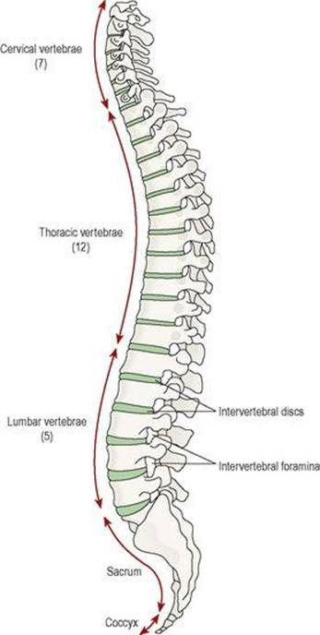
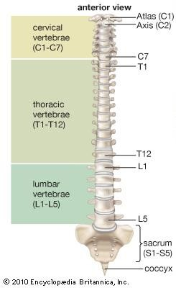
Figure;; The vertebral column. Lateral view.
Characteristics of a typical vertebra
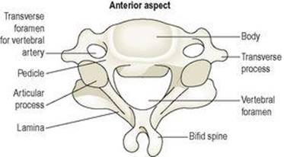
Figure.. A lumbar vertebra showing the features of a typical vertebra
Characteristics of a typical vertebra
The movable vertebrae have many characteristics in common, but some groups havedistinguishing features.
The body
This is the broad, flattened, largest part of the vertebra. When the vertebrae are stacked together in the vertebral column, it is the flattened surfaces of the body of each vertebra that articulate with the corresponding surfaces of adjacent vertebrae. However, there is no direct bone-to-bone contact since between each pair of bones is a tough pad of fibrocartilage called the intervertebral disc. The bodies of the vertebrae lie to the front of the vertebral column, increasing greatly in size towards the base of the spine, as the lower spine has to support much more weight than the upper regions.
The vertebral (neural) arch
This encloses a large vertebral foramen. It lies behind the body, and forms the posterior and lateral walls of the vertebral foramen. The lateral walls are formed from plates of bone called pedicles, and the posterior walls are formed from laminae. Projecting from the regions where the pedicle meets the lamina is a lateral prominence called a transverse process, and where the two laminae meet at the back is a process called the spinous process. These are the bony prominences that can be felt through the skin along the length of the spine. The neural arch has four articular surfaces: two articulate with the vertebra above and two with the one below. The vertebral foramina form the vertebral (neural) canal that contains the spinal cord.

Region-specific vertebral characteristics
Cervical vertebrae ::These are the smallest vertebrae. The transverse processes have a foramen through which a vertebral artery passes upwards to the brain. The first two cervical vertebrae, the atlas and the axis, are atypical
The first cervical vertebra, the atlas, is the bone on which the skull rests. Below the atlas is the axis, the second cervical vertebra (C2).
The atlas is essentially a ring of bone, with no distinct body or spinous process, although it has two short transverse processes. It possesses two flattened facets that articulate with the occipital bone; are condyloid joints and they permit nodding of the head.
The axis sits below the atlas, and has a small body with a small superior projection called the odontoid process (also called the dens, meaning tooth). This occupies part of the posterior foramen of the atlas above, and is held securely within it by the transverse ligament .The head pivots (i.e. turns from side to side) on this joint.
The 7th cervical vertebra, C7, is also known as the vertebra prominens. It possesses a long spinous prominence terminating in a swollen tubercle, which is easily felt at the base of the neck.
Thoracic vertebrae The twelve thoracic vertebrae are larger than the cervical vertebrae because this section of the vertebral column has to support more body weight. The bodies and transverse processes have facets for articulation with the ribs.
Lumbar vertebrae
These are the largest of the vertebrae because they have to support the weight of the upper body. They have substantial spinous processes for attachment of the muscles of the lower back.This consists of five rudimentary vertebrae fused to form a triangular or wedge-shaped bone with a concave anterior surface. The upper part, or base, articulates with the 5th lumbar vertebra. On each side it articulates with the ilium to form a sacroiliac joint, and at its inferior tip it articulates with the coccyx. The anterior edge of the base, the promontory, protrudes into the pelvic cavity. The vertebral foramina are present, and on each side of the bone there is a series of foramina for the passage of nerves.
Coccyx
This consists of the four terminal vertebrae fused to form a very small triangular bone, the broad base of which articulates with the tip of the sacrum.

Features of the vertebral column
Intervertebral discs
The bodies of adjacent vertebrae are separated by intervertebral discs, consisting of an outer rim of fibrocartilage (annulus fibrosus) and a central core of soft gelatinous material (nucleus pulposus). They are thinnest in the cervical region and become progressively thicker towards the lumbar region, as spinal loading increases. The posterior longitudinal ligament in the vertebral canal helps to keep them in place. They have a shock-absorbing function and the cartilaginous joints they form contribute to the flexibility of the vertebral column as a whole.
Intervertebral foramina
When two adjacent vertebrae are viewed from the side, a foramen formed by a gap between the vertebral pedicles can be seen. Half of the wall is formed by the vertebra above, and half by the one below.Throughout the length of the column there is an intervertebral foramen on each side between every pair of vertebrae, through which the spinal nerves, blood vessels and lymph vessels pass.
Ligaments of the vertebral column.
These ligaments hold the vertebrae together and keep the intervertebral discs in position.The transverse ligament maintains the odontoid process of the axis in the correct position in relation to the atlasThe anterior longitudinal ligament extends the whole length of the column and lies in front of the vertebral bodies.The posterior longitudinal ligament lies inside the vertebral canal and extends the whole length of the vertebral column in close contact with the posterior surface of the bodies of the bones.The ligamenta flava connect the laminae of adjacent vertebrae. The ligamentum nuchae and the supraspinous ligament connect the spinous processes, extending from the occiput to the sacrum.
Curves of the vertebral column
When viewed from the side, the vertebral column presents four curves: two primary and two secondary.The fetus in the uterus lies curled up so that the head and the knees are more or less touching. This position shows the primary curvature. The secondary cervical curve develops when the child can hold up his head (after about 3 months) and the secondary lumbar curve develops when he stands upright (after 12 to 15 months). The thoracic and sacral primary curves are retained.
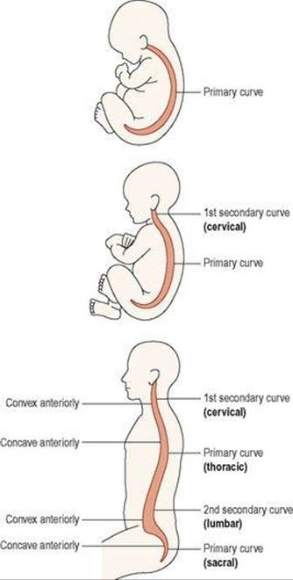
Movements of the vertebral column
The movements between the individual bones of the vertebral column are very limited. However, the movements of the column as a whole are quite extensive and include flexion (bending forward), extension(bending backward), lateral flexion (bending to the side) and rotation. There is more movement in the cervical and lumbar regions than elsewhere.
Functions of the vertebral column
These include the following.
• Collectively the vertebral foramina form the vertebral canal, which provides a strong bony protection for the delicate spinal cord lying within it.
• The pedicles of adjacent vertebrae form intervertebral foramina, one on each side, providing access to the spinal cord for spinal nerves, blood vessels and lymph vessels.
• The numerous individual bones with their intervertebral discs allow movement of the whole column.
• It supports the skull.
• The intervertebral discs act as shock absorbers, protecting the brain.
• It forms the axis of the trunk, giving attachment to the ribs, shoulder girdle and upper limbs, and the pelvic girdle and lower limbs.
Thoracic cage
The thoracic cage consists of the thoracic vertebrae, sternum, and ribs. It forms a more or less conical enclosure for the lungs and heart and provides attachment for the pectoral girdle and upper limb. It has a broad base and a somewhat narrower superior apex; it is rhythmically expanded by the respiratory muscles to create a vacuum that draws air into the lungs. The inferior border of the thoracic cage is formed by a downward arc of the ribs called the costal margin. The ribs protect not only the thoracic organs but also the spleen, most of the liver, and to some extent the kidneys.
Sternum
The sternum (breastbone) is a bony plate anterior to the heart. It is subdivided into three regions: the manubrium, body, and xiphoid process. The manubrium (ma-NOObree-um) is the broad superior portion. It has a superomedial suprasternal notch (jugular notch), which you can easily palpate between your clavicles (collarbones), and right and left clavicular notches, where it articulates with the clavicles. The body, or gladiolus, is the longest part of the sternum. It joins the manubrium at the sternal angle, which can be palpated as a transverse ridge at the point where the sternum projects farthest forward. In some people, however, it is rounded or concave. The second rib attaches here, making the sternal angle a useful landmark for counting ribs in a physical examination. The manubrium and body have scalloped lateral margins where cartilages of the ribs are attached. At the inferior end of the sternum is a small, pointed xiphoid (ZIF-oyd)process that provides attachment for some of the abdominal muscles.
Ribs
There are 12 pairs of ribs, with no difference between the sexes. Each is attached at its posterior (proximal) end to the vertebral column. A strip of hyaline cartilage called the costal cartilage extends from the anterior (distal) ends of ribs 1 to 7 to the sternum. Ribs 1 to 7 are thus called true ribs. Ribs 8 to 10 attach to the costal cartilage of rib 7, and ribs 11 and 12 do not attach to anything at the distal end but are embedded in thoracic muscle. Ribs 8 to 12 are therefore called false ribs, and ribs 11 and 12 are also called floating ribs for lack of any connection to the sternum. Ribs 1 to 10 each have a proximal head and tubercle, connected by a narrow neck; ribs 11 and 12 have a head only. Ribs 2 to 9 have beveled heads that come to a point between a superior articular facet above and an inferior articular facet below. Rib 1, unlike the others, is a flat horizontal plate. Ribs 2 to 10 have a sharp turn called the angle, distal to the tubercle, and the remainder consists of a flat blade called the shaft. Along the inferior margin of the shaft is a costal groove that marks the path of the intercostal blood vessels and nerve.
