**Lesson objectives**

**By the end of the lesson the student should**

Understand the functions of water

Understand the properties of water

Understand how water reacts with polar and non-polar substances

**Functions of water**

* Carries nutrients and waste products.
* Actively participates in chemical reactions.
* Serves as a solvent for minerals, vitamins, amino acids, glucose, and other small molecules.
* Serves as a lubricant and cushion around joints.
* Acts as a shock absorber (eyes, spinal column, amniotic sac)
* Aids in maintaining body’s temperature.

**Body water content**

* It’s about 75% in the newborn.
* Total water content declines throughout life.
* Healthy adult males are about 60% water; healthy adult females are around 50%
* This difference reflects females’:
* Higher body fat
* Smaller amount of skeletal muscle
* Less than 50% in older individual.
* Water content is greatest in brain tissue (about 90%) and least in adipose tissue (10%).

**The chemistry of Water**

Water is the medium in which all biomolecules are dissolved in.

Since some of the biomolecules are insoluble in water, it is possible for them to exist as an intact cell membrane.

cell organelles are able to survive due to the fact that they are insoluble in water.

The two hydrogen atoms in a water molecule are located in a tetrahedral arrangement around the oxygen atom (H2O).

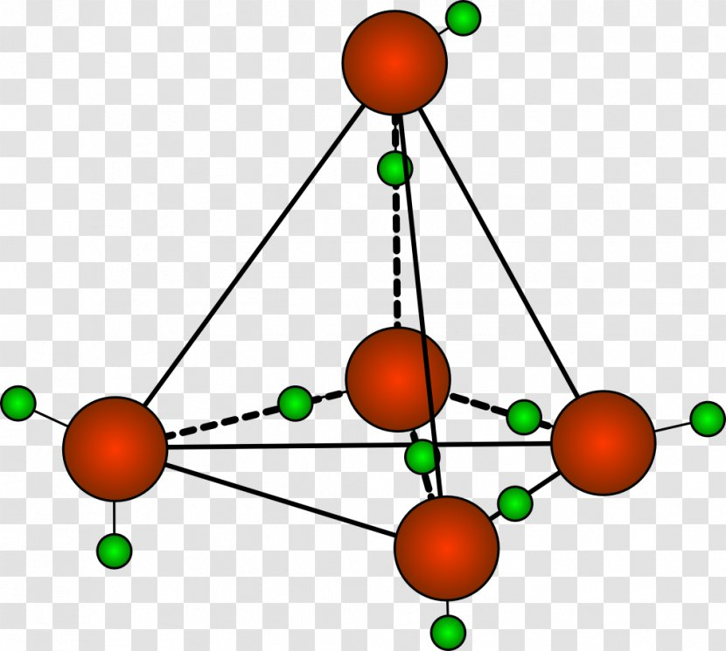

The end of the molecule with the unshared electrons has a partial negative charge whereas the other end with the hydrogen atoms has a partial positive charge. Furthermore, each H-O- bond has dipolar character due to the unequal sharing of electrons between the hydrogen and oxygen atoms. Water is therefore regarded as a polar solvent.

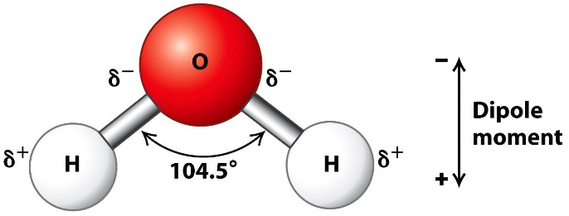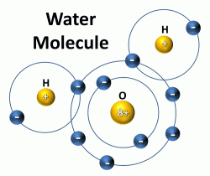

The other molecules in water are held together by hydrogen bonds. The H bond is the non-covalent attraction between the partially positive charged H atom and one of the unshared pairs of the oxygen atom (negatively charged)

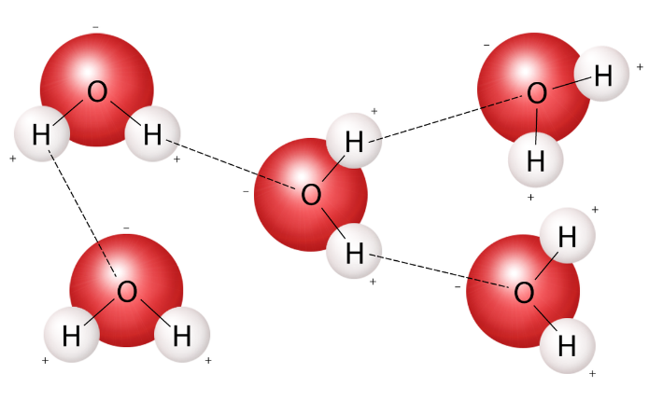

Each water molecule has two unshared electrons and two hydrogens that can participate in H bonding meaning that each molecule of water can form four H bonds with its neighbours.

In ice each water molecules are arranged in a rigid tetrahedral crystalline lattice with each H atom bonded to four others.

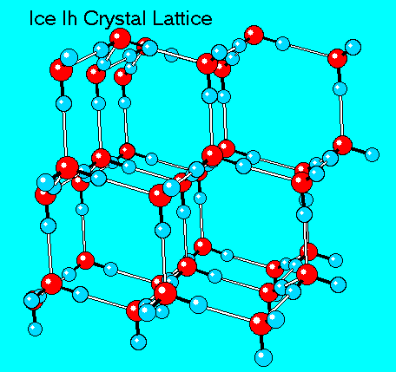

In liquid water a similar tetrahedral arrangement exists with some what an irregular packing allowing the water molecules to fit together rather closely.

This tetrahedral character of water molecules makes water highly cohesive and is responsible for the high boiling point and the low melting points.

Water has a high specific heat of vaporisation making it a good thermal buffer for cells and tissues engaged in high metabolic activities. This is also the reason as to why cold water is able to conduct heat away from a swimmer leading to hypothermia (low body temperature).

**Behaviour of ionic and polar substances in water**

These substances are referred to as hydrophilic

Water molecules also form H bonds with polar functional groups in polar biomolecules such as sugars and amino acids.

Many biomolecules contain both polar and nonpolar groups and therefore their solubility depends on the **proportions** of polar and nonpolar regions.

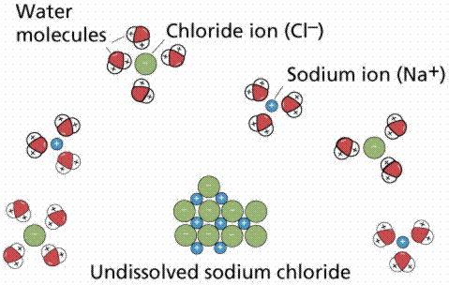

**Behaviour of non-polar substances**

They are relatively insoluble and are known as hydrophobic. Most are hydrocarbons containing methylene, methyl and aromatic ring functional groups. They also lack polar groups that can interact with water molecules.

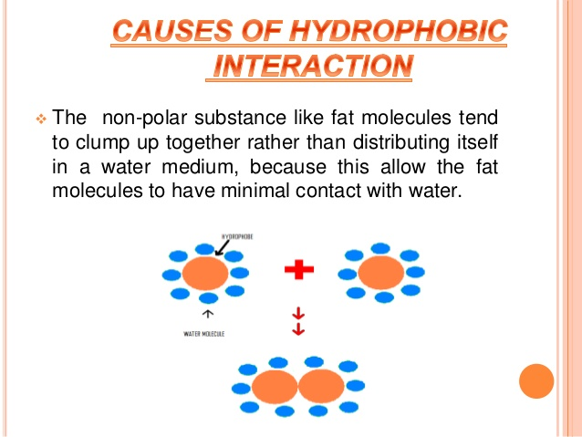

At the same time there is a clustering of together of non-polar molecules e.g. membrane lipids to keep off the effect of water molecules. This is the hydrophobic interaction but it is not considered a type of bond.

**Amphiphiles** have significant proportions of both hydrophilic and hydrophobic functional groups for instance detergents such as sodium dodecyl sulphate (SDS) which contains a highly water soluble sulphate group and an insoluble 12 carbon alkyl group. This makes the hydrocarbon chains cluster away from water molecules when SDS is added to water forming spherical structures known as micelle.

SDS is a useful detergent as the hydrocarbon tail bind to non-polar surfaces such as dirt and can be easily rinsed off.

**Non-covalent interactions in biomolecules**

Non-covalent interactions are individually weak but collectively strong and together stabilise the complex structures of biomolecules. Being individually weak allows them to bind reversibly to small biomolecules such as enzymes and nucleic acids.

**Charge-charge interactions**

These occurs between positive and negative functional groups

They are also known as ion pairing interactions and salt bridges. The strength of the bond depends on the medium they are suspended in with water medium weakening the interactions.

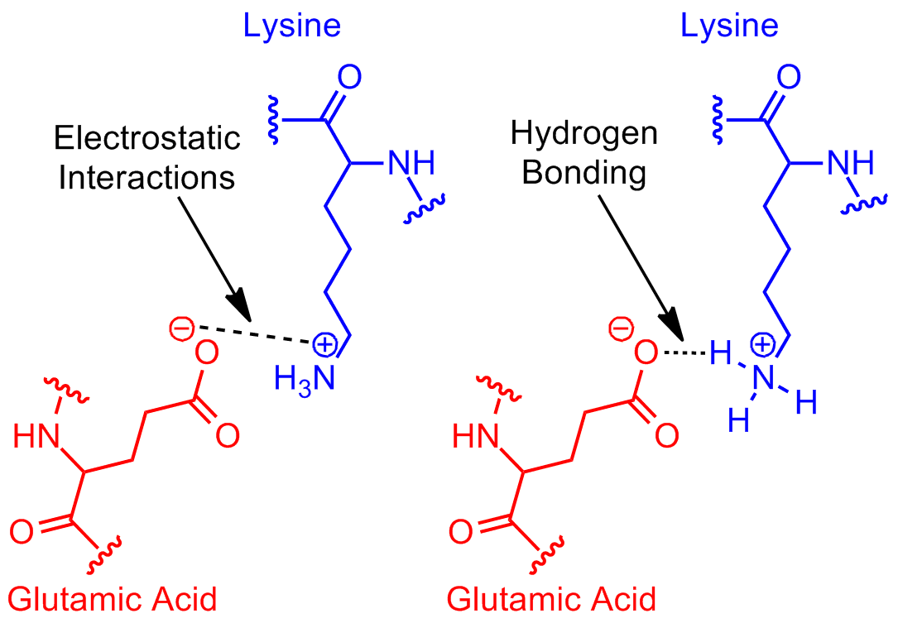

**H bonds**

A hydrogen bond is defined as the dipolar attraction between the hydrogen atom attached to one electronegative atom and a second electronegative atom. H atom must be covalently bonded to an electronegative atom such as O or N to generate a molecular dipole.

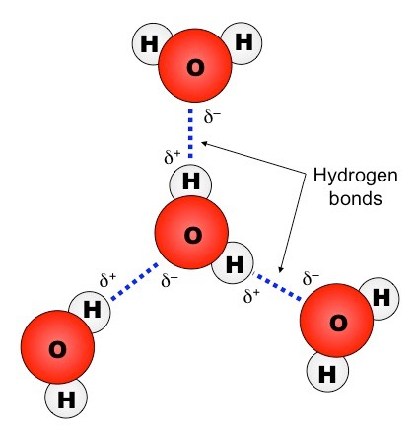

The atom containing the covalently bound hydrogen atom is called the hydrogen donor while the other atom is the hydrogen acceptor.

H bonds are strong when they are properly aligned and are therefore important in the specificity of molecular interactions e.g. A-T, C-G base pairing in DNA.

**Van der Waals forces**

These are attractions between oppositely oriented dipoles that are transiently induced in the electron clouds of closely molecules.

The strength is maximal when the molecules are just touching. If the molecules are compressed they tend to push the molecules apart and therefore become destabilised.

These are the weakest bond among the non-covalent interactions.

These forces are important in the packing of amino acids inside the protein and in the interactions between adjacent bases in the DNA double helix.

They can also mediate specific interactions since they become collectively strong when they have complementary shapes and are able to approach one another.

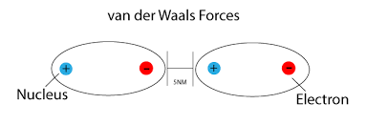

**Water as a nucleophile.**

A **nucleophile** is a chemical species that donates an electron pair to form a chemical bond in relation to a reaction. All molecules or ions with a free pair of electrons or at least one can act as **nucleophiles**.

In chemistry, an **electrophile** is a chemical species that forms bonds with nucleophiles by accepting an electron pair.

Water is a reactant in biochemical reactions. The unshared pairs of electrons in water molecules can behave as nucleophiles which can attack an electrophile in another molecule.

water serves as a nucleophile in the hydrolysis of peptide bonds.

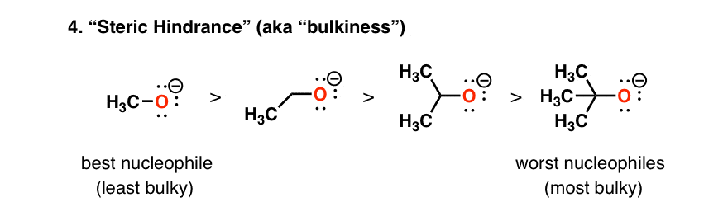

**Ionisation of water**

A water molecule has a tendency to undergo dissociation and loses a proton to another water molecule.

This produces a hydronium ion and hydroxyl ion

These hydronium ion can donate its proton to another molecule and is considered a proton donor.

A hydroxyl ion can accept a proton from an acid and is therefore an acceptor

Water has a finite and defined capacity to ionise and the ionisation has a characteristic equilibrium constant at a given temperature.

**Review questions**

Discuss the disorders associated with water intake -----------(20 marks)

Discuss the regulation of water intake in the body-------(20 marks)

Explain what is meant by osmolality----------------(5 marks)