# VEGETATION

**Definition**: - Vegetation is the collection of plant cover on the earth surface. Geographically, it entails the entire plant cover except cultivated crops.

## Types of Vegetation

1. **Natural vegetation**

* These are wild plants that grow naturally, without interference or modification by human beings/animals
* They grow and spread through natural means of seed dispersal, and are found areas of protected plant life, unsettled.

1. **Climax vegetation**

* Describes the plant cover that has established itself without interference in relation to the particular physical environment, relief and soils i.e. it is vegetation which is in a state of equilibrium with the existing environmental conditions.

1. **Derived vegetation**

* This is the type of natural vegetation which is in the process of recovering from humans’ disturbance but yet to reach a new climax.
* Also known as semi-natural or secondary bush

1. **Planted/cultivated vegetation**

* These are deliberately planted by human through agro-forestry, afforestation and re-afforestation programs; plants used as hedges (Cypress, euphorbia etc.).
* Planted crops (Maize, tea, coffee) don’t form part of the planted vegetation unless they grow wild after their seeds are dispersed through natural means.

## Factors influencing the distribution of vegetation

1. **Physiographic Factors**
   * + 1. **Relief/Altitude**

* These affect temperature and rainfall that in turn influence vegetation e.g. mangrove vegetation thrives in warm and low altitude areas whereas bamboo is found in highland areas with moderate temperature and heavy rainfall.
* Gentle slopes that are well drained with mature soils support luxuriant growth of vegetation.
* On steep slopes, soil development is hindered by heavy erosion and regular mass wasting. Consequently such soils are thin and hinder plant growth.
  + - 1. **Aspect**
* Slopes facing the sun to tend to be warmer hence support abundant plant growth compared to slopes facing away from the sun.
* Windward slopes of a mountain supports dense vegetation mainly forests due to the warm and wet conditions.
* Leeward slopes which are relatively drier, have grassland as the dominant vegetation.
  + - 1. **Drainage**
* Flat areas with poor drainage tend to be water logged and have swamp plants such as the papyrus. While well drained soils support large variety of plants

1. **Climatic Factors**
   * 1. **Rainfall**

* Areas with heavy rainfall support luxuriant growth of thick forests with variety of tree species. In areas where there is little rainfall, vegetation tends to be poor and scanty.

**2. Temperature**

* Temperature influences the rates at which plants grow flower and form fruits.
* Areas with warm temperatures have many varieties of vegetation as the temperatures facilitate their rapid growth.
* Colder temperatures slow down growth of plants and such areas lack or have few vegetation.

**3. Sunshine**

* Sunlight is essential for the process of photosynthesis. Places with long hours of sunlight have wide varieties of plants unlike those with less sunlight.

**4. Wind**

* Wind is responsible for pollination and seed dispersal where strong winds are dominant, tall trees/plant species is usually non-existent and those present become stunted.

1. **Soil Factors**

* Soils provide plants with moisture and nutrients for their growth. Fertile and well-drained soil tends to support thick vegetation.
* Poor and leached soils tend to support scanty vegetation with stunted growth.
* Conifers thrive in highly acidic soil while grasses are dominant in soils with lower acidity.

1. **Biotic Factors**

* These entail action of man, pests, bacteria and other living organisms on vegetation.
* Human beings modify and destroy vegetation through their activities such as mining, settlement, lumbering, cultivation, pastoralism, charcoal burning, reafforestration, afforestration, pollution.
* Insects, birds help in pollination and seed dispersal.
* Bacteria, earthworms, burrowing animals improve soil fertility and aeration.
* Bacteria, insects cause and spread diseases that may destroy vegetation.

**MAJOR VEGETATION REGIONS OF** **KENYA**

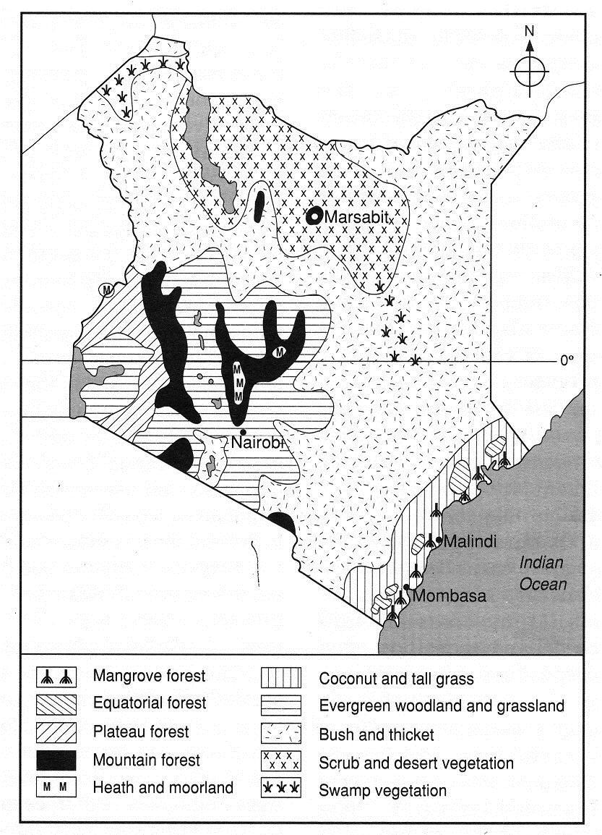

Kenya has four major zones of vegetation namely

1. Forests
2. Savannah woodland
3. Savannah grassland
4. Scrub and desert vegetation

**FORESTS**

Forests in Kenya occupy about 3% of the total land area less than the recommended forest cover of 10%.

**Categories of Forests in Kenya**

* 1. **Highland/Mountain forests**
* Occur in the mountains of central and western Kenya e.g. Mt. Kenya, Aberdares, Elgon, Cherangani hills and Nyambene hills.
* The forests contain indigenous hardwoods such as Meru Oak, Camphor, Elgon Teak, East African Olive and softwoods such cedar and Podo.
* Exotic hardwoods include blue gum, eucalyptus, and silver oak, soft woods of cypress, pine, brushwood and fir.
  1. **Lowland Forests**
* Their remnants are found along the coast stretching from Shimba hills to Malindi.
* They are mainly mangrove and tropical rain forests.
* Mangroves flourish in the shallow marine waters and mudflats especially between Kikambala and Gede on the north coast.
* Tropical rain forests are found in Kaya Bombo (Shimba hills) and around Arabuko Sokoke.
* Typical species of trees are camphor, mvuli, elgon teak, ebony, mahogany and plateau bamboo.
  1. **Plateau Forests**
* These are found in the lower altitudes of the mountain forests and along rivers and swamps especially in the Lake Victoria basin.
* Today, only patches of these forests are left.
* **Examples:** Nandi, Kodera, Tinderet, Turbo, Maragoli, Kaimosi and Kakamega

**SAVANNAH WOODLANDS**

* Vegetation consists of trees whose crowns (tree tops) more or less touch to form a light, fairly continuous canopy over a ground vegetation of grasses mixed with herbs and shrubs.
* There is a denser growth of grass and shrubs.
* Acacia and other thorny, drought resistant trees are the most common.
* The giant baobab trees are also common
* *Examples –* In Embu, Machakos, Mbeere, Makueni and parts of Kitui district

**SAVANNAH GRASSLANDS**

* Occurs between the more humid forests and the more arid deserts
* Characterized by open country grassland about 1m – 4m tall, dotted with trees and shrubs which do not form a canopy over the grass.
* Examples found in Laikipia, Nakuru, Kajiado, Trans Mara and Narok.

**SCRUB (DESERT VEGETATION)**

* Bush and thicket vegetation is typical in areas with 375 – 625mm of rainfall per annum.
* Bushy thorny tress between 5m -10m tall are densely interlaced with each other and with the scrub that grows between them.
* There is a dense growth of shorter thorny shrubs in large numbers forming thickets/bush.
* The gaps between the bushes are covered by scattered varieties of grasses or they may remain bare.
* As rainfall drops to below 375mm per annum, the vegetation becomes increasingly short and more widely spaced over bare ground. Grass becomes rare, except in moist depression.
* **Areas**: Garissa, Wajir, Mandera, Marsabit, Mwingi, Kitui, Turkana

**MAJOR VEGETATION ZONES IN THE** **WORLD**

The global vegetation zones can be categorized as

* + 1. Forests
    2. Grasslands
    3. Mountane Vegetation
    4. Desert Vegetation
    5. Alpine/Tundra Vegetation

1. **FORESTS**

* A forest is a continuous and extensive tract of land covered with a closed stand of tall trees usually of commercial value.
* They are divided into:

1. **Tropical rainforests/Equatorial rainforests**

* Confined within 40– 50 North and South of the equator in the following areas: The Amazon, (Eastern Brazilian Coast); Congo Basin, West African Coastlands, Indonesia, Malaysia, Vietnam, Philippines

***Characteristics***

* Trees form a closely set canopy of three distinct layers.
* Trees have buttressed roots for support.
* The trees grow in multiple or mixed species.
* Trees are mainly hardwoods e.g. Mahogany, sapele, camphor, African walnut, ironwood, green heart ebony, rosewood, mvuli, iroko, teak, etc.
* Trees are tall with smooth stems and straight trunks and lack branches in the lower sections.
* Trees have evergreen broad leaves with drip tips to eliminate excess water.
* There is little or no undergrowth except along river banks.
* There are many species of climbing and creeping plants such as the Lianas, lichens, ferns are parasitic.

1. **Tropical monsoon forests**

* They occur within 100–23½0 north and south of the equator in areas that experience tropical monsoon climate – seasonal variation in rainfall
* They are similar in many ways to the tropical rainforests in structure
* Found in the following areas: South West and Southern Coast of Mexico, parts of India, Bangladesh, Burma, Vietnam & Indonesia in Asia, East and West African Coast

**Characteristics**

- Most trees are deciduous i.e. shade all their leaves during the dry season.

- Tress do not form/lack canopies

- Trees have branches because of abundant sunlight at the lower levels.

- Less dense tall species of trees (30m)

- Denser undergrowth due to the more open forest.

- Dominant tree species are teak, bamboo, sapele, camphor, ebony, eucalyptus.

1. **Deciduous forests**

* Found in mid latitude land masses in areas characterized by cool temperate western margin climate; 450– 600North and South of the equator
* Found in Central and Western Europe, Eastern States of USA, Chile in South America, Japan, Korea & China in Asia

**Characteristics**

* Trees form dense canopies in summer and remain dormant in winter
* Trees grow in pure stands i.e. single species over a unit area.
* Trees are hardwoods and deciduous i.e. shed leaves in autumn, and remain leafless in winter.
* Trees are tall and broad leaved; hence shedding protects them from excessive weight of snow.
* Trees have thick trunks and outspreading branches.
* Major tree species are Oak, Elm, Ash, Beech, Birch, Poplar, Aspen, Alder, Chestnut, Sycamore, Maple, Hickory, Hornbeam, Lime’

1. **Coniferous forests**

* Found between latitudes 450and 700North and South mainly in the Northern hemisphere(dominant in cold climates).
* They extend from Canada, Scandinavian countries of Northern Europe, and Russia/Siberia to Pacific Coast.

**Characteristics**

* Most of the trees species are softwoods which mature faster.
* The trees are light in weight, easy to cut and transport
* Trees occur in pure stands i.e. one species is spread over a large area.
* There is little undergrowth.
* Most trees species are evergreen but a few are deciduous.
* Trees have conical shape which prevents accumulation of snow upon the branches thus allowing snow to slide off easily to the ground.
* Trees have shallow root system to fully utilize moisture from the top-soil since the sub-soil is permafrost most of the time.
* Tree trunks are straight and flexible to enable them sway without breaking during the strong winter winds.
* Trees have thick barks with a lot of resin which protects them from frost.
* Trees have needle-like leaves to reduce water loss in summer
* Trees take long time to mature (100yrs) due to extremely low temperatures.
* Major species are**:** Pine, larch, spruce, fir, hemlock

1. **Mixed forests**

* Found at the borders of deciduous and coniferous forests in Canada (provinces of Alberta and Saskatchewan), In USA, New York, through Pennsylvania, Michigan, Wisconsin to Minnesota, Scottish highlands, Germany and Sweden in Europe, North Korea, Japan and China in Asia
* Characteristics comprises of broad leaved deciduous and coniferous trees

1. **GRASSLANDS**

* Grasses generally grow in all climatic regions where a seasonal pattern of rainfall occurs with a prolonged drought of about 5-7 months.
* Are categorized into
  + - 1. **Tropical savanna** **grasslands**
  + Found in areas that experience tropical continental climate, approximately 100North and South of the equator
  + It is divided into open grasslands and woodlands with grass and trees dominant respectively with woodlands found in areas that receive more rainfall
  + Found in North and South of the Congo basin and along the East African plateau in Africa, Brazilian highlands and lowlands of Colombia & Venezuela, North East of Australian Desert

**Characteristics**

* Vegetation consists of mixture of scattered trees and a dense growth of grass.
* Acacia trees dominant species
* Trees are of medium height (13m) and their crowns are umbrella-shaped.
* Most of the trees are deciduous and shed their leaves in the dry season.
* The grasses are tall (3m) and have stiff blades in the wetter areas while in the drier areas the grasses are shorter and tufted.
* Some trees such as the Baobab have swollen trunks to store water.
* Trees have deep roots to tap water below
* Trees have thin leaves reduced to thorns to limit water loss
* River valleys have tall trees and thick bushes/Riverine vegetation.

1. **Temperate grasslands**

* These are best developed in continental interior of temperate latitudes where rainfall can only sustain the growth of grass but not trees (warm temperate climate)
* They are best developed between latitudes of 300– 500North and South of the equator
* They are further divided into
* Prairies of Canada and USA
* Pampas of Argentina
* Veldts of South Africa
* Steppes of Russia
* Downs of Australia and New Zealand

**Characteristics**

* Grasses form a continuous cover i.e. the vegetation forms a rich carpet of grass
* In areas experiencing less rainfall below 250mm, coarse grass grows in tufts surrounded by bare soil i.e. vegetation doesn’t form continuous cover
* Grass is normally short and sod-like i.e. grows very close to the ground.
* The grass grows in tussocks on the extensive rolling plains with patches of bare soil in between.
* The vegetation is treeless/or a few trees except along water course.
* The short grass is interspersed with bulbous and leguminous plants
* The grasses wither in summer and die in autumn (prairies) sprouts in spring

1. **Mountane grasslands**

* Occur in mountainous areas of the world especially in Europe and East Africa
* Occur in irregular patches of grass
* The grasses grow and mature within a short vegetative period
* Form thick tufts of grass

1. **Arid grasslands**

* These are limited to sandy areas, salt pans and limestone regions in mid latitude areas
* They are dominated by shrubs and spiny plants that are almost leafless

1. **DESERT VEGETATION**

* These are divided into
  1. **Tropical/Hot Desert Vegetation**
* Are located within the tropics in the hot deserts of the world such as
* Africa – Sahara, Namib and Kalahari
* Asia – Iranian and Arabian Deserts
* South America – Atacama and Chilean Deserts
* North America - Mohave, Colorado, Arizona, Californian & Mexican Deserts
* Great Australian Desert

**Characteristics**

* Some trees have long tap roots to tap the water deep below.
* Halophytes e.g. salt bush can withstand saline conditions.
* Some vegetation have seeds covered with almost impermeable coats to enable them survive long periods of drought without drying.
* Their seeds, tubers remain dormant during the dry period until a moist season stimulates them into germinating and growing.
* Scarce vegetation cover that varies from short bushes to bare sandy grounds
* The vegetation is characteristic of plants that are highly tolerant to drought (xerophytes). These include succulents e.g. euphorbia, drought evading e.g. lilies and drought resistant e.g. cactus
* Some plants are deciduous (shed their leaves during dry seasons)

1. **Cold Desert Vegetation**

* Aka temperate desert vegetation
* Found in polar regions and extremely high mountains that are very cold
* It is arid because water available to the plants is scarce due to freezing
* Located in the following places:
* Nevada and Utah Deserts in North America
* Patagonian Desert of Argentina – South America
* Gobi Desert in China
* Vegetation is adapted to moisture deficient/low evaporation rate and low temperatures/freezing conditions

**Characteristics**

* Most plants are dwarf-like due to the cold conditions and strong winds.
* Plants growth is continuous for only a maximum of three months (summer).
* Shrubs have shallow roots because of thin soils.
* Plants are xerophytic and halophytic (salt resistant).
* Vegetation comprises of grasses and woody shrubs which have spiny needle-like leaves.
* Small flowering shrubs, arctic meadow grass, mosses and snow lichens are dominant.
* Most shrubs are shallow rooted to avoid permafrost deep layer.

1. **MOUNTAIN VEGETATION**

* On high mountains, vegetation varies with altitude, soils, aspect and winds
* The vegetation is arranged in successive zones ranging from savanna grasslands at the mountain foot through savanna woodland, and rainforest to heath and moorland in high altitude

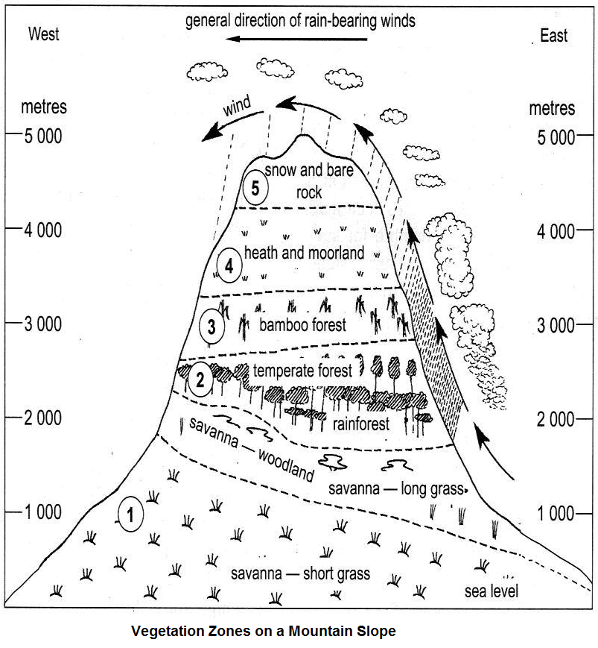

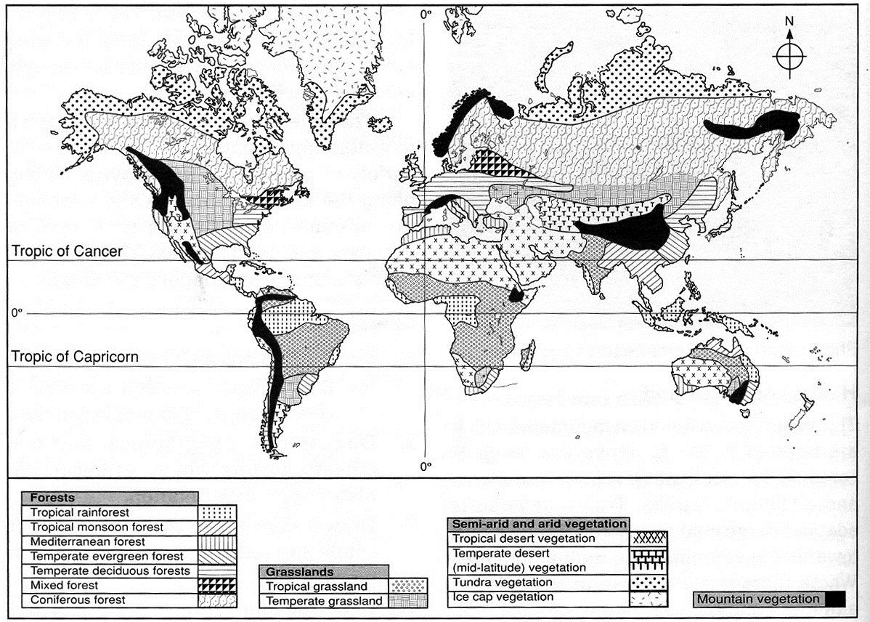

**MAJOR VEGETATION ZONES OF THE WORLD**

**Significance of Vegetation**

* Forested areas act as water catchment areas providing for sources of rivers that in turn provide water for domestic and industrial uses
* Promote tourism by providing habitat/homes for wild animals
* Provides poles used in electricity, fencing and pit props in mining, trees provide timber for furniture, building and construction
* Vegetation adds aesthetic value to the landscape e.g. flowers, grasses, etc.
* Purification of air through the release oxygen during photosynthesis
* Vegetation provides raw materials for paper, pulp, rubber and textile industries thus leading to industrialization
* Some vegetation are of medicinal
* Helps in checking soil erosion by binding soil particles together at the roots and the trees act as wind breakers

***Factors that have led to the decline of natural grasslands in Kenya***

* *Frequent fire outbreaks which destroy grass retarding its regeneration.*
* *Encroachment into the grasslands due to increasing human population to give provision for agriculture and settlement*
* *Pests e.g. worms & locusts destroy the grass degenerating the vegetation into semi-arid type.*
* *Wild and domestic animals overgraze and cause stunted growth of grass/reduction in the grass cover.*